Original Research Article

Interactive Learning of Algebraic Identities Using GeoGebra for Students with Dyscalculia

Abstract
In this article, an attempt is made to describe the dynamic properties of rapidly growing mathematical software GeoGebra, designed for teaching and learning algebraic identities while linking its relationship to geometry. GeoGebra can be utilized as a means of remedial teaching strategies to teach children with learning disabilities, specifically dyscalculia. It is observed in various studies that students who have trouble learning are known to struggle with a wide range of mathematical skills and operations. Several studies' findings revealed that GeoGebra could be used in inclusive classrooms to assist students with dyscalculia. Against this backdrop, in the present article, some examples of algebraic quantities are presented with steps involved in using geometric concepts in GeoGebra. Again, as geometric shapes are easier to understand for students than numbers, this strategy is likely to help learners with dyscalculia understand the fundamentals of algebraic calculations. Furthermore, this strategy would certainly help these children with dyscalculia to comprehend mathematical concepts and inspire them to learn other geometric forms, such as the square, cube, and square cuboid, easily.

Keywords: Dyscalculia, GeoGebra, Mathematics Education

- Introduction

The word "learning disabilities" is a phrase that includes a wide range of learning problems in an individual. These learning problems are confined to one or two cognitive areas, like the inability to speak, listen, read, write, and do mathematical calculations. Children with learning disabilities look like their peers in age and grade. In fact, they have a normal IQ range like other children in the class and seem to have strengths similar to those of their peers in several areas. But it is found in several studies that children having learning disabilities always lag behind in terms of academic achievement in comparison to their peers. The main reason behind this difference is that their rate of learning is unexpectedly slow (Smith, 2004). Further, their neurological functions are just built differently, which impacts their perceptual process and further processing of any information. In 1987, the National Joint Committee on Learning Disabilities (NJCLD) recommended the following comprehensive definition of learning disabilities
"Learning disabilities is a generic term that refers to a heterogeneous group of disorders manifested by significant difficulties in the acquisition and use of listening, speaking, reading, writing, reasoning or mathematical abilities. These disorders are intrinsic to the individual and presumed to be due to central nervous system dysfunction. Even though a learning disability may occur concomitantly with other handicapping conditions (e.g., sensory impairment, mental retardation, social and emotional disturbance) or environmental influences (e.g., cultural differences, insufficient/inappropriate instruction, psychogenic factors), it is not the direct result of those conditions or influences" (National Joint Committee on Learning Disabilities., 1987)

Some research on the prevalence of math learning difficulties has shown that 5 to 6 per cent of the population of school-age students has a significant problem in math achievement (Badian, 1983; Light & DeFries, 1995). Another study conducted by Alsina & Pastells in 2007 reported that mathematics is hard to learn, and usually, the rate of failure is highest, especially in the later stages of elementary school
However, some students find mathematics learning more difficult than others. This type of learning difficulty in mathematics is known as dyscalculia. Students with dyscalculia have a wider range of deficits related to mathematics skills than their counterparts without disabilities (Mabbott & Bisanz, 2008). Dyscalculia is basically a difficulty in creating or interpreting amounts, numerical symbols, or fundamental arithmetic operations. Students with dyscalculia are known to have trouble with a wide variety of mathematical abilities, including both fundamentals (such as calculation, decimals, and percentages) and more advanced ones (such as problem-solving) (Bryant et al., 2000). The incidence is thought to be approximately 6 per cent, and its symptoms become noticeable in roughly the second grade of Elementary Education (Shalev & Gross-Tsur, 2001).

Deshler et al. (2001), in the year 2001, reported in their study that the mathematics proficiency of adolescents with dyscalculia is likely to cease around the fourth grade and fully stabilize around the fifth or sixth-grade level by the time they graduate from high school. It can be inferred that children having dyscalculia are likely to face difficulties in understanding basic mathematics at the early stages of their development. Subsequently, if not diagnosed and intervened earlier, they might face difficulties in learning advanced mathematics applications as well. In light of the results of various research, it has been found that students with learning disabilities may benefit from various educational approaches, including computer-assisted instruction (CAI) (Ok et al., 2020).
One of the difficulties faced by students with dyscalculia is their inability to visualize mathematical formulas in a real-world context (Soares et al., 2018). Most studies show that computer software is most beneficial for those students. GeoGebra is one of the evolving computer software programs in this arena. GeoGebra is a school-based dynamic mathematics software that combines geometry, algebra, and calculus. With GeoGebra, it is possible to build structures out of points, vectors, segments, lines, and conic sections, as well as functions, and then change them dynamically. GeoGebra can not only be used as an advanced calculator, but it can also manipulate matrices and even solve a system of linear equations. This article aims to show how different algebraic formulas may be visualized using computer software. Visualization has been shown to be the most effective way for students to learn (Banerjee et al., 2015). As a result, students will benefit from visual representations of algebraic identities or formulas rather than remembering algebraic identities or formulae.

- Research Evidence

It has been proved in several studies that GeoGebra can be used in the classroom to help students learn maths. GeoGebra was shown to be helpful in the teaching of calculus by Hohenwarter et al. (Hohenwarter et al., 2008). GeoGebra was established to help teach geometry, algebra, and calculus by Haciomeroglu et al. (2009). As Rincon (2009) discovered that GeoGebra was an effective tool for teaching geometry, algebra, and calculus, as well as their subtopics. According to an article authored by Antohe (2009), GeoGebra was efficient and could be used to investigate arithmetic, geometry, algebra, and calculus. Researchers Zulnaidi & Syed Zamri (2017) said that GeoGebra aids students in better grasping the notion of functions and connecting them to real-world situations. Besides eliminating the need for symbolic algebraic operations, GeoGebra may be used as a simulator for modelling and understanding real-world situations (Dayi, 2015). Using graphics, pictures, images, and symbols to teach mathematical ideas and methods is widely accepted as the best way to utilize the programme (Zulnaidi et al., 2020). GeoGebra is also a two-way interactive programme that engages learners. Ljubica Dikovic (2009) shows that using GeoGebra tools to learn calculus helped students improve their ability to think and see things in a new way. Dogan & Icel (2011) performed an experiment with a pre-test and post-test to find out how well students learned with GeoGebra. It was a two-week-long, twelve-hour course that included two eighth-grade classes. Computer-based activities were shown to be effective in the learning process, and GeoGebra promoted higher-order thinking abilities. The software was also shown to be effective in inspiring students to study and retain information for longer periods of time. They found that students who used GeoGebra to learn about transformations did better than those who used the software they made. Students can use interactive GeoGebra files to explore, learn, and then understand math. This is possible and useful on a large scale. Because of this, GeoGebra is good for both individual and group talks, as well as classroom and online tasks that give people the freedom to explore and learn.

- Research Method

This study employs a descriptive research design that aims to explore strategies for teaching algebraic identities using GeoGebra to school students having dyscalculia. The primary objective of this research is to illustrate how interactive visual tools such as GeoGebra can be implemented to comprehend mathematical concepts such as algebraic identities. The primary tool used in this study is GeoGebra, a school-based dynamic mathematics software that combines geometry, algebra, and calculus.

- Strategies for teaching Mathematics

Technology's growth and accessibility in school settings have led to greater adoption as one strategy to boost the mathematical learning of children with dyscalculia (Ok & Bryant, 2016). CAI is characterized as an educational approach, employing both conventional desktop and laptop, as well as mobile devices like tablets and smartphones to give instructional material to boost students' abilities, knowledge, or academic accomplishment (Ok et al., 2020). Specifically, CAI is a suggested strategy for leveraging technology for mathematics education for learners with dyscalculia (Fitzgerald et al., 2008). Aside from that, it has been said that the usage of CAI may help learners with dyscalculia to enhance their desire to learning mathematics (Bouck & Flanagan, 2009).
All the available software for teaching and learning Mathematics is categorized into two forms (Hohenwarter & Jones, 2007):
- Computer Algebra Systems (CAS): These are used to manipulate symbolic expressions. Some examples are Derive and Maple.
- Dynamic Geometry Software (DGS): These visualize various geometric shapes. Carbi and Sketchpad are some of them.
Although the intersection of CAS and DGS is not empty, some software enjoys both the features of CAS and DGS. GeoGebra is one of this kind. Markus Hohenwarter developed this software at Salzburg University in 2001 and received funding from Florida Atlantic University. In the field of calculus software, GeoGebra is the most comprehensive and user-friendly. Such essential software should be included in the teaching of calculus, algebra, and geometry (Zulnaidi et al., 2020). An inexpensive computer-based assignment for pupils may be accomplished by downloading this free programme. There is a wide range of instructional materials available for the programme.

- Visualization of algebraic identities

Algebraic identities are a collection of formulae used in mathematics. They are the fundamental working concept of algebra, and they are useful for doing calculations in simple and straightforward stages. Algebraic formulas are equations in which the value on the left side of the equation is the same as the value on the right side. In contrast to algebraic formulas, algebraic identities match all of the values of the variables. These algebraic identities, discussed in this paper, are included in the syllabus of classes VII and VIII.

- Square of the sum of two numbers

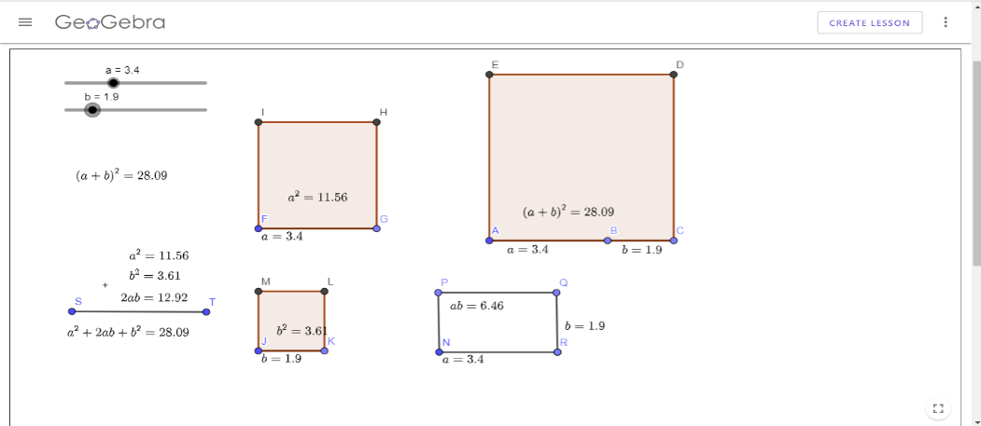
To represent geometrically the identity ${\left(a+b\right)}^{2}=a^{2}+2ab+b^{2}$, we follow the following steps:
Figure 1: Geometric representation of ${\left(a+b\right)}^{2}$
Source: https://www.geogebra.org/m/eppug6kq

Step 1: Create two variables $a$ and $b$ using the slider
Step 2: Create a square of side length $a+b$
Step 3: Calculate the area of this square, which is ${\left(a+b\right)}^{2}$
Step 4: Again, create two squares of side length $a$ and $b$ respectively
Step 5: Calculate the areas of these two squares, which are $a^{2}$ and $b^{2}$ respectively
Step 6: Create a rectangle with side lengths $a$ and $b$ and calculate the area, which is $ab$
Step 7: Now, take the sum of $a^{2}$, $b^{2}$ and $2ab$ and compare with ${\left(a+b\right)}^{2}$

In figure 1, a screenshot is given for the values $a=3.4$ and $b=1.9$. Students can check their identity by changing the values of $a$ and $b$. Similarly, the square of the subtraction of two numbers can be represented.

- Subtraction of two squares
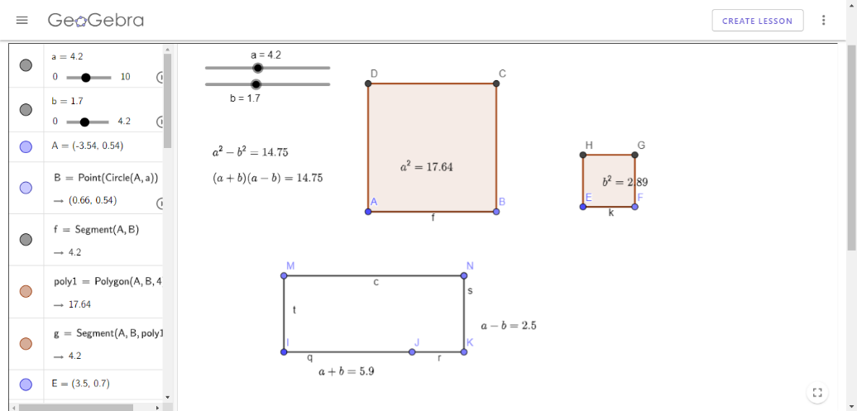
To represent geometrically the identity $a^{2}-b^{2}=(a+b)(a-b)$, we follow the following steps:
Figure 2: Geometric representation of $\left(a^{2}-b^{2}\right)=(a+b)(a-b)$
Source: https://www.geogebra.org/m/mjwxkcfz

Step 1: Create two variables $a$ and $b$ using the slider
Step 2: Create a rectangle of side lengths $a+b$ and $a-b$
Step 3: Calculate the area of this square, which is $(a+b)(a-b)$
Step 4: Again, create two squares of side length $a$ and $b$ respectively
Step 5: Calculate the areas of these two squares, which are $a^{2}$ and $b^{2}$ respectively
Step 6: Now, take the subtraction of $a^{2}$ and $b^{2}$ and compare with $(a+b)(a-b)$

Here, we have taken the value of $a$ as always greater than or equal to that of $b$. Otherwise, it is not possible to draw a line of length $a-b$. Figure 2 shows this representation when $a=4.2$ and $b=1.7$.
Students need to be encouraged to construct a similar representation of the following algebraic identities:
- ${\left(a-b\right)}^{2}=a^{2}-2ab+b^{2}$
- $ab={\left(\frac{a+b}{2}\right)}^{2}-{\left(\frac{a-b}{2}\right)}^{2}$
- ${\left(a+b+c\right)}^{2}=a^{2}+b^{2}+c^{2}+2ab+2bc+2ca$
- $2\left(a^{2}+b^{2}\right)={\left(a+b\right)}^{2}+{\left(a-b\right)}^{2}$

- Cube of the sum of two numbers

In this section, we demonstrate the geometric representation of the formula
$${\left(a+b\right)}^{3}=a^{3}+3a^{2}b+3ab^{2}+b^{3}$$
To represent this, we need a 3D interface of GeoGebra. The steps are as follows:

Step 1: Define the variables $a$ and $b$ using the slider
Step 2: Create a cube with a side length $\left(a+b\right)$
Step 3: Measure the volume of this cube, which is ${\left(a+b\right)}^{3}$
Step 4: Create two cubes with side lengths $a$ and $b$ respectively
Step 5: Calculate the volumes of these cubes, which are $a^{3}$ and $b^{3}$
Step 6: Construct a square cuboid with a base square side length $a$ and height $b$ and calculate its volume, which is $a^{2}b$
Step 7: Similarly, make another square cuboid with a base square side length $b$ and height $a$ and calculate its volume, which is $ab^{2}$
Step 8: Now, add all the volumes using the formula $a^{3}+3a^{2}b+3ab^{2}+b^{3}$
Step 9: Compare the above sum with the volume ${\left(a+b\right)}^{3}$
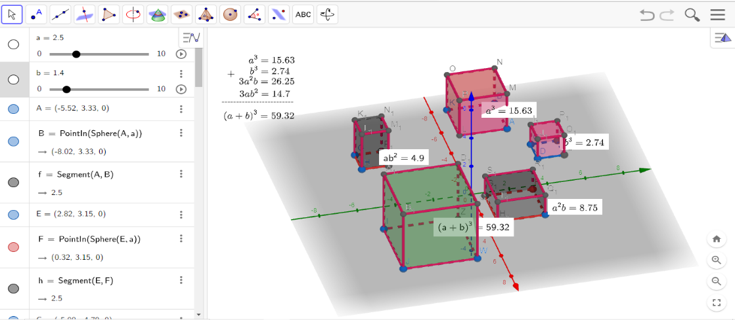
Figure 3: Geometric representation of ${\left(a+b\right)}^{3}=a^{3}+3a^{2}b+3ab^{2}+b^{3}$
Source: https://www.geogebra.org/m/tvuwehjp

Varying the values of the variables $a$ and $b$, the identity can be verified. In Figure 3, a sample is given for $a=2.5$ and $b=1.4$.
The following identities can also be represented similarly:
- ${\left(a-b\right)}^{3}=a^{3}-3a^{2}b+3ab^{2}-b^{3}$
- ${\left(a+b+c\right)}^{3}=a^{3}+b^{3}+c^{3}+3\left(a+b\right)(b+c)(c+a)$

- Discussion
The strategies and errors in secondary mathematics (SESM) research (Hart, 1984) is the most extensive investigation of students' frequent mistakes across a variety of algebra courses (e.g., ratios, algebra, graphs, measurement, fractions). The researchers discovered three areas where students struggled the most and resorted to poor tactics (Impecoven-Lind & Foegen, 2010).
- The first task was deciphering the meaning of variables denoted by letters. When faced with a variable, students used a variety of techniques, including ignoring it or guessing its value. Students usually viewed the variable as a single unknown, oblivious to the fact that it could mean a set of values or a connection between variables.
- In the second area, employing informal, intuitive approaches to arrive at a solution instead of the formal procedures required for more sophisticated algebraic issues, while working with letters.
- The symbols and conventions of algebra were the third area of difficulty. Students often lacked a basic understanding of coefficients and how to operate with negative values. Furthermore, several pupils misapplied the distributive property and misunderstood the meaning of the equal sign.
When announcing the results of the fourth math test of seventh- and eleventh-grade US students by the National Assessment of Educational Progress (NAEP), Brown et al. (Brown et al., 1988) concluded that:
"Secondary school students typically appear to have some grasp of fundamental algebraic and geometric ideas and abilities. However, the findings of this examination reveal, as the results of earlier tests have, that students typically are not able to use this knowledge in problem-solving situations, nor do they seem to comprehend many of the structures underpinning these mathematical ideas and abilities."

However, to mask their lack of knowledge, it seems that pupils resort to memorizing rules and processes, and they finally come to think that this activity reflects the substance of algebra. Brown et al. stated that a vast majority of the NAEP survey learners thought mathematics is rule-based, and roughly half considered that learning mathematics involves memorization primarily. These results are not confined to the NAEP examination.
Most teachers at all levels of education have endorsed the use of GeoGebra in the classroom. Consequently, it is one of the most often recommended tools for using technology to promote an innovative approach to teaching mathematics (Zakaria & Lee, 2012). Another study indicated that many students had good opinions of using GeoGebra, which improves students' learning outcomes, which is consistent with these findings (Shadaan & Leong, 2013). Algebra and geometry are taught separately in the school syllabus without mentioning any connection between them. And it leads to some adverse effects on students. According to Micheal Atiyah (Atiyah, 2001)

"when you pass over into algebraic calculation, essentially you stop thinking; you stop thinking geometrically, you stop thinking about the meaning."

Teaching algebra using geometrical representation in GeoGebra has several benefits:
- The very first one is that GeoGebra is absolutely free for all users. And it comes with a significant opportunity to use it anywhere, anytime. The GeoGebra user interface has a complex graphics menu for creating different elements, saving the whole building procedure, and displaying it in any of 45 languages accessible.
- The geometrical representations of various algebraic identities influence students to think about interrelated mathematical branches. They can have a clear concept of mathematical variables, and it enables them to investigate that algebraic identities remain invariant for any variable's values.
- Students with learning disabilities may find it relatively comfortable to learn algebra through geometry. As humans are more sensitive to geometric shapes than numbers (Sablé-Meyer et al., 2021), students can easily relate an algebraic quantity to its geometrical shape.

Various studies show that students who have GeoGebra lessons scored higher than students who study using conventional techniques (Saha et al., 2010). The findings of this research reveal substantial disparities between the mean scores of students in the post-test for the GeoGebra. Their results show that GeoGebra is highly beneficial in regular classroom teaching and more successful than traditional instruction. The augmentation in students' test scores is likely due to their attraction towards the technology. The emergence of technological tools raises students' curiosity to find new items. The students prefer to investigate the world of technology to study mathematics.

- Conclusion

In this article, several potential benefits of GeoGebra are studied in the classroom to explore some fundamental algebra and geometry topics. GeoGebra offers a wide range of capabilities for assisting learners in developing an intuitive sense and visualizing appropriate arithmetic processes. GeoGebra can be used most beneficial software for all learners by constructing and altering mathematical formulas, and children develop their own knowledge. Students may examine a wide variety of subjects using pre-set tools. Teachers can assist students with learning disabilities to participate in mathematics learning by providing an engaging learning environment in inclusive classroom settings. GeoGebra can be used as a part of universal design for learning (UDL) in a diverse classroom. Teachers can assist students who have trouble learning to take part in mathematics learning by providing an engaging learning environment and making mathematical information accessible to all learners with the help of this software. Also, the software is helpful for showing how ideas and steps work by making drawings, images, and symbols. GeoGebra is a very active teaching tool that would make a good learning setting if it were used, which can aid students in their mathematical exploration. Students may explore various tools using the software's features, creating links between symbolic and visual representations. Using GeoGebra to teach algebraic ideas through geometric shapes to learners with dyscalculia would help them to understand difficult mathematical concepts and problems easily. This, in turn, makes a significant impact on their academic achievement.

COMPETING INTERESTS DISCLAIMER:
Authors have declared that they have no known competing financial interests OR non-financial interests OR personal relationships that could have appeared to influence the work reported in this paper.

References

Antohe, V. (2009). Limits of Educational Soft “GeoGebra” in a Critical Constructive Review. Annals. Computer Science Series, 7(1), 47–54.
Atiyah, M. (2001). Mathematics in the 20th Century: geometry versus algebra. Mathematics Today, 37(2), 46–53.
Badian, N. A. (1983). Dyscalculia and nonverbal disorders of learning. Progress in Learning Disabilities, 5, 235–264.
Banerjee, G., Murthy, S., & Iyer, S. (2015). Effect of active learning using program visualization in technology-constrained college classrooms. Research and Practice in Technology Enhanced Learning, 10(1), 15. https://doi.org/10.1186/s41039-015-0014-0
Bouck, E. C., & Flanagan, S. (2009). Assistive Technology and Mathematics: What is There and Where Can We Go in Special Education. Journal of Special Education Technology, 24(2), 17–30. https://doi.org/10.1177/016264340902400202
Brown, C. A., Carpenter, T. P., Kouba, V. L., Lindquist, M. M., Silver, E. A., & Swafford, J. O. (1988). Secondary School Results for the Fourth NAEP Mathematics Assessment: Algebra, Geometry, Mathematical Methods, and Attitudes. The Mathematics Teacher, 81(5), 337–397. https://doi.org/10.5951/MT.81.5.0337
Bryant, D. P., Bryant, B. R., & Hammill, D. D. (2000). Characteristic Behaviors of Students with LD Who Have Teacher-Identified Math Weaknesses. Journal of Learning Disabilities, 33(2), 168–177. https://doi.org/10.1177/002221940003300205
Dayi, G. (2015). How geogebra contributes to middle grade algebra I students’ conceptual understanding of functions.
Deshler, D. D., Schumaker, J. B., Lenz, B. K., Bulgren, J. A., Hock, M. F., Knight, J., & Ehren, B. J. (2001). Ensuring Content-Area Learning by Secondary Students with Learning Disabilities. Learning Disabilities Research and Practice, 16(2), 96–108. https://doi.org/10.1111/0938-8982.00011
Dikovic, L. (2009). Applications GeoGebra into teaching some topics of mathematics at the college level. Computer Science and Information Systems, 6(2), 191–203. https://doi.org/10.2298/CSIS0902191D
Dogan, M., & Icel, R. (2011). The Role of dynamic geometry software in the process of learning: GeoGebra example about triangles. International Journal of Human Sciences, 8(1).
Fitzgerald, G., Koury, K., & Mitchem, K. (2008). Research on Computer-Mediated Instruction for Students with High Incidence Disabilities. Journal of Educational Computing Research, 38(2), 201–233. https://doi.org/10.2190/EC.38.2.e
Haciomeroglu, E. S., Bu, L., Schoen, R. C., & Hohenwarter, M. (2009). Learning to develop mathematics lessons with GeoGebra. MSOR Connections, 9(2), 24–26.
Hart, K. M. (1984). Ratio: Children’s strategies and errors. A report of strategies and errors in secondary school mathematics project.
Hohenwarter, M., Hohenwarter, J., Kreis, Y., & Lavicza, Z. (2008). Teaching and calculus with free dynamic mathematics software GeoGebra. ICME 11 Mexico 2008, 11th International Congress on Mathematical Education.
Hohenwarter, M., & Jones, K. (2007). Ways of linking geometry and algebra, the case of Geogebra. Proceedings of the British Society for Research into Learning Mathematics, 27(3), 126–131.
Impecoven-Lind, L. S., & Foegen, A. (2010). Teaching Algebra to Students With Learning Disabilities. Intervention in School and Clinic, 46(1), 31–37. https://doi.org/10.1177/1053451210369520
Light, J. G., & DeFries, J. C. (1995). Comorbidity of Reading and Mathematics Disabilities. Journal of Learning Disabilities, 28(2), 96–106. https://doi.org/10.1177/002221949502800204
Mabbott, D. J., & Bisanz, J. (2008). Computational Skills, Working Memory, and Conceptual Knowledge in Older Children With Mathematics Learning Disabilities. Journal of Learning Disabilities, 41(1), 15–28. https://doi.org/10.1177/0022219407311003
National Joint Committee on Learning Disabilities. (1987). LD Definition. Learning Disability Quarterly, 10(2), 136–138.
Ok, M. W., & Bryant, D. P. (2016). Effects of a Strategic Intervention With iPad Practice on the Multiplication Fact Performance of Fifth-Grade Students With Learning Disabilities. Learning Disability Quarterly, 39(3), 146–158. https://doi.org/10.1177/0731948715598285
Ok, M. W., Bryant, D. P., & Bryant, B. R. (2020). Effects of Computer-Assisted Instruction on the Mathematics Performance of Students with Learning Disabilities: A Synthesis of the Research. Exceptionality, 28(1), 30–44. https://doi.org/10.1080/09362835.2019.1579723
Rincon, L. F. (2009). Designing dynamic and interactive applications using Geogebra software in the 6–12 mathematics curriculum.
Sablé-Meyer, M., Fagot, J., Caparos, S., van Kerkoerle, T., Amalric, M., & Dehaene, S. (2021). Sensitivity to geometric shape regularity in humans and baboons: A putative signature of human singularity. Proceedings of the National Academy of Sciences, 118(16), e2023123118. https://doi.org/10.1073/pnas.2023123118
Saha, R. A., Ayub, A. F. M., & Tarmizi, R. A. (2010). The Effects of GeoGebra on Mathematics Achievement: Enlightening Coordinate Geometry Learning. Procedia - Social and Behavioral Sciences, 8, 686–693. https://doi.org/10.1016/j.sbspro.2010.12.095
Shadaan, P., & Leong, K. E. (2013). Effectiveness of Using Geogebra on Students’ Understanding in Learning Circles. Malaysian Online J. Educ. Technol., 1, 1–11.
Shalev, R. S., & Gross-Tsur, V. (2001). Developmental dyscalculia. Pediatric Neurology, 24(5), 337–342. https://doi.org/10.1016/S0887-8994(00)00258-7
Smith, C. R. (2004). Learning disabilities: the interaction of students and their environments. Pearson.
Soares, N., Evans, T., & Patel, D. R. (2018). Specific learning disability in mathematics: a comprehensive review. Translational Pediatrics, 7(1), 48–62. https://doi.org/10.21037/tp.2017.08.03
Zakaria, E., & Lee, S. L. (2012). Teachers’ Perceptions toward the use of GeoGebra in the Teaching and Learning of Mathematics. Journal of Mathematics and Statistics, 8(22), 253–257.
Zulnaidi, H., Oktavika, E., & Hidayat, R. (2020). Effect of use of GeoGebra on achievement of high school mathematics students. Education and Information Technologies, 25(1), 51–72. https://doi.org/10.1007/s10639-019-09899-y
Zulnaidi, H., & Syed Zamri, S. N. A. (2017). The Effectiveness of the GeoGebra Software: The Intermediary Role of Procedural Knowledge On Students’ Conceptual Knowledge and Their Achievement in Mathematics. EURASIA Journal of Mathematics, Science and Technology Education, 13(6). https://doi.org/10.12973/eurasia.2017.01219a

