A Comparative Study of Illustration Design in Chinese and Japanese Mathematics Textbooks: Taking the "Parallel Lines" Unit as an Example

Abstract：This paper takes the "Parallel Lines" unit in the seventh grade mathematics textbooks of Zhejiang Education Press in China and the eighth grade mathematics textbooks in Japan as an example, uses Kim's textbook illustration quality analysis framework, makes an in-depth exploration on distribution and quality differences of illustrations in junior high school mathematics textbooks between China and Japan. The paper first analyzes the quantity distribution of the four types of illustrations in both textbooks, namely, illustrations of the history of mathematics, mathematical illustrations, physical scene diagram class illustration and decorative diagram class illustration. Then, it quantitatively compares the accuracy, relevance, conciseness and contextua-lity of the illustrations through the F test method, and further discusses the differences of Mathematics education concepts reflected in the illustration design under different cultural backgrounds.
The results show that Chinese textbooks include some illustrations related to the history of mathematics, has a significantly higher number of real-world context illustrations compared to the Japanese textbooks, and scores higher in contextualization. In contrast, Japanese textbooks feature more decorative illustrations and demonstrates stronger relevance between illustrations and mathematical content. These findings reveal the differences in illustration design between the two countries’ textbooks, provide a new perspective for understanding mathematical education philosophies in different cultural contexts, and offer valuable insights for textbook development practices.
Key words: Illustration Quality; Junior High School Mathematics Textbooks; Parallel Lines; Cross-Cultural Comparison

1 Introduction
With the continuous advancement of globalization and the internationalization of education, China and Japan, as significant forces in the field of education in Asia and globally, have increasingly attracted widespread academic attention to the differences in their mathematics education systems and the design and utilization of textbook illustrations. Mathematics, as a fundamental discipline, plays an irreplaceable role in cultivating students logical thinking abilities and scientific literacy, especially in the parallel lines unit of Junior High School mathematics. Illustrations, as intuitive and visual teaching aids, can help students better understand and grasp the core content of parallel lines properties and judgment theorems.
In comparative studies on textbook illustrations, Zhang Weizhong and Hu Zhihui [1] empirically demonstrated the differences and commonalities in the quality of illustrations in Chinese and American middle school mathematics textbooks and their positive impacts on teaching. Rae Young Kim [2] revealed differences in student experiences based on a comparison of the quality of non-text elements in Korean and American mathematics textbooks. Wang Yiyun [3] verified the teaching effectiveness of illustrations in Junior High School mathematics from a teaching practice perspective. Lei Hao and Hu Yanfen [4] constructed an evaluation system for illustrations in science textbooks, providing methodological guidance for assessing the quality of illustrations.
This paper selects the seventh-grade mathematics textbook from the Zhejiang Education Press in China and the eighth-grade mathematics textbook Junior High School Mathematics from Japan. It employs methods such as literature analysis, comparative research, and text analysis to compare the differences in illustrations for the parallel lines unit in Chinese and Japanese Junior High School mathematics textbooks. By providing a theoretical foundation through literature analysis, followed by comparative research to reveal differences and distinct educational philosophies, and text analysis to explore the instructional value of illustrations, this study aims to offer a new perspective for understanding mathematics education philosophies in different cultural contexts. It also seeks to provide methodological support for international comparative studies on the design of mathematics textbook illustrations and offer practical guidance for textbook compilers.

2 Comparison of illustrations in Chinese and Japanese mathematics textbooks

2.1 Comparison of Illustration Types

2.1.1 Illustration Types
According to the different types of textbook illustrations, Wang Yiyun [3] divided the illustrations of mathematics textbooks into illustrations of scholars' deeds, illustrations of life and illustrations of mathematical knowledge. Qi Yinghong [5] divided the illustrations in physics textbooks into physical instruments, historical materials, natural phenomena, scientific and technological progress, experimental exploration, daily life, and conceptual principles. Fu Yuting [6] selects the most appropriate illustrations according to different types of knowledge, and classifies illustrations into illustration types selected by factual knowledge, illustration types selected by conceptual knowledge, illustration types selected by procedural knowledge, and illustration types selected by metacognitive knowledge. This paper refers to the classification of illustration types in mathematics textbooks by Zhang Nan [8] and Li Lu [9], dividing illustrations into four categories: illustrations of the history of mathematics, mathematical illustrations, physical scene diagram class illustration and decorative diagram class illustration. The relevant definitions are shown in Table 1.
Table 1 Classification and definition of illustration types
Type of illustration | Definition
Illustrations of the history of mathematics | Celebrity headshots and historical maps,etc
Mathematical illustrations | Schematic diagram, geometric diagram, function image, etc
Physical scene diagram class illustration | Related to life, science and technology related photos, cartoons, etc
Decorative diagram class illustration | Dialog box, title box, etc

2.1.2 Comparison Results of Illustration Types
According to the above classification, the illustrations of the unit "parallel lines" in the two textbooks are analyzed, classified from four aspects and the number of illustrations is counted. The results are shown in Table 2.
Table 2 Statistical table of the number of textbook illustrations in the two countries
Type of illustration | Chinese textbooks | Japanese textbooks
Illustrations of the history of mathematics | 1 | 0
Mathematical illustrations | 94 | 93
Physical scene diagram class illustration | 24 | 12
Decorative diagram class illustration | 10 | 19
The statistical results indicate that Chinese textbooks have one illustration of the history of mathematics , which deepens students' understanding by showcasing famous figures and historical images, while Japanese textbooks do not include such illustrations. In terms of Mathematical illustrations, the number is similar in both countries, reflecting a shared emphasis on using intuitive graphics to support teaching. Regarding physical scene diagram class illustrations , Chinese textbooks have significantly more than Japanese ones, highlighting the connection between mathematical knowledge and real-life applications. As for decorative diagram class illustrations, Japanese textbooks have more than Chinese ones, primarily serving to beautify pages and enhance interest. The comparison reveals that the two countries' textbooks have different focuses in the use of illustrations, and these differences reflect the distinct educational philosophies of China and Japan.

2.2 Comparison of illustration quality

2.2.1 Illustration Quality
Korean scholar Kim [2] proposed that the quality of mathematical illustrations can be evaluated through four dimensions:accuracy,connectivity,conciseness,and contextua-lity. Among them, the definitions of accuracy, connectivity, and contextuality are mainly based on the definitions in reference [9]. In China, Shen Qiong [10] proposed four principles: accuracy, tightness, conciseness, and authenticity. Zhang Weizhong [1] provided specific definitions for these four dimensions.
Kim [2] also proposed a specific and operational coding scheme for analyzing the quality of illustrations.This article draws on the analytical framework for evaluating the quality of illustrations in mathematics textbooks established by Kim, categorizing the four dimensions of accuracy, connectivity, conciseness, and contextua-lity into A, B, C, and D, respectively. Furthermore, each dimension is divided into three levels: completely accurate, roughly accurate, and inaccurate, which are assigned values of 10, 5, and 0, respectively. The analysis of illustrations in the "Parallel Lines" unit across two textbooks, including coding results, descriptions, and examples of illustration quality, is presented in Table 3.
Table 3 Detailed coding and description of illustration quality in mathematics textbooks
Quality dimension | specify | Assign | Specific description | Illustrative example
Accuracy  A | Completely accurate  A1 | 10 | Mathematical objects are accurate according to their definitions, concepts, and mathematical problems. | 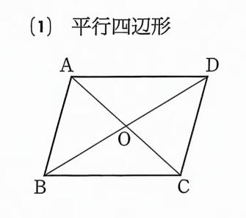
Accuracy  A | Roughly accurate A2 | 5 | While valid in terms of definition or problem statement, it does not demonstrate all required mathematical conditions (e.g., missing essential symbols or misleading representations), or includes properties that are inadequate for explaining the underlying concepts. | 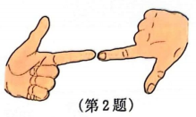
Accuracy  A | Inaccuracy  A3 | 0 | In terms of definition, the illustrations are inaccurate, containing obvious errors; or they employ inappropriate real-world objects to express a conceptual idea.The real-world objects or scenarios used in conceptual explanations contain critical flaws, or the illustrations entirely lack mathematical concepts. | 
Connectivity B | Text exposition B1 | 10 | Explicitly and completely related to mathematical content, it directly shows a concept or problem. | 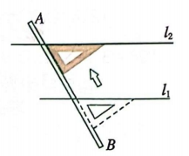
Connectivity B | Text correlation B2 | 5 | Partly related to mathematical content, it shows the content but does not explicitly show how it is connected to the content. | 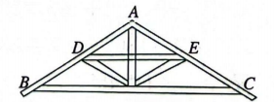
Connectivity B | Text-independent  B3 | 0 | There is no mathematical connection to the content. | 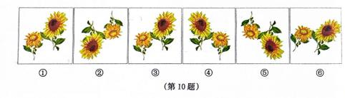
Conciseness  C | Very simple  C1 | 10 | A concept or problem can be displayed directly without any interference or other factors. | 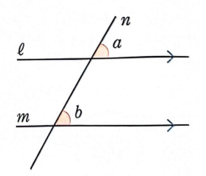
Conciseness  C | Roughly concise  C2 | 5 | It is easy to represent a concept or problem in terms of some other factor that might contribute to the concept. | 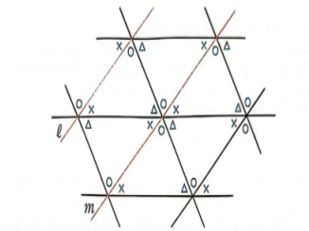
Conciseness  C | There is interference.  C3 | 0 | In addition to the elements needed to represent the concept or problem, there are distractions or other useless elements. | 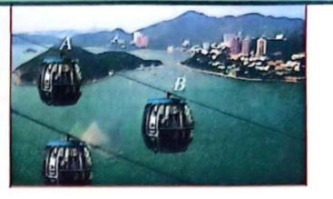
contextua-lity  D | Reality  D1 | 10 | Use real-world situations or objects to relate mathematical content. | 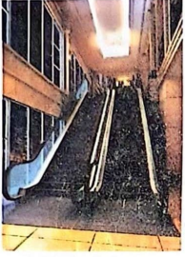
contextua-lity  D | Partial reality  D2 | 5 | There are no mathematical ideas or concepts, but there are some realistic situations (situations or objects to provide a problem or to facilitate related activities). | 
contextua-lity  D | Unrealistic  D3 | 0 | It contains neither real objects nor real situations. | 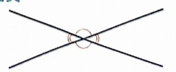

2.2.2 Comparison Results of Illustration Quality
The weight allocation for the four dimensions of illustration quality is a relatively subjective process, which depends on the specific application scenarios, target audiences, and evaluation purposes. Based on the actual situations of Chinese and Japanese textbooks, we have allocated the weights of the four dimensions of illustration quality as follows.
(1) Accuracy A (30%)
Accuracy is the primary property of illustrations, as it ensures the correct transmission of information. Incorrect illustrations may lead to misunderstandings or misdirection, so it should be given a higher weight.
(2) Connectivity B (25%)
Connectivity refers to the connection between the illustrations and the text content, theme, or target audience. An illustration closely related to the theme can better attract readers' attention and enhance the effectiveness of information transmission.
(3) Conciseness C (20%)
Conciseness requires that illustrations avoid redundancy and complexity when conveying information. A clear and concise illustration is easier to understand and remember, and also better meets the aesthetic needs of modern readers.
(4) contextua-lity D (25%)
Contextua-lity refers to whether the illustrations can effectively convey information in a specific context or environment. An illustration with contextua-lity can better integrate into the medium or environment where it is located, thereby enhancing the overall information transmission effect.
The following is the calculation formula for illustration quality,
where $i=1$indicates China, $i=2$indicates Japan,$Y_{i}$represents the total score for the quality of textbook illustrations,$a_{i}$ is the score for the accuracy of the textbook,$b_{i}$ is the score for the connectivity of the textbook,$c_{i}$ is a score for conciseness,$d_{i}$ is the score for the contextua-lity of the textbook.
Based on the above analysis, the illustrations of the unit "parallel lines" in the textbooks of the two countries are analyzed and compared, and scored according to the order in which the illustrations appear in the books. Pictures without mathematical significance are not included in the statistical scores. The specific data in the first section are given in Table 4. The other sections are based on the standards of the first section, with a total of 107 Chinese illustrations and 76 Japanese illustrations.
Table 4 Statistical data of the illustrations in Section 1 of the parallel lines unit
ID | Accuracy | Connectivity | contextua-lity | Conciseness | ID | Accuracy | Connectivity | contextua-lity | Conciseness
1 | 10 | 10 | 5 | 0 | 2 | 10 | 10 | 5 | 10
1 | 10 | 10 | 5 | 0 | 2 | 10 | 10 | 5 | 10
1 | 10 | 10 | 5 | 5 | 2 | 10 | 10 | 5 | 10
1 | 10 | 10 | 5 | 5 | 2 | 10 | 10 | 5 | 10
1 | 10 | 10 | 5 | 5 | 2 | 10 | 10 | 5 | 10
1 | 10 | 10 | 5 | 5 | 2 | 10 | 10 | 5 | 10
1 | 10 | 10 | 5 | 10 | 2 | 10 | 10 | 5 | 5
1 | 10 | 10 | 5 | 10 | 2 | 10 | 10 | 5 | 10
1 | 10 | 5 | 5 | 10 | 2 | 10 | 5 | 5 | 10
1 | 0 | 10 | 5 | 10 | 2 | 10 | 10 | 5 | 10
1 | 10 | 10 | 5 | 10 | 2 | 10 | 10 | 5 | 10
1 | 10 | 10 | 5 | 10 | 2 | 10 | 10 | 5 | 10
1 | 10 | 10 | 5 | 10 | 2 | 10 | 10 | 5 | 10
1 | 10 | 10 | 5 | 10 | 2 | 10 | 10 | 5 | 10
1 | 10 | 10 | 5 | 10 | 2 | 10 | 10 | 10 | 10
 |  |  |  |  | 2 | 10 | 10 | 5 | 10
 |  |  |  |  | 2 | 10 | 10 | 5 | 10
 |  |  |  |  | 2 | 10 | 10 | 5 | 10
 |  |  |  |  | 2 | 10 | 10 | 5 | 10
 |  |  |  |  | 2 | 10 | 10 | 5 | 10
 |  |  |  |  | 2 | 10 | 5 | 5 | 10
 |  |  |  |  | 2 | 10 | 10 | 5 | 10
In the above classification, Number 1 represents Chinese textbooks, while Number 2 denotes Japanese textbooks. The four dimensions obtained by calculation and the overall illustration quality level are shown in Table 5.
Table 5 Statistics of quality levels in each dimension of the illustrations of the parallel line unit
Teaching material | Accuracy | Connectivity | Conciseness | contextua-lity | Weighted total score
Chinese textbooks | 9.58 | 9.59 | 6.49 | 9.53 | 8.8
Japanese textbooks | 9.87 | 9.80 | 5.20 | 9.74 | 8.66
Based on the results of Table 5, the illustration quality of teaching materials in the two countries is analyzed and compared below.
(1) In terms of accuracy, the scores of Chinese and Japanese textbooks are close to each other, which indicates that both Chinese and Japanese textbooks pay attention to the accurate expression of mathematical concepts in the selection and drawing of illustrations, so as to avoid negative effects on students' learning caused by incorrect or ambiguous For example, Figure 1 is a schematic diagram of Chinese exercise and Figure 2 is a schematic diagram of Japanese exercise, both of which can accurately express the relevant graphic information.
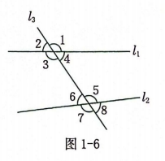
Figure 1 The illustration explaining the positional relationships of angles in Chinese textbooks

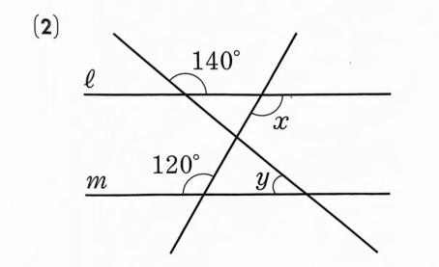
Figure 2 The illustration for the exercises on parallel lines and angles in Japanese textbooks
(2)In terms of connectivity, Chinese textbooks scored slightly lower than Japanese ones, but the difference was not significant. This shows that both countries 'textbooks do a good job in combining illustrations with mathematical content and can support students' understanding well. For example, Chinese textbooks use kites to connect the relationships between same side interior angles, internal misalignment angles, and same position angles (Figure 3). In the Japanese illustration (Figure 4), a young boy poses a question to bridge the relationship between same position angles and internal misalignment angles.
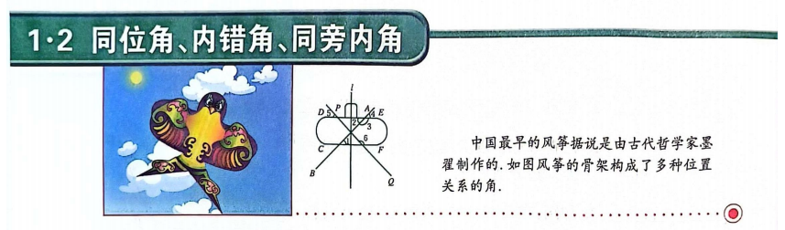
Figure 3 The illustration of same position angle, internal misalignment angle, and same side internal angle in Chinese textbook
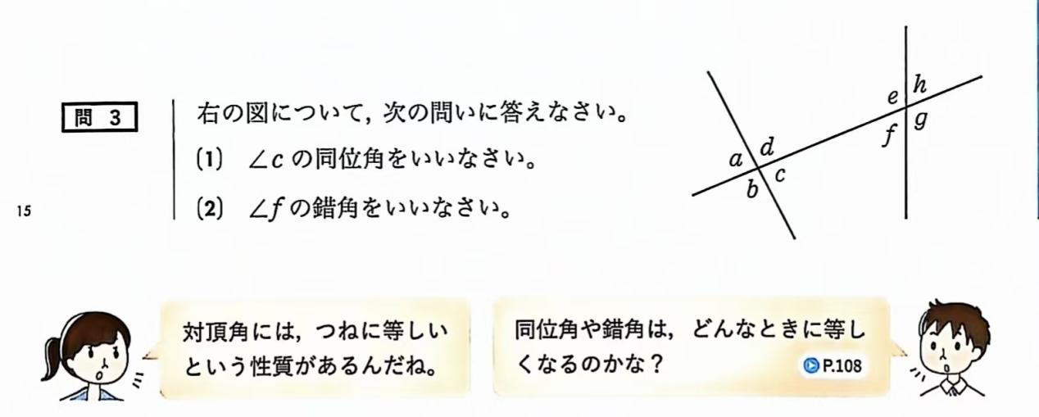
Figure 4 The illustration for examples of same position angles and internal misalignment angles in Japanese textbooks
(3)In terms of conciseness, Chinese textbooks scored slightly higher than Japanese ones.The conciseness requires that the illustration should remove redundant information and highlight the core content when expressing mathematical concepts.Chinese textbooks may pay more attention to this point in illustration design, making the illustrations clearer and more understandable. For example, the Chinese illustration in Figure 5 is more concise than the Japanese illustration in Figure 6.
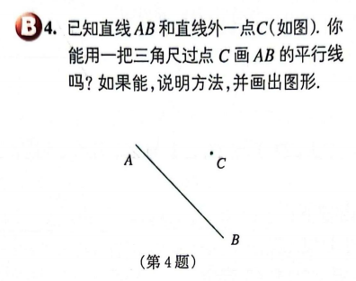
Figure 5 The illustration for the exercises on the criteria for parallel lines in Chinese textbooks
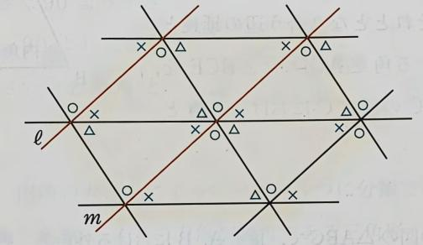
Figure 6-The introductory illustration for criteria of parallel line determination in Japanese textbooks
（4）In terms of contextua-lity, Chinese textbooks scored significantly higher than Japanese ones.This shows that Chinese textbooks pay more attention to the connection with real life in illustration design, and can better show the practical application and integrity of mathematical knowledge through illustrations. In Chinese textbooks, using conveyor belts to transport goods is used to understand the concept of translation in mathematics (Figure 7); In the extension module of parallel lines, the ancient Greek mathematician Eratosthenes used the properties of parallel lines to calculate the circumference of the Earth, and also cited the mathematician's portrait illustration (Figure 8). Furthermore, the abundant incorporation of everyday life illustrations underscores the extensive utilization of contextual visuals in Chinese textbooks. In Japanese textbooks (Figure 9), most of the pictures are mathematical.

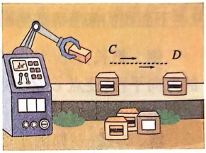
Figure 7 Illustration of understanding the concept of translation by transporting goods on a conveyor belt in Chinese textbooks
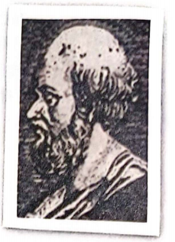
Figure 8 The illustration of the ancient Greek mathematician Eratosthenes in Chinese textbooks
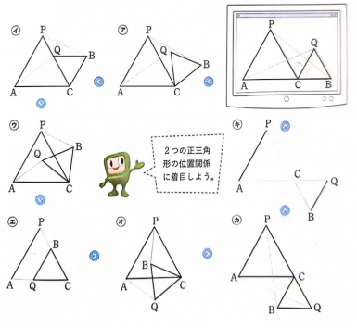
Figure 9 The illustration for extension problems on parallel lines and area calculations in Japanese textbooks
To sum up, Chinese and Japanese textbooks have their own strengths in the quality of illustrations. Chinese textbooks are better in terms of accuracy and conciseness, while Japanese textbooks are slightly better in terms of relevance. In terms of contextua-lity, Chinese textbooks may pay more attention to the connection with real life.

2.3 Result Test
To understand whether there are differences in non-text elements, we drew on Liu Qianwen's difference analysis [11], the differences in four aspects of teaching materials in China and Japan are calculated below, and F-test is carried out. The formula is as follows,
Where $k$ is the number of data independent variables, represents the data of various indicators of Chinese and Japanese textbooks,is the mean of a factor,is the mean of all observations, $n_{i}$is the sample size for each set of data,is the sum of squares between groups for each set of data,is the sum of intra-group squares for each set of data,is the variance between groups,is the variance within the group. The results are shown in Table 6.
Table 6 F test data
Variable Name | Variable Value | Sample Size | Mean value | Standard deviation | Variance test | Welch'sVariance test
AccuracyA | China | 107 | 9.673 | 1.419 | F=1.173  P=0.280 | F=1.397  P=0.239
AccuracyA | Japan | 76 | 9.868 | 0.806 | F=1.173  P=0.280 | F=1.397  P=0.239
 | sum | 183 | 9.754 | 1.204
ConnectivityB | China | 107 | 9.626 | 1.321 | F=0.974  P=0.325 | F=1.075  P=0.301
ConnectivityB | Japan | 76 | 9.803 | 0.98 | F=0.974  P=0.325 | F=1.075  P=0.301
 | sum | 183 | 9.699 | 1.192
ConcisenessC | China | 107 | 6.495 | 2.3 | F=21.414  P=0.000*** | F=27.138  P=0.000***
ConcisenessC | Japan | 76 | 5.197 | 0.98 | F=21.414  P=0.000*** | F=27.138  P=0.000***
 | sum | 183 | 5.956 | 1.972
contextua-lityD | China | 107 | 9.626 | 1.64 | F=0.259  P=0.611 | F=0.293  P=0.589
contextua-lityD | Japan | 76 | 9.737 | 1.124 | F=0.259  P=0.611 | F=0.293  P=0.589
 | sum | 183 | 9.672 | 1.446
Note: *** represents 1% significance level
The heat map is shown in Figure 10.
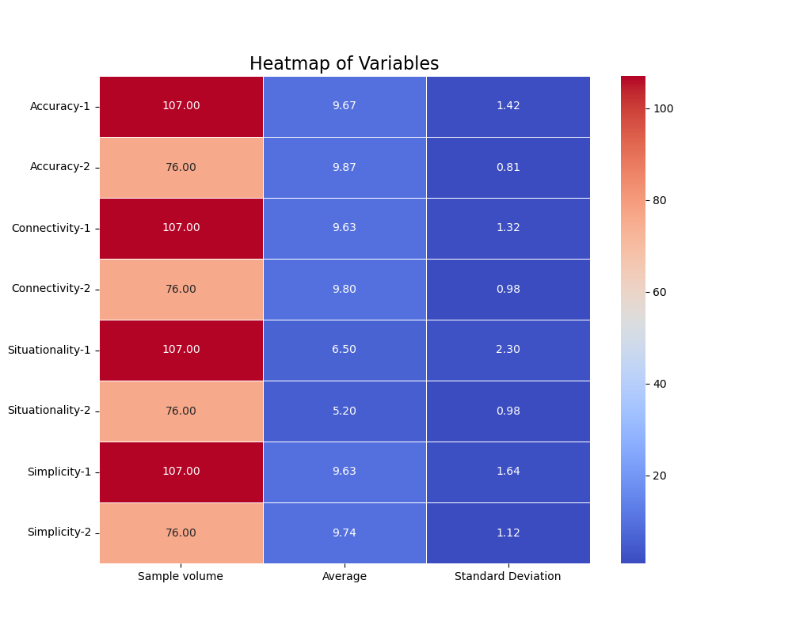
Figure 10 Heat map
In terms of accuracy, the mean values of the illustrations in Chinese textbooks and Japanese textbooks are 9.673 and 9.868 respectively. Since the data do not meet the homogeneity of variance condition, Welch's variance test is adopted. The test result shows that the P value of the variance analysis is 0.239, which is far greater than the significance level of 0.05. Therefore, the statistical result is not significant. This indicates that there is no significant difference in the accuracy of illustrations between textbooks from different countries.
Then, a comparison is made from three aspects: connectivity, contextua-lity and conciseness. In terms of connectivity, the mean values of the illustrations in the textbooks of the two countries are 9.626 and 9.803 respectively. Welch's variance test shows no significant difference. In terms of contextua-lity, the mean value of the illustrations in Chinese textbooks is significantly higher than that in Japanese textbooks, indicating a significant difference. In terms of conciseness, the mean values of the illustrations in the textbooks of the two countries are 9.626 and 9.737 respectively. The variance analysis shows no significant difference.

3 Research Conclusions and Implications
Based on the above analysis, it is evident that textbooks from China and Japan exhibit unique characteristics and significant differences in their illustration designs, which reflect distinct educational philosophies and cultural backgrounds of the two countries.
(1) Comparable Numbers of Mathematical Illustrations, but Differences in Historical and Decorative Illustrations
In terms of mathematical illustrations, the number in textbooks from both China and Japan is similar, with both emphasizing the use of intuitive graphics to aid students in understanding mathematical concepts. Regarding illustrations of the history of mathematics, Chinese textbooks provide students with historical backgrounds of mathematical developments by displaying portraits of famous mathematicians and images related to history, while Japanese textbooks do not include such illustrations, reflecting the emphasis placed by Chinese mathematics education on the inheritance of mathematical culture. However, Chinese textbooks have significantly fewer decorative illustrations compared to Japanese textbooks.
(2) Differences in Physical Scene Diagram Class Illustration and Contextua-lity Design
Chinese textbooks have significantly more physical scene diagram class illustration than Japanese textbooks, reflecting the concept that Chinese mathematics education emphasizes "the combination of mathematics and life", linking abstract mathematical concepts to daily life to enhance the practicality and interest of learning. According to the results of the F-test, Chinese textbooks score higher in contextua-lity design, but with a larger standard deviation, indicating significant variations in the contextua-lity design of illustrations, with some potentially being too complex and distracting students attention. In contrast, Japanese textbook illustrations focus more on the direct presentation of mathematical content, with relatively less contextua-lity design.
(3) Differences in Conciseness and Connectivity Design
In terms of conciseness, Chinese textbooks score slightly higher, but there is room for improvement in both countries. Chinese textbooks should further streamline redundant information to ensure that illustration designs are concise and clear, while Japanese textbooks can appropriately increase the visual appeal of illustrations while maintaining logical rigor. In terms of connectivity, illustrations in Chinese textbooks have some integration with mathematical content, but the presentation is often too monotonous, lacking sufficient richness and depth. Japanese textbooks perform slightly better, with illustrations more closely tied to mathematical content, although some designs may be too simple.
The findings of this paper provide some insights for textbook compilation and teaching practice. In the future, textbooks from both countries can learn from each other while maintaining their respective strengths. Chinese textbooks can maintain their contextua-lity strengths while appropriately adding diverse, creative, and life-related decorative diagram class illustration, streamlining redundant information, presenting core mathematical concepts in a more intuitive manner, and improving teaching effectiveness. Additionally, both countries textbooks can enhance the integration of mathematical culture by incorporating illustrations of the history of mathematics or cross-cultural elements to help students better understand the development process and global perspective of mathematics.

References
- Zhang Weizhong, Hu Zhihui. A Comparative Study of Illustration Quality in Chinese and American Junior High School Mathematics Textbooks [J]. Journal of Mathematics Education, 2022, 31(01):64-69+84.DOI:10.3969/j.issn.1004-9894.2022.1.sxjyxb202201011.
- Rae Young Kim.The quality of non-textual elements in mathematics textbooks: an exploratory comparison between South Korea and the United States.ZDM Mathematics Education (2012) 44:175–187..DOI.org/10.1007/s11858-012-0399-9.
- Wang Yiyun. Research on the Application of Illustrations in Junior High School Mathematics Teaching [J]. Middle School Mathematics, 2019, (24): 94-95.
DOI:10.3969/j.issn.1671-7724.2017.20.130.
- Lei Hao, Hu Yanfen. Evaluation Criteria for Illustrations in Science Textbooks: Theoretical Value, Generative Logic, and Application Pathways [J]. China Journal of Education, 2024, (10): 61-66.
- Qi Yinghong. A Comparative Study of Illustrations in Chinese and American Physics Textbooks [J]. Journal of Changchun Normal University, 2007, (08): 143-146.
DOI:10.3969/j.issn.1008-178X-B.2007.04.039.
- Fu Yuting. A Comparative Study of Illustrations in Function Content of Chinese and American Senior High School Textbooks [D]. Guizhou Normal University, 2017.
- Zhang Nan. Analysis and Comparison of Illustrations in Junior High School Mathematics Textbooks [D]. Capital Normal University, 2014.DOI:CNKI:CDMD:2.1014.260548.
- Li Lu, Li Sanping. A Comparative Study of Illustrations in Junior and Senior High School Mathematics Textbooks [J]. Teaching and Learning of Junior High School Mathematics, 2021, (10): 1–3+6.
- Wang Jianming. A Review of the 2000 Principles and Standards for School Mathematics by the National Council of Teachers of Mathematics (U.S.) [J]. Journal of Beijing Institute of Education, 2001, (4): 62-68. [2024-12-22]. DOI:10.3969/j.issn.1008-228X.2001.04.015. DOI: 10.3969/j.issn.1008-228X.2001.04.015.
- Shen Qiong. Innovation and Reflections on Presentation Design in the New Edition of Junior High School Mathematics Textbooks [J]. Class Adviser for Primary and Secondary Schools, 2024.DOI: 10.3969/j.issn.2096-3742.2024.24.003.
- Liu Qianwen, Chen Yuqing, Wu Yue, et al. A Comparative Study of Illustrations in Chinese and French Junior High School Mathematics Textbooks [J]. Journal of Mathematics Education, 2024, 33(05):18-26.

