Review Article
Formative Assessment Strategies in Social Science Education: A Conceptual Framework for Achieving the Goals of NEP 2020

ABSTRACT
Conventional evaluation techniques often emphasise rote memorisation rather than critical thinking, limiting students' capacity to apply knowledge in practical, real-world contexts. This shift necessitates the adoption of creative assessment methodologies that are more adaptable, holistic, and competency-oriented, as opposed to conventional evaluation methods. This paper introduces a conceptual framework integrating formative assessment methods in the social sciences. The study employs a qualitative-theoretical approach to explore and adapt formative assessment strategies for social science education, aligning them with the objectives of NEP 2020. This study examines formative assessment procedures, such as self and peer assessment, classroom discussions, Venn diagrams, think-pair-share activities, role-playing, simulations, and brief projects. These strategies promote active learning, critical thinking, and metacognitive skills by encouraging students to engage thoroughly with knowledge and enhance their understanding through continuous feedback. This shift aligns with the NEP 2020's objective of cultivating 21st-century competencies, such as problem-solving, adaptability, and multidisciplinary education. This study aims to synthesize effective formative assessment techniques, particularly in social science classrooms, while fostering teaching and learning within the practical context of addressing complex social issues. Through a theoretical outline, this paper provides teachers with practical insights and recommendations for the implementation of formative assessments that not only align with the objectives of NEP 2020 but also foster a dynamic and enriching learning environment. This approach, in the end, emphasises the requirement of modifying assessment techniques to create a classroom environment that is more responsive and learner-centred.
Keywords: Innovative Formative Assessment techniques, Social Science Education, NEP 2020, Conceptual Framework

- INTRODUCTION
The National Education Policy (NEP) 2020 IN India represents a significant shift in the educational environment, particularly in the field of social science education. The National Education Policy (NEP) 2020 promotes significant reform in assessment procedures, highlighting a competency-based, adaptable, and comprehensive educational framework. The assessment's major objective is to facilitate the learning process, helping teachers, students, and the entire educational system in continuously refining teaching and learning methodologies to enhance the learning and development of all students (NEP 2020, p.17). In this scenario, formative assessment procedures are essential for both assessment and enhancement of student learning. Formative assessment refers to several formal and informal evaluation methods employed by teachers throughout the learning process to optimise instructional strategies and learning activities (Black & Wiliam, 1998). This strategy corresponds with the NEP's aim of establishing a more dynamic and adaptive educational setting. The NEP 2020 advocates for a thorough revision of assessment methods (Meena, 2020). The NEP 2020 promotes a diverse educational framework encompassing multiple entry and exit points, as well as research-oriented programs. This switch requires the use of innovative assessment procedures that are more flexible, comprehensive, and competency-based, as opposed to traditional assessment methods (Pathak et al., 2024).Formative assessment is absolutely indispensable in the field of social science education. Students in the social sciences, which include fields like sociology, politics, geography, and history, are expected to critically analyse and evaluate complex concepts and societal problems (Dewey, 1938). Formative exams provide students an opportunity to contemplate their knowledge, receive immediate comments, and modify their learning practices to address complicated social concerns (Hattie & Timperley, 2007). Implementing formative assessment procedures in the classroom is essential for enhancing student learning and delivering immediate feedback to fix errors. These strategies can significantly enhance students' critical thinking, metacognitive abilities, experimental methodologies, and understanding of complex circumstances. Furthermore, formative assessment procedures may increase student engagement and motivation, which are essential for effective learning in social sciences. Studies demonstrate that when students engage actively in the assessment process, they are more inclined to take responsibility for their learning (Sadler, 1989). Methods like peer assessment, self-assessment, and reflective journals promote students' evaluation of their own and others' work, thereby cultivating a collaborative learning atmosphere (Boud & Falchikov, 2006). This collaborative method corresponds with the NEP's focus on teamwork and community engagement in education (Ministry of Education, 2020). Similarly, the cultural and contextual significance of social science education requires a personalised approach to formative assessment. Banks (2008) emphasises that culturally responsive pedagogy acknowledges students' different backgrounds and incorporates their experiences into the educational process. Formative evaluations that take into account students' cultural backgrounds can result in more significant learning experiences and enhanced academic outcomes (Ladson-Billings, 1994). This approach aligns with the NEP's commitment to inclusivity and equity in education. Through formative assessment strategies, teachers can efficiently provide recommendations to students, assess their learning needs, and provide feedback and guidance for enhancing their work (Dwivedi, 2021; Geeta, 2021). This study offers a conceptual framework that integrates research on innovative formative assessment procedures in social science disciplines, establishing a guide for transformative assessment practices per NEP 2020 objectives.
- NEED OF THE STUDY
It is essential to implement formative assessment techniques to accomplish the objectives of the National Education Policy 2020 (NEP 2020). These strategies encourage learners to engage in continuous learning, cultivate critical thinking, and improve the overall development of learners by giving feedback in real time. Feedback is an essential element of formative assessment techniques, capable of enhancing student learning and achievement (Ropohl & Rönnebeck, 2019). Formative assessment strategies that provide constructive feedback on the processes of students' learning should be implemented in the classroom to enhance the experience of learning and instruction (Schildkamp et al., 2020). Therefore, formative assessments aim to offer ongoing feedback rather than just evaluate results. They help students recognize their strengths and areas for enhancement during their educational journey. Social science is an interdisciplinary domain that combines multiple fields, including history, geography, political science, economics, sociology, anthropology, and literature. This integration offers a comprehensive understanding of social life, focusing specifically on interpersonal relationships and evolution over time (De Beer & Lautenbach, 2024). It is crucial to use various formative assessment strategies to eliminate the concept of rote memorisation and improve the way that social science concepts are taught in the classroom. Techniques such as peer assessment, self-assessment, one-minute papers, and classroom discussions facilitate active student engagement with the topic, promote reflection on understanding, and highlight areas for enhancement. These methods increase critical thinking and comprehension while offering students opportunities to amend their errors and cultivate a deeper understanding of the subject matter. Formative assessment strategies must be personalised to each subject area, considering various ways in which students interact with and exhibit their understanding of the material.
- METHOD
This paper discussed formative assessment strategies that are explicitly aligned with the objectives of NEP 2020 and are meant for use in the context of social science education. This study uses a qualitative-theoretical methodology to investigate and develop formative assessment procedures for social science education, ensuring alignment with the goals of NEP 2020. This approach is derived from Black and Wiliam (1998), who integrated existing literature to explain the process of formative assessment, thereby establishing its effectiveness in improving learning outcomes. Through a theoretical outline, this paper provides teachers with practical insights and recommendations for the implementation of formative assessments that not only align with the objectives of NEP 2020 but also foster a dynamic and enriching learning environment. This approach, in the end, emphasises the requirement of modifying assessment techniques to create a classroom environment that is more responsive and learner-centred.
- DISCUSSION
The paper discusses several innovative strategies for social studies assessment. These strategies include:
- Self and Peer Assessment
Students develop a sense of agency over their own education when they evaluate their own progress through self- and peer-assessment activities (Nicol & Macfarlane-Dick, 2006). Formative assessment strategies such as self-and peer assessment have proven to be useful in helping students gain a more thorough grasp of difficult concepts, improve their analytical and critical thinking abilities, and evaluate their own and others' work according to predetermined standards. It fosters an environment that encourages independent study and critical thinking. To achieve the learning objectives, students must critically assess their performance according to the evaluation criteria. Furthermore, integrating self and peer assessments with explicit evaluation criteria is essential for directing students in their evaluations and assuring the attainment of learning objectives (Sadler, 1989). Peer assessment enables students to evaluate their peers' work, thus improving their evaluative skills and enriching their comprehension of the subject (Topping, 1998). Through the process of peer assessment, students evaluate the work of their classmates using established criteria. Students benefit from one another's knowledge, work on their communication skills, broaden their understanding of course goals, and improve their problem-solving and self-awareness abilities when they give feedback to their classmates (Pathak & Maity, 2024). For instance, a historical discourse on Students studying Indian independence formed into groups to argue about a particular historical study, such as "Was Indian independence justified?"
- Class Discussions
Informal and formal discussions are both helpful to improve learning skills and learning concepts. Teachers can use classroom discussion as an effective formative assessment strategy to enhance student's academic and overall performance. So, in classroom discussions, teachers easily observe students' behaviour and their omissions and provide immediate feedback to improve their mistakes and enhance their performance. Educators may use open-ended questions to stimulate conversation and enable students to articulate their knowledge and perspectives. The use of the popsicle stick formative evaluation technique is one fair way to facilitate discourse. To ensure that every student has an opportunity to contribute to the class conversation, teachers often have students write their names on a popsicle stick (or other suitable object) and then randomly choose one name at a time. Using this method, teachers may pinpoint where their students are falling short in understanding and, by giving everyone a chance to speak, they can show them that their opinions matter. The use of this strategy enables educators to assess pupils' levels of comprehension while simultaneously imparting the knowledge that their thoughts are significant. Classroom discussion-based instruction can be combined with traditional lecture-based instruction. It helps students become better readers, thinkers, and writers, facilitating their achievements in standardized assessments (Deng, 2023, p.1). For instance, in a class discussion on the French Revolution, students will be able to evaluate the causes, significant events, and repercussions of the French Revolution.
- Venn diagram
Students can use the Venn diagram as a thinking tool to help them distinguish between two or more topics and their similarities. Teachers can use data on students' understanding of the subjects they are studying as a formative assessment tool. By visualizing complex ideas in a Venn diagram, students can further develop their abilities in critical analysis. So, this formative assessment tool helps to increase performance in the classroom. Venn diagrams are a methodological tool that can be utilized to conduct a comparative and contrasting evaluation of different groups of items. A Venn diagram is made up of circles that overlap one another. The complete collection of elements is contained within each circle. Circles that meet show the things that are in common with the set. In most cases, there are two or three circles. Joyce (2008) states that if the number of repetitions is increased, the exercise will become exceedingly difficult. It is a widely recognized norm for delineating commonalities and disparities, proficiency in their application enhances the key competency of utilizing language, symbols, and text.
- Think-Pair-Share
The think-pair-share technique combines individual thinking with communication, enhancing students' learning and listening skills. This strategy involves giving students time to think about and write down their responses to open-ended questions. They then discuss their ideas with a partner before sharing insights with the whole class (Cullinane, 2011, p.2; Fitzgerald, 2018). Teachers can see how much their students have learned using this formative assessment method, which involves having students talk to one another and then reflecting on what they have said. The method is simple to apply since it allows teachers to listen in on different conversations around the classroom, which provides vital information about students' understanding (Pathak & Maity, 2024). In the context of social studies, an instance of think-pair-share questions include: How would a historian in the twenty-first century interpret a past event if they were to look at it through a modern lens?
- Polls
A poll is an easy technique to see how much students know. Among the many uses for polls as a kind of formative assessment are the identification of misconceptions, the evaluation of students' prior knowledge, and the promotion of self-awareness about their progress. Polls are flexible in what they assess and how teachers conduct them (Ivory,2022). Teachers can use technology or traditional methods, such as raising hands, to conduct polls during or after a class. Class polls can inspire debates in response to questions and answers. Student reflection on class material can be facilitated through the use of post-lesson surveys. A social studies teacher could utilize a poll to gauge their students' opinions on the relative importance of inheritance, environmental influences, biological elements, and the hypothesis of neural growth after a class on the topic.

- Role-playing
Role-playing is an effective formative assessment used in the teaching of social science and improves students' critical thinking, engagement, and understanding of complex social issues. Experience-based learning occurs when students play historical or contemporary roles. The impact of role-playing methods on student assessment and the integration of these methods in social science education have been studied earlier. Manan and Mastul (2023) in their study found that fourth-grade students who engaged in role-playing activities demonstrated higher learning outcomes compared to those taught through traditional lecture methods. The research utilized observations, tests, and documentation to assess the effectiveness of role-playing in enhancing students' understanding and engagement in social studies. Mazlan and Wangid (2023) examined the effects of role-playing on fifth-grade students' social skills and self-confidence. Their findings indicated that role-playing methods positively influenced both social skills and self-confidence, suggesting that such interactive techniques turned out very effective in social science education. Tsergas et al. (2021) discuss how role-playing serves as a reliable teaching method for psychosocial intervention and data collection in fields like psychology and social work. Their study highlights that role-playing can approximate real-life events or experiences under controlled conditions, thereby enhancing students' understanding of complex social dynamics. Role-playing supports NEP 2020’s assessment reforms by shifting from rote memorization to competency-based formative assessments that evaluate students' understanding through interactive participation rather than traditional examinations. Through such activities, students develop problem-solving abilities, communication skills, and a deeper appreciation of constitutional values, preparing them for responsible citizenship in a democratic society. For example, in a lesson on the Indian Independence Movement, students can take on the roles of Mahatma Gandhi, Bhagat Singh, British officials, and Indian citizens to debate the effectiveness of non-violence versus armed struggle.
- Exit tickets and Admit tickets
Students are encouraged to reflect and think critically through the use of exit tickets, which are a kind of informal evaluation that may be used to evaluate their learning across disciplines. Teachers can select the topic of assessments using this method, which is a huge advantage. Additionally, this method offers greater flexibility. At the beginning of the lesson, students are required to complete a brief written answer known as an admit ticket. Students can use their admit tickets to answer questions about assignments or the previous day's teaching. Exit tickets, a straightforward yet efficient formative assessment instrument, are brief scraps of paper that students complete as they depart the classroom for the day (Pathak and Maity, 2024, p. 246). Both the admit and exit tickets are great ways to see how much students have learned, where they need more help, and how invested they are in the material.
- Timeline
Timeline functions as visual tools that assist us in comprehending history and the sequence of events. Time periods ranging from a few minutes to several centuries can be represented by them. Furthermore, timelines make it possible for pupils to make linkages between events. Students will find this especially helpful in understanding the development and interconnection of major ancient civilizations. When using a timelining method, a visual representation of the experience is added. This representation can serve as an anchor for the interview and assist the participant in concentrating on the most important aspects. Participants can engage with their experiences more fully and even generate new meanings and understandings through the use of timelines. When interviewees' oral language expression is limited owing to a number of situations, timelining is particularly appropriate (Marshall, 2017, p.1). Timelining is also appropriate when dealing with sensitive and difficult issues for interviews. The teacher employed this technique as a formative assessment to enhance students' mental capacity and facilitate their understanding of historical events.
- KWL Chart
A KWL chart is a graphic aid that students can use to bring together their existing knowledge (K), areas of interest (W), and new insights (L) for a certain subject. Before and after a lesson, teachers can utilize this formative assessment to determine the students' core comprehension of the material. For example, there are three steps that students go through when using the chart to study social studies topics like climate change and World War I:
K – What do I Know? This phase encourages learners to articulate their existing knowledge and experiences.
W – What do I Want to know? Here, students pose questions about their interests, fostering curiosity and setting learning objectives.
L – What did I Learn? After the lesson, students reflect on what they have learned, reinforcing new insights and enhancing metacognitive skills.
The KWL strategy engages students in group work, helping them process and communicate their understanding of reading texts effectively (Usman, 2018).
- One Minute Paper
Students are given one minute to write a brief response to a class topic before the class ends. For this test, students can either work alone or in small groups. According to Pathak and Maity (2024, p.246), the students are asked to jot down their thoughts or observations on paper. This is a quick revision technique used to memorize the concepts discussed in class. Additionally, it can be used to evaluate students' comprehension, how many ideas they have grasped, and memorization abilities related to the concept. Ashakiran and Deepthi (2013) state that a one-minute paper is an inexpensive, easy-to-use, formative, quick, and clear way to evaluate whether or not the learning objectives have been met.
- Gallery Walk
Students use this strategy by making posters or other visual representations of what they've learned and then walking around the room to see what their classmates have made. According to Pathak and Maity (2024, p.245), it is a novel approach to peer evaluation. Ridwan (2019, p.61) concluded that Gallery Walk enables students to walk around the class and observe other students' work, and Gallery Walk allows students to observe other groups' work. Students are more likely to engage in critical thinking when they work in groups and are encouraged to collaborate with their peers through the gallery walk method of instruction, which promotes active participation and collaboration (Makmun et al., 2020, p.20). Hence, we can say that gallery work is an effective technique used to develop learner observation skills and enhance teaching skills.
- Pass the Question
Students use the formative assessment strategy known as "pass the question" to complete a partially completed response to a question within a set amount of time. They get five or six minutes to complete the work, and when that time is up, they switch partners and each person gets a chance to make edits, additions, or final modifications to their response. With this method, students work in pairs and then provide and receive feedback on each other's work. By gathering and analyzing written responses and spoken evidence, one may track the students' diverse thought processes. It is important to note that for this to be an advantage, the development of a good question that will elicit student responses is pivotal to this FACT working well (Cullinane, 2011, p.2).
- Muddiest point
The muddiest point is a technique in which the student is asked to jot down the part of the lesson they are most unclear about at the end. Thus, students can reflect on their own learning processes and identify areas of strength and weakness (Cullinane, 2011, p.2). Once a session or presentation is over, the muddiest point is utilized to determine which concepts were unclear to the students (Kausar, et al., 2021). The fundamental benefit of this method is the instantaneous feedback it gives students regarding their comprehension of any given subject or idea. It is a formative assessment approach that is used in the classroom to determine which point or issue students may be uncertain and confused about. Additionally, it allows teachers to rapidly identify specific areas in which students may be having difficulty.

- Two-Tier Multiple-Choice Questions

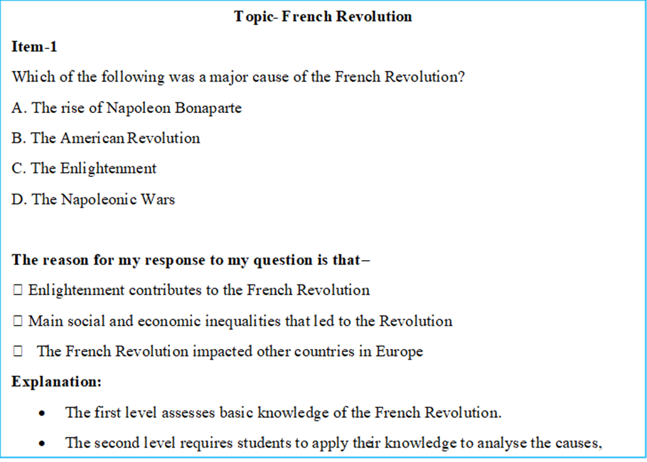

Figure 1: Example of Two-Tier Multiple-Choice Questions (Source: Author’s creation)
The two-tier multiple-choice questions are a type of objective test. This indicates that they typically possess only one correct response, requiring no additional assessment. This is an effective approach to determine whether students are understanding the subject matter. They also try to identify student misconceptions, as the alternative answers are based on typical misconceptions held by students (Cullinane, 2011, p.3).
- ABC graffitiing
The ABC graffitiing method is an innovative visual learning approach that employs the letters of the alphabet to create a mind map or diagram that represents the fundamental concepts, ideas, or terms associated with a particular subject. Each student in the class is assigned a different letter of the alphabet and they must select a word starting with that letter that is related to the topic being studied ((Ашим, 2017). This method is captivating and pleasurable to organise information and promote creativity.
Topic- French Revolution
Letter Word or Phrase
A Aristocracy, Assembly
B Bastille, Bourgeoisie
C Constitution, Citizen

Figure 2: Example of ABC Graffitiing (Source: Author’s creation)
- Concept Card Mapping
Concept card mapping is a similar strategy to concept mapping. Students are provided with cards that contain written ideas and are required to develop their ideas from scratch. They form a knowledge web by moving the cards (Cullinane, 2011). Students investigate and contemplate many different ideas by reorganising the cards. Cullinane (2011, p.4) suggests that the connections that students develop show the amount of level of sophistication of their ideas, the accuracy of their subject-matter knowledge, as well as the depth and breadth of their analytical abilities. This method can be implemented as a formative assessment method to foster the development of students' metacognition and creative thinking. It can also be used by students of different levels to evaluate them. Conceptual vocabulary and visual cards could be used at different grade levels, with students being asked to explain how the words and pictures connect.
- Quick Projects
Using quick projects as a dynamic method of assessment provides several benefits to students' education beyond traditional test scores. This method supports Bloom's Taxonomy's advanced stages of analysis, synthesis, and evaluation. Incorporating them into traditional classrooms can make learning more interesting by having students show what they've learned through practical, hands-on exercises (Pathak & Maity, 2024, p.248). By incorporating them into traditional classrooms, students may demonstrate their knowledge and skills through practical, hands-on activities, leading to more holistic learning experiences. According to Pathak and Maity (2024, p.248), this could change the way students are evaluated from a simple test to a more comprehensive learning experience that allows them to demonstrate their strengths and prepares them for the future.
- Rubrics
A rubric is a grading instrument that defines specific criteria for evaluation. For formative assessment, rubrics work particularly well in the social studies classroom because they give students specific directions on how to improve their knowledge and skills. They free teachers from the shackles of subjective grading while also motivating students to be active participants in their own education. This leads to a culture that fosters learning and makes students aspire to study (Pathak and Maity, 2024, p.248). Students' work can be consistently evaluated using criteria that are aligned with academic and professional standards through the use of rubrics. Student performance on assignments, in classes, or in programs can be measured using the use of rubrics. Additionally, rubrics are able to monitor the success of learning at the institutional level and can be communicated to both internal and external stakeholders (Olson & Krysiak, 2021, page 196).
4.1 Formative assessment techniques alignment with NEP 2020
NEP 2020 of India emphasizes the significance of making the transition to an education system that is more learner-focused, experiential, and holistic. These methods of formative assessment highlight the importance of promoting learning while accomplishing numerous NEP2020 objectives. The goals of NEP 2020, which promotes a multidisciplinary and comprehensive approach to education, are perfectly congruent with the tactics that have been laid out. Student-centered approaches, including collaborative projects and peer evaluation, are crucial in achieving NEP 2020's goal of improving students' capacity for critical thinking, creativity, and problem-solving. The policy's objective of encouraging the practical application of information through experiential learning resonates with the use of simulations and real-world initiatives. The use of two-tier examinations and Venn diagrams, which emphasize holistic development through critical analysis, aligns with NEP 2020's vision of comprehensive education that addresses both cognitive and emotional growth. Immediate feedback systems, such as polls and exit tickets, emphasize assessment as learning. This corresponds with the NEP's purpose of improving education and supporting adaptive teaching techniques. In a nutshell, these pedagogical approaches not only reflect NEP 2020's values but also help students thrive in an atmosphere that is friendly adaptable, and conducive to learning, all of which are necessary for meeting the problems of the future.
4.2 Identity Construction through Formative Assessment
The Cultural Historical school and the theoretical tradition of Vygotsky believe that the origins of consciousness are social. This method changes the focus from the course material as something to be learnt to how it manifests itself up in students' actions and how that connects to who they are (Pryor & Crossouard, 2008).

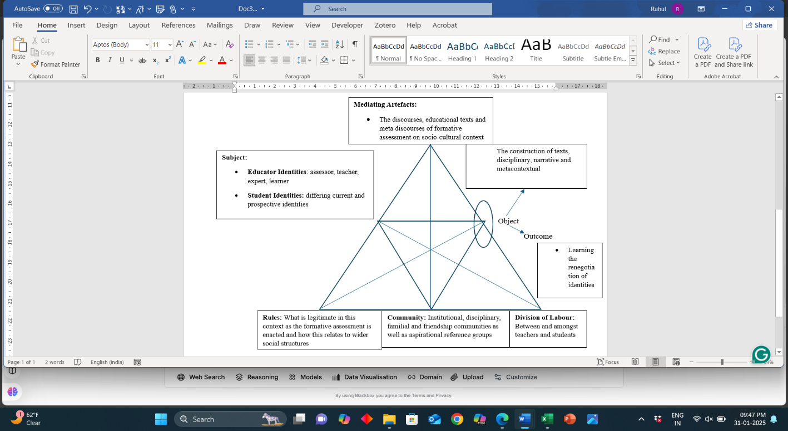

Fig 3. Source: Pryor and Crossouard (2008) Activity-theory framework for formative assessment.

Figure 3 represents an Activity Theory framework applied to formative assessment in education. The subject includes educators and students, each with evolving identities. Mediating artefacts refer to discourses, texts, and educational resources shaping the learning process. Rules define what is legitimate in assessment, influenced by broader social structures. Community includes institutional, disciplinary, and social groups impacting learning. Division of labour highlights interactions between teachers and students in knowledge construction. The object of formative assessment leads to the outcome of identity renegotiation, emphasizing the dynamic nature of learning and assessment practices. In Figure 3 the social, contextual, and interpersonal dimensions of learning emphasise how educators and students, through their changing identities, engage with mediating artefacts (such as texts and discourses) within a community that influences the learning and assessment process. Formative assessments lead to the restructuring of student identities, while the norms and division of labour define legitimate practices and roles. This process indicates the social construction of learning, as feedback and assessment not only influence academic advancement but also influence students' perceptions of themselves within the educational environment. This Activity theory framework shows social constructive feedback without a teacher-centered approach results in the successful delivery of Social Studies lessons (Bordoh et al., 2022).

- CONCLUSION
Implementing innovative formative assessment methodologies is essential for successfully achieving the objectives of the National Education Policy 2020 (NEP 2020). These strategies encourage critical thinking, continuous learning, and immediate feedback to help students progress. Educational institutions can promote instruction and encourage progress among students by using these methods. Rote memorisation is common in social science but fails to promote deep learning. Thus, formative assessments must help students develop critical thinking. We must implement these teaching practices to engage the students and encourage their overall growth to meet NEP 2020 goals. It is crucial to incorporate innovative formative assessment technologies into educational practices to improve learning outcomes and achieve the comprehensive objectives outlined by the National Education Policy 2020.

- REFERENCES
Anne Marshall, E. (2017). Timeline drawing methods. In P. Liamputtong (Ed.), Handbook of research methods in health social sciences. Springer. https://doi.org/10.1007/978-981-10-2779-6_10-1
Ashakiran, S., & Deepthi, R. (2013). One-minute paper: A thinking-centered assessment tool. Internet Journal of Medical Update, 8(2), 1–9. https://repository.globethics.net/handle/20.500.12424/836484
Ашим, Н. (2017). Tools for formative assessment: Techniques to check for understanding—Processing activities (K. Lambert, Comp.). OCPS Curriculum Services. https://www.academia.edu/32617382/Compiled_by_K_Lambert_OCPS_Curriculum_Services_4_2012_Tools_for_Formative_Assessment_Techniques_to_Check_for_Understanding_Processing_Activities
Black, P., & Wiliam, D. (1998). Assessment and classroom learning. Assessment in Education: Principles, Policy & Practice, 5(1), 7–74.
Bekoe, S. O. (2013). Formative assessment techniques tutors use to assess teacher-trainees’ learning in social studies in colleges of education in Ghana
Bordoh, A., Eshun, I., Ibrahim, A. W., Bassaw, T. K., Baah, A., & Yeboah, J. (2022). Technological, pedagogical content knowledge (TPACK) of teachers and their formative assessment practices in social studies lessons in the junior high schools in Komenda Edina Eguafo Abirem (K.E.E.A) Municipality of Ghana. Universal Journal of Social Sciences and Humanities, 2(4), 201–209. https://doi.org/10.31586/ujssh.2022.459
Boud, D., & Falchikov, N. (2006). Aligning assessment with long-term learning. Assessment & Evaluation in Higher Education, 31(4), 399–413.
Caldwell, J. (2007). Clickers in the large classroom: Current research and best-practice tips. CBE Life Sciences Education, 6(1), 9–20. https://doi.org/10.1187/cbe.06-12-0205
Cullinane, A. (2011). Formative assessment classroom techniques. NCE-MSTL. https://www.researchgate.net/publication/283328368
De Beer, M., & Lautenbach, G. V. (2024). Using online formative assessment tools in Grade 6 social sciences during the COVID-19 pandemic. South African Journal of Childhood Education, 14(1), Article 1438. https://doi.org/10.4102/sajce.v14i1.1438
Deng, Z., Xu, J., Jiang, Y., Choi, Y. J., Koomplee, S., & Ye, Y. (2023). Challenges and potentials of implementing discussion-based instruction in elementary and middle school classrooms: An interview with Catherine Snow at Harvard Graduate School of Education. ECNU Review of Education. Advance online publication. https://doi.org/10.1177/20965311231210308
Dewey, J. (1938). Experience and education. Macmillan.
Fitzgerald, Monica. (2018). Interactive Read-Aloud Strategies: Build Strong Relationships with Students [Blogs]. https://www.hmhco.com/blog/interactive-read-alouds
G., & Dwivedi, S. K. (2021). E-assessment and NEP 2020: Transforming assessment for students’ development. Praxis International Journal of Social Science and Literature, 4(7). https://doi.org/10.51879/PIJSSL/040710
Hattie, J., & Timperley, H. (2007). The power of feedback. Review of Educational Research, 77(1), 81–112. https://doi.org/10.3102/0034654302984
Ivory, A. (2022). 8 Formative Assessments for Social Studies [Blog post]. 8 Formative Assessment Examples for Social Studies.
Joyce, C. (2008). Venn diagrams [Blog post]. Venn Diagrams. https://arbs.nzcer.org.nz/venn-diagrams.
Kausar, F., Mahmood, M., & Saleem, T. (2021). One-minute paper, muddiest point and exit ticket formative evaluation methods used by teachers in daily classroom teaching. Journal of Critical Reviews, 8(2), 792–803.
Ladson‐Billings, G. (1995). But that’s just good teaching! The case for culturally relevant pedagogy. Theory Into Practice, 34(3), 159–165. https://doi.org/10.1080/00405849509543675
Makmun, M., Yin, K. Y., & Zakariya, Z. (2020). The gallery walk teaching and learning and its potential impact on students’ interest and performance. International Business Education Journal, 13(1), 17–22. https://doi.org/10.37134/ibej
Manan, N., & Mastul, A. H. (2023). The impact of applying the role-playing method on social studies lessons in fourth grade students. Journal of Pedagogy and Education Science, 2(1), 64–70. https://doi.org/10.56741/jpes.v2i01.99
Mazlan, M. P., & Wangid, M. N. (2023). The influence of role-playing methods on the social skills and self-confidence of Grade V elementary school students. International Journal of Multidisciplinary Research and Analysis, 6(9). https://doi.org/10.47191/ijmra/v6-i9-19
Meena, R. (2020). NEP 2020 and Assessment Reforms in Indian Education: A Comprehensive Analysis.
Ministry of Education, Government of India. (2020). National Education Policy 2020. https://www.education.gov.in/
Nicol, D. J., & Macfarlane‐Dick, D. (2006). Formative assessment and self‐regulated learning: a model and seven principles of good feedback practice. Studies in Higher Education, 31(2), 199–218. https://doi.org/10.1080/03075070600572090
Olson, J. M. & Krysiak, R. (2021). Rubrics as Tools for Effective Assessment of Student Learning and Program Quality. In T. Fudge & S. Ferebee (Eds.), Curriculum Development and Online Instruction for the 21st Century (pp. 173-200). IGI Global. https://doi.org/10.4018/978-1-7998-7653-3.ch010
Pathak, J. S., & Maity, S. (2024). Innovative assessment practices aligned with India’s National Educational Policy-2020. Asian Journal of Education and Social Studies, 50(9), 241–253.
Pryor, J., & Crossouard, B. (2008). A socio-cultural theorisation of formative assessment. Oxford Review of Education, 34(1), 1–20. https://doi.org/10.1080/03054980701476386
Ridwan, M. (2019). An Alternative Learning Strategy in Increasing Students’ Active Learning. Department of West Asian Studies, Faculty of Cultural Sciences, Hasanuddin University, 16(1), 49–63.
Ropohl, M., & Rönnebeck, S. (2019). Making learning effective—Quantity and quality of pre-service teachers’ feedback. International Journal of Science Education, 41(15), 2156–2176. https://doi.org/10.1080/09500693.2019.1663452
Sadler, D. R. (1989). Formative assessment and the design of instructional systems. Instructional Science, 18(2), 119–144. https://doi.org/10.1007/BF00117714
Schildkamp, K., van der Kleij, F. M., Heitink, M. C., Kippers, W. B., & Veldkamp, B. P. (2020). Formative assessment: A systematic review of critical teacher prerequisites for classroom practice. International Journal of Educational Research, 103, Article 101602. https://doi.org/10.1016/j.ijer.2020.101602
Topping, K. J. (1998). Peer assessment between students in colleges and universities. Review of Educational Research, 68(3), 249–276.https://doi.org/10.3102/00346543068003249
Tsergas, N., Kalouri, O., Democritus University of Thrace, School of Pedagogical and Technological Education, & Fragkos, S. (2021). Role-Playing as a method of teaching social sciences to limit bias and discrimination in the school environment. In Journal of Education & Social Policy (Vol. 8, Issue 2, pp. 13–91) [Journal-article]. https://doi.org/10.30845/jesp.v8n2p13
Usman, B., Fata, I. A., & Pratiwi, R. (2018). Teaching reading through Know-Want-Learned (KWL) strategy: The effects and benefits. Journal of Language, Education and Humanities, 6(1), 35–42. https://doi.org/10.22373/ej.v6i1.3607

