Enhancing the learning outcome of poetry through role play and art-based approaches

Abstract
Student’s performance in poetry has been consistently low compared to other genres like essays, short stories and drama. An analysis of the midterm examination result of a higher secondary school in Tsirang district reveals that significant number of students scored less in poetry than other literary genres. This pattern reflects a gap in understanding and engagement with poetry. As poetry implies a combination of analytical and imaginative skills, the existing teaching approaches might not adequately cater to the needs of students with different learning styles which would result in poor academic performance. Hence, this study seeks to address this issue by exploring innovative teaching strategies such as role play and art-based approaches to enhance student’s understanding and engagement with poetry. Using an action research framework, the study was conducted employing both qualitative and quantitative approaches to collect data. The quantitative data was gathered through survey questionnaire and student achievement test involving pre-test and post-test. The qualitative data was gathered through focus group discussion. The findings indicated that student’s demonstrated increased interest, improved analytical skills and a deeper appreciation for poetry. The study concluded that integrating role play and art-based approaches can effectively transform traditional teaching into a more interactive and impactful experience, providing a model for other teachers to adopt.

Key words: studying poetry, learning outcome, role play, art-based, class 8.
Introduction
The word poetry originates from the Greek word ‘poesis,' which means ‘to make' or ‘to create’. A poet is usually a creator and poetry is a creation. The English poet William Wordsworth defines poetry as “the spontaneous overflow of powerful feelings; it takes its origin from emotion recollected in tranquility” (Teaching English Literature, p.6). Poetry in Bhutan was influenced by folksongs which were sung using a four line poem. It was common to Himalaya regions influenced by Vajrayana Buddhism, the genre was perhaps popularised by the Sixth Dalai Lama Tsangyang Gyatso both in Tibet and the surrounding regions (Penjore, 2018).
Since the advent of western education to Bhutan, it is given the utmost importance. It has helped build verbal communication skills tap into the power of expression, make personal connections to texts, and build analytical thinking skills (Young, 2007). Besides imported education system, western poetry was also introduced along with it. Studying poetry provides students an opportunity to create powerful creative expression, inculcate educational values and develop their own sense of identity. For any level of student, reading and writing poetry can generate certain attitudes and understandings that are conducive to academic success: a sense of immediate achievement; a willingness to experiment and play with language; comprehension of the inherent connection between reading and writing; and an understanding of the importance of punctuation and word choice (Routman, 2001). Hence to contribute grow in these areas, role play and art- based approaches can be incorporated in promoting teaching and studying poetry.

Situational Analysis
The Mendrelgang School was first founded in the 1960s. The school was formerly called Lamedranara Junior High School. Unfortunately, the school closed in 1990 as a result of issues in the South. However, as a result of the landless people around the nation receiving a re-settlement program known as kidu from His Majesty the Fourth Druk Gyalpo, the population in this area grew and the necessity for a school became apparent. Hence, Lamedranra Junior High School reopened as Mendrelgang Community School on May 15, 1998. There are now 730 students enrolled in the school, ranging classes VII through XII. It is situated in the center of Mendrelgang gewog and offers an incredible view of the school from Raksha Dangra which is roughly 10 km from Damphu town.
Mendrelgang Central School has a good learning culture compared to other schools in Tsirang as per my observation. The school has initiated overnight study where by students are given an opportunity to seek help from the subject teachers focusing on their weaker subjects. On top of that, the school also has created a zero period every Saturday so that students get time to read the books of their choice. Moreover, every student has to submit academic enhancement strategy plan to the academic secretary every year which has strongly benefitted in the learning achievement of the students. Hence, the class eight participating student’s performance in English has improved significantly ranging from 65.21% and 68.19% to 73.61% in the year 2021, 2022 and 2023 which indicates that students learning ability in English improved significantly from the past years.
Table 1
National mean mark for English for the last three consecutive years
Year  Mean mark | 2021  65.21 | 2022  68.19 | 2023  73.61
Note: 2021(Home examination), 2022, 2023(BCSEA)

However, it was observed that student’s performance in poetry in examination was generally weak compared to other genres like essay, short story and drama. Majority of the students struggled and performed less in poetry section as it demanded critical thinking. This could be possibly due to teacher’s use of redundant teaching strategies and lack of activities to enhance student’s analysis. Similarly, Bhutan Council for School Examinations and Assessment (2013) result analysis depicts that the performance of class tens was generally weak in poetry. It was reported that most of the students failed to identify even the figures of speech used in the given poem. Further, the midterm result analysis of 2024 also revealed that significant number of students have consistently scored less in poetry section when compared to other sections. In the examination, the poetry section comprised total of 10 marks. The result revealed that Only 60 out of 152 students scored above the average while 92 out of 152 students scored below average indicating that significant number of students scored less in the poetry section.

Table 2
Poetry result of midterm examination, 2024
Class | Stds appearing exam | Students scoring above average (5/10) | Students scoring below average
8 A | 30 | 9 | 21
8 B | 30 | 10 | 20
8 C | 30 | 20 | 10
8 D | 31 | 15 | 16
8 E | 31 | 6 | 25
Total stds | 152 | 60 | 92

This clearly indicated that a majority of students rarely has reading, writing and reflecting habit which eventually handicaps in understanding the essence of the poem. Additionally, Basnet (2021) found that poetry is the most difficult and least discussed genre in the class. Further, it explained both teachers and students were aware that students have difficulty in scoring good marks in poetry compared to other genres.
Although the versatility of poetry plays an important role in sparking creativity, granting academic advantage and offering the freedom to express, nonetheless students’ face difficulty to comprehend poems as it demands analytical and critical thinking skills (Roebuck, 2015). Several studies revealed that poetry teaching in schools has been in decline for decades as it lacked a clear pedagogical vision (Carter, 2013; Farber, 2015; Sigvardsson, 2017). The decline in the quality of poetry teaching was due to a reticence on the part of teachers to utilize poetry in the classroom due to its seeming obscurity and complexity, poor reception to and engagement with poetry from students, who may see it as disconnected from their experience and interests (Benton, 2000; Doug, 2011; Dymoke, 2001; Myhill & Wilson, 2013; Vala, 2011; Xerri, 2013; Vala & Maresova, 2014).
On the other hand, the reason for students not being able to understand well in the classroom may be due to teachers’ inabilities to teach with effective strategies. Ofsted (2007) reported that teachers’ lack of subject knowledge was responsible for the limited range of poems and poets used in lessons. As a result of teacher and students apprehension, the love for poetry from the classroom is beginning to disappear. Thus, poetry is too valuable educational source to be neglected yet very less effort is taken to engage students and solve problems that accompany teaching poetry. Therefore, to further improve in the poetry performance of the students in Mendrelgang Central School, this study is deemed necessary. There are multiple approaches to teach poetry and among them role play and art-based approaches are feasible. Although several studies have been conducted on the subject, there is no adequate established research on this topic in Bhutanese context. Hence, the study aims to explore the integration of role play and art-based approaches in enhancing the understanding and engagements of 8th grade students studying poetry.
Objectives
This study aspires to:
- Help in the enhancement of students’ performance in poetry through role play and art-based approaches.
- Understand student’s perception when taught using role play and art-based approaches.
- Provide an alternative lens to view best practices of studying poetry.
Action research Question

How can the integration of role play and art-based approaches improve the understanding and engagement of 8th grade students studying poetry in one of the Higher Secondary schools in Tsirang district?

Competence
The teacher researchers involved in this action research are interested and enthusiastic in carrying out this study because we have experienced many students struggling with poetry. The lead researcher Chador Wangmo holds M.Ed in English from Samtse College of Education. I am teaching English in eighth and ninth grade. I am confident in carrying out this study since I have undergone M. Ed program from Samtse college of education and I have attended the research module for two consecutive years. Similarly, Mr. Chokey Wangchuk holding Masters in Public Administration from University of Canberra teaches class eight and is vital in carrying out this research. Mr. Yeshi Wangdi who has also completed his masters in Biology from Samtse College of Education and Dechen Peday completing her B.Ed in Biology and Chemistry from Samtse College of Education also aided the research. Both of them possess a sound knowledge in action research that helped us in carrying this study.

Literature review
Perception of poetry
Poetry has existed since the dawn of time and it serves to strengthen the other kinds of literature. There are different perceptions in defining poetry. No other genre allows the reader to express emotions and feelings like poetry does. The English poet, Robert Frost, stated that Poetry is when emotion has found its thought and the thought has found words (Kurian & Bazliel, 2018). Similarly, Ebrahimi and Zainal (2018) mentioned that poetry is a great genre to learn. It allows poets to express themselves as little or as much as they want. Additionally, one of the student participants from the study conducted by Kelly (2005) said that the poems give more feelings than pictures do. On the other hand, Weaven and Clark (2013) discusses that the length of poetry is shorter than a short story or a novel which allows teachers to create opportunities for students to have repeated practice of similar concepts and enjoy through a variety of texts. Carter (2013) also agrees to poetry as a stimulus or resources to encourage and discussion while giving pleasure and enjoyment to students. Thus, poetry is not only viewed as a means for expression, but also a way of knowing and viewing matters through a new perspective and developing personal identity which are enjoyed by students.

Perception on role play
Poetry can act as a catalyst for the development of language skills as it is an interesting blend of simple and complex, beauty and ugliness, paradoxes and similes, metaphors and juxtapositions (Kurian and Bazliel, 2018). Hence, there are strategies adopted in teaching poetry to the students such as role play and art based approach. Role play is one of the approaches teachers can choose to teach poetry where students take on various roles in a realistic environment. Garcia (2018) demonstrates the significance of role play as it can free students from the constraints of culture and expected behaviour and provide opportunities to develop an awareness of the various sociolinguistic elements of communication. Harmer (2015) also advocates the use of role play for it is fun and motivating for language learners. It gives shy and quiet students chances to express themselves and participate equally with their peers. It further gives students more occasions to interact with others and broadens the range of input and output, therefore, giving them exposure to different types of language. Poetry is one such platform which students take immense pleasure while involving into the role play. On the other hand, Ladousse (1987) pointed out that teachers may come across some common misconceptions about the nature of role play while teaching poetry. Students claiming to be shy to act won’t learn anything and their unwillingness to be someone are some objections that teachers face while teaching poems through role play. On the whole, it can be illustrated that role play can be used as a problem-solving tool to help students understand emotional expression, social interactions and gives opportunity for students to practice a range of speaking and listening skills while teachers may face difficulty to amend shy students while teaching through role play.
Perception on art-based
Arts based approach is another strategy that can contribute to conceptualizing new pedagogical practices beyond text‐based literacies (Huber et al., 2015). Poetry teaching using arts‐based responses such as dance and visual arts could revive and reintroduce poetry education. This approach would make students focus on doing, making, creating and performing something new. Teaching channel (2011) stated that in the 21st century, combining poetry and dance in the literature classroom has received increased visibility in anecdotal reports and teaching tips for teachers. So, the art-based teaching has been viewed as one of the successful pedagogical strategies to learn poem. Additionally, teaching poetry through arts-based responses could promote and deepen students’ understandings of poetry and facilitate their meaning-making if they were unfamiliar with the used art form (Jusslin, 2019). In relation to this, students could develop audience awareness when working with art forms in their poetry interpretations (Curwood & Cowell, 2011; Curwood & Gibbons, 2010; McVee et al., 2008) as well as note the value of viewing other students’ poetry interpretations (McVee et al., 2008). However, studies have pointed some of the challenges, limitations and constraints of using art-based responses to teaching poetry. For instance, Callahan and King (2011) shared that most language arts teachers have traditionally been trained to focus almost exclusively on text-based literacies, leading to some discomfort and perhaps resistance to new literacies that demand some expertise with multimodal forms of expression. Callahan and King (2011) found that such approaches might distract attention from the serious classroom work and the fear of students not taking the work seriously would be a major challenge. Hence, art-based responses can be a valuable teaching approach in poetry education thus helping students to enable and appreciate affective, emotional and experiential aspects needed for students to feel a connection to poetry. It is also student-centered and has positive aspects of working both individually and collaboratively yet such approaches can be distracting and distract students from serious classroom.
Hence, Poetry is like a music which evokes a wide range of emotions. Poetry helps students in their reading, writing and understanding of any text they come across. The process of introducing poetry into the classroom can be fun, if this is done through movement, dramatic play and art. Enactment, enthusiasm and engagement with students, so as to enhance their self-concepts, allow teachers and students to overcome seemingly insuperable difficulties. The strategies encourage teachers to enhance, inspire and encourage student learning. Poetry has the ability to be an incredibly useful tool in the classroom for the teacher and the student (Eva-Wood, 2004; Stickling, Prasun, & Olsen, 2011; Weaven & Clark, 2013; Wilfong, 2008). Therefore, teachers can use poems to teach a variety of aspects in regards to the English language.

Methodology
The research employed action research design collecting both qualitative (open-ended) and quantitative (closed -ended) data (Creswell & Creswell, 2018). The core assumption of this form of inquiry is that the integration of qualitative and quantitative data yields additional insight beyond the information provided by either the quantitative or qualitative data alone, minimizing the limitations of both approaches.
Action Research Matrix
The following table presents the action research matrix which outlines the planned interventions, data collection tools and expected outcomes for this study. The matrix provides a clear roadmap for the implementation of role play and art-based approaches aligning with the study’s objectives. The phased timeline ensures adequate testing of each strategy while the use of data collection tools (learning achievement test, Focus group interview and survey questionnaire) facilitates a comprehensive evaluation of the intervention’s impact on student’s understanding and engagement.

Table 3. Action research matrix
Focus area | Research question | Intervention | Data collection tools | Timeline | Expected outcomes
Enhancing understanding of poetry | How can the integration of role play and art-based approaches enhance the understanding and engagement of students studying poetry? | 1. Plan role-play sessions where students act out key themes or characters from poems. | - Learning Achievement Test  - Focus Group Interview  - Survey Questionnaires | August (Week 3–4)  September (week 1) | 1. Improved comprehension of poetic themes and elements.  2. Enhanced critical thinking and appreciation for poetry.
Enhancing engagement with poetry |  | 1. Conduct art-based activities such as drawing scenes, creating visual storyboards, or symbolic representations of poems. | - Survey Questionnaires  - Learning  Achievement Test  - Focus Group Interview | September (Week 2–4) | 1. Increased student participation and enjoyment in poetry classes.  2. Enhanced critical thinking and appreciation for poetry.

Participants and Sampling
Total participants comprised of 60 students from 2 sections I taught. Each section comprised of 30 students each in the class consisting of mixed gender and their abilities. The purposive sampling was used to select the targeted participants based on the specific pre-test scores. The section with the lowest mean score was chosen as the experimental group (EG) while the section with the higher mean score was assigned to be the control group (CG). On the other hand, convenience sampling was used to select 10 participants (5 males and 5 females) from EG for focus group discussion (FGD). The participants were chosen based on the accessibility and availability of the researcher.

Research tools
Both qualitative and quantitative tools were used to collect the data. The quantitative data was collected from pre-test and post-test administering both EG and CG. A set of survey questionnaires were also inquired to collect the data. The qualitative data was collected through FGD by engaging a smaller group of students in a guided discussion led by the researcher.
Quantitative data collection tool
Learning Achievement test
A total of 17 questions consisting of 5 multiple choice questions and 12 short answer questions and extended response questions were prepared from class 8 poems “Drop a pebble in the water” by James W. Foley and “The Grumble Family” by L.M Montgomery. Pre-test was firstly conducted for both the groups. After that, CG was taught applying the typical strategies like guided reading and question and answer session while EG was taught applying the strategies like role play and art-based. Finally post-test was conducted for both the groups with the same questions. The main reason for conducting the pre and the post tests were to compare the learning achievement in EG and CG before and after the intervention. The scores of the CG and EG were analyzed using SPSS software.
Survey questionnaire
A survey using Likert scale was conducted to understand the competency of students while approaching poems. It also measured the effectiveness of interventions carried out in students. The questionnaire consisted of two sections. Section (A) demographic information, section (B) consisted of questions to measure students’ understanding of poems and their ability to understand it. Students responded to these questions in a five Likert Scale namely Strongly Disagree (SDA), Disagree (D), Neutral (N), Agree(A) and Strongly Agree (SA) with a given value 1, 2,3, 4 and 5 respectively (refer to appendix). The scores for each of the items have been computed to generate an overall mean and standard deviation.

Qualitative data collection tool
Focus- Group Discussion (FGD)
The participants from the EG were selected for a guided group discussion led by the researcher. A focus group interview was conducted through semi-structured questions (refer to Appendix). The interview consisted of 24 questions to get a deeper understanding of the study highlighting the effectiveness of the methods in enhancing the learning outcomes. The responses were audio-taped, transcribed, coded and triangulated to support and deepen the result of the study.
Data Analysis
The data obtained from the pre-test and the post-test scores of the control group (CG) and the experimental group (EG) was compared in terms of mean and significance value. Further, the data collected from the interview was coded and analyzed thematically. Survey questionnaire used simple descriptive analysis where questions were computed for means and standard deviation (SD).
1. Analysis of Learning Achievement Test
Table 4
Comparison of pre-test and post-test between the groups (control and experimental group)
 | Group | N | Mean | Mean Difference | S.D | Sig (2-tailed)
Pre-Test | Experimental | 30 | 4.03 | 0.26 | 3.54 | 0.77
 | Control | 30 | 4.30 | 0.26 | 3.72 | 0.77
Post-Test | Experimental | 30 | 21.35 | 11.86 | 5.77 | 0.00
 | Control | 30 | 9.48 | 11.86 | 4.78 | 0.00
* Significant (P<0.05)
Table 4 illustrates the comparative analysis of pre-test mean score in EG (4.03) and CG (4.30) with the mean difference of 0.26 and the two tailed significance value (p) of 0.77 which is higher than (p>0.05) . This indicated that the test score in the pre-test for both experimental and control group were not statistically significant showing that students had equal learning ability before the intervention. Hence, the EG with the lower mean pre-test score was identified for the targeted intervention.
The mean difference of the post-test between the CG and the EG was 11.86 and significant value (p) was 0.00 which was lower than the significant value p<0.05. This indicated that there was a statistically difference in post-test scores between the experimental and the control group. Further, the mean difference of 11.86 between the groups indicates a substantial improvement in the experimental group’s performance as a result of intervention. As expected by the researcher, students in the experimental group who were taught using role play and art based strategy in poems performed better than the students in the control group who were using traditional method such as read aloud.
Thus, the data indicates that role play and art based strategies applied to the experimental group was impactful in enhancing student’s performance as evidenced by the significant increase in the post- test scores compared to the control group scores. The findings of this study were consistent with the REAP (Review Education and Arts Project) report where they found that students working with the drama (role play) and with theatre, art and music achieved higher scores. Thus, the report concluded that theatre improves reading, writing, vocabulary and oral language development in children (Palmarini, 2000). In addition, the analysis of Lafreniere and Cox (2013) revealed that art-based responses have the potential to offer complimentary or significant advantage over the use of traditional methods as emphatic understandings are generated which provide insight into what others are experiencing.
The probable reasons to account for such significant impact in the test scores of the experimental group could be due to paradigm shift from traditional teaching methods to more innovative, students- centered approaches. Use of the intervention had changed the role of a teacher to a facilitator and the students as an explorer, discovering their own new knowledge. The student centered activities helped students to create, share and view their own poetry interpretations thus helping to work both individually and collaboratively (Curwood and Gibbons, 2010). Another reason for better performance by the EG group was due to formative feedback after their presentation. Student’s presentations were being assessed using certain rubrics involving feedback and reflection. This might have allowed students to understand and improve their performance iteratively. Similarly, Curwood and Cowell (2011), McVee et al. (2008) & Wanders (2016) also agreed that the intervention approaches could empower students to critically reflect and extend perspectives on themselves and their lives. Hence, it can be implied that the intervention applied to EG have a significant impact. It also highlights that role play and arts-based approaches can serve as a powerful tools for recognizing, appreciating and utilizing student’s personal knowledge and experience. This in turn, enables them express their interpretations and creation of poetry in diverse ways.
2. Student’s perception on the effectiveness of role play
As shown in the table 5 (table attached), the analysis of the survey questionnaire on student’s perception on the effectiveness of role play also showed that the intervention applied is effective as majority of the students strongly agreed with an average mean of 4.74. All the statements under components of perception on effectiveness of role play were rated above 4.51 which consistently fall in Strongly Agree category on the Likert scale. This is because students have overwhelmingly perceived role play as a valuable pedagogical approach in understanding poetry. This is further supported by the participants (S3, S4, S6, S9 and S10) in focus group discussion (FGD) who agreed that role play is particularly effective in helping them improve their communicating skills, show casing their abilities and helps them mingle with friends, work together and share their thoughts on the poems they read. For instance, S6 mentioned that role play gives him an opportunity to act and practice to become an actor which is one of the components he likes about the approach. Likewise, almost half of the participants (S2, S3, S5, S10,) have memorable experiences to be shared to their friends where they learned poetry through role play. S5 shared a moment when she was in class seven and the challenges she had to face as a group captain. Further, she shared that ultimately her group performed well in the poetry presentation through a role play and can never forget how they role played the poem. Similarly, S2 too shared that he can still remember the poem he role played when he was in class three which prominently stands out that role play can have an everlasting impression in the learning of a student.
Some participants even felt that role play activities had a positive impact in the assessments. Both participants (S2 and S6) agreed that confidence is the factor to their success in the assessment. For instance, S2 stated that she believed she got good marks in the poetry assessment was because her group role played confidently and helped convey the message of the poem clearly. For S6, poetry assessment has incentivized active participation in the performance desiring to achieve high marks. Hence, it clearly indicated that participants engaging in role play helped them internalize and interpret poem’s themes, ideas and emotions leading to better demonstration of understanding. It had also allowed them to engage in meaningful dialogues, explore and present their interpretations creatively and confidently. Further, the assessment has helped students apply what they have learnt effectively which boosted their retention and confidence. This finding of the study aligns with the findings by Green (2005) and Garcia (2018) who concluded that use of role play helps discover learners own level of mastery and may be used as a stimuli for problem solving, understand emotional expression, social interactions and values of the target culture.
A possible reasons for student’s positive opinion towards learning poetry through role play could be because of autonomy provided to the learners where active and creative learning environment was developed which is consistent with the findings of Tatiana & Valentina (2018) concluding that promoting autonomy to their EG participants aroused reflection and awareness showing more self-control and self-assessment than the participants in the CG. Thus, it is concluded that students perceive role play as an effective and an impactful pedagogical approach that can enhance their understanding of poems and foster critical life skills such a teamwork, communication and creative expression. It also highlighted that role play can have an everlasting impression on learners, create memorable experiences, promote learner autonomy which will be beneficial to learners’ cognitive, emotional and social development.
Table 5
Illustration of the mean, standard deviation (SD) and ratings on perception of role play.
Perception on effectiveness of role play | Mean | SD | Rating
Role Play is effective in helping me understand poems | 4.73 | .450 | Strongly Agree
We often use role play in our poetry classes | 4.83 | .379 | Strongly Agree
I think role play has impacted me in understanding of poetry | 4.80 | .407 | Strongly Agree
I believe role approach is more helpful in understanding poetry | 4.63 | .490 | Strongly Agree
Average | 4.74 | 0.431 | Strongly Agree
Rating: 1-1.50 Strongly Disagree, 1.51-2.50 Disagree, 2.51-3.50 Neutral, 3.51-4.50 Agree, 4.51-5.00 Strongly Agree

3. Student’s perception on the effectiveness of art-based approach
Table 6
Illustration of the mean, standard deviation (SD) and ratings on perception of art based approach.
Perception of art-based approach | Mean | SD | Rating
We often use Art based approaches in our poetry classes | 3.77 | .817 | Agree
An Art based approach is effective in helping me understand poems | 4.70 | .466 | Strongly Agree
I think Art based approaches have impacted me in understanding of poetry | 4.87 | .346 | Strongly Agree
Art based approach is more helpful in understanding poetry | 4.83 | .379 | Strongly Agree
I believe combining role play and Art based approaches can improve my understanding of poetry | 4.80 | .407 | Strongly Agree
Average | 4.59 | 0.483 | Strongly Agree
Rating: 1-1.50 Strongly Disagree, 1.51-2.50 Disagree, 2.51-3.50 Neutral, 3.51-4.50 Agree, 4.51-5.00 Strongly Agree

The analysis from the questionnaire on the perception of students on art-based approach revealed that students moderately agree that the approach is sometimes used in their poetry classes with the mean score of 3.77 and 0.817 in SD. The relatively high SD suggest variations in the responses possibly indicating inconsistency in implementation of art-based approach across classes.
The possible reasons for the inconsistency in the implementation of art-based approach in the classes with relative high SD could be due to differences in teacher’s familiarity or expertise with the art-based method. Teachers familiar with the approach might have applied the approach more frequently and effectively than others due to lack of training and personal interest. Teacher’s lack of time management due to syllabus coverage might also be a reason for priotizing traditional method than Art-based which is more student centered and time consuming. Moreover, large class size and student indifferences or interest and behaviour might have led teachers to adjust their approaches. Jusslin and Hugland (2021) in their study also concluded that a major challenge they faced while applying visual and arts-based approach was that most language teachers have traditionally been trained to focus almost exclusively on text-based literacies which had discomfort with the new approach (art-based) which demanded some expertise with multimodal forms of expressions. Apart from that, the approach was found to be often time consuming, requiring extended time for students to analyse and compose their own ways of presentation (Callahan & King, 2011 and Curwood & Cowell, 2011 ) Further, the opinion of such approaches being mere ‘add-ons’ and ‘distractions’ from a serious classroom activities and also the fear of students not taking the approach too seriously were presented as challenges (Callahan and King, 2011).
On the other hand, almost all the student participants agreed that art-based approach is significantly effective in helping them understand poetry deeply with the mean score ranging from 4.70 to 4.83. As shown in table 3 the total mean for all the components was 4.59 out of 5 and 0.43 in SD falling under ‘Strongly Agree’ category on the Likert scale. The strong agreement with low variability depicts that art-based approach is well received and appreciated by the majority of the respondents. This data was further supported by participants in FGD where eight out of ten participants (S1, S2, S3, S4, S5, S8, S9, and S10) unanimously agreed that they liked art-based approach in learning poems. S9 particularly mentioned it was her first time learning poems through art-based approach and very much enjoyed learning poems through that approach because she got immense knowledge and learned to be creative from her friends and also build her communicating skills. One of the participants also mentioned,
We can go beyond our limits to learn to write, drawings and paintings and we can also showcase our talents (S3).
We can improve our handwriting and we can also show case our talent in the chart without having to speak in front of the friends (S10).
Additionally, almost half of the students (S1, S3, S5 and S9) agreed that art-based activities have positively impacted their interest in learning poetry. For example, S3 and S5 shared that art-based is something that is beyond words which helps them to build confidence and interest in learning poems through various ways. However, S1 stated that it takes a lot of time to prepare even though what they learnt was beyond just reading and understanding it.
Furthermore, half of the students (S1, S2, S3, S5 and S9) shared that art-based have entirely changed their perspective in learning poems. S9 never understood poems while reading when she was in lower classes but now she understands that it has a wonderful hidden meanings and can be portrayed through paintings and acting it out. S2 simply thought that poems were song of younger kids and now he knows that it holds a special meaning and can be presented beautifully. S1 further added that even outsiders who are not interested to read poems can change their perspective if poems are understood through various arts.
Thus, the effectiveness of art-based approach clearly highlights its value in the poetry education. Students not only understand poems better but also engage them in deeper thinking skills, preparing them for more advanced literary analysis with various artistic tools such as sketching painting and dances. Further, the positive impact reflects how art-based approach can make learning poetry more enjoyable and meaningful for students which demonstrate that such strategy can cater to diverse learning styles helping students connect emotionally and cognitively with poetic content. The transformation of students’ perception also indicates a departure from traditional approaches to more interactive and student-centered model. Art-based activities have reframed poetry learning as an active and participatory experience. The findings are in consistent with Jusslin and Hoglund (2021) whose analysis revealed that art-based responses promote and deepen students’ understanding of poetry; abilities to create new interpretations and explore aspects of poetry that otherwise may be overlooked. Curwood and Cowell (2011) also analysed that poetry education could become student-centered and have positive aspects both individually and collaboratively when using dance and visual arts.
The possible reasons for such significant gains in learning of poetry through art-based approach could be mainly because of the opportunities provided to the students to express themselves through any artistic forms that made the learning process enjoyable and exposing to such approach helped students discover new interests and talents, transforming their outlook on learning. This aligns with the previous study (Jusslin & Hoglund, 2021) highlighting that art-based approach applied in the poetry education act as a vehicle for valuing, appreciating and utilising students’ personal knowledge which helps to showcase their creation of poetry in different ways. Therefore, it is concluded that art-based approach effectively enhances students’ engagement and interest by making lessons dynamic and allowing creative expression broadening their perspectives. Furthermore, art-based learning created memorable stress free experiences that shifted perception of poetry from being tedious to an enriching transformative exploration.
Perception of competency in poetry
Table 7
Illustration of the mean, standard deviation (SD) and ratings on perception of competency in poetry
Perception of competency | Mean | SD | Rating
I am confident in my ability to understand poems. | 3.20 | .761 | Neutral
I often read poems outside of school | 3.13 | 1.074 | Neutral
I understand the themes and messages in the poems well. | 3.23 | .817 | Neutral
I find poetry interesting and engaging | 3.67 | .802 | Agree
I often discuss poems with my friends and teachers | 3.57 | 1.006 | Agree
Average | 3.36 | 0.892 | Neutral
Rating: 1-1.50 Strongly Disagree, 1.51-2.50 Disagree, 2.51-3.50 Neutral, 3.51-4.50 Agree, 4.51-5.00 Strongly Agree
Another set of questionnaires were examined to understand the competency level of students in reading poetry and also examine how they perceive their abilities and engagement in various aspects. The findings from the analysis of the questionnaire showed that students have moderate confidence in their ability to understand poems, understand the themes and engaging in poetry outside of school. The mean score ranged from 3.20 to 3.23 which falls under neutral agreement on the Likert scale. On the other hand, the relatively high mean of 3.57 and 3.67 suggests that they generally find poems interesting and some students are active to discuss poems with friends and teachers. The findings of the average mean score of 3.36 reflects that students generally have a positive perception about reading poems but are moderately competent in interpreting and engaging in poetry.
Several factors could possibly stem on why students moderate confidence in their ability to understand and interpret poems. Firstly, students might lack full confidence in their ability to interpret poems, even if they have a foundational understanding as poem often involves abstract ideas that may challenge their analytical skills. Secondly, some students may struggle with the literary nature of poetry, preferring more direct or structured forms of writing, which could impact their understanding of the poem. Further, the choice of poems like its complexity, themes, or relevance may not resonate with student’s ability to connect and understand them. Another factor could be, when limited opportunities are provided for active discussions or collaborative activities, it could affect students' perception of their ability to analyze and interpret poems effectively. Likewise, most of the students (S1, S2, S6, S8 and S9) in FGD also agreed that they read poems less compared to other genres. For instance, S9 narrated that they read just two poems in a year, one before midterm examination and one after that. Similarly, Eliasaro (2008) in her study concluded that inappropriate teaching methods during the learning process and student’s interest to express a relationship between them and the activity are factors that impact students to understand and comprehend poetry. Moreover, Daib (2005) also agrees that student’s negative attitude or perception to understand and learn poems, difficulty to understand the language, arrangement of sentences and unknown expression in the poem and lack of cultural knowledge about the poem leading to misinterpretation are some of the factors that makes students incompetent to understand poetry. Hence, several interconnected factors contributing to moderate confidence in understanding poetry arises from its abstract nature, limited exposure and teaching methods that lack engagement. Research points to negative attitudes, unfamiliar language and ineffective teaching. Thus, addressing these issues could significantly improve confidence and comprehension of poetry.
On the other hand, the possible factors on students finding poetry interesting to discuss with friends and teachers could be because some students might be engaging in active discussion creating a collaborative learning environment. Besides, some teachers might also be fostering an open and encouraging environment which is likely to promote more frequent discussions and engagement. Natividad (2008) in his study also revealed that teacher’s play a big role in influencing learners to display love or distaste towards poetry. Teachers strategizing appropriate methods can heighten the student’s reception of poetry. Thus, it is concluded that while students may enjoy reading poems, they may lack confidence in their analytical abilities and feel uncertain about expressing their interpretations.
Conclusion
The data analysis of learning achievement test revealed that students in the experimental group who were taught by applying role play and art-based approach providing autonomy to learners performed better than the students in the control group who were taught with the traditional method. The data analysis of the survey questionnaires clearly indicated that students have positive opinion on the strategies used in the classroom to teach poetry. The findings indicated that students strongly agreed that the approaches have an everlasting impression on learners, created memorable experiences and fostered critical life skills. Further, it helped broaden their perspectives of learning poems and transformed their learning into a memorable experience. Likewise, the result of the study was consistent with the previous studies on the similar topics. Therefore, the study concluded that integration of role play and art-based approaches improved and effectively enhanced student’s engagement in poetry.
Recommendation
The findings of the study indicated that integration of role play and art-based approaches improved the understanding and engagements of students studying poetry in grade eight. Therefore, the teachers may explore the approaches in classroom instructions wherever feasible.
The findings of the study also discovered that majority of the students found incorporating of role play and art-based approach to be effective approaches helping them to foster teamwork, communication and encouraging creative expression. It created memorable experiences and supported cognitive, emotional and social development transforming poetry learning from a tedious task to an enriching and stress free exploration. Therefore, students strongly recommend incorporation of role play and art-based approaches in teaching and learning poetry of eighth grade English.
Limitation of the study
This study was limited to one middle secondary school in southern part of Bhutan. Therefore, the findings may not be generalized to other students and school in Bhutan owing to differences in the geographical location of the school and the socio-economic backgrounds of students. Considering the fact that data was only collected from one school and the limitations of this study, it is questionable that the findings will have a significant impact on the total population. Participant honesty and interest were also limitation because some students did not feel comfortable enough to provide detailed comments on the combination of role play and art-based approach.
Ethical consideration
The Royal University of Bhutan's guidelines for teacher researchers’ ethics were adhered to in this study. The plan was presented to the School AR Committee. One important aspect of conducting research was taking ethical considerations into account when gathering data. Getting consent before starting any data collection was not just a moral obligation but also a necessary step in the informed consent process (Creswell, 2009). Creswell (2014) stated that participants in research should have their privacy respected. Therefore, following the data collection, the participants' privacy was safeguarded by not disclosing their names and instead using acronyms while reporting the study’s results.

References
Archambault, L. and Carlson, D. L. (2011) ‘ Poetry in motion: using VoiceThread to prepare 21st century English teachers’, in M. Koehler, P. Mishra (Eds.) Proceedings of the Society for Information Technology & Teacher Education International Conference. Chesapeake, VA: Association for the Advancement of Computing in Education, pp. 4265–4272.
Benton, P. (2000). The conveyor belt curriculum? Poetry teaching in the secondary school: part II. Oxford Review of Education, 26(1), 81–93. doi.org/10.1080/030549800103872
Callahan, M., & King, J. M. (2011). Classroom remix: Patterns of pedagogy in a techno‐ literacies poetry unit. Journal of Adolescent & Adult Literacy, 55(2), 134-144.
https://doi.org/10.1002/JAAL.00016
Carter, D. (2013). Teaching poetry in the primary school: Perspectives for a new generation. David Fulton Publishers.
Centre for educational research & development. (2009). Teachers’ perception about the new english curriculum: Reflections and insights from the classroom. Proceedings of rinpung experiment XVI.
Choak, C. (2013). Asking questions: Interviews and evaluations. In Research and research methods for youth practitioners (pp. 90-112). Routledge.
Creswell, J.W., & Creswell, J.D. (2018). Qualitative, quantitative and mixed methods approaches (5th ed.). Sage publications.
Cohen, L., Manion, L., & Morrison, K. (2000). Research methods in education. Routledge, London ECP4 4EE.
Curwood, J. S. and Gibbons, D. (2010) “Just like I have felt”: multimodal counternarratives in youth-produced digital media. International Journal of Learning and Media, 1.4, pp. 59– 77.
Curwood, J. S. and Cowell, L. L. H. (2011) iPoetry: creating space for new literacies in the English curriculum. Journal of Adolescent & Adult Literacy, 55.2, 110–120. https://eric.ed.gov/?id=EJ1095020
Doug, R. (2011). The British schools’ National Curriculum: English and the politics of teaching poetry from ‘different cultures and traditions’. Journal of Curriculum Studies, 43(4), 439-456. https://doi.org/10.1080/00220272.2011.576772
Dymoke, S. (2001). Taking poetry off its pedestal: The place of poetry writing in an assessment-driven curriculum. English in Education, 35(3), 32-41. https://doi.org/10.1111/j.1754-8845.2001.tb00746.x
Ebrahimi, S. S., & Zainal, S. (2018). Actual poetry reading strategies by English as a foreign language learners. International Journal of Advanced Research, 6(6), 953-975. https://bit.ly/3VgdS9m
Eliasari, E. (2018). Students’ Difficulties in Learning Poetry at Faculty of Cultural Science of Mulawarman University Academic Years 2017/2018. E3L: Journal of English Teaching, Linguistic, and Literature, 1(1), 10-22.
Eva-Wood, A. L. (2004). How think-and-feel-aloud instruction influences poetry readers. Discourse processes, 38(2), 173-192. doi: 10.1207/s15326950dp3802.2
Farber, J. (2015). On not betraying poetry. Pedagogy, 15(2), 213-232. https://muse.jhu.edu/article/578831/summary
García, N. M. (2018). Using dialogues, role plays, songs, and poetry in teaching speaking. The TESOL Encyclopedia of English Language Teaching, 1-6. 10.1002/9781118784235.eelt0259
Giebert, S. (2014). Shall I approach thee through improvised play? Dramatising poetry. Scenario: A Journal of Performative Teaching, Learning, Research, 8(2), 107- 114.
Green, M. (2005). Might students increase their understanding and enjoyment of the poem “Paul revere’s ride” through roleplaying or creative dramatics. Culminating experience empirical and theoretical research projects. University of Tennessee at Chattanooga. W. Watson (Ed). College of Health, Education and Professional Studies, 61-87.
Harmer, J. (2015). The practice of English language teaching (5th ed.). White Plains, NY: Pearson Education ESL.
Huber, A., Dinham, J. and Chalk, B. (2015) Responding to the call: arts methodologies informing 21st century literacies: arts methodologies informing 21st century literacies. Literacy, 49(1), 45–54. doi.org/10.1111/lit.12054
Jusslin, S. (2019) ‘Creative dance in the literature classroom: (re) making meaning and stretching boundaries’. Turku, Finland: Åbo Akademi University Press, pp. 273–288.
Jusslin, S., & Höglund, H. (2021). Arts‐based responses to teaching poetry: A literature review of dance and visual arts in poetry education. Literacy, 55(1), 39-51.
Kelly, A. (2005). “Poetry? Of course we do it. It's in the National Curriculum.” Primary children's perceptions of poetry. Literacy, 39(3), 129-134. doi.org/10.1111/j.1467- 9345.2005.00410.x
Kurian, L., & Bazliel, S. R. (2018). Collaborative strategies to teach literature in two specific areas—poetry and short stories. Catalyst, 17. https://tinyurl.com/6wxbbnr5
Ladousse, G. P. (1987). Role play (Vol. 3). Oxford University Press.
Lafreniere, D., & Cox, S. M. (2013). ‘If you can call it a poem’: toward a framework for the assessment of arts-based works. Qualitative Research, 13(3), 318-336.
McCormick, J. (2011) Transmediation in the language arts classroom: creating contexts for analysis and ambiguity. Journal of Adolescent & Adult Literacy, 54.8, pp. 579–587.
McVee, M. B., Bailey, N. N. and Shanahan, L. E. (2008) Using digital media to interpret poetry: Spiderman meets Walt Whitman. Research in the Teaching of English, 43.2, pp. 112– 143.
Myhill, D., & Wilson, A. (2013). Playing it safe: Teachers’ views of creativity in poetry writing. Thinking Skills and Creativity, 10, 101-111. https://doi.org/10.1016/j.tsc.2013.07.002
Natividad, R. R. (2008). Developing interest in poetry among elementary learners. Manual for interesting poetry instruction.
Ofsted. (2007). Poetry in schools: A survey of practice 2006/2007. www.ofsted.gov.uk/publications
Palmarini, J. (2000, Fall). The REAP Report: A New Study Examines the Connection between Arts Education and Academic Outcomes. Teaching Theatre, 12-14, 17- 22.
Penjore, D. (2018). A note on tsangmo, a bhutanese quatrain. Journal of Bhutan Studies, 38. https://tinyurl.com/yc63pe53
Qu, S. Q., & Dumay, J. (2011). The qualitative research interview. Qualitative research in accounting & management, 8(3), 238-264.
RGOB. (1999). BHUTAN 2020: A Vision for Peace, Prosperity and Happiness. Thimphu: Planning
Roebuck, C. D. (2015). Impact and import of poetry in high school pedagogy: A study of practice and student learning. Rutgers The State University of New Jersey-New Brunswick.
Roopa, S., & Rani, M. S. (2012). Questionnaire designing for a survey. Journal of Indian Orthodontic Society, 46(4_suppl1), 273-277.
Routman, R. (2001). Everyone Succeeds with Poetry Writing. Instructor, 111(1), 26-30. https://eric.ed.gov/?id=EJ633816
Rowley, J. (2014). Designing and using research questionnaires. Management research review, 37(3), 308-330.
Schuelka, M. J., & Maxwell, T. W. (2016). Education in bhutan: culture, schooling, and gross national happiness. Springer.
Sigvardsson, A. (2017). Teaching poetry reading in secondary education: Findings from a systematic literature review. Scandinavian Journal of Educational Research, 61(5), 584-599. doi.org/10.1080/00313831.2016.1172503
Stickling, S., Prasun, M., & Olsen, C. (2011). Poetry: What's the Sense in Teaching it. Illinois Reading Council Journal, 39(3), 31-40.
Tatiana, B., & Valentina, S. (2018). Learner autonomy through role plays in English language teaching. Journal of Language and Education, 4(4 (16)), 8-19.
TeachingChannel. (2011) Literacy through creative dance. Create and perform dance movements to interpret the meaning of a poem. https://www. teachingchannel.org/video/literacy-through-creative-dance
Thinley. D., & Maxwell, T. W. (2003). The role of English in culture preservation in Bhutan. Journal of Bhutan studies, 28, 1-29.
Vala, J. (2011). Exact research on the reception of poetry. Procedia-Social and Behavioral Sciences, 29, 520-527. https://doi.org/10.1016/j.sbspro.2011.11.270
Vala, J., & Maresova, H. (2014). The comparison of reception of selected poems by students from varied schools. Procedia–Social and Behavioral Sciences, 112, 284–289. https://doi.org/10.1016/j.sbspro.2014.01.1166
Wandera, D. B. (2016) Teaching poetry through collaborative art: an analysis of multimodal ensembles for transformative learning. Journal of Transformative Education, 14.4, pp. 305–326.
Weaven, M., & Clark, T. (2013). “I guess it scares us”: Teachers discuss the teaching of poetry in senior secondary English. English in Education, 47(3), 197-212. doi:10.1111/eie.12016
Wilfong, L. G. (2008). Building fluency, word‐recognition ability, and confidence in struggling readers: The poetry academy. The Reading Teacher, 62(1), 4-13. https://doi.org/10.1598/RT.62.1.1
Xerri, D. (2013). Colluding in the ‘torture’of poetry: Shared beliefs and assessment. English in Education, 47(2), 134-146. DOI: 10.1111/17548845.2013.11912485
Young, L. (2007). Portals into poetry: Using generative writing groups to facilitate student engagement with word art. Journal of Adolescent & Adult Literacy, 51(1), 50-55. https://doi.org/10.1598/JAAL.51.1.5

Appendices
Appendix A: Survey questionnaire
Instruction: Please, put a check mark [ √] in the box of each item that is applied to you.
Name of the School: ……………………………………………………………………
Class: ………………………… Section: ………………….
- Gender: Male Female Others

- Age: 12-14 15-16 17-18 19-20
Sl.no | Statement | Strongly disagree (SDA) | Disagree (D) | Neutral (N) | Agree(A) | Strongly Agree (SA)
1. | I am confident in my ability to understand poems.
2. | I often read poems outside of school.
3. | I understand the themes and messages in the poems well.
4. | I find poetry interesting and engaging.
5. | I often discuss poems with my friends and teachers.
6. | We often use role play in our poetry classes.
7. | Role play is effective in helping me understand poems.
8. | We often use arts based approaches in our poetry classes.
9. | An arts-based approach is effective in helping me understand poems.
10. | I think role play has impacted me in understanding of poetry.
11. | I think arts-based approaches have impacted me in understanding of poetry.
12. | I think role play approach is more helpful in understanding poetry.
13. | I think arts based approach is more helpful in understanding poetry.
14. | I think combining role play and art-based approaches can improve my understanding of poetry?

Appendix B: Focus- Group Discussion questions

- How long have you been studying poetry in school?
- What is your understanding of the term poetry/what is your definition of poetry? please explain.
- What is your understanding of the term role play in general? Elaborate
- How often your teacher uses or applies role play to understand poems and other texts? Please explain
- What is your understanding of the term art based approach in general?
- Have you ever used arts-based approaches (drawing, painting, etc.) in your poetry classes?
- What do you like most about learning poetry through role play?
- What do you like most about learning poetry through art-based approaches?
- Can you describe a memorable experience of learning poetry through role play or art-based approaches?
- How did the role-play activities affect your interest in learning poetry?
- How did the art-based activities affect your interest in learning poetry?
- How did the role-play and art-based activities change your perspective on poetry?
- How much did role-playing characters and scenarios from poems help you understand the themes and messages of the poems?
- How much did creating art based on poems help you understand the themes and messages of the poems?/ Can you share a memorable moment or activity from the role-play sessions that helped you understand a poem better?
- In what ways did these activities help you connect with your classmates and their interpretations of poetry?
- Can you give an example of a poem that you understood better through role-play or art-based activities? Please explain.
- How did the role-play activities influence your ability to express yourself creatively?
- How did the art-based activities influence your ability to express yourself creatively?
- How do you feel the role-play activities affected your performance in poetry assessments?
- How do you feel the art-based activities affected your performance in poetry assessments?
- How do you think these activities could be improved to help students learn poetry more effectively? or What suggestions do you have for improving the use of role play and art-based approaches in learning poetry?
- Other than role play and art based approaches, what are other methods or activities do you think will be interesting to learn poetry and help you understand poetry better. / How do you think you can learn poetry better with other strategies/activities that will help you make understand poetry better.
- Do you have any other things to add?

Appendix C: Pictorial evidence of student’s performance in poetry in the midterm examination
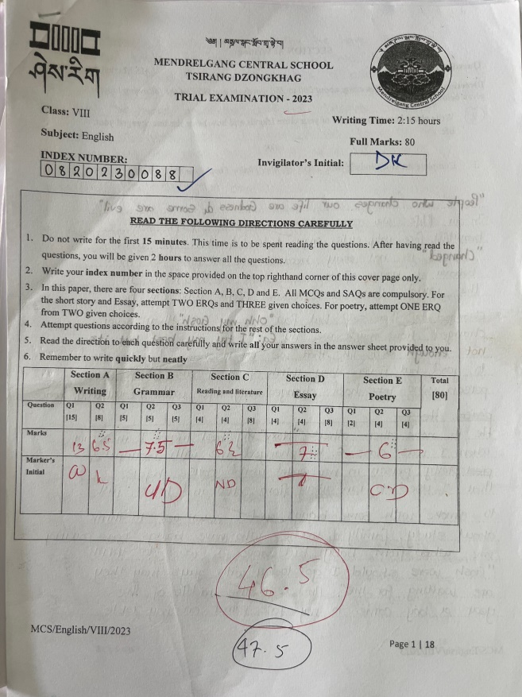
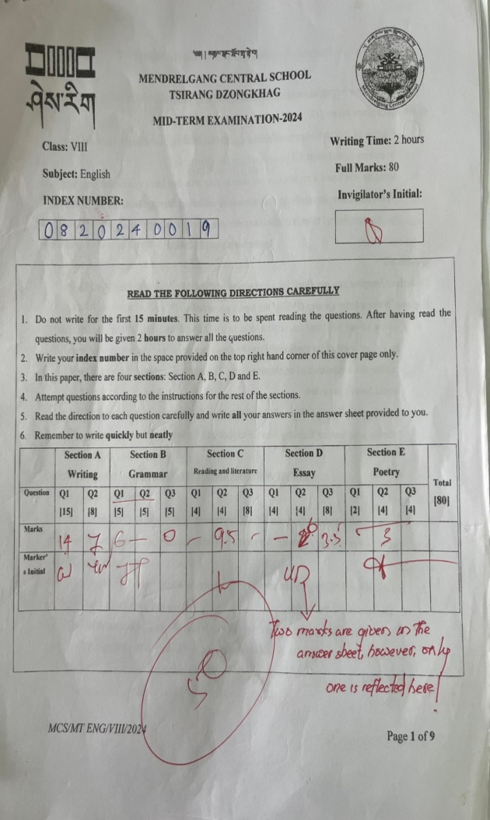
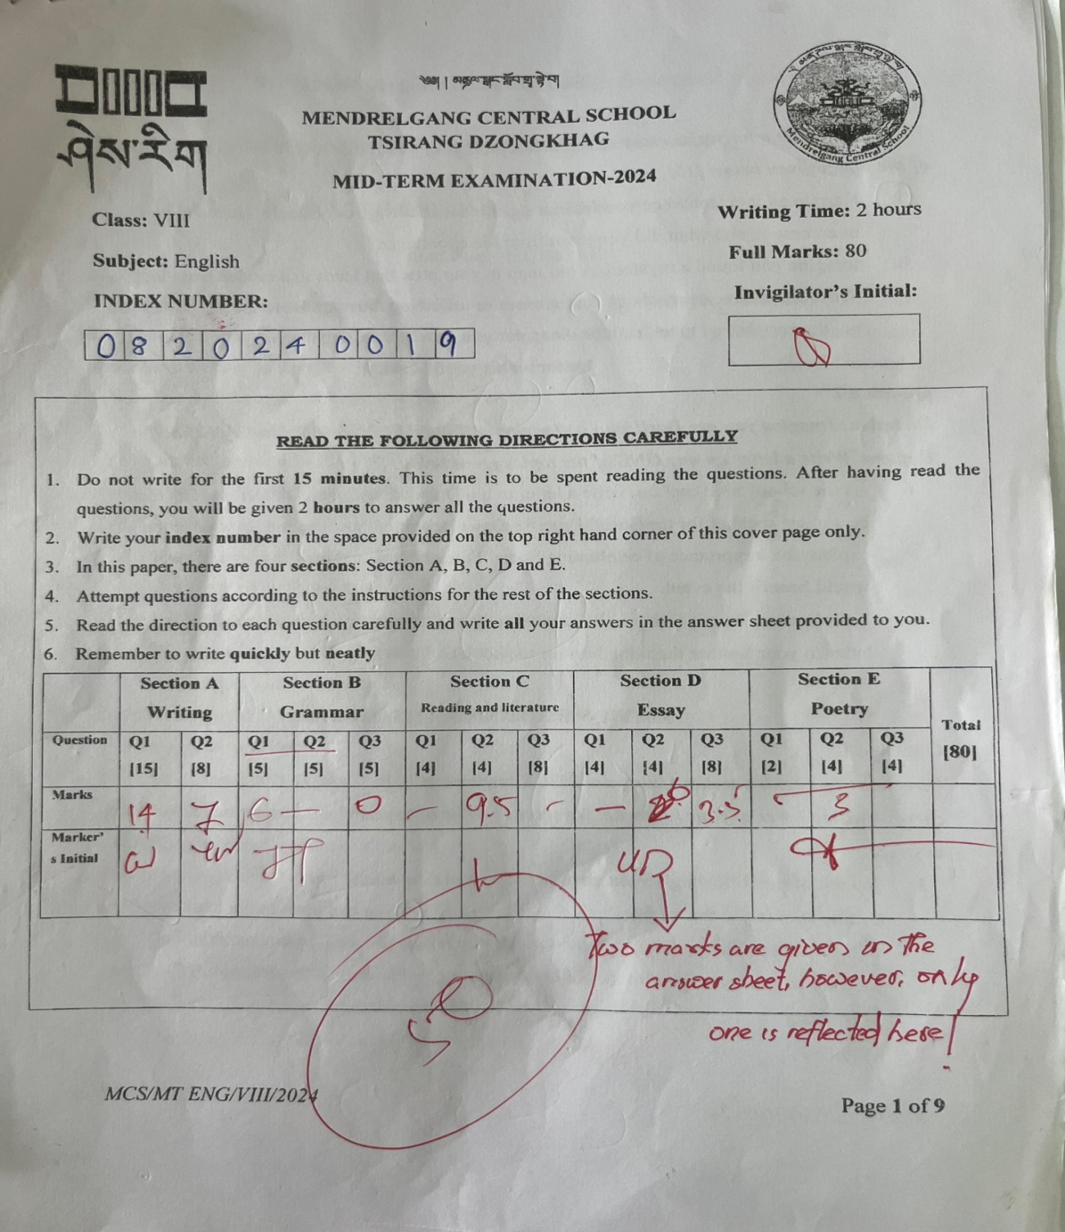

Appendix C: Pictorial Evidences of the conduct of Action Research

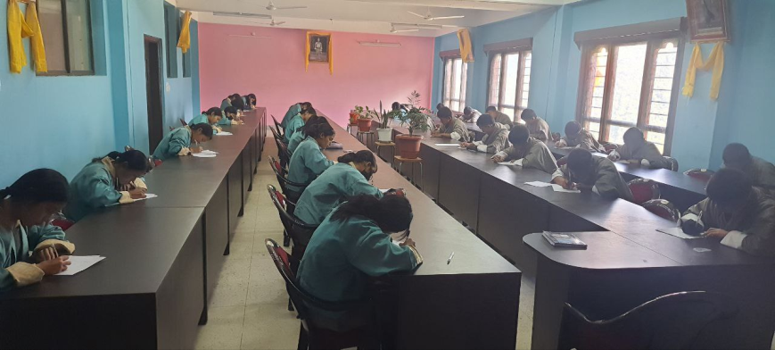
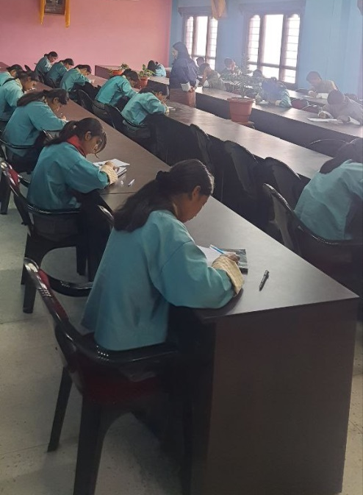
Conduct of pre and post-test

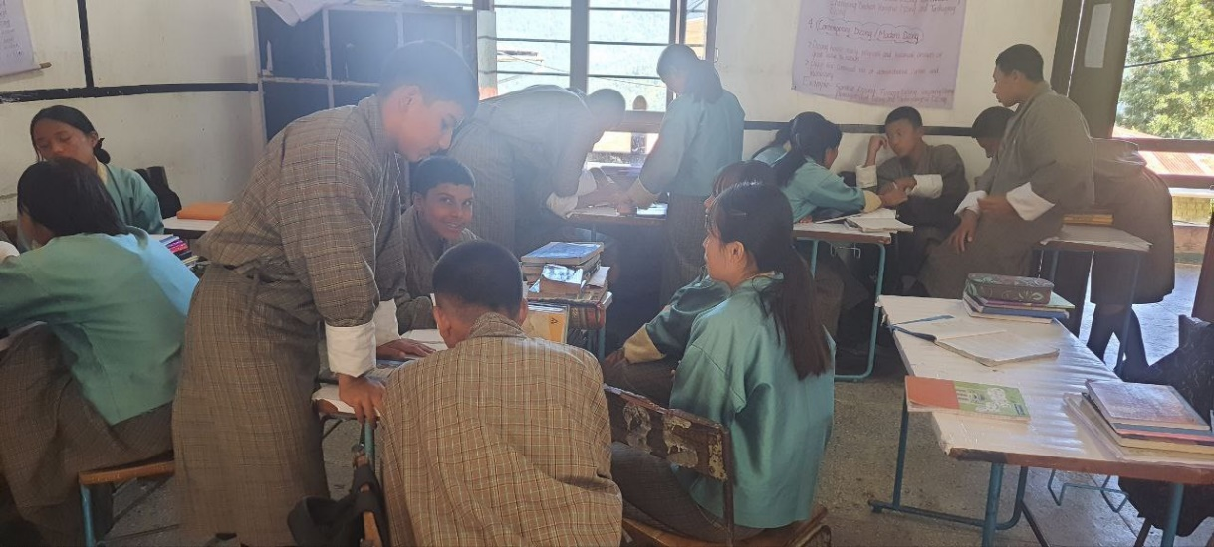
Students discussing for the presentation

