**Assessment of Health Risks Associated with Potentially Toxic Elements in Groundwater Sources within a Petroleum Depot-Hosting Community in Ibadan, Oyo State, Nigeria**

**ABSTRACT**

Groundwater constitutes the primary source of potable water for residents of Adebisi Layout in Apata, Ibadan, Oyo State, Nigeria. However, the proximity of the Nigeria National Petroleum Corporation (NNPC) Depot to residential areas raises concerns about potential contamination of this critical resource. This study evaluated the physicochemical characteristics and concentrations of potentially toxic elements (PTEs)—cadmium (Cd), chromium (Cr), nickel (Ni), lead (Pb), and zinc (Zn)—in groundwater samples collected from ten locations within the community. Analytical methodologies included Atomic Absorption Spectrometry (AAS) for PTE quantification and standardized procedures for physicochemical assessments.

The measured physicochemical parameters exhibited the following ranges: Total Dissolved Solids (TDS: 0.99–1.60 mg L⁻¹), Dissolved Oxygen (DO: 1.05–1.65 mg L⁻¹), pH (6.64–7.38), and temperature (27.2–29.2 °C). Heavy metal concentrations varied significantly, with Cd (0.04–0.31 mg L⁻¹) and Cr (0.09–0.67 mg L⁻¹) exceeding permissible limits in several samples, while Zn (ND–0.04 mg L⁻¹) and Ni (ND–0.16 mg L⁻¹) were detected at lower levels. Lead (Pb) concentrations remained below the instrument’s detection threshold. The elemental distribution followed a descending order of Cd > Ni > Zn > Cr, suggesting Cd as the dominant contaminant.

Health risk assessments were conducted to evaluate carcinogenic and non-carcinogenic hazards associated with groundwater consumption. Carcinogenic risk analysis indicated no significant cancer threat within the study area. However, non-carcinogenic risk evaluations, expressed through hazard quotients (HQ), revealed elevated health risks for the local population, particularly from Cd exposure. The hazard index (HI) values exceeded the acceptable threshold (HI > 1), underscoring the urgency for mitigation strategies. These findings highlight the need for continuous monitoring and public health interventions to safeguard groundwater quality in petroleum depot-host communities.

**Keywords:** Petroleum Contamination, Heavy Metals, Human Health Hazard, Groundwater Contamination.

**1.0 Introduction**

A strong country and good health depend on having access to safe drinking water (WHO, 2008; Pal et al., 2018). However, due to the ongoing population growth and rural-urban migration, this natural resource is under high demand, leading to shortages. Furthermore, water-borne infections, which cause 6.3% of deaths worldwide, can spread as a result of poor water management methods (WHO, 2008; Omole and Ndambuki, 2014). Despite the concerted worldwide effort to achieve the Millennium Development Goals (MDGs) target, 2.4 billion people lack adequate access to excellent sanitation facilities, and around 9% of the world's population lacks access to drinkable water (UNICEF/WHO, 2015; WHO, 2021). Accordingly, it is crucial to have access to enough drinkable water in order to advance social welfare and development among the general population (WHO, 2016)

In addition to being a major global source of water supply, groundwater is one of the planet's most important renewable resources. Approximately 98% of the fresh water on Earth comes from groundwater, which is widely dispersed throughout the world (Mishra, 2023). About 20% of the world's water (600–700 km3) is extracted each year by about two billion people (roughly one-third of the world's population), who rely on groundwater sources, most of which come from shallow aquifers. Groundwater is a vital source of sufficient drinkable water in both urban and rural parts of Nigeria (Danert and Healy, 2021). Furthermore, the lack of municipal pipe-borne water in cities has made residents more dependent on groundwater supplies for everyday needs.

Nigeria is one of the world's leading producers of crude oil. It uses pipelines to deliver petroleum products to a number of oil depots spread across the nation, from where mobile tankers deliver them to final consumers. Accidental spills and leaks that occur during the loading and unloading of tankers at the depots and the cleaning of oil storage tanks contaminate the environment with these products (Konarska, 2019). All of these discharges are the result of various activities at the depot and seriously damage the soil, which in turn contaminates the groundwater and surface water through filtration or leaching, posing serious health and environmental risks to local aquatic resources and people. Apata, Ibadan, Oyo State is home to the Nigerian National Petroleum Cooperation (NNPC) depot, which provides consumers with refined petroleum products. Heavy metals including Cd, Cr, Pb, Ni, and Zn are known to be common components of petroleum (Fu et al., 2014), and numerous studies have connected petroleum contamination to higher concentrations of hazardous heavy metals in groundwater (Ogunlaja et al., 2019; Ogunlaja et al., 2018; Onojake and Frank, 2013). The environment and the local inhabitants may be at risk due to the depot's close proximity to populated areas, mainly because of its use of groundwater. The elemental examination is therefore essential.

Groundwater contamination is currently one of the most important environmental problems. Of the wide range of contaminants affecting water supplies, heavy metals are of special concern because of their high toxicity, even at low concentrations (Hazrat et al., 2019; Wendling, 2018; Masindi and Muedi, 2018). The impact of the NNPC Depot's vicinity on human settlement was examined in the current study using multivariate statistical analyses, specifically principal component analysis (PCA) and cluster analysis (CA). Furthermore, the ingestion pathway was used to evaluate the potential health effects and daily human exposure to the hazardous components by groundwater intake.

**2.0 Materials and Methods**

**2.1** **Description of the Study Area**

The research location is situated in the Ido Local Government location of Oyo State, Nigeria, not far from the NNPC Apata Depot, Ibadan (Figure 1). With 103,261 residents and an area of 986 km2, Ido is the third largest Local Government Area in Ibadan. It is situated between latitudes 7º17'50” and 7º44'50” and longitudes 3° 33'20” to 3º51'11” (NPC, 2006). The catchment area spans latitudes 7º22'43” to 7º23'55” and longitudes 3º47'13” to 3º49'41” The average yearly temperature in Apata, which is located in a wet climate zone, is 26.8 oC, with March seeing the highest monthly average temperature. With an average temperature of 24.6 °C, August is the coldest month of the year. Rainfall in the study region averages 1131 mm per year. Groundwater is the primary supply of drinking water for the residents of this village, according to the preliminary inquiry conducted in the study area.

**2.2** **Sample Collection and Preparation**

Using a straightforward randomisation technique, ten representative groundwater samples were taken from a few chosen tube wells in the Apata research area. Before being examined, the samples were moved, sealed in 1-liter plastic bottles, and refrigerated.

**2.3** **Chemical Analysis and Quality Control**

A portable calibrated mercury-in-glass thermometer and a pH meter with a glass electrode were used to measure the temperature and pH right away. The complexometric approach was used to calculate Total Hardness (TH). Titrimetry was used to quantify alkalinity, and a membrane probe (Tutron WA-2015) with a suitable calibration solution was used to assess conductivity, total dissolved solids (TDS), and dissolved oxygen (DO). The World Health Organisation (WHO) and Nigerian Standard for Drinking Water Quality (NSDWQ) standards were used to compare all of the physicochemical values to allowable limits (NSDWQ, 2007; WHO, 2011).

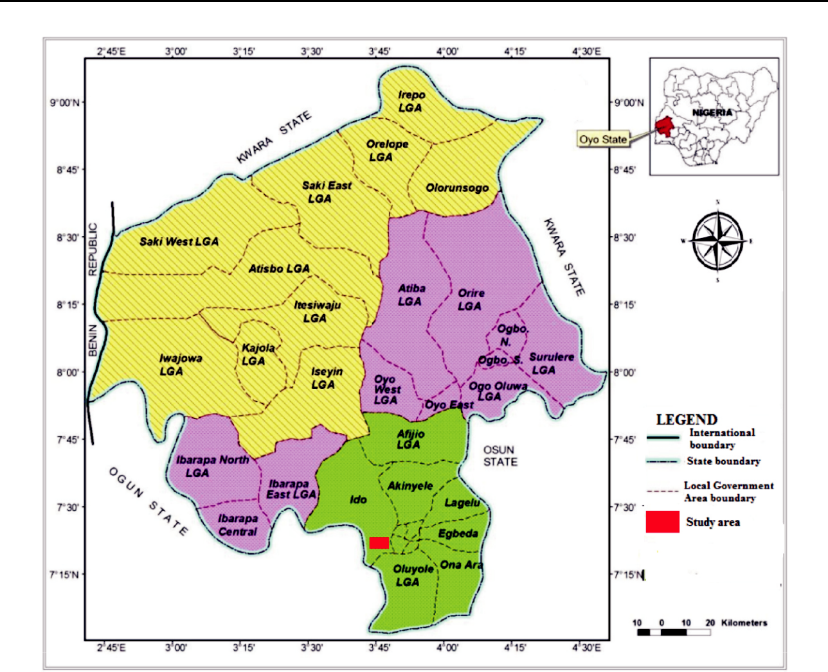

**Figure.1: Map Showing the Study Area**

Suitable calibration solution was used to assess conductivity, total dissolved solids (TDS), and dissolved oxygen (DO). The World Health Organisation (WHO) and Nigerian Standard for Drinking Water Quality (NSDWQ) standards were used to compare all of the physicochemical values to allowable limits (NSDWQ, 2007; WHO, 2011).

Analytical grade HNO3 was used to digest a known volume of water samples in order to assess the presence of heavy metals. Prior to instrumental analysis, the digested sample was placed in a polyethylene bottle that had been cleaned with nitric acid, filtered into a 25 ml standard flask, and filled to the appropriate level with deionised water. The atomic absorption spectrometer (Schimazo model 2380) was used to analyse the water extracts for metals (Cd, Cr, Pb, Zn, and Ni). Trace detection and enhanced sensitivity were employed in all measurements to detect concentrations at the sub-ppb range for the elements under study, and the detection limits were established using instrumental parameters optimised for each element based on a 98% confidence level (3 standard deviations). Additionally, blank analyses were performed, triplicate analyses of the samples were performed, and the average of the results was calculated.

**2.4** **Reagents, Analytical Quality Assurance and Standards**

Chemicals of the spectroscopic grade were used as standards, while samples were of the analytical reagent grade. Spectroscopic grade stock standard solutions of 1000 mg L-1 were used to create elemental calibration standards. Analysis of blanks was done for quality control. To avoid contamination before use, glassware and other equipment were cleansed with 6M HNO3 and rinsed with double-distilled water. All of the trials were conducted using deionised water. After being cleaned with double-distilled water, all plastic containers were left to soak in 1M HNO3 for the entire night.

**2.5** **Statistical Analysis**

The quantities of heavy metals in this study were examined using Pearson's correlation matrix in order to look into the potential origins of various metals from these aquifers. The Statistical Package for the Social Sciences (PASW version 24, IBM Corporation, Cornell, NY, USA) was used for all statistical analyses.

**2.6** **Elemental Analysis**

**2.6.1** **Health Risk Assessments**

It was determined whether drinking water from these groundwater sources posed a long-term health risk. The lifetime average daily dose (LADD), as adopted by USEPA (2005), was used to quantify daily human exposure to heavy metals through the ingestion pathway. The human exposure risk was calculated in this investigation using the modified USEPA algorithm developed by Belkhiria et al. (2017) and Kavcar et al. (2009). The hazard quotient (HQ) index and chronic daily intake (CDI) were used to calculate the chronic risk.

CDI = (C × DI) / (BW)…………………………………………………. (1)

where BW is body weight (15 kg for children and 72 kg for adults), CDI is the human exposure risk through ingestion pathway (mg/kg-day)-1, C is the concentration of heavy metal in drinking water in mg L-1, and DI is the average daily intake rate (2.0 L/day-person)-1.   
Equation 2 was used to calculate the hazard quotient (HQ), which measures the non-carcinogenic hazard.   
HQ = CDI/ RfD………………………………………………………. (2)

RfD, which was acquired for this investigation from the USEPA, is the oral reference dose (mg/kg_day)-1 for each particular heavy metal (Table 1) to which humans may be exposed. Each heavy metal's HQ is determined, and the total HQ of all the metals is used to generate the hazard index (HI), which measures the non-carcinogenic danger. It is deemed safe for human health if HQ is less than 1. HQ ≤ 5 is a low-risk number. High risk is defined as HQ ≤ 10 and medium risk as HQ ≤ 10.

**Table 1: The toxicity responses to heavy metals as the oral reference dose (RfD) and oral**

|  |  |  |
| --- | --- | --- |
| **slope factor (SF)** |  |  |
| **Metals** | **Oral RfDa (mg/kg-day)-1** | **Oral SFb (mg/kg-day)- 1** |
| Cd | 5.0 × 10- 4 | 3.8×10- 1 |
| Cr | 3.0 × 10- 3 | 5.0 ×10- 1 |
| Pb | 3.6 × 10- 3 | 9.0×10- 3 |
| Zn | 3.0 × 10- 1 | ND |
| Ni | 2.0 × 10- 2 | 1.7 |



aUS EPA IRIS (2011), bUSEPA (2015) and ND - not determined

The carcinogenic risk was also calculated. Slope factor (SF), a contaminant intake and toxicity measure used in carcinogenic risk characterisation (Table 1), is used to calculate the risk of developing cancer. The incremental likelihood of a person getting cancer over the course of their lifetime due to exposure to the potential carcinogen was used to estimate the cancer risk (Equation 3).

Target Carcinogenic Risk (TCR) = SF × CDI…………………………………………………... (3)

Where the slope factor (SF) converts the chronic daily intake (CDI) to the incremental risk of individual developing cancer.

**3.** **Results and Discussion of Findings**

**3.1.** **Physico-Chemical Parameters**

Table 2 provides a summary of the findings from the physicochemical analysis of groundwater samples. The pH distribution across all sampling sites is displayed in Figure 2A, and the values ranged from 6.64 to 7.38. According to these readings, the majority of the groundwater samples under study are neutral and fall within the permitted ranges specified by the NDWQS and WHO.

Well water samples with a pH of less than 6.5 are softer and more corrosive, which raises the quantities of harmful metals. The distribution of DO in the investigated groundwater samples, which varied from 1.05 to 1.65 mg L-1 and were all within permissible WHO limits, is also displayed in Figure 2B. Additionally, the temperature fluctuated slightly from well A to well J and ranged from 27.2 to 29.2 oC (Figure 2C).  
The conductivity values varied significantly from well A to well J, ranging from 0.361 to 1.139µs cm-1 (Figure 2D). Likewise, there was little to marginally significant variance in the TDS values, which varied from 0.99 to 1.60 mg L-1 (Figure 2E). However, all of the wells' TDS readings fell below the permissible range of 1000 mg L-1. The total hardness levels in the groundwater samples under study varied greatly and ranged from 25 to 151 mg L-1 (Figure 2F). With the exception of Well C, which had a value of 154 mg L-1, every sample examined for TH was within permissible bounds. Additionally, Figure 2G displays Alkalinity, which varied from 0.07 to 0.17 mg L-1.

Distribution of the water samples from the well under study. An indication of the natural salts in water is given by its alkalinity. With the exception of TH (Table 2), the mean values for practically all of the physicochemical parameters under investigation showed no significant changes (p>0.05). This finding points to a shared genesis. Except for well C, which had a mean of 151 ± 5.0 mg L-1 and varied from 147 to 154 mg L-1, all of the physicochemical parameter values in this investigation fell within the permitted bounds of the WHO and NSDWQ drinking water standards, respectively. Therefore, drinking from these wells might not be harmful to one's health.

**3.2. Elemental Analysis:** The examination of water CRM and experimental values showed a good agreement with the certified values (p<0.05), confirming the analytical procedure's correctness and precision (Table 3). The range of recoveries was 99.8% to 101%.

**Table 3: Validation of the Analytical Method using Certified Reference Materials (CRM)**

|  |  |  |  |  |  |
| --- | --- | --- | --- | --- | --- |
| Certified Reference Materials | Elements | Measured (µg g- 1) | | Certified (µg g- 1) | Recovery (%) |
| Water GBW08608 | Cd | 0.104 | ± 0.002 | 0.104 ± 0.002 | 100.0 |
|  | Cr | 0.509 | ± 0.05 | 0.51 ± 0.01 | 99.8 |
|  | Cu | 1.029 | ± 0.01 | 1.03 ± 0.01 | 99.9 |
|  | Ni | 0.516 | ± 0.003 | 0.517 ± 0.006 | 99.8 |
|  | Pb | 1.04 ± 0.08 | | 1.03 ± 0.02 | 101.0 |
|  | Zn | 5.14 ± 0.01 | | 5.15 ± 0.05 | 99.8 |

*Values mean ± standard deviation, 95% confidence interval, n = 3

7.5

|  |  |  |
| --- | --- | --- |
|  |  | A |
| 7 |  | B |
| **H** |  | C |
| **p** |  | D |
| 6.5 |  |
|  |  | E |
| 6 |  | F |
| ABCDEFGHI | J | G |
| H |
| **Wells** |  |
|  | I |
|  |  | J |

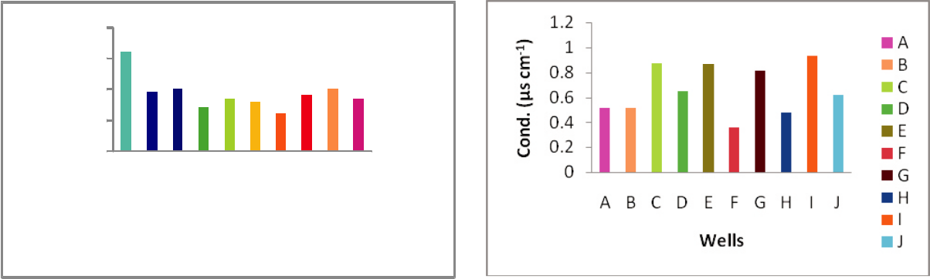

|  |
| --- |
| **Temp (oC)** |

|  |
| --- |
| **Temp (oC)** |

30

29

28

27

26

2

1.5

1

0.5

0

 A

 B

 C

 D

 E

 F

ABCDEFGHIJ  G  H

**Wells**  I

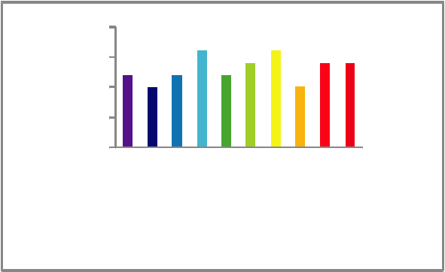

 A

 B

 C

 D

 E

 F

ABCDEFGHI J  G  H

**Wells**  I

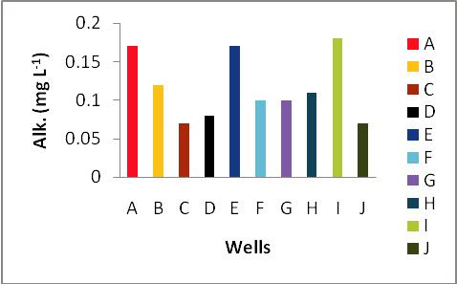

|  |
| --- |
| C |

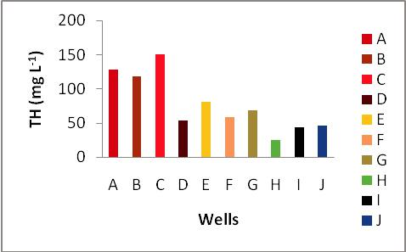

**Figure 2:** Distribution of Physicochemical Parameters in Studied Groundwater Samples

List 1 : Physicochemical Parameters in Studied Groundwater Samples



|  |  |  |  |  |  |  |  |  |  |  |
| --- | --- | --- | --- | --- | --- | --- | --- | --- | --- | --- |
| **Well** | **pH** | **DO (mg L-1)** | | **Temp (0C)** | **Cond. (µs cm-1)** | | **TDS (mg L-1)** | **TH (mg L-1)** | **Alk. (mg L-1)** | |
| **A** | 7.38 ± 0.3a | 1.35 | ± 0.1a | 29.2 ± 0.3a | 0.512 | ± 0.02a | 1.20 ± 0.01a | 128 ± 2.1a | 0.17 | ± 0.01a |
| **B** | 7.15 ± 0.7a | 1.4 ± 0.1a | | 27.9 ± 1.6a | 0.515 | ± 0.01a | 0.99 ± 0.02a | 118 ± 2.8a | 0.12 | ± 0.01a |
| **C** | 6.92 ± 0.5a | 1.6 ± 0.1a | | 28.0 ± 1.4a | 0.876 | ± 0.01ab | 1.20 ± 0.01a | **151** ± 5.0ab | 0.07 | ± 0.01ab |
| **D** | 6.86 ± 0.4a | 1.45 | ± 0.1a | 27.4 ± 2.3a | 0.647 | ± 0.01a | 1.60 ± 0.02a | 54 ± 5.1c | 0.08 | ± 0.02ab |
| **E** | 6.89 ± 0.8a | 1.55 | ± 0.1a | 27.7 ± 1.9a | 1.139 | ± 0.01b | 1.20 ± 0.01a | 81 ± 3.5c | 0.17 | ± 0.01a |
| **F** | 7.08 ± 0.8a | 1.05 | ± 0.1ab | 27.6 ± 1.9a | 0.361 | ± 0.01a | 1.40 ± 0.02a | 59 ± 2.1c | 0.10 | ± 0.01a |
| **G** | 6.93 ± 0.7a | 1.55 | ± 0.1a | 27.2 ± 2.6a | 0.816 | ± 0.01b | 1.60 ± 0.01a | 69 ± 7.1c | 0.10 | ± 0.01a |
| **H** | 6.89 ± 0.5a | 1.55 | ± 0.1a | 27.8 ± 1.7a | 0.477 | ± 0.01a | 1.0 ± 0.01a | 25 ± 3.5d | 0.11 ± 0.01a | |
| **I** | 6.64 ± 0.5a | 1.65 | ± 0.1a | 28.0 ± 1.4a | 0.933 | ± 0.01ab | 1.40 ± 0.02a | 44 ± 5.7c | 0.18 | ± 0.01a |
| **J** | 7.14 ± 0.9a | 1.7 ± 0.1a | | 27.7 ± 1.8a | 0.618 | ± 0.01a | 1.40 ± 0.01a | 46 ± 2.8c | 0.07 | ± 0.02ab |
| **NSDWQ** | 6.50-8.50 | N/S |  | N/S | 1000 |  | 500 | N/S | N/S |  |
| **WHO** | 6.50-8.50 | 6.0 |  | N/S | 25.0 |  | 500 | 100-150 | ? 120 | |

Temp (Temperature), EC (Electrical Conductivity), TDS (Total dissolved solute), TH (Total Hardness), Alk. (Alkalinity), DO (Dissolved Oxygen). All values are presented as (mean ± SD) n = 3. N/S = Not specified, NSDWQ (Nigerian Standard for Drinking Water Quality, 2007), WHO (World Health Organization, 2011). Different superscript letters within columns indicate mean separations by Tukey's post-hoc tests at the 5% level.

The levels of Cd, Cr, Ni, Pb, and Zn in groundwater samples were summarised in Table 4. According to Table 4, the heavy metal concentrations in groundwater were found to be in decreasing order: Cd > Ni > Zn > Cr > Pb. While Pb was below the detection limit for all groundwater samples, the mean elemental values of Zn and Ni in groundwater samples ranged from ND to 0.04 mg L-1 and ND to 0.16 mg L-1, respectively (Table 4). For all groundwater samples except E, F, and I, the mean Cd concentration was greater than the WHO-recommended drinking water limit of 0.005 mg L-1. Seventy percent of the groundwater under study is represented by this elemental elevation of concentration. Similarly, 50% of the groundwater under study had Ni concentrations over the WHO recommended drinking water limit (Table 4). Over time, these heavy metals may build up in human tissues as a result of drinking from these groundwater samples. Kidney impairment may result from accumulated Cd in the kidney (Baldwin and Marshall, 1999). Animals that live adjacent to a petroleum refinery have also been found to have elevated Ni levels, which can lead to several types of cancer (Wuana and Okieimen, 2011). Pb is not included in Table 4 because its concentration was below the instrument detection limit.

**Table 4: Concentrations of Heavy Metals in Well Samples Compared with WHO Standards**

|  |  |  |  |  |  |
| --- | --- | --- | --- | --- | --- |
|  | Ni |  | Zn | Cr | Cd |
| A | 0.02 | ± 0.01a | ND | ND | **0.18**± 0.01a |
| B | ND |  | 0.01 ± 0.005 a | 0.03 ± 0.001 a | **0.12**± 0.01 a |
| C | **0.08**± 0.02 b | | 0.01 ± 0.001 a | ND | **0.13**± 0.001a |
| D | ND |  | ND | ND | **0.08**± 0.001 a |
| E | 0.02 | ± 0.01 a | 0.04 ± 0.01 a | 0.02 ± 0.001 a | ND |
| F | 0.01 | ± 0.006 a | ND | ND | ND |
| G | **0.11**± 0.02 b | | 0.04 ± 0.01 a | ND | **0.09**± 0.002 a |
| H | **0.15**± 0.05 b | | ND | 0.01 ± 0.005 a | **0.1**± 0.01 a |
| I | **0.16** | ± 0.01b | ND | ND | ND |
| J | **0.06** | ± 0.02 a b | ND | 0.01 ± 0.005 a | **0.17**± 0.01 a |
| WHO | 0.02 |  | 5.00 | 0.05 | 0.005 |

Values are in mg L -1 (Mean ± SD) and WHO (2017).

**3.3. Human Health Risk Assessment**

**3.3.1. Hazard Quotient (HQ)**

Heavy metals have a major role in groundwater contamination, which is a major environmental and health concern in many rural and urban regions (Marcovecchio et al., 2007; Vodela et al., 1997). Therefore, evaluating the risk to human health posed by potential heavy metal poisoning linked to drinking water from these wells is essential.   
The non-carcinogenic risk (HQ) estimations for Cd, Cr, Ni, Pb, and Zn for two age groups were presented in Table 5. With the exception of wells E, F, and I, the HQ (child and adult) for Cd was 1, indicating an unacceptable non-carcinogenic danger to human health, even though the HQ (child and adult) for the majority of the heavy metals under study were? Children had a larger non-carcinogenic hazard of cadmium than adults did, and well A had the highest HQ value of cadmium, at 48.0 for adults and 10.0 for children. Additionally, the HI showed that Cd accounted for 97% of the HI for children and was the main pollutant in the Well samples. Similarly, the most common pollutants in the Well samples were Cd and Ni, which accounted for 46.9% and 52.4% of the HI in adults, respectively. In the past, water supplies near a petroleum-contaminated area were also linked to Cd and Ni (Ogunlaja et al., 2019). This finding suggests that the residents may be exposed to some possible health hazards as a result of consuming heavy metals from wells. However, because of the physiological differences, children are exposed to a higher non-carcinogenic risk than adults, as indicated by the mean HI values. Additionally, all water sources and age groups had HI values of? 1, indicating an intolerable risk of non-carcinogenic consequences on the local population's health (ECETOC, 2001).

**Table 5**: Non-carcinogenic Risk (Hazard Quotient, HQ) and Overall Toxic Risk (Hazard

Index, HI)

|  |  |  |  |  |  |  |
| --- | --- | --- | --- | --- | --- | --- |
| **Group** | **HQ** | Ni | Zn | Cr | Cd | **HI** |
| **Child** | A | 0.1 | 0 | 0 | 48.0 | **48.1** |
|  | B | 0 | 0.004 | 1.3 | 32.0 | **33.3** |
|  | C | 0.5 | 0.004 | 0 | 34.7 | **35.2** |
|  | D | 0 | 0 | 0 | 21.3 | **21.3** |
|  | E | 0.1 | 0.02 | 0.9 | 0 | 1.0 |
|  | F | 0.1 | 0 | 0 | 0 | 0.1 |
|  | G | 0.7 | 0.02 | 0 | 24.0 | **24.8** |
|  | H | 1.0 | 0 | 0.4 | 26.7 | **28.1** |
|  | I | 1.1 | 0 | 0 | 0 | 1.1 |
|  | J | 0.4 | 0 | 0.4 | 45.3 | **46.2** |
| **Adult** | A | 0.03 | 0 | 0 | 10.0 | **10.0** |
|  | B | 0 | 0.001 | 0.3 | 6.7 | **7.0** |
|  | C | 0.1 | 0.001 | 0 | 7.2 | **7.3** |
|  | D | 0 | 0 | 0 | 4.4 | **4.4** |
|  | E | 0.03 | 0.004 | 0.185 | 0 | 0.2 |
|  | F | 0.01 | 0 | 0 | 0 | 0.01 |
|  | G | 0.2 | 0.004 | 0 | 5 | **5.2** |
|  | H | 0.2 | 0 | 0.093 | 5.6 | **5.9** |
|  | I | 53.3 | 0 | 0 | 0 | **53.3** |
|  | J | 0.1 | 0 | 0.1 | 9.4 | **9.6** |

Table 6 summarises the TCR for Ni, Cr, and Cd, which varied from 0 to 18.2 for children and 0 to 90 for adults. For children and adults, respectively, the elemental TCR values were in the decreasing order of Cd? Ni? Cr and Ni? Cd? Cr. There is a potential of developing cancer because the TCR values of exposure to Ni, Cr, and Cd in both adults and children were often found to be higher than the USEPA-recommended safe level for cancer risk (1 × 10-4) (USEPA, 2011 and 2012). According to the cumulative risk (∑TCR) of exposures to Ni, Cr, and Cd, adults are more likely than children to get cancer. Ni contributes 83.1% to the total carcinogenic risks in adults, compared to Cd's 16.6% and Cr's 0.3%, while Cd accounts for 91.1% of the carcinogenic hazards in children, compared to Ni's 7.2% and Cr's 1.6%.

**Table 6: Target Carcinogenic Risk (TCR) of the Elements in Well Water Samples**

|  |  |  |  |  |  |
| --- | --- | --- | --- | --- | --- |
| **Age group** | **Cancer risk (TCR)** | |  |  | **TCR** |
|  |  | Ni | Cr | Cd |  |
| **Child** | A | 0.23 | 0 | 18.2 | 18.5 |
|  | B | 0 | 0.67 | 12.2 | 12.8 |
|  | C | 0.91 | 0 | 13.2 | 14.1 |
|  | D | 0 | 0 | 8.11 | 8.11 |
|  | E | 0.23 | 0.44 | 0 | 0.67 |
|  | F | 0.11 | 0 | 0 | 0.11 |
|  | G | 1.25 | 0 | 9.12 | 10.4 |
|  | H | 1.7 | 0.22 | 10.1 | 12.1 |
|  | I | 1.81 | 0 | 0 | 1.81 |
|  | J | 0.68 | 0.22 | 17.2 | 18.1 |
| **Adult** | A | 0.05 | 0 | 3.8 | 3.85 |
|  | B | 0 | 0.14 | 2.53 | 2.67 |
|  | C | 0.19 | 0 | 2.74 | 2.93 |
|  | D | 0 | 0 | 1.69 | 1.69 |
|  | E | 0.05 | 0.09 | 0 | 0.14 |
|  | F | 0.02 | 0 | 0 | 0.02 |
|  | G | 0.26 | 0 | 1.9 | 2.16 |
|  | H | 0.35 | 0.05 | 2.11 | 2.51 |
|  | I | 90.7 | 0 | 0 | 90.7 |
|  | J | 0.14 | 0.05 | 3.59 | 3.78 |



A-J-Well water

**Conclusion**

The study assessed the health risks posed by potentially toxic elements (PTEs) in groundwater sources near a petroleum depot in Apata, Ibadan, Nigeria. Groundwater samples revealed elevated levels of cadmium (Cd) and chromium (Cr), exceeding WHO permissible limits, while zinc (Zn) and nickel (Ni) were detected at lower concentrations. Lead (Pb) remained below detection limits. The descending order of contamination was Cd > Ni > Zn > Cr > Pb, with Cd identified as the dominant pollutant, likely linked to petroleum-related activities. Health risk assessments indicated no significant carcinogenic threat, but non-carcinogenic risks, particularly from Cd exposure, were alarmingly high, with hazard index (HI) values exceeding safe thresholds for both adults and children. Children faced higher risks due to their physiological vulnerability. The findings underscore the urgent need for mitigation strategies, including continuous groundwater monitoring, public health interventions, and community education on water safety. The study highlights the potential health hazards posed by petroleum depot operations in residential areas and calls for stricter regulatory measures to safeguard water quality. these risks is critical to protecting the health of vulnerable populations and ensuring sustainable access to safe drinking water in affected communities.

**Recommendation**

In order to reduce harmful hazards to human health from potentially contaminated groundwater, the findings of this study may be used to educate host communities of petroleum depots on the safety of groundwater intake.

**References**

Ali, H., Khan, E., & Ilahi, I. (2019). Environmental chemistry and ecotoxicology of hazardous heavy metals: environmental persistence, toxicity, and bioaccumulation. Journal of Chemistry, 2019. https://doi.org/10.1155/2019/6730305.

Annals of clinical biochemistry, 36(3), 267-300.

Baldwin, D. R., & Marshall, W. J. (1999). Heavy metal poisoning and its laboratory investigation.

Belkhiri, L., Mouni, L., Narany, T. S., & Tiri, A. (2017). Evaluation of potential health risks of heavy metals in groundwater using the integration of indicator kriging and multivariate statistical methods. Groundwater for Sustainable Development, 4, 12-22.

Danert, K., & Healy, A. (2021). Monitoring groundwater use as a domestic water source by urban households: analysis of data from Lagos State, Nigeria and Sub-Saharan Africa with implications for policy and practice. *Water*, *13*(4), 568.

European Centre for Ecotoxicology of Chemicals. (2001). Aquatic toxicity of mixtures. Technical Report 80. (Brussels, Belgium).

Fu, J., Wang, Q., Wang, H., Yu, H., & Zhang, X. (2014). Monitoring of non-destructive sampling strategies to assess the exposure of avian species in Jiangsu Province, China to heavy metals. Environmental Science and Pollution Research, 21, 2898-2906.

Kavcar, P., Sofuoglu, A., &Sofuoglu, S. C. (2009). A health risk assessment for exposure to trace metals via drinking water ingestion pathway. International journal of hygiene and environmental health, 212(2), 216-227.

Konarska, A. (2019). Environmental impact of mishandlings on tankers. *Polish Journal of Political Science*, *5*(2),119-151.

Marcovecchio, J. E., &Botté, S. E. (2007). Heavy metals, major metals, trace elements. In: Nollet, L.M. (Ed.), Handbook of water analysis, second ed. CRC Press, London, UK. (pp. 289-326).

Masindi, V., & Muedi, K. L. (2018). Environmental contamination by heavy metals. Heavy metals, 10, 115-132.

Mishra, R. K. (2023). Fresh water availability and its global challenge. *British Journal of Multidisciplinary and Advanced Studies*, *4*(3), 1-78.

Muta'aHellandendu, J. (2012). Health implications of water scarcity in Nigeria. European Scientific Journal, 8(18). ISSN: 1857 – 7881 (Print) e - ISSN 1857- 7431.

Nigeria Standard for Drinking Water Quality. (2007). Nigeria Industrial Standard Approved by Standard Organization of Nigeria Governing Council ICS 13. 060. 20:15-19.

NPC (National Population Commission). (2006). Population Distribution by Sex State LGAs and Senatorial District: 2006 Census Priority Tables (Vol 3). Abuja.

Ogunlaja, A., Ogunlaja, O. O., &Okewole, D. M. (2018). Risk assessment and profiling of selected heavy metals in water sources within a petroleum refinery host community. Toxicology Digest 2,13-36.

Ogunlaja, A., Ogunlaja, O. O., Okewole, D. M., &Morenikeji, O. A. (2019). Risk assessment and source identification of heavy metal contamination by multivariate and hazard index analyses of a pipeline vandalised area in Lagos State, Nigeria. Science of the total environment, 651, 2943-2952.

Omole, D. O., & Ndambuki, J. M. (2014). Sustainable living in Africa: Case of water, sanitation, air pollution and energy. Sustainability, 6(8), 5187-5202.

Onojake, M. C., & Frank, O. (2013). Assessment of heavy metals in a soil contaminated by oil spill: a case study in Nigeria. Chemistry and Ecology, 29(3), 246-254.

Pal, M., Ayele, Y., Hadush, M., Panigrahi, S., & Jadhav, V. J. (2018). Public health hazards due to unsafe drinking water. *Air Water Borne Dis*, *7*(1000138), 2.

Rasheed, T., Bilal, M., Nabeel, F., Adeel, M., & Iqbal, H. M. (2019). Environmentally-related contaminants of high concern: potential sources and analytical modalities for detection, quantification, and treatment. Environment International, 122, 52-66.

US Environmental Protection Agency. (2005). Guidelines for carcinogen risk assessment. In Risk Assessment Forum. Washington, Dc: US EPA.

US Environmental Protection Agency. (2015) Risk-based screening table. Composite table: summary tab 0615.

US Environmental Protection Agency's integrated risk information system (2011). Environmental protection agency region I. Washington DC, 20460.

Vodela, J. K., Renden, J. A., Lenz, S. D., McElhenney, W. H., & Kemppainen, B. W. (1997). Drinking water contaminants (arsenic, cadmium, lead, benzene, and trichloroethylene). 1. Interaction of contaminants with nutritional status on general performance and immune function in broiler chickens. Poultry Science, 76(11), 1474-1492.

Wendling, Z. A., Emerson, J. W., Esty, D. C., Levy, M. A., de Sherbinin, A., et al. 2018. Environmental Performance Index. New Haven, CT: Yale Center for Environmental Law & Policy. https://epi.yale.edu/

WHO/UNICEF Joint Water Supply, & Sanitation Monitoring Programme. (2015). Progress on sanitation and drinking water: 2015 update and MDG assessment. World Health Organization.

World Health Organization, & United Nations Children's Fund. (2021). *Progress on household drinking water, sanitation and hygiene 2000-2020: five years into the SDGs*. World Health Organization.

World Health Organization. (2008). Safer Water, Better Health, p. 10.

World health organization. (2011). Guidelines for drinking-water quality. 4th edn 216, 303-304.

World Health Organization. (2016). World Health Statistics 2016 [OP]: monitoring health for the sustainable development goals (SDGs). World Health Organization.

World Health Organization. (2017). Guidelines for Drinking-water Quality. 4th ed. incorporating the first 400 addendum. World Health Organization, Geneva.

Wuana, R.A., Okieimen, F.E., 2011. Heavy metals in contaminated soils: a review of sources, Chemistry, risks and best available strategies for remediation. ISRN Ecol., 1–20 https://doi.org/10.5402/2011/402647.