**COMMUNITY PERCEPTIONS OF URBAN RENEWAL PROJECTS IN ENUGU NIGERIA**

**Abstract**

The implementation of urban renewal projects (URP) in Enugu City, Nigeria, faces multi-faceted challenges in balancing sustainable development and social equity. This study aims to assess community perceptions of urban renewal projects by investigating residents’ concerns and needs in Enugu City, Nigeria. Employing a quantitative research approach, a structured questionnaire survey was administered to a sample of 605 respondents. The findings reveal mixed perceptions among community members, with residents associating urban renewal projects with improved infrastructure, but also fearing displacement and increased costs. However, a notable consensus emerged regarding the need for inclusive planning, community engagement, and consideration of social impacts in urban renewal projects. The results indicate that residents' concerns comprise: displacement (71%), gentrification (64%), and social injustices (58%), highlighting the importance of community-centered approaches. The study identifies the need for policymakers to engage community members in decision-making processes to ensure equitable development and effective stakeholder engagements. Highlights include contributing to existing knowledge on sustainable urban development, informing policy decisions, and promoting community-centered urban renewal projects.

1. **Introduction**

Urban renewal and housing estate development are interconnected concepts aiming to revitalize urban areas, differing in objectives and processes. Urban renewal, also known as urban regeneration or redevelopment, is a comprehensive scheme addressing urban decay, involving clearance of deteriorated structures, slum clearance, and redevelopment of land for new housing, businesses, and public facilities [1]. This process encompasses various strategies for revitalizing urban areas, including housing estate development, which focuses on constructing and enhancing residential buildings to provide affordable and adequate housing options, particularly in urban areas experiencing housing shortages [2]. Housing estate development involves planning and development of large-scale housing projects, incorporating design and planning, infrastructure improvement, and community engagement, ultimately enhancing the overall quality of life for urban residents [1, 3, and 4]. Urban renewal and housing estate development are not unique to specific regions but rather a global phenomenon. Cities worldwide face similar challenges, such as housing shortages, urban decay, and the need for sustainable development [5]. Globally, urban renewal strategies, including housing estate development, are being implemented in various forms and scales [6]. For instance, the United Nations' Sustainable Development Goals (SDGs) emphasize the need for sustainable urbanization and adequate housing [4].

Nigeria is currently witnessing a significant push towards enhancing urban living conditions and addressing housing shortages across various states, as evident in recent initiatives and developments in urban renewal projects and housing estate development. At the federal level, the Ministry of Housing and Urban Development has launched the "Renewed Hope Cities & Estates Programme," which includes a groundbreaking ceremony for 3,112 housing units in Abuja, aiming to enhance urban living standards and promote sustainable development nationwide [7]. The current state of urban renewal projects and housing estate development in Enugu City demonstrates a proactive approach by the government to address urban challenges and expand residential options. This development is part of a broader strategy to expand Enugu City, which is facing space constraints in its current layout [8, 9]. Thus, this study seeks to contribute to the existing body of knowledge by exploring the community's perceptions of urban renewal projects in Enugu City, with a focus on housing estate development. Community displacement and resistance have historically accompanied urban renewal projects, with residents fearing loss of homes and livelihoods. This tension highlights questions about the balance between urban renewal objectives and residents' rights. There is a lack of understanding about how community members perceive the effectiveness of urban renewal efforts, including factors such as housing quality, accessibility to amenities, and overall improvements in living conditions.

Previous studies indicate that residents often feel that urban renewal initiatives fail to address their needs or improve their living conditions [10, 11]. The socio-economic impacts of housing estate developments are profound, with potential increases in property values and changes in community demographics. However, if not managed properly, these developments may exacerbate existing inequalities, further disadvantaging marginalized groups. Understanding community perceptions of these socio-economic changes is crucial for assessing the overall impact of urban renewal projects [8]. Effective urban renewal relies on active community participation in planning and implementation. However, a common disconnect between government initiatives and community involvement can result in projects that fail to meet residents' needs and desires [7, 12]. This lack of engagement can result in skepticism and mistrust towards urban renewal efforts. Additionally, concerns exist regarding the sustainability and maintenance of infrastructure and service delivery improvements [8, 13]. This study contributes to the existing body of knowledge on urban renewal projects and housing estate developments by investigating the perceptions of Enugu City residents. The research aims to address the gaps in current understanding by examining community perceptions, identifying key benefits and drawbacks, and developing a framework for urban renewal strategies that prioritize residents' needs. In the light of present environmental, social, and economic realities, the study assesses the impacts and implications of urban renewal projects and housing estate developments on Enugu City residents. The research focuses on the experiences and perspectives of community members, exploring the opportunities and challenges they encounter in the context of urban renewal projects. The study draws data from surveys and insights from affected community members, discussing the viability and approach employed in urban renewal projects and housing estate developments. By exploring the challenges, opportunities, and debates surrounding urban renewal in Enugu City, the study seeks to provide a comprehensive understanding of the factors that influence the success and sustainability of urban renewal projects.

The findings of this study have significant implications for urban planning, policy development, and community engagement in Enugu City and beyond. By identifying the key factors that contribute to the success and sustainability of urban renewal projects, the study can inform strategies to support the growth and development of Enugu City, enabling policymakers and stakeholders to make informed decisions about urban renewal initiatives. Moreover, the insights gained from this research can guide community members, policymakers, and stakeholders in navigating the complex landscape of urban renewal, promoting inclusive, sustainable, and equitable developments.

*1.1 Study area*

Enugu City, capital of Enugu State in southeastern Nigeria, serves as the primary research location. The city's historical development was significantly shaped by the coal mining industry, established in the early 1900s, which influenced its growth and urbanization trajectory. As a post-colonial city, Enugu has undergone substantial transformations driven by rapid urbanization, economic growth, and government-led development initiatives, resulting in a complex and dynamic urban environment [10, 14]. Enugu City features a diverse landscape, encompassing both formal and informal residential areas. The city spans three local government areas: Enugu North, Enugu South, and Enugu East. Specifically, the research focuses on the Ogui community in Enugu North, the Amechi community in Enugu South, and the Nike community in Enugu East. These areas have undergone ongoing or completed urban renewal projects, housing estate development initiatives, and road construction and rehabilitation efforts [10, 15].

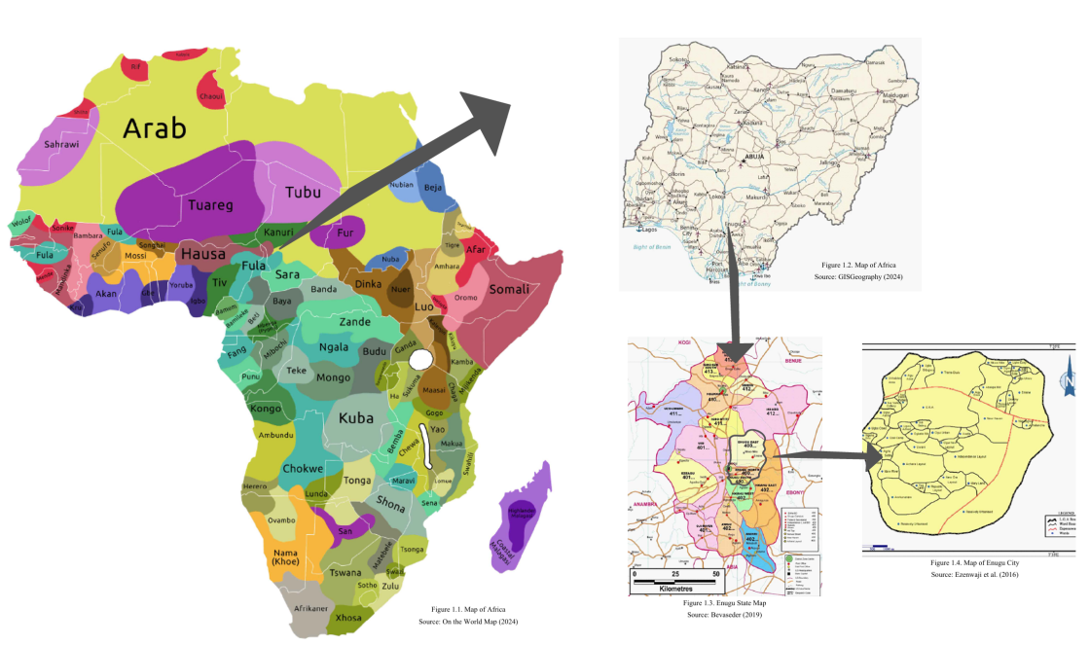

*Figure1. Map of Enugu city highlighted out of map of Nigeria and map of Africa.*

1. **Literature review**

*2.1 Overview of Urban Renewal and Housing Estate Development*

Urban renewal and housing estate development are interconnected processes aimed at revitalizing urban areas, improving living conditions, and addressing urban decay. Originating in the 19th century, urban renewal emerged as a response to industrialization's unsanitary conditions, focusing initially on housing reform and public health improvements. Evolving into comprehensive slum clearance and redevelopment initiatives, urban renewal gained momentum globally in the mid-20th century, particularly in the US and UK. Historical examples, such as Paris' renovations, demonstrate urban renewal's impact on urban aesthetics and living conditions. Post-War II reconstruction efforts further accelerated urban renewal, significantly altering urban demographics and landscapes worldwide [16, 17, and 18]. Housing estate development, a crucial aspect of urban renewal, focuses on constructing modern, affordable residential options, enhancing residents' quality of life [1]. Critics argue that urban renewal and housing estate development often displace low-income and minority communities, destroying culturally significant neighborhoods without adequate compensation or relocation options [2, 19]. This highlights the need for community-inclusive planning processes prioritizing existing residents' needs, ensuring they benefit from urban development initiatives.

*2.2 Urban Renewal and Housing Estate Development in Nigeria*

Nigeria's rapid urbanization has led to significant challenges, including infrastructure decay, housing shortages, and socioeconomic disparities. Urban renewal and housing estate development are crucial strategies for addressing these issues and creating sustainable, livable cities [11]. However, past urban renewal efforts in Nigeria have been hindered by issues such as displacement, sustainability concerns, funding, and management [20, 21]. The demolition of informal settlements and roadside shops has resulted in significant displacement and livelihood losses. Furthermore, community participation in urban planning has been lacking, leading to resistance and resident dissatisfaction [22, 23]. Effective urban renewal requires inclusive planning; balancing development with residents' needs and rights [8, 22 and 24]. This involves addressing challenges such as affordability crises, regulatory complexities, infrastructure deficits, environmental concerns, community resistance, and economic uncertainty [1, 3]. In Enugu City, housing estate development is a critical issue, with a history dating back to the 1909 coal discovery [25, 26]. Despite efforts to prioritize housing development, challenges persist, including inadequate funding, regulatory hurdles, and environmental concerns [26]. Addressing these challenges is essential for successful housing estate development and creating sustainable, livable cities in Nigeria [25, 26]. The success of urban renewal and housing estate development in Nigeria depends on the ability of policymakers, developers, and communities to work together to create inclusive, sustainable, and livable cities [22].

*2.3 Community Perceptions and experiences of urban renewal projects*

Community perceptions and experiences significantly impact the effectiveness and acceptance of urban renewal projects. Residents' reactions vary depending on socioeconomic status and involvement in planning. Higher-income residents tend to support initiatives, while lower-income residents fear displacement and lack affordable housing options [13, 28]. In Enugu City, residents appreciate modern housing estates' improved living conditions, reliable infrastructure, green spaces, and security, viewing them as significant upgrades. Housing estate development is also seen as an economic catalyst, creating jobs and attracting businesses [2, 31]. However, concerns persist regarding displacement, gentrification, and affordability. Demolitions and rising property values threaten existing residents, especially those in informal settlements [30, 31]. The neglect of existing neighborhoods' basic amenities, such as reliable water supply, contrasts with new estates' modern infrastructure [22]. The affordability crisis further exacerbates tensions, as lower-income residents find new housing estates unaffordable. Enhancing community participation requires inclusive decision-making processes and collaborative relationships between public and private stakeholders [22, 28]. Two key strategies facilitate community participation: inclusive planning and public-private partnerships [30]. Inclusive planning engages community members through participatory methodologies, ensuring their voices are heard and integrated into development processes [28, 30]. Public-private partnerships leverage sector strengths for collaborative planning, resource sharing, and community benefits [28, 31]. Implementing these strategies fosters sustainable, equitable outcomes, revitalizing urban spaces and benefiting all residents [30, 32]. Prioritizing community participation ensures resident needs and aspirations drive decision-making, ultimately leading to more effective and acceptable urban renewal projects [28, 33]. Addressing concerns around displacement, affordability, and gentrification is crucial for urban renewal efforts to succeed in creating thriving, inclusive communities that promote social equity and economic growth. This, in turn, can enhance the quality of life for residents, support local businesses, and contribute to the city's overall development.

**3. Research method**

*3.1 Research Design and Population*

This quantitative study employs a survey methodology, to examine community perceptions of urban renewal and housing estate development in Enugu City. This method is considered appropriate for the study because, it offers insights to practical issues impacting on stakeholders, policymakers, and the community. The study population comprises residents, stakeholders, and experts within Enugu Metropolis; divided into three strata corresponding to the three local government areas within Enugu Metropolis: Enugu North, Enugu South, and Enugu East LGAs, encompassing various districts and communities. Enugu North LGA comprises: Ogui, Amaigbo Lane, Onuato, Umunevo, Enugwu-Ngwo, Ihenwuzi, Asata Township, China Town, G.R.A, New layout, Ihewuzi, Independence Layout, New Haven, Ogbete East, Ogbete West, Ogui Township, Onu-asata, Udi Siding/Iva Valley/Hill-Top, and Umunevo. South LGA consists of: Amaechi, Akwuke, Ugwuaji, Obeagu, Awkunanaw, and Amechi-Uwani while Enugu East LGA consists of Nike and Ugwogo districts. Nike district comprises the following communities: Agbogazi, Ako, Akpoga, Alulu, Amoji, Amokpo, Azama, Edem, Effokwe, Emene, Ibagwa, Amaowelle, Nbulunjodo, Nchantacha, Neke Odenigbo, Nekeuno, Ugwuomu, Nkwubo, Nokpa, Obinagu, Onuogba, and Onyohu. Ugwogo District consists of Adaeze, Amankpa, Obinagu, Ogbodogo, Okpuhu, Ugwunkwo, Umunagbo, Umunnameze, Umunonu Utazi, and farm settlement.

However, this study focuses on the districts/ communities directly affected by urban renewal projects and housing estate developments in Enugu Metropolis. These communities for investigations are: Ogui community in Enugu North, Amaechi community in Enugu South and Nike district communities in Enugu East LGAs. Since the three communities are directly affected by urban renewal projects and housing developments, due to their geographic locations, affiliations and experience, it is expected that they will offer valuable insights on the subject under study. According to City Population, Enugu (State, Nigeria) as of 2022 [34], based on 2006 census data, Enugu communities' estimated projected population is calculated thus:

C:\Users\deema\AppData\Local\Temp\ksohtml14780\wps1.png; Where P = projected population, p = population, r= growth rate (0.023 from 2006 to 2022 and 0.0342 from 2023 to 2024), 1= constant

**Total projected population for Ogui community (Enugu North) is:**

**C:\Users\deema\AppData\Local\Temp\ksohtml14780\wps2.png=** 94,067 **(**for 2007-2022) and

C:\Users\deema\AppData\Local\Temp\ksohtml14780\wps3.png = 69,926 (for 2023-2024)

Total projected population (P) **= (**94,067+69,926) **=163, 994**

**Total projected population for Amaechi community (Enugu South) is:**

**C:\Users\deema\AppData\Local\Temp\ksohtml14780\wps4.png** = 119,673 (for 2007-2022) and

C:\Users\deema\AppData\Local\Temp\ksohtml14780\wps5.png = 88,960 (for 2023-2024)

Total projected population (P) **=** (119,673+ 88,960) = 208,635

**Total projected population for Nike community (Enugu East) is:**

C:\Users\deema\AppData\Local\Temp\ksohtml14780\wps6.png = 251,778 (for 2007-2022) and

C:\Users\deema\AppData\Local\Temp\ksohtml14780\wps7.png= 187,162 (for 2023 - 2024)

Total projected population (P) = (251,778+ 187,162) = 438,940

*3.2 Sampling Size determination*

This study employs a combination of sampling techniques to ensure representativeness and diversity. A multistage sampling approach was used for the survey, incorporating stratified and simple random sampling methods to select participants proportionally. For Focus Group Discussions (FGDs), purposive and snowball sampling were employed, selecting participants based on expertise, experience, and diversity. Convenience sampling was also utilized, considering availability and willingness [35]. The sampling frame focuses on stakeholders from Enugu East, South, and North Local Government Areas, specifically targeting Nike, Amechi, and Ogui communities. These communities were selected due to urban renewal and housing development initiatives [11]. Stakeholders include local government officials, urban planners/developers, community leaders, and residents/community members. Participants were selected based on expertise/experience, representation, diversity, and willingness to participate.

The sample size is determined by research objectives, study design, and population characteristics. Taro Yamane's sample size formula was applied, using the following total projected population sizes of the communities in the area of study:

- Ogui community (Enugu North LGA): 163,994

- Amechi community (Enugu South LGA): 208,634

- Nike community (Enugu East LGA): 438,940

These population projections will serve as the basis for calculating the required sample size for each community.

Formula to estimate the sample size:

C:\Users\deema\AppData\Local\Temp\ksohtml14780\wps8.jpg

Where: n = sample size

E = margin of error (e.g., 0.05 for 5% error)

N= population size (approximate)

C:\Users\deema\AppData\Local\Temp\ksohtml14780\wps9.jpg **= 199 ~ 200**

C:\Users\deema\AppData\Local\Temp\ksohtml14780\wps10.jpg **= 205**

Sample size (n) = [438,940 * 0.5] / [1 + 438,940(0.05)2] **= 200**

**Therefore the sample sizes are:**

- Ogui (Enugu North LGA): 200

- Amechi (Enugu South LGA): 205

- Nike (Enugu East LGA): 200

**4. Results**

Out of the 605 participants sampled for this study, 535 returned completed questionnaires, yielding a high response rate of 90.3%. This high response rate enhances the reliability and representativeness of the study findings. The high participation level also suggests a strong interest in the topic community perceptions of urban renewal projects/housing estate development in the study area. Table 1 demonstrates the distribution of the questionnaires to the respondents by LGAs and their response rates. This geographic distribution of the respondents in Enugu metropolis indicates a near balanced representation of the communities in local government areas of study: with 97.5% (205) in Enugu South; 98.1% (200) from Enugu North and 76.5% (200) from Enugu East LGAs. This almost even distribution response rate of respondents may reflect their perceived views to the concentration of urban development activities in specific regions of the state, possibly due to urbanization patterns, economic factors, and the location of major projects.

This first section of the questionnaire sought to identify Socio-demographic characteristics of respondents to assess their suitability for the survey. Table 2 illustrates details of respondents Socio-demographic characteristics. The sample profile indicates a balanced gender representation: 51.5% male and 48.5% female respondents. This minor disparity would not influence the perspectives and experiences reported in the study potentially, tending towards male-centric viewpoints. The age profile demonstrates a young adult’s concentration: 58.4% being 18-29 years while 27.7% of the respondents are between 30-39 years. The smaller portion (14%) are aged 40years and above. This limited representation of older age groups (4% for 50-59 years and 3% for 70% and above) reveals a minimal input from more senior and experienced residents. With regards to the level of education of respondents, the data reveals a high literacy profiling of formal higher education degrees: 15% diploma certificates, 60% bachelor degrees and 18% post graduate degrees. Only a small proportion (2%) has no formal education. The occupational distribution suggests a predominance of private sector workers (28.3%), free lancers (27.3%) and skilled artisans in construction industries (25.3%) while market traders of agricultural goods (10.1%) and civil servants (9.1%) constitute the smaller proportions.

The second section of the questionnaire explored the respondents’ perceptions on perception of urban renewal projects, covering awareness, impacts, benefits, shortcomings/setbacks and merits of communityengagements in the study area. Table 3 provides the details of respondents’ awareness of urban renewal projects. The communities’ knowledge, attitudes, and opinions about urban renewal projects are crucial for effective impacts assessments and identifying possible improvements. From table 3, the result revealed that 43% (232) of the 535 surveyed community residents self-reported having awareness, implying a moderate knowledge of urban renewal projects. Majority of the respondents (57%) were either totally ignorant (12%) or not very aware (17%) while 30% were unsure of the subject matter. Table 3 also depicts the community residents’ perception of the goals of urban renewal projects. While 49.5% of the respondents indicate economic development as a major goal, 40.6% opinionates environmental sustainability while a minority (9.9%) suggests social welfare as major aim of urban renewal projects in Enugu metropolis.

**Table 1**

Distribution of the Questionnaires and response rate by the LGAs communities

|  |  |  |  |  |
| --- | --- | --- | --- | --- |
| S/no | Communities by LGAs | Questionnaire Distributed | Questionnaire Returned | Response rate (%) |
| 1. | Ogui Community- Enugu North | 200 | 195 | 97.5 |
| 2. | Amechi Community- Enugu South | 205 | 201 | 98.1 |
| 3. | Nike Community- Enugu East | 200 | 153 | 76.5 |
|  | **Total** | **605** | **535** | **90.7** |

**Table 2**

Socio- Demographics characteristics of the respondents (n=535)

|  |  |  |  |
| --- | --- | --- | --- |
| S/no | Characteristics | Frequency | Percentage of response % |
|  | Gender |  |  |
| 1. | male | 275 | 51.5 |
| 2. | Female | 260 | 48.5 |
|  | Age groups (years) |  |  |
| 1. | 18 - 29 | 312 | 58.4 |
| 2. | 30 - 39 | 148 | 27.7 |
| 3. | 40 - 49 | 37 | 6.9 |
| 4. | 50 - 59 | 11 | 2 |
| 5. | 60 - 69 | 11 | 2 |
| 6. | 70 - above | 16 | 3 |
|  | Level of education |  |  |
| 1. | No level of Education | 6 | 1 |
| 2. | Primary School Certificate | 5 | 1 |
| 3. | Level Certificate | 32 | 6 |
| 4. | National Diploma | 27 | 5 |
| 5. | Higher National Diploma | 48 | 9.3 |
| 6. | Bachelor of Science | 321 | 60 |
| 7. | Master Degree | 91 | 17 |
| 8. | PhD | 5 | 1 |
|  | TOTAL | 535 | 100 |
|  | Respondents Occupation |  |  |
| 1. | Trader | 54 | 10.1 |
| 2. | Civil Servants | 48 | 9.1 |
| 3. | Private sector workers | 152 | 28.3 |
| 4. | Freelancers | 146 | 27.3 |
| 5. | Skilled Workers (Artisans) | 135 | 25.3 |
|  | Years of Practice |  |  |
| 1. | 1- 5 years | 139 | 26 |
| 2. | 6 - 10 years | 80 | 15 |
| 3. | 11 - 15 years | 21 | 4 |
| 4. | 16 - 20 years | 38 | 7 |
| 5. | 20 years and above | 257 | 48 |

**Table 3**

Awareness and Perception of Urban Renewal Projects

|  |  |  |  |
| --- | --- | --- | --- |
| S/no | Characteristics | Frequency | Response rate (%) |
|  | Level of Awareness |  |  |
| 1. | Not aware at all | 64 | 12 |
| 2. | Not very aware | 80 | 15 |
| 3. | Not sure | 159 | 30 |
| 4. | Aware | 95 | 18 |
| 5. | Very aware | 137 | 25 |
|  | TOTAL | 535 | 100 |
|  | Primary goals of urban renewal projects |  |  |
| 1. | Economic development | 265 | 49.5 |
| 2. | Social welfare | 53 | 9.9 |
| 3. | Environmental sustainability | 217 | 40.6 |
|  | TOTAL | 535 | 100 |

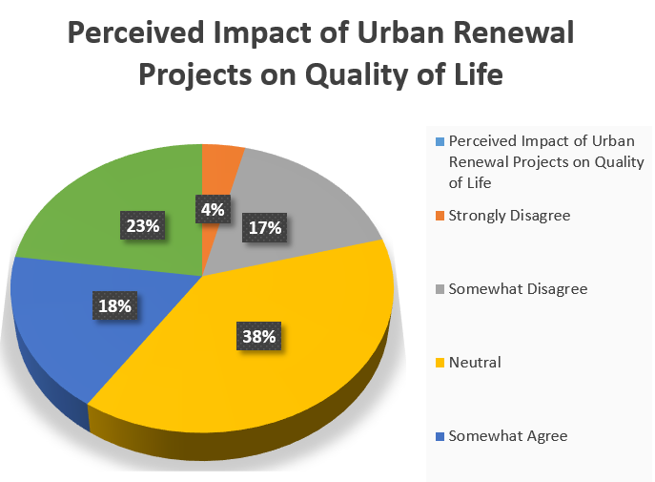

**Fig. 2:** Perceptions of urban renewal projects on improved quality of life

As seen in fig 2, as regards the impacts of urban renewal projects on community residents improved quality of life. Only 22.8% (122) strongly agree, 17.8% somehow agree on perceived improved quality of life while majority of the respondents (20.8%) disagreed and 38.6% neutral opinion indicating a consensus on their dissatisfaction. This data highlight complexities surrounding urban renewal initiatives in the study area emphasizing diverse resident experiences and expectations. The survey data in fig. 3 reveals summarizes the gains of urban renewal projects. A greater proportion of respondents (62%) feel that urban renewal projects in Enugu city yield improved infrastructure indicating a positive perception, while also a substantial number of the subjects (53.5%) suggests that economic opportunities is the top benefits. Similarly, 48.5% of the residents are of the view that environmental sustainability is major benefit of urban renewal projects while enhanced community amenities (35.6%) is the opinion of many community residents in the study area. This unanimous acknowledgment of the benefits of urban renewal and housing project development underscores the importance such developments.

However, respondents identified significant drawbacks and challenges confronting urban renewal developments. Fig. 4 depicts the details of the setbacks. While increased cost of living is the concern of the majority of the residents (61%), a greater proportion of the respondents (54%) fear displacements and loss of houses. Additionally, fears of community character affect 28% of the residents while environmental degradation impacts is worry and concerns of a many of community residents (25%). A small percentage (0.9%) of the residents envisages traffic jam and increased accident and death rates. These findings again, underscore the complexities surrounding urban renewal and housing project development.

**Figure 3:** Benefit of Urban Renewal and Housing Project development

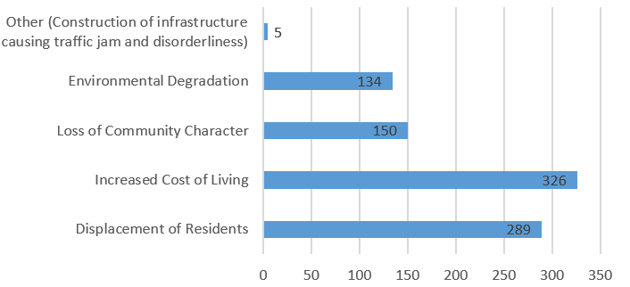

**Figure 4:** Drawbacks from Urban Renewal and Housing Project development

The interplay between economic benefits and social implications emerges. While residents prioritize economic growth, gentrification and community displacement concerns prevail. Balancing these competing interests is crucial for sustainable urban renewal. Key trade-offs include economic opportunities versus increased cost of living, improved infrastructure versus displacement and environmental sustainability versus degradation. These insights inform holistic urban renewal strategies, emphasizing community needs and sustainable development.

As seen in table 4, majority of the respondents (81.1%) indicate no community involvements in both planning and decision- making processes of the urban renewal projects in study area. This is of great concern to the residents since community participation is crucial for most successful urban renewal projects globally. The survey findings also revealed that the smaller proportion (18.9%) that was engaged served as construction professionals (8.6%), collaborators with developers/project teams (7.5%), urban planning professionals (1.9%) and advisory committee members (0.9%).

**Table 4**

Community Engagement Urban Renewal Projects/Housing Estate Development

|  |  |  |  |
| --- | --- | --- | --- |
| S/no | Characteristics | Frequency | Percentage of response % |
|  | Participation in Urban Renewal Planning or Decision-Making Processes |  |  |
| 1. | Yes | 101 | 18.9 |
| 2. | No | 434 | 81.1 |
|  | TOTAL | 535 | 100 |
|  | Involvement capacity |  |  |
| 1. | Professional in Construction Team | 46 | 8.6 |
| 2. | Collaborated with Developers/Project Team | 40 | 7.5 |
| 3. | Professional in Urban Planning Team | 10 | 1.9 |
| 4. | Served on Advisory Committee | 5 | 0.9 |
| 5. | Zero Involvement | 434 | 81.1 |
|  | TOTAL | 535 | 100 |

*4.1 Inclusive urban renewal decision-making.*

The study also explored the importance and possible opportunities of encouraging community involvement in urban renewal projects. Community engagement is crucial for inclusive urban renewal decision-making. From Table 5, there is a positive finding that 81.6 % of the 535 community residents self-reported great importance of community involvement in urban renewal decision-making process, implying a general understanding and acceptance of this environmental concept of development. Fig 5 highlights several key options that will aide community involvement and success of urban renewal projects in the study area. Public meetings would have possible remarkable impacts, with 68% of respondents agreeing that dialogue and negotiations with communities are keys to most successful governmental projects. A face-to-face interaction with communities or their representatives was another major factor, with (38.5%) of respondents acknowledging it as a frequent positive contributor to successful renewal projects development. Focus groups were recognized by 38.5% of respondents as impacting inclusive urban renewal decision-making. One-on-one consultations influenced 37.6% of respondents, while 31.7% preferred Online surveys. Lastly, 0.93% of the respondents opted for other media outlets like radio, TV and Newspapers.

Table 5: Importance of Community engagement tin Urban Renewal Decision-Making

|  |  |  |  |
| --- | --- | --- | --- |
| S/no | Perception ratings of importance of community involvement in URP | Number of Responses | Percentage rate |
| 1. | Not Important | 0 | 0 |
| 2. | Somewhat Important | 27 | 5 |
| 3. | Neutral | 74 | 13.9 |
| 4. | Important | 90 | 16.8 |
| 5. | Very important | 344 | 64.8 |
|  | TOTAL | 535 | 100 |

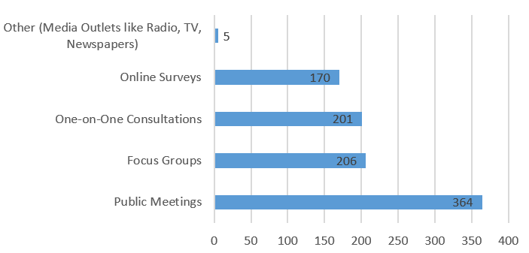

Figure 5: Preferred Methods for Community Engagement

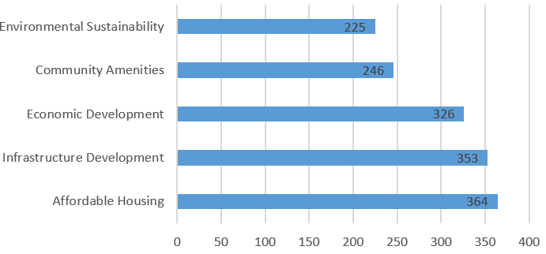

Figure 6: Respondent’s perception of the purpose of urban renewal projects

* 1. *Integration of sustainability in urban renewable and housing estate projects*

The inclusion of sustainability principles into urban renewal projects plays a critical role in defining the future of sustainable development. Figure 6 depicts that a significant proportion of respondents (42.1%) believe that environmental sustainability would positively impact on the future of urban renewal projects if well integrated at the initial decision-making process. However, a greater percentage of the subjects (68%) suggest that the prime goal of all urban renewable projects should be affordable housing for community residents to reduce the high cost of housing in urban cities. Similarly, larger proportions, 353 respondents (66%) feel that infrastructure development would be the priority of urban renewal projects while 61% of resident emphasizes economic development, indicating demand for job creation and economic growth initiatives. Additionally, 46% of respondents indicate community amenities as the focus of urban renewal developments.

5. **DISCUSSION**

The findings of this study offer insights into the perceptions and opinions of urban renewal projects in Enugu City and align with several themes and trends identified in the existing literature on urban renewal in other developing cities. One notable trend is the increasing emphasis on community engagement in the planning and social justice within the field. A study by [12, 13] explored the concept of "community-led urban renewal" and highlighted the growing importance of community participation and social responsibility for urban renewal projects in the 21st century. They argue that stakeholders who embrace community engagement planning are better equipped to navigate the complexities of the modern urban landscape and create value for their communities and society as a whole. Since the survey data reveals a strong consensus among the respondents concerning the importance of community engagement in the planning of urban renewal, it indicates a significant shift in the professional landscape of the study area. This suggests that stakeholders are increasingly adopting a community-led mindset and engaging in community-led activities, possibly to expand their opportunities and adapt to the changing demands of urban renewal. This concept of urban renewal agrees with [19] who opined that a significant portion of successful urban renewal projects have been achieved through community-led initiatives and this is reflective of Enugu urban and other Nigerian cities.

The study revealed significant knowledge gaps among community residents regarding urban renewal projects, with 25.7% being very aware while a greater proportion (56.5%) are partly ignorant or totally not aware. Economic expectations dominate residents' perspectives, with 49.5% believing urban renewal aims to stimulate economic development. This finding implies that most residents believe urban renewal projects can lead to economic benefits, although it disagrees with [20] that urban renewal projects often prioritize economic growth over social justice. Moreover, it is worth noting that 22.8% of respondents strongly agreed that urban renewal projects have improved their quality of life, suggesting that there may be some positive experiences regarding the social impacts of urban renewal projects. This finding aligns with the opinion of [21] who submitted that urban renewal projects can have positive social impacts when communities are involved in the planning of urban renewal and housing development.

Subsequently, the study results reveal a notable division in opinions of stakeholders regarding the future goals of urban renewal projects. While 68% of respondents prioritize affordable housing, 66% suggests improved infrastructure, and 61% prefers economic development. However, some stakeholders favor sustainable infrastructure, economic growth, and innovative transportation systems. This split indicates a lack of consensus on the demands from urban renewal projects. The debate is rooted in the historical and theoretical foundations of urban renewal, which emphasize community-led planning, affordable housing, and social justice [22, 25]. It can be inferred that those who support community-led planning argue that urban renewal projects should prioritize community needs, social responsibility, and environmental sustainability. On the other hand, the opposing side may have favoured economic growth and financial viability, believing that urban renewal projects should focus primarily on generating revenue and stimulating economic development.

The ongoing debate about the goals of urban renewal projects is further complicated by the changing nature and increasing complexity of urban renewal projects, the rapid advancement in technology, and the growing demand for sustainable and resilient design solutions. This demands increased knowledge, thought process, skills and preferences of what is really expected by residents from urban renewal and housing estate projects [13]. As the scenario unfolds, it will be important for stakeholders to find a balance between economic ambitions, social responsibilities, and environmental sustainability.

Restoration and preservation of community character are considered essential by a majority of the respondents, and this perception aligns with the challenges often associated with urban renewal projects. As noted by [28], the costs of restoring and preserving community character can be substantial, often exceeding the financial returns. Additionally, the complex regulations, specialized skills, and limited funding opportunities associated with such projects may contribute to the perception of non-lucrativeness. In stark contrast, the provision of additional services like community engagement, social impact assessments, and sustainable design is perceived as highly valuable by an overwhelming majority of respondents. This finding reflects the growing demand for community-led planning and social responsibility in urban renewal projects. As highlighted by [29] the integration of community engagement and social impact assessments has become increasingly valuable in urban renewal practice, offering new opportunities for community development and social justice. Interestingly, community development projects, disaster response, and public services are regarded as essential by a majority of respondents. This perception may stem from the often community-led nature of such projects and endeavors, which prioritize social impact over financial gain. As discussed by [13, 30], stakeholders involved in community development and disaster response often face challenges in securing adequate funding and balancing social responsibility with financial sustainability. But on the other hand, urban renewal projects are unanimously perceived as essential for community development by all respondents. This finding reinforces the core value proposition of urban renewal, emphasizing the importance of community-led planning, affordable housing, and social justice. As noted by the United Nation Report [5], urban renewal projects can have positive social impacts when community perception and social justice are considered.

6. **CONCLUSION AND RECOMMENDATIONS**

This quantitative research explored community perceptions of urban renewal projects in Enugu City, highlighting complexities and diverse perspectives. Findings revealed tensions between economic growth, infrastructure development and social justice, emphasizing inclusive planning and community engagement. Urban renewal impacts varied among stakeholders, while some residents experienced improved infrastructure but feared displacement and increased costs, others opined inequality and loss of community identity. Divergent priorities involving affordable housing, sustainable infrastructure and community-led planning underscored challenges in balancing competing interests.

Acknowledging complexities, this research provides a foundation for exploring effective strategies for inclusive, equitable and sustainable urban development. Urban renewal is a social and cultural process requiring consideration of community needs, aspirations and concerns. As Enugu City evolves, prioritizing community-centered approaches is crucial, recognizing relationships between physical infrastructure, economic development and social well-being.

* Involve community members in planning through advisory boards, feedback mechanisms and capacity-building initiatives.
* Conduct community impact assessments to identify displacement mitigation strategies and prioritize affordable housing, social services and community facilities.
* Preserve cultural heritage and community identity through sensitive urban design and sustainable infrastructure.
* Foster partnerships between government, private sector and community organizations.
* Develop inclusive zoning regulations prioritizing community needs, affordable housing and social services.
* Establish transparent decision-making processes integrating community concerns and feedback.
* Provide relocation assistance and support services for displaced residents and businesses, mitigating gentrification and displacement.

**7. Declarations**

**7.3. Institutional Review Board statement**

Not applicable

**7.4. Informed Consent statement**

The authors confirm they sought and got informed consent from all participants in the study.

**7.5. Declaration of competing interest**

The authors declare that there is no dispute of interests in regards to the publication of this manuscript. In addition, the ethical issues, including plagiarism, informed consent, misconduct, data fabrication and/or falsification, double publication and/or submission, and redundancies have been completely observed by authors.

**REFERENCE**

1. Zheng, H. W., Shen, G. Q., & Wang, H. A review of recent studies on sustainable urban renewal. Habitat International, 41, 272–279. (2014). <https://doi.org/10.1016/j.habitatint.2013.08.006>
2. Howarth, J. 9 top real estate trends in 2024. Exploding Topics. (2024). https://explodingtopics.com/blog/real-estate-trends

[3] Li, X., Wang, J., Luo, K., Liang, Y., & Wang, S. Exploring the spillover effects of urban renewal on local house prices using Multi-Source data and machine learning: the case of Shenzhen, China, Land, 11(9), 1439. (2022). <https://doi.org/10.3390/land11091439>

[4] Rafferty, J. P. (2024). Urban sprawl: Definition, Examples, Problems, Causes, & Alternatives. Britannica Encyclopedia. <https://www.britannica.com/topic/urban-sprawl>

[5] United Nation (2018).World Urbanization Prospect. Population.un.org. https://population.un.org/wup/

[6] World Bank: Overview Urban Development. (2023). <https://www.worldbank.org/en/topic/urbandevelopment/overview>

[7] Federal Ministry of Works and Housing Ministry of Housing and Urban Development Engages Un-Habitat on Funding, Technical Support for Nationwide Urban Renewal and Slum Grading Projects. In worksandhousing.gov.ng (Read 2998): Federal Ministry of Works and Housing (2023). https://worksandhousing.gov.ng/read/2998

[8] Ali, R. S. Urban Renewal: Enugu Govt creates new estate in Udi community - NEWS AGENCY OF NIGERIA, News Agency of Nigeria. (2024). <https://nannews.ng/2024/06/23/261343/>

[9] From Vision to Reality: In NewEnugu.com, Enugu State Government ICT. (2022). https://newenugu.com/

[10] Uwadiegwu, B. O. The Structural Profile of the Socio Economic and Housing Problems of the Slum Areas in Enugu City, Nigeria; An Insider’s Perception, The International Journal of Engineering and Science (IJES), 2(3). (2013). <https://www.theijes.com/papers/v2-i3/Part.Vol.2.3%20%283%29/B023308014.pdf>

[11] John-Nsa, C. Understanding the factors influencing the spatial dynamics of informal settlements: The case of Enugu City, Nigeria. Town and Regional Planning, no. 79, pp. 29-43.(2021).

[12] Jegede, F. O., Adewale, B. A., & Olaniyan, O. D. Evaluation of Sustainable Urban Renewal Strategies in an evolving Residential District of Lagos Island, Nigeria, IOP Conference Series Earth and Environmental Science, 331(1), 012001. (2019). <https://doi.org/10.1088/1755-1315/331/1/012001>

[13] Kam, M. K. Urban Renewal, Sense of Community and Social Capital: A Case Study of Two Neighborhoods in Hong Kong, Research Gate. (2018). https://www.researchgate.net/publication/324905310_Urban_Renewal_Sense_of_Community_and_Social_Capital_A_Case_Study_of_Two_Neighbourhoods_in_Hong_Kong

[14] Ezenwaji, E. E., Nzoiwu, C., & Eduputa, B. M. Enhancing Urban Water Supply through Rainwater Collection in Enugu Town, Nigeria (2016). Research Gate, <https://www.researchgate.net/figure/Map-of-Enugu-urban-area_fig1_317562141>

[15] Bevaseder. Enugu State Zip code map, Nigeria Zip Codes. (2019). <https://nigeriazipcodes.com/414/enugu-state-zip-code-map/>

[16] Keresztély, K. Urban Renewal as a Challenge for European Urban Development in the 21st century, Citego (2015). <https://www.citego.org/bdf_fiche-document-532_en.html>

[17] Urban Renewal, Encyclopedia.com, (2018). https://www.encyclopedia.com/history/united-states-and-canada/us-history/urban-renewal

[18] McGill Chapter 1: Urban Renewal. Minimum Cost Housing Group. (2024). <https://www.mcgill.ca/mchg/student/neighborhood/chapter1>

[19] Kotzias, N.P. Urban Renewal and Disconnect: Varying perceptions on the value of urban development in Tbilisi, Georgia. (2023). https://studenttheses.uu.nl/handle/20.500.12932/45389

[20] Roelofs, P. Urban renewal in Ibadan, Nigeria: World class but essentially Yoruba. African Affairs, 120(480), 391–415. (2021). <https://doi.org/10.1093/afraf/adab021>

[21] Timson, R. URBAN RENEWAL IN NIGERIA: The Sustainable Environment Dimension, By HABEEB SHUAEEB, Managing Director, Built Ability in Nigeria (BAIN) Limited, 09,(2011). https://www.semanticscholar.org/paper/URBAN-RENEWAL-IN-NIGERIA:-The-Sustainable-By-HABEEB-Timson/f1dbd28dda41613de7cfa326b31c4785400c2d95

[22] Adedeji, J., & Arayela, O. Urban Renewal Strategies and Economic Growth in Ondo State, Nigeria: A Case Study. Journal of Contemporary Urban Affairs, 2(1), 76-83.  (2018). <https://doi.org/10.25034/ijcua.2018.3662>

[23] Oriih, C. Urban renewal in Nigeria: case study of Lagos state. www.academia.edu. (2017). https://www.academia.edu/31715037/Urban_renewal_in_Nigeria_case_study_of_Lagos_state

[24] Ayik, C., Ayatac, H., & Sertyesilisik, B. A gap analysis on urban sustainability studies and urban sustainability assessment tools, Architecture Research, 7(1), 1–15. (2017). https://doi.org/10.5923/j.arch.20170701.01

[25] Umeora, C. O., Olotuah, A. O., & Ezeji, K. Average Monthly Income Of Residents As A Predictor Of Residents’ Satisfaction In Private Housing Estates In Enugu, Nigeria. (2020).

[26] Enugu State Housing Development Corporation: In eshdc.en.gov.ng. ESHDC. (2024). <https://eshdc.en.gov.ng/>

[27] Kalfan, M. What are the trends shaping the future of real estate development? (2024). https://www.linkedin.com/pulse/what-trends-shaping-future-real-estate-development-mohamed-kalfan-5avec

[28] Clark, J., & Wise, N. Urban renewal, community and participation: In ˜The œurban book series (2018). <https://doi.org/10.1007/978-3-319-72311-2>

[29] Liao, Z., & Liu, M. Critical barriers and countermeasures to urban regeneration from the stakeholder perspective: a literature review, Frontiers in Sustainable Cities, 5. (2023). https://doi.org/10.3389/frsc.2023.1115648Nigeria News.

[30] Umeora, C. O. Assessment of residents’ satisfaction with housing unit features in private housing estates in Enugu Metropolis, Nigeria, (2021). <https://www.researchgate.net/publication/358623081_Assessment_of_residents%27_satisfaction_with_housing_unit_features_in_private_housing_estates_in_Enugu_Metropolis_Nigeria>

[31] Bonnifet, F., Ashe, J., & Littman, S. What are the most effective frameworks for community development? (2024). https://www.linkedin.com/advice/1/what-most-effective-frameworks-community-qtm7f

[32] Rabiu, S. A., & Enebeli, A. Urban renewal: Enugu govt creates new estate in Udi community: NAN News. (2024). <https://nannews.ng/2024/06/23/261343/>

[33] Sorren, F. Community engagement strategy: 6 elements for action plans. Go Vocal. (2023). <https://www.govocal.com/blog/6-elements-community-engagement-strategy>

[34] City Population. Enugu (State, Nigeria) - population statistics, charts, map and location. (2022). <https://citypopulation.de/en/nigeria/admin/NGA014__enugu/>

[35] Knott, E., Rao, A. H., Summers, K., & Teeger, C. Interviews in the social sciences: Nature Reviews Methods Primers, 2(1). (2022). https://doi.org/10.1038/s43586-022-00150-6