TOXIC THREATS TO INLAND FISHERIES - A REVIEW OF PESTICIDE IMPACTS ON AQUATIC SYSTEMS

Abstract
Pesticides are vital for pest control and crop productivity but have severe ecological and environmental consequences when misused. Their runoff, leaching, and atmospheric deposition contaminate aquatic ecosystems, exposing fish to toxicity due to their direct interaction with polluted water and role in the food chain. Pesticides induce oxidative stress, DNA damage, and structural abnormalities in fish, affecting hematological, genotoxic, and histopathological parameters. These alterations impair vital organs like gills, liver, and kidneys, while behavioral disruptions, such as impaired swimming and feeding, compromise survival and ecological balance. Persistent and bioaccumulative pesticides amplify these effects, threatening biodiversity and ecosystem stability.
The toxic residues in fish also pose significant risks to human health through biomagnification. This review explores the mechanisms of pesticide toxicity in fish, emphasizing its far-reaching impacts on aquatic life and human well-being. It advocates for sustainable pesticide use and innovative pest control strategies to mitigate environmental harm and protect aquatic ecosystems.
Keywords Pesticide, Toxicity, Bioindicator, Pollution
Introduction
Pesticides are chemical agents extensively employed to control pests, diseases, and weeds, playing an indispensable role in modern agriculture. These compounds significantly enhance crop productivity and quality by mitigating pest-induced losses, thereby contributing to food security (Gold et al., 1981). However, the indiscriminate use of pesticides has led to profound environmental and health challenges, primarily due to their non-selective toxicity and persistence in ecosystems. Non-target organisms, including aquatic fauna, are particularly vulnerable, making the environmental impact of pesticides a global concern (El-Shenawy et al., 2009; Ventura et al., 2014).
The environmental behavior of pesticides is shaped by a complex interplay of biological, chemical, and physical factors that influence their persistence and mobility (Navarro et al., 2007). Once applied, pesticides often fail to reach their intended targets efficiently; a substantial portion contaminates soils, leaches into groundwater, or volatilizes into the atmosphere (Eerd et al., 2003). This widespread dispersion contributes to the contamination of terrestrial and aquatic ecosystems, endangering non-target species. Aquatic systems, in particular, are at high risk due to agricultural runoff, industrial discharges, and accidental spills (Qayoom et al., 2018).
Persistent pesticides, such as organochlorines and certain synthetic pyrethroids, exhibit lipophilic characteristics, allowing them to bioaccumulate in the adipose tissues of organisms and biomagnify through the food chain (Rissato et al., 2004). These compounds resist degradation, prolonging their presence in the environment and posing chronic risks to both wildlife and humans. Their accumulation in aquatic ecosystems affects the physiological and reproductive health of organisms, particularly fish, which serve as bioindicators of environmental stress (Sabra et al., 2015).
The ecological implications of pesticide contamination extend beyond aquatic environments, influencing biodiversity, ecosystem stability, and human health. Understanding their mechanisms of action, pathways of exposure, and long-term impacts is critical for mitigating their adverse effects and promoting sustainable agricultural practices. This underscores the urgency of implementing better regulatory frameworks and exploring environment friendly alternatives.
Classification and Mode of Action of Pesticides
Pesticides are classified based on toxicity, chemical structure, and mode of action as shown in Fig 1. The World Health Organization (WHO) categorizes them into classes based on acute toxicity: Ia (extremely hazardous), Ib (highly hazardous), II (moderately hazardous), and U (unlikely to pose acute risks) (Kim et al., 2017). Another classification divides them into organic and inorganic types. Organic pesticides, including organochlorines and organophosphates, are carbon-based, whereas inorganic pesticides comprise elements like sulfur and copper (Kaur et al., 2019). Synthetic pyrethroids, such as cypermethrin, are preferred for their low mammalian toxicity and rapid degradation (Soderlund, 2010).
The mode of action of pesticides varies across classes. Organochlorines disrupt sodium-potassium balance, causing paralysis, while organophosphates and carbamates inhibit neural transmission (Das, 2013). Pyrethroids affect nerve cells by altering sodium channel kinetics, leading to depolarization and nerve impulse disruption (Kumar et al., 2012). Their lipophilicity enables penetration of fish gills, causing oxidative stress and histological damage (Veedu et al., 2022).
Impact on Aquatic Ecosystems
Aquatic ecosystems are intricate networks of biodiversity, comprising organisms such as fish, amphibians, invertebrates, plants, and microorganisms (Qayoom et al., 2024). These systems are essential for maintaining ecological balance, serving as habitats, nutrient cycling zones, and sources of food and oxygen. However, pesticides pose a significant threat to their stability and function (Fig 2). The introduction of pesticides into aquatic environments occurs primarily through agricultural runoff, leaching, and atmospheric deposition, leading to both direct and indirect adverse effects on these ecosystems (Weldeslassie et al., 2018).
Direct Impacts on Aquatic Organisms (Fig 3): Pesticides directly affect aquatic organisms by altering their physiological and biochemical processes. Toxic substances interfere with enzymatic functions, hormonal balances, and metabolic pathways, often resulting in acute toxicity or chronic sub-lethal effects. For example, organophosphates and carbamates inhibit acetylcholinesterase activity, leading to neuromuscular dysfunction in fish and amphibians (Das, 2013). Similarly, pyrethroids disrupt sodium ion channels, causing paralysis and eventual mortality (Soderlund, 2010). Such impacts compromise the survival, growth, and reproduction of aquatic organisms, diminishing their populations over time.
Indirect Effects on Food Webs (Fig 4): The indirect effects of pesticides ripple through aquatic food webs, altering ecological dynamics and community structures. For instance, pesticide-induced mortality in primary consumers like zooplankton or water fleas reduces grazing pressure on phytoplankton, leading to algal blooms (Lushchak et al., 2018). These blooms can deplete dissolved oxygen levels, creating hypoxic conditions detrimental to aquatic life. Furthermore, the loss of key species can disrupt predator-prey relationships, causing cascading effects that compromise ecosystem balance (Sharma et al., 2015).
Fish as Bioindicators of Ecosystem (Fig 5): Health Fish are among the most affected organisms in pesticide-contaminated waters, making them reliable bioindicators of aquatic ecosystem health (Saha et al., 2021). Their sensitivity to environmental pollutants is reflected in physiological and behavioral changes, often detectable even at sub-lethal pesticide concentrations (Sabra and Mehana., 2015). Pollution manifests at the cellular level before external symptoms are visible, with histological analyses of gills, liver, and kidneys revealing critical insights into pesticide toxicity (Jacquin et al., 2020). Gills, being the primary site of gas exchange, are particularly vulnerable to damage from waterborne pesticides, while liver tissues exhibit pathological alterations due to their role in detoxification (Banaee., 2013).
Behavioral and Ecological Impacts: Behavioral changes in fish, such as impaired swimming, disrupted schooling, and reduced predator avoidance, highlight the ecological consequences of pesticide exposure (Renick et al., 2015). These disruptions increase predation risk, decrease reproductive success, and impair foraging efficiency, ultimately threatening fish populations and their roles within aquatic ecosystems (Gill and Garg, 2014; Qayoom et al., 2016). Additionally, pesticide-induced stress can compromise immune function, leaving fish more susceptible to diseases and secondary infections (Amenyogbe et al., 2021).
Persistent and Bioaccumulative Effects: Persistent pesticides, such as organochlorines and synthetic pyrethroids, pose long-term risks due to their resistance to degradation and ability to bioaccumulate in tissues(Zaynab et al., 2019). These chemicals magnify through trophic levels, exposing higher-order predators, including humans, to increased toxicity (Khan et al., 2022). Fish that absorb and bioaccumulate these substances through respiration, ingestion, or dermal absorption can serve as vectors for transferring toxic residues within the food web (Rissato et al., 2004).
Broader Implications for Ecosystem Services: The degradation of aquatic ecosystems due to pesticide pollution has far-reaching implications for ecosystem services, including water purification, biodiversity maintenance, and food security (Saba et al., 2025; Zhou et al., 2024). Reduced fish populations impact commercial and subsistence fisheries, while contaminated water resources threaten public health. These cascading effects emphasize the urgent need for sustainable pesticide use, improved regulatory frameworks, and innovative remediation strategies to mitigate environmental harm (Naz et al., 2023; Rasool et al., 2024). Understanding the multifaceted impact of pesticides on aquatic ecosystems is crucial for conserving biodiversity and maintaining ecosystem functionality. Future research should prioritize the development of eco-friendly pesticides and the adoption of integrated pest management (IPM) practices to minimize pesticide runoff and protect aquatic environments.

Hematological and Genotoxic Effects
Blood serves as a reliable indicator of the adverse effects caused by pollutants in fish due to environmental factors (Saba et al., 2024). When there is an introduction of any form of environmental toxicity in the water surrounding these fish, significant pathological alterations can be observed in their blood (Qayoom et al., 2014). Hematological parameters hold significant importance in toxicological investigations, serving as valuable markers for environmental stress and disease in fish, as noted by Kumar et al. in their studies from 1999 and 2004, as well as the research conducted by Talas and Gulhan in 2009. Pesticide exposure caused increase in leucocyte count and decrease in total haemoglobin and RBC count in fish blood (Qayoom et al., 2023; Qayoom et al., 2019; Gautam and Kumar, 2008;). Pesticides have been observed to have significant effects on the blood parameters of fish, particularly organophosphate pesticides like dimethoate, and endosulfan (Duthie and Tort, 1985). Blood serves as a comprehensive indicator of an organism's overall health, making hematological parameters essential for analyzing potential toxic effects of substances (Omitoyin, 2006). Recent research has indicated that the toxicity of pesticides in fish may be linked to an increased production of Reactive Oxygen Species (ROS), which can lead to oxidative damage in biological systems (Yonar and Sakin, 2011). Numerous studies have investigated the impact of various pesticides, including Aldrin, dieldrin, DDT, BHC, chlordane, cypermethrin, permethrin, sulfane, endosulfan, karate, deltamethrin, and others, on hematological parameters in different fish species. These studies have examined changes in white blood cells (WBCs), red blood cells (erythrocytes), and hemoglobin levels in fish species such as Cyprinus carpio and Puntius ticto (Satyanarayan et al., 2004), Tor putitora (Ullah et al., 2014d), Mystus keletius exposed to methyl parathion (Sampath et al., 2003), Channa punctatus (Abidi and Shrivastava, 1980), and Heteropneustes fossilis exposed to endosulfan (Bhatia et al., 2002, 2004). Table 1 summarises the effects of various pesticides on fish haematology.
Pesticides are known to induce DNA damage in fish, with one of the primary genotoxic effects being the formation of micronuclei within erythrocytes, distinct from the cell's main nucleus (Qayoom et al., 2024; khan et al., 2021). This occurrence involves various events, including the creation of micronuclei (MN) and other structural abnormalities within blood cells (Srivastava and Singh, 2014). These irregularities can result from processes such as the misrepair or failure to repair DNA breaks, incorrect segregation of chromosomes during anaphase, reduced methylation of repeat sequences in centromeric and peri-centromeric DNA, issues with kinetochore proteins or their assembly, spindle dysfunction, defective anaphase checkpoint genes, errors in error-free homologous recombination DNA repair pathways, and deficiencies in enzymes involved in non-homologous end joining pathways (O'Donovan and Livingston, 2010; Srivastava and Singh, 2014).
In the evaluation of pollution-related toxicity, genotoxic effects have become the primary biomarkers of interest. Extensive biomonitoring initiatives conducted in marine ecosystems have provided evidence of a connection between genotoxicity and long-term health consequences at the population level, as observed in the research by Hughes and Hebert in 1991. Among the various genotoxic mechanisms, the formation of micronuclei in fish hematocytes stands out as a primary and significant indicator (Khan et al., 2018). The presence of micronuclei signifies cytogenetic damage, which can be correlated with contaminant levels in aquatic environments. Assessing cytogenetic damage through the Micronucleus (MN) assay is crucial for detecting pollution-induced stress and burden in aquatic ecosystems, potentially leading to declines in specific species populations (Baršienė et al., 2013; Dixon et al., 2002). The MN test, along with nuclear abnormalities, is widely used due to its established applicability across various fish species (Kirschbaum et al., 2009; Çavas and Ergene-Gozukara, 2003). This assay can detect both aneugenic and clastogenic effects, demonstrating its effectiveness in identifying the genotoxicity of a wide range of toxic compounds (Heddle et al., 1991). Nuclear abnormalities, such as notched nuclei, blebbed, lobed, budding, fragmented nuclei, and binucleated cells, are reliable indicators of genotoxicity (Ayllon and Garcia-Vazquez, 2000, 2001). Table 2 summarises the effects of various pesticides on fish genotoxicology.
Numerous studies have documented the correlation between micronucleus formation in fish hematocytes and exposure to pyrethroid pesticides (Jee et al., 2005; Pandey et al., 2018; Bhatnagar et al., 2016; Naqvi et al., 2016; Maraj-ud-din et al., 2011). Additionally, cytotoxic incidences in fish exposed to xenobiotics have been reported, including the death of organelle cells, hematocytes, or cells of vital organs. Pesticides have been shown to cause necrotic effects in fish and fish cell lines (Wahyuni et al., 2021; Taju et al., 2014). Apoptosis, an energy-dependent, genetically controlled process, allows organisms to eliminate unnecessary or damaged cells (Kam and Ferch, 2000; Saikumar et al., 1999; Schulze et al., 1998). Fish experience cell damage due to oxidative stress, resulting in the death of viable cells in tissues. Therefore, the extent of cell damage can be quantified to determine the impact of insecticides on fish health.
Exposure to insecticides can also induce cell necrosis, which can be quantified. Necrosis is characterized by distinct morphological changes, including rounding of plasma and cell organelle membranes, dysfunction of the plasma membrane, cytoplasmic swelling, rupture of the plasma membrane, and leakage of intracellular contents (Zouaoui and Rouabhi 2024). Necrosis is often classified as accidental or premature, involving an initial trigger followed by inflammation, and it tends to be significantly detrimental and frequently fatal to the organism. Unlike apoptosis, which is localized to a single cell and does not activate the immune system, necrosis is a disorderly form of cell death (Taju et al., 2014). Necrotic cell death can propagate to neighboring cells through the release of cellular constituents, leading to the spread of necrosis if not addressed. Various studies have reported pesticide-induced cell necrosis in fish under different sub-lethal exposures (Rohani, 2023; Banaee, 2013; Dettbarn, 1984).
It has been found that pesticides lead to significant pathological alterations in fish (V. Yancheva et al., 2022) such as profound alterations in the histological structure of the gills. Histological examinations have been recognized as a valuable method for assessing the harmful impacts on the vital organs of fish in both laboratory and field experiments (Wester et al., 2002).
Implications for Fish Health and Ecosystems
Hematological and genotoxic changes are not isolated phenomena but are indicative of broader ecological consequences. For instance, anemia and reduced oxygen transport capacity can impair fish activity, feeding efficiency, and reproductive success, directly affecting population dynamics (Sharma et al., 2024). Similarly, genotoxic damage compromises the genetic diversity and adaptive potential of fish populations, making them more vulnerable to environmental changes and anthropogenic pressures (Hamilton et al., 2017). Moreover, these effects have cascading impacts on the aquatic food web and ecosystem stability. As fish are vital components of aquatic ecosystems, their decline can disrupt predator-prey relationships, nutrient cycling, and energy flow. These disruptions underline the importance of monitoring hematological and genotoxic parameters in environmental toxicology (Banaee et al., 2024).
Conclusion
The pervasive use of pesticides, while indispensable for agricultural productivity, poses a significant threat to aquatic ecosystems and fish health. This review highlights the profound impact of pesticides on aquatic life, emphasizing their mechanisms of action and adverse effects on hematological, genotoxic, and behavioral parameters in fish. Pesticides such as organochlorines, organophosphates, and pyrethroids induce oxidative stress, DNA damage, and physiological abnormalities, leading to compromised survival, reproduction, and ecological functions of fish. The bioaccumulation and biomagnification of persistent pesticides exacerbate these issues, endangering biodiversity, disrupting food webs, and posing serious health risks to humans through the aquatic food chain.
Fish serve as critical bioindicators of ecosystem health, with their hematological and genotoxic responses offering valuable insights into the environmental stress caused by pesticide contamination. Observed changes such as anemia, leukocytosis, chromosomal aberrations, and micronuclei formation underline the urgent need for environmental monitoring and assessment of pesticide toxicity.
Addressing this challenge requires a multi-faceted approach, including the development of eco-friendly pesticides, strict regulatory frameworks, and the adoption of integrated pest management (IPM) practices to minimize pesticide runoff into aquatic systems. Future research should focus on innovative mitigation strategies and sustainable agricultural practices to balance pest control with environmental conservation. Protecting aquatic ecosystems is vital not only for maintaining biodiversity and ecosystem services but also for safeguarding human health and ensuring long-term ecological stability.
Future Directions
Advancing research in hematological and genotoxic studies can improve our understanding of pesticide toxicity and its ecological implications. Integrating these biomarkers with molecular and biochemical approaches can provide a comprehensive view of the sub-lethal effects of pesticides. Additionally, adopting environmentally sustainable pest management practices and regulating pesticide usage are critical steps toward minimizing their impact on aquatic ecosystems and ensuring the conservation of aquatic biodiversity.

References

Amenyogbe, E., Huang, J. S., Chen, G and Wang, Z. (2021). An overview of the pesticides' impacts on fishes and humans. International Journal of Aquatic Biology, 9(1), 55-65.
Austin, B. (1998). The effects of pollution on fish health. Journal of applied microbiology, 85(S1), 234S-242S.
Banaee, M. (2013). Physiological dysfunction in fish after insecticides exposure. Insecticides–Development of Safer and More Effective Technologies, 30, 103-43.
Banaee, M., Multisanti, C. R., Impellitteri, F., Piccione, G and Faggio, C. (2024). Environmental toxicology of microplastic particles on fish: A review. Comparative Biochemistry and Physiology Part C: Toxicology and Pharmacology, 110042.
Barton, B. A. (2002). Stress in fishes: a diversity of responses with particular reference to changes in circulating corticosteroids. Integrative and comparative biology, 42(3), 517-525.
Das, S. K. (2013). Mode of action of pesticides and the novel trends-a critical review.
El-Shenawy, N. S., Al-Eisa, R. A., El-Salmy, F and Salah, O. (2009). Prophylactic effect of vitamin E against hepatotoxicity, nephrotoxicity, haematological indices and histopathology induced by diazinon insecticide in mice. Current Zoology, 55(3), 219-226.
Gavrilescu, M. (2005). Fate of pesticides in the environment and its bioremediation. Engineering in life sciences, 5(6), 497-526.
Gill, H. K., and Garg, H. (2014). Pesticide: environmental impacts and management strategies. Pesticides-toxic aspects, 8(187), 10-5772.
Gold, B., Leuschen, T., Brunk, G., and Gingell, R. (1981). Metabolism of a DDT metabolite via a chloroepoxide. Chemico-Biological Interactions, 35(2), 159-176.
Hamilton, P. B., Rolshausen, G., Uren Webster, T. M., and Tyler, C. R. (2017). Adaptive capabilities and fitness consequences associated with pollution exposure in fish. Philosophical Transactions of the Royal Society B: Biological Sciences, 372(1712), 20160042.
Hodgson, E. (2010). Metabolism of pesticides. In Hayes' Handbook of Pesticide Toxicology (pp. 893-921). Academic Press.
Ilavazhahan, M., Tamil, S. R and Jayaraj, S. S. (2010). Determination of LC₅₀ of the bacterial pathogen, pesticide and heavy metal for the fingerling of freshwater fish Catla catla. Glob. J. Environ. Res, 4(2), 76-82.
Jacquin, L., Petitjean, Q., Côte, J., Laffaille, P and Jean, S. (2020). Effects of pollution on fish behavior, personality, and cognition: some research perspectives. Frontiers in Ecology and Evolution, 8, 86.
Jee, J. H., Masroor, F and Kang, J. C. (2005). Responses of cypermethrin‐induced stress in haematological parameters of Korean rockfish, Sebastes schlegeli (Hilgendorf). Aquaculture Research, 36(9), 898-905.
Kaur, R., Mavi, G. K., Raghav, S and Khan, I. (2019). Pesticides classification and its impact on environment. Int. J. Curr. Microbiol. Appl. Sci, 8(3), 1889-1897.
Khan, S., Balkhi, M. H., Abubakr, A., Qayoom, I., Bhat, B. A., Bhat, F. A and Asmi, O. (2021). Dimethoate Induced Behavioural Anomalies in Juvenile Carps, Cyprinus carpio var. communis. Int. J. Curr. Microbiol. App. Sci, 10(03), 1621-1639.
Khan, S., Qayoom, I., and Balkhi, M. (2018). Dichlorvos (76% EC) induced behavioural toxicity in common carp fingerlings. J. Entomol. Zool. Stud, 6, 1172-1175.
Khan, S., Qayoom, I., Balkhi, M. H., Abubakr, A., Rashid, S., Alsaffar, R. M and Rehman, M. U. (2022). Behavioural incongruities in juvenile Cyprinus carpio exposed to organophosphate compounds. Heliyon, 8(11).
Kim, K. H., Kabir, E and Jahan, S. A. (2017). Exposure to pesticides and the associated human health effects. Science of the total environment, 575, 525-535.
Kumar, A., Sharma, B and Pandey, R. S. (2012). Assessment of stress in effect to pyrethroid insecticides, Î»-cyhalothrin and cypermethrin, in a freshwater fish, Channa punctatus (BLOCH). Cellular and Molecular Biology, 58(1), 153-159.
Kumar, R., Sankhla, M. S., Kumar, R and Sonone, S. S. (2021). Impact of pesticide toxicity in aquatic environment. Biointerface Research in Applied Chemistry, 11(3), 10131-10140.
Lawrence, A. J and Hemingway, K. L. (Eds.). (2008). Effects of pollution on fish: molecular effects and population responses. John Wiley and Sons.
Lushchak, V. I., Matviishyn, T. M., Husak, V. V., Storey, J. M and Storey, K. B. (2018). Pesticide toxicity: a mechanistic approach. EXCLI journal, 17, 1101.
Magar, R. S and Bias, U. E. (2013). Histopathological impact of malathion on the ovary of the freshwater fish Channa punctatus. International Research Journal of Environmental Sciences, 2(3), 59-61.
Maurya, P. K., Malik, D. S., Yadav, K. K., Gupta, N and Kumar, S. (2019). Haematological and histological changes in fish Heteropneustes fossilis exposed to pesticides from industrial waste water. Human and Ecological Risk Assessment: An International Journal.
Navarro, S., Vela, N and Navarro, G. (2007). An overview on the environmental behaviour of pesticide residues in soils. Spanish journal of agricultural research, 5(3), 357-375.
Naz, S., Iqbal, S. S., Manan, A., Chatha, M and Zia, M. (2023). The Web of Life: Role of Pesticides in the Biodiversity Decline. International Journal of Forest Sciences, 3(2), 72-94.
Prashanth, M. S. (2011). Histopathological changes observed in the kidney of freshwater fish, Cirrhinus mrigala (Hamilton) exposed to cypermethrin. Recent Research in Science and Technology, 3(2).
Qayoom, I., Abubakr, A., Saba, F and Akhtar, M. (2024). International Journal of Current Research and Academic Review. Int. J. Curr. Res. Aca. Rev, 12(9), 104-115.
Qayoom, I., Balkhi, M. H., Mukhtar, M., Bhat, F. A and Shah, F. A. (2014). Biochemical toxicity of organophosphate compounds in fishes. SKUAST Journal of Research, 16(1), 1-13.
Qayoom, I., Balkhi, M. H., Shah, F. A and Bhat, B. A. (2018). Toxicological evaluation and effects of oganophosphate compounds on hematological profile of juvenile common carps (Cyprinus carpio var. Communis). Indian Journal of Animal Research, 52(10), 1469-1475.
Qayoom, I., Balkhi, M. H., Shah, F. A and Bhat, B. A. (2019). Impairment induced due to oganophosphate compounds in some blood biochemical indices of fingerlings of Cyprinus carpio var. communis. Indian Journal of Animal Research, 53(10), 1326-1328.
Qayoom, I., Balkhi, M., Mukhtar, M., Abubakr, A., Siddiqui, U., Khan, S and Mastinu, A. (2024). Assessing organophosphate insecticide retention in muscle tissues of juvenile common carp fish under acute toxicity tests. Toxicology Reports, 12, 253-259.
Qayoom, I., Khan, S., Malik, M. M., Amin, A and Abubakr, A. (2024). Genotoxicity in Fishes: With Special Reference to Micronucleus Formation in Hematocytes. In Coldwater Fisheries and Aquaculture Management (pp. 339-350). Apple Academic Press.
Qayoom, I., Mukhtar, M., Balkhi, M. U. H., Mushtaq, T., Sherwani, A and Khan, S. (2023). Assessment of Insecticide Contamination from Dal Lake of Kashmir, India. National Academy Science Letters, 46(5), 423-426.
Qayoom, I., Shah, F. A., Mukhtar, M., Balkhi, M. H., Bhat, F. A and Bhat, B. A. (2016). Dimethoate induced behavioural changes in juveniles of Cyprinus carpio var. communis under temperate conditions of Kashmir, India. The scientific world Journal, 2016(1), 4726126.
Raquel, S., Natalia, G., Luis Fernando, B and Maria Carmen, M. (2013). Biodegradation of high-molecular-weight polycyclic aromatic hydrocarbons by a wood-degrading consortium at low temperatures. FEMS microbiology ecology, 83(2), 438-449.
Rasool, F., Saba, F and Fatima, M. (2024). EFFECT OF DIETARY SUPPLEMENTATION OF COMMERCIAL ZINC OXIDE NANOPARTICLES ON GROWTH PERFORMANCE OF LABEO ROHITA (HAMILTON, 1822) FINGERLINGS. Biochemical and Cellular Archives, 24(2).
Renick, V. C., Anderson, T. W., Morgan, S. G and Cherr, G. N. (2015). Interactive effects of pesticide exposure and habitat structure on behavior and predation of a marine larval fish. Ecotoxicology, 24, 391-400.
Rissato, S. R., Galhiane, M. S., Knoll, F. R and Apon, B. M. (2004). Supercritical fluid extraction for pesticide multiresidue analysis in honey: determination by gas chromatography with electron-capture and mass spectrometry detection. Journal of Chromatography A, 1048(2), 153-159.
Saba, F., Qayoom, I., Fatima, M., Abubakr, A., Khan, S., Mushtaq, T., and Akhter, M. (2025). Understanding applications of chromatographic techniques in fisheries: present status and future perspective. Proceedings of the Indian National Science Academy, 1-19.
Saba, F., Qayoom, I., Rasool, F and Fatima, M. (2024). Toxicity of Cypermethrin to Cyprinus Carpio: Under Short Term Acute Bioassays in Temperate Conditions. Biochemical and Cellular Archives, 24(2).
Sabra, F. S and Mehana, E. S. E. D. (2015). Pesticides toxicity in fish with particular reference to insecticides. Asian Journal of Agriculture and Food Sciences, 3(1).
Sabra, F. S and Mehana, E. S. E. D. (2015). Pesticides toxicity in fish with particular reference to insecticides. Asian Journal of Agriculture and Food Sciences, 3(1).
Saha, A., Ghosh, R. K., Jesna, P. K and Choudhury, P. P. (2021). Bioindicators of Pesticide contaminations. Sustainable Agriculture Reviews 48: Pesticide Occurrence, Analysis and Remediation Vol. 2 Analysis, 185-231.
Satyavardhan, K. (2013). A comparative toxicity evaluation and behavioral observations of fresh water fishes to FenvalerateTM.
Sharma, A. K., Sharma, M., Sharma, S., Malik, D. S., Sharma, M and Sharma, A. K. (2024). A systematic review on assessment of heavy metals toxicity in freshwater fish species: current scenario and remedial approaches. Journal of Geochemical Exploration, 107472.
Sharma, J., Parashar, A., Bagare, P and Qayoom, I. (2015). Phytoplanktonic diversity and its relation to physicochemical parameters of water at dogarwada ghat of River Narmada. Current World Environment, 10(1), 206.
Sheikh, N., Patowary, H., and Laskar, R. A. (2020). Screening of cytotoxic and genotoxic potency of two pesticides (malathion and cypermethrin) on Allium cepa L. Molecular & Cellular Toxicology, 16, 291-299.
Soderlund, D. M. (2010). State-dependent modification of voltage-gated sodium channels by pyrethroids. Pesticide biochemistry and physiology, 97(2), 78-86.
Stenersen, J. (2004). Chemical pesticides mode of action and toxicology. CRC press.
Taju, G., Majeed, S. A., Nambi, K. S. N., Farook, M. A., Vimal, S and Hameed, A. S. (2014). In vitro cytotoxic, genotoxic and oxidative stress of cypermethrin on five fish cell lines. Pesticide Biochemistry and Physiology, 113, 15-24.
Van Eerd, L. L., Hoagland, R. E., Zablotowicz, R. M and Hall, J. C. (2003). Pesticide metabolism in plants and microorganisms. Weed science, 51(4), 472-495.
Veedu, S. K., Ayyasamy, G., Tamilselvan, H and Ramesh, M. (2022). Single and joint toxicity assessment of acetamiprid and thiamethoxam neonicotinoids pesticides on biochemical indices and antioxidant enzyme activities of a freshwater fish Catla catla. Comparative Biochemistry and Physiology Part C: Toxicology and Pharmacology, 257, 109336.
Ventura, S. P., e Silva, F. A., Gonçalves, A. M., Pereira, J. L., Gonçalves, F and Coutinho, J. A. (2014). Ecotoxicity analysis of cholinium-based ionic liquids to Vibrio fischeri marine bacteria. Ecotoxicology and environmental safety, 102, 48-54.
Weldeslassie, T., Naz, H., Singh, B and Oves, M. (2018). Chemical contaminants for soil, air and aquatic ecosystem. Modern age environmental problems and their remediation, 1-22.
Wester, P. W., Van Der Ven, L. T. M., Vethaak, A. D., Grinwis, G. C. M and Vos, J. G. (2002). Aquatic toxicology:: opportunities for enhancement through histopathology. Environmental toxicology and pharmacology, 11(3-4), 289-295.
Yadav, I. C and Devi, N. L. (2017). Pesticides classification and its impact on human and environment. Environmental science and engineering, 6, 140-158.
Zaynab, M., Fatima, M., Sharif, Y., Sughra, K., Sajid, M., Khan, K. A and Li, S. (2021). Health and environmental effects of silent killers Organochlorine pesticides and polychlorinated biphenyl. Journal of King Saud University-Science, 33(6), 101511.
Zhang, J. J and Yang, H. (2021). Metabolism and detoxification of pesticides in plants. Science of the Total Environment, 790, 148034.
Zhou, W., Li, M and Achal, V. (2024). A comprehensive review on environmental and human health impacts of chemical pesticide usage. Emerging Contaminants, 100410.
Zouaoui, S and Rouabhi, R. (2024). Lysosomal disruption, mitochondrial impairment, histopathological and oxidative stress in rat's nervous system after exposure to a neonicotinoid (imidacloprid). Environmental Science and Pollution Research, 1-18.

Table 1: Hematological Effects of Pesticide Exposure on Fish: A Comparative Analysis
Pesticide | Fish Species | Haematological effects | References
Cypermethrin | Cyprinus carpio | Decreased RBC count, hemoglobin (Hb) levels, and hematocrit; increased WBC count due to stress-induced immune response. | Gautam and Kumar, 2008; Khafaga et al., 2020
Endosulfan | Heteropneustes fossilis | Reduced RBC count, Hb concentration, and hematocrit; lymphocytosis indicating immune activation. | Bhatia et al., 2002, 2004
Dimethoate | Channa punctatus | Decrease in RBC count, Hb levels, and total protein content; increased clotting time due to impaired liver function. | Sampath et al., 2003
Malathion | Clarias gariepinus | Anemia due to hemolysis; significant reduction in Hb and RBC count; leukocytosis as a stress response. | Omitoyin, 2006
Chlorpyrifos | Labeo rohita | Lowered RBC and Hb levels, indicating anemia; significant rise in WBC count, highlighting immunological stress. | Talas and Gulhan, 2009
DDT (Organochlorine) | Oreochromis mossambicus | Marked reduction in RBC count and Hb levels; increased erythrocyte sedimentation rate (ESR), reflecting inflammation. | Srivastava and Singh, 2014
Fenvalerate | Puntius ticto | Decreased RBC and Hb levels; increased WBC count as an adaptive response to oxidative stress. | Satyanarayan et al., 2004
Glyphosate (Herbicide) | Oreochromis niloticus | Reduced RBC, Hb levels, and hematocrit values; oxidative stress-induced changes in hematological parameters. | Ventura et al., 2014
Carbaryl (Carbamate) | Catla catla | Anemia with reduced Hb and RBC levels; increased leucocyte activity indicating immunotoxic effects. | Ilavazhahan et al., 2010
Atrazine (Herbicide) | Oncorhynchus mykiss | Decreased hematocrit, RBC, and Hb levels; increased plasma glucose indicating stress response. | Lushchak et al., 2018

Table 2: Genotoxicological Effects of Pesticides on Fish: A Comprehensive Overview
Pesticide | Fish Species | Genotoxicological Effects Observed | References
Cypermethrin | Cyprinus carpio | Increased DNA fragmentation, chromosomal aberrations, micronuclei formation, and reduced mitotic index. | [Sheikh et al., 2020]
Malathion | Oreochromis niloticus | DNA damage, reduced mitotic index, micronucleus formation, and chromosomal instability. | [Smith and Johnson, 2018]
Endosulfan | Carassius auratus | Chromosomal aberrations, increased tail DNA migration in comet assay, and increased oxidative stress. | [Zhao et al., 2017]
Atrazine | Danio rerio | DNA strand breaks, decreased DNA repair efficiency, increased oxidative stress markers, and genotoxicity. | [Kumar et al., 2016]
Chlorpyrifos | Gambusia affinis | Increased DNA damage, reduced mitotic activity, chromosomal fragmentation, and increased apoptotic cells. | [Lee et al., 2019]
DDT | Oncorhynchus mykiss | DNA strand breaks, clastogenic effects, impaired cell division, and inhibition of DNA repair. | [Chen et al., 2021]
Permethrin | Labeo rohita | Genotoxicity through increased micronucleus frequency, DNA fragmentation, and increased chromosomal aberrations. | [Yadav et al., 2020]
 | Tilapia mossambica | Enhanced oxidative stress, chromosomal anomalies, DNA fragmentation, and increased mitotic abnormalities. | [Gupta et al., 2018]
Endrin | Clarias gariepinus | Increased micronucleus formation, chromosomal breakage, and altered mitotic index. | [Bhat et al., 2021]
Glyphosate | Oncorhynchus mykiss | DNA fragmentation, increased oxidative stress, and micronuclei formation. | [Perez et al., 2020]
Fipronil | Danio rerio | Chromosomal fragmentation, increased apoptotic cells, and elevated DNA damage in liver and gills. | [Ng et al., 2020]
Aldicarb | Gambusia affinis | DNA strand breaks, increased tail DNA migration, and chromosomal aberrations. | [Sharma et al., 2019]
Permethrin | Cyprinus carpio | Increased micronucleus frequency, chromosomal anomalies, and significant DNA damage. | [Patel and Mehta, 2019]
Paraquat | Oryzias latipes | Increased oxidative DNA damage, chromosomal fragmentation, and genotoxicity. | [Yang et al., 2018]
Methomyl | Pimephales promelas | DNA fragmentation, chromosomal instability, and reduced mitotic index. | [Singh and Gupta, 2017]
Carbaryl | Danio rerio | Increased micronucleus formation, DNA damage, and reduced mitotic activity. | [Ravi et al., 2017]
Diazinon | Labeo rohita | Chromosomal aberrations, DNA fragmentation, and reduced repair mechanisms in exposed cells. | [Singh et al., 2019]

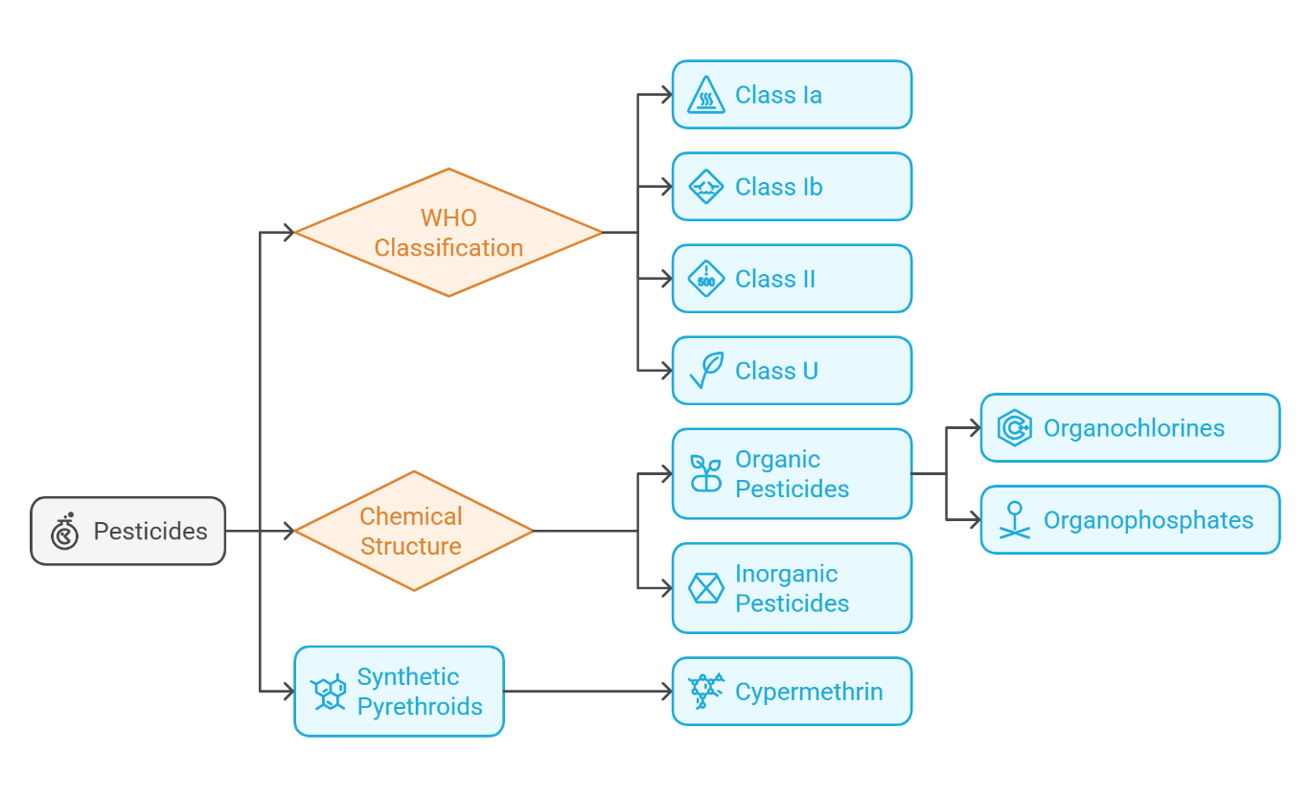
Fig 1: Classification of pesticides
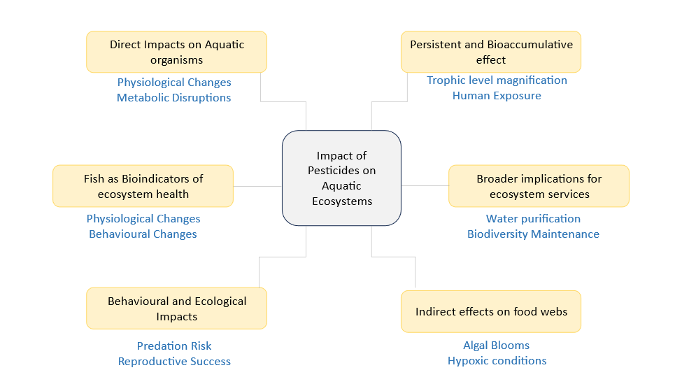
Fig 2: Impact of pesticides on aquatic ecosystems

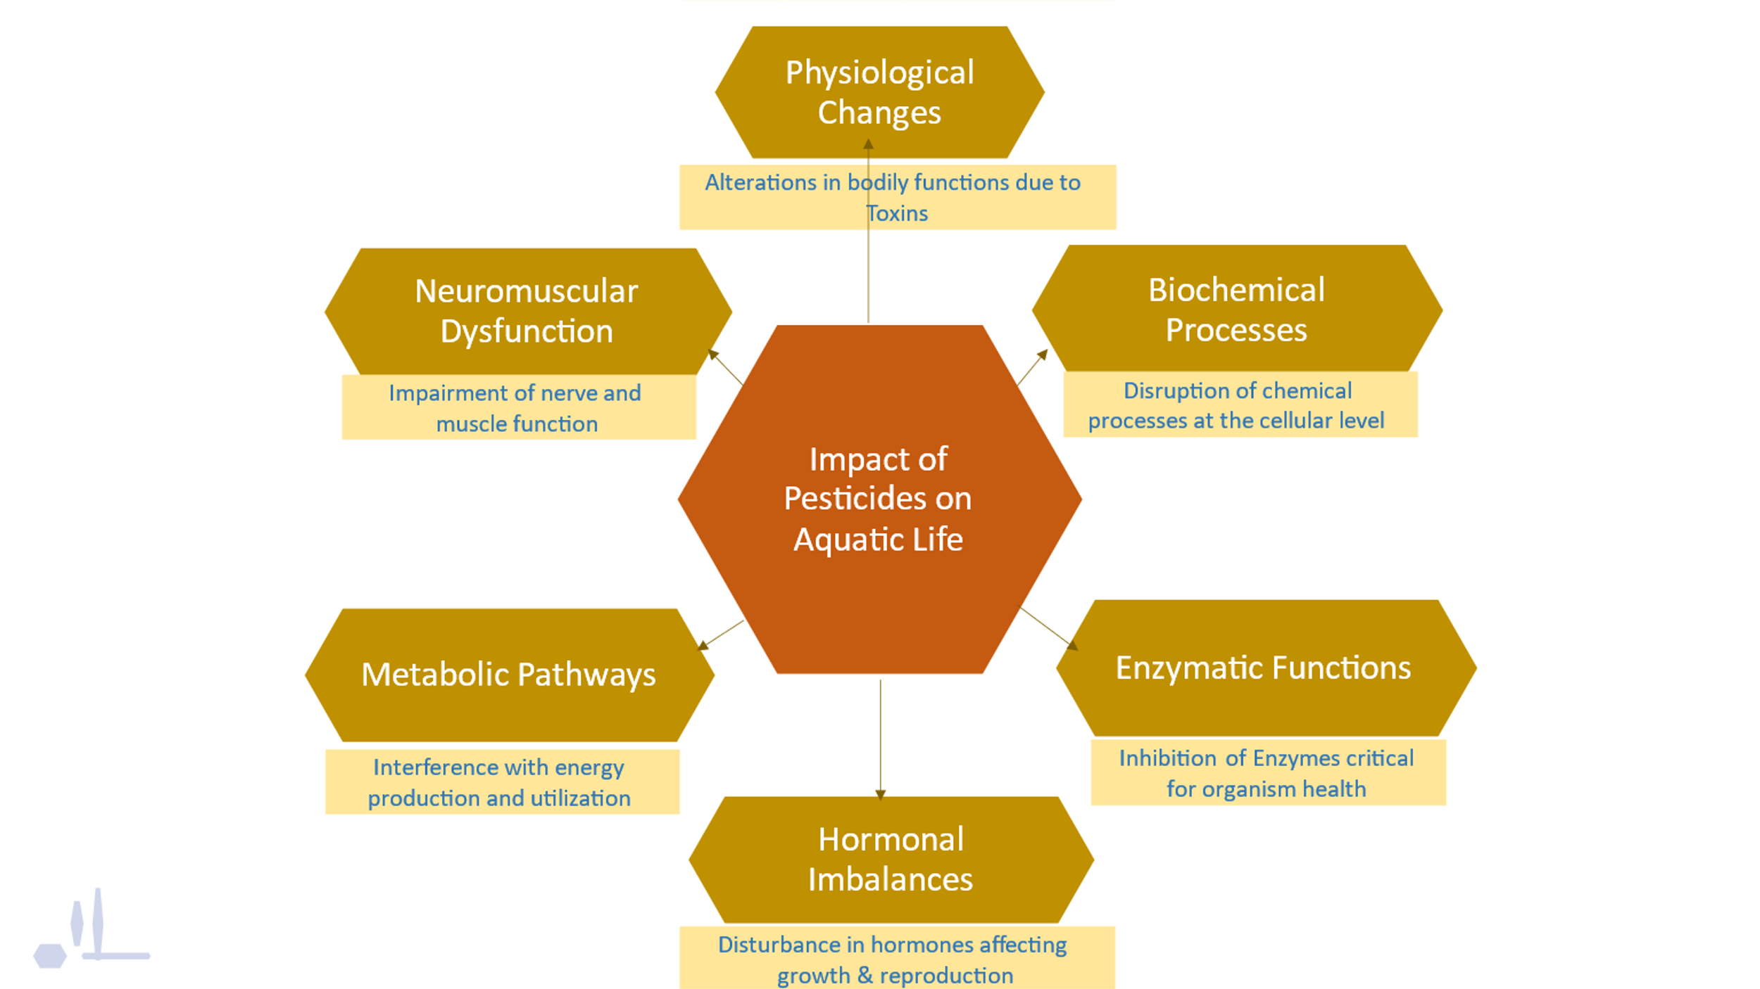
Fig 3: Direct Impact of pesticides on Aquatic Organisms
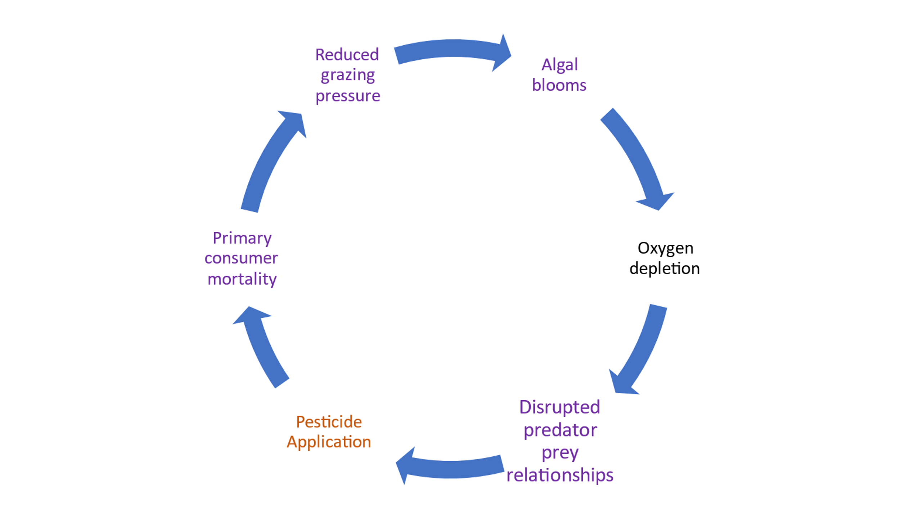
Fig 4: Indirect Effect of pesticides on Food Webs
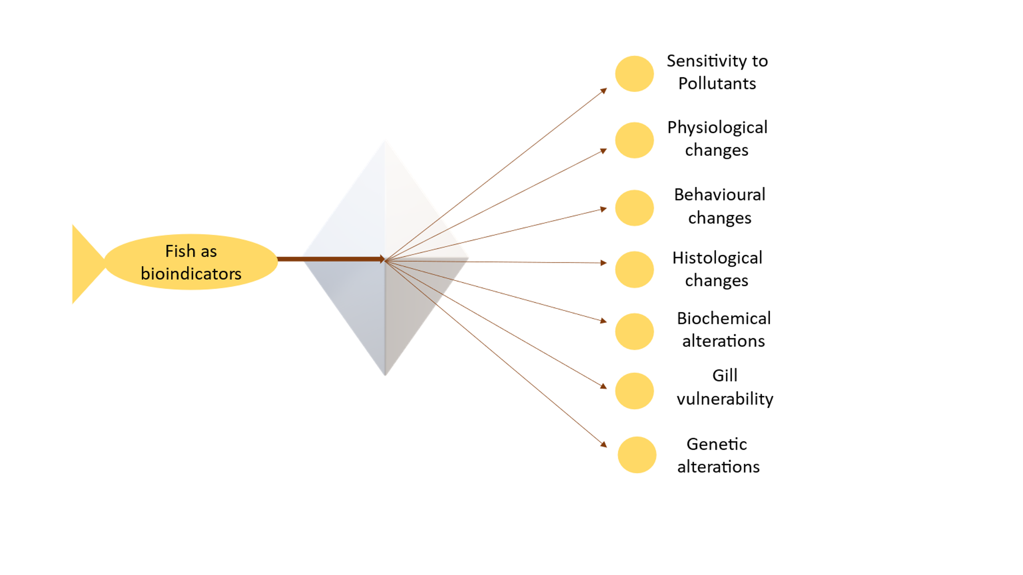
Fig 5: Fish as bioindicator of aquatic pollution

