Original Research Article
Ecological Patterns and Composition of Plant Diversity in Grasslands of Deccan Plateau, India

.
ABSTRACT

Aims: The study investigates plant diversity and ecological patterns in the grasslands of Vikarabad district, Deccan Plateau, India, using quantitative and multivariate methods.
Study Design: A total of 81 quadrats (1 m × 1 m) were laid across the study area. Species accumulation and rarefaction curves were generated using R (Vegan package) and PAST software to assess sampling adequacy. QGIS 3.14 ‘Pi’ version was used to map collection locations.
Place and Duration of Study: The study was conducted in Vikarabad District, Telangana, during the post-monsoon season of 2019. Sampling was carried out across four geographically distinct forest zones: Damagundam, Parigi-Naskal, and Vikarabad Ranges, and Ananthagiri Hills.
Methodology: Diversity was quantified using various metrics. Significance in difference in diversity across ranges was analysed using Dummy variable regression and Kruskal-Wallis test. Pairwise similarity in species composition was assessed using Jaccard Similarity Index. Pearson’s coefficient was computed to examine Pairwise correlations among biotic variables. Site-level groupings were examined with Non-metric Multidimensional Scaling (NMDS). Statistical analyses were conducted using R, Python, and MS Excel.
Results: A total of 125 taxa were documented, with only 12 taxa common across all zones, indicating low similarity in species composition. Heteropogon contortus was the most frequent and abundant species. Based on most diversity measures, Damagundam Range harboured the most diverse grassland community. Regression analysis and the Kruskal-Wallis Test showed statistically significant (P =.000) differences in mean and median diversity across the zones. Significant correlation was observed between biotic variables. NMDS grouped sites into two clusters based on abiotic and biotic variables.
Conclusion: The study highlights the presence of diverse and two ecologically distinct zones in grassland community within Vikarabad district.

Keywords: Deccan Plateau, Grassland diversity, Intermediate Disturbance Hypothesis, Non-metric Multidimensional Scaling (NMDS), Vikarabad district

1. INTRODUCTION

Peninsular India broadly consists of four geographical zones viz., Coastal Areas, Western Ghats, Deccan plateau and Eastern Ghats. The Deccan Plateau was formed as a result of volcanic eruptions at the end of the Cretaceous period about 66 million years ago. It lies to the south of Narmada river between the Western Ghats and Eastern Ghats, and generally sloping eastwards, forms the largest portion of peninsular India. Deccan plateau mostly consists of dry deciduous forests and secondary scrublands (Rawat 1997). Several notable taxonomic works have been done in the peninsular India. In recent years, grass flora of Telangana has been well documented by Nagaraju and Prasanna (2023). Kunhikannan and Rama Rao (2013) studied graminaceous flora of Tadoba National Park, lying in Deccan Plateau in Chandrapur, Maharashtra, and reported 103 species of grasses, having Eragrostis as the dominant genus, with grass dominated areas forming savannah type of vegetation having characters like low species richness of woody elements and high species richness of herbaceous elements with higher percentage of grasses, also showing that protection from grazing and fire led to the formation of climax community. Datar (2016) studied phytodiversity and effect of anthropogenic pressure on grasslands of Deccan plateau of Maharashtra. Various aspects of floristic diversity of Andhra Pradesh and Telangana have been studied by various workers. The state floras of Telangana state have been published by Pullaiah (2015) and Reddy & Reddy (2016). Rao (1999) studied ecology of Anantapur district. Sivaraj et al (2007) conducted an ecological study of the weed flora of the groundnut field in the Medak district. Mishra et al. (2008) provided ecological notes on the orchid flora of Andhra Pradesh. Rao et al. (2012) carried out biomass and carbon stock estimation of trees outside the forests in Kadapa district. Raju et al. (2014) investigated the phytospectrum of a southern tropical deciduous forest in the Godavari Valley, employing remotely-sensed integrated data to delineate three distinct forest zones and facilitate the comparison of vegetation types within this forest ecosystem. Rao et al. (2015) carried out phytosociological studies on the tree diversity of Khammam district. Murthy (2015) described 177 species of angiosperms in study of composition and community structure of the tropical dry deciduous forests of Kawal Wildlife Sanctuary, based on the data from randomly laid 81 sample plots covering the entire sanctuary area. Srinu and Reddy (2022) studied changes in land cover and land use pattern of Vikarabad district and observed most significant changes in built-up areas, forests, water bodies, agricultural land and wastelands. Suthari and Raju (2018) studied tree species composition and forest stratification along the gradients in the dry deciduous forests of Godavari Valley, and reported 110 taxa of flowering plants, with top 10 dominant taxa sharing nearly 41% of the total density of the forest cover having Tectona grandis (teak) as the dominant species forming pure stands in Adilabad, gradually replaced by Terminalia alata further down to the Warangal district. Gopalkrishna et al (2018) studied regeneration, recruitment and succession of tree species in three vegetation zones of Godavari valley in Warangal region by observing regeneration ability of the individual forest species by examining proportion of mature individuals to its saplings and seedlings to predict the future vegetation of a tropical deciduous forest ecosystem. They predicted that unless protected, Tectona grandis, Madhuca and Haldinia will be replaced by those of Cleistanthus and Terminalia species along the environmental gradient of Godavari river valley in Telangana. Pullaiah & Mohammed (2000) documented flora of Rangareddy District, in which they reported 698 wild and naturalized species of plants belonging to 414 genera and 110 families, including 70 species of Poaceae. Sureshbabu & Ramakrishna (2015) and Ramakrishna et al. (2017) documented the traditional knowledge of medicinal plants of of Vikarabad and Rangareddy districts. However, the phytosociological studies on herbs of grasslands of the Deccan Plateau have received scant attention. Therefore, the present study was undertaken to study the patterns of herbaceous diversity of the Deccan Plateau of Vikarabad district.

2. material and methods

Study Area
Vikarabad is one of the westernmost districts of Telangana, sharing a border with the state of Karnataka. It covers an area of 3,386 sq km. The district lies within Deccan plateau, which is broadly the area lying between Western Ghats and Eastern Ghats. Vikarabad district lies between 77° 21’ E to 78° 04’ E and 16° 54’ N to 17° 38' N.

Field Collection
The study was carried out in the post-monsoon season of 2019. Plants were identified with the help of floristic works detailed earlier as well as consulting the herbarium of Botanical Survey of India, Deccan Regional Centre, Hyderabad. In order to study the biodiversity of the study area, a total 81 quadrats of 1 m × 1 m were laid in four range forests viz., Damagundam Range (24: Q54-Q77), Parigi-Naskal Range (21: Q27-Q47), Vikarabad Range (10: Q48-Q53, Q78-Q81) and Ananthgiri Hills (26: Q1-Q26). Fig. 1 shows a map of the study area showing locations of quadrats associated with different forest ranges of Vikarabad district, made with QGIS 3.14 ‘Pi’ version. While Ananthgiri Hills lies within the Vikarabad Range, it has been considered as a separate unit due to its distinct geography in being densely forested, while the rest of the sites within the Vikarabad Range are relatively sparsely forested (as evident from Fig.1).
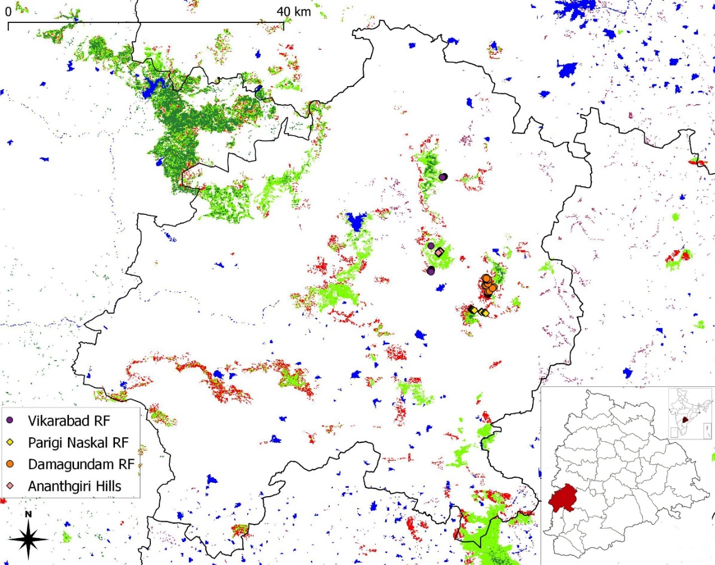
Fig. 1. Study area plotted with QGIS 3.14 ‘Pi’ version showing the location of quadrats in different range forest (RF) areas of Vikarabad district with the location of the district within Telangana state of India shown in inset (On vegetation map, Red = scrub, light green = moderately dense forest, dark green = very dense forest, blue = water bodies, white = others).

Data analysis
We analyzed data on species richness (number of observed species), abundance, and influence of geographical factors using a range of diversity metrics and multivariate algorithms. To evaluate sampling adequacy, species accumulation and rarefaction curves were drawn using the Vegan package in R and PAST, respectively. Diversity was quantified using Simpson’s Index, Gini-Simpson’s Index, Shannon’s Index, Pielou’s Evenness Index. The functional forms of key metrics (Gotelli & Ellison, 2004) are:
Frequency (F_{i}) = q_{i}/Q
Simpson’s Index = D = $\sum_{i=1}^{S}{{{ p}_{i}}^{2}} ={\sum_{i=1}^{S}{{ (n}_{i}}/N)}^{2}$
Gini-Simpson’s Index = $1-D$
Shannon’s index ($H)= \sum_{i=1}^{S}{p_{i}ln\left(1∕p_{i}\right)}$
Pielou’s evenness index (𝐽) = 𝐻/ln(S)
Here, q_{i} is the number of quadrats in which species ‘i’ occurs; Q is the total number of quadrats; p_{i} (= n_{i}/N) is a proportional abundance of i^{th} species; n_{i} is the number of individuals of i^{th} species; N is the total number of individuals; S is the number of distinct species; and ln is the natural logarithm.
As a measure of "true diversity", we used Shannon’s effective number of species (N1 or First Order Hill Number), which is derived from Shannon’s Index (H) as follows (Gotelli & Ellison, 2004):
N1 = e^{H}
N1 adjusts species richness (the Zeroth Order Hill Number, N0​) by incorporating abundance, equally weighting both common and rare species, providing a more realistic diversity estimate (explained in greater detail in Appendix), unlike N0 and N2 (second order Hill Number) which overweigh rare and common species, respectively (Gotelli & Ellison, 2004; Dubey & Pandey, 2022). Lower values of 1−D, H and N1​ indicate lower diversity and vice-versa, while higher values of Pielou’s Index (J) represent greater equitability. Pairwise correlations among variables were computed using Pearson’s coefficient of correlation along with their statistical significance (Spiegel et al., 2012) to identify and mitigate multicollinearity in multivariate analyses.
We analyse significance in difference in true diversity across ranges, we used dummy variable regression and the non-parametric Kruskal-Wallis Test. Dummy variable regression was modeled as:
$\hat{N1}$ = β₀ + β₁DP + β₂DD + β₃DV
Here, DO, DD, and DV represent range dummies for Parigi-Naskal, Damagundam, and Vikarabad, respectively, with β0 as the mean N1​ for Vikarabad (benchmark category). Regression diagnostics about residual normality and heteroskedasticity were carried out to ensure compliance with OLS assumptions. Kruskal-Wallis was used to test for differences in medians without distributional assumptions of underlying variable.
Pairwise similarity in species composition between ranges was assessed using the Jaccard Similarity Index (JSI):
$$JSI= \frac{n(X∩Y)}{n(X∪Y)}= \frac{n(X∩Y)}{n(X) + n(Y) - n(X∩Y)}$$
Where (X∩Y) is number of species common to both locations X and Y; n(X∪Y) is total number of species, and n(X) and n(Y) are number of species in locations X and Y respectively. A lower value implies lower similarity.
Site-level groupings were investigated using Non-metric Multidimensional Scaling (NMDS), using Euclidean distance, incorporating biotic features (e.g., diversity indices) and abiotic factors (e.g., latitude, longitude, altitude). Prior to NMDS, numerical variables were standardized to zero mean and unit variance, and multicollinearity checks were conducted to drop highly correlated variables. Stress values in NMDS configurations quantified the discrepancy between observed dissimilarities and the NMDS solution, with lower values indicating a better fit.
All statistical analyses and visualizations were carried out using R, Python, and MS Excel, leveraging packages such as Vegan, SciPy, Statsmodels, and Scikit-learn.

3. results and discussion

Results
Species accumulation curve drawn in Fig. 2 show that the study area was adequately sampled. Fig. 3 shows adequate sampling for all 81 quadrats shown on map (Fig. 1) – Parigi Range-Naskal RF (21), Damagundam RF (24), Vikarabad Range (10), Ananthgiri Hills (26).
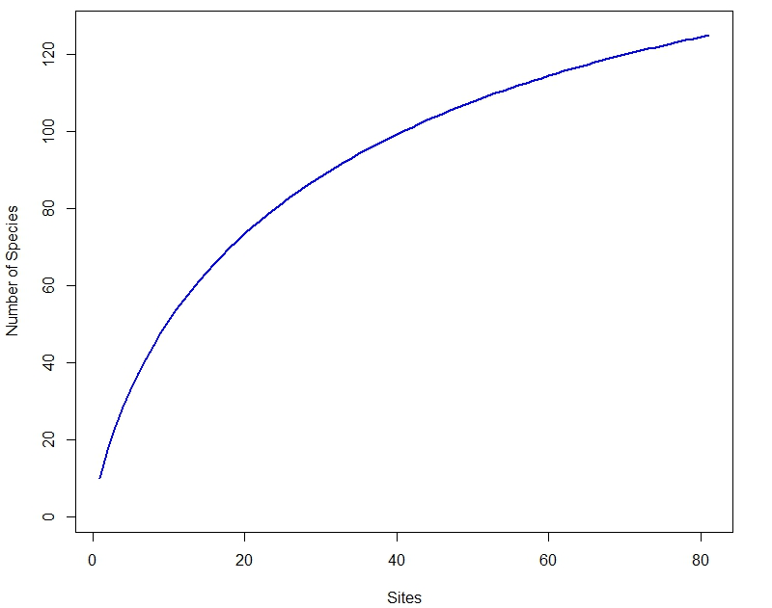
Fig. 2. Species Accumulation Curve for Study Area
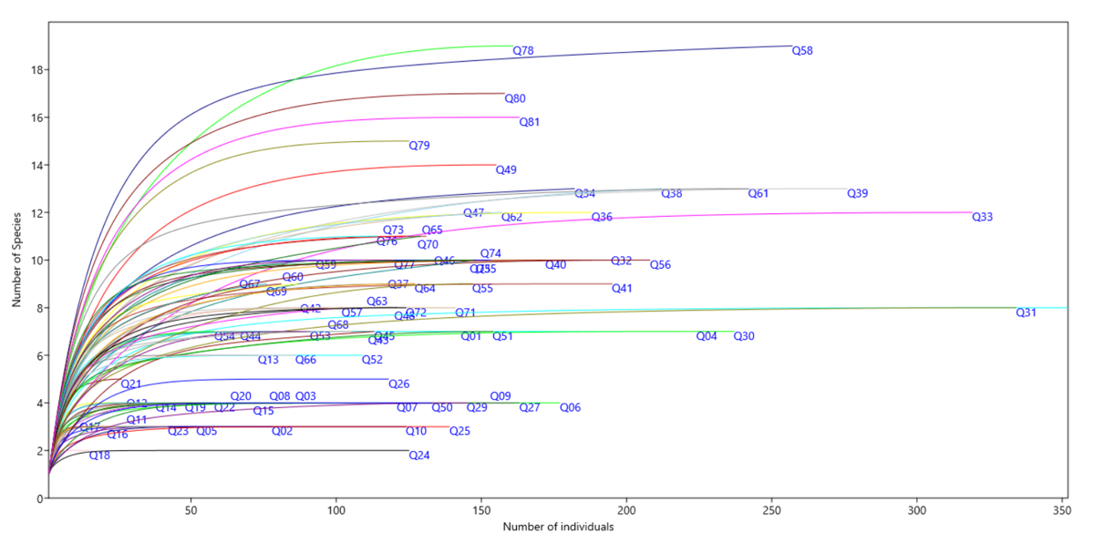
Fig. 3. Rarefaction curves of quadrats

The study area revealed presence of a total of 125 taxa. All 125 taxa with their currently accepted names, presence-absence in 4 sub-regions defined above, and respective Proportional Abundance (p_{i}) and Frequency (F_{i}) are given in the Table 1. The lowest (=26) number of taxa are reported for Ananthgiri Hills, and highest (=81) for Damagundam Range Forest (Table 2). Heteropogon contortus (L.) P.Beauv. ex Roem. & Schult. was the most frequent (found in 59 out of 81 plots, Frequency =72.84%) as well as most abundant (2417 of a total 12761 individuals, Proportional Abundance =18.94%) species. It was closely followed by Chrysopogon fulvus (Spreng.) Chiov. (Frequency = 70.37%, Proportional Abundance =10.04%). Table 2 is derived by pooling up data for each range as well as the study area as a whole. Damagundam RF was most diverse in terms of maximum Species richness (=81), Shannon’s (=3.4337) and Gini-Simpson’s Index (0.9494), and True Diversity (=30) and minimum for Simpson’s Index (=0.0506), while opposite was true for Ananthgiri Hills. Vikarabad Range showed the highest equitability with maximum value (=0.8295) for Pielou’s Index, whereas Parigi Range- Naskal RF was least equitable (J = 0.7625). Maximum number of plants (=4438) were observed in Parigi Range- Naskal RF, while the minimum (=1699) in Vikarabad Range. In Tables 2 and 3, the highest values are in bold, while lowest values are underlined (excluding whole study area).
The highest similarity in species composition (Jaccard Similarity Index, JSI = 0.4074; Table 3) was observed between Damagundam RF and Parigi-Naskal RF, while the lowest similarity (JSI = 0.1786) occurred between Ananthagiri Hills and Parigi-Naskal RF. Twelve taxa were common across all ranges, representing 9.60% of the total species. These shared taxa include Apluda mutica L., Aristida adscensionis L., Aristida hystrix L.f., Chrysopogon fulvus (Spreng.) Chiov., Eragrostis nutans Nees ex Steud., Eragrostis viscosa (Retz.) Trin., Heteropogon contortus (L.) P.Beauv. ex Roem. & Schult., Indigofera cordifolia B.Heyne ex Roth, Lepidagathis cristata Willd., Lophopogon tridentatus (Roxb.) Hack., Senna tora (L.) Roxb. And Themeda helferi Hack.
Regression analysis of true diversity (Table 4) revealed statistically significant differences in mean true diversity across ranges (P =.000), with all dummy variables being highly significant (P <.01). However, the Ordinary Least Squares (OLS) model was marred by violations of its assumptions: residuals were non-normal (Jarque-Bera Test, P <.05) and heteroskedastic (Breusch-Pagan Test, P =.000). The non-parametric Kruskal-Wallis Test (Table 4) confirmed significant differences in median true diversity among ranges (P =.000). Box-whisker plots of various diversity measures (Fig. 4) illustrate their dispersion.
Correlation analysis (Table 5) showed that true diversity was highly correlated with most diversity measures, except for moderate to weak correlation with Pielou’s equitability (r = 0.4641) and the number of individuals (r = 0.3723). All correlations were statistically significant (P<.01). Since true diversity integrates species richness and abundance, while Pielou’s index captures equitability, these two variables were retained as biotic features for Non-Metric Multidimensional Scaling (NMDS) and clustering, with other highly correlated biotic variables excluded to avoid multicollinearity in subsequent multivariate analysis (NMDS).
NMDS plot (Fig. 5) provides an overall clear picture of how different sites group together, with a stress value of 0.136 indicating a good fit, characterized as “usable” by Clarke (1993). The plot revealed two distinct, unequal clusters: a smaller cluster comprising four sites and a larger cluster containing the majority of sites. The smaller cluster included 3 northernmost sites (Q78-Q80, Near Phulamaddi village) of Vikarabad Range (Fig. 1) and 1 site (Q77, near Onduru Thanda village) of Damagundam Range. Thus, site clusters did not consistently align with forest ranges.

Table 1. Enumeration of Species
Sr. No. | Species | Parigi Range- Naskal RF | Damagundam RF | Vikarabad Range | Ananthgiri Hills | Frequency | Proportional Abundance
1 | Alternanthera ficoidea (L.) P.Beauv. | 0 | 1 | 1 | 0 | 4.94% | 0.20%
2 | Acalypha indica L. | 0 | 1 | 0 | 0 | 1.23% | 0.01%
3 | Acanthaceae | 0 | 0 | 0 | 1 | 1.23% | 0.24%
4 | Acanthospermum hispidum DC. | 0 | 0 | 1 | 0 | 3.70% | 0.08%
5 | Achyranthes sp. | 1 | 0 | 0 | 0 | 1.23% | 0.01%
6 | Ageratum conyzoides L. | 1 | 1 | 1 | 0 | 8.64% | 0.38%
7 | Alysicarpus longifolius (Rottler ex Spreng.) Wight & Arn. | 1 | 1 | 0 | 0 | 4.94% | 0.08%
8 | Alysicarpus monilifer (L.) DC. | 1 | 0 | 1 | 0 | 3.70% | 0.08%
9 | Alysicarpus scariosus (Spreng.) Thwaites | 0 | 1 | 0 | 0 | 4.94% | 0.23%
10 | Alysicarpus tetragonolobus Edgew. | 1 | 1 | 0 | 0 | 11.11% | 0.28%
11 | Ammannia baccifera L. | 0 | 0 | 0 | 0 | 2.47% | 0.16%
12 | Ammannia multiflora Roxb. | 0 | 0 | 0 | 0 | 2.47% | 0.04%
13 | Andropogon pumilus Roxb. | 0 | 1 | 1 | 1 | 20.99% | 3.17%
14 | Apluda mutica L. | 1 | 1 | 1 | 1 | 14.81% | 1.28%
15 | Aristida adscensionis L. | 1 | 1 | 1 | 1 | 11.11% | 1.31%
16 | Aristida hystrix L.f. | 1 | 1 | 1 | 1 | 17.28% | 2.48%
17 | Aristida redacta Stapf | 0 | 0 | 1 | 0 | 3.70% | 0.55%
18 | Asystasia gangetica (L.) T.Anderson | 0 | 1 | 0 | 0 | 1.23% | 0.02%
19 | Biophytum sensitivum (L.) DC. | 1 | 1 | 0 | 0 | 3.70% | 0.20%
20 | Blainvillea acmella (L.) Philipson | 0 | 0 | 1 | 0 | 2.47% | 0.05%
21 | Brachiaria sp. | 1 | 0 | 0 | 0 | 1.23% | 0.06%
22 | Caesulia axillaris Roxb. | 0 | 1 | 0 | 1 | 4.94% | 0.32%
23 | Cajanus scarabaeoides (L.) Thouars | 1 | 1 | 1 | 0 | 17.28% | 0.40%
24 | Canscora alata (Roth) Wall. | 1 | 0 | 0 | 0 | 2.47% | 0.20%
25 | Canscora stricta Sedgw. | 1 | 1 | 0 | 0 | 4.94% | 0.18%
26 | Carex sp. | 0 | 1 | 0 | 0 | 3.70% | 0.40%
27 | Celosia argentea L. | 0 | 1 | 1 | 1 | 4.94% | 0.25%
28 | Celosia sp. | 0 | 0 | 0 | 1 | 4.94% | 0.24%
29 | Cenchrus pedicellatus (Trin.) Morrone | 0 | 0 | 1 | 0 | 2.47% | 0.24%
30 | Chamaecrista absus (L.) H.S.Irwin & Barneby | 0 | 0 | 0 | 1 | 1.23% | 0.02%
31 | Chrysopogon fulvus (Spreng.) Chiov. | 1 | 1 | 1 | 1 | 70.37% | 10.04%
32 | Chrysopogon polyphyllus (Hack. ex Hook.f.) Blatt. & McCann | 0 | 1 | 0 | 0 | 1.23% | 0.12%
33 | Chrysopogon sp. | 1 | 0 | 0 | 0 | 2.47% | 0.63%
34 | Cleome simplicifolia (Cambess.) Hook.f. & Thomson | 0 | 1 | 1 | 0 | 3.70% | 0.04%
35 | Cocculus hirsutus (L.) W.Theob. | 1 | 0 | 1 | 0 | 3.70% | 0.05%
36 | Coleus strobilifer (Roxb.) A.J.Paton | 1 | 0 | 0 | 0 | 1.23% | 0.02%
37 | Crotalaria calycina Schrank | 0 | 1 | 0 | 0 | 1.23% | 0.01%
38 | Crotalaria prostrata Rottler | 0 | 0 | 1 | 0 | 1.23% | 0.03%
39 | Cyanotis axillaris (L.) D.Don ex Sweet | 0 | 1 | 0 | 0 | 1.23% | 0.20%
40 | Cyanotis fasciculata (B.Heyne ex Roth) Schult. & Schult.f. | 0 | 1 | 1 | 0 | 2.47% | 0.63%
41 | Cymbopogon sp. | 0 | 1 | 1 | 1 | 7.41% | 0.32%
42 | Cyperus sp. | 0 | 1 | 1 | 1 | 6.17% | 0.57%
43 | Dactyloctenium aristatum Link | 0 | 1 | 0 | 0 | 2.47% | 0.10%
44 | Dichanthium annulatum Stapf | 1 | 0 | 1 | 0 | 2.47% | 0.25%
45 | Dichanthium caricosum (L.) A.Camus | 0 | 0 | 1 | 0 | 1.23% | 0.12%
46 | Dichanthium foveolatum (Delile) Roberty | 1 | 1 | 1 | 0 | 16.05% | 2.05%
47 | Digitaria longiflora (Retz.) Pers. | 0 | 1 | 0 | 0 | 2.47% | 0.35%
48 | Dimeria connivens Hack. | 1 | 0 | 0 | 0 | 1.23% | 0.43%
49 | Dimeria orissae Bor | 1 | 0 | 0 | 0 | 1.23% | 0.24%
50 | Emilia sonchifolia (L.) DC. | 1 | 1 | 0 | 0 | 4.94% | 0.20%
51 | Eragrostiella bifaria (Vahl) Bor | 0 | 0 | 0 | 1 | 6.17% | 0.33%
52 | Eragrostiella brachyphylla (Stapf) Bor | 0 | 1 | 0 | 0 | 1.23% | 0.16%
53 | Eragrostis bifaria (Vahl) Bor | 0 | 1 | 0 | 1 | 2.47% | 0.20%
54 | Eragrostis nutans Nees ex Steud. | 1 | 1 | 1 | 1 | 8.64% | 1.00%
55 | Eragrostis tenella (L.) P.Beauv. ex Roem. & Schult. | 1 | 0 | 0 | 0 | 1.23% | 0.12%
56 | Eragrostis unioloides (Retz.) Nees ex Steud. | 1 | 0 | 0 | 0 | 1.23% | 0.08%
57 | Eragrostis viscosa (Retz.) Trin. | 1 | 1 | 1 | 1 | 13.58% | 1.63%
58 | Eriocaulon sp. | 1 | 1 | 0 | 0 | 2.47% | 0.47%
59 | Euphorbia hirta L. | 1 | 1 | 1 | 0 | 7.41% | 0.26%
60 | Euphorbia hypericifolia L. | 0 | 1 | 1 | 0 | 2.47% | 0.06%
61 | Euphorbia indica Lam. | 0 | 1 | 1 | 0 | 6.17% | 0.08%
62 | Euphorbia prostrata Aiton | 1 | 0 | 0 | 0 | 1.23% | 0.02%
63 | Euphorbia rosea Retz. | 1 | 1 | 1 | 0 | 11.11% | 0.43%
64 | Evolvulus alsinoides (L.) L. | 1 | 0 | 1 | 0 | 6.17% | 0.14%
65 | Exacum pedunculatum L. | 0 | 1 | 1 | 0 | 2.47% | 0.16%
66 | Fimbristylis kingii Gamble ex Boeckeler | 1 | 0 | 0 | 0 | 1.23% | 0.39%
67 | Grona triflora (L.) H.Ohashi & K.Ohashi | 1 | 1 | 1 | 0 | 7.41% | 0.45%
68 | Hackelochloa granularis (L.) Kuntze | 1 | 1 | 1 | 0 | 6.17% | 0.71%
69 | Hackelochloa granularis (L.) Kuntze | 0 | 0 | 1 | 0 | 3.70% | 0.17%
70 | Hemidesmus indicus (L.) R.Br. | 1 | 0 | 0 | 0 | 2.47% | 0.02%
71 | Heteropogon contortus (L.) P.Beauv. ex Roem. & Schult. | 1 | 1 | 1 | 1 | 72.84% | 18.94%
72 | Hoppea dichotoma Willd. | 0 | 1 | 0 | 0 | 3.70% | 0.96%
73 | Indigofera cordifolia B.Heyne ex Roth | 1 | 1 | 1 | 1 | 45.68% | 2.92%
74 | Indigofera linifolia (L.f.) Retz. | 1 | 1 | 1 | 0 | 25.93% | 1.15%
75 | Indigofera tsiangiana Metcalf | 1 | 1 | 1 | 0 | 12.35% | 0.37%
76 | Ipomoea eriocarpa R.Br. | 0 | 1 | 0 | 0 | 1.23% | 0.02%
77 | Iseilema prostratum (L.) Andersson | 0 | 1 | 0 | 1 | 4.94% | 0.77%
78 | Kyllinga sp. | 0 | 1 | 0 | 0 | 1.23% | 0.05%
79 | Lavandula bipinnata (Roth) Kuntze | 1 | 0 | 0 | 0 | 1.23% | 0.02%
80 | Lepidagathis cristata Willd. | 1 | 1 | 1 | 1 | 58.02% | 2.35%
81 | Leucas biflora (Vahl) Sm. | 1 | 1 | 0 | 0 | 2.47% | 0.04%
82 | Lobelia heyneana Schult. | 1 | 1 | 0 | 0 | 2.47% | 0.09%
83 | Lophopogon tridentatus (Roxb.) Hack. | 1 | 1 | 1 | 1 | 24.69% | 8.10%
84 | Melanocenchris rothiana Nees | 1 | 0 | 1 | 1 | 6.17% | 1.39%
85 | Melanocenchris sp. | 1 | 1 | 0 | 0 | 4.94% | 0.34%
86 | Merremia emarginata (Burm. f.) Hallier f. | 1 | 0 | 0 | 0 | 1.23% | 0.02%
87 | Mesosphaerum suaveolens (L.) Kuntze | 1 | 1 | 1 | 0 | 9.88% | 0.45%
88 | Microchloa indica (L.f.) P.Beauv. | 1 | 0 | 0 | 0 | 2.47% | 0.31%
89 | Oligochaeta divaricata (DC.) K.Koch | 1 | 0 | 1 | 1 | 3.70% | 0.24%
90 | Oropetium roxburghianum (Schult.) S.M.Phillips | 1 | 0 | 0 | 0 | 3.70% | 0.84%
91 | Oropetium thomaeum (L.f.) Trin. | 1 | 0 | 0 | 0 | 3.70% | 0.94%
92 | Panicum sp. | 0 | 0 | 1 | 0 | 2.47% | 0.13%
93 | Parasopubia delphiniifolia (L.) H.-P.Hofm. & Eb.Fisch. | 1 | 1 | 0 | 0 | 6.17% | 0.35%
94 | Parthenium hysterophorus L. | 0 | 0 | 1 | 0 | 4.94% | 0.09%
95 | Phyllanthus virgatus G.Forst. | 1 | 1 | 1 | 0 | 9.88% | 0.48%
96 | Pigea enneasperma (L.) P.I.Forst. | 1 | 0 | 1 | 0 | 2.47% | 0.03%
97 | Polygala sp. | 0 | 1 | 1 | 0 | 2.47% | 0.03%
98 | Pulicaria wightiana (DC.) C.B.Clarke | 1 | 0 | 1 | 1 | 24.69% | 1.09%
99 | Rostellularia quinqueangularis (J.Koenig ex Roxb.) Nees | 1 | 1 | 1 | 0 | 49.38% | 4.84%
100 | Sehima nervosa (Rottler) Stapf | 0 | 1 | 0 | 1 | 14.81% | 1.57%
101 | Selaginella bryopteris (L.) Baker | 0 | 0 | 1 | 0 | 1.23% | 0.39%
102 | Senna tora (L.) Roxb. | 1 | 1 | 1 | 1 | 12.35% | 0.55%
103 | Senna uniflora (Mill.) H.S.Irwin & Barneby | 0 | 1 | 1 | 0 | 11.11% | 0.38%
104 | Setaria pumila (Poir.) Roem. & Schult. | 1 | 1 | 1 | 0 | 8.64% | 1.25%
105 | Setaria viridis (L.) P.Beauv. | 0 | 1 | 1 | 0 | 3.70% | 0.15%
106 | Sida spinosa L. | 0 | 0 | 1 | 0 | 2.47% | 0.04%
107 | Spermacoce articularis L.f. | 1 | 1 | 1 | 0 | 18.52% | 1.61%
108 | Spermacoce ocymoides Burm.f. | 1 | 1 | 1 | 0 | 24.69% | 2.26%
109 | Striga asiatica (L.) Kuntze | 1 | 0 | 0 | 0 | 1.23% | 0.04%
110 | Striga sp. | 0 | 1 | 0 | 0 | 1.23% | 0.02%
111 | Stylosanthes hamata (L.) Taub. | 1 | 0 | 0 | 0 | 1.23% | 0.01%
112 | Tephrosia pumila (Lam.) Pers. | 0 | 0 | 1 | 0 | 2.47% | 0.08%
113 | Tephrosia strigosa (Dalzell) Santapau & Maheshw. | 0 | 1 | 0 | 0 | 1.23% | 0.03%
114 | Thelepogon elegans Roth | 0 | 1 | 1 | 0 | 2.47% | 0.04%
115 | Themeda helferi Hack. | 1 | 1 | 1 | 1 | 20.99% | 3.57%
116 | Trichodesma indicum (L.) Sm. | 0 | 1 | 0 | 0 | 1.23% | 0.02%
117 | Tridax procumbens L. | 0 | 1 | 0 | 0 | 1.23% | 0.02%
118 | Tripogon jacquemontii Stapf | 0 | 0 | 0 | 1 | 4.94% | 0.93%
119 | Tripogon sp. | 1 | 1 | 1 | 0 | 8.64% | 1.42%
120 | Tripogon trifidus Munro ex Stapf | 1 | 0 | 0 | 0 | 1.23% | 0.08%
121 | Triumfetta rhomboidea Jacq. | 0 | 0 | 1 | 0 | 1.23% | 0.09%
122 | Urochloa ramosa (L.) T.Q.Nguyen | 1 | 0 | 0 | 0 | 1.23% | 0.05%
123 | Vicoa indica (L.) DC. | 1 | 1 | 1 | 0 | 22.22% | 0.88%
124 | Waltheria indica L. | 0 | 0 | 1 | 0 | 2.47% | 0.06%
125 | Zornia gibbosa Span. | 1 | 1 | 1 | 0 | 14.81% | 0.68%
Note: 0-Absence, 1-Presence, Frequency = q_{i}/Q, Proportional Abundance = n_{i}/N

Table 2. Diversity Measures for the Study Area
 | Parigi Range- Naskal RF | Damagundam RF | Vikarabad Range | Ananthgiri Hills | Study Area: Vikarabad Dist.
Number of Quadrats | 21 | 24 | 10 | 26 | 81
Number of Individuals | 4438 | 3845 | 1699 | 2779 | 12761
Species Richness (Number of Species) | 70 | 81 | 58 | 28 | 125
Simpson’ Index (D) | 0.0734 | 0.0506 | 0.0622 | 0.1397 | 0.0633
Shannon’s Index | 3.2395 | 3.4337 | 3.3683 | 2.5479 | 3.5776
Pielou's Index | 0.7625 | 0.7814 | 0.8295 | 0.7646 | 0.7402
Gini-Simpson's Index | 0.9266 | 0.9494 | 0.9378 | 0.8603 | 0.9367
True Diversity (Shannon’s Effective Number of Species, eᴴ) | 25 | 30 | 29 | 12 | 35

Table 3. Jaccard Similarity Index
 | Parigi Range- Naskal RF | Damagundam RF | Vikarabad Range | Ananthgiri Hills
Parigi Range- Naskal RF | 1.0000
Damagundam RF | 0.4112 | 1.0000
Vikarabad Range | 0.3617 | 0.4040 | 1.0000
Ananthgiri Hills | 0.1807 | 0.2529 | 0.2113 | 1.0000

Table 4. Results of OLS and Kruskal Wallis Test
OLS | $\hat{H1}$ = 3.7308 + 2.5549DP + 4.3526DD + 6.1692DV  Std. error: 0.575 0.860 0.830 1.091  t-statistic: 6.487 2.970 5.244 5.654  p-value: 0.000*** 0.004*** 0.000*** 0.000***  F-statistic: 14.57; P =.000***  No. of observations: 81; R²: 0.362; Adj. R²: 0.337  Jarque-Bera (JB) Test for residual Normality – statistic: 6.248; P =.044**  Breusch-Pagan test for heteroskedasticity – statistic: 39.3898; P =.000***  Note: *P<0.10, **P<0.05, ***P<0.01
Kruskal-Wallis Test | Statistic: 33.2657; P =.000

Table 5. Correlation Matrix showing Pearson’s Correlation Coefficient between diversity measures
 | Number of Individuals | Species Richness (Number of Species) | Simpson’s Index (D) | Shannon Index (H) | Pielou's Evenness Index (J) | Gini-Simpson’s Index (1-D) | True Diversity (e^{H})
Number of Individuals | 1.0***
Species Richness (Number of Species) | 0.513*** | 1.0***
Simpson’s Index (D) | -0.2115* | -0.682*** | 1.0***
Shannon Index (H) | 0.368*** | 0.896*** | -0.9197*** | 1.0***
Pielou's Evenness Index (J) | -0.2259** | 0.1882* | -0.7621*** | 0.5506*** | 1.0***
Gini-Simpson’s Index (1-D) | 0.2115* | 0.682*** | -1.0*** | 0.9197*** | 0.7621*** | 1.0***
True Diversity (e^{H}) | 0.3723*** | 0.925*** | -0.7821*** | 0.9463*** | 0.4641*** | 0.7821*** | 1.0***
*P<0.10, **P<0.05, ***P<0.01

Table 6. Comparative Analysis of Diversity Data in Deccan Plateau of Telangana
Location | Focus | Species Richness | Shannon’s Index (H) | True Diversity (N1) | Study
Kawal Tiger Reserve, Jannaram Division, Grasslands, Telangana | Herbaceous | 65 | 3.46 | 31 | Kumaraswamy et al. (2023)
Kawal WLS, Dry Deciduous Forest, Telangana | All Plants | 177 | 2.88* | 17 | Murthy (2015)
Adilabad | Tree | 60 | 2.41 | 11 | Suthari & Raju (2018)
Warangal | Tree | 83 | 3.21 | 24 | Suthari & Raju (2018)
Nizamabad | Tree | 41 | 2.73 | 15 | Suthari & Raju (2018)
Karimnagar | Tree | 70 | 3.27 | 26 | Suthari & Raju (2018)
Vikarabad Dist. | Herbaceous | 125 | 3.5776 | 35 | Present Study
Parigi Range- Naskal RF | Herbaceous | 70 | 3.2395 | 25 | Present Study
Damagundam RF | Herbaceous | 81 | 3.4337 | 30 | Present Study
Vikarabad Range | Herbaceous | 58 | 3.3683 | 29 | Present Study
Ananthgiri Hills | Herbaceous | 28 | 2.5479 | 12 | Present Study
*Shannon’s index was calculated with base 2. Hence, multiplied by ln(2) to convert to natural base

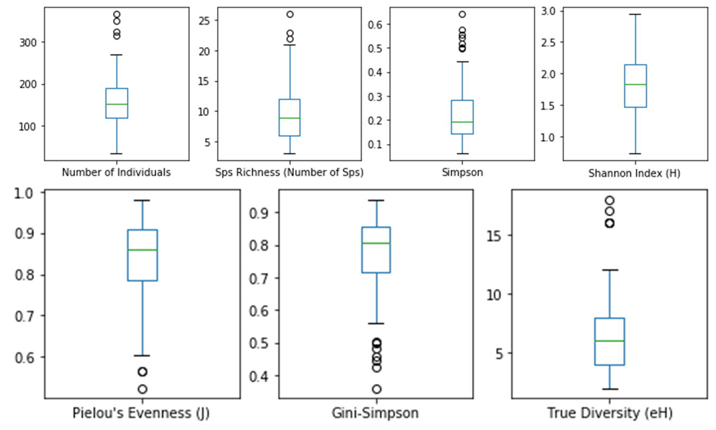
Fig. 4. Box-whisker plots showing various diversity measures for 81 quadrats

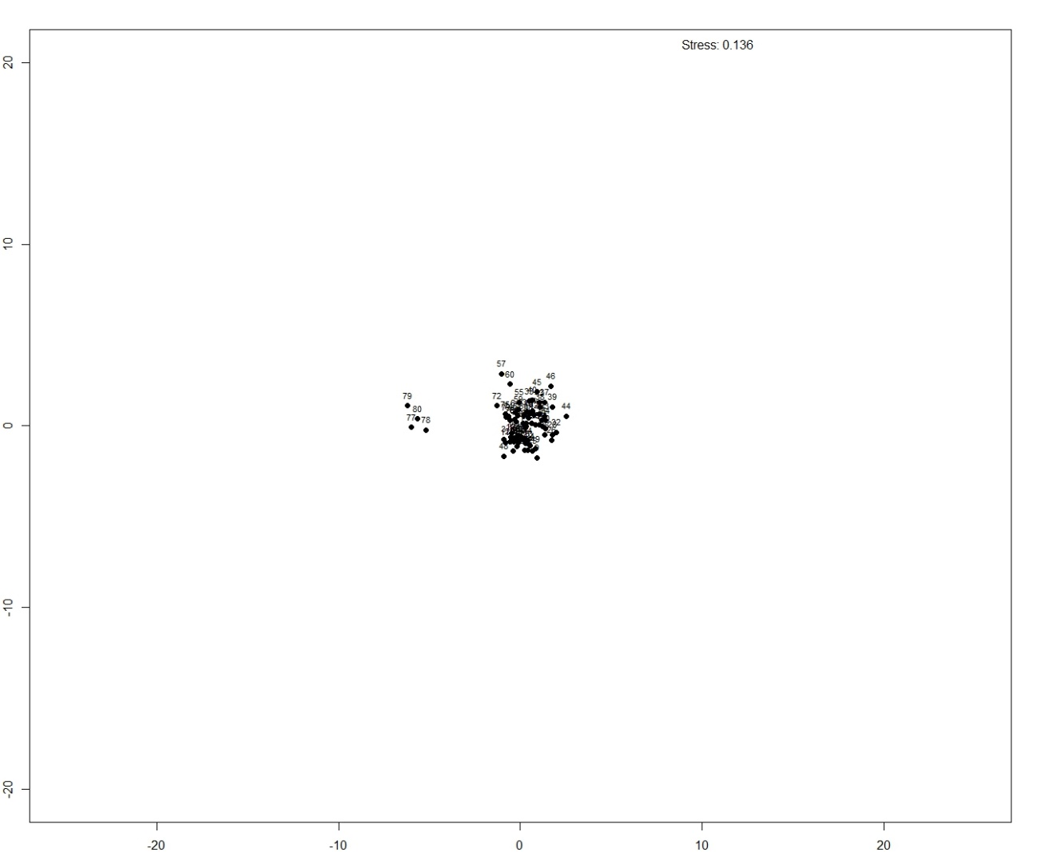
Fig. 5. NMDS plot showing two distinct groupings of locations based on underlying species presence data, abiotic and biotic features.

Discussion
The present study aims to examine the phytodiversity of the Deccan Plateau in Vikarabad district. While the floristics of the region have been relatively well-documented, few studies address the ecological aspects of this region. Thus, the present study fills an important gap. A total of 125 plant taxa were enumerated across 81 quadrats laid in four geographically distinct regions: Parigi Range-Naskal RF (21 quadrats), Damagundam RF (24), Vikarabad Range (10), and Ananthgiri Hills (26). Sampling adequacy was ensured through species accumulation and rarefaction curves.
Diversity measures indicate that Damagundam RF was the most diverse, while Ananthgiri Hills was the least diverse region. Pairwise similarity in species composition was low across regions, with the maximum Jaccard Similarity Index (JSI) being 41.12%, and only 12 species (9.6% of the total) common to all four regions. As seen in Table 2, a consistent pattern emerges where species richness exceeds true diversity. For example, Ananthgiri Hills showed a species richness of 28, but its effective number of species (true diversity) was only 12 after accounting for species abundance. Similarly, while Damagundam RF had a 35% higher Shannon’s Index than Ananthgiri Hills, the difference in true diversity was approximately 150%, illustrating the non-linear nature of diversity indices and their tendency to blur differences in diversity magnitude.
A notable finding is that the densely forested Ananthgiri Hills (with 26 quadrats) had fewer species (28) than the relatively sparsely forested Vikarabad Range (58 species from 10 quadrats). This supports the Intermediate Disturbance Hypothesis (IDH), which posits a bell-shaped relationship between disturbance levels and species richness. According to IDH, moderate levels of disturbance maximize species richness, while excessive disturbance reduces it. The relatively sparse forest cover in the Vikarabad Range may represent moderate ecological disturbance, allowing greater sunlight penetration to the forest floor, thereby promoting herbaceous plant growth. This observation justifies treating Ananthgiri Hills as a separate analytical unit due to its unique ecological characteristics.
Statistical analysis also revealed significant differences in true diversity across the four regions (P = .000), as shown by dummy variable regression and the Kruskal-Wallis Test. Although the OLS model exhibited non-normal and heteroskedastic residuals, these violations were not strong enough to invalidate results, as similar findings were obtained using the Kruskal-Wallis Test. True diversity, measured as Shannon’s effective number of species (First Order Hill Number), was chosen as the dependent variable because it integrates species richness and abundance, giving equal weight to common and rare species. True diversity showed a strong correlation with species richness and most other diversity metrics, with the exception of Pielou's equitability and the total number of individuals.
Non-metric multidimensional scaling (NMDS) yielded a low stress value, indicating a usable fit (Clarke, 1993). The NMDS plot showed close clustering of similar locations, highlighting their ecological similarities. Inclusion of categorical variables of soil (soil types) and geography (ranges) by means of soil and range dummies led to negligible improvement in the performance of NMDS. Therefore, these variables were dropped. However, this does not mean that categorical variables of soil and geography have no influence. The influence of soil variable is already captured in species presence-absence matrix, whereas role of geography is most prominently captured in regression analysis, Kruskal-Wallis Test and Jaccard Similarity matrix.
Finally, the present study provides a valuable basis for comparing herbaceous plant diversity in Vikarabad district with other regions of Telangana (Table 6). Among the studies listed, the most comparable in focus and vegetation type (herbaceous flora) is that of Kumaraswamy et al. (2023), though it is restricted to the Jannaram Division of Kawal Tiger Reserve—a protected area, unlike the broader district-level scope of the present study. This distinction highlights the uniqueness of the current work as the only study focused on the herbaceous flora at a district scale in the region. Diversity metrics reveal that Vikarabad district exhibits higher Shannon’s Index (H = 3.5776) and true diversity (N1 = 35) than the herbaceous grasslands of Jannaram Division in Kawal Tiger Reserve (H = 3.46; N1 = 31), as reported by Kumaraswamy et al. (2023). Notably, even sub-regions within Vikarabad—such as Damagundam Range Forest (H = 3.4337; N1 = 30)—compare favorably. This supports the view that the herbaceous flora of Vikarabad is both species-rich and compositionally diverse. While other studies listed focus on tree diversity and therefore are not directly comparable in terms of life form or methodology, the present study stands out in its exclusive and detailed assessment of herbaceous communities at the district scale. This makes Vikarabad one of the better-explored districts for herbaceous diversity within the Deccan Plateau.

4. Conclusion

The present study documented 125 plant taxa from Vikarabad District, Telangana, lying on Deccan plateau. Species accumulation and rarefaction curves showed adequacy of sampling. Various indices of diversity, equitability and pairwise similarity were calculated, many of which showed high and significant pairwise correlation. Multivariate dimensionality reduction algorithm (NMDS) revealed two distinct groups of sites, based on biotic and abiotic variables. The present study provides valuable contribution in understanding phytodiversity and ecological patterns of a geographically dominant, yet relatively overlooked part of India. Thus, based on documented phytodiversity and quantitative analysis of ecological aspects, an important part of Deccan Plateau has been comprehensively studied.

References

Catford, J. A., Daehler, C. C., Murphy, H. T., Sheppard, A. W., Hardesty, B. D., Westcott, D. A., Rejmánek, M., Bellingham, P. J., Pergl, J., Horvitz, C. C., & Hulme, P. E. (2012). The intermediate disturbance hypothesis and plant invasions: Implications for species richness and management. Perspectives in Plant Ecology, Evolution and Systematics, 14(3), 231–241.
Clarke, K. R. (1993). Non-parametric multivariate analyses of changes in community structure. Australian Journal of Ecology, 18, 117–143.
Datar, M. N. (2016). Floristic diversity and effect of anthropogenic activities on human-dominated grasslands in subtropical regions of peninsular India. Tropical Grasslands-Forrajes Tropicales, 4(1), 8–18.
Dubey, R., & Pandey, A. D. (2019). Statistical analysis of foliicolous fungal biodiversity of Konkan region, Maharashtra, India: A novel approach. Plant Pathology & Quarantine, 9(1), 77–115.
Dubey, R., & Pandey, A. D. (2022a). Documentation & statistical analysis of diversity of microfungi of Sanjay Gandhi National Park, Maharashtra, India. Asian Journal of Mycology, 5(1), 130–196.
Dubey, R., & Pandey, A. D. (2022b). Documentation and statistical approach towards foliar fungi found in Western Ghats (Desh region of Maharashtra), India. Plant Pathology & Quarantine, 12(1), 77–104.
Dubey, R., & Pandey, A. D. (2023). Microfungi of Sanjay Gandhi National Park, Mumbai (Maharashtra). Kolkata: Botanical Survey of India.
Gotelli, N. J., & Ellison, A. M. (2004). Primer of ecological statistics (2nd ed.). Sinauer Associates Publishers.
Gujarati, D. N. (2012). Econometrics by example. McGraw Hill.
Jost, L. (2006). Entropy and diversity. Oikos, 113(2), 363–375.
Legendre, P., & Legendre, L. (2012). Numerical ecology. Elsevier.
Mishra, S., Panda, S. P., & Sahoo, D. (2008). Orchid flora of Andhra Pradesh, India. Bulletin of Botanical Survey of India, 50, 129–146.
Pielou, E. C. (1995). Biodiversity versus old-style diversity. Measuring and monitoring biodiversity in tropical and temperate forests. In T. J. B. Boyle & B. Boontawee (Eds.), Proceedings of an IUFRO Symposium held at Chiang Mai, Thailand, August 27 - September 2, 1994 (pp. 5–17). Center for International Forestry Research (CIFOR).
Pullaiah, T. (2015). Flora of Telangana – the 29th state of India (Vols. 1–3). Regency Publications.
Raju, V. S., Krishna, P. G., & Suthari, S. (2014). Environmental assessment of climate of a habitat through floristic life-form spectra: A case study of Warangal North Forest Division, Telangana, India. Journal of Natural Sciences, 2(1), 77–93.
Rao, D. S., Murthy, P. P., & Kumar, O. A. (2015). Plant biodiversity and phytosociological studies on tree species diversity of Khammam District, Telangana State, India. Journal of Pharmaceutical Sciences and Research, 7(8), 518–522.
Rao, N. R. (1999). Ecology and environment of Anantapur district in Andhra Pradesh. Indian Forester, 125, 1089–1094.
Rao, V. S., Veeranjaneyulu, D., Priyadarsini, P., Swetha, B., Manjula, M., & Rao, B. R. P. (2012). Standing biomass and carbon stocks of trees outside forests in Kadapa district of Andhra Pradesh, India. Journal of Economic and Taxonomic Botany, 36, 736–743.
Reddy, K. N., & Reddy, C. S. (2016). Flora of Telangana State, India. Dehra Dun: Bishen Singh Mahendra Pal Singh.
Siddabathula, N., & Prasanna, P. V. (2023). Grasses of Telangana. Botanical Survey of India, Ministry of Environment, Forest & Climate Change.
Sivaraj, N., Sunil, N., Kamala, V., & Pandravada, S. R. (2007). Weed flora in the ground field – An ecological study. Journal of Economic and Taxonomic Botany, 31, 901–906.
Spiegel, M. R., Schiller, J. J., & Srinivasan, R. A. (2012). Schaum's Outlines Probability and Statistics. McGraw Hill.

APPENDIX
Supplementary Information
Comparing NMDS with Other Multivariate Algorithms
Methods
Apart from NMDS, we explored two other clustering algorithms, assessed their quality and compared their performance.
In NMDS, stress value quantifies the discrepancy between the observed dissimilarities and the distances in the NMDS configuration. Lower stress values indicate a better fit, meaning that the configuration better represents the original dissimilarities. In NMDS plot, the closer the points are to each other, the more similar the locations they represent based on underlying features, and vice-versa.
In Hierarchical Clustering, Cophenetic correlation coefficient (CCC) is a measure of how well the dendrogram preserves the pairwise distances between data points. It quantifies the correlation between the original dissimilarity matrix (distance matrix) and the matrix derived from the dendrogram. The Cophenetic correlation coefficient ranges from 0 to 1, where a value closer to 1 indicates a better fit or better preservation of distances in the dendrogram. A Cophenetic correlation curve as a function of various linkage methods (viz., Single, Average, Complete and Ward) was plotted to select the best linkage method which maximised the value of the coefficient of Cophenetic correlation. Additionally, another machine learning algorithm viz., K-Means clustering was used.
The Silhouette method has been employed in both hierarchical and K-means clustering to obtain optimum number of clusters as well as assess quality of clustering. In Silhouette method, the optimum number of clusters is the one which maximizes Silhouette score, while the quality of clustering depends upon the value of the Silhouette score – the value of +1 indicates best clustering, 0 indicates that some data lying on the borderline of two clusters may be misclassified, a value close to -1 indicates poor clustering with a lot of misassignments.
Results & Discussion
NMDS plot (Fig. 5) showed two well-separated, unequal clusters, providing an overall clear picture of how different sites group together. The stress value of 0.136 being less than 0.2 provides a good fit, characterized as “usable” (being < 0.20) by Clarke (1993). As the NMDS plot shows, sites often do not separate well in keeping with the forest ranges they belong to. The dendrogram (Supplementary Fig. 1), constructed using Average linkage in hierarchical clustering achieved the highest CCC of 0.8999, indicating a good fit. Visual inspection of the dendrogram and the Silhouette score of 0.37 identified two major clusters. Two clusters are shown by broken lines on dendrogram. K-means clustering performed relatively poorly, with Silhouette score was 0.2050 and corresponding 3-4 optimum number of clusters (same score for k=3 and k=4, Supplementary Fig. 2). Therefore, of the two clustering algorithms, hierarchical clustering was chosen over K-means clustering, as the former showed better separation of clusters with a higher Silhouette score. Addition of soil and range dummy variables led to higher stress value (=0.138) in NMDS; little improvement in the Silhouette score (=0.2250) in K-means clustering, but deterioration of the same (=0.36) in hierarchical clustering with slightly higher cophenetic correlation (=0.9077).
Though, both NMDS and hierarchical clustering show two well separated unequal clusters with 4 sites forming smaller and rest of the sites forming larger cluster, they differ in minor details regarding composition of smaller cluster: while Quadrat no. 81 is in dendrogram, but not on NMDS plot; while Quadrat no. 77 is in NMDS, but not on dendrogram. Also, all members of smaller cluster on dendrogram are from northernmost part of Vikarabad Range, the same on NMDS plot consists of 3 sites of northern Vikarabad and 1 site of Damagundam RF.
The difference in NMDS with respect to composition of smaller cluster can be attributed to the difference in algorithms. First, while NMDS is a dimensionality reduction technique which is meant to project distance between two points (sites) in multi-dimensional space onto two-dimensional plot as accurately as possible, hierarchical clustering also aims to additionally reflect the hierarchy on dendrogram. Second, while NMDS deals with ranking of distances, hierarchical clustering deals with absolute distances. Both provide complimentary insights: While NMDS most clearly shows separation among two groups, with a larger cluster appearing as a homogenous mass, a point corroborated by short merge distance at many places in dendrogram suggesting poor separation of sub-clusters; Dendrogram, on the other hand, better shows differences among sites within the larger cluster.
Thus, NMDS and hierarchical clustering, both provide essentially same insight viz., two well separated unequal clusters with 4 sites forming smaller and rest of the sites forming larger cluster. However, this separation was more effectively visualized on the NMDS plot, making NMDS the preferred choice for analysis and interpretation.
One common thread passing through all these algorithms was that inclusion of categorical variables of soil (soil types) and geography (ranges) by means of soil and range dummies led to negligible improvement in their performance (Supplementary Table 1). Therefore, these variables were dropped. However, this does not mean that categorical variables of soil and geography have no influence. The influence of soil variable is already captured in species presence-absence matrix, whereas role of geography is most prominently captured in regression analysis, Kruskal-Wallis Test and Jaccard Similarity matrix.
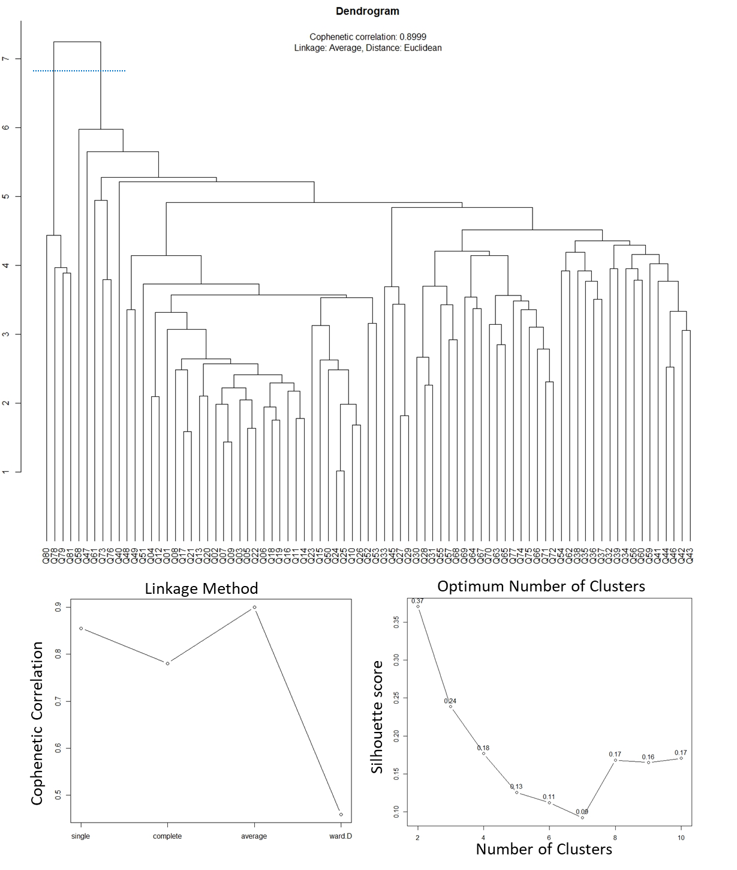
Supplementary Fig. 1. Dendrogram obtained from Hierarchical Clustering showing interrelationships among locations based on underlying species presence data, abiotic and biotic features; also showing plots of Cophenetic correlation maximizing Linkage method and Silhouette Score maximizing optimum number of clusters (No Dummy Variables).

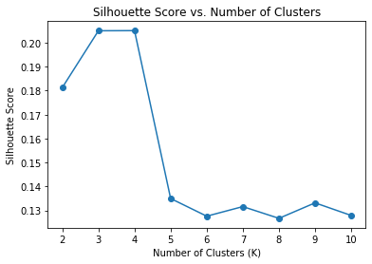
Supplementary Fig. 2. Plot of Silhouette Score maximizing optimum number of clusters (No Dummy Variables) for K-means clustering.
Supplementary Table 1. Performance of Dimensionality Reduction and Clustering Algorithms
 | Presence Absence Data with Features | Stress Value | Cophenetic Correlation | Optimum number of clusters maximising Silhouette score | Cophenetic Correlation maximising linkage method | Silhouette score
NMDS | Numerical Features | 0.136 | NA | NA | NA | NA
 | With additional soil and range dummies | 0.138 | NA | NA | NA | NA
Hierarchical Clustering | Numerical Features | NA | 0.8999 | 2 | Average | 0.37
 | With additional soil and range dummies | NA | 0.9077 | 2 | Average | 0.36
K-Means Clustering | Numerical Features | NA | NA | 3-4* | NA | 0.205
 | With additional soil and range dummies | NA | NA | 4 | NA | 0.225
* Silhouette score for 3 clusters = Silhouette score for 4 clusters; NA: Not Applicable

