Modelling human impact on Land Use and Land Cover in the Téné Protected Forest, Center-West Ivory Coast: Past Trends (1986 - 2017)
and Future Prediction (2029)

.
ABSTRACT
Similar to other Ivorian protected forests, the Téné Protected Forest (TPF), located in the Centre-West of Côte d’Ivoire, is experiencing unprecedented anthropogenic pressure, leading to the degradation of its forest cover and changes in land use. This study aims to analyse and predict the spatio-temporal dynamics of land use within the TPF. Land use analysis was conducted using the ENVI 5.1 software over the period 1986–2017, employing Landsat satellite imagery (TM 1986, ETM+ 2000, and OLI 2017). These data were combined with field observations to classify land use in 1986, 2000, and 2017. The classified images were exported to QGIS 2.18, where the MOLUSCE plugin was used to generate a transition matrix. This matrix facilitated modelling via a first-order Markov chain to predict the progression of anthropogenic impacts up to 2029. The results reveal a drastic decline in dense forests, dropping from 20.30% in 1986 to 0% in 2017, replaced by perennial crops, fallow lands, and bare soils. Land use classes exhibited high instability, with an overall stability index below 0.50, indicative of intense anthropogenic pressure. Modelling forecasts a continued decline in the TPF’s forest cover by 2029, with complete disappearance of dense forests and an increase in fallow and bare soils. These findings underscore the urgent need to implement new forest management policies adopted by the country in this forest, to preserve remaining ecosystems and restore degraded areas.

Keywords: anthropisation, LULC, dynamics, remote sensing, protected forest, Ivory Coast

1. INTRODUCTION
Forest ecosystems provide indispensable ecological services that underpin human well-being and survival (Nasi et al., 2011). However, these ecosystems face intensifying pressures from rapid population growth and climate change. Land use and land cover (LULC) changes both drivers and consequences of global environmental shifts (Lambin et al., 2003) profoundly alter the Earth’s surface (Rindfuss et al., 2004; Ouedraogo et al., 2010). In tropical regions, a critical outcome of these transformations is biodiversity loss (Balmford & Bond, 2005), despite these areas harbouring the planet’s highest species richness (Puig, 2001; Gillet et al., 2016). Anthropogenic activities driving this devastating biodiversity decline include unsustainable agricultural practices, overgrazing, vegetation fires, and unregulated exploitation of woody and non-timber forest products (N’Guessan et al., 2022). In Côte d’Ivoire, forest ecosystems, particularly protected forests, endure significant anthropogenic pressures, resulting in marked forest cover reduction. For instance, the country’s forested area declined by 4.25 million hectares between 1986 and 2015 (SEP-REDD+ & FAO, 2017). In the Central-West region, protected forests exist in name only, as nearly all face persistent human encroachment (Traoré, 2018). To counter these threats, the Ivorian government, via the Forest Development Society (SODEFOR), has initiated multiple management projects for protected forests. However, these efforts are undermined by continual agricultural encroachment into protected zones (N’Guessan et al., 2019). Addressing current and future environmental challenges necessitates transforming agricultural policies and practices. This sector must enhance productivity while safeguarding forest ecosystem functionality and biodiversity conservation a transition reliant on robust scientific data and precise understanding of historical and contemporary forest conditions. The Téné Protected Forest (TPF) exemplifies a site where scientific data on land cover dynamics remain scarce. This study, aimed at addressing this gap, seeks to analyse and predict the spatio-temporal dynamics of land use in the Téné Protected Forest (TPF), which is subject to anthropogenic activities. It will provide essential data to inform decisions on sustainable management and conservation of this forest.
2. METHODOLOGY
2.1 Study Area and Data Selection
The Téné Protected Forest (TPF) is located in the Gôh region, specifically in the Oumé department, in the Center-West of Côte d’Ivoire, on the eastern edge of forested zones transitioning to the central savannahs. Geographically, it lies between longitudes 5°20' and 5°38' West and latitudes 6°27' and 6°37' North (Figure 1). Established by ministerial decree on June 30, 1973, it covers an area of 29,812.77 hectares. The Oumé department is bordered to the east by the Bandama River, whose main tributary is the Téné River. This river, which gives the TPF its name, is the most significant watercourse within the forest and forms part of its southern boundary. The department experiences a tropical subequatorial climate with four seasons and high climatic variability (Kassin et al., 2008). Annual rainfall ranges between 1,200 and 2,000 mm, and the average annual temperature varies from 26 to 28°C. The terrain of Oumé is characterized by low-elevation domes, plains, and predominantly plateaus, with average altitudes ranging between 160 m and 400 m. The soils are weakly desaturated ferrallitic types, overlying granite bedrock. These soils are clayey and deep in low-lying areas. The TPF belongs to the mesophilic sector of the Guinean domain, where vegetation is characterized by semi-deciduous forests dominated by Celtis spp. and Triplochiton scleroxylon K. Schum. (Guillaumet & Adjanohoun, 1971). However, the current vegetation in Oumé is heavily anthropized, consisting of fragmented, degraded forest patches, extensive fallows dominated by Chromolaena odorata (L.) R.M.King & H.Rob. (Asteraceae), coffee and cocoa plantations, and artificial forest plantations established by SODEFOR (OIBT, 2004). The population comprises indigenous groups (Gagou or Gban), Ivorian migrants (Baoulé, Malinké, Senufo, etc.), and non-Ivorians (Burkinabè and Malians). Key economic activities include agriculture (employing over 80% of the population), logging (highly developed), fishing, livestock rearing, and seasonal grazing by transhumant herds from northern regions.
Within the framework of this study, three satellite images were used: Landsat TM (16 January 1986), Landsat ETM+ (31 January 2000), and Landsat OLI (23 December 2017). These images, each with a resolution of 30 metres, were downloaded from the Earth Explorer platform (https://earthexplorer.usgs.gov) using the study area’s coordinates (Path 197 and Row 055). All images were acquired during the dry season, a period when biases caused by atmospheric factors are minimal (Oszwald et al., 2010). During fieldwork, a GPS device was employed to identify land use and land cover classes. The study also utilised several software tools, including ENVI 5.1 (Environment for Visualizing Images) for digital processing of satellite imagery; QGIS (Quantum Geographical Information Systems) and IDRISI Selva for Geographical Information Systems (GIS) applications and cartographic outputs.
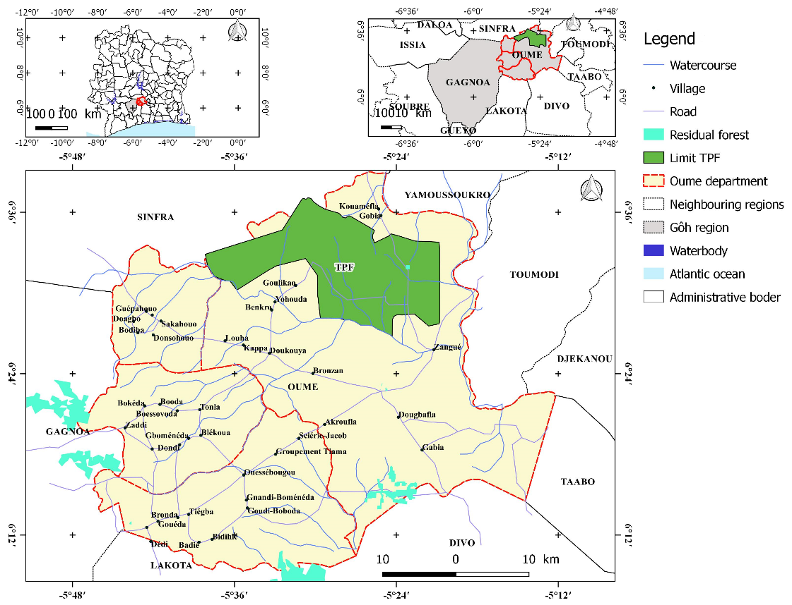
Fig. 1: Map of the study Area
2.2 Pre-processing of Landsat Images
The pre-processing primarily involved radiometric correction of the images (Girard & Girard, 1989; Song et al., 2001) and extraction of the study area window centred on the Téné Protected Forest. The FLAASH (Fast Line-of-sight Atmospheric Analysis of Spectral Hypercubes) model, based on converting calibrated digital numbers for each pixel into radiance and reflectance, was employed to perform the radiometric correction (Guo & Zeng, 2012; N’Guessan, 2021). These operations, which aim to produce standardised reflectance images, are intended to correct errors caused by atmospheric effects (Oszwald, 2005). The extraction of the study area from the full scene was carried out using the boundary of the Téné Protected Forest with the "Resize Data" tool (spatial/spectral) in the ENVI 5.1 software.
2.3 Classification of Landsat Imagery
A series of processing steps aimed at enhancing visual quality was applied to each corrected image. This primarily involved generating a false colour composite by assigning the mid infrared, near infrared, and blue bands to red, green, and blue channels, respectively, as well as deriving new channels from Normalised Difference Vegetation Index (NDVI) calculations. Contrast enhancement was then performed to improve detectability of changes (Tabopda & Fotsing, 2010). This process redistributes pixel values more uniformly across the image. Combined analysis of multispectral bands, colour composites, and derived indices enabled the identification and mapping of seven land use and land cover (LULC) classes on each composite image using a supervised classification approach. This method involves defining training areas as pixel polygons, which were analysed by a neural network algorithm (N’Guessan et al., 2022). This nonparametric classification algorithm was selected due to its demonstrated superior accuracy and generalisation capabilities (Hosni, 2002). The final LULC classes retained were: dense forests, degraded forests, forest plantations (primarily Tectona grandis), croplands (perennial and subsistence crops), fallow lands (old and recent), lowlands and bare soils (exposed surfaces and rocky outcrops). Tectona grandis plantations, which shed leaves during the dry season, exhibited spectral signatures similar to fallow lands. These were therefore merged into a single "fallow" class. Classification accuracy was assessed using confusion matrices to calculate overall accuracy and the Kappa coefficient (Congalton, 1991). Kappa values below 50%, between 50 to 75%, and above 75% indicate poor, acceptable, and excellent classification, respectively (Bogaert et al., 2014). A minimum of 70 validation points per class were used. A 3x3 pixel filter (Frost Filter in ENVI’s Spatial Analysis Tools) was applied to classified images to eliminate isolated pixels and homogenise thematic outputs. The filtered raster data were then vectorised and exported as shapefiles for compatibility with QGIS 2.12 and IDRISI Selva. Post-processing editing generated final land use/land cover maps for 1986, 2000, and 2017.
2.4 Development of the Transition Matrix
A transition matrix is a square matrix that describes state changes of land cover elements within a given site over a specific period (Schlaepfer, 2002). It is generated by overlaying two land cover maps using the MOLUSCE plugin in QGIS 2.18. This matrix quantifies transitions from a land use/land cover (LULC) type i at time t to type j at time t+1 (Cousins, 2001; Zanini et al., 2006). The transition matrix displays the frequency and magnitude of all changes between LULC types over the study period. Diagonal values represent the proportion of each class that remained unchanged, while off-diagonal values indicate the percentage of areas converted from one class to another relative to the original class area. Row totals reflect the total loss of a class, whereas column totals represent gains in class area (Zanini et al., 2006; Bogaert et al., 2014). In this study, transition matrices were developed to analyse changes in land cover composition between 1986–2000 and 2000–2017. Changes were further assessed using a stability index, calculated as the ratio of the sum of diagonal values to the sum of off-diagonal values in the transition matrix (Bogaert et al., 2014).
2.5 Modelling Land Use/Land Cover Dynamics Using a First-Order Markov Chain
Land use/land cover (LULC) modelling was performed using a first-order Markov chain based on transitions observed between 2000 and 2017 land cover states. This approach employed transition matrices (Bell, 1974) and first-order Markov chain principles (Barima et al., 2010; Toyi et al., 2013). Transition matrices were used to derive annual probability matrices (APM), which quantify the likelihood of a land cover class transitioning to another within a one-year period. The areal proportions of land cover classes at the initial time step were encoded into a vector denoted TS (Transition State). This vector was then multiplied by the annual probability matrix to predict the land use composition at time t+1 (CP t+1) using the first-order Markov model (Rakotondrasoa et al., 2017), as outlined in Equations 1 and 2:
$$APM×TS={CP}_{t+1} (1)$$
$$\left\lfloor \begin{matrix}P_{i}\left(t\right) \\ P_{k}\left(t\right) \\ P_{m}\left(t\right)\end{matrix}\right\rfloor ×\left\lfloor \begin{matrix}P_{i.i} & P_{i.k} & P_{i.m} \\ P_{k.i} & P_{k.k} & P_{k.m} \\ P_{m.i} & P_{m.k} & P_{m.m}\end{matrix}\right\rfloor =\left\lfloor \begin{matrix}P_{i}\left(t+1\right) \\ P_{k}\left(t+1\right) \\ P_{l}\left(t+1\right)\end{matrix}\right\rfloor (2)$$
In these equations, 𝑃_{𝑖} (𝑡) represents the proportion of the area belonging to class i at time t, 𝑃_{𝑖. 𝑖} denotes the probability that a pixel in class i at time t transitions to class j at time t+1 and m is the total number of land cover classes (Barima et al., 2010).
3. results and discussion
3.1 Results
3.1.1 Land Use and Land Cover Status of the Téné Protected Forest
The accuracy assessment of the supervised classifications revealed overall accuracy values of 95.83%, 88.60%, and 86.48%, with Kappa coefficients of 0.95, 0.86, and 0.84 for the years 1986, 2000, and 2017, respectively. These performance metrics indicate excellent classification quality across all three years, validating the reliability of the land cover maps. Visual analysis of the 1986 land cover map highlights an agriculturally dominated landscape. Large swathes of cropland and fallow systems formed a mosaic across the forest periphery. Dense and degraded forests occupied a central rectangular strip within the classified forest, with additional gallery forest fragments along low lying areas. Bare soils were concentrated in the eastern sector, appearing as broad rectangular patches. By 2000, cropland and fallow systems remained the dominant land cover. However, dense forest cover had sharply declined, persisting only in a small central area (approximately 3 km²), now termed the “Experimental Perimeter”. The land cover matrix remained unchanged in 2017, but all land cover classes exhibited notable reductions in area, particularly dense forests, which had completely disappeared. The former Experimental Perimeter transitioned to degraded forest, while bare soils and degraded forests expanded significantly.
3.1.2 Dynamics of Land Use and Land Cover Composition, 1986–2017
The results of land use/land cover (LULC) composition dynamics during the study period (1986 to 2017) are summarised in Table 1. This table details land cover transitions via transition matrices for 1986 to 2000 and 2000 to 2017. Overall, the table reveals low global stability indices (<0.50), reflecting intense land transformation dynamics and limited persistence of initial land cover classes. This underscores significant anthropogenic pressure, marked by deforestation and agricultural expansion. 1986 to 2000 Period, fallow (JA) dominated, covering 38.50% of the total area. It expanded significantly, particularly into perennial crops (12.95%) and dense forests (3.27%). Perennial Crops (CP) occupied 31.83% of the total area, with most conversions to fallow (13.53%).
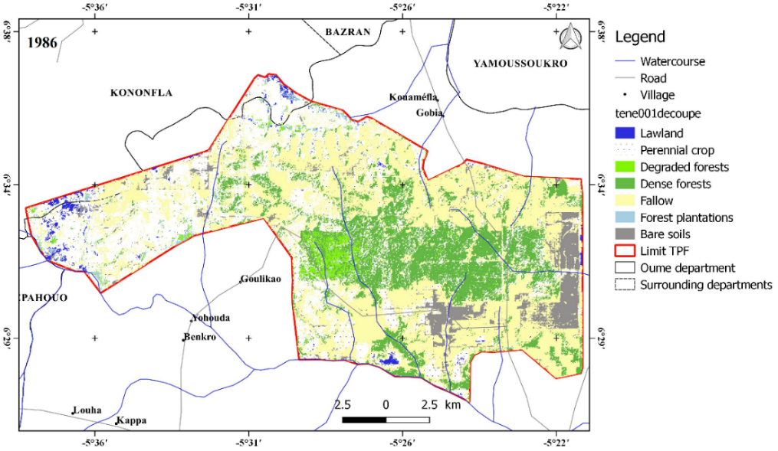
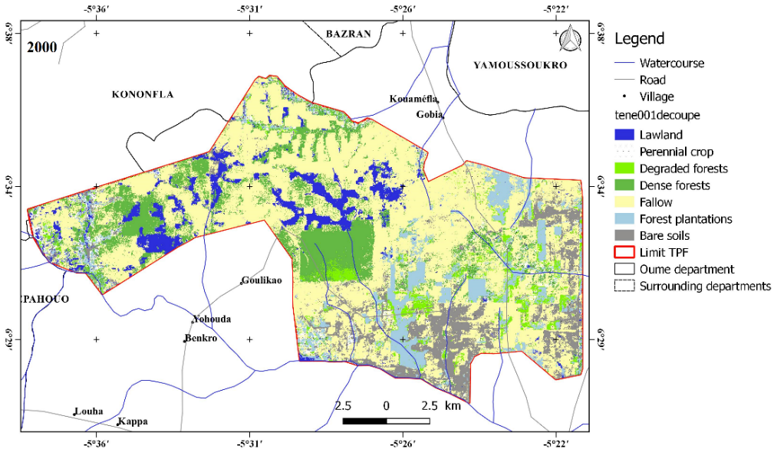
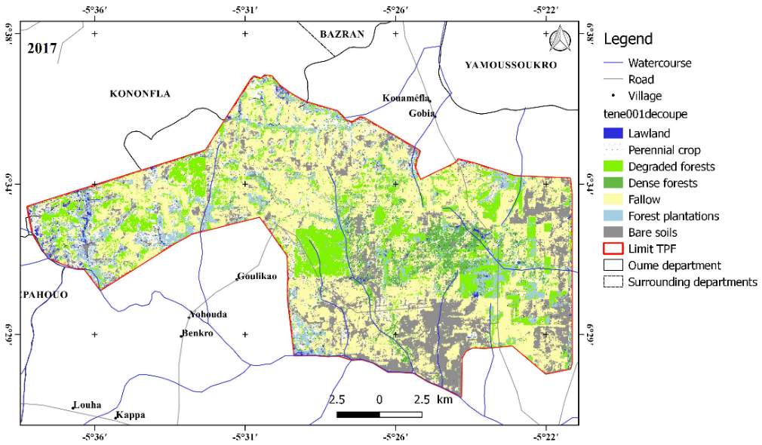

Fig. 2: Land Use and Land Cover of the Téné Protected Forest for the Years 1986, 2000, and 2017
Dense Forests (FD), representing 20.30% of the area, experienced severe degradation, primarily transitioning to fallow (7.13%) and perennial crops (5.29%). 2000 to 2017 Period, the stability index (0.36) indicates ongoing transformations, though some classes (e.g., fallow and perennial crops) began stabilising. Fallow (JA) remained dominant at 39.32% of the total area, showing relative stability compared to the earlier period. Perennial Crops (CP) covered 25.65% of the landscape, confirming their central role. Gains were driven by conversions from fallow (10.73%) and degraded forests (1.39%). Dense Forests (FD) were nearly eradicated as an initial class (0%), reflecting near total conversion to other uses, primarily fallow and perennial crops.
Table 1: Land Use/Land Cover (LULC) Transition Matrix and Stability Indices for the Téné Protected Forest, 1986–2000 and 2000–2017
FD_ Dense Forest, Fd_ Degraded Forest, PF_ Forest Plantation, JA_ Fallow Land, CP_ Cropland, BF_ Lowland et SN_ Bare Soil.
1986 to 2000 Period | FD | Fd | PF | CP | BF | JA | SN | Totals
FD | 2,92 | 0,52 | 2,96 | 5,29 | 1,44 | 7,13 | 0,04 | 20,30
Fd | 1,21 | 0,19 | 0,05 | 0,02 | 0,13 | 0,13 | 0,00 | 1,74
PF | 0,29 | 0,02 | 0,11 | 0,00 | 0,24 | 0,06 | 0,00 | 0,72
CP | 5,97 | 0,51 | 2,18 | 4,53 | 4,95 | 13,53 | 0,17 | 31,83
BF | 0,13 | 0,02 | 0,21 | 0,12 | 0,31 | 0,24 | 0,00 | 1,03
JA | 2,67 | 0,59 | 3,27 | 12,95 | 1,92 | 16,93 | 0,18 | 38,50
SN | 0,11 | 0,10 | 0,17 | 3,95 | 0,21 | 1,30 | 0,06 | 5,89
Totals | 13,30 | 1,94 | 8,94 | 26,86 | 9,19 | 39,32 | 0,45 | 100
Stability Index: 0,27
2000 to 2017 Period | FD | Fd | PF | CP | BF | JA | SN | Totals
FD | 0,00 | 5,08 | 1,14 | 2,35 | 0,05 | 3,96 | 0,71 | 13,30
Fd | 0,00 | 0,67 | 0,12 | 0,38 | 0,00 | 0,61 | 0,14 | 1,94
PF | 0,00 | 2,54 | 1,63 | 2,61 | 0,12 | 1,30 | 0,75 | 8,94
CP | 0,00 | 1,39 | 0,80 | 6,37 | 0,07 | 10,73 | 7,50 | 26,86
BF | 0,00 | 1,08 | 1,80 | 3,56 | 0,24 | 1,50 | 1,00 | 9,19
JA | 0,00 | 4,29 | 2,27 | 10,23 | 0,23 | 17,67 | 4,64 | 39,32
SN | 0,00 | 0,02 | 0,03 | 0,14 | 0,00 | 0,15 | 0,11 | 0,45
Totals | 0,00 | 15,07 | 7,79 | 25,65 | 0,71 | 35,91 | 14,86 | 100
Stability Index : 0.36

Fig. 3: Evolution of Land Use/Land Cover Class Proportions in the Téné Protected Forest from 2017 to 2029, Based on Markov Chain Simulation
3.2 Discussion
3.2.1 Effectiveness of the Adopted Methodology
The assessment of human-driven land use transformation in the Téné Protected Forest required analysis of 30 m resolution Landsat imagery combined with field observations. Supervised classification using a neural network algorithm yielded excellent accuracy (overall accuracy and Kappa coefficient), underscoring the importance of in-depth knowledge of the study area to optimise image processing quality, despite the relatively coarse spatial resolution (Toyi et al., 2013; Mama et al., 2014; N’Guessan et al., 2022). The simulation of land use anthropisation in this study aims to enhance understanding of LULC dynamics rather than precisely predict future trends. Its primary objective is to support policymakers in adopting proactive strategies to anticipate and mitigate accelerated degradation of natural resources. The first-order Markov chain model was selected for its simplicity and flexibility, enabling adaptation to historical land use patterns (Ladet et al., 2005). The model assumes constant transition probabilities (2000–2017), implying no significant shifts in socio-economic or environmental drivers during this period. While effective for temporal projections, the Markov chain lacks spatial explicitness. Integrating spatially explicit models—incorporating socio-environmental variables such as demographics, policy frameworks, and climate change—would refine projections and target interventions more effectively. In-depth socio-economic studies are needed to understand local stakeholders’ motivations and constraints, informing context-specific management strategies. Combining Markov chains with spatially explicit drivers (e.g., distance to roads, population density) could improve predictive accuracy and policy relevance. Despite its limitations, the first-order Markov chain remains a valuable tool for exploratory analysis and scenario illustration. Observed trends provide a robust overview of land cover dynamics, highlighting irreversible forest loss and agricultural encroachment. These findings align with broader regional studies on West African deforestation (Bogaert et al., 2014; Oszwald et al., 2010) and underscore the urgency of conservation interventions.
3.2.2 Anthropogenic Activities and Land Use Dynamics
The analysis of spatial dynamics reveals that deforestation is the dominant process, leading to the near disappearance of dense forest in favour of agricultural systems and fallow lands. The primary drivers of this transformation are vegetation fires and agricultural expansion, particularly perennial crops such as cocoa. Additionally, the uncontrolled exploitation of woody forest resources including firewood, service wood, and non-timber products derived from bark stripping and the gathering of fruits and leaves intensifies pressure on forest ecosystems. This is compounded by intensive grazing by transhumant herds from the north, which contributes to gradual degradation. These factors stem from a mass influx of agricultural migrants from various regions within Côte d'Ivoire and neighbouring countries (Burkina Faso and Mali). The primary motivation for migration to the Téné Protected Forest (TPF) is the depletion of agricultural land in migrants’ regions of origin. Consequently, the demand for land driven by crop cultivation, forestry, grazing, and the production of timber and non-timber forest products by both indigenous and migrant populations (Ivorian and non-Ivorian) has profoundly altered land use patterns in the protected forest. These findings reflect the broader trend of land use dynamics in Côte d'Ivoire, particularly in the Oumé Department, where economic, demographic, cultural, and environmental factors underpin social changes that also impact forest cover (Sagne 2009; N’Guessan et al. 2019, N’Guessan et al 2022). Similar trends have been observed in other African regions (Bogaert et al. 2008; Barima et al. 2009; Brink & Eva 2009; Mama et al. 2014; Abdou et al. 2019).
Over a 31-year period, anthropogenic pressure on TPF’s land use dynamics has resulted in an increase in the stability index and a notable expansion of fallow lands, which dominate in both study periods. This rise in stability may indicate land-use saturation, a consequence of human interventions promoting the establishment of perennial agricultural systems. The predominance of fallow lands suggests unsustainable land management, with insufficient fallow periods to enable effective forest regeneration. This phenomenon could also be linked to forest plantations, primarily of Tectona grandis, whose dry-season leaf drop gives this species a spectral signature similar to fallow land. Simulations of land use changes by 2029, based on trends observed between 2000 and 2017, indicate that dense forests already nearly absent by 2017 will disappear entirely by 2029. This loss is driven by intense anthropogenic pressure, including the expansion of perennial crops (cocoa, coffee) and unsustainable exploitation of forest resources. This aligns with Kouassi et al. (2021), who highlight the large-scale conversion of classified forests into cocoa and rubber plantations. Fallow lands, already dominant, will continue to expand, reflecting inadequate crop rotation for soil regeneration, while bare soils will increase slightly, signalling fertility loss and accelerated erosion. These observations corroborate Tondoh et al. (2015), who found that nearly 40% of Ivorian soils are degraded, particularly in cocoa-producing areas. These trends have major implications for biodiversity and ecosystem services. The loss of dense forests destroys habitats for numerous species, threatening biological diversity. Soil degradation and reduced vegetation cover disrupt hydrological cycles, heightening risks of floods and droughts. Finally, the decline in ecosystem services such as carbon sequestration has local and global repercussions. Historically a carbon sink, Côte d'Ivoire has become a net CO₂ emitter due to deforestation (FAO 2021). Key drivers include the influx of agricultural migrants drawn to fertile lands, exerting growing pressure on forest resources. These migrants, often from Burkina Faso and Mali, practice extensive agriculture that accelerates deforestation and soil degradation. Unsustainable practices, such as monoculture and excessive chemical use, deplete soils, while illegal resource exploitation exacerbates the crisis.
4. Conclusion
This study has highlighted the growing human encroachment and accelerated degradation of the Téné Protected Forest (TPF) between 1986 and 2017 through remote sensing and Geographic Information System (GIS) analysis. The results reveal a profound transformation in land cover, characterised by the near-total disappearance of dense forests and their replacement with perennial crops, fallow lands, and bare soils. This dynamic is primarily driven by vegetation fires, agricultural expansion, unsustainable exploitation of forest resources, and intensive grazing, all exacerbated by the influx of agricultural migrants. Prospective modelling up to 2029 confirms the persistence of these trends, projecting a complete absence of dense forests and a further increase in perennial crops, fallow lands, and bare soils. These projections underscore the urgent need to reverse this trajectory. Our findings emphasise the necessity of sustainable land management, integrating environmentally friendly agricultural practices, restoration of degraded areas, and protection of remaining forest relics to safeguard biodiversity and ecosystem services.

References

Abdou, I. K., Abasse T., Massaoudou, M., Rabiou, H. Soumana, I. and Bogaert, J. (2019). Influence of Anthropogenic Pressures on the Landscape Dynamics of the Dosso Partial Wildlife Reserve (Niger). International Journal of Biological and Chemical Sciences, 13 (2) 1094 – 1108.
Balmford, A. and Bond, W. (2005). Trends in the state of nature and their implications for human well-being. Ecology Letters 8 (11): 1218 – 1234.
Barima, Y.S.S., Egnankou, M.W., N’doumé, C.T.A., Kouamé, F.N. and Bogaert, J. (2010). Modeling forest landscape dynamics in the forest-savanna transition region of eastern Côte d'Ivoire. Remote Sensing, 9, 2, 129-138.
Barima, Y. S. S., Barbier, N., Bamba, I., Traoré, D.J. L. & Bogaert, J. (2009). Landscape dynamics in the Ivorian forest-savanna transition environment. Tropical Woods and Forests 299: 15-25.
Bell, E. J. (1974). Markov analysis of land use change: an application of stochastic processes to remotely sensed data. Socio-Economic Planning Sciences 8: 311-316. Bogaert, J., Bamba, I., Kabulu, J.P., Koffi, K. J., De Cannière, C., Visser, M. and Sibomana, S. (2008). Fragmentation of forest landscapes in central Africa: causes, consequences and management. In: Lafortezza R., Chen J., Sanesi G. & Crow Th.R. (Editors), Patterns and Processes in Forest Landscapes: Multiple Use and Sustainable Management. Springer, Verlag, New York, pp. 67-87.
Bogaert, J., Vranken, I. and Andre, M. (2014). Anthropogenic effects in landscapes: historical context and spatial pattern. In: Biocultural Landscapes Diversity, Functions and Values. Edition Springer Science + Business Media Dordrecht: 89 - 112.
Brink, A. B. & Eva, H. D. (2009). Monitoring 25 years of land cover change dynamics in Africa: a sample based remote sensing approach. Applied Geography, 29, 501-512.
Cohen, W. B., Spies, T. A., & Fiorella, M. (1995). Estimating the age and structure of forests in a multi-ownership landscape of western Oregon, U.S.A. International Journal of Remote Sensing, 16, 721-746.
Congalton, R.G (1991). A review of assessing the accuracy of classification of remotely sensed data, Remote Sensing of Environment, 37 35 – 46.
Cousins, S. A. O. (2001). Analysis of land-cover transitions based on 17th and 18th century cadastral maps and aerial photographs. Landscape Ecology, 16: 41 – 54.
FAO (2021). Global Forest Resources Assessment 2020: Main Report. Rome. https://doi.org/10.4060/ca9825fr.
Gillet, P., Vermeulen, C., Feintrenie, L., Dessard, H., and Garcia, C. (2016). What are the causes of deforestation in the Congo Basin? A literature review and case studies. Biotechnology, Agronomy, Society and Environment 20 (2): 183–194.
Guillaumet, J. L. & Adjanohoun, E. (Eds). (1971). The vegetation of Côte d’Ivoire. In: The natural environment of Côte d’Ivoire. Avenard J-M, Eldin M, Girard G, Sircoulon J, Touchebeuf P, Guillaumet J-L, Adjanohoun E and Perraud, Mémoires ORSTOM, Paris, France 50: 161-263.
Guo, Y. and Zeng, F. (2012). Atmospheric correction comparison of SPOT-5 image based on model FLAASH and model QUAC. International Archives of the Photogrammetry, Remote Sensing and Spatial Information Sciences, Volume XXXIX-B7, XXII ISPRS Congress, 25 August - 01 September 2012, Melbourne, Australia.
Hall, F. G., Botkin, D. B., Strebel, D. E., Woods, K. D., & Goetz, S. J. (1991). Large-scale patterns of forest succession as determined by remote sensing. Ecology, 72, 628-640.
Hosni, G. (2002). Using Neural Networks for Wetland Mapping from a Time Series of RADARSAT 1 Images. Doctoral Thesis: University of Quebec, 230 p.
Kassin, K.E., Doffangui, K., Kouamé, B., Yoro R.G., and Assa, A. (2008). Rainfall Variability and Prospects for Cocoa Replanting in West-Central Côte d’Ivoire. Journal of Applied Biosciences 12: 633–641.
Kouassi, J.-L., Gyau, A., Diby, L., Bene, Y., Kouamé, C. (2021). Assessing Land Use and Land Cover Change and Farmers’ Perceptions of Deforestation and Land Degradation in Southwest Côte d’Ivoire, West Africa. Land 2021, 10, 429. https://doi.org/10.3390/land10040429.
Ladet, S., Deconchat, M., Monteil, C., Lacombe, J.P., Balent, G. (2005). Spatially-based Markov chains as a simulation tool. Géomatique, 4, 159–173.
Lambin, E. F., Geist, H. J., and Lepers, E. (2003). Dynamics of land-use and land-cover change in tropical regions. Annual review of environmental resources 28: 205–241.
Mama, A., Bamba, I., Sinsin, B., Bogaert, J., and De Cannière, C. (2014). Deforestation, savannah transformation, and agricultural development in savannah-forest landscapes in the Sudano-Guinean zone of Benin. Wood and Forests of the Tropics, 322: 65–75.
N’Guessan, Y. J., Kablan, K. R., Ouattara, N. D., Douffi, K. G-C., Gnahoré, É., and Koné, M. (2022). Anthropization and land use dynamics of the Sangoué classified forest in central-western Côte d’Ivoire. Africa Science 21 (6): 80–91.
N’Guessan , Y. J., Koné, M., Douffi, K. G-C. and Gnahoré, E. (2019). Impact of Peasant Intrusions on the Physiognomy and Vegetation Dynamics of the Laouda Classified Forest in Central-West Côte d’Ivoire. European Scientific Journal, 24 (15) 360 – 383.
N’Guessan, Y.J. (2021). Flora, Vegetation Structure and Land Use Dynamics Using Satellite Imagery of the Téné, Sangoué and Laouda Classified Forests in Central-West Côte d’Ivoire. Doctoral Thesis, Nangui Abrogoua University (Abidjan), UFR Sciences de la nature, 182 p.
Nasi, R., Billand, A. and Van Vliet, N. (2011). Managing for Timber and Biodiversity in the Congo Basin. Forest Ecology and Management DOI: 10.1016/j.foreco.2011.04.005.
ITTO (2004). Study of the floristic composition and combustibility of fallow land, wasteland, and savannahs around the classified forests of Téné and Soungourou, 87 p.
Oszwald, J. (2005). Dynamics of agroforestry formations in Côte d'Ivoire (from the 1980s to the 2000s), Monitoring by remote sensing and development of a cartographic approach. Doctoral thesis: University of Science and Technology of Lille, France, 304 p.
Oszwald, J., Lefebvre, A., Sartre, X. A. D., Thalès, M., and Gond, V. (2010). Analysis of the directions of change in vegetation surface conditions to inform the dynamics of the Maçaranduba pioneer frontier (Para, Brazil) between 1997 and 2006. Remote Sensing Review 9 (2): 97–111.
Ouedraogo, I., Tigabu, M., Savadogo, P., Compaore, H., Oden, P. C., and Ouadba, J. M. (2010). Land cover change and its relationship with population dynamics in Burkina Faso, West Africa. Land Degradation & Development, 21: 453–462.
Puig, H. (2001). Species diversity and deforestation: the example of tropical rainforests in Mexico. Tropical Woods and Forests 268 (2): 41–55.
Rakotondrasoa, L. O., Malaisse, F., and Bogaert, J. (2017). Modeling the dynamics of the forest landscape in the Ambatovaky Special Reserve (northeastern Madagascar). Tropicultura 35 (4): 312-324.
Rindfuss, R. R., Stephen, J., Walsh, B. L., Turner, II B. L., Fox, J., and Mishra, V. (2004). Developing a science of land change: Challenges and methodological issues. Proceedings of the National Academy of Sciences 101 (39): 13976-13981.
Sangne, Y. C. (2009). Forest cover dynamics in a protected area subject to anthropogenic pressures: the case of the Téné classified forest in the Oumé department (central-western Côte d'Ivoire). Doctoral thesis: University of Cocody, Abidjan (Côte d'Ivoire), 220 pp.
Schlaepfer, R. (2002). Landscape Dynamics Analysis. Teaching Sheet 4.2, Ecosystem Management Laboratory, École Polytechnique de Lausanne, Switzerland.
SEP-REDD+ and FAO (2017). Baseline Data for REDD+ in Côte d'Ivoire. Mapping Forest Dynamics from 1986 to 2015. Abidjan, Rome.
Tabopda, W. G. & Fotsing, J.-M. (2010). Quantifying Vegetation Cover Change in the Laf-Madjam Forest Reserve in Northern Cameroon Using Satellite Remote Sensing. Drought, 21 (3) 169–178.

