Short communication
Additional site record of an Indian Giant Squirrel (Ratufa indica indica) in northern Sahyadri Western ghats

ABSTRACT
The Indian Giant Squirrel (Ratufa indica), a large arboreal rodent endemic to India’s tropical forests, is experiencing habitat fragmentation and decline due to local hunting. On 5 May 2018, a sighting of R. i. indica was recorded for the first time in Dapoli, Ratnagiri district, Maharashtra—outside its previously known range. The squirrel was observed foraging and nesting in a biodiversity park surrounded by orchards and exotic plantations. Its distinct maroon dorsal coloration and buff tail tip confirmed the subspecies identity. Dapoli, located within the Northern Western Ghats, offers varied vegetation types and may serve as a corridor connecting known populations from regular habitats. Also study accumulates all the news records to present the small-scale movement of species within the Maharashtra state. These records suggest a possible range expansion, potentially driven by habitat adaptability and the availability of food sources in orchards. The finding highlights the need for revisiting subspecies distribution and ensuring the conservation of emerging corridors vital for sustaining viable metapopulations of this iconic species.

Keywords: Ratufa indica indica, wander individuals, new sighting, northern western ghats, Konkan, Dapoli

INTRODUCTION
Indian Giant Squirrel Ratufa indica (Erxleben 1777), is arboreal, diurnal, and herbivorous species endemic to tropical forests of India. Occurring at altitudes from 180 to 2,300 meters above sea level often favouring denser riparian growth (Molur et al. 2005 ; Datta & Goyal 1996). Its habitat encompasses wooded areas in Andhra Pradesh, Chhattisgarh, Goa, Gujarat, Jharkhand, Karnataka, Kerala, Madhya Pradesh, Maharashtra, Orissa, and Tamil Nadu. (Srinivasulu et al. 2004; Molur et al. 2005). The species exhibits fragmented distribution primarily due to sensitivity to habitat degradation (Molur et al. 2016). Ratufa indica (R. i.) is a schedule I protected species by Wildlife protection act, 1973, India. It is classified as "least concern," in IUCN red list but with a declining population trend (Molur 2016). Corbet and Hill (1992), following Moore & Tate (1965), identified four subspecies namely R. i. indica, located in the northern and central Western Ghats, R. i. centralis is found in central-east India, particularly in the Satpura Range and the Eastern Ghats. R. i. maxima is from the southern Western Ghats in Kerala. The subspecies discovered in the far northern Western Ghats of southern Gujrat is R. i. dealbata, is extinct (Molur et al. 2005). It underlines the importance of conservation of this species. Also its distribution is shown all over western ghats in ground reality its vanished from much of northern western ghats, and constricted in small pockets in Maharashtra. every new location is important for tracing movement and habitat preferences.
2. MATERIAL AND METHODS
Dr Balasaheb Sawant Konkan Krishi Vidyapeeth is situated in Dapoli, Ratnagiri, in the northern Northwestern Ghats and in the Konkan Zone of Maharashtra state, India. The College of Forestry biodiversity park is regularly surveyed for mammals and seasonal birds. Present observation is part of the routine survey in the park.
Other secondary data is gathered from various local newspapers and online news channels along with social media sites as www.YouTube.com, Facebook, etc. Interviewing Local rescuers and personal communications to locals and forest staffs was also done. Every location and news is cross-checked, and only confirmed news is accepted in the data. Also, news without actual photographs of animals is withdrawn from the data.
3. RESULT AND DISCUSSION
On 5 may 2018 at morning 10.16 am. Among us Zende J.Y., sighted male of Ratufa indica from the region not reported previously (Molur et al. 2005) also not reported based on Predicted Occupancy (Prachi et al. 2012). Individual was ascending on tree and coming on ground to collect Khaya senegelensis fruits. It was again seen after months, at the Biodiversity Park, College of Forestry constructing nests on tall trees and feeding on Terminalia (Fig. 3). The park is encircled by mango, cashew orchards. Park has extensive areas of exotics like Acacia mangium, A. auriculiformis, Gliricidia sepium and bamboo septum. Terminalia paniculata (Kinjal) , T. arjuna (Arjun) trees, Gmelina arborea plantations is also there. Water availability is less except monsoon channel and excavated pond.
Fur colouration of the individual spotted, perfectly resembles with R. i. indica subspecies. The dorsal surfaces of the coat and the initial portion of the tail display a lush reddish-maroon or brown hue. The far end of the tail appears whitish or buff in colour (Abdulali & Daniel 1952). This specific colour pattern is restricted to the northern Western Ghats of Maharashtra.

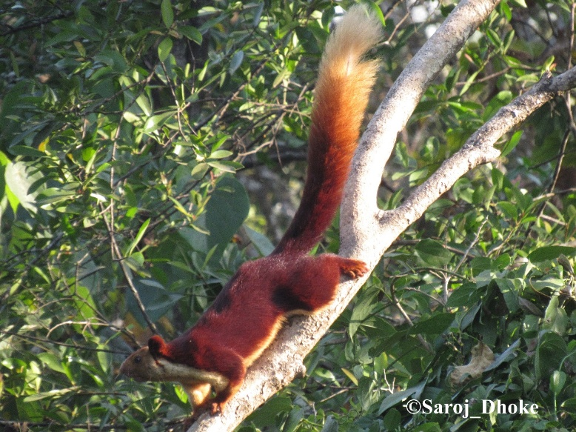

Fig. 1: Ratufa indica indica coat colour pattern can be seen.

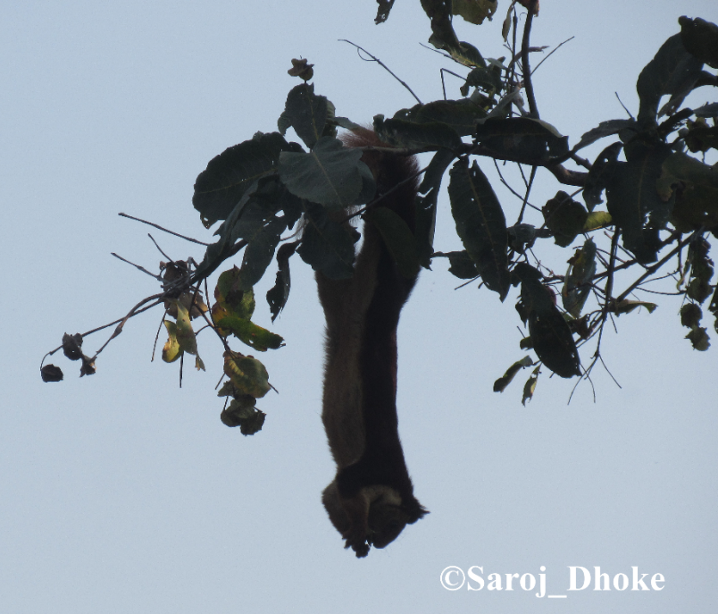

Fig. 2: Ratufa indica indica feeding on fresh Terminalia elliptica fruits.

In Maharashtra, reports indicated the distribution of Ratufa indica is notably uneven and population constricted in protected areas (Molur et al. 2005). In the Satpuda region of Amravati district, the subspecies R. i. centralis is identified. Population R. i. maximas subspecies seen at Tadoba National Park (Molur et al. 2005) and the Giant Squirrel Conservation Centre, Gadchiroli (Shukla & Mishra 2017) from eastern Maharashtra, exhibit a deciduous forest type, distinct from the evergreen forests found in the Western Ghats habitats - like high elevation southern tropical semi-evergreen Bhimashankar WLS with sacred groves (Rahangdale & Rahangdale 2017) and Phansad WLS with west coast semi-evergreen forests with Memecylon umbellatum slopes (Katwate et al. 2013), only low land habitat of R. i (Shinde 2012). These two sites have R.i. indica subspecies (Molur et al. 2005). Near to Bhimashankar WLS, specifically in the Bhandara WLS, Harishchandra gad Kalsubai WLS (Ladge 2017) this R.i. Indica population is present.

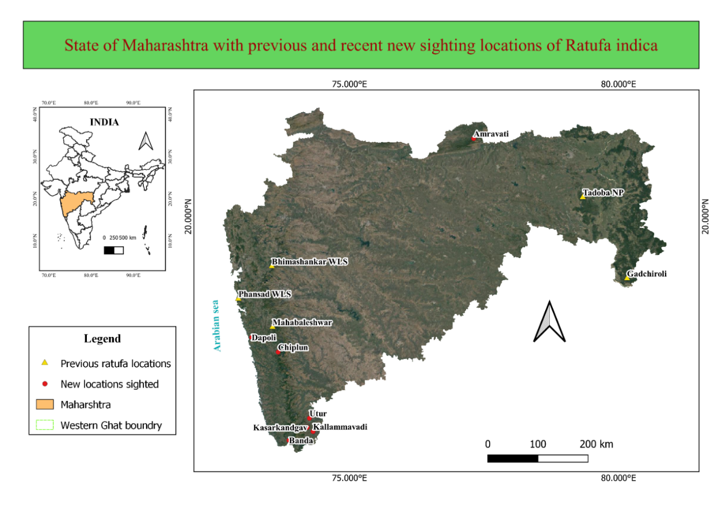

Fig. 3: present report area location
Table 1: Recent and previously recorded locations of Ratufa indica and probable subspecies
Sr. no | Place name | Date of sighted | Identified subspecies colouration | Reference
1. | Bhimashankar WLS | Previous records (PR) | R. i. indica | Molur et al 2005; Rathod et al 2022
2. | Phansad WLS | (PR) | R. i. indica | (Dhamorikar 2013)
3. | Mahabaleshwar | (PR) | R. i. indica | Sayyad et al 2014;
4. | Tadoba NP | (PR) | R. i. maxima | Molur et al 2005
5. | Gadchiroli IGS rescue centre | (PR) | R. i. maxima (photographic evidence not available) | (Shukla & Mishra, 2017) (Anonymous, 2016)
6. | DBSKKV campus, Dapoli, Ratnagiri | 5 May 2018 | R. i. indica | Present study
7 | Riparian forest of the Bandhtivare (Lat 17.7940020; Long 73.1809566) on the ‘Jog River’. | 2017 | unknown | (Varak, personal communication 2017) RFO, Maharashtra Forest department gave account of presence of Ratufa indica by local forest workers
8 | Kolkewadi, Chiplun, Ratnagiri  17°32'50.90"N Latitude 73°32'5.16"E Longitude | 21 January 2021 | Probably R. i. maxima (Dark coloured claimed by viewer) | (Indulkar personal communication 2019)
9 | Utur, Kolhapur | 11 June 2020 | R. i. indica | Toraskar 2020
10. | Kallammavadi village in Kolhapur | 2020 | unknown | Kesarkar, 2020
11. | Kasarkandgav of Amboli- Ajra forest Sindhudurg-Kolhapur border district | 2020 | Probably R. i. maxima | Toraskar 2020
12. | Private reserved area for Giant squirrels, Banda, Sindhudurg | 10 January 2021 | R. i. indica | Lad, 2021
13. | Satpuda region of Amravati district | 5 June 2019 | R. i.centralis | Babrekar, 2019

As compared to above mentioned isolated sites, Dapoli is placed in Western ghats of Ratnagiri district having large spectrum vegetation types including sacred groves, mangroves, riparian forests and extensive orchards. Though R. i. preferred tall trees with considerable girth which represented by old forest, still its adaptable to disturbed habitats (Datta & Goyal 1996). R. i. indica subspecies are reported also from Mahabaleshwar hill ranges (Sayyad et al 2014). We speculate this Dapoli individuals came from Mahabaleshwar via Mandangad tehsil.
R. indica expanding its range have become common in recent years (Seetharamaraju 2011; Srinivasulu & Srinivasulu 2011). May due to expanding population needs, more territories and farmers shifting from agricultural crops to perennial orchards. These fruit crops act as corridors, refuge, and food source for expanding giant squirrel population. In historical notes migration of squirrels were recorded like mass migration of Gray squirrel (Sciurus carolinensis) in Texas, USA (Casto 2003). The survival of species is significantly influenced by the creation of new habitats, new corridors, and the disconnection of existing corridors. Research on squirrels has indicated that metapopulations exhibiting robust rescue effects can be beneficial for the survival of species (Stacey et al. 1997).
Data in table 1. shows the presence of three Ratufa indica. subspecies in Maharashtra state. These local records are mentioned by various local news reports, and crucial for further dispersion and habitat suitability’s studies. As following records are overlapping R. i. maxima and R.i. indica in may places in Western ghats of Maharashtra, thereby advocating for a re-evaluation of documented distributions of subspecies. Which will help to conserve undiscovered migration corridors for these arboreal mammals.
CONCLUSION:
This new record of Ratufa indica indica from Dapoli suggests a possible range extension and highlights the species’ adaptability to semi-modified habitats like perennial fruit orchards. It underscores the importance of protecting emerging habitat corridors and conducting further studies to reassess subspecies distribution for informed conservation planning in the Western Ghats region.

REFERENCES:
- Abdulali, H.; J.C. Daniel (1952). "Races of the Indian giant squirrel (Ratufa indica)". Journal of the Bombay Natural History Society. 50: 469–474.
- Babrekar Vaibhav,(2019). State animal an Indian Giant squirrel reached Amravati (5 June 2019), Lokmat e-paper [https://www.lokmat.com/amravati/state-animal-indian-giant-squirrel-reached-amravati/\]
- Casto, S. D. (2003). The Texas gray squirrel migration of 1857. East Texas Historical Journal, 41(2), 9.
- CITES. (2023). CONVENTION ON INTERNATIONAL TRADE IN ENDANGERED SPECIES OF WILD FAUNA AND FLORA (CITES). Appendices I, II and III valid from 21 May 2023. Retrieved from https://cites.org/eng/app/appendices.php
- Corbet, G. B., & Hill, J. E. (1992). The mammals of the Indomalayan region: a systematic review (Vol. 488): oxford university press Oxford.
- Datta, A., & Goyal, S. (1996). Comparison of forest structure and use by the Indian giant squirrel (Ratufa indica) in two riverine forests of Central India. Biotropica, 394-399. doi:10.2307/2389203
- Anonymous, (2016, June 18). Lokmat news: Shakaru-found-Gadchiroli; Online accessed 4 June 2023 [https://www.lokmat.com/gadchiroli/shakaru-found-gadchiroli/]
- Katwate, U., Apte, D., & Raut, R. (2013). CEPF Western Ghats Special Series: Diversity and distribution of anurans in Phansad Wildlife Sanctuary (PWS), northern Western Ghats of India. Journal of Threatened Taxa, 5(2), 3589-3602.
- Kesarkar, V. (Producer). (2020, August 5). Indian Giant Squirrel | हाक मारल्यावर खांद्यावर येणारा शेकरू, दुर्मिळ असणारा प्राणी थेट घरात! [vedio news] Retrieved from https://www.youtube.com/watch?v=k7ALnJhqpNY
- Lad Sadashiv. (10 January 2021) Declared His Own Private Farm Reserved For State Animal Shekru, abp Maza https://marathi.abplive.com/news/maharashtra/declared-his-own-private-farm-reserved-for-state-animal-shekru-849391
- Landge, A. A. (2017). Tourism potential in Akole tahsil of Ahmednagar District (Maharashtra). International Journal of Researches in Social Sciences and Information Studies, 5(1), 26-29. chrome-extension://gphandlahdpffmccakmbngmbjnjiiahp/https://ijrssis.in/upload_papers/080320171236165.pdf
- Molur, S. (2016). Ratufa indica. The IUCN Red List of Threatened Species, 6, T19378A2226202. [doi:10.2305/IUCN.UK.2016-2.RLTS.T19378A22262028.en.]
- Molur, S., Srinivasulu, C., Srinivasulu, B., Walker, S., Nameer, P., & Ravikumar, L. e. (2005). Status of south Asian non-volant small mammals: conservation assessment and management plan (C.A.M.P.) workshop report. Zoo Outreach Organization/CBSG-South Asia, Coimbatore, India, 618pp.
- Varak S, personal communication, (January 21, 2017).
- Indulkar R, personal communication, (November 19, 2019).
- Dhamorikar A. 2013. Phansad Wildlife Sanctuary (October 09, 2013) [https://www.sahyadrica.com/2013/10/phansad-wildlife-sanctuary.html]
- Rathod, G., Bharucha, E., & Yardi, K. (2022). Population density and nesting behaviour of Indian Giant squirrel Ratufa indica (Erxlebeln, 1777) in Bhimashankar wildlife sanctuary, Western Ghats of Maharashtra, India. Journal of Threatened Taxa, 14(9), 21786-21796.
- Sayyed, A., Mahabal, A., & Sharma, R. M. (2014). Albinism in Indian Giant Squirrel Ratufa indica (Erxleben) and Lesser Bandicoot Rat Bandicota bengalensis (Gray)(Rodentia: Mammalia) from Satara District, Maharashtra. Small Mammal Mail, 5(2), 28â.
- Seetharamaraju M., C. S. a. B. S. (2011). Additional site records of Indian Giant Squirrel Ratufa indica ( Erxleben, 1777) (Mammalia: Rodentia) in Godavari River Basin, Andhra Pradesh, India Small Mammal Mail - Bi-Annual Newsletter of CCINSA & RISCINSA, 2(July-December 2010), 6-7.
- Shinde, P. (2012) Saving the White-rumped Vultures at Phansad Wildlife Sanctuary.
- Shukla, P. N., & Mishra, V. K. (2017). Population distribution of Indian Giant squirrel Ratufa indica in dry and moist deciduous forest of Sironcha forest Division, Central India. Indian Forester, 143(10), 1021-1026.
- Srinivasulu, A., & Srinivasulu, C. (2011). New site records of the Indian Giant Squirrel Ratufa indica and the Madras Tree Shrew Anathana ellioti (Mammalia, Rodentia and Scandentia) from the Nagarjunasagar-Srisailam Tiger Reserve, Andhra Pradesh. Small Mammal Mail-Bi-Annual Newsletter of CCINSA & RISCINSA, 3(2), 8-9.
- Stacey, P. B., Taper, M. L., & Johnson, V. A. (1997). Migration within metapopulations: the impact upon local population dynamics. In Metapopulation biology (pp. 267-291): Elsevier.
- Toraskar Ashok, (11 June 2020) Shekru is a rare animal found in Utur area of ​​Ajra taluka, Sakal e-paper https://www.esakal.com/paschim-maharashtra-news/kolhapur/shekru-rare-animal-found-utur-area-%E2%80%8B%E2%80%8Bajra-taluka-305817
- Rahangdale, S. S., & Rahangdale, S. R. (2017). Floristic diversity of Bhimashankar Wildlife Sanctuary, northern Western Ghats, Maharashtra, India. Journal of Threatened Taxa, 9(8), 10493-10527.
- Prachi, M., Kulkarni, J., Pawar, T., Sahoo, R. K., Arulmalar, E., & Punjabi, G. (2012). Status and Distribution of Malabar Giant Squirrel Ratufa indica in Western Ghats of Maharashtra. Wildlife Research and Conservation Society, Pune. pp74.

