Empowering Small Businesses and Rural Industries: The Impact of MSME Ministry in India-A select Study

Abstract
The Ministry of Micro, Small and Medium Enterprises (MSME) in India governs and supports the growth of small businesses and rural industries through its four statutory bodies. The Khadi and Village Industries Commission (KVIC) promotes and develops khadi and village industries, fostering employment opportunities in rural areas and strengthening the rural economy. The Coir Board focuses on the overall development of the coir industry, improving the working conditions of laborers in this sector. The National Small Industries Corporation Limited (NSIC) plays a crucial role in aiding and fostering the growth of micro and small enterprises, mainly on a commercial basis. The National Institute for Micro, Small and Medium Enterprises (NI-MSME) is dedicated to enterprise promotion, entrepreneurship development, and policy research, contributing to business creation and economic development. Lastly, the Mahatma Gandhi Institute for Rural Industrialization (MGIRI) is committed to accelerating rural industrialization, empowering traditional artisans, and fostering innovation through research and pilot projects.
In line with its commitment to supporting small enterprises, the MSME Ministry extended the validity of the Udyog Aadhaar Memorandum from December 31, 2021, to June 30, 2022. This extension provided relief to small businesses by allowing them additional time to transition to the updated registration system under Udyam Registration. By overseeing these statutory bodies and implementing policy reforms, the MSME Ministry continues to drive sustainable economic development, generate employment, and promote technological advancements in rural industries. Its efforts contribute significantly to self-reliance, economic empowerment, and inclusive growth, particularly in rural and small-scale industrial sectors.

Key words: key functions, statutory bodies, and policy initiatives.

Introduction

The Micro Small and Medium Enterprises (MSMEs) sector is a major contributor to the socio-economic development of the country. In India, the sector has gained significant importance due to its contribution to Gross Domestic Product (GDP) of the country and exports. The sector has also contributed immensely with respect to entrepreneurship development especially in semi-urban and rural areas of India. A revision in Micro Small and Medium Enterprises (MSME) definition was announced under the Aatmanirbhar Bharat Abhiyaan Scheme on May 13, 2020. The Ministry of Micro, Small, and Medium Enterprises, vide its gazette notification dated June 1, 2020, has announced the upward definition and criteria of the MSME. The new classification for MSME came into effect from July 1, 2020.
Therefore, according to the new classification of Micro, Small and Medium Enterprises (MSME) under the Aatmanirbhar Bharat Abhiyaan Scheme, enterprises are defined based on the investment criteria in plant and machinery and turnover.
MSME Ministry has four statutory bodies namely, Khadi and Village Industries Commission (KVIC) who is responsible for promoting and developing khadi and village industries for providing employment opportunities in rural areas, thereby strengthening the rural economy, Coir Board in charge of promoting overall development of the coir industry and improving living conditions of workers in this industry, National Small Industries Corporation Limited (NSIC) responsible for promoting, aiding and fostering growth of micro and small enterprises in the country, generally on commercial basis, National Institute for Micro, Small and Medium Enterprises, (NI-MSME) in-charge of enterprise promotion and entrepreneurship development, enabling enterprise creation, performing diagnostic development studies for policy formulation, etc. and lastly, Mahatma Gandhi Institute for Rural Industrialization (MGIRI) responsible for accelerating rural industrialization for sustainable village economy, attract professionals and experts to Gram Swaraj, empower traditional artisans, encourage innovation through pilot study/field trials and R&D for alternative technology using local resources. The Ministry of Micro, Small and Medium Enterprises extended the validity of Udyog Aadhaar Memorandum from December 31, 2021, to June 30, 2022.

Micro Small and Medium Enterprises (MSMEs) are the cornerstone of the Indian economy, with their substantial impact felt in terms of employment generation across rural and urban sectors. These enterprises have played a key role in facilitating the industrialization of less developed areas, effectively reducing regional disparities and promoting a more inclusive distribution of national wealth and income. History of Growth and Expansion of MSMEs
MSMEs have been the backbone of India’s economy for decades, playing a pivotal role in fostering entrepreneurship, generating employment opportunities, and driving inclusive growth. The history of MSMEs in India is intertwined with the nation’s journey towards economic development, providing a nurturing environment for small-scale enterprises to flourish and contribute significantly to the country’s GDP. This article takes a closer look at the evolution and significance of small businesses throughout India’s history. The roots of MSMEs in India can be traced back to the pre-independence era when various cottage industries, handicrafts, and small-scale enterprises thrived. Traditional skills and craftsmanship were passed down through generations, creating a rich tapestry of diverse local industries. These small enterprises were the economic backbone of rural areas, contributing to the self-sufficiency of local communities. The growth of MSMEs in India in recent years has been remarkable, driving economic development, job creation, and innovation. These enterprises have helped industrialize underdeveloped regions, reducing regional imbalances. Government support has further accelerated the growth and development of MSMEs in India, fostering innovation, entrepreneurship, and a more inclusive economic landscape.
Review of Literature:
Mali (1998) observed that micro, small and medium enterprises have to face increasing competition in the present scenario of globalization. They have to specifically improve themselves in the fields of management, marketing, product diversification, infrastructural development, technological up- gradation. Moreover, new small and medium enterprises may have to move from slow growth area to the high growth area and they have to from strategic alliance with entrepreneurs of neighbouring countries. Subrahmanya (2004) highlighted the impact of globalization and domestic reforms on small-scale industries sector by emphasizing that small industry had suffered in terms of growth of units, employment, output and exports. He also suggested that the focus must be turned lo technology development and strengthening of financial infrastructure in order to make Indian small industry internationally competitive and contribute to national income and employment. Sudan (2005) described the challenges in Micro and Small Scale Enterprises Development and policy issues by raising different questions related to MSMEs. Rathod (2007) analysed the growth and pattern of the SSI sector and identified the reasons for success and failures, evaluated the impact of globalization on SSis and export opportunity and identified the barriers and constraints that SSis were facing lo cope with globalization. Singh, Venna and Anjum (2012) analyzed the performance of MSMEs in India and focused on policy changes which have opened new opportunities for this sector and concluded that MSME sector has made good progress in terms of number of MSME units, production and employment levels. Venkateshand Muthiah (2012) fouQd that the role of MSMEs in the industrial sector is growing rapidly and they have become a thrust area for future growth. They emphasized that nurturing MSME sector is essential for the economic well-being of the nation. Srinivas (2013) analysed about the performance ofMSMEs, their contribution in India's economic growth, identified the number of enterprises, employment in MSMEs and concluded that MSMEs play a significant role in inclusive growth of Indian economy.

Categorization of MSMEs
The MSME in India plays a crucial role in the country’s economy by fostering employment and innovation. The categorisation of MSMEs is based on the investment in the plant and machinery equipment:
- Micro Enterprise: Investment in plant and machinery not exceeding Rs. 1 crore and annual turnover not exceeding Rs. 5 crore.
- Small Enterprise: Investment in plant and machinery exceeding Rs. 1 crore but not exceeding Rs. 10 crore and annual turnover exceeding Rs. 5 crore but not exceeding Rs. 50 crore.
- Medium Enterprise: Investment in plant and machinery exceeding Rs. 10 crore but not exceeding Rs. 50 crore and an annual turnover exceeding Rs. 50 crore but not exceeding Rs. 250 crore.
The Role of MSMEs in India
The role of MSMEs in India extends beyond economic contribution. They act as a critical link in the supply chain for large industries, boosting the development of various sectors such as textiles, food processing, and technology. MSMEs are crucial in promoting exports, as they contribute to about 48% of the country’s total exports. Their ability to adapt quickly to changing market conditions and technological advancements makes them a key player in India’s economic resilience. Government initiatives such as financial support, digitalization, and market access have further enhanced the growth and development of MSMEs in India, enabling them to scale up, compete globally, and contribute significantly to the nation’s economic progress.

Digital Age and MSMEs
With the advent of the digital age and technological advancements, MSMEs in India witnessed a new era of growth and innovation. E-commerce platforms and digital marketing enabled small businesses to reach a wider customer base and compete in the global marketplace. The government’s Digital India initiative further accelerated the digital transformation of small firms, facilitating online registrations, access to credit, and various e-governance services.

Sustainable Practices
Many MSMEs are recognizing the importance of sustainability and incorporating eco-friendly practices in their operations. From using renewable energy sources to adopting waste management systems, they are aligning with global sustainability goals, enhancing their reputation, and attracting socially-conscious consumers.

Collaborative Networks
MSMEs are forming partnerships and alliances to overcome resource limitations and gain a competitive edge. Collaborative networks enable them to pool resources, share knowledge, and jointly explore new business opportunities. This trend promotes collective growth and fosters innovation within the MSME sector.

Government Initiatives for MSME in India
The Indian government has taken several measures to support the growth and development of MSMEs. The Govt of India has launched several Government schemes for MSMEs, such as the:

Atmanirbhar Bharat Abhiyan:
Launched in 2020, this initiative aims to make India self-reliant by promoting local manufacturing, supporting innovation, and enhancing competitiveness. It includes measures such as access to credit, ease of doing business, and capacity-building programs for MSMEs.

Digital India Campaign:
The government’s Digital India program promotes the adoption of digital technologies by small businesses. Initiatives like digital payment platforms, e-marketplaces, and digital skill development programs have facilitated MSMEs’ transition into the digital economy.
Need of the Study:
The MSME sector is a crucial driver of economic growth, yet the effectiveness of its categorization in enabling businesses to access financial support and government schemes remains under-explored. There is a need to assess whether the current classification system aligns with evolving industry demands and technological advancements. Additionally, challenges related to transitioning between categories and limitations in financial accessibility require further investigation. Research is essential to identify policy gaps, propose improvements, and explore international best practices. A refined classification framework can enhance MSME competitiveness, ensuring sustainable growth and fostering innovation in India's dynamic business environment.
Scope of the study:
The categorization of Micro, Small, and Medium Enterprises (MSMEs) in India plays a critical role in shaping their access to financial support, government schemes, and overall business growth. This research aims to explore the effectiveness of the current classification system in facilitating financial aid, tax benefits, and incentives for MSMEs while ensuring their competitiveness in the market. It will assess whether the investment and turnover criteria align with the evolving business landscape and technological advancements. Furthermore, the study will examine the challenges enterprises face in meeting classification thresholds, particularly in transitioning between categories. It will explore whether the current system adequately supports innovation, scalability, and sustainability of MSMEs across different industries. By identifying potential gaps in policy implementation and financial accessibility, the research will provide insights into optimizing the classification framework. Additionally, the study will explore international MSME classification models and compare their effectiveness with India’s system. This comparative analysis may help propose policy recommendations to enhance the MSME ecosystem, ensuring a balance between regulatory support and business autonomy. The findings will contribute to policymaking, enabling MSMEs to maximize their growth potential while maintaining financial and operational efficiency in a competitive economic environment.
Objectives of the Study:
- To analyze the impact of MSME categorization on access to government schemes, financial support, and business growth.
- To evaluate the challenges and limitations of the current MSME classification system and its effectiveness in fostering competitiveness.
- To identify gaps in the current framework and suggest improvements for fostering sustainable growth and competitiveness in the MSME sector.
Research Methodology :
This study adopts a mixed-methods research design to comprehensively analyze the impact of MSME categorization on access to government schemes, financial support, and business growth. Primary data will be collected through structured questionnaires and interviews with MSME owners, policymakers, and financial institutions across various sectors. Secondary data will be sourced from government reports, policy documents, and existing literature. A comparative analysis will be conducted to evaluate the performance of micro, small, and medium enterprises under the current classification system. Qualitative insights will be gathered to assess the challenges and limitations faced by MSMEs in accessing support due to categorization. Quantitative data will be analyzed using statistical tools to identify trends, correlations, and gaps in the framework. The findings will help in suggesting evidence-based improvements for fostering sustainable growth, inclusivity, and competitiveness in the MSME sector. Ethical considerations, including informed consent and data confidentiality, will be strictly maintained throughout the study.

State-wise Distribution of estimated MSME:
State of Uttar Pradesh had the largest number of estimated MSME with a share of 14.20%of MSME in the country. Top 10 States accounted for a share of 74.05% of the total estimated number of MSME in the country. Statement No.1. and Figure 2. show the distribution of estimated enterprises in top ten States.
Statement No. 1: State-wise Distribution of enterprises
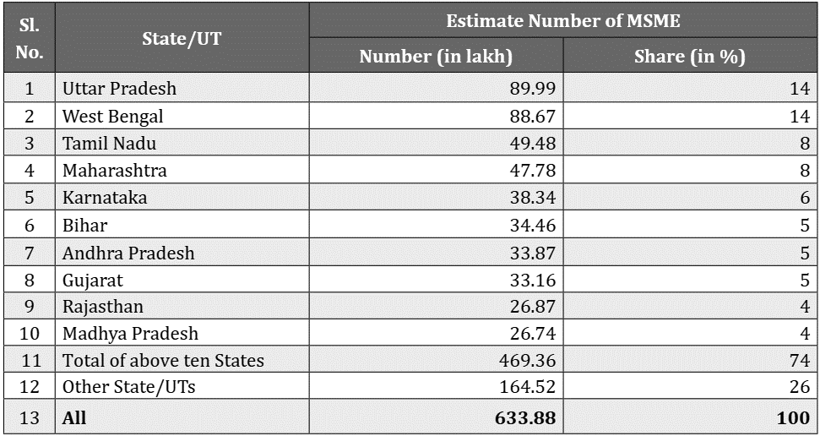

Figure 1: Distribution of MSME in Top Ten States
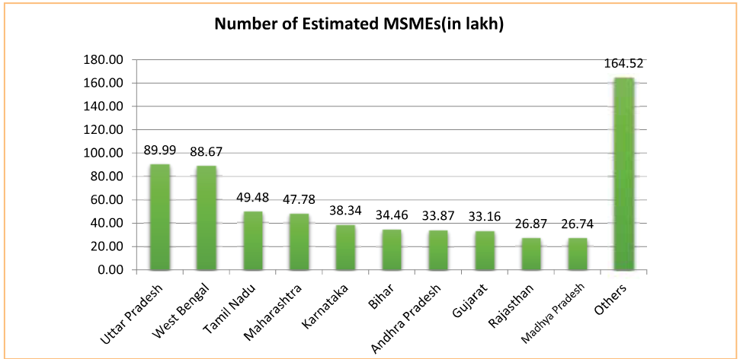

Interpretation: The bar chart represents the number of estimated MSMEs (in lakh) across different states in India. Uttar Pradesh leads with 89.99 lakh MSMEs, followed closely by West Bengal with 88.67 lakh. Tamil Nadu and Maharashtra also have a significant MSME presence, with 49.48 lakh and 47.78 lakh, respectively. Other states like Karnataka, Bihar, and Gujarat have moderate MSME numbers, ranging between 30–40 lakh. The category labeled "Others" collectively accounts for the highest number, at 164.52 lakh. This distribution indicates the concentration of MSMEs in industrially active states, reflecting their role in employment generation and economic contribution.
Figure 2: Investment range of MSME as per Udyam
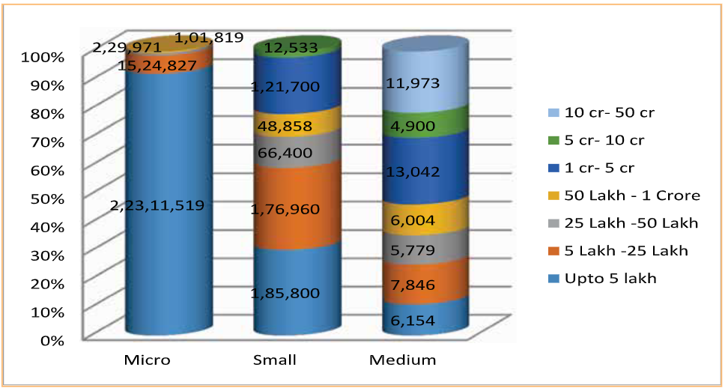
Interpretation: The bar chart represents the distribution of MSMEs across different investment categories. The Micro sector is dominated by enterprises with investments up to ₹5 lakh (2.23 crore), followed by ₹5 lakh - ₹25 lakh (15.24 lakh). In the Small sector, most enterprises fall within the ₹1 crore - ₹5 crore category (1.76 lakh), while significant numbers exist in the ₹50 lakh - ₹1 crore and ₹25 lakh - ₹50 lakh ranges. The Medium sector has fewer enterprises, with most investments in the ₹1 crore - ₹50 crore range. This distribution highlights how MSMEs are primarily micro-level businesses with lower capital investments.
Figure 3: Turnover range of MSME as per Udyam as on 31st March, 2024.
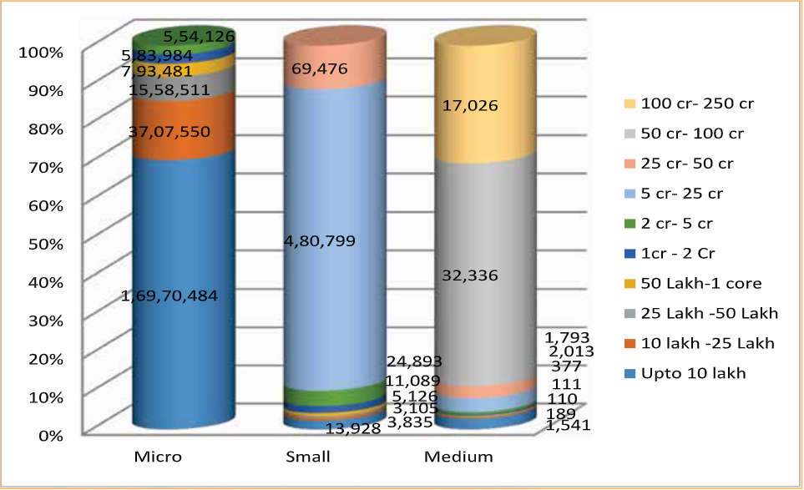
Interpretation: The bar chart illustrates the distribution of MSMEs based on investment levels. The Micro sector is dominated by enterprises with investments up to ₹10 lakh (1.69 crore), followed by ₹10 lakh - ₹25 lakh (37.07 lakh). The Small sector has most enterprises in the ₹1 crore - ₹2 crore category (4.80 lakh), with fewer in higher investment ranges. The Medium sector sees significant representation in the ₹25 crore - ₹50 crore and ₹50 crore - ₹100 crore categories. This indicates that most MSMEs have low capital investment, with only a few scaling into higher investment brackets.
Findings :
States like Uttar Pradesh, West Bengal, Tamil Nadu, and Maharashtra have the highest number of MSMEs, indicating that MSME growth is strongly aligned with regions having robust infrastructure, industrial activity, and access to markets. This suggests a correlation between state-level industrial policies and MSME proliferation.
The “Others” category, contributing 164.52 lakh MSMEs, surpasses any individual state. This points to a significant cumulative contribution from smaller states and union territories. A deeper disaggregated analysis of this group could uncover hidden regional potentials and inform targeted MSME policy support.
States with moderate MSME presence, such as Bihar, Karnataka, and Gujarat, demonstrate that MSMEs are contributing to economic decentralization. These enterprises are fostering local employment and development even outside traditional industrial hubs, highlighting the role of MSMEs in balanced regional economic growth.
The overwhelming concentration of MSMEs in the Micro category, especially with investments up to ₹5 lakh, suggests that India’s MSME landscape is driven by grassroots entrepreneurship. This highlights the need for targeted microfinance schemes, simplified compliance processes, and localized support systems to sustain and scale these small businesses.
The sharp drop in the number of enterprises as investment levels increase—from Micro to Small and Medium categories—indicates systemic barriers preventing MSMEs from scaling. These may include restricted access to credit, market linkages, technology, and regulatory challenges. This calls for policy interventions to facilitate smoother transitions across investment tiers and promote business growth.
The majority of MSMEs fall within the Micro sector, particularly in the investment range of up to ₹10 lakh. This trend underscores the accessibility of entrepreneurship at lower capital thresholds in India, emphasizing the need for continued support in micro-credit, training, and digital enablement to nurture these early-stage businesses.
The gradual decline in the number of enterprises as investment levels rise—from Small to Medium sectors—suggests significant barriers to scaling. These may include difficulties in accessing growth capital, regulatory hurdles, or market entry challenges, highlighting a critical need for targeted policy reforms and infrastructure support to help viable MSMEs grow beyond the micro stage.
Conclusion:
- The distribution of MSMEs across Indian states highlights their significant role in economic development and employment generation. Uttar Pradesh and West Bengal lead in MSME presence, followed by Tamil Nadu and Maharashtra. The "Others" category collectively accounts for the largest share, indicating widespread MSME activity. This concentration in industrially active states underscores the sector’s importance in fostering regional economic growth, innovation, and entrepreneurship across diverse industries.
- The distribution of MSMEs by investment categories reveals that the majority operate at the micro level, with investments primarily up to ₹5 lakh. Small enterprises are concentrated in the ₹1 crore - ₹5 crore range, while medium enterprises have fewer players but span a wider investment range. This trend highlights that MSMEs predominantly function with lower capital investments, emphasizing the need for supportive policies to facilitate their growth, scalability, and transition to higher investment brackets for sustained economic contribution.
- The distribution of MSMEs by investment levels shows that most enterprises operate with low capital, especially in the micro sector. Small and medium enterprises have fewer businesses in higher investment brackets. This highlights the need for better financial support and policies to help MSMEs scale and expand their operations.

References
Annual Report (2022-24). GovemmenL of India, Ministry or Micro, Small and Medium EnLerprises.
__ (2022-24). Government of India, Minislry of Micro, Small and Medium Enterprises.
Bala Subrahmanya, M.H. (2019). "Small Industry and Globalizalion: Implicalions, Perfonnance and
Prospects", Economic and Political Weekly, XXXIX, 18, pp. 1826-1834.
Bidani, S.N. and Milra, P.K. (1983). Industrial Sickness-Identification and Rehabilitations, Vision Book,
New Delhi.
Garg, lshu. and Walia, Suraj. (2012). "Micro, Small & Medium Enterprises (MSMEs) in Post Refonn India:
Status & Perfonnance", International Journal or Latest Trends in Engineering and Technology (IJLTET),
I (3), SepLember.
Mali, D.D. (1998). "Development of Micro, Small and Medium Enterprises of India: Current Scenario
and Challenges", SEDME Journal, 25(4).
Rathod, C.B. (2007). "Contribution or Indian Small Scale Entrepreneurs Lo Economic Growth in India:
Opportunities and Challenges in Global Economy", Prabandh-Joumal or Management & Researt:h, 23,
June.
RBI (2011-12). Handbook of statistics on Indian Economy.
Sandesara, J.C. (1993). "Modem Small Industry, 1972 and 1987-88: Aspects or Growth__and Structural
Change", Economic and Polilical Weekly, 28 (6).
115

