Conceptual Direction for New Learning Approaches in Forensic Strategy Management at Universities in COVID-19-Affected Countries: A Content Analysis
ABSTRACT

Aims: The increasing complexity of modern business environments has heightened the need for interdisciplinary approaches within accounting education, particularly integrating strategic management and forensic accounting.
Study design: This study investigates the relationship between strategic management practices and forensic accounting techniques, exploring how their intersection can inform the development of quality learning frameworks in accounting education.
Place and Duration of Study: Several priors research about strategic management linking to forensic accounting
Methodology: Drawing on bibliometric analysis, prior empirical research, and conceptual synthesis, the paper argues that the alignment of strategic thinking with forensic analytical skills equips future accountants with a holistic understanding of organizational risk, fraud prevention, and ethical governance.
Results: The findings highlight that fostering this interdisciplinary integration enhances both the relevance and quality of learning outcomes in accounting, preparing graduates not only to detect and investigate financial irregularities but also to contribute to the strategic resilience and ethical integrity of organizations.
Conclusion: This research contributes to the ongoing discourse on accounting curriculum development and offers practical recommendations for educators, policymakers, and professional bodies seeking to advance excellence in accounting education.

Keywords:strategic management, forensic accounting, analytical skills, bibliometric analysis

1. INTRODUCTION

Learning in Higher Education (HE) is a process of interaction (reciprocal relationship) between lecturers and students, supported by various key elements. Objectives, learning materials, facilities, learning conditions, media, learning environment, teaching methods, and evaluation are all components that influence the success of the teaching and learning process as well as enhance student achievement. The teaching-learning process is affected by both internal and external factors related to students and the learning model. Internal factors refer to physiological and psychological aspects, while external factors include the surrounding social and non-social environment (Suryabrata, 2010). The use of appropriate learning models plays a significant role in determining the success of the learning process.
Learning itself is an internal process within an individual that leads to behavioral changes, including changes in thinking, attitudes, and actions (Sumarwati et al., 2022). From a cognitive-constructivist perspective, learning is defined as changes in mental structures containing information and procedures for operating that information (Koes, 2003). Learning is not merely an outcome or goal but a process and an activity. It is not just memorization but an experience; learning outcomes reflect behavioral changes rather than mere mastery from repetition (Hamalik, 2009). Therefore, learning can be summarized as an internal process aimed at achieving specific goals and resulting in behavioral change — in other words, learning is both a process and an outcome.
On the other hand, teaching essentially refers to efforts to create a conducive system or environment that enables the learning process. Teaching is often narrowly interpreted as the transfer of knowledge and culture to students, which tends to make students passive since the focus is only on knowledge acquisition. This highlights the critical role of lecturers in the classroom because the teaching process is often teacher-centered. More broadly, teaching is about creating a supportive environment for learning activities, requiring students to actively participate. Efforts to establish such a system go beyond mere knowledge transfer; they involve complex activities aimed at helping, guiding, and accompanying students toward positive change. The combined process of learning and teaching is referred to as instruction or education.
Forensic accounting is the application of technology and knowledge in accounting, finance, management, and criminology to investigate and uncover evidence of illegal acts, fraud, or other financial disputes (Rezaee, Lo, Ha, & Suen, 2016). Education in forensic accounting equips individuals to identify fraud indicators (red flags) within organizations where they work and understand what steps to take when such issues are detected. Forensic accounting education has become increasingly popular worldwide, driven by the growing demand from companies and organizations for university graduates with anti-fraud expertise and awareness. A survey by the Association of Certified Fraud Examiners found that tips or suspicious information provided by employees or external parties interacting with the company are the primary sources of fraud detection within organizations (ACFE, 2020). This underscores that anti-fraud education is a critical foundation for combating financial fraud.
Researchers in several countries have thus been motivated to study forensic accounting education. Some studies focus on public perceptions of the need for forensic accounting and how it is taught in specific countries (Rezaee & Burton, 1997; Rezaee et al., 2016; Yusof et al., 2007), while others assess how and to what extent forensic accounting education has been implemented (Meier, Kamath, & He, 2010).
One interesting insight from these international studies is the notable similarities and differences they reveal. For example, Rezaee & Burton (1997) found that both academics and practitioners in the U.S. expect a significant increase in demand for forensic accounting services in the future. Similar conclusions were drawn in studies from China (Rezaee et al., 2016) and Malaysia (Yusof et al., 2007). However, there are differences regarding the readiness of accounting curricula to accommodate this demand. In the U.S., both practitioners and academics believe existing curricula are insufficient (Rezaee & Burton, 1997), while in Malaysia, academics believe the curriculum is adequate, but practitioners disagree (Yusof et al., 2007).
These findings demonstrate that perceptions and applications of forensic accounting education vary across countries. Forensic accounting has been established longer in the U.S. compared to other countries, which explains why research in this field is more developed there. Rapid economic growth in many countries has increased the need for forensic accounting, yet research on this topic remains scarce outside the U.S. (Seda & Kramer, 2014). This is unfortunate, as each country has unique business and governance characteristics, creating distinct needs for forensic accounting (Rezaee et al., 2016). Therefore, local research on forensic accounting education is essential, as findings from other countries may not be fully applicable.
Strategic management is the process of combining three interrelated activities: analysis, strategy formulation, and implementation. These components apply to all types of organizations, including corporations, social organizations, and educational institutions. Michael Hit, R. Duane Ireland, and Robert E. Hoskisson (1999:29) define the dynamic process of strategic management as a series of full commitments, decisions, and actions necessary for an organization to achieve strategic competitiveness and above-average performance. Effective strategic inputs derived from internal and external environmental analysis are crucial for strategy formulation and implementation.
The process of strategic management can be summarized using models developed by experts. One commonly recommended model includes the following stages: internal and external environmental analysis, strategy formulation, strategy selection, strategy implementation, and strategy evaluation (Gregory Dess-Lex Miller, 1993).
Specifically, environmental analysis is the initial process aimed at monitoring all internal and external factors affecting organizational goals. The results typically provide an overview of the organization’s condition, often using SWOT (strengths, weaknesses, opportunities, threats) analysis. Defining and setting the organization’s direction comes next, followed by strategy formulation — which focuses on adapting and reacting better and faster than competitors. Strategy implementation is a complex stage requiring managers to understand emerging issues and address them effectively, including organizational structure, culture, and leadership. Lastly, strategy control focuses on monitoring and implementing the strategic management process.
Based on the above discussion, both forensic accounting and strategic management are crucial for shaping future learning concepts. Therefore, this study proposes the development of a Forensic Strategic Management (FSM) course — a hybrid between forensic accounting and strategic management. The rationale for developing a learning framework for this course lies in its focus on designing systems, strategies, and plans to address actual findings related to accounting phenomena. For instance, as outlined earlier, Indonesia faces significant fraud issues, posing challenges for accountants to manage strategies in response to the rising number of fraud cases. This need suggests a new learning direction that should be developed into a dedicated curriculum within accounting programs.
The Islamic University of Indonesia (UII), as of late February 2019, is one of the first universities to offer an FSM course that integrates strategy and forensic accounting within the legal framework to uncover facts and gather evidence. Given this trend, all universities offering accounting programs should aim to develop expertise focusing on implementing FSM.
To achieve the expected student competencies, the existence of structured learning modules becomes essential. As discussed earlier, FSM is a relevant learning issue because it addresses a disciplinary field that continues to evolve with the times (Luis et al., 2014). Previously, forensic accounting courses lacked a strategic framework addressing how students should approach legal findings. Therefore, FSM helps students develop policy-making skills for legal cases.
The FSM course plays a vital role in helping students understand both theoretical and real-world applications. Another key goal is to enhance graduates’ employability and practical usefulness, making FSM an essential subject for preparing students for professional roles. As explained, FSM emerged as a result of developments in forensic accounting and strategic management, both of which have evolved over time.
The development of strategic management research provides a conceptual basis for understanding its relevance to organizational or individual policy direction (Felin & Foss, 2005; Abell et al., 2010; Aguinis et al., 2011; Mathieu & Chen, 2011). Strategic management is also frequently discussed conceptually within organizations as a framework for policymaking and decision-making in legal contexts (Rumelt et al., 1994; Hoskisson et al., 1999; Claver-Cortés et al., 2020; Nag et al., 2007; Azar & Brock, 2008; Furrer et al., 2008; Ramos-Rodríguez & Nerur et al., 2008; García-Merino & Santos-Álvarez, 2009; Guerras-Martín & Ronda-Pupo, 2016). Moreover, strategic management is complex in its application, even for SMEs (Hopper et al., 1999; Jarvis et al., 2000; Marriott & Marriott, 2000; Reid & Smith, 2002; Sousa & Galdi, 2016; Nandan, 2010), not just large industries (Scarbrough et al., 1991; Donaldson, 1991; Drury, 1993; Anderson & Sullivan, 1993; Innes & Mitchell, 1995; Ghosh & Chan, 1997; Chenhall & Langfield-Smith, 1998; Joshi, 2001; Szychta, 2002; El-Ebaishi et al., 2003; Islam & Kantor, 2005; Abdel-Kader & Luther, 2006; Wu et al., 2007; Van Triest & Elshahat, 2007; Frezatti, 2007; Leftesi, 2008; Nimtrakoon, 2009; Setiawan & Rahmawati, 2017).
The practice and role of strategic management accounting have entered various industries, including manufacturing, trade, and services, as reflected in research by Hoque (2004), Hynoven (2007), Flemming (2009), Lee & Yang (2011), Bastian & Muchlish (2012), Teeratansirikool et al. (2013), Cadez & Guilding (2008), Manciati & Pessina (2014). Additionally, studies by Cadez & Guilding (2008), Bisbe & Malagueno (2012), Macinati & Pessina (2014), and Cleary (2015) have shown that the practice and implementation of strategic management accounting can impact both financial and non-financial performance.
The evolving paradigms of strategic management across various disciplines, especially accounting, point to a new direction, highlighting the vital role of forensic strategic management in ensuring organizational success over time.
This study is designed to produce a conceptual framework for the development of forensic strategic management learning over time. It employs a content analysis approach, aiming to construct key terms or concepts from journals focusing on strategic management and forensic accounting to explore future knowledge development. The essence of these journal findings will be coded and categorized based on levels such as words, meanings, phrases, sentences, or themes, and then examined using the fundamental methods of content analysis: concept or relational analysis.
The documented findings are expected to provide an evaluation that strengthens the importance of forensic strategic management. This study also explores content and themes related to forensic-focused strategic management learning, aiming to enhance students’ mastery of knowledge, skills, and competencies in strategic management (Ronda-Pupo & Guerras-Martin, 2010) and improve the quality of learning in line with the output quality demands of higher education in developing countries. Furthermore, this research introduces the concept of forensic strategic management as a new novelty in the evolving field of strategic management, equipping graduates to act wisely and responsibly and to help their organizations succeed in the future.

Provide a factual background, clearly defined problem, proposed solution, a brief literature survey and the scope and justification of the work done.]

2. LITERATURE REVIEW
Constructivist Learning Theory
The Constructivist Learning Theory is a framework that grants individuals the freedom to learn or seek their needs by developing the ability to identify their desires or needs with the assistance of others. This theory encourages learners to actively discover their own competencies, knowledge, technologies, and other necessary elements for self-development. The constructivist learning theory posits that individuals generate knowledge and construct meaning based on their personal experiences. In constructivism, learning is viewed as a constructive process in which learners build internal representations of knowledge and interpret personal experiences.
The concept of constructivist learning has historical roots in the works of Dewey (1929), Bruner (1961), Vygotsky (1962), and Piaget (1980). Bednar et al. (1992) and Glasersfeld (1995) have proposed several implications of constructivist theory for instructional developers, emphasizing that learning outcomes should focus on the process of knowledge construction and that learning objectives should be derived from authentic tasks with specific goals (Bada & Olisegun, 2015). Constructivist studies of learning focus on how individuals make sense of the world (Singh & Yaduvanshi, 2015). Constructivism is an approach to teaching and learning based on the premise that cognition (learning) results from "mental construction." In other words, students are able to learn by integrating new information with their existing knowledge.
Constructivism is a learning theory found in psychology that explains how individuals can acquire knowledge and learn; therefore, it has direct applications in education. This theory suggests that humans construct knowledge and meaning from their experiences (Bada & Olisegun, 2015). This aligns with the statement by Paradesa (2015), who describes constructivism as an approach based on the belief that individuals actively build or create their own knowledge, and that reality is determined by one’s own experiences. The constructivist theory asserts that knowledge exists only in the human mind and does not necessarily need to match objective reality. The constructivist learning theory offers individuals the freedom to learn or seek their needs by developing the ability to identify their desires or needs, with facilitation from others, thus encouraging learners to actively discover their own competencies, knowledge, technologies, or other elements necessary for personal development (Rangkuti, 2014).
Strategic management learning is an inseparable part of the sciences, where direct experiential learning is emphasized to develop competencies, enabling students to explore and understand scientifically. Science education is aimed at "exploring" and "doing," while social science education, particularly in the teaching of strategic management, focuses on helping students gain a deeper understanding of the practice of strategy application in real-world business contexts.
In higher education, the learning process requires students to play an active role, positioning lecturers primarily as facilitators. Consequently, the teaching approach shifts from a lecture-based format to a student-active or student-centered instruction approach. This shift is expected to foster more active, adaptable students capable of thriving in any environment. This change in the learning model represents one form of student-active or student-centered instruction. Through the implementation of this model, it is hoped that lecturers, as educators, can stimulate student learning interest, motivation, and participation in the learning process.
The world of education is currently transforming into a global market — an efficient and transparent marketplace that spans across limitless regions. Globalization is becoming a trend across all types of organizations, whether business, social, or educational. Countries that fail to enhance efficiency and transparency risk falling behind due to the dynamic pace of change. The continuous evolution of the times also affects various aspects of human life. Education, which was traditionally managed in a conventional manner, is now evolving into integrated educational management, adopting principles from corporate management.
Since early 2020, on March 11, 2020, the World Health Organization (WHO) declared the coronavirus (Covid-19) outbreak a global pandemic. The rapid transmission and difficulty in detecting individuals infected with the virus led to the swift escalation of Covid-19 cases. The absence of a cure and the high number of Covid-19 patients made it one of the leading causes of death. The complexity of handling this outbreak prompted leaders of both developed and developing countries, including Indonesia, to implement strict policies to break the chain of Covid-19 transmission. This situation also forced higher education stakeholders worldwide to rethink the implementation of modified learning methods so that students and graduates would still meet the expectations of surrounding organizations and the global market. The implementation of lockdowns at various universities also posed challenges for students in completing their research projects, such as theses, master’s theses, and dissertations. Social restrictions compelled students to think creatively about continuing their student activities. The government’s decision to abruptly shift learning and teaching activities from campuses to homes created numerous difficulties for many parties. This condition sparked new thinking about effective learning methods for students across all universities in Covid-19-affected countries. The goal is to ensure that new learning methods continue to provide education encompassing all forms of activities to facilitate individuals in living within society.

3. RESEARCH METHOD
This research was conducted using a literature review method combined with content analysis techniques. The nature of this research is descriptive analysis, which involves systematically describing the data obtained and then providing interpretation and explanation so that it can be clearly understood by the reader. Articles or journals that meet the defined inclusion and exclusion criteria were selected for further analysis. This literature review uses literature/articles published between 2011 and 2020 that are accessible in full-text PDF format and classified as scholarly (peer-reviewed journals). The criteria for the reviewed journals include research articles on strategic management and forensic accounting that have been published in internationally indexed Scopus journals (Q1, Q2, or Q3) and are freely accessible or available as open-access journals. The subject areas were specifically defined to include “Economics” AND/OR “Econometrics” AND/OR “Finance” AND/OR “Business” AND/OR “Management” AND/OR “Accounting.”
Based on the established subject area criteria, this study identified a total of 37 research articles to be reviewed. These 37 studies were then compiled, sorted, and analyzed according to their year of publication, covering the period from 2011 to 2020, with a focus on strategic management and forensic accounting.

Picture 1-research scheme
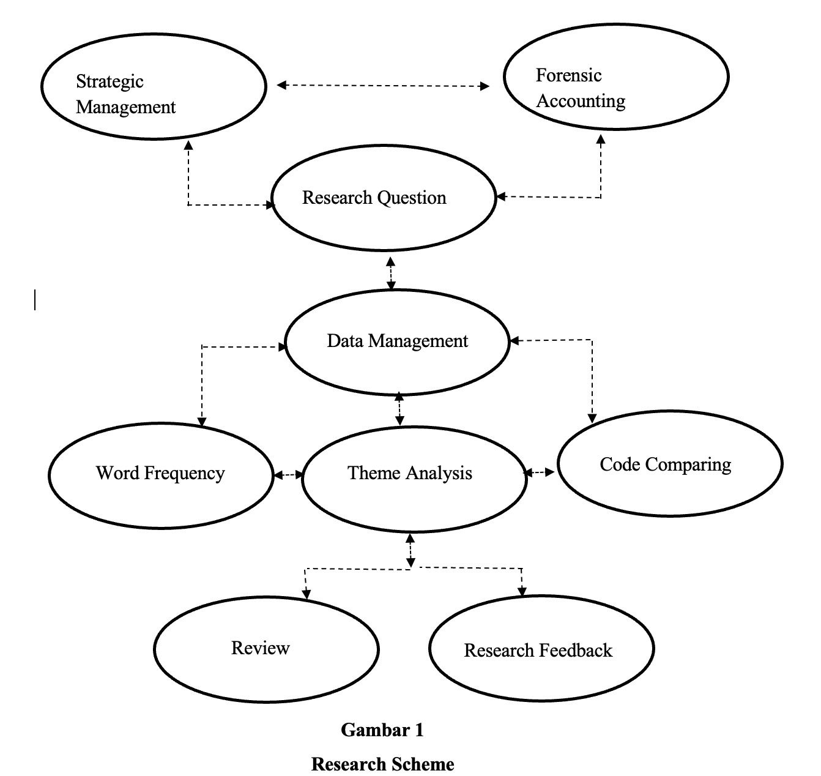
Content analysis has a long history. Neuendorf notes that content analysis has been used as far back as 4,000 years ago during ancient roman times. Aristotle’s concept of rhetoric is one example of early use, where messages were crafted and adjusted according to audience conditions. Compared to field research, the content analysis research design offers several advantages: it allows for investigation across long periods of time and does not produce social effects, as its objects are passive.
The content analysis process begins with formulating research questions, which are as follows:
- What words most frequently appear in previous research references (word counts) using atlas.ti?
- What themes emerge from the thematic analysis results?
- How are the themes interconnected, particularly in relation to the broader research themes of strategic management and forensic accounting?
- What themes can be used for future research?
The research stages are as follows:
- Data is retrieved from the universitas airlangga (unair remotes) library service. The main keywords used are strategic management and forensic accounting. Data is limited only to articles published in international journals indexed by scopus.
- All 37 articles are analyzed using atlas.ti software to identify the most frequently occurring words (word counts), limited to the top 100 words.
- From the top 100 most frequently occurring words, a content analysis process is conducted to extract research themes.
- Based on these research themes, the final research step involves analyzing them again using atlas.ti software. The results of this analysis will generate a conceptual research framework and themes for future studies.
Content analysis is conducted using the literature review method. Literature review research is a study that critically examines knowledge, ideas, or findings within the body of academic-oriented literature and formulates its theoretical and methodological contributions to a specific topic (cooper, 2010). This research is descriptive in nature, systematically describing the data obtained, followed by interpretation and explanation to ensure clarity for the reader. Articles or journals that meet the inclusion and exclusion criteria are selected for analysis. This literature review uses literature/articles published between 2011 and 2020 that are accessible in full-text pdf format and are scholarly (peer-reviewed journals). The reviewed journals consist of research articles on strategic management and forensic accounting, published in international scopus-indexed journals (q1, q2, and q3), and accessible freely or as open-access journals. The subject areas are specifically defined within economics, econometrics and finance, and business, management and accounting.
This literature review is synthesized using a narrative method, grouping similar extracted data according to measured results to answer the research objectives. Research journals that meet the inclusion criteria are collected and summarized, including the researcher’s name, year of publication, research title, methods, and a summary of results or findings. These journal summaries are entered into a table following the outlined format. To clarify the analysis, abstracts and full-text articles are carefully read and examined. The journal summaries are then analyzed based on the research objectives and results/findings. The content analysis focuses on the essential elements of each reviewed journal, breaking them down into sentences; once collected, similarities and differences across studies are identified and discussed to draw conclusions. The selection process for research journals was conducted rigorously, and the results of the journal tabulations are presented as follows.**

3. results and discussion

Figure 1 Bibilometric Between Strategic Management And Forensic Accounting
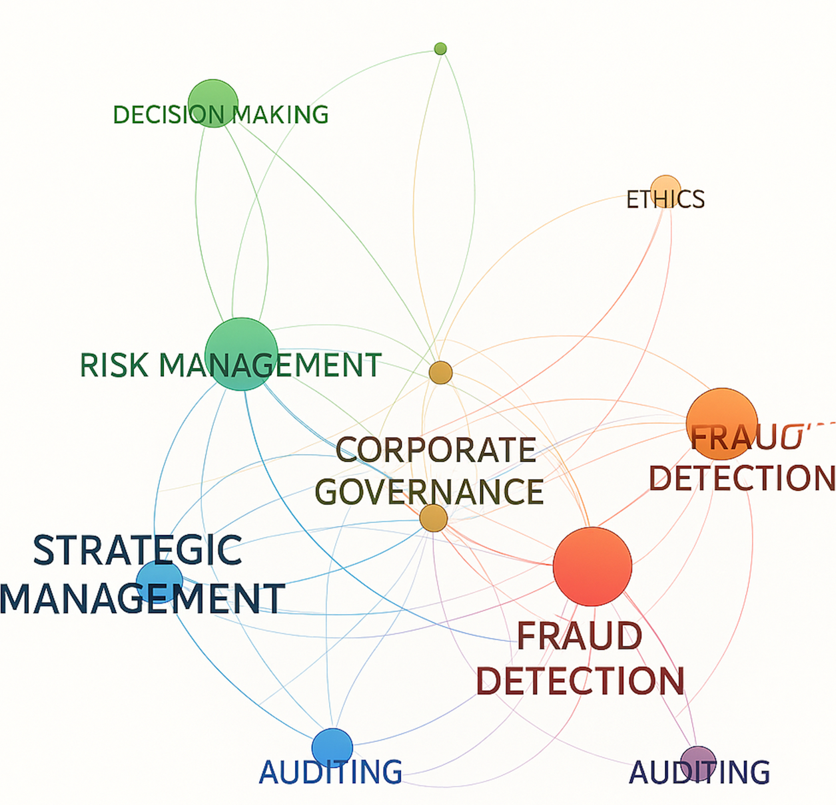

Explanation of the Visualization
The bibliometric network visualization above illustrates the conceptual and research connections between strategic management and forensic accounting.
Central Nodes:
Strategic Management and Fraud Detection appear as large, central nodes, showing they are highly frequent keywords or themes in the literature.
Corporate Governance acts as a linking node, connecting management strategies with forensic practices.
Key Connections:
Strategic Management ↔ Risk Management: Reflects how strategic decision-making integrates risk assessment frameworks to prevent financial irregularities.
Forensic Accounting ↔ Fraud Detection: Indicates that forensic accounting research is deeply tied to uncovering and analyzing fraud.
Auditing and Ethics serve as bridging concepts, linking the operational tools (like audits) with broader governance and ethical concerns.
Network Structure:
The visualization suggests two overlapping clusters: one management-focused (strategic management, risk management, decision-making) and one accounting-focused (forensic accounting, fraud detection, auditing), both converging on governance issues.

Findings from Prior Research (Academic English)
1️.Wells (2003) emphasized that forensic accounting has evolved as a response to the increasing complexity of corporate fraud, requiring integration with strategic management to create proactive anti-fraud strategies.
2️.Beasley, Carcello, & Hermanson (1999) showed that firms with strong corporate governance frameworks (a key element of strategic management) experience fewer instances of financial fraud, highlighting the protective role of governance in forensic investigations.
3️.Rezaee (2002) argued that the success of fraud prevention hinges on the alignment between management’s strategic vision and the deployment of forensic accounting tools — companies that embed fraud risk assessment into their strategic planning are more resilient against financial crimes.
4️ Omoteso (2012) explored how auditing and forensic accounting techniques support managerial decision-making, especially in contexts where strategic goals include ethical compliance and financial transparency.

Synthesis
In sum, the visualization and prior research show that the relationship between strategic management and forensic accounting is not isolated but interdependent, especially around shared concerns like risk management, corporate governance, and fraud prevention. This underscores the importance of interdisciplinary research to strengthen organizational resilience and ethical accountability.

A.RISK MANAGEMENT AND INTERNAL CONTROL FOR DECISION MAKING
Risk management and internal control are intricately linked in the context of organizational governance. Risk management refers to the process of identifying, assessing, and mitigating potential risks that could impact an organization's objectives. Internal control, on the other hand, refers to the policies, procedures, and processes implemented by an organization to ensure the accuracy, completeness, and reliability of financial reporting, as well as compliance with laws and regulations.Effective risk management relies heavily on robust internal controls, which provide a framework for identifying and mitigating risks. Internal controls help to prevent or detect errors, irregularities, and fraud, thereby reducing the likelihood of adverse events that could impact the organization's objectives. In turn, risk management informs the design and implementation of internal controls, ensuring that they are effective in addressing identified risks.The relationship between risk management and internal control can be seen in several ways:
1. Risk assessment: Risk management involves identifying and assessing potential risks, which informs the design of internal controls to mitigate those risks.
2. Control activities: Internal controls provide the mechanisms for managing risks, such as authorization, approval, and verification processes.
3. Monitoring and review: Risk management and internal control are ongoing processes that require continuous monitoring and review to ensure their effectiveness.In summary, risk management and internal control are interdependent and complementary processes that work together to ensure the achievement of organizational objectives. Effective risk management relies on robust internal controls, and internal controls are designed and implemented to mitigate identified risks.
B.RISK MANAGEMENT AND DATA ANALYTICS FOR ETHICS
Risk management and data analytics are closely intertwined in the context of organizational governance. Risk management involves identifying, assessing, and mitigating potential risks that could impact an organization's objectives. Data analytics, on the other hand, is the process of examining data sets to conclude about the information they contain.
Data analytics plays a crucial role in risk management by providing insights that inform risk assessment, risk mitigation, and risk monitoring. By analyzing large datasets, organizations can identify patterns, trends, and anomalies that may indicate potential risks. Data analytics can help organizations to:

1. Identify risks: Data analytics can help identify potential risks by analyzing historical data, industry trends, and market conditions.
2. Assess risks: Data analytics can help assess the likelihood and impact of identified risks by analyzing data on past events, industry benchmarks, and market conditions.
3. Mitigate risks: Data analytics can help mitigate risks by identifying areas where controls can be implemented or improved, and by monitoring the effectiveness of those controls.
4. Monitor risks: Data analytics can help monitor risks by tracking key risk indicators, detecting anomalies, and alerting stakeholders to potential issues.

The benefits of using data analytics in risk management include:

1. Improved risk assessment: Data analytics can provide more accurate and comprehensive risk assessments by analyzing large datasets.
2. Enhanced decision-making: Data analytics can inform decision-making by providing insights into potential risks and opportunities.
3. Increased efficiency: Data analytics can automate risk monitoring and reporting, freeing up resources for more strategic activities.
4. Better risk mitigation: Data analytics can help identify areas where controls can be implemented or improved, reducing the likelihood of adverse events.

In summary, data analytics is a critical component of effective risk management, enabling organizations to identify, assess, and mitigate risks more effectively. By leveraging data analytics, organizations can make more informed decisions, reduce the likelihood of adverse events, and achieve their objectives.
C. The Relationship Between Risk Management and Fraud Detection
The relationship between risk management and fraud detection is deeply interconnected, as both are critical components of an organization’s internal control and governance framework. While risk management focuses broadly on identifying, assessing, and mitigating threats that could compromise organizational objectives, fraud detection specifically targets the identification and investigation of fraudulent activities that can undermine financial integrity, reputation, and regulatory compliance.

Conceptual Linkage
From a conceptual standpoint, fraud risk is a subset of overall organizational risks. As defined by frameworks such as the Committee of Sponsoring Organizations of the Treadway Commission (COSO), risk management encompasses operational, strategic, financial, and compliance risks, with fraud risk falling under both financial and compliance domains. Therefore, effective fraud detection relies heavily on an organization’s ability to identify fraud risk factors during the broader risk assessment process.
Mechanisms of Integration
Research indicates that risk management and fraud detection are integrated through several key mechanisms:
1️Fraud Risk Assessment:
As part of the enterprise risk management (ERM) process, organizations conduct specialized fraud risk assessments to identify where they are most vulnerable to fraud schemes (Rezaee, 2005). This involves examining internal and external pressures, opportunities, and rationalizations that may lead to fraudulent behavior (aligned with Cressey’s Fraud Triangle theory).
2️.Internal Controls Design:
The outputs of risk management directly inform the design and implementation of internal controls aimed at preventing, detecting, and deterring fraud (Wells, 2003). Controls such as segregation of duties, authorization procedures, and monitoring systems are put in place to reduce fraud risk exposure.
3️.Data-Driven Monitoring and Detection Tools:
Risk management also guides the selection of fraud detection tools, including data analytics, forensic audits, and continuous monitoring systems, which are aligned with identified risk profiles (Button et al., 2007).

Empirical Insights from Research
Academic studies have underscored the significance of integrating risk management and fraud detection:
- Beasley, Carcello, and Hermanson (1999) found that organizations with mature risk management systems are more effective at detecting financial statement fraud, largely due to enhanced governance oversight.
- Troy, Smith, and Domino (2011) showed that firms employing enterprise risk management practices were able to reduce the incidence and impact of fraud through early identification of warning signs.
- Rezaee (2002) argued that the collaboration between risk managers and forensic accountants enhances the organization’s ability to anticipate fraud scenarios and implement targeted controls.
Practical Implications
For practitioners, this relationship implies that fraud detection cannot function effectively in isolation; it must be embedded within the broader risk management strategy. Organizations that fail to integrate these functions may face fragmented efforts, where fraud risks go unnoticed due to poor risk identification or weak control environments. On the other hand, firms with well-aligned risk management and fraud detection processes can achieve proactive fraud prevention, enhance regulatory compliance, and protect stakeholder interests.

D. The Relationship Between Risk Management and Corporate Governance
The relationship between risk management and corporate governance is foundational to the sustainable functioning and accountability of modern organizations. Corporate governance refers to the system of rules, practices, and processes by which a company is directed and controlled, focusing on balancing the interests of stakeholders such as shareholders, management, customers, regulators, and the broader community (OECD, 2015). Risk management, meanwhile, is the structured approach through which organizations identify, assess, mitigate, and monitor risks that could hinder the achievement of their strategic objectives (COSO, 2004).
These two domains are not separate; rather, they are mutually reinforcing components that together shape organizational resilience, ethical conduct, and long-term value creation.
Conceptual Linkage
Corporate governance provides the oversight framework within which risk management operates. Good governance ensures that the board of directors and executive leadership are accountable for understanding and managing the risks facing the organization. Conversely, effective risk management supplies governance bodies with the information and tools they need to make informed decisions, discharge their fiduciary responsibilities, and fulfill their duty of care.
Mechanisms of Interaction
Academic literature identifies several key mechanisms linking governance and risk management:
1️.Board Oversight and Risk Responsibility
Corporate governance frameworks assign boards — particularly audit and risk committees — explicit responsibility for overseeing the adequacy and effectiveness of the company’s risk management systems (Beasley, Clune, & Hermanson, 2005). This includes setting the organization’s risk appetite, reviewing risk reports, and ensuring alignment between strategy and risk exposure.
2️.Internal Controls and Accountability Structures
Governance mechanisms ensure the design and enforcement of internal controls that enable risk management to function effectively (Aguilera & Cuervo-Cazurra, 2004). Without strong governance, risk management efforts can become superficial or under-resourced, leading to unmitigated vulnerabilities.
3️.Transparency and Disclosure
Corporate governance practices emphasize transparent reporting of material risks and uncertainties to stakeholders, often through annual reports and regulatory filings (Solomon, 2007). Effective risk management supports this transparency by systematically identifying and quantifying risks.
Empirical Evidence from Prior Research
Several studies have examined how governance influences risk management effectiveness:
- Beasley et al. (2005) found that firms with active and informed boards are more likely to implement enterprise risk management (ERM) systems and to integrate risk considerations into strategic decisions.
- Kleffner, Lee, and McGannon (2003) showed that corporate governance pressures, including regulatory requirements and board expectations, are key drivers of formal risk management adoption, particularly in publicly traded companies.
- Gordon, Loeb, and Tseng (2009) provided evidence that firms with stronger governance structures achieve better alignment between ERM processes and firm performance, suggesting that governance enhances the strategic value of risk management.

Practical and Theoretical Implications
From a practical perspective, the governance–risk management relationship highlights that risk oversight is not just a technical or compliance function but a core governance responsibility. Boards and senior executives must foster a risk-aware culture, allocate appropriate resources, and ensure that risk management is integrated into all levels of decision-making. Theoretically, this relationship emphasizes the interdependency of governance and risk systems, where weaknesses in one domain can undermine the effectiveness of the other.

4. Conclusion

The synthesis of bibliometric data suggests a shift from disciplinary silos toward interdisciplinary integration. Strategic management can no longer afford to operate independently of forensic insights, especially in an era marked by heightened regulatory scrutiny, technological disruptions, and complex financial crimes. Likewise, forensic accounting must be aligned with organizational strategies to ensure its findings are actionable and supportive of long-term goals.
This interconnectedness carries important implications for research and practice:
For researchers, it calls for cross-disciplinary studies that explore how managerial strategies influence the design and effectiveness of forensic practices, and vice versa.
For practitioners, it emphasizes the need for collaboration between strategic leaders and forensic experts to create cohesive anti-fraud cultures, enhance risk management systems, and ensure that governance structures are both robust and adaptable.

References
Abayomi, S. O. (2016). Integrating Forensic Accounting into the Accounting Curriculum in Nigerian Universities: Challenges and Remedies. International Journal of Academic Research in Progressive Education and Development, 5(1), 59–64. https://doi.org/10.6007/ijarped/v5-i1/2062
Abell, P., Felin, T., & Foss, N. (2010). Causal and Constitutive Relations, and the Squaring of Coleman’s Diagram: Reply to Vromen. Erkenntnis (1975-), 73(3), 385–391. http://www.jstor.org/stable/40929397
Aguinis, H., Boyd, B. K., Pierce, C. A., & Short, J. C. (2011). Walking new avenues in management research methods and theories: Bridging micro and macro domains. Journal of Management, 37(2), 395–403. https://doi.org/10.1177/0149206310382456
Akani, F. N., & Ogbeide, S. O. (2017). Forensic accounting and fraudulent practices in the Nigerian public sector. AFRREV IJAH: An International Journal of Arts and Humanities, 6(2), 171–181. https://doi.org/10.4314/ijah.v6i2.13
AKINTUNDE, A. (2019). Contemporary issues in Forensics Accounting and Forensics Audit. Journal of Accounting, Finance and Development (Jafid), 147.
Alabdullah, T. T. Y., Alfadhl, M. M. A., Yahya, S., & Rabi, A. M. A. (2013). The Role of Forensic Accounting in Reducing Financial Corruption: A Study in Iraq. International Journal of Business and Management, 9(1), 26–34. https://doi.org/10.5539/ijbm.v9n1p26
Anderson, E. W., & Sullivan, M. W. (1993). The Antecedents and Consequences of Customer Satisfaction for Firms. Marketing Science, 12(2), 125–143. https://doi.org/10.1287/mksc.12.2.125
Azar, O., & Brock, D. (2008). A Citation-Based Ranking of Strategic Management Journals. Journal of Economics & Management Strategy, 17, 781–802. https://doi.org/10.1111/j.1530-9134.2008.00195.x
Chenhall, R. H., & Langfield-Smith, K. (1998). Adoption and benefits of management accounting practices: an Australian study. Management Accounting Research, 9(1), 1–19. https://doi.org/https://doi.org/10.1006/mare.1997.0060
Claver-Cortés, E., Marco-Lajara, B., Úbeda-García, M., García-Lillo, F., Rienda-García, L., Zaragoza-Sáez, P. C., Andreu-Guerrero, R., Manresa-Marhuenda, E., Seva-Larrosa, P., Ruiz-Fernández, L., Sánchez-García, E., & Poveda-Pareja, E. (2020). Students’ perception of CSR and its influence on business performance. A multiple mediation analysis. Business Ethics, 29(4), 722–736. https://doi.org/10.1111/beer.12286
Donaldson, Lex., D. J. H. D. (1991). Stewadship Theory or Agency Theory: CEO Governance and Shareholder Returns. Australian Journal of Management. The University of New South Wales.
Drury, C. (1993). A survey of management accounting practices in UK manufacturing companies.
Eyo Bassey, B. (2018). Effect of forensic accounting on the management of fraud in microfinance institutions in cross river state. IOSR Journal of Economics and Finance, 9(4), 79–89. https://doi.org/10.9790/5933-0904017989
Fargher, I. (2018). The ‘value to the owner’ objective and its implications in the separate recognition of personal and enterprise goodwill. Australasian Accounting, Business and Finance Journal, 12(3), 67–86. https://doi.org/10.14453/aabfj.v12i3.6
Felin, T., & Foss, N. J. (2005). Strategic organization: a field in search of micro-foundations. Strategic Organization, 3(4), 441–455. https://doi.org/10.1177/1476127005055796
Furrer, O., Thomas, H., & Goussevskaia, A. (2008). The structure and evolution of the strategic management field: A content analysis of 26 years of strategic management research. International Journal of Management Reviews, 10(1), 1–23. https://doi.org/10.1111/j.1468-2370.2007.00217.x
García-Merino, M., & SANTOS-A´LVAREZ, V. (2009). Characterizing the Top Journals in Strategic Management: Orientation, Style, Originality, and Readability. Journal of Scholarly Publishing - J SCHOLARLY PUBLISHING, 40, 420–439. https://doi.org/10.3138/jsp.40.4.420
Ghosh, B. C., & Chan, Y. (1997). Management accounting in Singapore ‐ well in place? Managerial Auditing Journal, 12(1), 16–18. https://doi.org/10.1108/02686909710155966
Guerras-Martín, L., & Ronda-Pupo, G. (2016). Strategic Management Journal (pp. 1–5). https://doi.org/10.1057/978-1-349-94848-2_565-1
Hamalik, oemar. (2009). Proses Belajar Mengajar. PT bumi Aksara, Jakarta.
Hopper, T., Koga, T., & Goto, J. (1999). Cost accounting in small and medium sized Japanese companies: An exploratory study. Accounting and Business Research - ACCOUNT BUS RES, 30, 73–86. https://doi.org/10.1080/00014788.1999.9728925
Hoskisson, R., Hitt, M., Wan, W., & Yiu, D. (1999). Theory and Research in Strategic Management: Swings of a Pendulum. Journal of Management - J MANAGE, 25, 417–456. https://doi.org/10.1177/014920639902500307
Huber, W. D. (2012). Is Forensic Accounting in the United States Becoming a Profession? Journal of Forensic & Investigative Accounting, 4(1), 255–284.
Innes, J., & Mitchell, F. (1995). A survey of activity-based costing in the U.K.’s largest companies. Management Accounting Research, 6(2), 137–153. https://doi.org/https://doi.org/10.1006/mare.1995.1008
Jarvis, R., Curran, J., Kitching, J., & Lightfoot, G. (2000). The use of quantitative and qualitative criteria in the measurement of performance in small firms. Journal of Small Business and Enterprise Development, 7(2), 123–134. https://doi.org/10.1108/EUM0000000006834
Joshi, P. L. (2001). The international diffusion of new management accounting practices: the case of India. Journal of International Accounting, Auditing and Taxation, 10(1), 85–109. https://doi.org/https://doi.org/10.1016/S1061-9518(01)00037-4
Koes, S. (2003). Strategi Pembelajaran Fisika. JICA.
Marriott, N., & Marriott, P. (2000). Professional accountants and the development of a management accounting service for the small firm: barriers and possibilities. Management Accounting Research, 11(4), 475–492. https://doi.org/https://doi.org/10.1006/mare.2000.0142
Mathieu, J. E., & Chen, G. (2011). The etiology of the multilevel paradigm in management research. Journal of Management, 37(2), 610–641. https://doi.org/10.1177/0149206310364663
Modugu, K. P., & Anyaduba, J. O. (2013). Forensic Accounting and Financial Fraud in Nigeria: An Empirical Approach. International Journal of Business and Social Science, 4(7), 281–289.
Naamati Schneider, L. (2020). Strategic management as adaptation to changes in the ecosystems of public hospitals in Israel. Israel Journal of Health Policy Research, 9(1), 65. https://doi.org/10.1186/s13584-020-00424-y
Öztürk, M. S., & Usul, H. (2020). Detection of Accounting Frauds Using the Rule-Based Expert Systems within the Scope of Forensic Accounting. In S. Grima, E. Boztepe, & P. J. Baldacchino (Eds.), Contemporary Issues in Audit Management and Forensic Accounting (Vol. 102, pp. 155–171). Emerald Publishing Limited. https://doi.org/10.1108/S1569-375920200000102013
Peterson, K., & Ozili, P. K. (2020). Munich Personal RePEc Archive Forensic accounting theory Forensic accounting theory. 102566.
Rehman, A., & Hashim, F. (2019). Impact of Mature Corporate Governance on Detective Role of Forensic Accounting: Case of Public Listed Companies in Oman. KnE Social Sciences, 2019, 637–665. https://doi.org/10.18502/kss.v3i22.5080
Sarker, M. (2020). Forensic Accounting and Fraud Examination : Evidence from Bangladesh. International Journal of Science and Business, 4(9), 138–144. https://doi.org/10.5281/zenodo.4300251
Setiawan, A. S., & Rahmawati, R. (2017). HUBUNGAN RATING BINTANG TERHADAP PERAN AKUNTANSI MANAJEMEN STRATEGIS (Studi Empiris Pada Perusahaan Hotel di Sumatera Selatan). Jurnal Akuntansi, 21(1), 114. https://doi.org/10.24912/ja.v21i1.137
Sousa, E. F. de, & Galdi, F. C. (2016). The relationship between equity ownership concentration and earnings quality: evidence from Brazil. Revista de Administração, 51(4), 331–343. https://doi.org/https://doi.org/10.1016/j.rausp.2016.07.006
Sumarwati, S., Amiruddin, M. H., & Madar, A. R. (2022). Oj-TP The Comparison Level of Entrepreneurial Intention and Creative Thinking Skills Among Polytechnics Students in Malaysia. 1, 75–84.
Suryabrata. (2010). Metodologi Penelitian.
Uribe, J. (2020). Multipoint Contact Without Forbearance? How Coverage Synergies Shape Equity Analysts’ Forecasting Performance. Strategic Management Journal, 41. https://doi.org/10.1002/smj.3188
van Straten, R. (2020). Six Actionable Canons for Rationality in Strategy Practice. Philosophy of Management, 19(4), 409–426. https://doi.org/10.1007/s40926-020-00136-y

.

