Critical Evaluation of Sustainable Supply Chain Management Frameworks: Identifying Inconsistencies and Proposing a Refined Model

ABSTRACT
Aims: This study aims to address design inconsistencies, application shortcomings, and verification inconsistencies in existing Sustainable Supply Chain Management (SSCM) frameworks. It seeks to explore and resolve structural inconsistencies, gaps in application, and construct issues by developing an improved SSCM model.
Study design: This is a meta-analytical and design-based research study.
Place and Duration of Study: Sample: The study is based on a meta-analysis of 40 peer-reviewed articles on SSCM frameworks. The research and framework development were conducted during 2012 to 2024.
Methodology: A systematic meta-analysis was performed on 40 peer-reviewed articles to identify inconsistencies in adaptation, validation, and implementation of SSCM frameworks. The study also critiques the lack of integrated technologies such as IoT and data analytics in existing models and highlights the inefficiency due to a lack of domain-specific approaches. In response, the study proposes a new SSCM framework incorporating structured design methodologies like DMAIC and interpretive structural modeling. The model also integrates lean management and sustainability approaches for balanced and efficient operations.
Results: The analysis revealed major inconsistencies and lack of standardization in current SSCM frameworks. Key findings include limited use of digital transformation tools, and underperformance in both manufacturing and service industries due to domain-generic designs. The proposed framework, integrating environmental and technological strategies, enhances visibility, efficiency, and decision-making in supply chains. Empirical testing via case studies and expert inputs is suggested for validation and improvement.
Conclusion: The developed SSCM framework addresses existing inefficiencies by offering a structured, technology-driven, and flexible model. It enhances sustainable and efficient supply chain operations across industries, providing valuable insights for both researchers and practitioners. Further empirical validation is needed to confirm robustness and wide applicability.

Keywords: Sustainable Supply Chain Management, SSCM Framework, Lean Management, Data Analytics, IoT Integration

1. INTRODUCTION

To undergo against the global competition, various associations are adopting a few quality correction strategies, but the majority of them are not realizing it in palmist manner, hence to break free from the failure of use it is elementary to differentiate and prioritize the barriers of the procedure to be done. SSCM has evolved as a remarkable among the most helpful system implemented by associations in the recent decade. SSCM is an arranged thought that was formed toward the end of 90s and flourished amongst assembling alongside organization part (Abate & Anteneh, 2024). The intrinsic starting point bloomed when businesses that were practicing SCM as solo framework struggled with environmental trade-off. Other than manageability, there is no other philosophy meets the quality requirement at most optimum scale (Sheykhzadeh et al., 2024). The system deviates it’s fascinating criticality since it not only envisions the exigent behavior of influencing parameters but also enlightens a rational model of the process to be carried out. A system strives to reveal the interrelations between the considered parameters (Lang et al., 2024; Li & Martins, 2024). It revealed the actual conditions and explains the quality of each parameter and its effect on the final run of the system (Paulmani, 2020). Some experts estimated that the system provides improved visibility to the experts to initially explore the weaknesses and barriers, and subsequently implement the quality program in an efficient manner to enhance the hierarchical performance (Mohammadzadeh et al., 2020; Digalwar et al., 2020).
Amounts of SSCM frameworks are suggested by various analysts around the globe, yet there is irregularity in the constructions used by the experts (Oliveira-Dias, 2022). Lack of bound together hypothesis is observed in SSCM literature, which leads to significant change in the developed systems (Frau et al., 2022). Hypothesis works as foundation for organization of any methodology to be recognized wholeheartedly and any non-consistency between the correct understanding of strategy weakens its foundation (Pasławski & Rudnicki, 2021). Some researchers who suggested SSCM structures applied varying measurements which is a fundamental issue which needs to be verified (Ariadi et al., 2021). This instance leads disapproval of these systems in contemporary fields and often leads SSCM implementation failures. The companies demand for the institutionalized SSCM framework. The afore-mentioned problem shifts the pattern of experts into a distinctive manner that finally brings them away from institutionalization. Therefore, with an aim to identify the deficiencies in the available structures and elements used for developing them, an in-depth examination of available system in writing is urgently needed.
The current analysis is an attempt to explore the benefits provided by current SSCM frameworks eliminated via writing and study the shortcomings of every model in order to construct a modified SSCM framework that can enhance the overall implementation of the framework. Twenty-six structures triggered via writing look are explored in this analysis. Each structure is studied in entirety to represent its major outcomes and extension the gaps identified in each system. The four questions required which should be understood prior to constructing a good structure:
• "Why" should the system be created? - identifying with requirements of improvement, decision among conventional and area explicit structures.
• "What" advantages can be determined out of the structure? - identifying with the idea of structure, adaptability, clearness of activities and center to guarantee improved execution anticipated from the system.
• "Where" can the structure have connected? - identifying with the space region of use.
• "How" would framework be able to be executed? - identifying with the assets and bolster required alongside arrangement of consecutive arrangement of builds for system to encourage activities for wanted result.
Since many technologies are now available, they are both difficult and simple questions for the SSCM space area. In this manner, it becomes essential to 1) carefully examine current SSCM structure studies and pinpoint system anomalies so that experts and scientists can gain a general understanding of the constructs and design/create existing frameworks; 2) look for solutions to methodically posed research needs in order to accomplish utilization and structure arrangement process 3) Look for advice on anomalies for structural squares and constructions. The study aims to address new advancements in addition to analyzing the irregularities in the SSCM frameworks that are currently in use. Both analysts and experts need solutions that are up to date with industry demands.

2. LITERATURE REVIEW

Survey writing and the subsequent exploratory study were carried out in separate steps, as can be seen in the research approach depicted in Figure 1. Figure 1 makes it clear how the publications were screened in order to find 27 SSCM systems. In order to fill in the gaps in earlier writing survey considerations, the authors additionally included all of the SSCM writing audit articles. The promises of a few chosen questions that demonstrate SSCM frameworks are shown in the next step to show the current advancements in the SSCM system sector.
2.1 To capture contributions of chosen SSCM framework studies
The publications were vetted and only examined, as was described in the section on the study approach. Regarding the use of SSCM, the following are the promises and characteristics of the chosen research studies. It is clear from analyzing the chosen papers that researchers attempted to link SSCM implementation and applications to frameworks and to provide particular attention to the structures that make up these frameworks.
An integrated convention system that aims for a start-to-finish approach was created by Abideen et al. in 2021. Since the underlying parameters serve as the foundation for other parameters, the system first explains the underlying parameter that drives execution before going into how different values are attained. The integrated SSCM system and spread strategy, equipment, and processes are recommended by (Aisyah et al., 2021). Scholars and specialists can use their framework as a guide to design their execution method and complete supporting research. At every level, the framework adheres to the DMAIC march toward six sigma. (Qureshi et al., 2023) propose a framework with thirteen essential elements that are important for SSCM implementation. Their study employs review method for acceptance. Creators employ unshakeable quality studies, content validity, develop validity and criteria related validity for acceptance purpose (Allen, 2022). The message of the study is, DMAIC approach closer to most suitable for assembly units.
A system that demonstrates the significance of fundamental quality features and important execution indicators in SSCM application is developed by (Soares et al., 2022) and (Algorri et al., 2022a). In addition to using the DMAIC technique to demonstrate the importance of the toolset at every level, their architecture includes the key enablers of SSCM. Evaluation (Çalık, 2021) validates the framework by investigating the connections between factual procedure control, collaboration, and shared vision, which ultimately have a major impact on hierarchical implementation. Finally; based on this study, the SSCM framework is designed. The framework encompasses three information parameters and one output parameter.

Table 1. Literature review articles of SSCM

S.N. | Framework | Description
1 | (Besseris, 2021) | This Study develop An Integrative structure for SSCM
2 | (Mathiyazhagan et al., 2021) | This Study reduce danger due to experience And Make improvement In Their Own SSCM
3 | (Darvazeh et al., 2022) | This Study develops A structure base on progression Analysis move towards.
4 | (Abukhamis & Abdelhadi, 2022) | This learning Develops Sustainable Logistic arrangement
5 | (Bottani et al., 2022) | This learning develops Inter-Relation between Information contribution; Decision organization; And Incentive association
6 | (Junejo et al., 2022) | This Study assess the price of Sustainability in An Organization's premeditated Plan
7 | (Algorri et al., 2022b) | This Study develop A structure Based on SSCM practice
8 | (Sharma et al., 2023) | This Study analysis Procurement practice linking Third Party Logistics And clients
9 | (Niekurzak et al., 2023) | This Study develop A Sustainable inspected frame
10 | (Overbeck et al., 2023) | This Study describe in order Trade-Off decision in SSC
11 | (ForouzeshNejad, 2023) | This Study describe The Essentialities For incorporate Sustainability In SC
12 | (Sekhar et al., 2023a) | This Study develop A frame By Integrating Green Promotion And SSCM
13 | (Widiwati et al., 2024) | This Study describe How ﬁrm Internal Applications and SSC association Leads to SSCM winner
14 | (Javaid et al., 2024) | This Study explore the achieve Of SSC Practices on SSC routine
15 | (Li & Martins, 2024b) | This Study explore How community social dependability Is incorporated In the Relationship With clients And supplier

Unfortunately, even audit writing considers similarly don't support on this need in relation to the structures and any useful guidance concerning the builds and sub-develops is really missing or broken. Consequently, the inconsistency at level 1 regarding the structures is echoed.

3. Analysis of SSCM frameworks considering usage and research trends to explore inconsistency at Stage 2

A total of 45 articles from peer reviewed journals containing SSCM frameworks are shortlisted for this study. These articles are analysed according to the criteria’ mentioned in section 2. The analysis details are presented in later part of this section.

3.1 Framework novelty

This classification examines whether the displayed system is changed or adapted from some other existing structure and on the off chance that this situation doesn't exist, then the constructed structure is referred to as singular or new structure. The story structure provides the basic design to the researchers and experts regarding recent developments and advancement in the concerned area. A gigantic number of new systems indicate absence of cumulative structures and also illustrates the shakiness of current examination. Although, the vast amount of modified system features lacks development and limitation of the examination scope.

Table 2. Novelty of framework

Novelty | Framework | Frequency
Novel | 1,2,3,4,6,7,8,9,10,11,12,13,15,16,17,18,20,21,22,23,25,26,27,31,32,33,34, 35,36,37,38,40,41,42,43,44,45 | 37
Adapted | 5,14,19,24,28,29,30,39 | 8

3.2 Framework contribution

This order is modified from (Frau et al., 2022b). As suggested by their analysis, commitment of structure can be divided into three classes to be precise; professionals, academicians and specialists. The structure developed from scholarly sources implies that the suggested system is an exploration yield conducted at scholastic area. The structures developed through doing contextual investigation or effective SSCM execution at any contemporary association are referred as specialists' system.

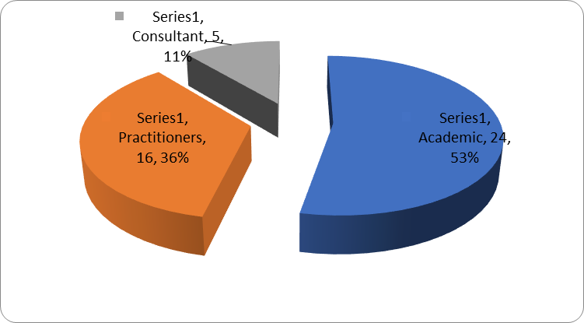

Fig. 1. Framework contribution
3.3 Framework verification

The fundamental objective of framework is to give a guideline to tackle/explain/implement any specific condition/process/methodology which is a set of parameters/factors to attain the intended goal. These frameworks are utilized often in real-world domain or reaction for the case is pulled out from industry expert having knowledge in the research field. Therefore, this exercise of inquiry of the created framework is referred to as framework verification. This whole process done for a specific framework justifies and validates its significance and relevance in respective research field. After citing some articles from literature, it has been found that some articles suggesting frameworks puts it into conceptual stage without validating and reporting its future research directions.

Table 3. Framework verification

Verified | Framework | Frequency
Yes | 1,2,3,4,5,7,10,12,15,16,17,18,20,21,22,23,25,26,27,28,29,30,31, | 18
No | 33,34,35,36,37,38,40,41,42,43,44,45 | 8

3.4 Framework verification mode

As discussed under previous grouping, that the verification of structure possesses unparalleled significance in order to articulate the applicability of the constructed system, similarly the selected check mode possesses the same importance. The system check can be carried out by employing a number of modes, for instance, overview, interviews, contextual analysis, master board and focused gathering or combining these modes.

3.4 Framework applicability

The constructed framework remains valid only when it can be used to some extent in a particular domain. Therefore, the classification of applicability of proposed framework to a particular/prescribed domain gains significance. For the present study, the applicability of framework is noted under three categories viz.; manufacturing industry, service industry and generalized.

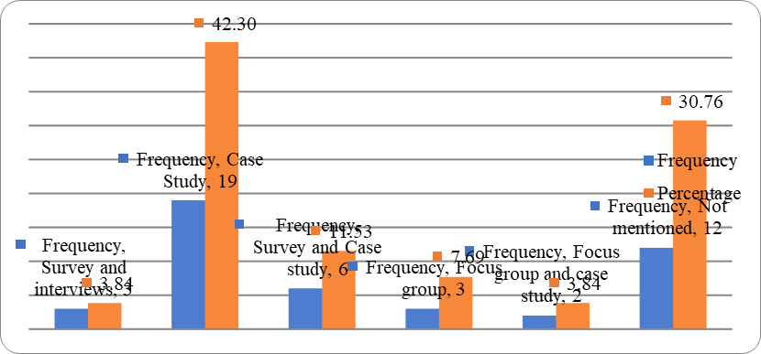

Fig. 2. Framework verification mode

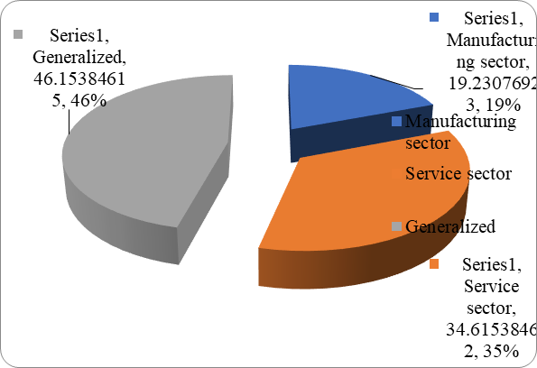

Fig. 3. Framework applicability

3.5 Framework measures

The product of framework is a crucial element in determining its importance. Therefore, it is extremely important to note that what are the main elements being gauged by the framework. The measures of the framework are classified under four elements namely; operational, financial, customer satisfaction and innovation and learning development. The research outcome proves that money related and operational perspectives are widely estimated by detailed frameworks followed by consumer loyalty.

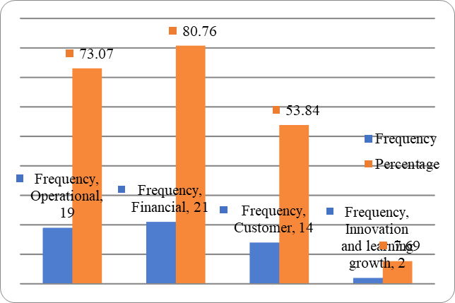

Fig. 4. Framework measures

3.6 Framework design

One of the fundamental criteria is the system setup, which takes into account the organizational structure strategy that was chosen. Researchers' ideas for structural development are also revealed (Moerth-Teo et al., 2021). Four categories—"DMAIC", "top-base methodology", "interpretive auxiliary demonstrating," and "not indicated"—are used to group the systems for this study. It is evident from the data in Table 5 that, with the exception of the DMAIC approach, experts are least likely to accept any other viewpoint. Surprisingly, the majority of frameworks are created based on analyst impressions.

Table 4. Framework design
Design | Framework | Frequency
DMAIC | 5,14,15,16,17,18,19,24,26 | 9
ISM | 6 | 1
Top-bottom approach | 1 | 1

3.7 Framework focus

This classification of system is modified from (Jadoon et al., 2020) where the author researched information executives’ structures and stated that systems can be business center, information learning center and empowering influence center (Kumar et al., 2022). This hierarchy is fundamental, as it analyzes the reason behind the development of structure. The analysis of selected structures indicates that the majority of extreme systems are either business center or empowering influence center; although only few systems are information learning center (Jocic, 2024). Information learning model is a fundamental component of every association which strengthens its establishment. This problem needs to be accompanied by experts while developing SSCM structure in the future.

4. Conclusion, establishment of inconsistencies at three stages covering frameworks, research trends and constructs

After an ordered method designers carried out this investigation, trends were examined in accordance with the research purpose and related coherence needs about a system. As far as designers are aware, no survey contemplation has ever detailed the peculiarities of the current SSCM frameworks and recommendations for the future industry requirements (Hariyani & Mishra, 2022). Some analysts and professionals in the field of SSCM study and implementation have provided their own systems, and there are also survey considerations available. Nevertheless, none of the studies provide a comprehensive overview of system design from the ground up after gaining knowledge of the advantages and disadvantages of existing systems and research trends. Researchers anticipate that this work will have an impact on other fields in addition to stimulating new research and applications in the SSCM field. Such a study is highly recommended by (Sekhar et al., 2023b), who also assert that adaptability and general knowledge of anomalies in existing systems will open the door to the creation of better, region-specific structures.

The primary goal of this analysis, as stated at the outset of the study, was to investigate the anomalies in the current SSCM structures, which were divided into three stages. At three different points in time, creators created irregularity in systems and their constructions.
• System-level irregularities are observed in the first stage. Based on the strengths and weaknesses identified in the SSCM system, the first stage's analysis of the nominated exams reveals that their structures include a non-uniform mix of cost-effective supply chain executives' segments. A lot of scientists ignore the crucial lean perspectives. When it comes to application, this oddity creates confusion on whether to go for a traditional structure or use an area-based approach after making minimal adjustments.

• The second stage irregularity is exhibited at utilization or application level. In the second stage, the shortlisted systems were surveyed by various necessities-based orders to assess the structure curiosity, check, pertinence, plan, center and kind of yield measures. From the nitty gritty examination, one gets genuinely smart thought about the current irregularities concerning picked prerequisites. This comprehension of irregularity unmistakably directs about utilization and research related necessities.

• In the third phase, irregularities are depicted at structure square or build level. Creators strive to explore irregularity at structure square or build level. For this purpose, first the develops of present structures are arranged. From this exploration one receives truly brilliant idea about the present irregularity winning at build level. Creators show about the irregularities as well as guide with respect to the new prerequisites of industry and as needs be recommend, four new arrangements of develops and sub-builds. Creators trust this expansion will be helpful for the two specialists and professionals.

This analysis consideration further contributes towards refinement of SSCM structures unveiled by some authors in their works. This study also categorizes the interviewed structures for understanding SSCM structures examination patterns better.

5. Implications for researchers and practitioners

Both the SSCM structure and its constructions are necessary for a blend design like that. When all is said and done, only one of the “outlines” and "parts within the edge" can provide the flawless final product that is anticipated from a cross-breed design like SSCM. In this sense, the development of a rational system necessitates commitments from both networks with a clear grasp of the structure and its squares. While working toward its implementation and practical suitability, the expert helps build the theoretical underpinnings and methodological features of a structure. They both enhance and enhance one another. It becomes necessary to periodically assess whether the structure is functioning effectively or requires adjustment. The availability of a general image facilitates this change. As a result, a proper framework that has undergone major adjustments makes it easier for professionals to carry out the complete operation. Similar to this, a suitable structure that may cover all the elements and make implementation simple is necessary for a blending strategy like SSCM. The study reports on the following pledges and suggestions.

It's interesting to note that the role of sustainability and supportability was incorporated into the frameworks of restricted SSCM systems. However, the current situation is moving toward cleaner creation, and experts judge any method that ignores these perspectives as inadequate and unsatisfactory. The aforementioned points of view can be altered by the researchers in order to create new SSCM systems that will be more quickly adopted by businesses. In a similar vein, innovators think that their efforts to incorporate current technologies like data analytics and the Internet of Things (IOT) are novel and encourage new studies and advancements in the field of SSCM.

This study proposes the fundamental foundation of SSCM system fixes (builds), which can be expanded upon other researchers to create the full SSCM framework. The proposed builds integrate the advancements of existing SSCM systems with the additional current construction requirements put forth by certain professionals to satisfy contemporary demands.

According to the research, the current SSCM frameworks did not incorporate the proper quantity of real-world supply chain experience that executives should have brought to the creation of the SSCM system. According to experts, the main goal of SSCM structure implementation is to manage the quality (six sigma) dimensions in the same proportion as the elimination of waste (lean). The analysts can move forward in these directions to design the SSCM system, which might offer the best possible combination of feasible supply chain management tools.

Although one learns from the survey that the particular inclusion in relation to developments in the studies necessitates learning about these structure squares in order for specialists to employ SSCM while taking into account the obvious requirements of their field. Scientists and experts learn from these investigations that there is a stage available, but that there are also the primary requirements for a thorough integration of develops and subbuilds. The specialists additionally communicate this need to choose a plan for their SSCM application approaches in order to expedite the adoption of SSCM. It is also communicated that present systems must be modified when existing builds and gaps have been understood. The designers think their project will meet the two networks' requirements.

6. Limitations and future scope of the study

People who are unfamiliar with SSCM may think it's hard to implement because of the structure's increased complexity due to the vast number of developments inside the system as a whole. But with the right instruction and the help of a qualified coach or specialist, this shortcoming can be overcome. Although it does not offer any structure, the current study compiles the existing SSCM system developments and also indicates the need for more developments that might make the SSCM structure comprehensive. It does seem like there is a lack of study. Nevertheless, it is stated at the outset that the goal of the current study is to find anomalies in the SSCM systems that are in place. The constructs shown in the analysis should be used by the researchers to create a complete system and validate it across many mechanical domains so that experts can use it to apply SSCM effectively in the future. When evaluating each development as a whole, the developers never considered the risk. In addition to helping scientists and specialists create beneficial structures by avoiding anomalies, the developers hope their research project will prove to be application friendly. This will hasten departmental adoption of SSCM.

7. Recommendation for an Enhanced SSCM Framework

From the evidence of this study, an enhanced Sustainable Supply Chain Management (SSCM) framework should correct the inconsistencies found in current models. The following are recommended:

• Standardization of SSCM Structures: To minimize inconsistencies, a consistent and flexible framework should be designed, including necessary constructs like lean management, environmental sustainability, and digital integration.

• Holistic Framework Structure: A systematic framework that combines DMAIC, top-bottom approach, and interpretive structural modeling must be applied to achieve completeness and flexibility across various industries.

• Verification and Validation: New SSCM frameworks in the future should be tested rigorously by using industry case studies, empirical research, and expert validation to improve their applicability and validity.

• Integration of Advanced Technologies: Advanced technologies like IoT, data analytics, and AI must be integrated into SSCM frameworks to enhance visibility, traceability, and decision-making effectiveness.

• Balanced Approach to Lean and Quality Management: The framework must prioritize eliminating waste while producing high-quality outputs through a hybrid combination of lean and six sigma principles.

• Domain-Specific Adaptability: The SSCM framework must be able to offer adaptability to meet the needs of both manufacturing and service sectors to ensure sector-specificity that fosters greater adoption.

These guidelines are intended to improve the robustness, effectiveness, and applicability of SSCM frameworks for successful implementation in contemporary industrial settings.

References

Abate, S. G., & Anteneh, M. B. (2024). Assessment of agricultural land suitability for cereal crops based on the analysis of soil physico-chemical characteristics. Environmental Systems Research, 13(1). https://doi.org/10.1186/s40068-024-00333-y
Abideen, A. Z., Sundram, V. P. K., Pyeman, J., Othman, A. K., & Sorooshian, S. (2021). Food Supply Chain Transformation through Technology and Future Research Directions—A Systematic Review. In Logistics (Vol. 5, Issue 4). MDPI. https://doi.org/10.3390/logistics5040083
Abukhamis, F., & Abdelhadi, A. (2022). A Critical Analysis of Agile and Lean Methodology to Fulfill the Project Management Gaps in Nonprofit Organizations (NPOs). Applied Sciences (Switzerland), 12(11). https://doi.org/10.3390/app12115467
Aisyah, S., Purba, H. H., Jaqin, C., Amelia, Z. R., & Adiyatna, H. (2021). Identification of implementation Lean, Agile, Resilient and Green (LARG) approach in indonesia automotive industry. Journal Europeen Des Systemes Automatises, 54(2), 317–324. https://doi.org/10.18280/JESA.540214
Algorri, M., Abernathy, M. J., Cauchon, N. S., Christian, T. R., Lamm, C. F., & Moore, C. M. V. (2022a). Re-Envisioning Pharmaceutical Manufacturing: Increasing Agility for Global Patient Access. In Journal of Pharmaceutical Sciences (Vol. 111, Issue 3, pp. 593–607). Elsevier B.V. https://doi.org/10.1016/j.xphs.2021.08.032
Algorri, M., Abernathy, M. J., Cauchon, N. S., Christian, T. R., Lamm, C. F., & Moore, C. M. V. (2022b). Re-Envisioning Pharmaceutical Manufacturing: Increasing Agility for Global Patient Access. In Journal of Pharmaceutical Sciences (Vol. 111, Issue 3, pp. 593–607). Elsevier B.V. https://doi.org/10.1016/j.xphs.2021.08.032
Allen, G. J. (2022). ConcepturealizeTM: a new contribution to generate real-needs-focussed, user-centred, lean business models. Journal of Innovation and Entrepreneurship, 11(1). https://doi.org/10.1186/s13731-022-00198-4
Ariadi, G., Surachman, Sumiati, & Rohman, F. (2021). The effect of lean and agile supply chain strategy on financial performance with mediating of strategic supplier integration & strategic customer integration: Evidence from bottled drinking-water industry in Indonesia. Cogent Business and Management, 8(1). https://doi.org/10.1080/23311975.2021.1930500
Besseris, G. (2021). Fast, lean-and-agile, multi-parameter multi-trending robust quality screening in a 3D-printed product. Advances in Industrial and Manufacturing Engineering, 3. https://doi.org/10.1016/j.aime.2021.100051
Bottani, E., Bigliardi, B., & Rinaldi, M. (2022). Development and proposal of a LARG (lean, agile, resilient, green) performance measurement system for a food supply chain. IFAC-PapersOnLine, 55(10), 2437–2444. https://doi.org/10.1016/j.ifacol.2022.10.074
Çalık, A. (2021). A novel Pythagorean fuzzy AHP and fuzzy TOPSIS methodology for green supplier selection in the Industry 4.0 era. Soft Computing, 25(3), 2253–2265. https://doi.org/10.1007/s00500-020-05294-9
Darvazeh, S. S., Mooseloo, F. M., Vandchali, H. R., Tomaskova, H., & Tirkolaee, E. B. (2022). An integrated multi-criteria decision-making approach to optimize the number of leagile-sustainable suppliers in supply chains. Environmental Science and Pollution Research, 29(44), 66979–67001. https://doi.org/10.1007/s11356-022-20214-0
Digalwar, A., Raut, R. D., Yadav, V. S., Narkhede, B., Gardas, B. B., & Gotmare, A. (2020). Evaluation of critical constructs for measurement of sustainable supply chain practices in lean-agile firms of Indian origin: A hybrid ISM-ANP approach. Business Strategy and the Environment, 29(3), 1575–1596. https://doi.org/10.1002/bse.2455
ForouzeshNejad, A. A. (2023). Leagile and sustainable supplier selection problem in the Industry 4.0 era: a case study of the medical devices using hybrid multi-criteria decision making tool. Environmental Science and Pollution Research, 30(5), 13418–13437. https://doi.org/10.1007/s11356-022-22916-x
Frau, M., Moi, L., Cabiddu, F., & Keszey, T. (2022a). Time to clean up food production? Digital technologies, nature-driven agility, and the role of managers and customers. Journal of Cleaner Production, 377. https://doi.org/10.1016/j.jclepro.2022.134376
Frau, M., Moi, L., Cabiddu, F., & Keszey, T. (2022b). Time to clean up food production? Digital technologies, nature-driven agility, and the role of managers and customers. Journal of Cleaner Production, 377. https://doi.org/10.1016/j.jclepro.2022.134376
Hariyani, D., & Mishra, S. (2022). Drivers for the adoption of integrated sustainable green lean six sigma agile manufacturing system (ISGLSAMS) and research directions. In Cleaner Engineering and Technology (Vol. 7). Elsevier Ltd. https://doi.org/10.1016/j.clet.2022.100449
Jadoon, G., Din, I. U., Almogren, A., & Almajed, H. (2020). Smart and agile manufacturing framework, a case study for automotive industry. Energies, 13(21). https://doi.org/10.3390/en13215766
Javaid, M., Haleem, A., Singh, R. P., & Gupta, S. (2024). Leveraging lean 4.0 technologies in healthcare: An exploration of its applications. Advances in Biomarker Sciences and Technology, 6, 138–151. https://doi.org/10.1016/j.abst.2024.08.001
Jocic, D. (2024). Psychological safety perception in community pharmacies: A randomized controlled trial of agile interventions. Exploratory Research in Clinical and Social Pharmacy, 14. https://doi.org/10.1016/j.rcsop.2024.100452
Junejo, I., Campus, H., Mehtab, P., & Siddiqui, B. (2022). Sustainable Business and Society in Emerging Economies Role of Agile and Lean Supply Chain Strategy on Firm Performance: Evidence from Drinking-Water Industry of Sindh, Pakistan. Sustainable Business and Society in Emerging Economies, 4(2). www.publishing.globalcsrc.org/jbsee
Kumar, R., Singh, K., & Jain, S. K. (2022). Assessment of Agile manufacturing impact on business performance of Indian manufacturing industry: A PLS-SEM approach. Sustainable Manufacturing and Service Economics, 1, 100001. https://doi.org/10.1016/j.smse.2022.100001
Lang, J., Dörner, A., & Abels-Schlosser, S. (2024, June 6). Digital Kanban for Agile Production Planning and Scheduling in Automotive Supplier Industry. https://doi.org/10.46254/an14.20240025
Li, X., & Martins, A. L. (2024a). Leagility in the healthcare research: a systematic review. In BMC Health Services Research (Vol. 24, Issue 1). BioMed Central Ltd. https://doi.org/10.1186/s12913-024-10771-0
Li, X., & Martins, A. L. (2024b). Leagility in the healthcare research: a systematic review. In BMC Health Services Research (Vol. 24, Issue 1). BioMed Central Ltd. https://doi.org/10.1186/s12913-024-10771-0
Mathiyazhagan, K., Agarwal, V., Appolloni, A., Saikouk, T., & Gnanavelbabu, A. (2021). Integrating lean and agile practices for achieving global sustainability goals in Indian manufacturing industries. Technological Forecasting and Social Change, 171. https://doi.org/10.1016/j.techfore.2021.120982
Moerth-Teo, O., Weger, F., & Ramsauer, C. (2021). Design for Agile Manufacturing: Product Design Principles that Enhance Agile Manufacturing of Powertrain Systems. Journal of Industrial and Intelligent Information, 7–14. https://doi.org/10.18178/jiii.9.1.7-14
Mohammadzadeh, M., Sobhanallahi⇔, M., & Khamseh, A. A. (2020). Closed loop supply chain mathematical modeling considering lean agile resilient and green strategies. Croatian Operational Research Review, 11(2), 177–197. https://doi.org/10.17535/crorr.2020.0015
Niekurzak, M., Lewicki, W., Coban, H. H., & Bera, M. (2023). A Model to Reduce Machine Changeover Time and Improve Production Efficiency in an Automotive Manufacturing Organisation. Sustainability (Switzerland), 15(13). https://doi.org/10.3390/su151310558
Oliveira-Dias, D. d. , M. M. J. M. and M.-F. J. (2022). “Lean and agile supply chain strategies: the role of mature and emerging information technologies.” The International Journal of Logistics Management, 33(5), 221–243. https://doi.org/10.13039/501100011033
Overbeck, L., Voigtländer, S., & Lanza, G. (2023). Optimal line configurations for agile production systems for battery cell manufacturing. Procedia CIRP, 118, 976–981. https://doi.org/10.1016/j.procir.2023.06.168
Pasławski, J., & Rudnicki, T. (2021). Agile/flexible and lean management in ready-mix concrete delivery. Archives of Civil Engineering, 67(1), 689–709. https://doi.org/10.24425/ace.2021.136497
Paulmani, G. (2020). Improving research skills with lean-agile-based instruction: Lean-agile led, analytics oriented platform for flexible, self-regulated, inclusive learning. Proceedings - IEEE 20th International Conference on Advanced Learning Technologies, ICALT 2020, 387–389. https://doi.org/10.1109/ICALT49669.2020.00122
Qureshi, F., Ellahi, A., Javed, Y., Rehman, M., & Rehman, H. M. (2023). Empirical investigation into impact of IT adoption on supply chain agility in fast food sector in Pakistan. Cogent Business and Management, 10(1). https://doi.org/10.1080/23311975.2023.2170516
Sekhar, R., Solke, N., & Shah, P. (2023a). Lean Manufacturing Soft Sensors for Automotive Industries. Applied System Innovation, 6(1). https://doi.org/10.3390/asi6010022
Sekhar, R., Solke, N., & Shah, P. (2023b). Lean Manufacturing Soft Sensors for Automotive Industries. Applied System Innovation, 6(1). https://doi.org/10.3390/asi6010022
Sharma, M., Antony, R., & Tsagarakis, K. (2023). Green, resilient, agile, and sustainable fresh food supply chain enablers: evidence from India. Annals of Operations Research. https://doi.org/10.1007/s10479-023-05176-x
Sheykhzadeh, M., Ghasemi, R., Vandchali, H. R., Sepehri, A., & Torabi, S. A. (2024). A hybrid decision-making framework for a supplier selection problem based on lean, agile, resilience, and green criteria: a case study of a pharmaceutical industry. Environment, Development and Sustainability. https://doi.org/10.1007/s10668-023-04135-7
Soares, D., da Silva, F. J., Ramos, S. C. F., Kirytopoulos, K., Sá, J. C., & Ferreira, L. P. (2022). Identifying Barriers in the Implementation of Agile Methodologies in Automotive Industry. Sustainability (Switzerland), 14(9). https://doi.org/10.3390/su14095453
Widiwati, I. T. B., Liman, S. D., & Nurprihatin, F. (2024). The implementation of Lean Six Sigma approach to minimize waste at a food manufacturing industry. Journal of Engineering Research (Kuwait)

