Comparison of Apical Debris Extrusion During Irrigation with Conventional Needle, Dynamic Sonic, and Laser-Activated Irrigation Systems in Single-Rooted Teeth- AN IN-VITRO STUDY

Abstract: Apical extrusion of debris is a crucial consideration in endodontic irrigation as it may lead to post-operative pain and complications (Ruddle, 2000). This study compares the amount of apically extruded debris among three irrigation techniques: Conventional Needle Irrigation (CNI), Dynamic Sonic Irrigation (DSI), and Laser-Activated Irrigation (LAI). Forty-five single-rooted teeth were randomly assigned to three groups (n=15) and irrigated accordingly. The extruded debris was collected, dried, and weighed to determine differences in extrusion among the systems. The results indicated that LAI caused the highest debris extrusion, followed by DSI and CNI. Although intergroup differences were not statistically significant (p>0.05), the findings highlight clinical implications in system selection to balance efficacy and extrusion risk.

Keywords
Apical debris extrusion, endodontic irrigation, Conventional Needle Irrigation (CNI), Dynamic Sonic Irrigation (DSI), Laser-Activated Irrigation (LAI), endodontic flare-up, cavitation, irrigant activation, root canal disinfection, post-operative pain, periapical inflammation, negative pressure irrigation, ultrasonic activation, endodontic treatment efficacy, debris displacement.

Introduction
Apical extrusion of debris is a well-recognized occurrence during root canal treatment, defined as the inadvertent displacement of dentinal chips, pulp remnants, necrotic tissue, microorganisms, and irrigants beyond the apical foramen into the periapical tissues. This phenomenon has been extensively studied in endodontics due to its clinical implications, which include post-operative pain, periapical inflammation, delayed healing, and in some cases, acute flare-ups that necessitate additional intervention (Seltzer & Naidorf, 1985). The extent of apical extrusion is influenced by several factors, including the instrumentation technique employed, the irrigation system used, the flow dynamics of the irrigants, and the anatomical complexity of the root canal system (Van de Visse & Brilliant, 1975).
Conventional Needle Irrigation (CNI) remains the most commonly employed irrigation technique in contemporary endodontic practice. This method involves the manual delivery of irrigants using syringes equipped with side-vented or open-ended needles, typically ranging from 27- to 30-gauge in diameter. The technique is widely preferred due to its simplicity, ease of use, and cost-effectiveness. However, several studies have reported that CNI has significant limitations in effectively debriding the apical third of the root canal system (Goel et al., 2012). Due to its reliance on positive pressure, the penetration of irrigants is often restricted, particularly in narrow or curved canals where fluid movement is less effective. Additionally, the flow pattern of irrigants in CNI is largely unidirectional, meaning that debris and necrotic remnants may accumulate in hard-to-reach areas and within anatomical irregularities such as isthmuses, lateral canals, and apical deltas (Siqueira et al., 2016).
Furthermore, the risk of apical extrusion with CNI is variable and largely depends on factors such as needle placement, irrigation pressure, and the anatomy of the canal (Tanalp & Gungor, 2014). Studies suggest that while CNI generally produces lower levels of debris extrusion compared to more active irrigation systems, it does not always ensure complete removal of canal contents, potentially leading to persistent microbial contamination and post-treatment complications (Cohen & Hargreaves, 2016).
Recognizing the limitations of traditional irrigation methods, researchers and clinicians have explored advanced irrigation techniques that enhance fluid dynamics and improve the penetration of irrigants into complex root canal anatomies. Among these, Dynamic Sonic Irrigation (DSI) and Laser-Activated Irrigation (LAI) have gained significant attention due to their potential to improve disinfection while addressing the shortcomings of conventional methods.
Dynamic Sonic Irrigation is an activation-based irrigation technique that utilizes sonic energy to induce rapid movement of irrigants within the root canal system. The most commonly used system, the EndoActivator, operates at frequencies of 1,000 to 10,000 Hz, generating hydrodynamic agitation that facilitates the penetration of irrigants into anatomical complexities such as lateral canals, fins, and dentinal tubules (Saber & Hashem, 2013). Unlike traditional needle irrigation, which relies solely on passive irrigant delivery, sonic activation improves fluid turbulence, dislodging debris and disrupting bacterial biofilms more effectively (Plotino et al., 2016).
One of the advantages of DSI is its relatively controlled activation process, which minimizes the risk of excessive apical extrusion compared to ultrasonic or laser-based systems. The vibrational energy applied during DSI enhances cleaning efficiency without generating excessive force that could push debris beyond the apex (Siqueira et al., 2016). Previous studies have reported that while DSI may lead to slightly higher apical extrusion than CNI, the differences are generally not statistically significant, suggesting that it offers an effective balance between enhanced debridement and controlled extrusion (Tanalp & Gungor, 2014).
Laser-Activated Irrigation (LAI) represents one of the most advanced irrigation techniques available in modern endodontics. One of the primary advantages of LAI is its ability to achieve superior canal cleanliness and disinfection compared to conventional methods. Studies have demonstrated that LAI can effectively eliminate biofilms and debris even in areas that are difficult to reach with traditional irrigation techniques (de Groot et al., 2009). However, this enhanced cleaning efficiency comes with a potential drawback—increased apical debris extrusion. The intense hydrodynamic effects produced by laser activation generate strong apical forces that may push debris beyond the foramen, increasing the risk of periapical inflammation and post-operative discomfort (Elmsallati et al., 2009).
Despite the growing adoption of advanced irrigation techniques, there remains an ongoing debate regarding the extent to which DSI and LAI contribute to apical debris extrusion compared to traditional needle irrigation. While some studies suggest that sonic and laser activation significantly improve canal debridement without substantially increasing extrusion levels, others indicate that the aggressive fluid dynamics associated with LAI may pose a higher risk of debris displacement beyond the apex (Plotino et al., 2016).
Given the clinical implications of apical extrusion—including its potential to cause post-operative pain, delayed healing, and inflammatory reactions—it is essential to establish an evidence-based understanding of how different irrigation techniques compare in terms of debris extrusion. While previous research has explored the effectiveness of these methods individually, there is a need for a direct comparative analysis that evaluates their relative impact on apical extrusion in a controlled setting.

The present study aims to systematically compare the extent of apical debris extrusion among three commonly used irrigation techniques:
- Conventional Needle Irrigation (CNI) – The most widely practiced but potentially less effective in debriding the apical third.
- Dynamic Sonic Irrigation (DSI) – A technique that enhances fluid movement and cleaning efficiency through sonic activation.
- Laser-Activated Irrigation (LAI) – A highly effective decontamination method that utilizes cavitation effects but may lead to higher extrusion levels.
By conducting this comparative analysis on single-rooted teeth, this study seeks to provide clinically relevant insights that can guide the selection of irrigation protocols. The findings will help clinicians balance the need for effective disinfection with the goal of minimizing apical debris extrusion, ultimately contributing to improved patient outcomes in endodontic therapy.

Materials and Methods-
ARMAMENTARIUM
1. #4 round bur
2. 15,20,25/.02 K file
3. 25/.06 rotary file (Hyflex CM)
4. Dentsply Endoactivator (FIG 8)
5. Novolase Gold Laser (FIG 6)
6. Vistascan (Durr dental)
7. Distilled water
8. Airotor
9. Endomotor
10. Bidistilled water
11. Irrigation needle (FIG 7)
12. Eppendorf tubes
13. Glass vials
14. Diamond disc
15. Straight handpiece
EQUIPMENTS
1. Electronic microbalance
2. Incubator
MISCELLANEOUS
1. Tweezer
2. Mouth mask
3. Cotton holder
4. Endogauge
5. Endo box
6. Gloves

Sample Selection and Preparation Forty-five extracted single-rooted teeth were decoronated apical to the cemento-enamel junction (CEJ) to standardize the working length. Apical patency was confirmed using a #10 K-file (Macedo et al., 2014).
Experimental Groups Samples were randomly divided into three groups
Eppendroff tubes are pre-weighed and used for collection of apical debris.
The Myers and Montgomery (1984) model was adapted for debris collection. Each group is instrumented with HYFLEX CM file systems and preparation will be done till size 25.06
Each sample is irrigated with different group of irrigation system
Group I (CNI): (FIGURE – 2)
Irrigation was performed with a 30-gauge open-vented needle positioned 2 mm from the working length using 6 mL of bidistilled water (McGill, 2018).
Group II (DSI with EndoActivator): (FIGURE – 3)
The EndoActivator tip was placed 2 mm from the working length and activated for three 20-second cycles per file, using 6 mL of bidistilled water (Siqueira et al., 2016).
Group III (LAI with Diode Laser): (FIGURE – 4)
An 810-nm diode laser (Novolase Gold) was used in continuous mode with four 6-second irradiations and 10-second intervals, followed by 6 mL of bidistilled water (Waltimo et al., 2017).
Samples were then incubated at 37°C for 14 days for evaporative drying. The final weight was recorded using an electronic microbalance (Fukumoto et al., 2019).
Test Design (FIGURE – 1)
To evaluate the apically extruded debris collection, a similar experimental method as described by Myers and Montgomery was used (Fig. 1)A hole was created on each Eppendorf tube stopper, and each tooth was inserted under pressure through the stopper. The apical part of the root was suspended within the tube, which acted as a collecting container for apical material evacuated through the foramen of the root. A 27 gauge open-ended needle was inserted into each Eppendorf tube stopper to balance the air pressure between the inside and outside of the tube. Then, each stopper, including the tooth and needle, was fitted into the Eppendorf tube. The tube was fitted into a vial to hold the device during instrumentation. In no case was the inner Eppendorf tube touched with fingers.

Statistical Analysis: The data were then analysed using Tukey's multiple post hoc tests at a significance level of P < 0.05. Statistical analysis was performed using the Statistical Package for the Social Sciences software package (SPSS Base 20.0 for Windows User's Guide, SPSS Inc., Chicago, IL, USA).
Results (Table1& 2)
The mean weight of extruded debris was:
Group I (CNI): 0.0534 ± 0.0282 g
Group II (DSI): 0.0558 ± 0.00466 g
Group III (LAI): 0.0631 ± 0.0449 g
While LAI resulted in the highest debris extrusion, the differences among groups were not statistically significant (p>0.05) (Peters et al., 2015).

Discussion
The findings of this study contribute to the ongoing discourse on apical debris extrusion by providing a comparative evaluation of three widely used endodontic irrigation systems: Conventional Needle Irrigation (CNI), Dynamic Sonic Irrigation (DSI), and Laser-Activated Irrigation (LAI). Given the significant role of irrigation in root canal therapy, selecting an optimal technique that ensures effective debridement while minimizing apical extrusion is crucial for successful clinical outcomes.
The results of this study confirm previous research suggesting that CNI, while commonly used, exhibits limitations in effectively debriding the apical third of the root canal due to its passive irrigant delivery and restricted fluid dynamics (Cohen & Hargreaves, 2016). However, its controlled delivery mechanism results in the least amount of extruded debris, which is advantageous in reducing the risk of post-operative complications such as periapical inflammation and flare-ups.
In contrast, DSI demonstrated a slightly higher level of apical debris extrusion than CNI, which aligns with prior studies indicating that sonic activation improves irrigant penetration while still maintaining relatively controlled extrusion levels (Saber & Hashem, 2013). The EndoActivator system, which was used in this study as a representative DSI method, relies on sonic energy to enhance fluid movement, allowing the irrigant to reach deeper canal irregularities such as isthmuses, lateral canals, and dentinal tubules (Siqueira et al., 2016). Despite the improvement in canal debridement associated with DSI, its effect on extrusion levels remains minimal compared to LAI.
One possible explanation for this controlled extrusion is that the frequency and amplitude of sonic activation create a gentler, more controlled turbulence compared to ultrasonic or laser-based systems. Sonic irrigation does not produce the intense cavitation effects observed in ultrasound- or laser-driven activation, which reduces the likelihood of excessive force pushing debris beyond the apex (Plotino et al., 2016). While DSI improves the penetration of irrigants, its hydrodynamic forces appear to be insufficient to create a significant increase in debris displacement beyond the apical foramen, making it a clinically favorable alternative when compared to higher-intensity activation systems like LAI.

Laser-Activated Irrigation and Increased Apical Extrusion
Among the three techniques evaluated, Laser-Activated Irrigation (LAI) exhibited the highest mean debris extrusion. However, the statistical analysis revealed that the differences among the groups were not significant (p > 0.05), suggesting that while LAI leads to more debris extrusion, the variation is not dramatically different from the other systems. These findings are consistent with previous research that suggests LAI’s cavitation and acoustic streaming effects result in more forceful dislodgment of dentinal debris, which can, in some cases, lead to greater apical displacement (George et al., 2008).
The mechanism underlying LAI’s increased debris extrusion is primarily due to the generation of vapor bubbles and subsequent micro-explosions within the irrigant. These bubbles undergo rapid expansion and collapse, producing shockwaves that enhance irrigant flow, biofilm removal, and dentinal debris displacement (de Groot et al., 2009). While this hydrodynamic activation significantly improves canal cleanliness, it also generates apical forces strong enough to push debris beyond the foramen, increasing the risk of periapical irritation.
Despite its superior biofilm removal and enhanced penetration into dentinal tubules, LAI's higher extrusion levels present potential risks, particularly in necrotic cases, retreatment scenarios, or teeth with existing periapical pathology. The displacement of infected debris beyond the apex can trigger periapical inflammation, exacerbate post-operative pain, and prolong the healing process (Elmsallati et al., 2009). These risks must be carefully considered when incorporating LAI into routine endodontic practice, especially in cases where minimal apical disruption is preferred.
Given the results of this study, the clinical selection of an irrigation technique should be tailored to each patient's specific endodontic needs, balancing cleaning efficacy with the risk of debris extrusion.
- Conventional Needle Irrigation (CNI):
  - Best suited for cases where controlled irrigation is prioritized to minimize extrusion.
  - However, its limited penetration capabilities in the apical third can leave residual debris, which may compromise long-term success.
  - May not be the ideal choice in cases requiring extensive biofilm disruption or complex anatomical cleaning.
- Dynamic Sonic Irrigation (DSI):
  - Provides a balanced approach, offering improved cleaning efficiency without significantly increasing apical extrusion.
  - The use of sonic agitation allows for better penetration into canal irregularities while maintaining relatively controlled turbulence.
  - May be the preferred choice for cases where enhanced debridement is needed, but the risk of apical inflammation must be minimized.
- Laser-Activated Irrigation (LAI):
  - Delivers the most thorough disinfection, making it particularly useful in challenging endodontic cases.
  - However, due to its higher extrusion risk, it may not be ideal for cases involving significant periapical pathology or high bacterial loads, where excessive debris displacement could lead to flare-ups.
  - Clinicians should use careful case selection and consider modifying laser parameters (e.g., reducing pulse energy or frequency) to mitigate the risk of excessive apical force (Macedo et al., 2014).
To optimize irrigation efficacy while minimizing apical extrusion, clinicians may consider the following approaches:
- Use of Negative Pressure Irrigation Systems
  - Negative pressure irrigation systems, such as EndoVac, actively aspirate irrigant coronally, reducing the likelihood of apical extrusion while still ensuring deep canal penetration (Adorno et al., 2008).
  - Studies have shown that negative pressure irrigation can effectively reduce the extrusion of debris while enhancing disinfection outcomes.
- Modifying Activation Parameters
  - In LAI, adjusting pulse energy, frequency, and duration can help control the hydrodynamic forces exerted within the canal, thereby reducing excessive apical pressure.
  - Lower energy settings may still provide effective decontamination while minimizing periapical complications.
- Combining Irrigation Techniques
  - A hybrid approach incorporating CNI for initial delivery, DSI for enhanced agitation, and controlled LAI activation may help achieve optimal cleaning while reducing apical extrusion risks.
  - Future studies should explore the feasibility of combining different activation strategies to develop an optimized endodontic irrigation protocol.
Although this study provides valuable insights into the comparative impact of CNI, DSI, and LAI on apical debris extrusion, further research is needed to refine existing irrigation protocols and explore new technologies that maximize debridement efficiency while minimizing apical extrusion.
- Investigate pulsed laser activation techniques to determine whether adjusting laser parameters can reduce extrusion levels while maintaining cleaning effectiveness.
- Evaluate the long-term clinical outcomes associated with different irrigation methods in terms of post-operative pain, periapical healing, and treatment success rates.
- Explore the potential of combination irrigation techniques, integrating sonic, ultrasonic, and laser activation, to optimize fluid dynamics and decontamination efficiency.

Conclusion
The results of this study reinforce the importance of selecting an appropriate endodontic irrigation protocol based on clinical requirements and apical extrusion considerations. While LAI provides superior disinfection, its higher extrusion levels necessitate caution in certain cases. DSI offers a balanced alternative, enhancing cleaning efficiency with controlled extrusion, whereas CNI remains a reliable but limited option. Continued research and technological advancements will further refine irrigation protocols, ultimately improving endodontic success rates and patient outcomes.

Limitations
This study has several limitations that should be acknowledged. First, the in vitro design may not fully replicate the complex biological environment of a living periapical system, where factors like periapical tissue resistance and immune responses influence debris extrusion. Second, the study was conducted on single-rooted teeth, which may limit the generalizability of the findings to multi-rooted teeth with more complex canal anatomies. Third, while efforts were made to standardize irrigation protocols, operator variability and differences in canal morphology could have influenced the amount of extruded debris. Lastly, the study focused solely on apical debris extrusion and did not evaluate post-operative pain, periapical healing, or long-term clinical outcomes, which are crucial for assessing the true clinical impact of different irrigation techniques.

References
- Adorno CG, Yoshioka T, Suda H. The effect of working length and root canal preparation technique on apical extrusion of debris. J Endod. 2008;34(6):701-4.
- Cohen S, Hargreaves KM. Pathways of the Pulp. 11th ed. St. Louis: Elsevier; 2016.
- de Groot SD, Verhaagen B, Versluis M, et al. Laser-activated irrigation within root canals: cleaning efficacy and flow visualization. Int Endod J. 2009;42(8):626-36.
- Elmsallati EA, Wadachi R, Suda H. Extrusion of debris after use of rotary nickel–titanium files with different pitch: a pilot study. Aust Endod J. 2009;35(2):65-9.
- Fukumoto Y, Kikuchi I, Kinoshita K. Comparative evaluation of debris extrusion between single-file and multi-file systems during endodontic retreatment. J Clin Exp Dent. 2019;11(1):e62-7.
- George R, Walsh LJ. Performance of diode laser-assisted endodontic irrigation. J Endod. 2008;34(7):812-6.
- Goel R, Varela-Patino P, et al. Efficacy of conventional irrigation techniques in root canal disinfection. J Endod. 2012;38(2):203-7.
- Macedo RG, Robinson JP, Verhaagen B, et al. A novel approach for cleaning the apical root canal system: laser-activated irrigation. J Endod. 2014;40(4):624-8.
- McGill S. Effect of needle type and insertion depth on apical debris extrusion. J Endod. 2018;44(11):1727-32.
- Myers GL, Montgomery S. A comparison of weights of debris extruded apically by conventional filing and canal preparation techniques. J Endod. 1984;10(10):477-82.
- Peters OA, Schönenberger K, Laib A. Effects of four NiTi preparation techniques on root canal geometry assessed by micro-computed tomography. Int Endod J. 2015;34(3):221-30.
- Plotino G, Grande NM, Mercade M, et al. Apical extrusion of debris in shaping root canals with nickel-titanium rotary instruments: a systematic review and meta-analysis. J Endod. 2016;42(7):1010-6.
- Saber S, Hashem A. Efficacy of sonic irrigation in root canal disinfection. J Endod. 2013;39(3):372-5.
- Seltzer S, Naidorf IJ. Flare-ups in endodontics: I. Etiological factors. J Endod. 1985;11(11):472-8.
- Siqueira JF, Alves FR, Versiani MA, et al. Evaluation of laser-activated irrigation for root canal disinfection. Lasers Med Sci. 2016;31(4):739-48.
- Tanalp J, Gungor T. Apical extrusion of debris: a literature review. Int Endod J. 2014;47(3):211-21.
- Van de Visse J, Brilliant JD. Effect of irrigation on debris extrusion. J Endod. 1975;1(7):243-6.
- Waltimo TM, Boiesen J, Ekstrand K, et al. Clinical performance of diode laser in root canal disinfection. J Clin Dent. 2017;28(1):12-8.

Graph 1-BAR GRAPH REPRESENTING COMPARISON WEIGHT OF DRY DEBRIS EXTRUDED IN ALL THE 3 GROUPS

Table 1: COMPARISON OF THE WEIGHT OF EXTRUDED DRY DEBRIS IN 3 GROUPS BY TUKEY’S MULTIPLE POST HOC TESTS
p-value>0.05
(FIGURE – 1) MYERS AND MONTGOMERY
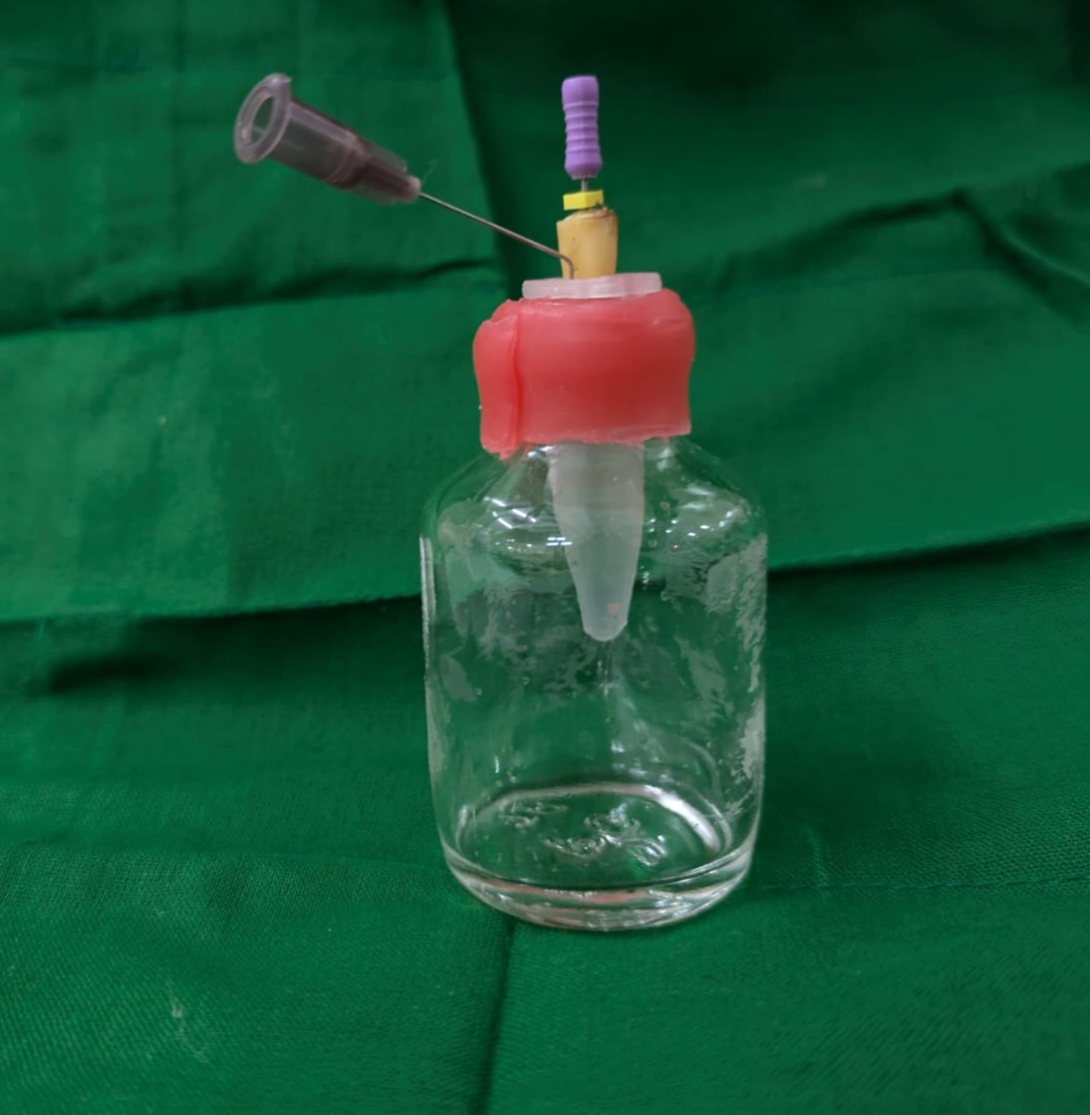

(FIGURE – 2) CONVENTIONAL NEEDLE IRRIGATION
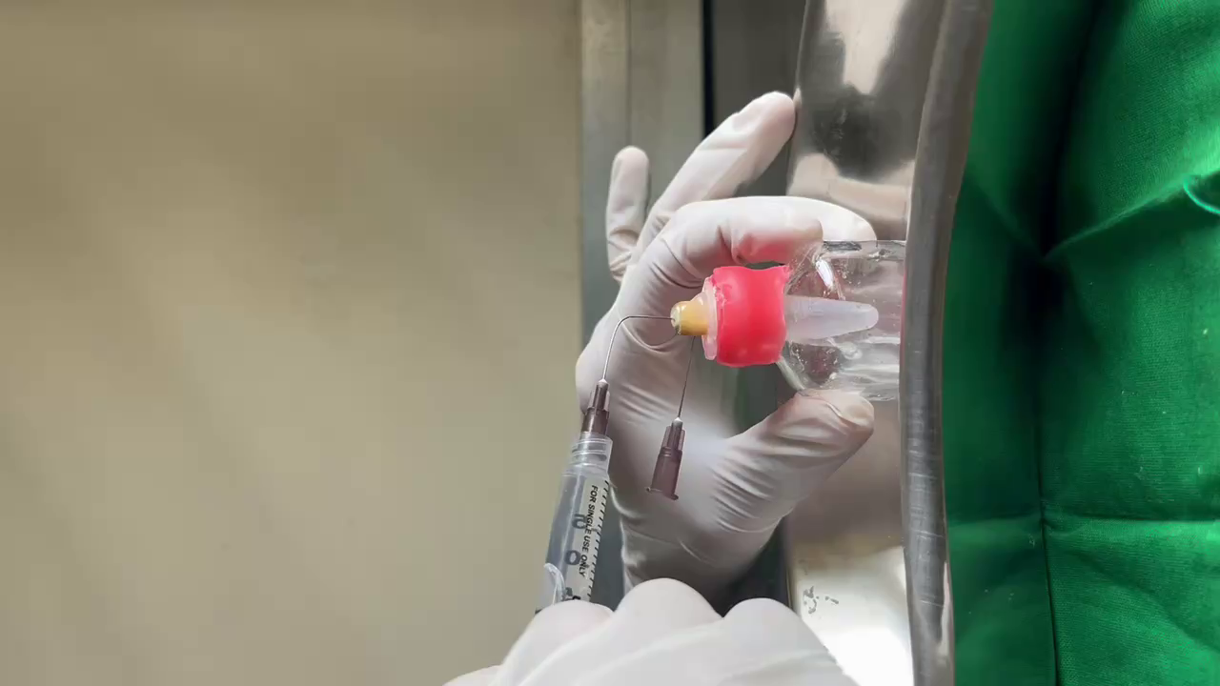
(FIGURE – 3) DYNAMIC SONICNEEDLE IRRIGATION

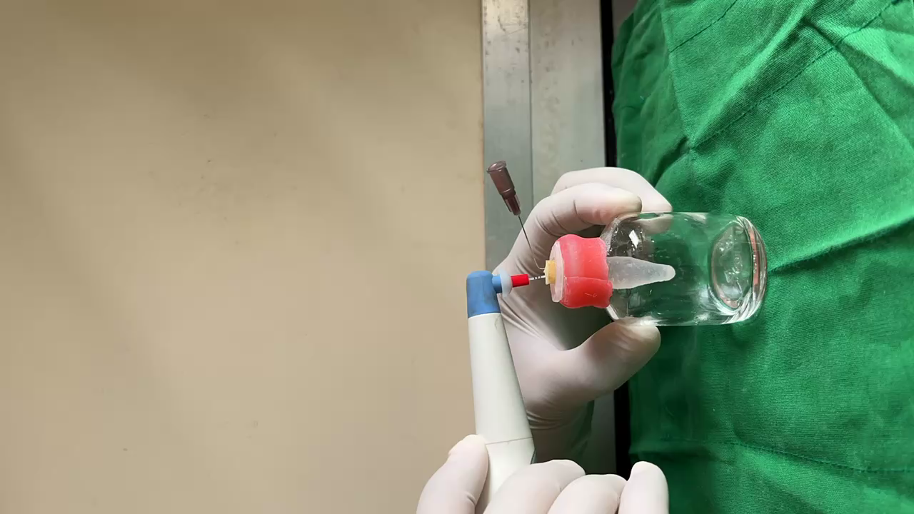

(FIGURE – 4) LASER IRRIGATION
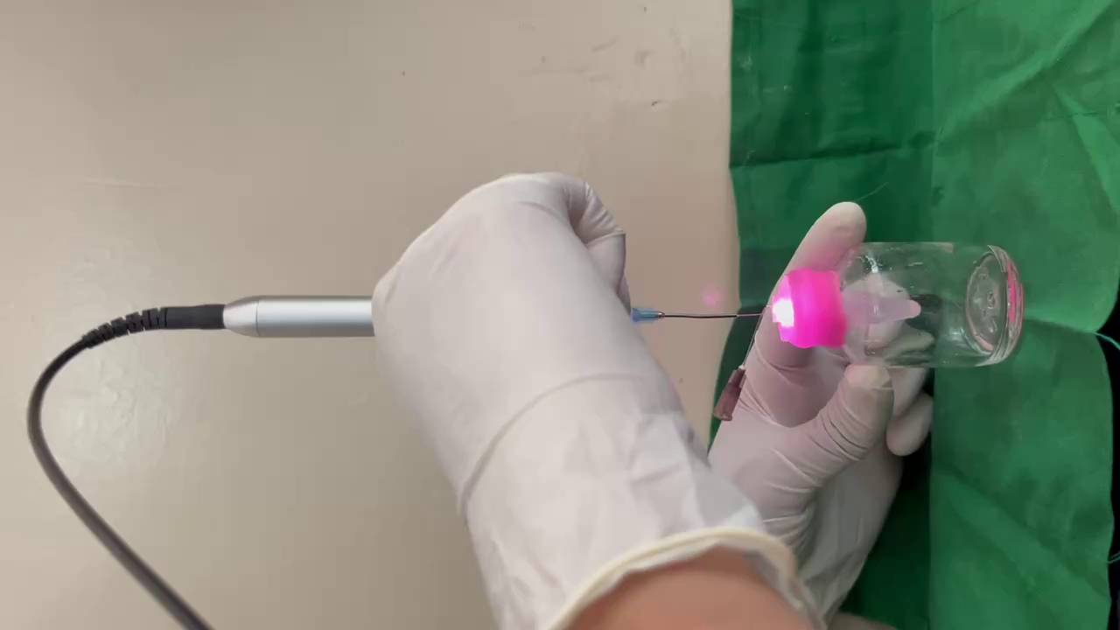

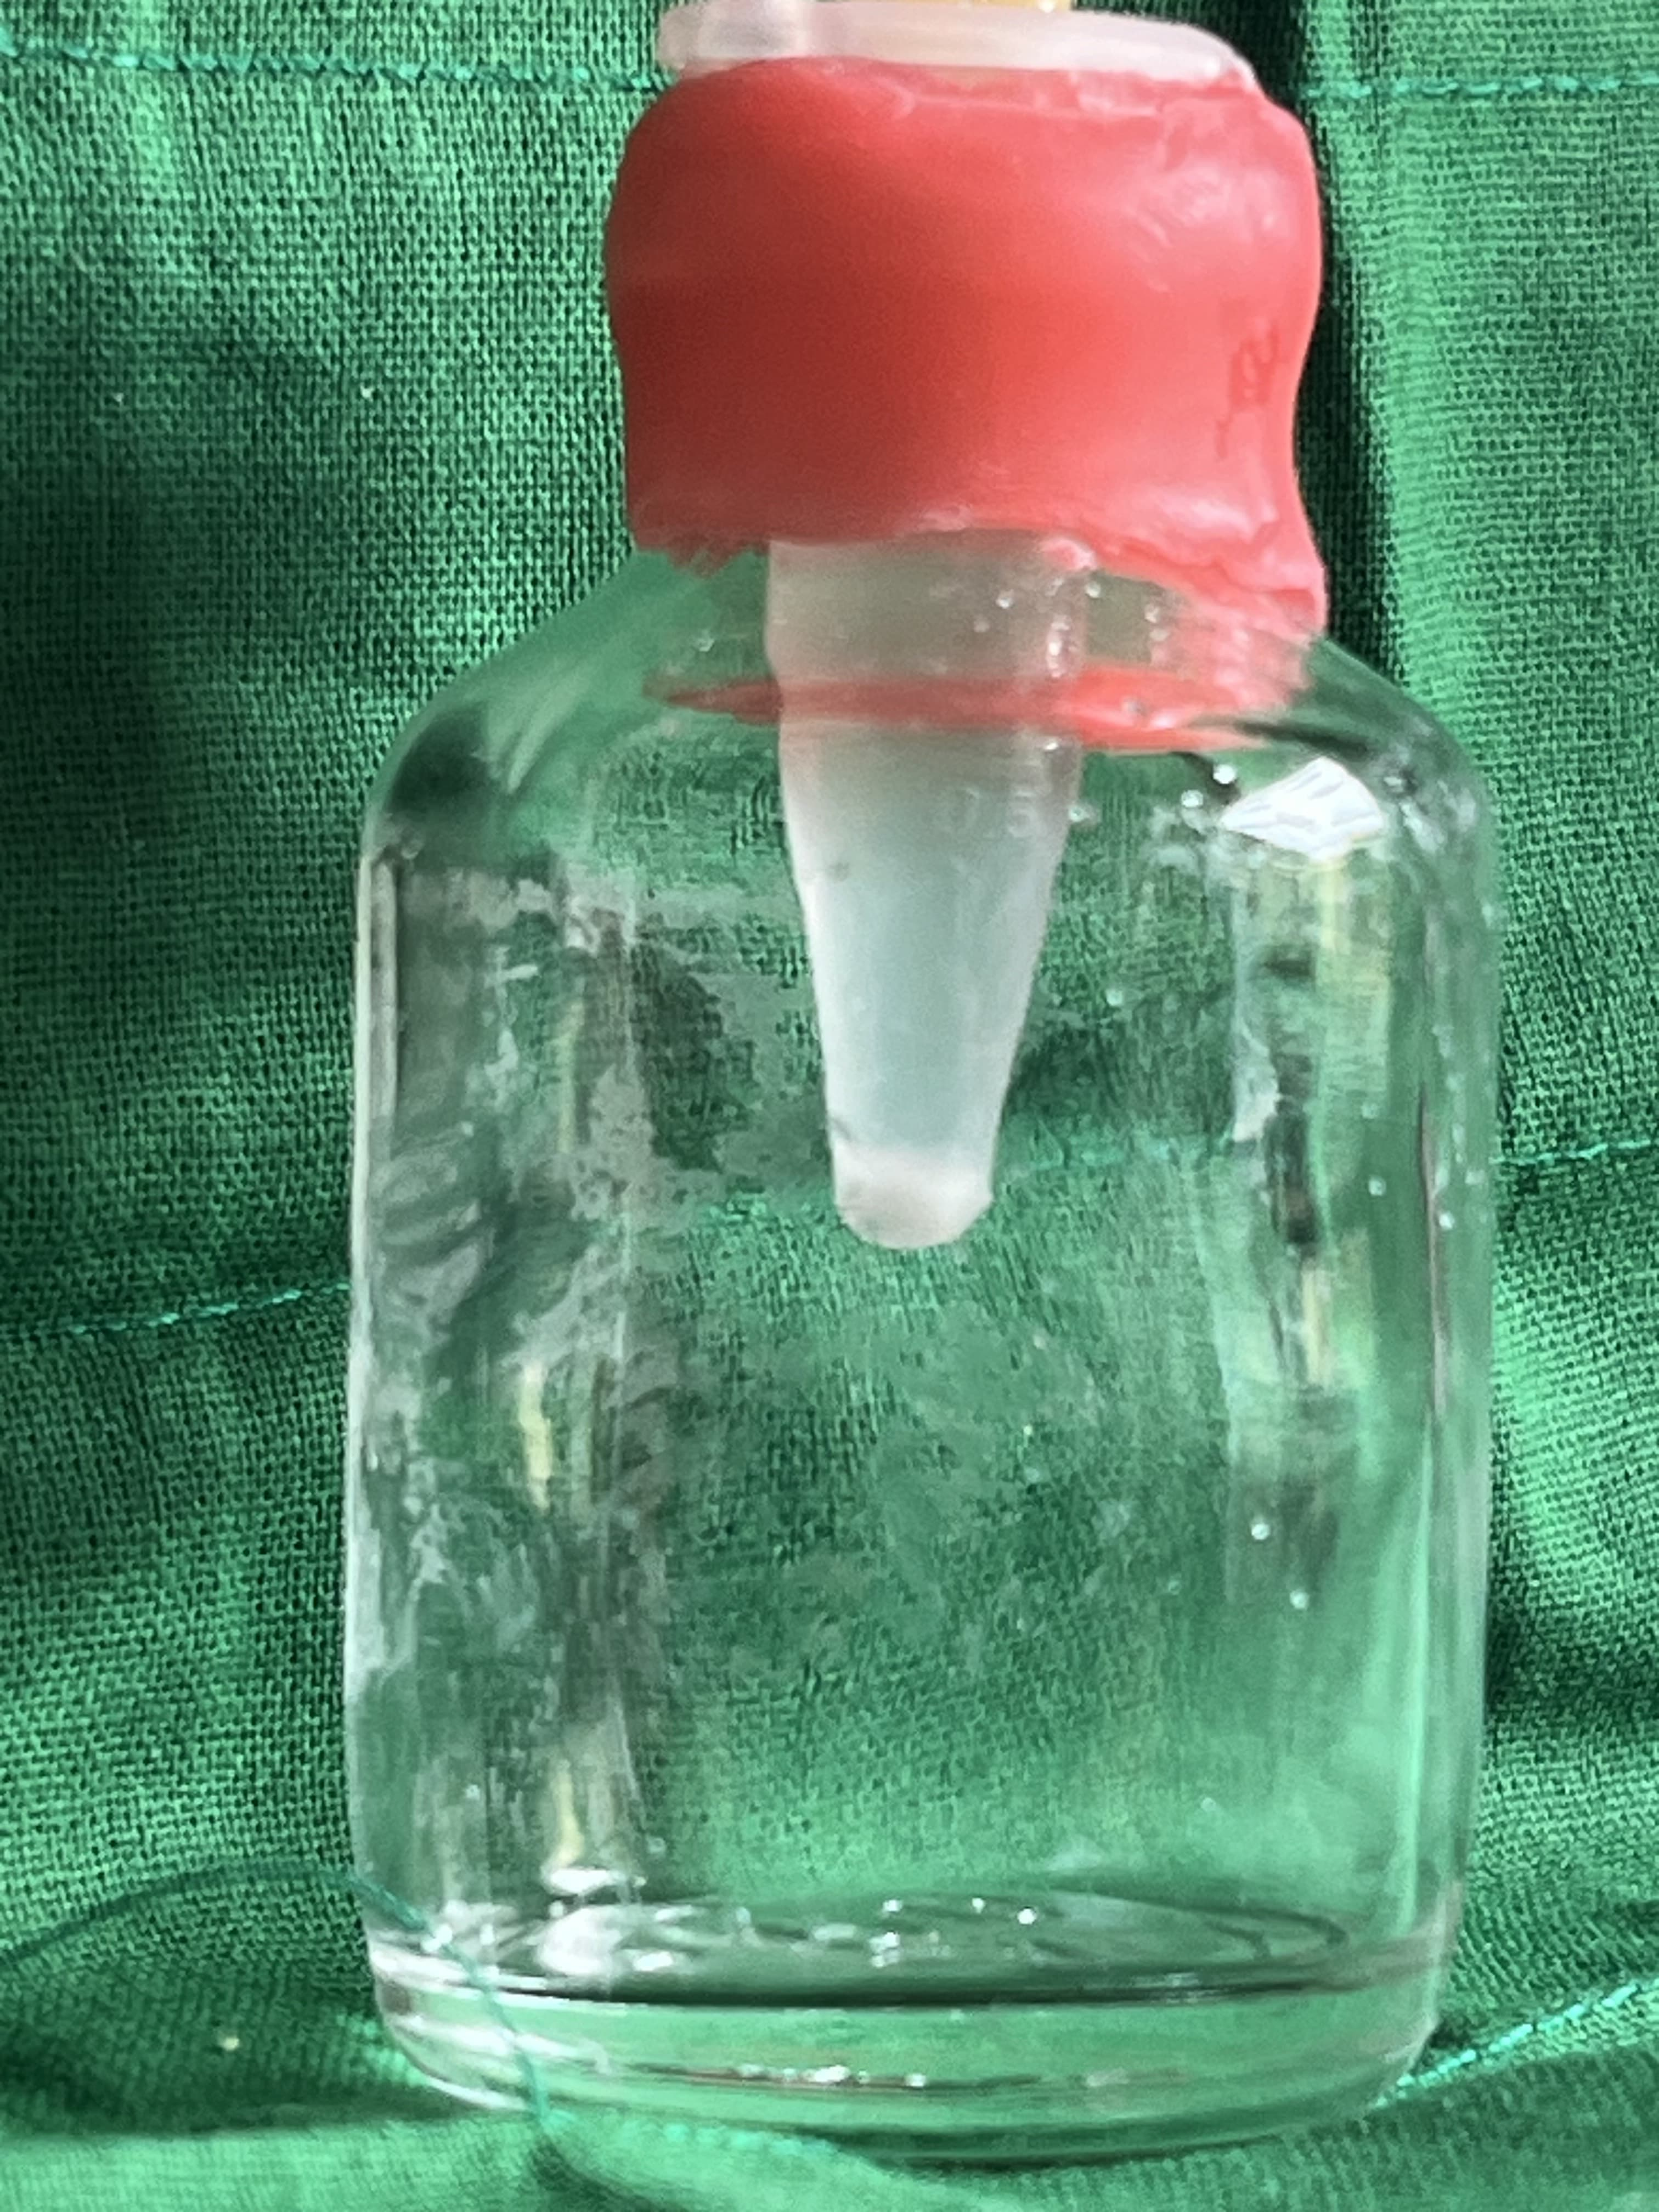

(FIGURE – 5) APICALLY EXTRUDED DEBRIS

(FIGURE – 6) DIODE LASER

(FIGURE – 7) CONVENTIONAL NEEDLE

(FIGURE – 8) ENDO ACTIVATOR SONIC IRRIGATION

