Clinical Practice Article
The Art and Algorithm of Smile Makeovers: A Digital Prosthodontic Case Series

ABSTRACT
Aim: This case series investigates the clinical implementation and effectiveness of Digital Smile Design (DSD) in prosthodontics, emphasizing its contribution to esthetic and functional dental rehabilitation. The study explores how digital technology enhances diagnostic accuracy, treatment planning, and procedural execution to optimize patient outcomes and predictability.
Presentation of Case: Three patients requiring partial prosthetic rehabilitation were included in this series. DSD software was utilized to assess facial and dental harmony, generate digital mock-ups, and direct restorative procedures. Advanced tools such as intraoral scanners, 3D facial imaging, and CAD/CAM systems ensured precision in treatment execution. The cases presented diverse challenges, including tooth wear, malalignment, and missing teeth. The digital approach facilitated active patient involvement in smile design, leading to customized and satisfactory results.
Discussion: The use of DSD provided a structured and efficient workflow for prosthodontic rehabilitation, enhancing collaboration among clinicians, dental technicians, and patients. Virtual previews minimized procedural errors and reduced clinical time while improving esthetic predictability. Despite initial challenges such as the learning curve and dependence on high-resolution imaging, the benefits—greater accuracy, patient engagement, and streamlined treatment—were significant.
Conclusion: Digital Smile Design is a transformative tool in prosthodontics, delivering patient-centered, reliable, and time-efficient smile rehabilitation. Its adoption in clinical practice improves both functional and cosmetic results, positioning it as a key advancement in contemporary dentistry. Additional long-term research is warranted to further establish its efficacy across varied clinical cases.

Introduction :
Digital Smile Design (DSD) represents a paradigm shift in modern prosthodontics, merging digital technology with artistic principles to achieve predictable aesthetic outcomes [1]. This case series examines three clinically challenging scenarios where traditional treatment planning methods proved inadequate: first, a 20-year-old male with severe anterior tooth malalignment and compromised esthetics; second, a 32-year-old male with generalized spacing even after the orthodontic treatment; and third, a 45-year-old patient with severe midline diastema . Each case demonstrates unique applications of DSD in overcoming the limitations of conventional diagnostic wax-ups through its three key advantages: digital facial analysis, 3D smile simulation, and guided restorative execution [2].
The series highlights DSD's transformative role in complex prosthodontic management by: (1) facilitating interdisciplinary treatment planning through standardized digital workflows, (2) improving accuracy in outcome prediction compared to analog methods, and (3) enhancing patient engagement through visual treatment simulations [3]. Particular emphasis is placed on DSD's ability to quantify aesthetic parameters - including tooth proportions, gingival levels, and smile symmetry - while simultaneously addressing functional requirements [4].
These cases collectively demonstrate how digital workflows can reduce clinical time, improve laboratory communication, and ultimately deliver superior aesthetic results in challenging rehabilitations [5]. The findings underscore DSD's growing indispensability in contemporary prosthodontic practice.

Presentation of case :
Case Report 1: 20-Year-Old Male College Student with Missing and Malaligned Maxillary Anterior Teeth
A 20-year-old male college student with no significant medical history presented with missing and malaligned maxillary anterior teeth due to trauma, leading to compromised esthetics. The patient reported difficulty in chewing and dissatisfaction with his smile. Clinical examination revealed missing 22 and proclined 12, 11 with mild gingival discrepancies. Intraoral periapical (IOPA) radiographs confirmed the absence of periapical pathology, and Digital Smile Designing (DSD) was used to plan prosthetic rehabilitation, ensuring optimal tooth proportions and gingival harmony. Intentional root canal treatment was performed on 12, 11. The treatment involved a fixed partial denture (12-11-21-22-23 splinted 5-unit zirconia bridge), resulting in excellent immediate functional and esthetic outcomes.

Case Report 2: 32-Year-Old Male Lawyer with Generalized Spacing in Maxillary Anteriors
A 32-year-old male lawyer, previously treated with orthodontics, presented with persistent generalized spacing in his maxillary anterior teeth and poor esthetics. Despite prior orthodontic correction, the spacing remained, affecting his smile. Clinical examination revealed no active periodontal disease, and radiographic investigation ruled out periapical pathology. Digital Smile Designing (DSD) was employed to plan a 6-unit zirconia bridge (13-12-11-21-22-23), which successfully restored proper tooth proportions and smile aesthetics.

Case Report 3: 45-Year-Old Male Businessman with Severe Midline Diastema
A 45-year-old male businessman complained of a severe midline diastema in the maxillary arch, which affected his smile and self-confidence. Clinical and radiographic (IOPA) evaluation confirmed no underlying pathology. Digital Smile Designing (DSD) was used to plan diastema closure with a 6 unit zirconia bridge ( 13 to 23) initially but the treatment plan was changed to conservative by involving 4-unit zirconia bridge (12-11-21-22), achieving excellent symmetry and natural tooth morphology. The immediate post-treatment results met the patient's aesthetic expectations.

CASE REPORT-1 :
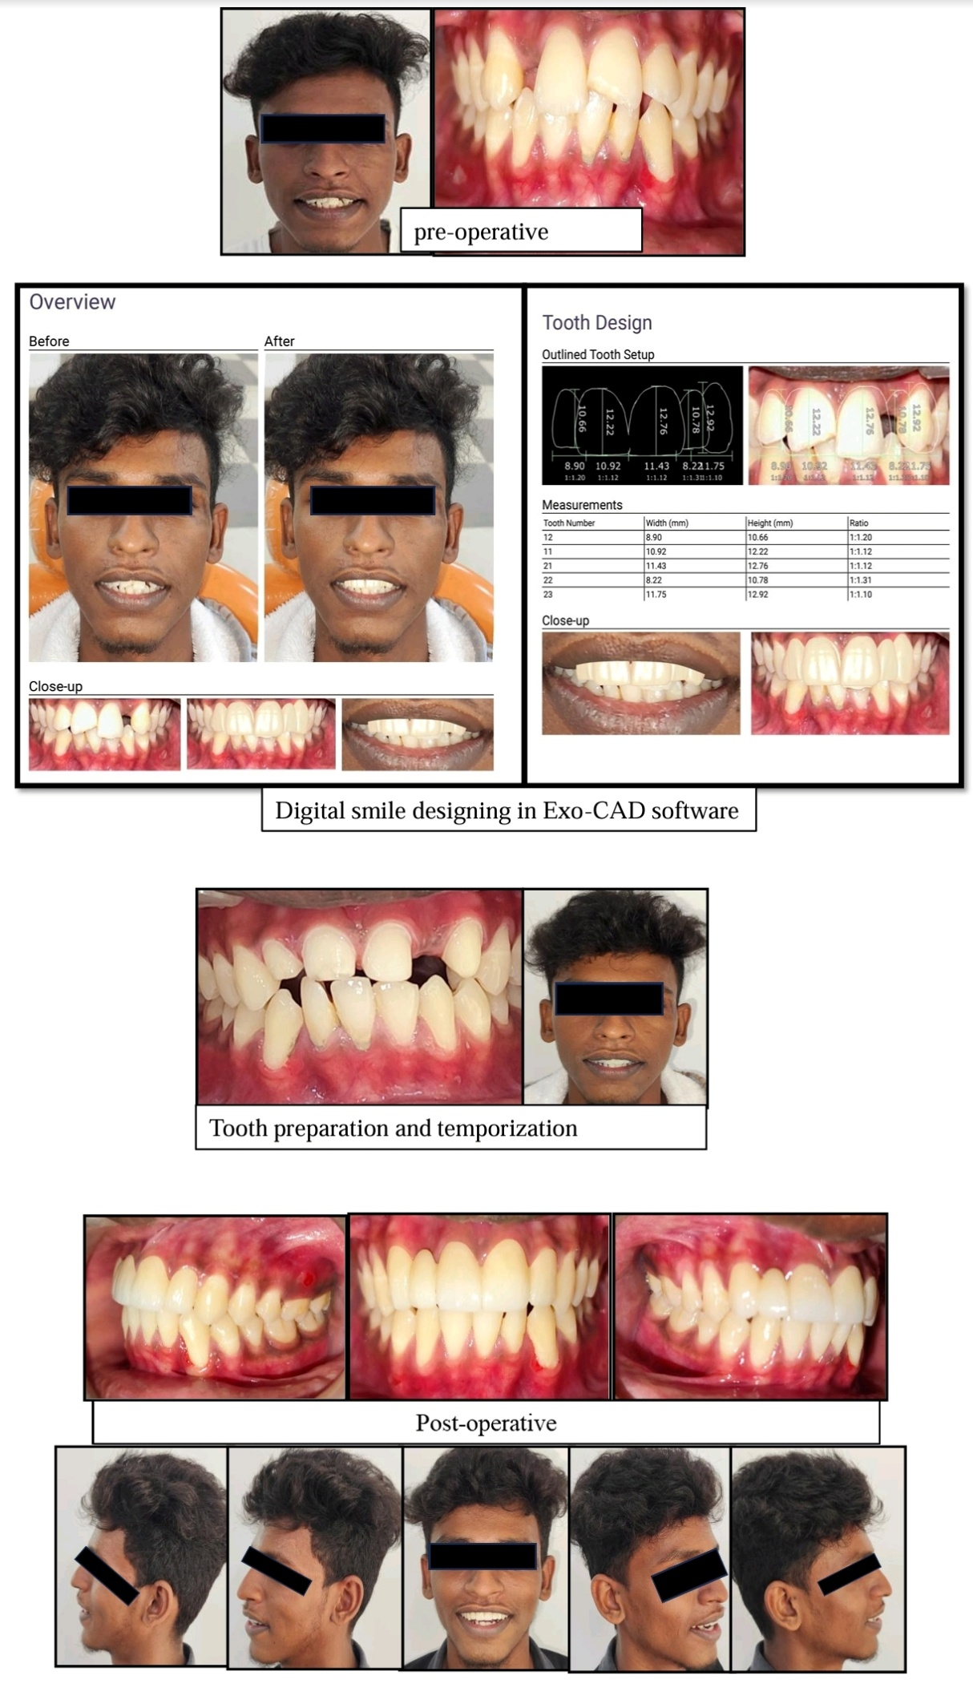

:
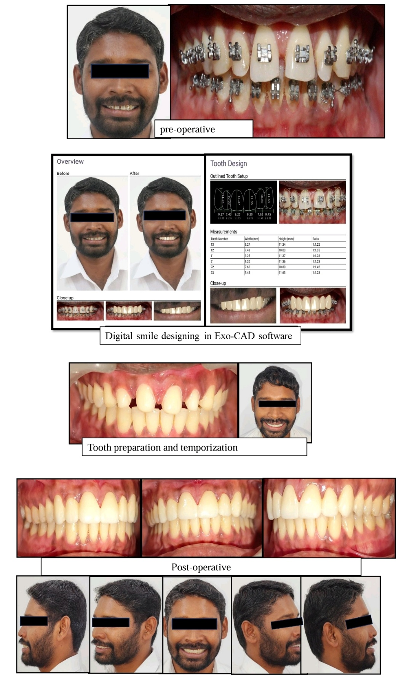
CASE REPORT-2 :
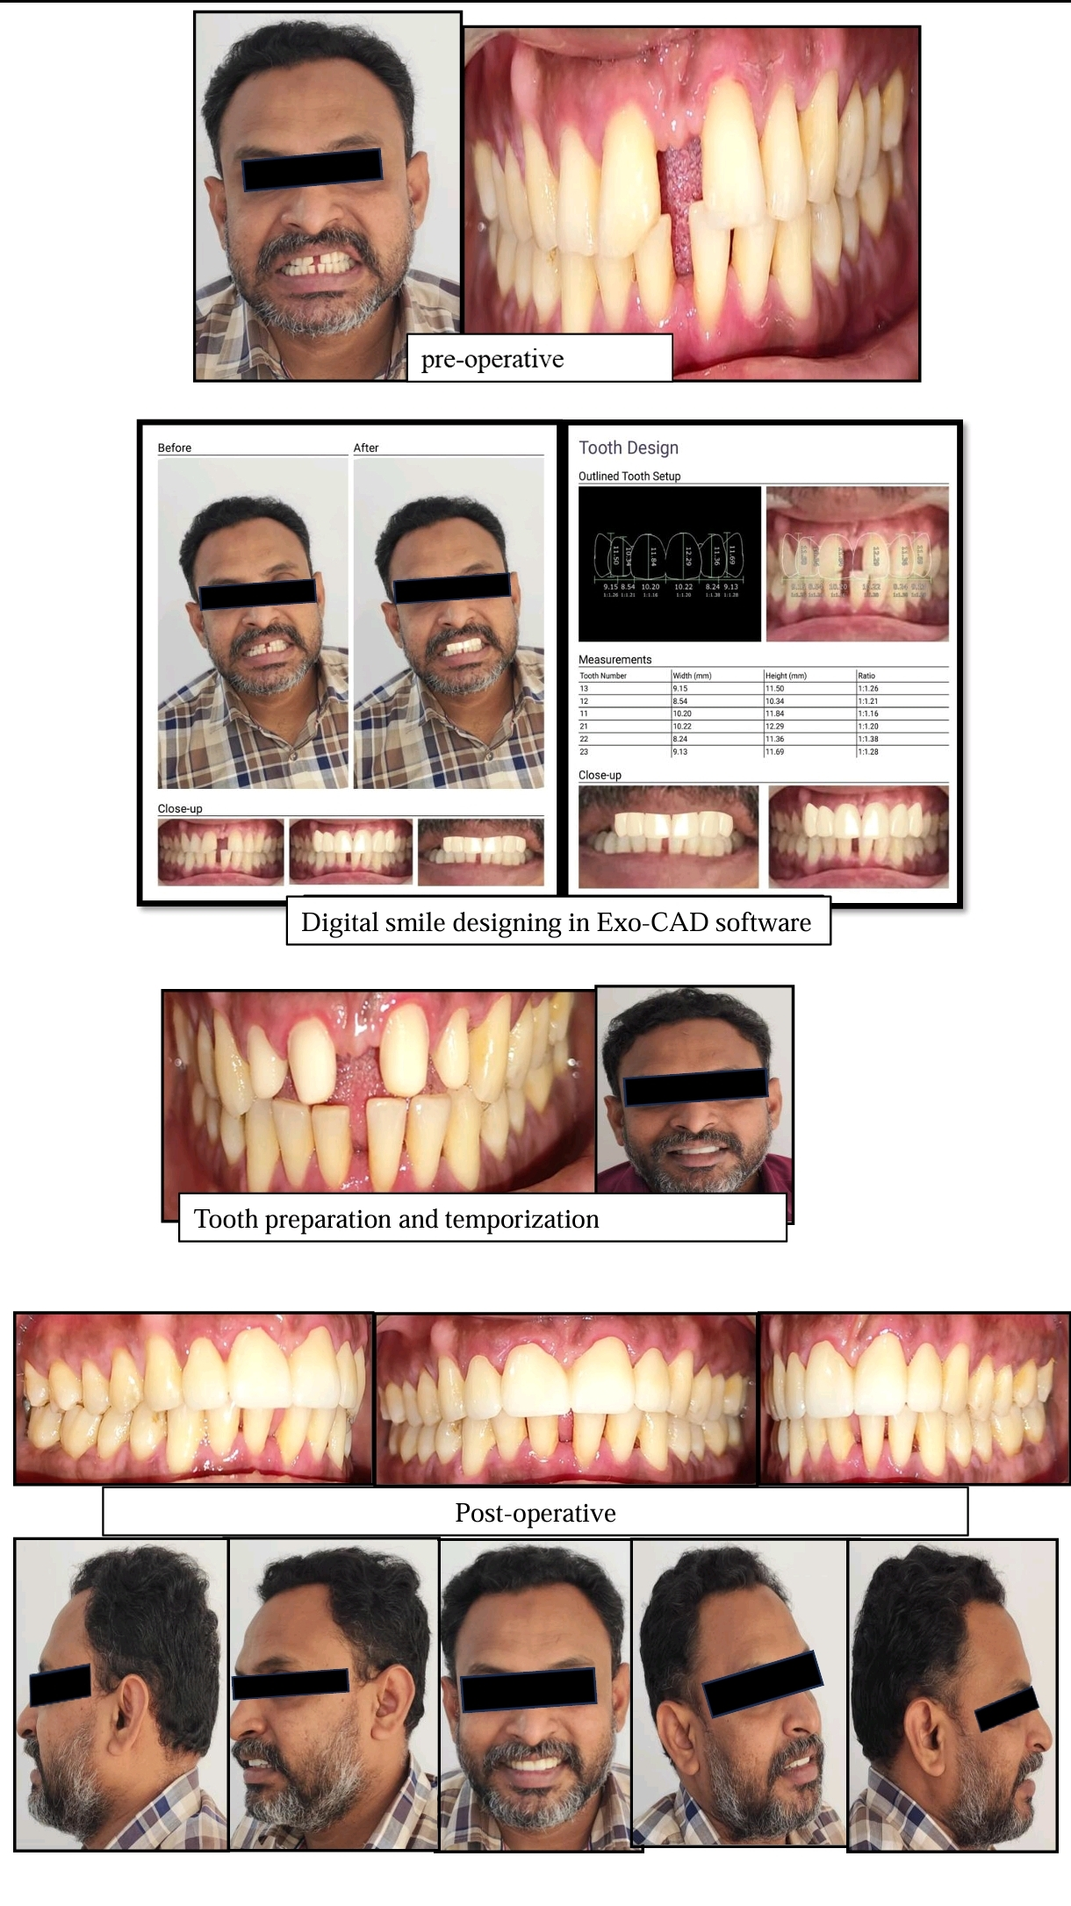
CASE REPORT-3:
Discussion :

The integration of Digital Smile Design (DSD) with contemporary prosthetic techniques has revolutionized anterior aesthetic dentistry, enabling predictable outcomes in complex cases[1]. This discussion analyzes three representative cases demonstrating DSD's clinical applications while addressing its inherent challenges.
Case 1: Traumatic Tooth Loss and Malposition. The 20-year-old patient presented with missing #22 and proclined #12-11 due to trauma. Treatment required intentional RCT of #12-11 to accommodate necessary tooth reduction and create parallel abutments for a 5-unit zirconia bridge (#12-23). DSD facilitated precise visualization of tooth positions and gingival architecture before preparation. Zirconia was selected for its strength and biocompatibility [5], particularly suitable given the patient's young age and occlusal demands. The digital workflow enhanced interdisciplinary communication, ensuring aesthetic expectations were met.
Case 2: Persistent Spacing Post-Orthodontics. The 32-year-old lawyer's generalized spacing persisted despite orthodontic treatment, highlighting limitations in addressing tooth size discrepancies[3]. A 6-unit zirconia bridge (#13-23) was chosen over more conservative options due to the extent of spacing and need for comprehensive recontouring. DSD's digital preview demonstrated proposed changes to incisal edge position and gingival display, significantly improving case acceptance. The technology enabled precise planning of tooth proportions critical for natural-looking results.
Case 3: Midline Diastema Management. The 45-year-old businessman's severe diastema required careful. evaluation of papilla condition and facial symmetry. A 4-unit zirconia bridge (#12-22) was preferred over orthodontics or composites due to the diastema width and patient's desire for definitive treatment. DSD ensured symmetrical proportions and natural emergence profiles, crucial for midline cases where minor asymmetries are noticeable [4]. Digital planning improved laboratory communication for optimal contour and texture matching.
Material Considerations: Zirconia's selection across all cases reflects its unique combination of mechanical properties and aesthetic potential[5]. Modern translucent formulations provide natural-looking results while maintaining the strength needed for long-span anterior bridges. However, the significant tooth reduction required represents an important trade-off between conservation and restoration longevity.
DSD Workflow Advantages: The DSD protocol enhanced treatment predictability through digital mock-ups[1], allowing patients to visualize outcomes before irreversible procedures. The standardized workflow - incorporating facial analysis, digital planning, and virtual smile design - improved communication between clinicians, technicians, and patients. This systematic approach reduced potential misunderstandings and facilitated exceptional aesthetic results.
Clinical Challenges and Limitations: The absence of follow-up visits prevented assessment of long-term outcomes, a common issue when patients are satisfied with initial results. Other limitations include: Irreversible tooth preparation committing patients to lifelong prosthetic maintenance, Significant cost of high-quality zirconia prostheses, Potential technical complications like veneer chipping in layered restorations, Wear characteristics against natural dentition requiring further study

Conclusion :
These cases demonstrate DSD's effectiveness in anterior aesthetic rehabilitation when combined with zirconia prosthetics. The digital workflow enhances treatment predictability through precise 3D planning and virtual smile simulations, while improving patient communication and case acceptance. However, clinicians must carefully consider the irreversible nature of tooth preparation and long-term maintenance requirements. The significant investment in high-quality zirconia prosthetics may also limit accessibility for some patients. Future advancements in ultra-translucent zirconia formulations and AI-assisted smile design promise to address current limitations while maintaining excellent outcomes. Emerging CAD/CAM technologies continue to streamline workflows from diagnosis to final delivery. Ultimately, successful treatment requires balancing technological innovation with fundamental biological principles, combining digital precision with clinical expertise. The synergy between advanced technology and prosthodontic artistry will continue to drive progress in aesthetic rehabilitation, offering improved solutions for patients with complex anterior restorations while maintaining emphasis on individualized care and evidence-based practice. This approach ensures optimal outcomes that meet both functional demands and aesthetic expectations.

References :

1. Coachman C, Van Dooren E, Gürel G, Landsberg CJ, Calamita MA, Bichacho N. Smile design: From digital treatment planning to clinical reality. Inside Dentistry. 2017;13(2):98-110.
2. Gurel G. The science and art of porcelain laminate veneers. Berlin: Quintessence Publishing; 2016.
3. Spear FM, Kokich VG, Mathews DP. Interdisciplinary management of anterior dental esthetics. Journal of the American Dental Association. 2006;137(2):160-9.
4. Kokich VO, Kokich VG, Kiyak HA. Perceptions of dental professionals and laypersons to altered dental esthetics: Asymmetric and symmetric situations. American Journal of Orthodontics and Dentofacial Orthopedics. 2006;130(2):141-51.
5. Zhang Y, Lawn BR. Novel zirconia materials in dentistry. Journal of Dental Research. 2018;97(2):140-7.

