*Case report*

**From Transient Ischemic Attack to Acute Heart Failure: Unmasking Fabry Disease in a Young Woman with Hypertrophic Cardiomyopathy**

.

ABSTRACT

|  |
| --- |
| We report the case of a 20-year-old woman admitted to the cardiology intensive care unit for acute heart failure. Initial evaluations suggested hypertrophic cardiomyopathy (HCM), but cardiac magnetic resonance imaging (MRI) revealed diffuse myocardial fibrosis and features consistent with Fabry disease. Despite optimal medical therapy, her condition deteriorated, culminating in atrial fibrillation and death. This case underscores the importance of considering Fabry disease in young patients presenting with unexplained cardiomyopathy. |

**Keywords**: Fabry disease, Hypertrophic cardiomyopathy, Heart failure.

**Abbreviations**:   
MRI: magnetic resonance imaging  
HCM: hypertrophic cardiomyopathy  
LVEF: left ventricular ejection fraction  
RVEF: right ventricular ejection fraction  
LVH: Left ventricule hypertrophy  
ERT: Enzyme replacement therapy  
LGE: gadolinium enhancement

**Introduction**

Fabry disease is a rare X-linked lysosomal storage disorder resulting from deficient α-galactosidase A activity, leading to systemic accumulation of globotriaosylceramide. Cardiac involvement is common and can mimic other cardiomyopathies, often leading to misdiagnosis. Early recognition is crucial for initiating appropriate therapy and improving outcomes. We report the case of a young girl who presented with a severe heart failure caused by a hypertrophic cardiomyopathy revealing a fabry disease.

**Case Presentation**

A 20-year-old female, with medical history of a transient ischemic attack that was neglected by the patient 2 months ago, and she presented with acute dyspnea and fatigue. The illness began about 2 weeks prior with progressive dyspnea and lower limb edema, in an afebrile context with general health deterioration. Upon admission, the clinical examination found the patient to be orthopneic, without chest pain, but with exertional fatigue. Hemodynamically, she was stable with a blood pressure of 100/50 mmHg, heart rate of 110 bpm, respiratory rate of 40 breaths/min, On auscultation, pulmonary crackles were heard, suggesting pulmonary congestion with an oxygen saturation at 92% on room air, and temperature of 37.5°C.  
The ECG showed sinus tachycardia at 115 bpm ,a left ventricule hypertrophy and T wave inversion in the lateral and inferior leads. Chest X-ray: Demonstrated cardiomegaly with pulmonary congestion. Holter monitoring Detected episodes of paroxystic atrial fibrillation.

Transthoracic echocardiography showed an inferior and septal hypertrophy ( 17mm/18mm) with no anterior systolic motion of the mitral valve, no mitral valve abnormalities,and no obstruction. It also showed a dilated left and right ventricules with a severe biventricular dysfunction with an ejection fraction (LVEF) of 20% features suggestive of hypertrophic cardiomyopathy in an advanced stage.(figure 1 and 2 )

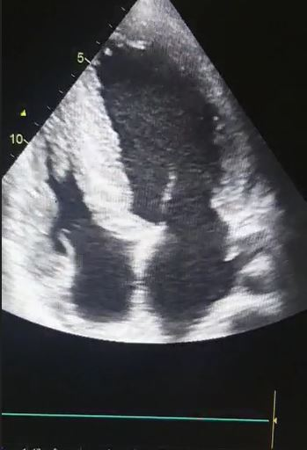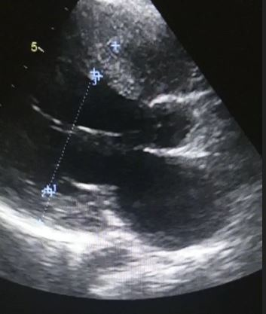  
**Figure 1 (left)** :transthoracic echocardiography at 4 cavity view showing the left ventricule dilatation   
**Figure 2 (right)**: septal thickness at 17mm and inferior wall thickness at 18mm

Cardiac MRI demonstrated Moderate hypertrophic cardiomyopathy at the stage of diffuse myocardial fibrosis of the left ventricle, with involvement of 80% of the myocardium, associated with right ventricular hypertrophy with moderate fibrosis, and right ventricular longitudinal dysfunction. LVEF: 13.3%, RVEF: 25%, with right ventricular dilation. Advanced Fabry disease is suspected due to the young age, moderate LV hypertrophy, predominance of dense intramyocardial fibrosis zones, involvement of the RV and papillary muscles. Enzymatic assays of alpha-galactosidase dosage confirmed the diagnosis of Fabry disease.(figure 3)

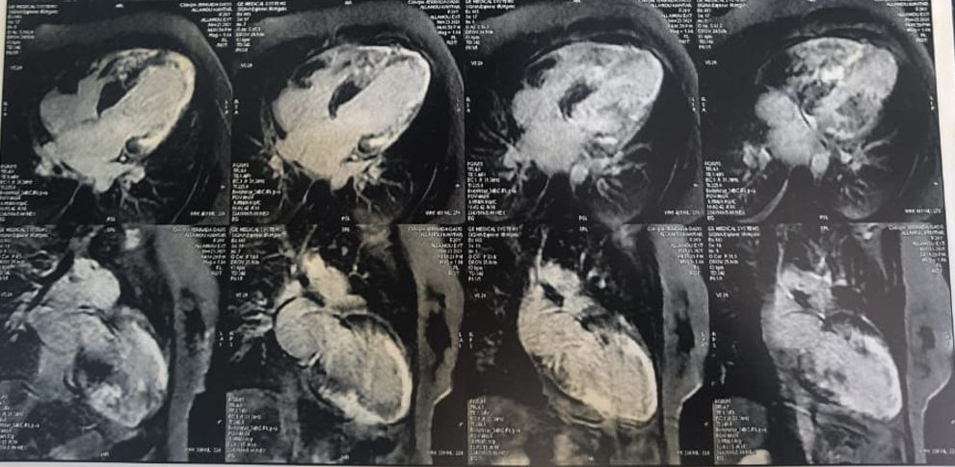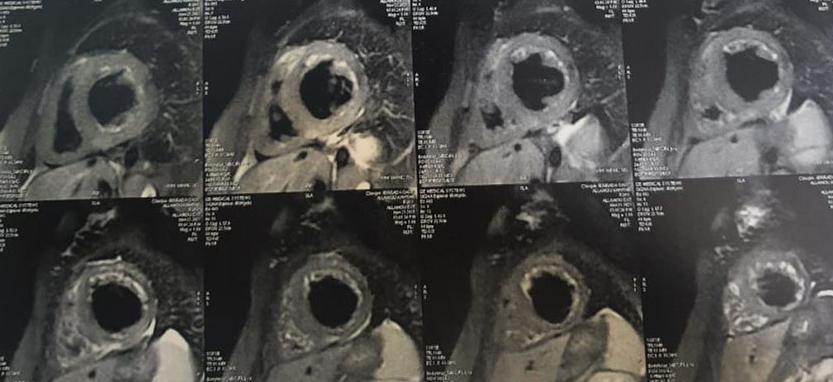

Figure 3: Cardiac MRI with Late gadolinium enhancement shows diffuse myocardial hypersignal in the hypertrophic walls, suggesting the presence of fibrosis."

The patient was managed with intravenous diuretics and heart failure therapy but she rapidly developed atrial fibrillation, which worsened her clinical condition and despite aggressive management she succumbed to her illness shortly thereafter.

**Discussion**

This case highlights the diagnostic challenge of fabry disease and the importance of the early diagnosis to avoid the dramatic death of young patients, particularly in female patients where the phenotype may be less typical and the diagnosis is often delayed. In Fabry disease, cardiac involvement can manifest as left ventricular hypertrophy (LVH), often concentric and accompanied by myocardial fibrosis, conduction abnormalities, and arrhythmias [1,2].

The presentation of our patient as a Hypertrophic cardiomyopathy at the stage of dilation and severe biventricular dysfunction is not that frequent with the Fabry disease.

In women, the presentation may be subtle due to X-chromosome inactivation, leading to heterogeneous clinical expression. This often results in delayed diagnosis until advanced stages when irreversible myocardial damage has occurred [3].

The use of cardiac magnetic resonance imaging (MRI) is crucial, especially with late gadolinium enhancement (LGE) sequences which can detect characteristic mid-wall fibrosis in the inferolateral segments—a finding highly suggestive of Fabry cardiomyopathy [2]. This imaging modality can guide further diagnostic steps, including measurement of α-galactosidase A activity and genetic testing.

Enzyme replacement therapy (ERT) has been shown to reduce cardiac mass and delay disease progression, but it is most effective when initiated before extensive fibrosis has developed [3,4]. In our patient, diagnosis occurred at an advanced stage, highlighting the need for earlier clinical suspicion and intervention.

Atrial fibrillation is a recognized complication in Fabry disease, associated with poor prognosis and increased risk of thromboembolic events [5]. The arrhythmogenic substrate is likely due to progressive fibrosis, left atrial dilation, and autonomic dysfunction. Management of arrhythmias in Fabry patients should be proactive, and early initiation of anticoagulation and rhythm control may improve outcomes.

This case also emphasizes the importance of multidisciplinary care. In young patients with unexplained heart failure and LVH, a high index of suspicion for metabolic or infiltrative diseases such as Fabry should be maintained. Early recognition and diagnosis not only improve outcomes but may also allow for family screening and genetic counseling.

**Conclusion**

In young patients presenting with unexplained cardiomyopathy and heart failure, Fabry disease should be considered as a differential diagnosis. Advanced imaging modalities and enzymatic assays are essential for accurate diagnosis, which is critical for timely initiation of disease-specific therapies. This case underscores the potentially fatal consequences of delayed diagnosis and the importance of multidisciplinary evaluation.

**Declarations**

Consent for publication: Written informed consent was obtained from the patients for publication of this case  
report and any accompanying images.

**Availability of data and material**: All data generated or analysed during this study are included in this  
published article.

**References**

1. Linhart A, Elliott PM. The heart in Anderson-Fabry disease and other lysosomal storage disorders. Heart. 2007;93(4):528-535.
2. Nordin S, Kozor R, Bulluck H, et al. Cardiac Fabry disease with late gadolinium enhancement is a chronic inflammatory cardiomyopathy. J Am Coll Cardiol. 2016;68(15):1705-1707.
3. *Germain DP. Fabry disease. Orphanet J Rare Dis. 2010;5:30.*
4. *Weidemann F, Niemann M, Breunig F, et al. Long-term effects of enzyme replacement therapy on Fabry cardiomyopathy: evidence for a better outcome with early treatment. Circulation. 2009;119(4):524-529.*
5. *Patel MR, Cecchi F, Cizmarik M, et al. Cardiovascular events in patients with Fabry disease: natural history data from the Fabry Registry. J Am Coll Cardiol. 2011;57(9):1093-1099.*