***Case report***

**An Unusual Case of Massive Prosthetic Aortic Valve Thrombosis in a Hypocoagulated Patient**

**Abstract**

Background : Prosthetic valve thrombosis (PVT) is a rare but life-threatening complication of mechanical valve replacement, with an incidence of 0.5% in the aortic position. While thrombus is the primary culprit, pannus formation frequently coexists, complicating diagnosis. Clinical presentation ranges from asymptomatic to cardiogenic shock. Echocardiography and cinefluoroscopy are essential for assessing hemodynamics and leaflet motion. Management hinges on urgent surgery or fibrinolysis if surgery is unavailable.

Case presentation : We report a 34-year-old woman with rheumatic valvular disease and prior aortic/mitral mechanical valve replacement (St. Jude Medical) who presented with cardiogenic shock and acute pulmonary edema due to massive aortic PVT, despite an INR of 6.5. Cinefluoroscopy confirmed leaflet immobilization, and emergency valve replacement revealed mixed thrombus and pannus obstruction.

Keys words : aortic prosthesis, valve obstruction, thrombus, pannus, anticoagulation.

**Introduction**

Prosthetic valve thrombosis is the second leading cause of prosthetic valve deterioration and is being more readily diagnosed with the use of echocardiography and multidetector cardiac CT. Presentation of valve thrombosis can be acute or subacute and any change in clinical status of a patient with a prosthetic valve should raise a suspicion of prosthetic valve thrombosis. Choosing a prosthetic valve for patients meeting the criteria for aortic valve replacement requires careful consideration of valve durability, patient age, and contraindications to anticoagulation, and a shared decision-making approach (10,11). This case report highlights an unusual case of massive prosthetic aortic valve thrombosis in a hypocoagulated patient.

**Case Présentation**

A 34-year-old female was admitted to the hospital with severe orthopnea and extreme fatigue, after a 2 week history of increasing dyspnea as well as hemoptysis and macroscopic hematuria. Her medical record showed a previous history of rheumatic valve desease for which she underwent an aortic (19mm ST JUDE) and mitral (27mm ST JUDE) mechanical valve replacement at the age of 28. Although oral anticoagulation with acenocoumarol was then instaured for thromboembolism prophylaxis, the patient had poor adherence to therapy and INR monitoring.

On physical examination, our patient had a low systemic pressure of 85/46 mmHg, a heart rate of 112 bpm, bilateral rales with a respiratory frequency of 28 bpm, as well as new murmurs of both aortic stenosis and regurgitation. Based on these findings, the diagnosis of acute pulmonary edema and cardiogenic shock was made.

The electrocardiogram showed sinus tachycardia with left atrial enlargement, and the chest X ray demonstrated cardiomegaly as well as severe pulmonary venous congestion.

A transthoracic echocardiography was performed, it showed significant flow acceleration through the aortic valve, as well as a significant regurgitation, a severely increased mean gradient of 98mmHg, and an effective surface area of 0.3 cm2, consistent with a massive aortic prosthetic valve thrombosis (Figure 1 and 2).

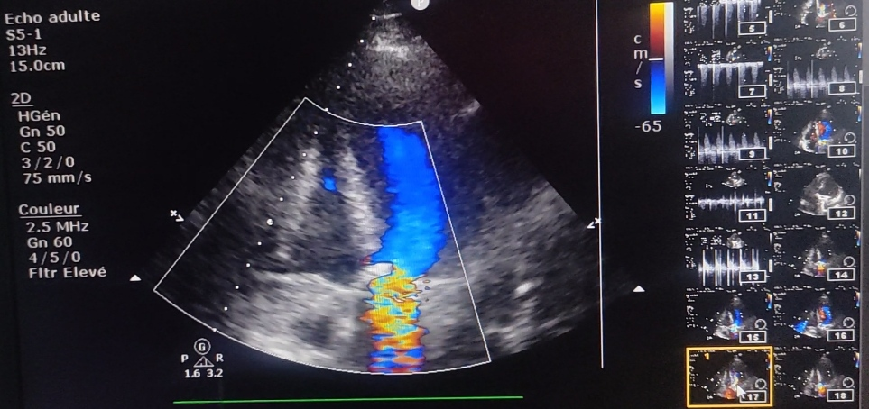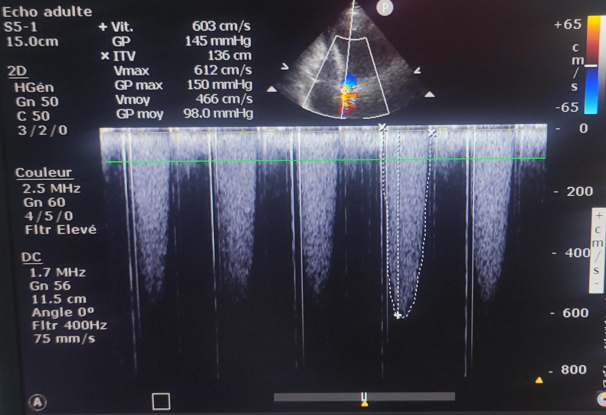

Figure 1a : Color Doppler echocardiography demonstrating aliasing artifact across the prosthetic aortic valve, indicative of severe stenosis with high-velocity turbulent flow (Nyquist limit exceeded at 65 cm/s)

Figure 1b : Continuous-wave Doppler echocardiography demonstrating severely elevated transvalvular gradients accross the aortic valve (peak velocity 603 cm/s, mean gradient 98 mmHg), consistent with acute prothetic thrombosis.

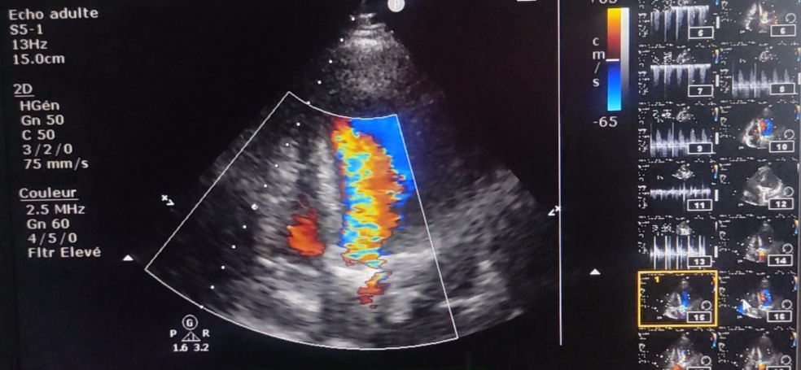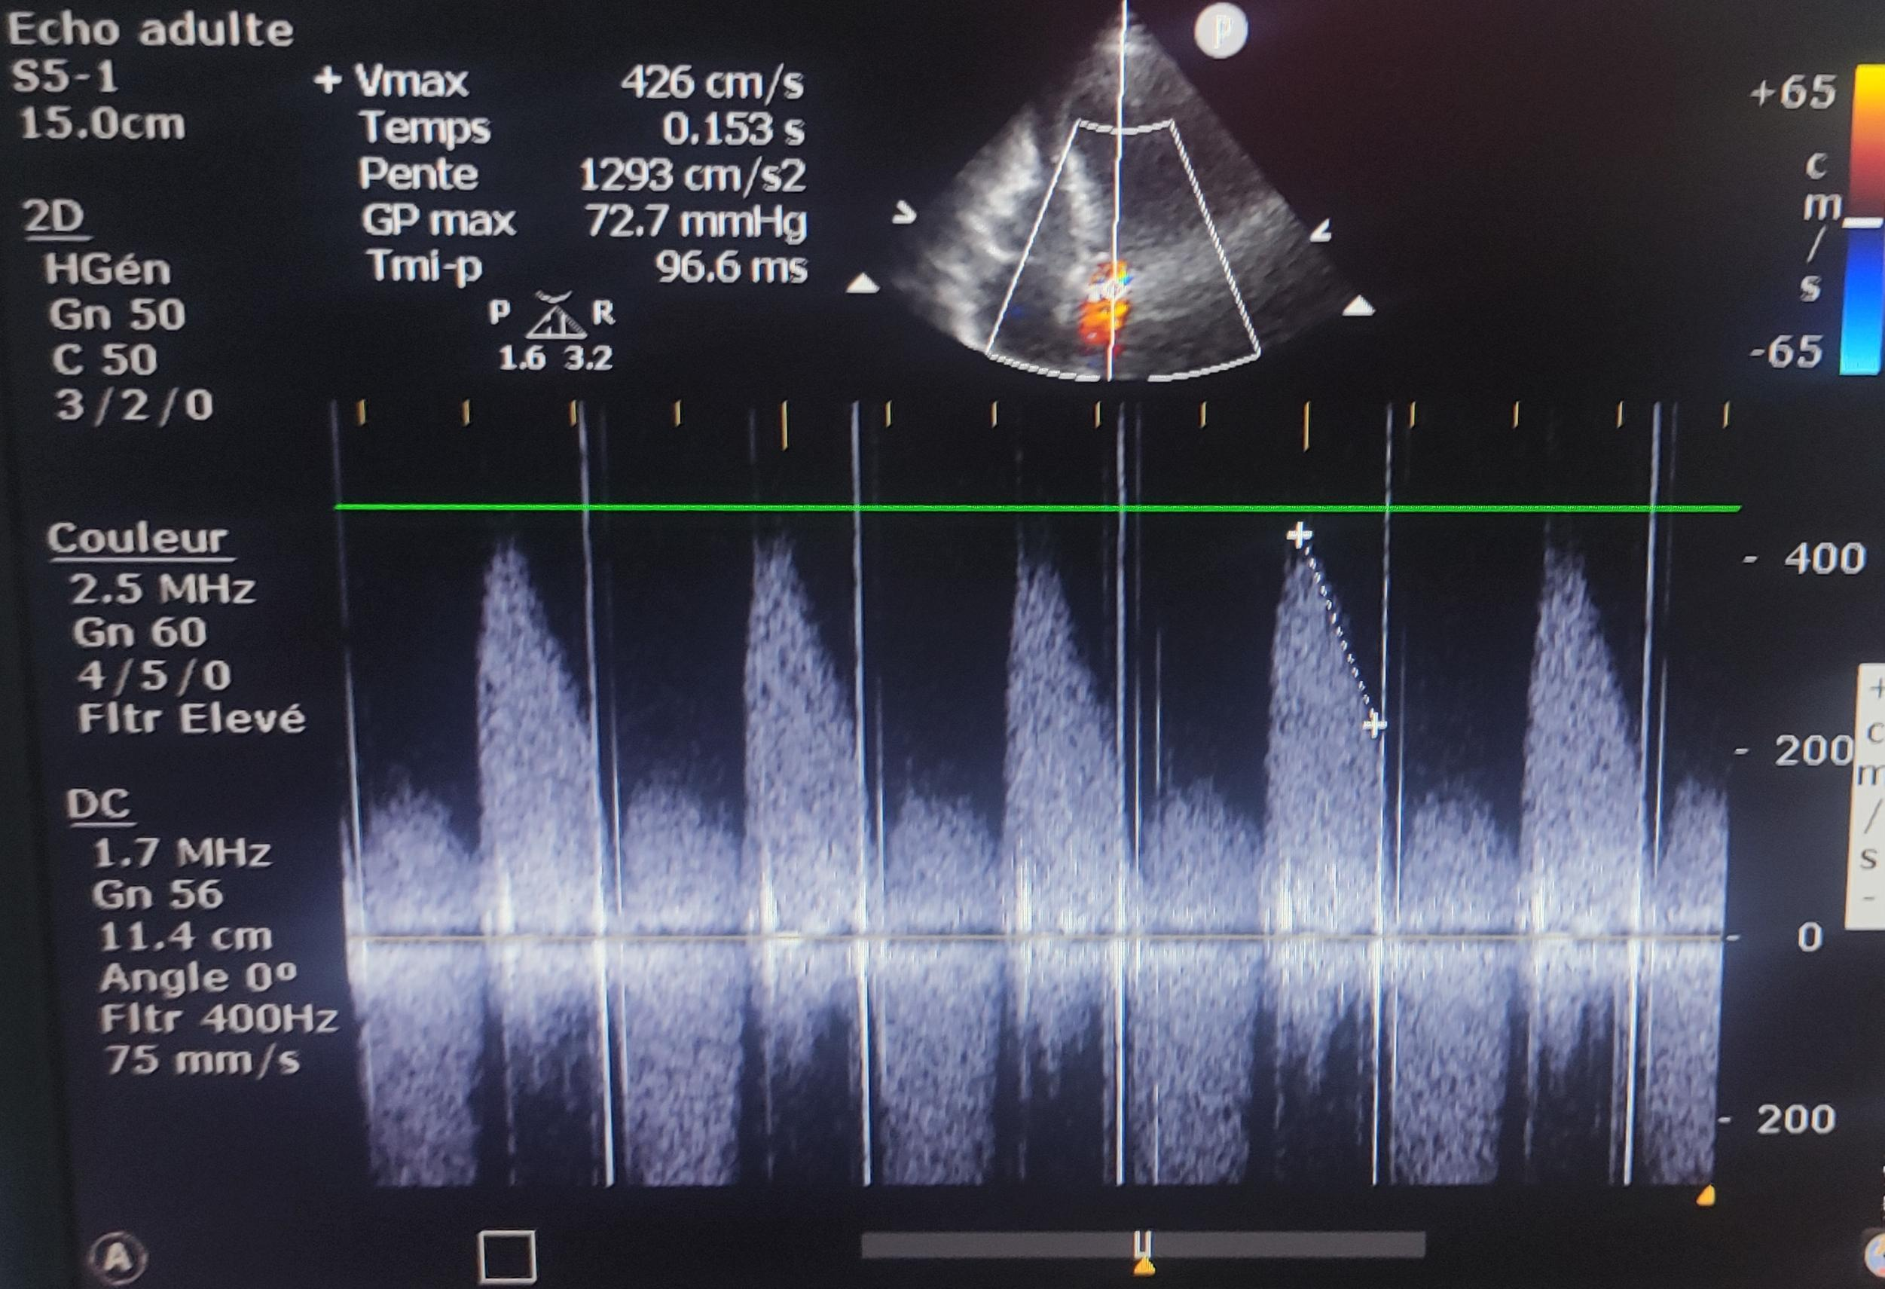

Figure 2a : Color Doppler echocardiography demonstrating a turbulent flow pattern with aliasing as well as a large regurgitant jet (15.0 cm), consistent with severe aortic regurgitation.

Figure 2b : Continuous-wave Doppler echocardiography demonstrating high-velocity diastolic flow reversal (peak velocity 426 cm/s) with rapid deceleration (short pressure half-time 96.6 ms), consistent with acute severe regurgitation in the setting of prosthetic valve dysfunction.

Initial laboratory tests oddly revealed an increased INR at 6.5 with a prothrombin time of 11% contrasting with the diagnosis of valve thrombosis. A follow-up cinefluoroscopy then realized, demonstrated extremely limited opening of both leaflets, stuck in a semi-open position, confirming the diagnosis (Figure 3). Immediately after completion of the cinefluoroscopy, the patient was taken to the operating room for emergency valve replacement.

The nature of obstruction was assessed by the surgeon as a fresh and organized thrombus, adherent to the prosthesis spikes, blocking the leaflets movement in a semi open position. After laborious extraction of the prosthesis, circomferential sub aortic pannus was discovered (Figure 4). The mitral prosthesis was intact. The occluded prosthesis was excised and replaced with a 19-mm ST JUDE mechanical prosthesis. Discontinuation of cardiopulmonary bypass was possible with the use of inotropic agents.

By the second postoperative day, the patient’s hemodynamic status had improved considerably and the inotropic drugs were discontinued. She is currently recovering in the intensive care unit.

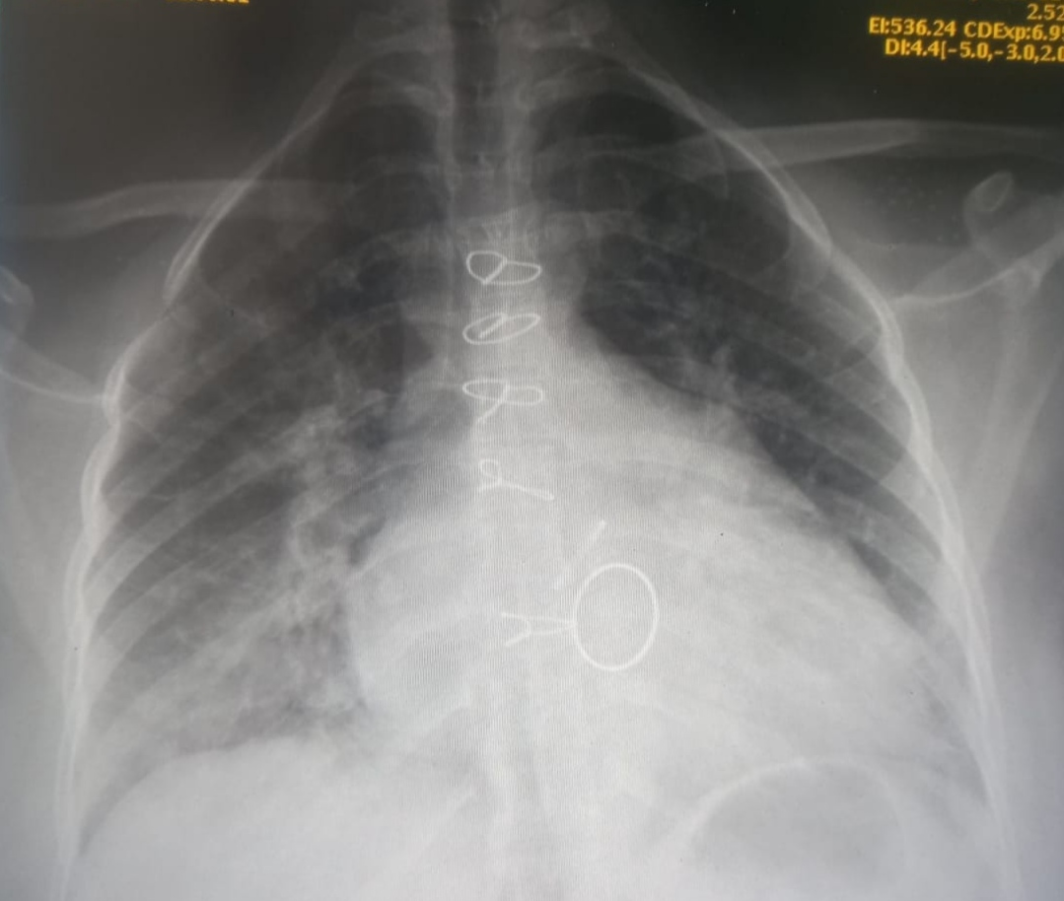

Figure 3 : Cinefluoroscopy of the mechanical aortic prosthesis demonstrating severely restricted leaflet motion (opening angle <10°) with asymmetric leaflet immobilization in semi-open position.

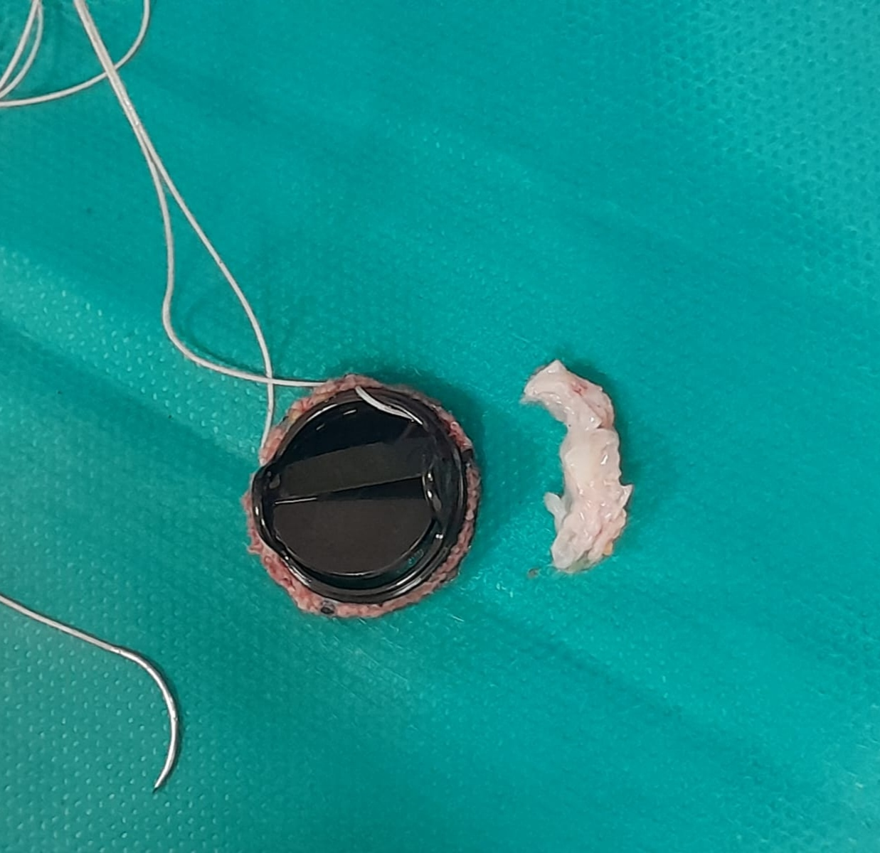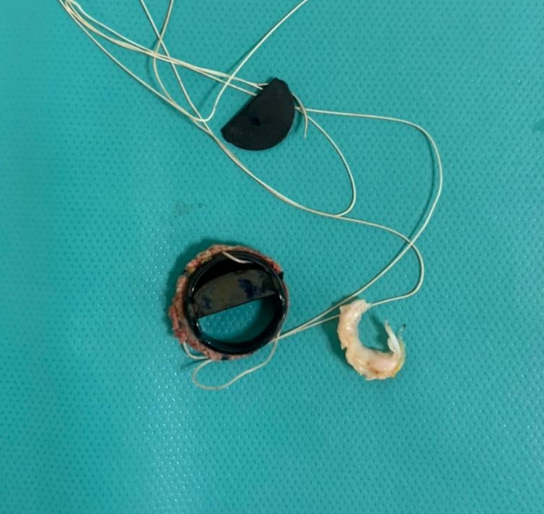

Figure 4 : Macroscopic aspect of resected pannus after complete excision of adherent thrombotic material from the prosthetic aortic valve surface.

**Discussion**

Over the past decades, many improvements have been made in the design and hemodynamics of mechanical valve prostheses in order to increase durability and reduce valve dysfunction risk (1). An unsolved problem, however, is the ever-present risk of thrombus or pannus formation, and the subsequent need for continuous anticoagulation and repeated open heart surgery.

Prosthetic valve thrombosis (PVT) is defined by any thrombus, in the absence of infection, attached to or near an operated valve, occluding part of the blood flow or interfering with valvular function. The incidence of PVT can be as high as 13% in the first year in any valve position. And at any time, the overall incidence for PVT in the mitral and/or aortic position is 0.5% to 6% per patient-year, highest in the mitral position (2)

The physiopathology of prosthesis obstruction is more complex than is widely believed. Although thrombus has been considered to be the sole cause of obstruction, pannus formation plays an important role in the mechanism of obstruction and may even be its sole cause. (3)

Pannus is a non-immune inflammatory reaction, leading to proliferation of fibroelastic tissue and collagen, starting at the suture area and evolving centripetally to the body of the prosthesis. It usually proliferates on the ventricular side of aortic prostheses and is associated with certain risk factors, such as operative technique, prosthesis characteristics, as well as patient characteristics. These include small valve ring, young age, female sex, low cardiac output, turbulent flow, and inadequate anticoagulation (4). Subvalvular pannus formation was proved to cause substantial changes in the transvalvular peak velocity and opening angle of the prosthetic valve (2)

Pannus forming around the prosthesis can also contribute to the generation of thrombi. In fact, the incidence of thrombotic obstruction may be as high as 8.1 % per patient-year if anticoagulation is omitted or discontinued after valve replacement (5) Therefore, proper anticoagulation continues to be recommended for all patients with mechanical valves including the St. Jude valve (29-33). Aside from inadequate anticoagulation, other factors are known to increase thromboembolic risk, such as atrial fibrillation, left atrial enlargement and multiple valve replacement, as is it the case for our patient.

Thrombosed heart valves may have various degrees of organized and fresh clot, as illustrated in our patient. The thrombotic process is initiated much earlier than the onset of symptoms. Gradual organization and "ingrowth" of the thrombus restrict leaflet mobility until a critical reduction in effective orifice area is reached.

The thrombotic formation on the aortic valve in our case may have been caused by turbulent flow and recirculation within the relatively small orifice of a 19mm prosthesis. As a second reason, fluctuations of the prothrombin levels due to the patient’s compliance have also to be taken into consideration. This event emphasizes the importance of accurate, life-long anticoagulant therapy to avoid severe complications after mechanical valve replacement, including SJM prosthesis, especially if a tricuspid prosthesis has been im- planted (6).

The clinical presentation of prosthetic valve thrombosis varies from insidious onset of mild symptoms to abrupt circulatory decompensation, depending on the presence or absence of obstruction and the location of the valve (right or left side). The most important diagnostic feature in the physical examination is a change in the opening and closing sounds of the valve. The presence of systolic and diastolic murmurs is not an accurate indication of valve malfunction (7). Transthoracic Echocardiography (TTE) is the most widely used diagnostic tool in patients with suspected PVT. The transprosthetic mean gradient can be estimated and a reduction of the effective area of the valve detected. However, these findings must be interpreted with caution since all prostheses are intrinsically stenotic, often demonstrating a considerable gradient despite normal function (8). Cineradiography may be helpful in evaluating the function of prosthetic valves with a radiopaque marker. It can reveal decreased excursion, or immobility of the leaflets.

Guidelines recommend emergent surgery for patients with left heart valve prosthetic thrombosis who present in cardiogenic shock. Systemic thrombolysis is reserved in scenarios where surgery is not immediately available. During cardiotomy, the thrombus may be debrided from the valve anulus or the valve itself may be replaced with a new prosthesis. (9)

Oral anticoagulant therapy is effective for the prevention of arterial thromboembolism in various patient groups. The increased risk of hemorrhage remains the major drawback to this therapy. Finding the optimal intensity at which the overall incidence rate of both bleeding and thromboembolic events is minimized represents a way to improve the safety of oral anticoagulant treatment.

**Conclusion**

Prosthetic mechanical valves have undergone various improvements in design and structure over the past few decades. Howerver, prosthetic valve obstruction remains one of the most serious complications. Failure to make the diagnosis early and intervene promptly increases the mortality rate associated with this complication. It is most often caused by thrombus with or without pannus, and infrequently by pannus only. Clinical presentation highly varies from minimal symptoms to cardiocirculatory collapse. Prompt surgical treatment is associated with a relatively low mortality rate. The high prevalence of inadequate anticoagulation underlines the need for patient education and medical awareness.

**Declarations**

**Ethics approval and consent to participate**

Not applicable.

**Consent for publication**

Written informed consent was obtained from the patient for publication of this case report and accompanying images.

**Availability of data and materials**

All data analysed during this study are included in the published articles cited in the section « references »

**Competing interests**

None.

**References**

(1) Sakamoto Y, Hashimoto K, Okuyama H, Ishii S, Shingo T, Kagawa H. Prevalence of pannus formation after aortic valve replacement: clinical aspects and surgical management. Journal of Artificial Organs. 2006;9(3):199-202. doi:10.1007/s10047-006-0349-9.

(2) Cáceres-Lóriga FM, Pérez-López H, Santos-Gracia J, Morlans-Hernández K. Prosthetic heart valve thrombosis: Pathogenesis, diagnosis and management. International Journal of Cardiology. 2006;110(1):1-6. doi:10.1016/j.ijcard.2005.07.064.

(3) Deviri E, Sareli P, Wisenbaugh T, Cronje SL. Obstruction of mechanical heart valve prostheses: clinical aspects and surgical management. Journal of the American College of Cardiology (JACC). 1991;17(3):646-650.

(4) Bodizs G, Serban M, Musetescu A, et al. Pannus-related prosthetic valve dysfunction. Case report. Clujul Medical. 2015;88(4):548-551. doi: 10.15386/cjmed-510

(5) Bjork VO, Henze A. Ten years' experience with the Bjork-Shiley tilting disc valve. 1 Thorac Cardiovasc Surg 1979;78:331-42.

(6) Ha H, Koo HJ, Huh HK, Kim GB, Kweon J, Kim N, et al. Effect of pannus formation on the prosthetic heart valve: In vitro demonstration using particle image velocimetry. PLoS ONE. 2018;13(6):e0199792. doi:10.1371/journal.pone.0199792.

(7) Moreno-Cabral RJ, McNamara JJ, Mamiya RT, Brainard SC, Chung GKT. Acute thrombotic obstruction with Björk-Shiley valves: Diagnostic and surgical considerations. The Journal of Thoracic and Cardiovascular Surgery. 1978;75(3):321-329.

(8) Barbetseas J, Zoghbi WA. Evaluation of prosthetic valve function and associated complications. Cardiol Clin 1998 (Aug);16(3): 505 – 30.

(9) Juárez-Nájera S, Solís-Jiménez F, Jiménez-Ruán LA, et al. Systemic thrombolysis in a patient with massive acute valvular thrombosis. American Journal of Emergency Medicine. 2021. doi:10.1016/j.ajem.2021.04.061.

10. Dangas, G. D., Weitz, J. I., Giustino, G., Makkar, R., & Mehran, R. (2016). Prosthetic heart valve thrombosis. Journal of the American College of Cardiology, 68(24), 2670-2689.

11. Puri, R., Auffret, V., & Rodés-Cabau, J. (2017). Bioprosthetic valve thrombosis. Journal of the American College of Cardiology, 69(17), 2193-2211.