Case report

Acute Type A Aortic Dissection Revealing Undiagnosed Marfan Syndrome in a Young Patient: A Case Report

.
ABSTRACT

Aim & Background: Acute aortic dissection is a life-threatening cardiovascular emergency characterized by a tear in the aortic intima, allowing blood to enter the medial layer and creating a false lumen. In young patients, underlying connective tissue disorders such as Marfan syndrome are significant risk factors. The diagnosis should be suggested in presence of skeletal, ocular and cardiovascular abnormalities.
Case Description:
We report the case of a 41-year-old male with a history of spontaneous pneumothorax and retinal detachment, presenting with exertional dyspnea and retrosternal chest pain. Examination found a normal heart rate with an asymmetrical arterial blood pressure , a diastolic murmur in the aortic area and congestive left heart failure signs. Carotid murmur and abdominal murmur were also found. Femoral pulses were decreased without peripheric hypoperfusion signs. There were no neurological signs. Transthoracic echocardiography revealed a Stanford type A aortic dissection extending from the ascending aorta to the abdominal aorta, accompanied by severe aortic regurgitation and dilated cardiomyopathy with a severe left ventricular dysfunction (ejection fraction of 27%) and elevated left ventricular filling pressures. Clinical skeletal features and history were suggestive of Marfan syndrome. The patient was initiated on beta-blocker and diuretic therapy and was sent for an emergency surgical repair .

Conclusion :
This case underscores the importance of considering genetic connective tissue disorders in young patients presenting with aortic dissection, facilitating prompt diagnosis and management.
Clinical Significance:
Early recognition of Marfan syndrome in patients with suggestive clinical features is crucial for timely intervention and improved outcomes in acute aortic dissection.
Keywords: Aortic dissection; Marfan syndrome; Connective tissue disorder; Cardiovascular emergency; Case report.

Keywords: Aortic dissection; Marfan syndrome; Connective tissue disorder; Cardiovascular emergency.

1. INTRODUCTION

The aorta is a conduit that extends from the left ventricle that delivers pulsatile blood distally to organs and tissue beds.
Acute aortic dissection is a critical cardiovascular condition characterized by a tear in the aortic intima, allowing blood to enter the medial layer and creating a false lumen.This condition is a lethal disease that requires prompt diagnosis and surgical intervention. [1,2] While it predominantly affects older individuals with hypertension, younger patients with connective tissue disorders, notably Marfan syndrome, are also at risk. Marfan syndrome is an autosomal dominant disorder affecting the fibrillin-1 gene, leading to systemic manifestations including cardiovascular, ocular, and skeletal abnormalities.
Early diagnosis, meticulous echocardiographic follow-up and multidisciplinary assessment are essential. [3]

2. case PRESENTATION

A 41-year-old male, with a history of smoking, presented to the emergency department with a 20-day history of exertional dyspnea and recent onset of retrosternal chest pain, without irradiation . His medical history was notable for a spontaneous pneumothorax , drained 9 years ago and a spontaneous bilateral retinal detachment 19 years ago, treated . No explorations were previously conducted to research the etiology of both the pneumothorax and bilateral retinal detachment history.
On examination, the patient exhibited features suggestive of a connective tissue disorder: tall stature, long limbs (dolichostenomelia), scoliosis, and joint hypermobility. Vital signs revealed a normal heart rhythm of 71 bpm, and an asymmetrical blood pressure of 105/5 cmHg and 123/6 cmHg . Cardiac auscultation detected a diastolic in the aortic area. Pulmonary auscultation found crackling sound in the bases as a congestive heart failure sign. There were no right heart congestive signs. Further examination found a bilateral carotid murmur, an abdominal murmur and a hardly precepted femoral pulses, without peripheric hypoperfusion signs.
Electrocardiogram showed a sinus rhythm with an electrical left ventricular hypertrophy and secondary repolarization abnormalities.
Urgent transthoracic echocardiography demonstrated a dilated initial aorta with an ascending aorta aneurysm diameter measuring 61mm , with an evidence of the dissection channel confirming a type Stanford A aortic dissection , with a severe aortic regurgitation and a very dilated left ventricle with a telediastolic diameter of 70 mm with severe dysfunction and an ejection fraction of 27% . The evaluation also found high left ventricular filling pressures and an important pulmonary hypertension of 65 mmHg. A dilated right ventricle in dysfunction and a non compliant inferior vena cava. ( Figures 1-3)
Supra sternal view and abdominal view showed the dissection extending to the abdominal aorta and supra-aortic arteries.
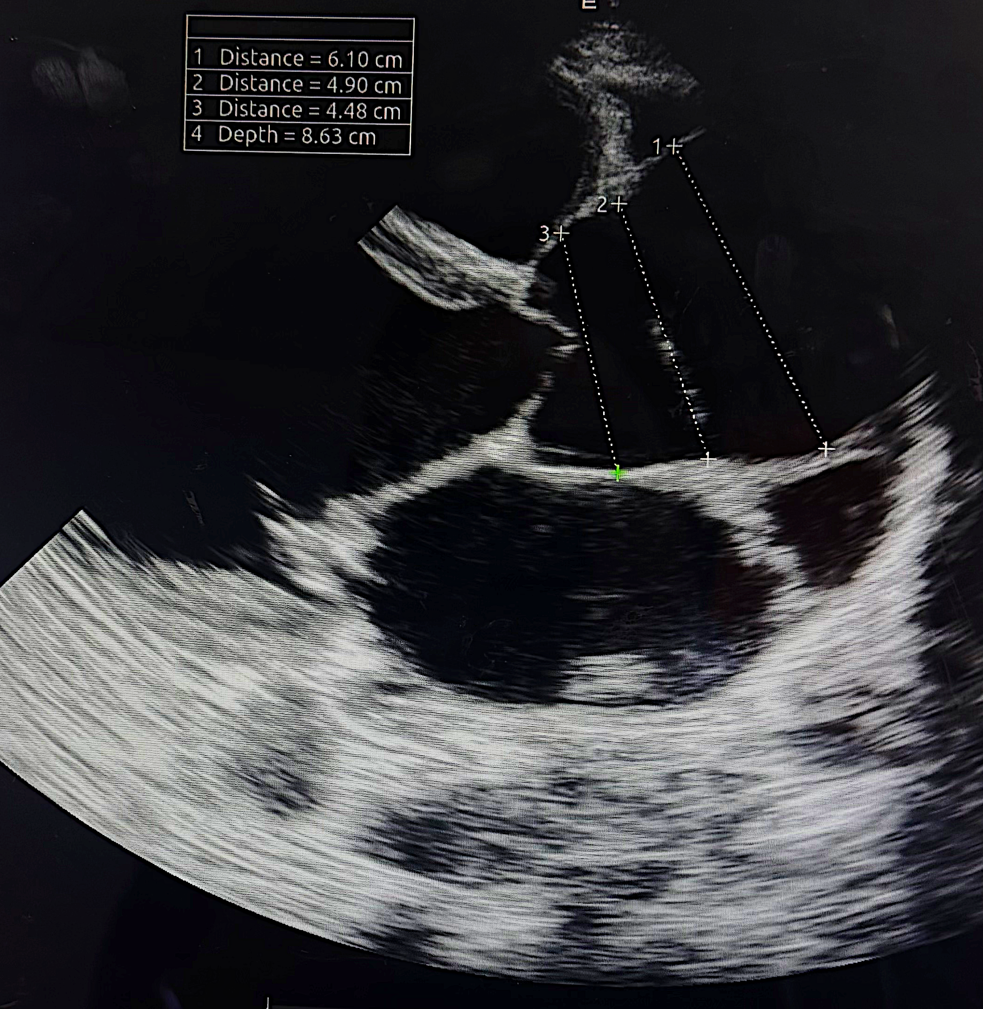
Figure 1 : Long axis parasternal view showing a dilated aorta in its initial segments : sinus, junction and ascending aorta.
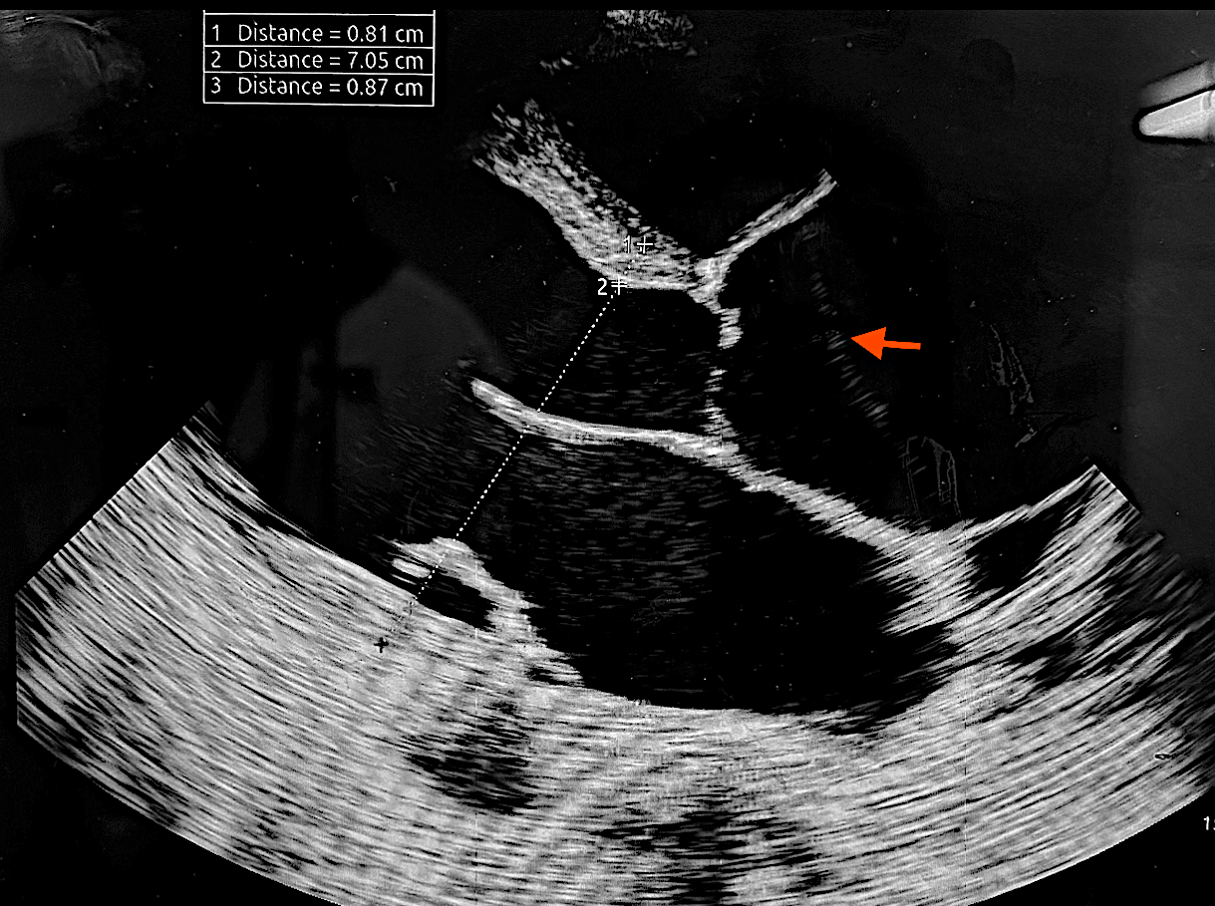
Figure 2 : Long axis parasternal view showing a type A aortic dissection and a dilated left ventricle and right ventricle .
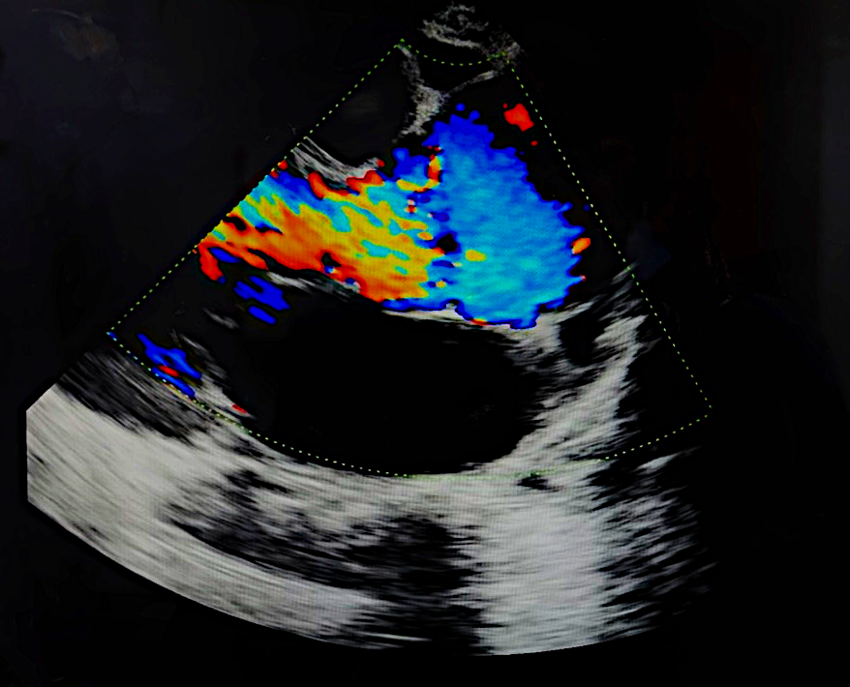
Figure 3: Long axis view showing aortic regurgitation
Heart surgery Team was informed for an urgent management along with an urgent computed tomography angiography that confirmed a Stanford type A aortic dissection extending from the ascending aorta to the abdominal aorta , carotid arteries and iliac arteries. (Figures 4 and 5)
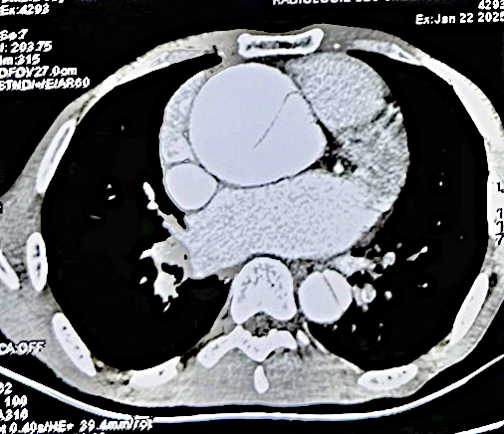
Figure 4 : Aortic CT scan showing an enlarged aortic aorta with extensive aortic dissection.
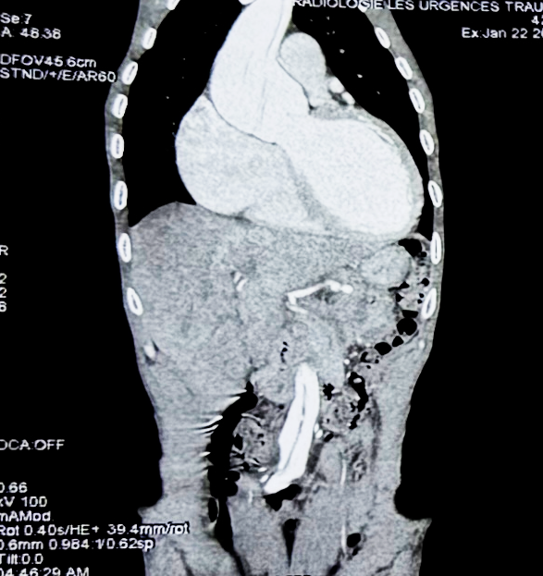
Figure 5 : Aortic CT scan showing the extension of the aortic dissection from the ascending aorta to the descending aorta
Given the age of patient, the history of spontaneous pneumothorax and bilateral retinal detachment in the young age, the clinical findings suggestive a connective tissue disorder and imaging findings of aortic aneurysm complicated by a type A aortic dissection , the dilated cardiomyopathy with biventricular dysfunction, the diagnosis of acute type A aortic dissection in the context of suspected Marfan syndrome was made. A beta-blocker therapy was initiated to manage heart rate and reduce aortic wall stress. Diuretics were established to treat the congestive heart failure. No hypertensive drugs were prescribed as the blood pressure remained normal. The patient was sent for an emergency surgical repair, with a poor prognosis.

3. discussion

Aortic dissection is a medical emergency with a high mortality rate if not promptly treated. In younger patients, connective tissue disorders like Marfan syndrome are significant predisposing factors due to the structural weakness of the aortic wall.
Marfan syndrome affects the fibrillin-1 gene, leading to systemic manifestations that increase the risk of aortic aneurysm and dissection. Limited life expectancy among affected individuals was primarily attributable to fatal aortic dissection. [4]
A study showed that younger patients had a dissection involving the supra-aortic vessels significantly more often than older patients and dissection extended significantly further downstream of the aorta. Younger patients showed significantly higher incidences of end-organ malperfusion correlating with dissection extension. [5]

The patient's history of spontaneous pneumothorax and retinal detachment, along with skeletal features, raised suspicion for Marfan syndrome. The diagnosis of Marfan syndrome is clinical, based on the revised Ghent criteria, which incorporate systemic features and family history. Genetic testing can provide confirmation but was not available in this case .[6]
Management of type A aortic dissection involves emergency surgical intervention to prevent complications such as cardiac tamponade, aortic rupture, and death. [7] Postoperative medical therapy, including beta-blockers, is essential to control blood pressure and reduce the risk of further aortic complications.[8]

In the past 30 years, research efforts have not only identified the genetic locus responsible but have begun to elucidate the molecular pathogenesis underlying this disorder, allowing for the development of seemingly rational therapeutic strategies for treating affected individuals. In spite of these advancements, the cardiovascular complications including mitral valve prolapse, aortic insufficiency, dilatation of the aortic root, and aortic dissection still remain as the most life-threatening clinical manifestations. [9

Studies are in progress to further refine the timing of thoracic aortic aneurysm repair to prevent dissection. Functional imaging to understand the pathophysiological process in the aortic wall and four-dimensional imaging to assess the flow patterns and wall stress are currently being pursued. Biomarkers, such as vertebral artery tortuosity and the presence of branch aneurysms. [10,11]

The management of patients with aortic dissection remains complex, at times controversial, and is continuously evolving with the innovation of operative and endovascular techniques and devices.[12]

4. Conclusion

This case report highlights the importance of considering connective tissue disorders like Marfan syndrome in young patients presenting with aortic dissection. Early recognition and prompt surgical intervention are critical for improving patient outcomes. Clinicians should maintain a high index of suspicion for Marfan syndrome in patients with suggestive clinical features to facilitate timely diagnosis and management. Although the research progress the mortality remains important in type A aortic dissection and the prognosis is even more serious in extending aortic Stanford type A aortic dissection with Marfan disease. Genetic testing and family screening are indicated to search for an unknown Marfan disease in the relatives. Aortic dissection is a rare but a life-threatening condition, a close follow-up is necessary even after treatment.

5. CLINICAL SIGNIFICANCE

Recognizing the signs of Marfan syndrome in patients can lead to earlier diagnosis of this connective tissue pathology, and can prevent the aortic dissection , by close echocardiographic screening researching a dilated aorta , an aneurysm or other cardiac manifestations of the disease. Also, the presence of suggestive connective tissue disorder signs is a warning to think about an aortic dissection as an the main etiology of chest pain. Urgent transthoracic echocardiography can confirm the diagnosis and indicates urgently an appropriate surgical intervention, and implementation of medical therapy to stabilize blood pressure, heart rate and prevent future cardiovascular events.

6. Declarations

Ethics Approval and Consent to Participate: Not applicable.

Patient Consent for Publication:
Written informed consent was obtained from the patient for publication of this case report and accompanying images.

References

1 . Elsayed RS, Cohen RG, Fleischman F, Bowdish ME. Acute Type A Aortic Dissection. Cardiol Clin. 2017 Aug;35(3):331-345. doi: 10.1016/j.ccl.2017.03.004. Epub 2017 May 26. PMID: 28683905.

2. Nienaber CA, Clough RE, Sakalihasan N, Suzuki T, Gibbs R, Mussa F, Jenkins MP, Thompson MM, Evangelista A, Yeh JS, Cheshire N, Rosendahl U, Pepper J. Aortic dissection. Nat Rev Dis Primers. 2016 Jul 21;2:16053. doi: 10.1038/nrdp.2016.53. PMID: 27440162.

3. Stuart AG, Williams A. Marfan's syndrome and the heart. Arch Dis Child. 2007 Apr;92(4):351-6. doi: 10.1136/adc.2006.097469. PMID: 17376944; PMCID: PMC2083669.
4. Murdoch JL, Walker BA, Halpern BL, Kuzma JW, McKusick VA. Life expectancy and causes of death in Marfan syndrome. N Engl J Med 1972;286:804–808.

5. Okita Y. Aortic dissection is more violent in the young. Eur J Cardiothorac Surg. 2023 Jun 1;63(6):ezad209. doi: 10.1093/ejcts/ezad209. PMID: 37233032.

6. Loeys BL, Dietz HC, Braverman AC, Callewaert BL, De Backer J, Devereux RB, Hilhorst-Hofstee Y, Jondeau G, Faivre L, Milewicz DM, Pyeritz RE, Sponseller PD, Wordsworth P, De Paepe AM. The revised Ghent nosology for the Marfan syndrome. J Med Genet. 2010 Jul;47(7):476-85. doi: 10.1136/jmg.2009.072785. PMID: 20591885.

7. Zhu Y, Lingala B, Baiocchi M, Tao JJ, Toro Arana V, Khoo JW, Williams KM, Traboulsi AA, Hammond HC, Lee AM, Hiesinger W, Boyd J, Oyer PE, Stinson EB, Reitz BA, Mitchell RS, Miller DC, Fischbein MP, Woo YJ. Type A Aortic Dissection-Experience Over 5 Decades: JACC Historical Breakthroughs in Perspective. J Am Coll Cardiol. 2020 Oct 6;76(14):1703-1713. doi: 10.1016/j.jacc.2020.07.061. PMID: 33004136.

8. Coelho SG, Almeida AG. Marfan syndrome revisited: From genetics to the clinic. Rev Port Cardiol (Engl Ed). 2020 Apr;39(4):215-226. English, Portuguese. doi: 10.1016/j.repc.2019.09.008. Epub 2020 May 18. PMID: 32439107.

9. Zeigler SM, Sloan B, Jones JA. Pathophysiology and pathogenesis of Marfan syndrome. Adv Exp Med Biol. 2021;1348:185–206. doi:10.1007/978-3-030-80614-9_8. PMID: 34807420; PMCID: PMC8915437.

10. Morris SA, et al. Increased vertebral artery tortuosity index is associated with adverse outcomes in children and young adults with connective tissue disorders. Circulation. 2011;124(4):388–396.

11. Lopez-Sainz A, et al. Aortic branch aneurysms and vascular risk in patients with Marfan syndrome. J Am Coll Cardiol. 2021;77(24):3005–3012. doi:10.1016/j.jacc.2021.04.054.

12. Khaja MS, Williams DM. Aortic Dissection: Introduction. Tech Vasc Interv Radiol. 2021 Jun;24(2):100745. doi: 10.1016/j.tvir.2021.100745. Epub 2021 Jul 25. PMID: 34602274.

