Case report

Probable right atrial myxoma in two adult Nigerian patients: Case series

Abstract
Primary cardiac tumors are uncommon, being documented at an estimated low incidence of less than 0.19%. Myxoma is the most common neoplasm encountered in many series, commonly involving the left atrium, with right atrial location occurring in about one-fifth of cases. The manifestations in patients with cardiac myxoma is protean, ranging from being asymptomatic to mimicking hosts of cardiac disorders, and diagnosis is commonly established using 2D-echocardiography. We present two cases of probable right atrial myxoma presenting with paroxysmal palpitation, lightheadedness and constitutional symptoms. The series demonstrates the occurrence of this rather rare disorder in our population and the prevailing limitations experienced in treatment.
Keywords: Right atrium; Mass; Myxoma

Introduction
Primary tumors of the heart are comparatively uncommon with incidence ranging between 0.0017% and 0.19% in postmortem series [1]. Three-quarters of these tumors are benign with almost 50% being myxomas. Locations of myxomas are mainly in the left atrium in about 75% of cases and 15-25% in the right atrium, and rarely in ventricles, superior vena cava and pulmonary veins. Multiple sites are found in about 5% of series [1, 2]. The predominant sites are in the atrial septum and fossa ovalis [3]. Majority of patients present between the third and sixth decade of life [4]. Right atrial myxoma may remain asymptomatic [5] before ultimately causing constitutional, obstructive and embolic symptoms and signs [6, 7]. Constitutional symptoms consist of fever, weight loss and arthralgia. The commonly observed embolic phenomenon is pulmonary embolism from tumor fragments or thrombi reaching the pulmonary circulation, resulting in chest pain, dyspnea, hemoptysis and hypotension [8]. Occasionally, blockage of the tricuspid valve may result in breathlessness on exertion, syncope or sudden death [6, 7, 8]. The most common laboratory abnormality is elevated erythrocyte sedimentation rate (ESR), resulting from elaboration of interleukin-6 by the neoplasm [9]. Diagnosis is commonly established using 2D-echocardiography and definitive treatment is surgical removal [10]. We present two cases of probable right atrial myxoma from northeast Nigeria, a rare cardiac tumor with varying clinical presentation.

Case Presentation
Case 1
A 33-year-old lady has been receiving care for systemic hypertension in our division since 2008. She had pregnancy-induced hypertension in 2005 and maintained normal blood pressure postpartum until 2008 when systemic hypertension was diagnosed. Her blood pressure has been well controlled on 10mg of amlodipine with no target organ damage. She began to experience paroxysms of palpitation, central chest discomfort and shortness of breath a year prior to presentation. Palpitation was felt predominantly over the chest with occasional light-headedness and perspiration but there was no history of syncope. She noticed recent onset weight loss, lethargy and occasional pyrexia prior to prsentation. There was no history of cough, leg or abdominal swelling, and review of systems was unremarkable.
When examined, she was afebrile and not distressed. There was no peripheral lymph node enlargement, evidence of weight loss or thyroid enlargement. She had a regular and normal volume pulse of 90 beats per minute with no radio-femoral delay. Other peripheral pulses were present and normal. The blood pressure was 125/81 mm Hg and comparable in both arms. The jugular venous pressure was normal, and precordium was only remarkable for an accentuated first heart sound. There was no murmur. Chest and abdomen were essentially normal. Other systems and the breast were normal.
Resting 12-lead ECG obtained on several occasions revealed sinus tachycardia with no features of pre-excitation, prolonged or shortened QT interval, abnormal ST segments or epsilon wave. There were no features of atrial abnormality or left ventricular hypertrophy. When subjected to 24-hour Holter ECG, sinus tachycardia (maximum rate of 154 bpm) was documented coincidental with palpitations. Other parameters were within normal limits. Transthoracic 2D-echocardiography revealed a pedunculated non-homogenous mass measuring 28 x 24 mm attached to the right atrial side of the inter-atrial septum [Figure 1], protruding through the right ventricular inflow track during diastole. There was a mild tricuspid regurgitation (peak velocity of 2m/s), but other cardiac structures were normal. There was no significant diastolic gradient across the tricuspid valve. The left ventricular ejection fraction was 60%. There was no pericardial effusion. Transesophageal echo, 3D-echo, cardiac CT and cardiac MRI were not available. The erythrocyte sedimentation rate, white cell count and packed cell volume were 80mm/hr, 7.0 x 10⁹/L and 0.38L/L respectively. Thyroid function test and casual blood glucose were normal. Assessment of serum catecholamine and its metabolites was not done.
A presumptive diagnosis of right atrial myxoma was made, and she opted for referral to India, where she underwent open heart surgery and excision of the mass. Details of the histologic diagnosis was not available.
Case 2
This was a forty-two-year-old male who presented with fever, lethargy and anorexia over a two-month period. These symptoms were followed by dyspnea, paroxysmal nocturnal dyspnea, cough, hemoptysis, dizziness and ankle swelling that developed two weeks prior to presentation. Important findings were pallor, icterus, pedal edema, raised jugular venous pressure, S₃ gallop, hepatomegaly, ascites and left infra-scapular bronchial breath sounds. Chest radiogram showed left lower zone homogeneous opacity with air bronchogram. The recorded ESR was 47mm/Hr. Total and direct bilirubin levels were elevated at 122µmol/L and 92 µmol/L. Aspartate transaminase and alanine transaminase levels were raised at 148iu/L and 25iu/L. Alkaline phosphatase level was elevated at 50 iu/L. Total protein level was normal at 75 g/L while albumin level was slightly low at 30 g/L. Abdominal ultrasound showed enlarged liver with granular parenchymal echo-pattern, massive ascites and multiple enlarged paraortic nodes. Patient experienced subjective improvement with the treatment regime of community-acquired pneumonia. Echocardiogram demonstrated right atrial mass [Figure 2] with left sided pleural effusion. There was no pericardial effusion. The patient collapsed suddenly and expired despite resuscitation measures three weeks into his admission. Autopsy was not done.
Discussion
The presentation in our first case illustrated the non-specific features of atrial myxomas. Paroxysmal palpitation and lightheadedness in a young female could result from many cardiac conditions ranging from those not so uncommon like paroxysmal supraventricular tachycardia to rare ones like pheochromocytoma (especially with history of hypertension) and other forms of cardiac arrhythmia. Holter ECG documented only sinus tachycardia coincidental with episodes of palpitations, suggesting that the symptoms might not be related to other forms of cardiac arrhythmia. Protrusion of the right atrial mass into tricuspid valve could limit right ventricular filling with the eventual low cardiac output resulting in symptomatic hypotension and compensatory sinus tachycardia, syncope or sudden cardiac death [6, 7, 8]. Although excluding pheochromocytoma is essential in our first patient with hypertension, paroxysmal palpitation, diaphoresis and central chest discomfort, work-up for pheochromocytoma is not routinely available in our center. However, thyroid function test was normal.
The protean manifestations of atrial myxoma involving the spectrum of cardiovascular symptomatology is illustrated by the cases in view. The second case presented with symptoms consistent with congestive cardiac failure. The right-sided symptoms and signs could be driven by obstruction of the tricuspid valves, resulting in leg and abdominal swellings and abnormal liver enzymes. Both patients had constitutional symptoms of fever, lethargy, and had weight loss. However, these symptoms were only related to myxoma in retrospect, following the detection of cardiac mass on echocardiography. This is a common scenario in many cases where constitutional symptoms are only attributed to myxomas in retrospect. Interestingly, the second patient in the series had community-acquire pneumonia, which could as well be responsible for these symptoms. Other malignant conditions that could result in right atrial mass include renal and hepatocellular carcinomas especially when associated with pericardial effusion [11]. None of the patients in our series had pericardial effusion. The appearance of the liver on ultrasound, along with elevated liver enzymes warrants further evaluation. Alpha-feto protein was negative, and the patient passed away before biopsy could be done.
The diagnosis of atrial myxoma is commonly established using echocardiography (mainly transthoracic 2-D echocardiography) with transesophageal echocardiography having higher sensitivity. The typical nature of the mass and its attachment notwithstanding, additional imaging with cardiac CT and MRI will provide a better characterization of the mass and help to differentiate malignancies from myxoma [12, 13, 14]. The presence of pericardial effusion, enhancement of the pericardium, myocardial thickening and lymphadenopathy on CT are consistent with malignancies. Myxomas have lower attenuation than the myocardium on CT, with few having similar attenuation. Higher attenuation denotes the presence of calcification. On cardiac MRI, the presence of myocardial infiltration and asynergy of the underlying wall is suggestive of malignancy. Myxomas have hypointense appearance during first-pass perfusion and exhibit late gadolinium enhancement. Histological confirmation will be required to exclude other causes of right atrial masses. Cardiac CT, MRI and histology were not available, reducing our diagnosis to probable cases of right atrial myxoma, especially since differentiating right atrial myxoma from metastatic cancers often requires multiple imaging modalities [15].
Both patients had elevated ESR, a common finding in atrial myxoma. Elevated liver enzymes and hepatomegaly have been documented in patients with right atrial myxoma [7], resulting from obstruction of tricuspid valve by a pedunculated myxoma. Another important, but rare cause of right atrial mass in a female is an extension of intravenous leiomyomatosis from the inferior vena cava into to the right atrium. No mass was visualized in the IVC, and both atrial masses had demonstrable attachments to the interatrial septum.
The circumstances and manner of death in the second case is reminiscent of sudden cardiac death, as improvement was documented in his clinical status following treatment of community acquired pneumonia. Embolization of right atrial myxoma could result in pulmonary embolism and sudden death [6, 7], an outcome that could also result from sudden severe obstruction of the tricuspid opening.
The evaluation and management of the index cases is limited by lack of advanced diagnostic facilities like 3D echo, cardiac CT and cardiac MRI; and onsite cardiothoracic services. Albeit rare, pheochromocytoma remains an important differential diagnosis that wasn’t excluded in the first case, and hepatocellular carcinoma was not excluded in the second case. These limitations are typical scenario in the evaluation and management the growing population of patients with cardiovascular diseases in Nigeria, and sub-Saharan Africa in general.

References
- Reynen K. Cardiac myxomas. N Engl J Med 1995; 333: 1610-7
- Pritchard RW. Tumours of the heart. Review of the subject and report of hundred and fifty cases. Arch Path 1951; 51: 98-128
- Roscher AA, Kato NS, Quan H, Padmanabhan M. Intra-atrial myxomas, clinical-pathologic correlation based on two case studies including historical review. Presented at the 5th World Congress of the International Society of cardio-thoracic Surgeons (ISCTS), Dorado, Puerto Rico, June 4-8, 1995
- Bulkley BH, Hutchins GM. Atrial myxomas: A fifty-year review. Am Heart J 1979; 97: 639-43
- Yuce M, Dagdelen S, ergelen M, Eren N, caglar N. A huge obstructive myxoma located in the right heart without causing any symptom. Int J cardiol 2007; 114: 405—6
- Azevedo O, Almeida J, Nolasco T, Medeiros R, Casanova J, Bartosch C, Almeida J, Pinho P. Massive right atrial myxoma presenting as syncope and exertional dyspnea: case report. Cardiovascular Ultrasound 2010; 2: 23
- Ojji DB, Ajiduku SS, Omonua OO, Abdulkareem LL, Parsonage W. A probable right atrial myxoma prolapsing through the tricuspid valve into the right ventricle: a case report. Cases Journal 2008; 1: 386
- Bilku RS, Loubani M, Been M, Patel RL. Massive right atrial myxoma causing exertional dyspnea. Eur J Echocardiogr 2008; 9: 130-2
- Kanda T, Umeyama S, Sasaki S, Nakasato Y, Morishita Y, Imai S, Suzuki T, Murata K. Interleukin-6 and cardiac myxoma. Am J Cardiol 1994; 74: 965-7
- Nwiloh J, Oludara M, Adebola P. Left atrial myxoma: Case report and literature review. East Afr Med J 2011; 88: 71-2
- Reynen K, Kockeritz U, Strasser RH: Metastases to the heart. Ann Oncol 2004; 15:375-81
- Randhawa K, Ganeshan A, Hoet ET. Magnetic resonance imaging of cardiac tumors: part 1, sequences, protocols and benign tumors. Curr Diagn Radiol 2011; 40:158-168
- Kassop D, Donovan MS, Chezum MK, et al. Cardiac masses on cardiac CT: A review. Curr Cardiovasc Imaging Rep 2014; 7: 9281
- Restrepo CS, Largoza A, Lemos DF, et al. CT and MR imaging findings of malignant cardiac tumors. Curr Probl Diagn Radiol 2005; 34: 1-11
- Nakabayashi K, Murata S, Kato H and Oka T. The differentiation of giant right atrial myxoma from metastatic cancer with the use of multiple imaging modalities. Intern Med 2016; 55: 925-928

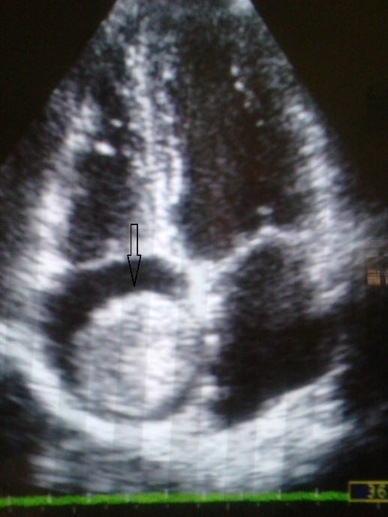
Figure 1: Apical four chamber view showing a non-homogenous right atrial mass (arrow) attached to interatrial septum

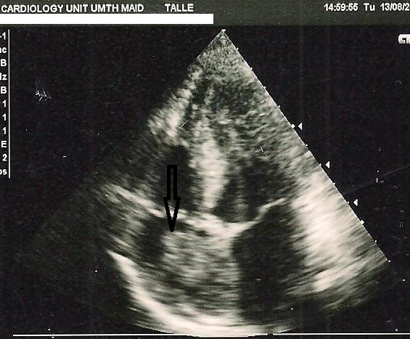
Figure 2: Non-homogenous right atrial mass (arrow) attached to the interatrial septum

