Case report

Cardiac Arrest Due to Unprotected Acute Left main coronary artery Occlusion: A Life-Saving Approach with Angioplasty and Veno-Arterial ECMO

ABSTRACT

Acute occlusion of the unprotected left coronary common Artery is a rare but very serious angiographic finding with short-term life-threatening consequences. The clinical presentation is severe, with a high incidence of cardiogenic shock and sudden death. Treatment must be rapid and organized, and requires an angioplasty combined with hemodynamic support and the usual resuscitation resources.
We report the case of a 62-year-old patient admitted to our center after a resuscitated cardiac arrest, vasoactive drugs were initiated and the patient was rushed to the angiography room, we objectified a complete occlusion of the LCA. Provisional stenting followed by kissing was the technique used, with rapid restoration of TIMI III flow.
The persistence of shock with metabolic acidosis despite improvement in BP led to the use of hemodynamic support. VA ECMO type was introduced via the F-F line.
This case underscores the importance of rapid diagnosis, coordinated multidisciplinary response, and the use of mechanical circulatory support to improve outcomes

Keywords: Left main coronary artery, cardiac arrest, VA-ECMO, PCI, acute coronary syndrome, cardiogenic shock

1. INTRODUCTION
The left main coronary artery (LMCA) supplies a critical myocardial territory, including the left anterior descending (LAD) and left circumflex (LCx) arteries. Acute occlusion of the unprotected LMCA is a rare but catastrophic event that results in rapid and extensive myocardial ischemia. Given the magnitude of the myocardial area at risk, unprotected LMCA occlusion frequently presents with profound cardiogenic shock, malignant arrhythmias, or sudden cardiac arrest, often within minutes of symptom onset. Mortality rates in these patients approach 90% when left untreated or when reperfusion is delayed [1,2].
Prompt restoration of coronary perfusion is essential to improve survival, yet the management of such patients remains profoundly challenging due to hemodynamic instability and the risk of periprocedural cardiac collapse. While coronary artery bypass grafting (CABG) remains the gold standard for stable LMCA disease [3], it is not feasible in the acute setting, particularly in unstable or arresting patients. Percutaneous coronary intervention (PCI) has emerged as the preferred initial strategy in emergent settings due to its rapid deployment, especially in centers equipped with advanced mechanical circulatory support (MCS) modalities [4,5].
Veno-arterial extracorporeal membrane oxygenation (VA-ECMO) offers full cardiopulmonary support by diverting venous blood, oxygenating it externally, and returning it to the arterial system. In the setting of cardiogenic shock or cardiac arrest, VA-ECMO can maintain end-organ perfusion, stabilize the hemodynamic profile, and provide a bridge to definitive intervention such as PCI or surgical revascularization. Moreover, it serves as a critical tool in allowing time for myocardial recovery in patients who would otherwise succumb to circulatory collapse.
2. Presentation of Case

This is a 62-year-old patient admitted to the intensive care unit (ICU) for recuperative arrest, with no particular personal or family history, whose cardiovascular risk factor is hypertension on treatment.

The patient presented in unconscious cardiogenic shock.
Blood pressure was unmanageable. The per-critical electrocardiogram (ECG) showed sinus rhythm, with an anterior shift and a few ventricular extrasystoles.
The patient underwent specialized cardiopulmonary resuscitation with IOT and vasoactive amines (dobutamine).
Echocardiography revealed severe left ventricular dysfunction with global hypokinesia and an ejection fraction of 25%.

The patient was rushed to the catheterization room for coronary angiography, which revealed acute unprotected obstruction of the left main (Fig.1).

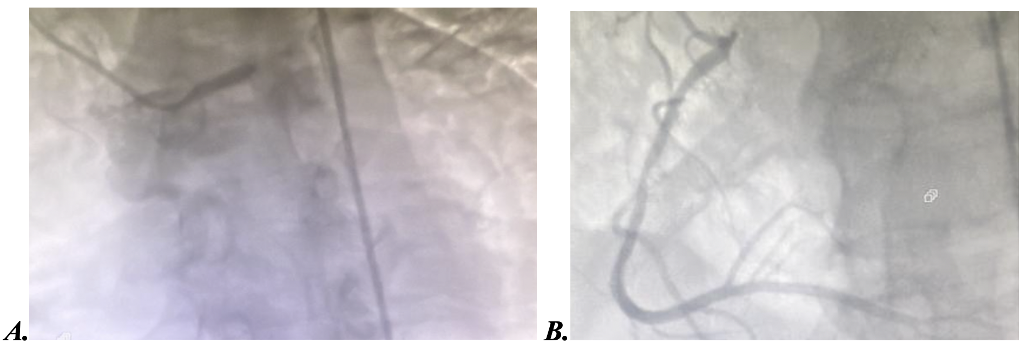
Fig. 1: A. Thrombotic acute occlusion of the distal left main. B. Very tight stenosis of the RCA2.

Passage of the guide enabled recovery of a TIMI 3 flow and revealed a very tight stenosis from the distal left main to the proximal IVA (Fig.2).

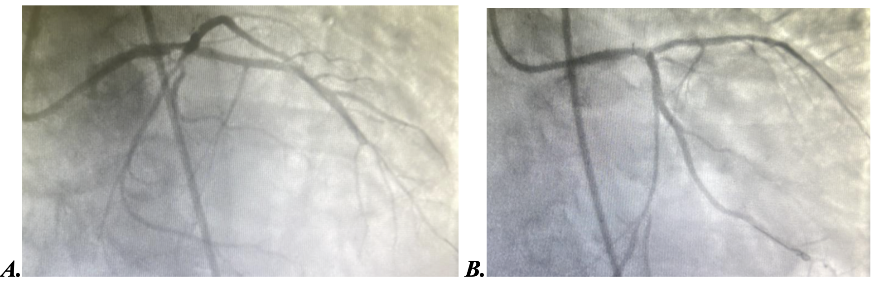
Fig. 2: A. TIMI3 flow recovery after guidewire passage. B. Tight stenosis of the distal LM.

Recanalization of the LM distal to the IVA with implantation of an active stent (Fig.3) with mesh opening towards the circumflex with a good result.

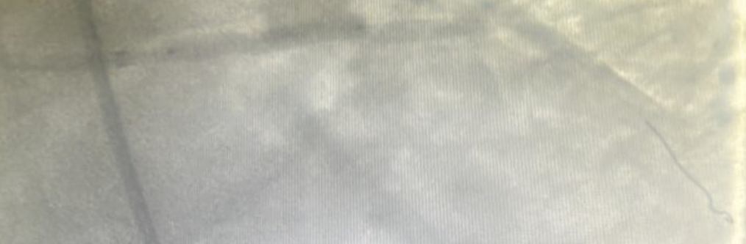
Fig. 3: Placement of a LM-IVA proximal stent.

The persistence of shock with metabolic acidosis despite improvement in blood pressure led to escalation to hemodynamic support. Circulatory assistance of the veno-arterial ECMO type was introduced via the femoral-femoral line (Fig.4).

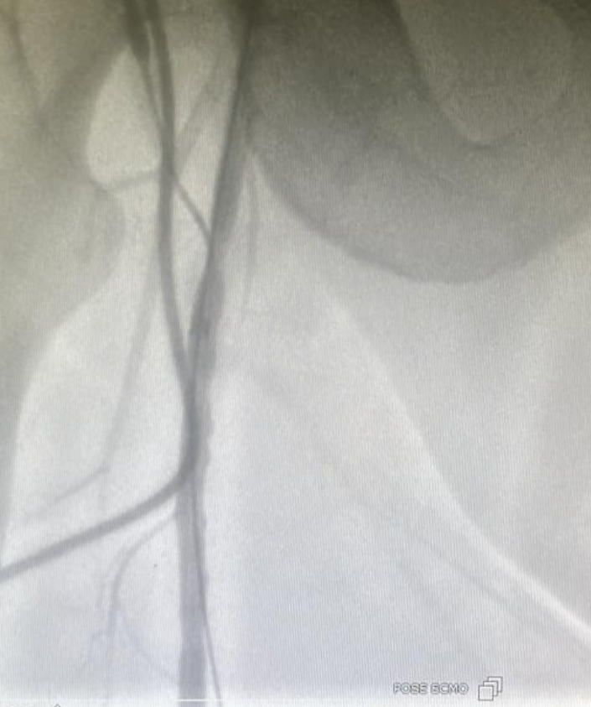
Fig. 4: Veno-arterial ECMO via the femoral-femoral route

The evolution was marked by clinical-biological, gasometric and echocardiographic improvement.
Weaning from ECMO was achieved on day 5. Coronary control was scheduled after 10 days.

3. discussion

The LM perfuses more than 75% of the left ventricular myocardium, making acute occlusion of the left ventricular myocardium very serious [6]. Although rare, this is a serious situation.
The incidence of cardiogenic shock ranges from 64% to 92% [7]. This condition is associated with high morbidity and mortality, as highlighted by the study by Luca et al [8], which reported an in-hospital mortality rate of 58% and an incidence of cardiogenic shock of 80%.
Poor prognostic factors include delayed diagnosis, transition to cardiogenic shock (which was the case in our patient), failure of revascularization, left-hand dominance and absence of collateral circulation [9].

Provisional stenting followed by kissing remains the most widely used technique in the acute phase of a common trunk obstruction, given its rapidity. The aim is to rapidly restore TIMI III flow in the IVA and circumflex. The technique of provisional stenting of the LM-IVA followed by a kissing balloon is the most commonly used, given its rapidity and feasibility. This was not the case for our patient, where provisional stenting was preferred, followed by diagonal mesh opening. With regard to antithrombotic therapy, the patient was treated with antigIIB-IIIA in view of the thrombotic burden associated with dual antiaggregation therapy.

The use of thromboaspiration prior to stenting in ST+ ACS has been shown to be effective both angiographically and in terms of mortality [10]. However, there are no data in the literature on its use in AOLM.

Despite the improvement in our patients' blood pressure parameters, the use of circulatory assistance helped to redress the hemodynamic situation and break the vicious circle of SIRS.

ECMO (Extra Corporeal Membrane Oxygenation) is a mechanical circulatory assistance tool capable of providing the patient with systemic flow with or without oxygen supplementation in the event of advanced cardiac failure.
It is the mechanical circulatory support of choice for the most severe cases refractory to maximal medical treatment.
At present, it is still reserved for the sub-group of patients in cardiogenic shock known as refractory, i.e. those who worsen under maximum medical treatment and whose in-hospital mortality rates exceed 70%, as suggested by current classifications of cardiogenic shock (INTERMACS, SCAI).

Acute obstruction of the LM complicated by cardiogenic shock is an ideal indication for bypass surgery, but the time of initiation must be carefully chosen to obtain the best results.
In our case, ECMO enabled us to get through the acute phase, while providing adequate flow, oxygenation and decarboxylation. Gasometry improved markedly after 24 h.

4. Conclusion
Acute unprotected LMCA occlusion resulting in cardiac arrest is often fatal. Early initiation of VA-ECMO can provide critical hemodynamic support and allow for successful revascularization via PCI. A multidisciplinary team approach and rapid deployment of ECMO can dramatically improve survival and neurological outcomes in such critically ill patients.
Consent

As per international standards or university standards, patient written consent has been collected and preserved by the author.

References

- unprotected left main coronary artery occlusion. Ann Thorac Surg. 2003;76(3):947–951
- Lee MS, Shlofmitz E, Kaplan B, et al. Percutaneous coronary intervention for unprotected left main coronary artery disease. J Am Coll Cardiol. 2016;68(11):1233–1246.
- Fihn SD, Gardin JM, Abrams J, et al. 2012 ACCF/AHA/ACP/AATS/PCNA/SCAI/STS guideline for the diagnosis and management of patients with stable ischemic heart disease. Circulation. 2012;126(25):e354–e471
- Neumann FJ, Sousa-Uva M, Ahlsson A, et al. 2018 ESC/EACTS Guidelines on myocardial revascularization. Eur Heart J. 2019;40(2):87–165
- Dzavík V, DeVries JT, Christakis GT, et al. Emergency revascularization for acute left main coronary artery occlusion: percutaneous versus surgical intervention. J Am Coll Cardiol. 2001;38(3):722–727
- Ghrissi, O. Nallet ∗, W. Amara et al. Infarctus par occlusion aiguë du tronc commun non protégé : à propos de six cas traités par angioplastie. Annales de Cardiologie et d’Angéiologie 58 (2009) 293–298.
- Tan CH, Hong MK, Lee CW, Kim YH, Lee CH, Park SW, et al. Percutaneous coronary intervention with stenting of left main coronary artery with drug-eluting stent in the setting of acute ST elevation myocardial infarction. Int J cardiol 2008 ;126:224–8
- De Luca G, Suryapranata H, Thomas K, van’t Hof AW, de Boer MJ, Hoorntje JC, et al. Outcome in patients treated with primary angioplasty for acute myocardial infarction due to left main coronary artery occlusion. Am J Cardiol 2003;91:235
- Sakai K, Nakagawa Y, Kimura T, Ando K, Yokoi H, Iwabuchi M, et al. Primary angioplasty of unprotected left main coronary artery for acute anterolateral myocardial infarction. J Invasive Cardiol 2004;16: 621–5
- Vlaar PJ, Svilaas T, Van der Horst IC, Diercks GF, Fokkema ML, de Smet BJ, et al. Cardiac death and reinfarction after 1 year in thrombus aspiration during percutaneous coronary intervention in acute myocardial infarction study (TAPAS): a 1-year follow up study. Lancet 2008;371:1915–20

ABBREVIATIONS
LMCA : left main coronary artery
LCx : left circumflex
CABG : coronary artery bypass grafting (CABG
PCI : Percutaneous coronary intervention (PCI)
MCS : mechanical circulatory support (MCS)
VA-ECMO : Veno-arterial extracorporeal membrane oxygenation

