Case report

A TELESCOPING TUMOUR!!! SPINDLE CELL TUMOUR A LEAD POINT OF INTUSSUSSEPTION – A RARE CASE REPORT

Abstract:
Background: This is a rare case of a benign spindle cell tumour in an adult acting as a lead point for intussusception.
Presentation of case: We hereby present a case of 65 yr old male patient presenting to our emergency department with complaints of abdominal pain more in the right lower abdomen for 4 days and abdominal distention for 2 days and non-passage of stools and flatus for 2 days. Patient was stabilized and investigated for subacute intestinal obstruction and was found to have ileocecal intussusception. Patient was taken up for emergency surgery and intraoperative findings corelated with preoperative CT reports. patient underwent resection of the ileal segment and ileo-ileal anastomosis. The specimen was subjected to histopathological examination revealing a globular growth in the lumen of the ileum which on microscopic evaluation revealed benign spindle cell tumour of the gastrointestinal tract. recovery of the patient was uneventful and was discharged as per hospital protocol.
Conclusion: In adults of elderly age group such tumours causing bowel obstruction or intussusception are usually malignant with possible metastasis at the time of presentation whereas in this case the tumour acting as a lead point was benign hence making it a rare presentation This case highlights the importance of thorough evaluation and prompt surgical intervention.
Keywords: intussusception, spindle cell tumour, lead point, resection, anastomosis

Introduction:
Intussusception is defined as a condition in which a part of the bowel telescopes into another part of the bowel^{1.} Segment of bowel (the intussusceptum) glides into an adjacent distal segment of bowel (the intussuscepien)².It is more commonly seen in paediatric population and rarely seen in adult population. In adults the causes can idiopathic, benign or malignant ¹.The symptoms of the condition are very vague like lethargy, vague abdominal pain, fever and very rarely obstructive symptoms and hence the detection of this condition is very challenging clinically³. With the advent of newer radiological investigations, it’s easier to diagnose this condition and thereby treating the same promptly. In childhood intussusception 90% of cases the aetiology is idiopathic whereas in adults there is demonstrable lead point in about 70% to 90% of the cases⁴.
The main types of intussusceptions are Enteric type( intussusception is limited to the small intestine), Ileocolic type( the ileum passes the ileocolic segment, but the appendix does not invaginate),Ileocecal type( the ileocecal portion invaginates into the ascending colon)and Colo colic type( the intussusception is limited to the colon and rectum) with enteric type being the most common overall⁵.The mainstay of management of intussusception in adults is mainly surgical as most of the cases have a lead point and hence prompt surgical treatment is required for prevention of complications in order to prevent dreaded complications like bowel ischemia, perforation peritonitis, sepsis and even death of patient⁶.

CASE PRESENTATION:
Hereby a elderly male patient of 65yrs of age came to the emergency department of Victoria hospital with complaints of abdominal pain since 4 days in the right lower abdomen , colicky in nature with on and off attacks of pain .Patient also had history of abdominal distension since 2 days with history of non-passage of flatus and stools since 2 days with history of breathing difficulty due to severe abdominal distension .There was no significant history of any previous abdominal surgeries done in the past. There was no history suggestive of unprecedented or intentional weight loss. There was no history of any bleeding per rectum nor difficulty in passage of stools before this episode. On examination abdomen appeared completely distended with tenderness noted in right iliac fossa with guarding over the same region, bowel sounds on admission was hyperperistaltic. Per rectal examination revealed roomy cavity with normal tone and no evidence of any palpable mass as such.
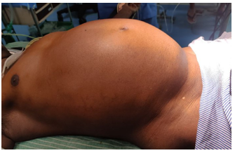
Fig 1: Preoperative picture of the abdomen showing gross abdominal distension

Patient had tachycardia on arrival with other vital parameters stable. Patient underwent preliminary investigations such as routine blood investigations and radiological investigations. Erect radiograph of the abdomen revealed dilated bowel loops with multiple significant air- fluid levels suggestive of bowel obstruction. Ultrasonography of the abdomen and pelvis revealed dilated hypoperistaltic bowel loops with minimal interbowel fluid with ‘target sign’ appearance in the right lilac fossa suggestive of intussusception. To further confirm the diagnosis patient underwent contract enhanced computed tomography (CECT) of the abdomen and pelvis on an emergency basis which revealed features suggestive of ileo- caecal intussusception with secondary small bowel obstruction with dilated jejunal loops with collapsed terminal ileum for a distance of 7.8 cm extending into the caecum forming a transition point. Telescoping of ileal segment into the caecum up to 1.7 cm noted. Patient was catheterized and a Ryles tube was inserted and patient was counselled and prepared for emergency laparotomy.
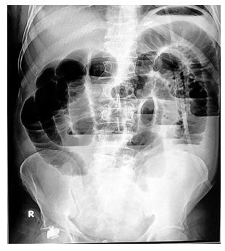
Fig 2: Erect abdominal radiograph depicting multiple dilated small bowel loops with air-fluid levels suggestive of bowel obstruction

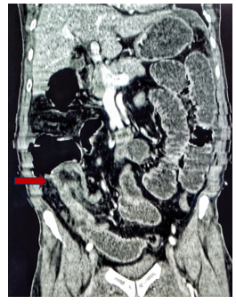
Fig 3: coronal section of contrast CT of abdomen showing the telescoping of terminal ileum into the caecum

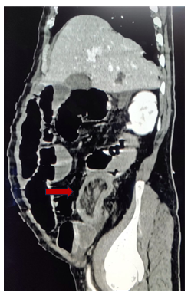
Fig 4 :A sagittal section of contrast CT of abdomen showing the intussusception
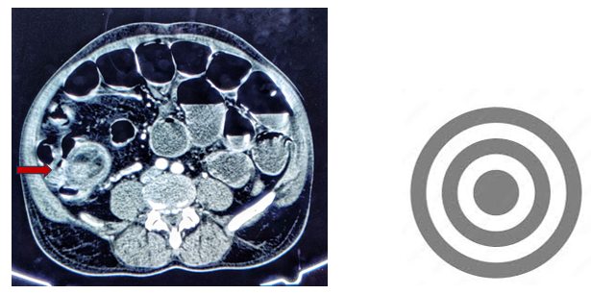
Fig 5: A transverse section of contrast CT of abdomen showing ‘target mass sign’

Perioperative findings:
Patient was taken for emergency laparotomy under general anaesthesia. Liberal midline incision was made from below xiphisternum to just above the symphysis pubis. Thorough exploration and visual examination of the abdomen was done. Intraoperatively the jejunal loops were dilated and shiny. The point of intussusception was identified and on palpation a firm structure noted within the lumen of the terminal ileum. Hence decision was to go ahead with resection of the segment from about 10 cm from ileocecal junction to around 30 cm from ileocecal junction, resecting about 20 cm of the ileum involved. Ileoileal anastomosis was done and abdominal drain placed in the anastomotic site and abdomen closure done.

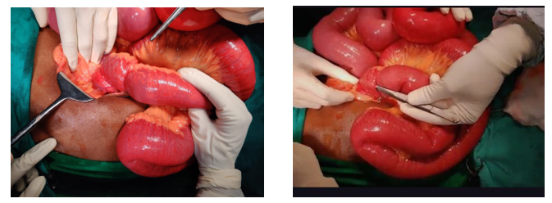
Fig 6: Intraoperative pictures showing the telescoping of ileum into the caecum

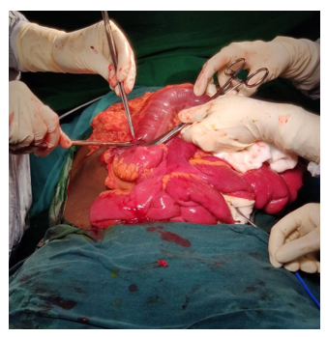
Fig 7: Intraoperative picture showing resection of the involved ileal segment

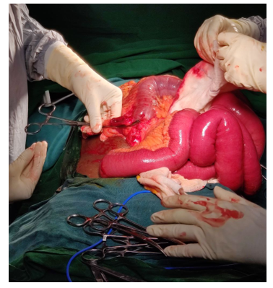
Fig 8: Intraoperative picture depicting post resection of the involved ileal segment

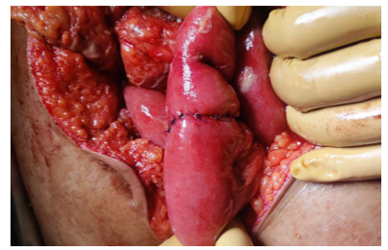
Fig 9: Intraoperative picture showing post ileal segment resection ileo-ileal anastomosis

The resected specimen was examined and cut open to reveal a globular pedunculated growth of size 3cm x 3 cm completely obstructing the ileal lumen. The specimen was sent for histopathological examination in our dedicated pathology lab.

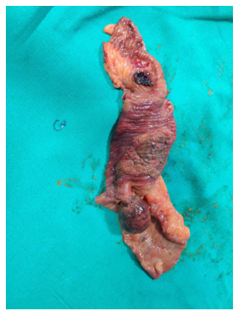
Fig 10: Resected specimen of the ileum showing the well defined globular pedunculated tumour arising from the mucosa

Patient postoperative period was uneventful; patient was started orally on post operative day 2 and patient tolerated well. Abdominal drain removed on post operative day 4 and was discharged on post operative day 8. patient was followed up for a month and patient is doing well at present.

HISTOPATHOLOGICAL EXAMINATION
On examination of the resected specimen a greyish brown globular well-defined growth noted with a broad peduncle within the lumen arising from the antimesenteric side of the resected specimen. Microscopic examination revealed multiple spindle shaped cells with no signs of atypia suggestive of benign spindle cell neoplasm. The bowel wall normal histologically.
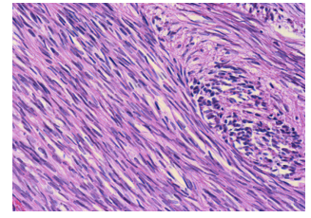
Fig 11: Microscopic picture showing the histopathology of the tumour

DISCUSSION:
Adult intussusception is a rare condition, with the majority of cases linked to a pathological lead point. Malignant tumours are the most common cause, accounting for a significant portion of cases. However, benign tumours, including gastrointestinal stromal tumours (GISTs), leiomyomas, and spindle cell neoplasms, can also act as lead points. These benign tumours are rare, and their diagnosis often requires histopathological examination.
Spindle cell tumours are mesenchymal neoplasms that can arise in various organs, including the gastrointestinal tract and are typically asymptomatic and often detected incidentally ⁷ .In this case, the benign nature of the spindle cell tumour is remarkable because it contrasts with the more common presentation of malignancy in adult intussusception.
The mainstay of treatment for adult intussusception is surgical intervention. Unlike paediatric cases, where non-surgical reduction may be attempted, adults with intussusception typically require resection due to the high likelihood of a pathological lead point. In this case, emergency laparotomy and resection of the affected ileal segment were performed with a successful outcome. The ileo-ileal anastomosis restored bowel continuity. In this case, the lead point was a benign spindle cell tumour, a rare finding in adult intussusception. The absence of systemic signs and histological features of malignancy supported the benign nature of the lesion. Surgical resection led to complete resolution, and the patient recovered well.

CONCLUSION:
Intussusception is a common condition in children whereas rare condition in adults. Even if seen in adults most common cause of it will be malignancy but benign tumours are a rare feature. They are usually incidental until they produce symptoms and signs of obstruction which may further lead to complications such as perforation peritonitis and few chances of the lead point being malignant. A thorough workup is required in such conditions to act and intervene in conditions of intussusception and to realize the cause for intussusception to occur. A vigilant eye and keen thought are hence required in management of such cases.
CONSENT:
As per international standards and/or university standards consent has been taken and ethical approval has been taken and preserved by the author(s)
ETHICAL APPROVAL:
Ethical approval has been approved and preserved according to the required international standards by the author(s)

REFERENCES:
- Aydin N, Roth A, Misra S. Surgical versus conservative management of adult intussusception: Case series and review. Int J Surg Case Rep. 2016;20:142-6. doi: 10.1016/j.ijscr.2016.01.019. Epub 2016 Jan 22. PMID: 26859872; PMCID: PMC4818310.
- Bradshaw CJ, Johnson PR. Intussusception. Paediatrics and Child Health. 2018 May 1;28(5):222-6.
- Felix EL, Cohen MH, Bernstein AD, Schwartz JH. Adult intussusception; case report of recurrent intussusception and review of the literature. Am J Surg. 1976;131:758–761. doi: 10.1016/0002-9610(76)90196-3
- Yakan S, Caliskan C, Makay O, Denecli AG, Korkut MA. Intussusception in adults: clinical characteristics, diagnosis and operative strategies. World J Gastroenterol. 2009 Apr 28;15(16):1985-9. doi: 10.3748/wjg.15.1985. PMID: 19399931; PMCID: PMC2675089.
- Panzera F, Di Venere B, Rizzi M, Biscaglia A, Praticò CA, Nasti G, Mardighian A, Nunes TF, Inchingolo R. Bowel intussusception in adult: Prevalence, diagnostic tools and therapy. World J Methodol. 2021 May 20;11(3):81-87. doi: 10.5662/wjm.v11.i3.81. PMID: 34026581; PMCID: PMC8127421.
- Lu T, Chng YM. Adult intussusception. The Permanente Journal. 2015;19(1):79.
- Palazzo WL, Schulz MD. Spindle-cell tumors of the gastro-intestinal tract. Radiology. 1948 Dec;51(6):779-89.

