Case report

EFFECTIVENESS OF VACUUM-SUPPORTED AND LARVAL THERAPY ON PERSISTENT PRESSURE INJURIES IN DEBILITATED BED-BOUND PATIENT

ABSTRACT

Introduction: The management of pressure injuries (PIs) and immobility-related wounds poses significant clinical challenges, often necessitating multimodal therapeutic interventions. This case report evaluates the integration of vacuum-assisted closure (VAC) therapy and larval debridement therapy (LDT) alongside systemic antibiotics and supportive care in a high-risk patient. Case: A 79-year-old bedridden male with advanced dementia, type II diabetes mellitus, and hypertension presented with a necrotic, infected sacral pressure injury. Conclusion: Following initial wound care and antibiotic therapy, sequential VAC and then LDT using (Lucilia sericata) were implemented, resulting in marked tissue granulation and infection resolution without complications. A multidisciplinary approach is crucial in managing complicated pressure wounds.

Keywords: vacuum therapy, larval therapy, pressure injuries, debilitated patients, Lucilia sericata.

1. INTRODUCTION:

Decubitus ulcers and hospital-acquired pressure injuries (HAPIs) represent persistent complications among bedridden patients, particularly those with multimorbidity and immunocompromised states [1]. The development of infectious pathogens and hospital infections is very common in such cases [2]. In addition to morbid diseases, extensive tissue loss, necrosis, and the growth of resistant pathogens make the situation more serious [3]. We have seen positive effects of vacuum (VAC) and larval therapy (LDT) on wound healing time, along with basic support and antibiotic therapy. In this case, we thought that a single method would not be sufficient [4,5]. This report details the successful application of a combined VAC-LDT protocol in a high-risk patient, emphasizing the synergistic potential of these interventions.

2. CASE PRESENTATION:

A 79-year-old male with advanced dementia, hypertension, and type II diabetes mellitus was admitted following a severe pneumonia episode. The bedridden patient who has urinary and fecal incontinence, dependent on percutaneous endoscopic gastrostomy (PEG) feeding, exhibited non-cooperative behavior and cognitive disorientation.

During a 14-day intensive care unit (ICU) stay for pneumonia management, a Stage IV sacral pressure injury developed [Figure 1a-c]. Initial treatment included daily wound cleansing with topical epithelizing agents, systemic piperacillin-tazobactam, and repositioning protocols. Despite these measures, progressive necrosis and cavitation were observed at palliative care transfer [Figure 1c].

On admission to palliative care, inflammatory markers included leukocytosis (WBC: 7,600/μL) and elevated C-reactive protein (CRP: 209 mg/L). Wound cultures identified ESBL-producing Enterobacterales, prompting escalation to intravenous tazocin/sulbactam. Accordingly, the diagnosis of cavitated, infected, necrotic sacral defect was made.

The wound was debrided and necrotic tissues were removed [Figure 1d]. Then, VAC with washing was applied 3 times by 3-day intervals. Debridement was performed again between every two sessions [Figure 2a-c]. Continuous VAC was used and gradually increased from 80 to 120 mmHg. We thought that VAC with debridments would not be sufficient and started LDT by using (Lucilia sericata). The results we obtained within one month were quite satisfactory [Figure 3a-d]. Systemic antibiotics were stopped and enteral (by PEG) ciprofloxacin was started on the 15th day. By the day 30, the patient was able to be dressed with granulation tissue covered >90% of the wound surface [Figure 4]. He was sent home under the control of periodic home care service.
The patient was not notified of any complications or adverse events during routine visits from our home care team.

3. DISCUSSION:
A multidisciplinary approach is required to combat decubitus and pressure injuries [6]. In such cases, the situation is even more severe in comorbid, bedridden patients. The growth of stubborn microorganisms complicates the situation [6,7]. This case illustrates the critical role of staged biophysical therapies in managing complex PIs. While VAC therapy enhances angiogenesis and reduces edema, its efficacy is limited in biofilm-dominated infections [7,8]. In some studies, VAC therapy was applied for a long time and was insufficient in some cases [8,9]. LDT complements mechanical debridement via proteolytic enzymes that target necrotic tissue while sparing viable matrix [10]. LDT was applied alone or in combination. In some studies, the protocol was applied and partial success was achieved [10,11]. The sequential protocol here aligns with findings by Steenvoorde who reported a 40% reduction in healing time with combined VAC-LDT approaches [12]. We applied both VAC and then LDT in order to accelerate the treatment with in the guidance of literature before the general condition deteriorated further. We believe that we have given a good direction in the treatment of our patient by looking at his clinical course and general condition. However, the absence of randomized controls limits causal inference, a limitation common to single-case designs.
4. CONCLUSION:
Complex pressure injuries in comorbid patients demand integrative strategies addressing microbial resistance, tissue perfusion, and biofilm persistence. A multidisciplinary approach is very important in complicated pressure ulcers. In such cases, it would be appropriate to apply various and simultaneous treatments. We believe that simultaneous debridement and vacuum therapy followed by larval therapy, along with appropriate antibiotics and care support, will further increase success.

References

- Klein TM, Andrees V, Kirsten N, Protz K, Augustin M, Blome C. (2021) Social participation of people with chronic wounds: A systematic review. Int Wound J. 18(3):287-311. https://doi.org/10.1111/iwj.13533
- Sydnor ER, Perl TM. (2011) Hospital epidemiology and infection control in acute-care settings. Clin Microbiol Rev. 24(1):141-173. https://doi.org/10.1128/CMR.00027-10
- Hakkarainen TW, Kopari NM, Pham TN, Evans HL. (2014) Necrotizing soft tissue infections: review and current concepts in treatment, systems of care, and outcomes. Curr Probl Surg. 51(8):344-362. https://doi.org:10.1067/j.cpsurg.2014.06.001
- Cangel U, Sirekbasan S, Polat E. (2022) Comparison of Larval Therapy and Vacuum-Assisted Closure Therapy after Revascularization in Peripheral Artery Disease Patients with Ischemic Wounds. Evid Based Complement Alternat Med. 2022:8148298. Published 2022 Mar 29. https://doi.org/10.1155/2022/8148298
- Parizad N, Hajimohammadi K, Goli R. (2021) Surgical debridement, maggot therapy, negative pressure wound therapy, and silver foam dressing revive hope for patients with diabetic foot ulcer: A case report. Int J Surg Case Rep. 82:105931. https://doi.org/10.1016/j.ijscr.2021.105931
- Samuriwo R. (2012) Pressure ulcer prevention: the role of the multidisciplinary team. Br J Nurs. 21(5). https://doi.org/10.12968/bjon.2012.21.Sup5.S4
- Gomes F, Furtado GE, Henriques M, Sousa LB, Santos-Costa P, Bernardes R, Apóstolo J, Parreira P, Salgueiro O. (2022) A. The skin microbiome of infected pressure ulcers: A review and implications for health professionals. Eur J Clin Invest. Jan. 52(1):e13688. https://doi.org/10.1111/eci.13688
- Gabriel A, Shores J, Bernstein B, de Leon J, Kamepalli R, Wolvos T, Baharestani MM, Gupta S. (2009) A clinical review of infected wound treatment with Vacuum Assisted Closure (V.A.C.) therapy: experience and case series. Int Wound J. 6 Suppl 2(Suppl 2):1-25. https://doi.org/10.1111/j.1742-481X.2009.00628.x
- Plikaitis CM, Molnar JA. (2006) Subatmospheric pressure wound therapy and the vacuum-assisted closure device: basic science and current clinical successes. Expert Rev Med Devices. 3(2):175-184. https://doi.org/10.1586/17434440.3.2.175
- Whitaker IS, Twine C, Whitaker MJ, Welck M, Brown CS, Shandall A. (2007) Larval therapy from antiquity to the present day: mechanisms of action, clinical applications and future potential. Postgrad Med J. 83(980):409-413. https://doi.org/10.1136/pgmj.2006.055905
- Babamiri B, Nikkhah F, Faraji N, Goli R, Moghaddam NV, Rahimi K. (2023) Diabetic foot ulcer: Successful healing with combination therapy, including surgical debridement, maggot therapy, and negative pressure wound therapy. Int J Surg Case Rep. 110:108695. https://doi.org/10.1016/j.ijscr.2023.108695
- Steenvoorde P. (2008, January 9). Maggot Debridement Therapy in Surgery. Retrieved from https://hdl.handle.net/1887/12552

FIGURES:
Figure 1a, 1b, 1c, 1d: The condition of the patient in the intensive care unit and cavity formation.
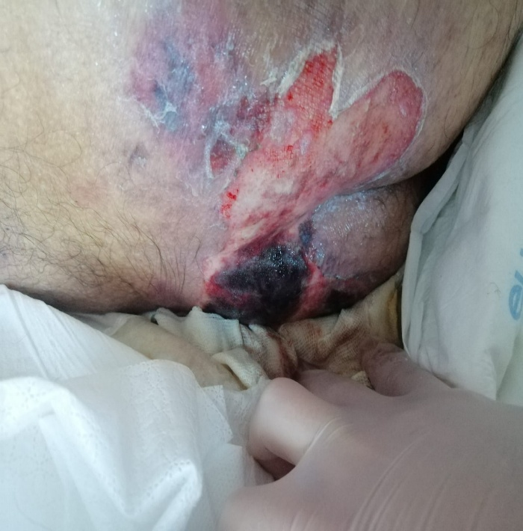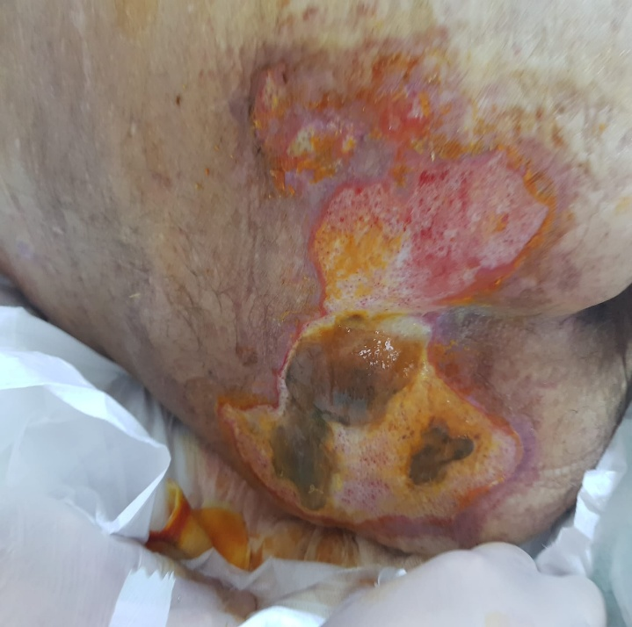
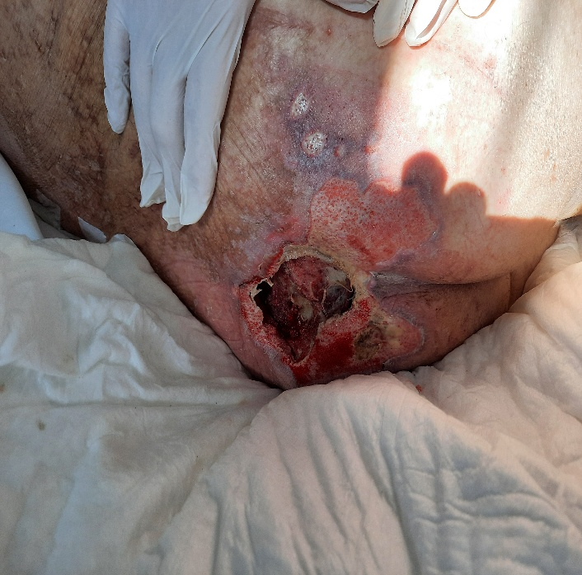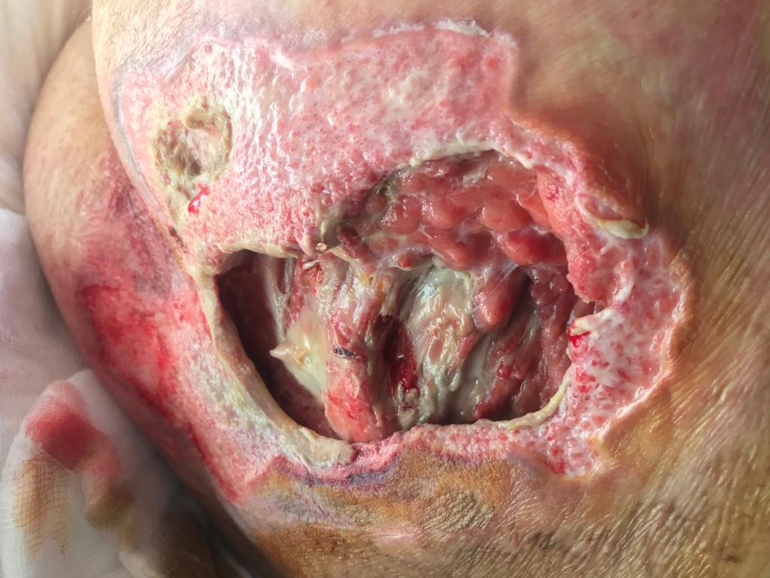
_______________________________________
Figure 2a, 2b, 2c: Vacuum therapy.

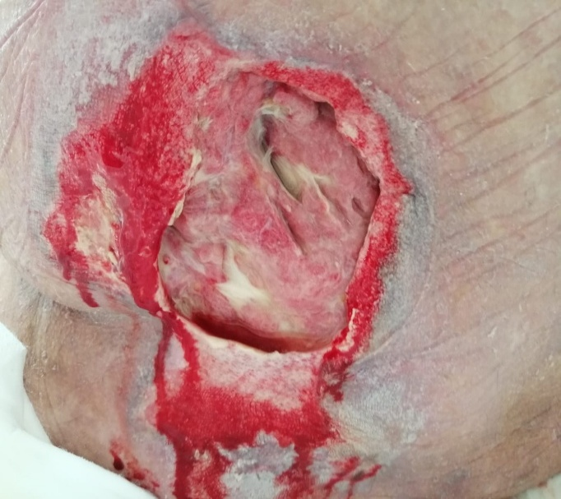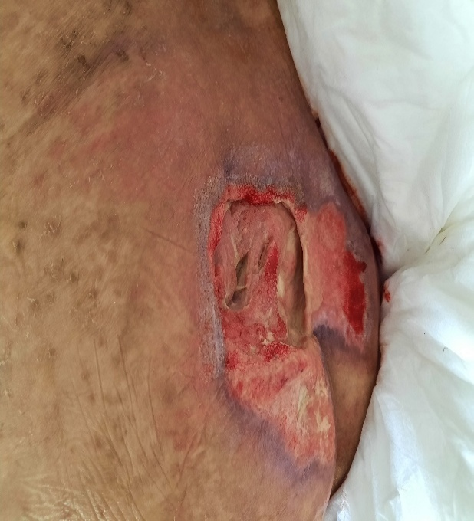
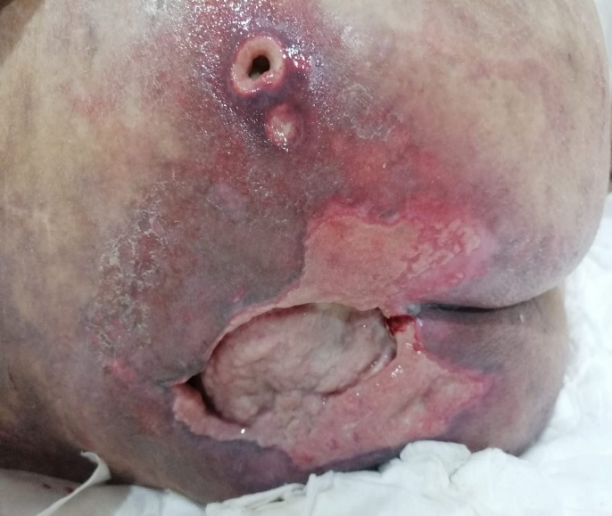
______________________________________
Figure 3(a-d): Larval treatment.
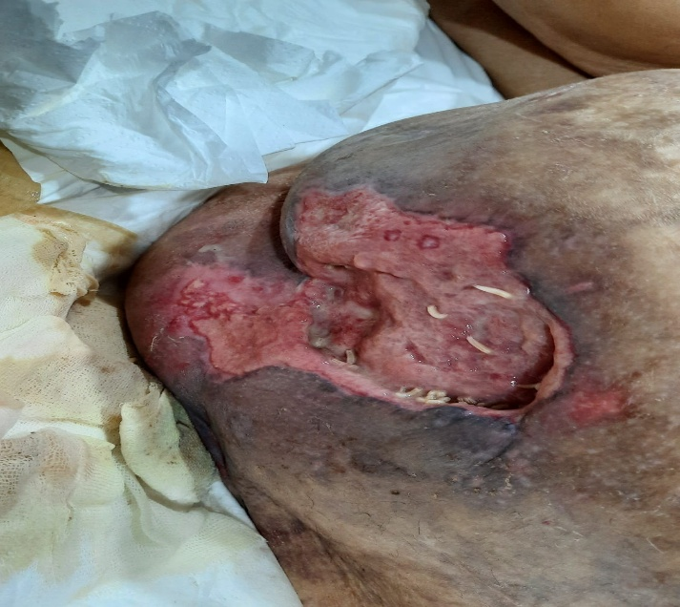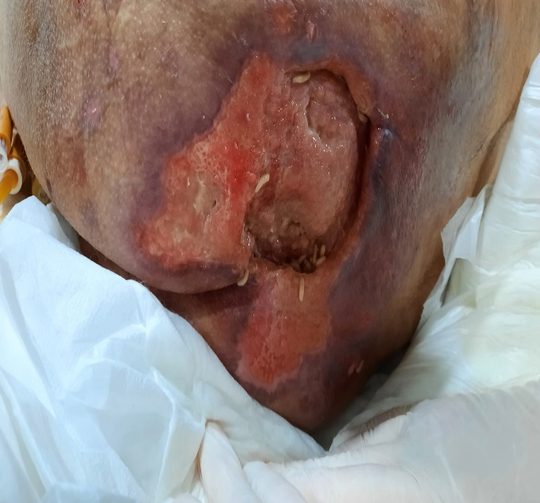
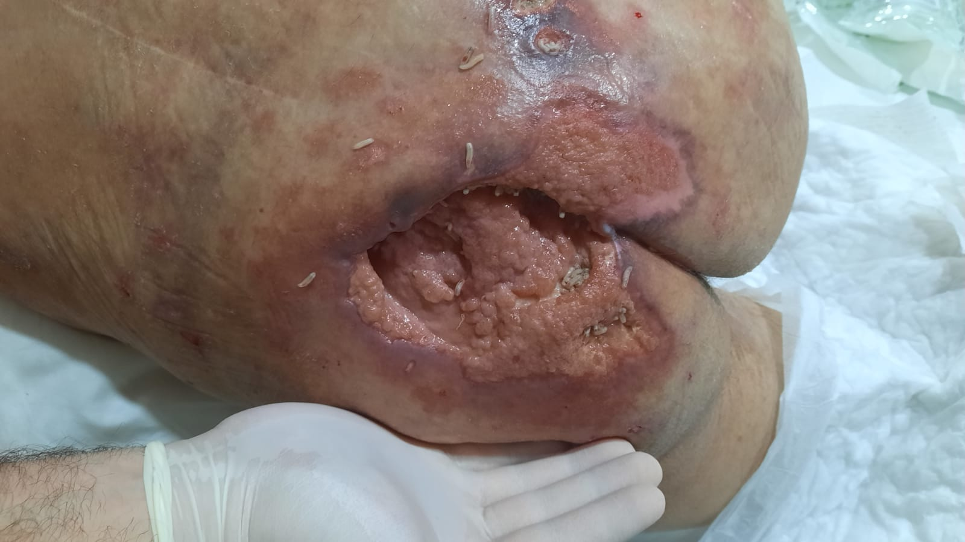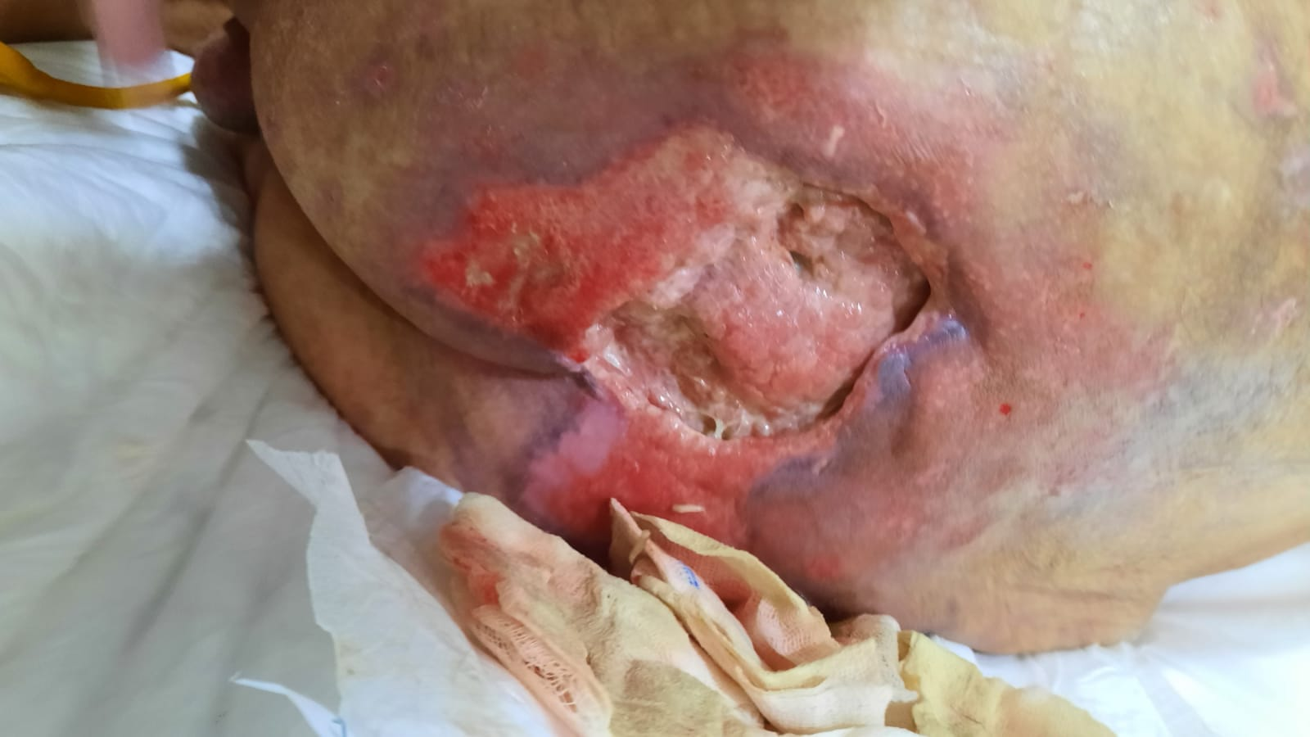
_____________________________________
Figure 4: The patient's current condition.
