Case report

ILEAL MASS PRESENTING AS INCARCERATED INGUINAL HERNIA: A RARE CASE REPORT

Abstract:
Background: This is a case report of ileal mass presenting as a content of incarcerated right inguinal hernia
Presentation of case: We present a case report of 75 years old male patient presented to the casualty with obstructed right inguinal hernia. Patient was stabilized and taken up for surgery. Perioperative findings revealed right indirect hernia with ileal loop with mass infiltrating right testis and bladder as the content. The loop of ileum containing the mass was resected and anastomosed, right orchidectomy done, bladder separated from the mass. Anatomical repair of the inguinal hernia was done and the sample was sent to histopathology. HPE revealed chronic inflammatory lesion of the ileum with no microscopic infiltration into the testis and surrounding soft tissue. Patient had uneventful recovery and was discharged .
Conclusion: incarcerated inguinal hernia usually contains gangrenous bowel or omentum, in this case it is a benign mass infiltrating the testis which is a rare presentation.

(Key words: incarcerated hernia, ileal mass, benign mass, resection, anastomosis)

Introduction:
An inguinal hernia is defined as the protrusion of intra-abdominal contents through a defect in the abdominal wall in the inguinal region, either directly through the posterior wall of the inguinal canal or indirectly via the deep inguinal ring. It is the most common type of abdominal wall hernia, particularly in males, and often presents as a reducible groin swelling that becomes more prominent with straining or standing ^{[1]}. When the herniated contents become trapped and cannot be returned to the abdominal cavity, the hernia is termed incarcerated [5,6]. Incarceration can lead to intestinal obstruction, presenting clinically with pain, vomiting, abdominal distension, and constipation ^{[2]}. Although blood supply is initially preserved, prolonged incarceration may lead to strangulation, where vascular compromise results in ischemia and potential bowel necrosis ^{[1,3]}. Strangulated hernias are surgical emergencies requiring immediate intervention to prevent severe complications such as perforation, peritonitis, and sepsis ^{[3,7,8]}. Imaging modalities like ultrasonography and CT scan can support diagnosis, but clinical assessment remains the cornerstone ^{[2]}. Timely recognition and operative repair are essential to prevent morbidity and mortality associated with obstructed or strangulated inguinal hernias ^{[1, 2]}.

CASE PRESENTATION
Here is a 75 years male patient came to the casualty with complaints of swelling in the right inguinal region since past 4 years initially reducible, but now non reducible since 2 days. He also complained of vomiting since past 2 days and not passage of stools since 2 days. On examination patient was hemodynamically stable and diagnosed as right incarcerated inguinal hernia (figure 1). Erythematous skin color changes was noted in the skin over the right scrotum. Patient had no comorbidities. Patient was admitted under department of general surgery and was prepared, catheterized, Ryle’s tube inserted and taken up for surgery.

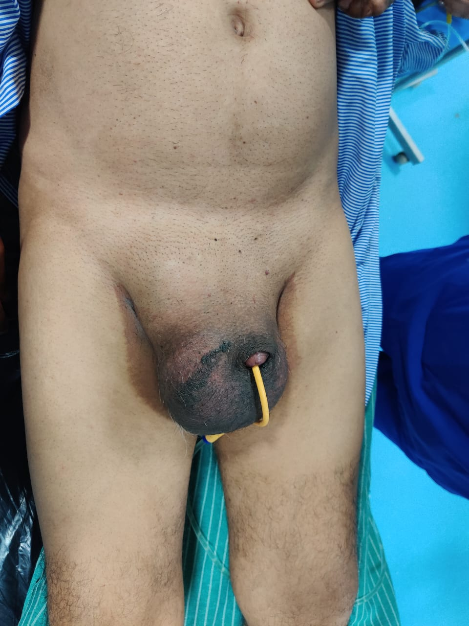
figure 1: Pre-operative picture which shows the right strangulated inguinal hernia with erythematous change in the right scrotum

Perioperative finding:
Patient was prepped and taken up for surgery under spinal anesthesia. Incision was made in inguinal region and the sac was opened, fluid of 10cc was noted and aspirated. Small bowel was found as the content and was traced to the testis which was found to be adherent to it (fig 2). The small bowel was also adherent to the lateral wall of the bladder proximally (fig 3). The small bowel was identified as ileum around 20 to 25cm proximal to the ileocolic junction. The mas was carefully separated from the testis and the testis was examined. On examination of testis hydrocele was found with 50ml of fluid in the sac which was drained. Right orchidectomy was done. Anatomical repair of the inguinal hernia was done. The ileal mass was found to be necrosed in the center with pus around 20cc which was aspirated. There was no bowel perforation noted. The bladder was confirmed by clamping the Foley’s catheter which caused distension and later was separated carefully from the bowel. Since the ileal loops were healthy with good peristalsis, resection and anastomosis of the mass was done by lower midline incision in the abdomen. Abdominal drains placed and closure done. Patient was shifted to post-operative ward for further observation. The resected specimen was sent for histopathology (fig 4).
The resected specimen was examined and the lumen of the specimen was found to be patent. There was no signs of invasion in to the lumen (fig 5).
Patient recovered postoperatively, had no symptoms of obstruction or anastomotic leak and healthy on discharge. Patient was advised for regular followup.

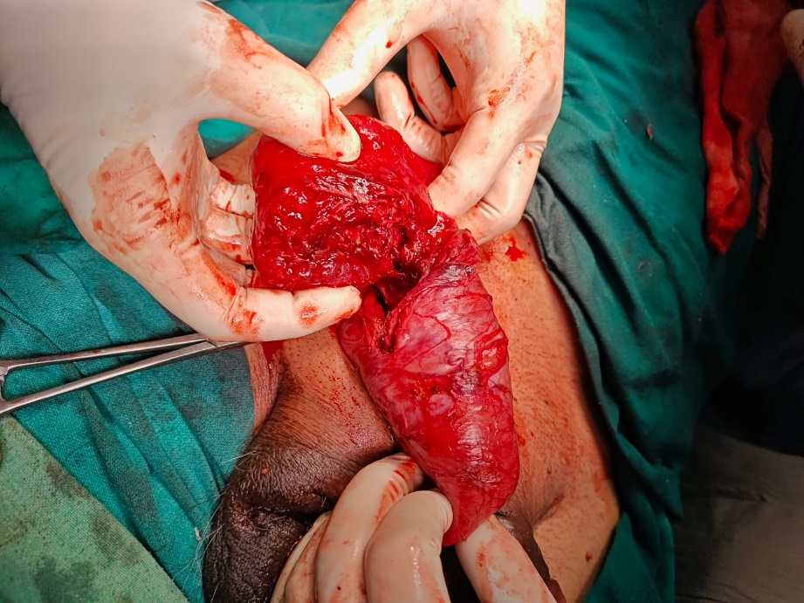
Figure 2: Image showing the ileal mass infiltrating the right testis with central necrosis of the ileal mass

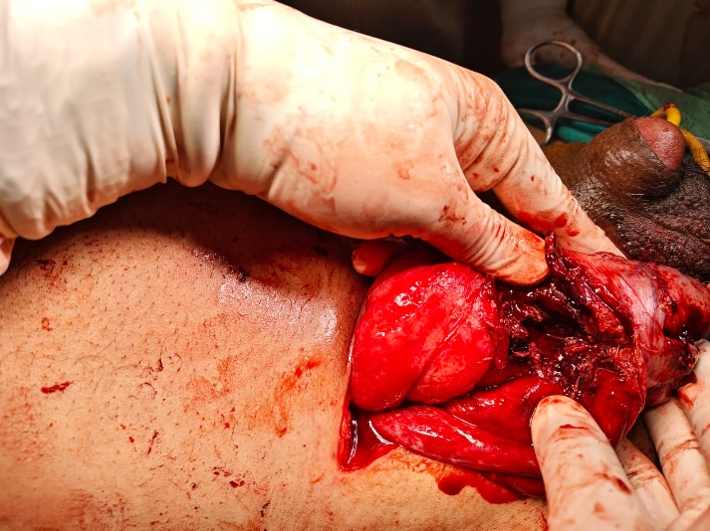
Figure 3: Image showing the filled bladder after clamping the foley’s catheter(structure just below the left thumb shown by arrow)

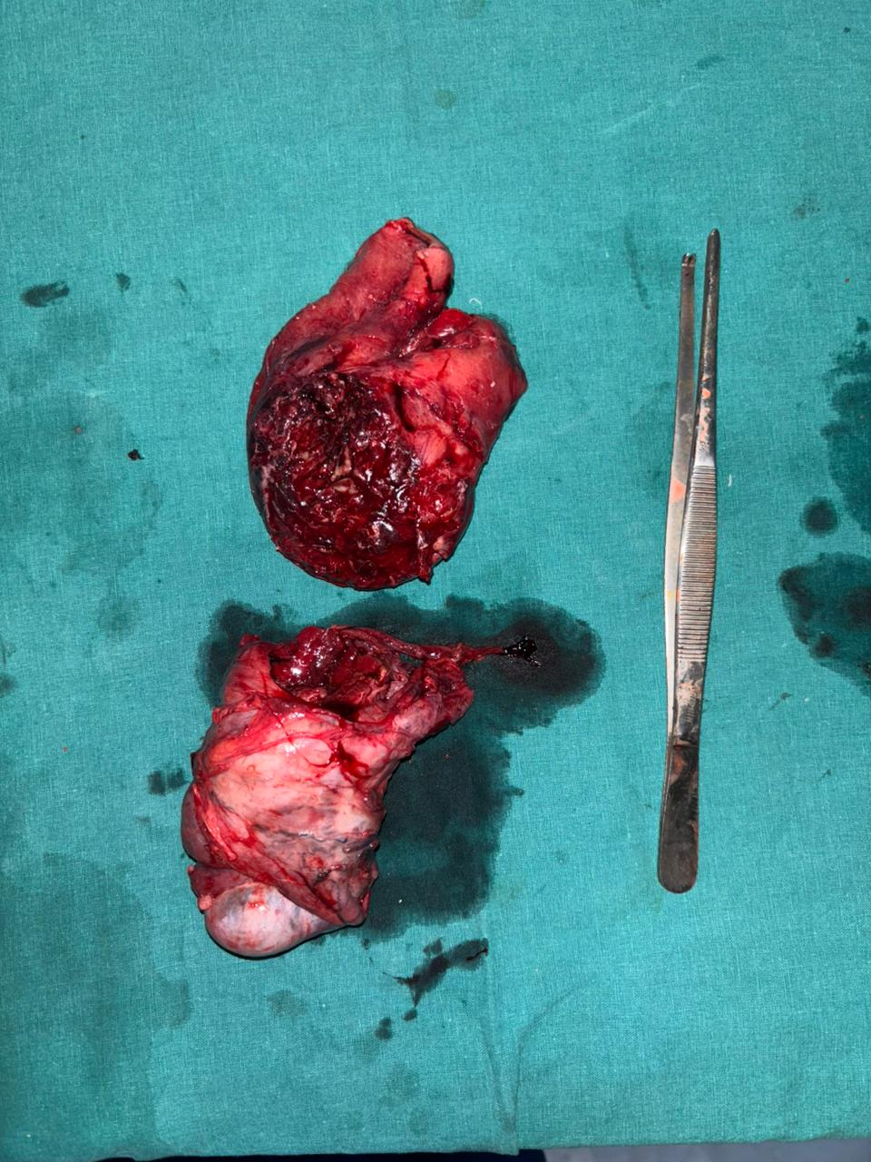
Figure 4: Resected specimen of ileum above and the right testis below
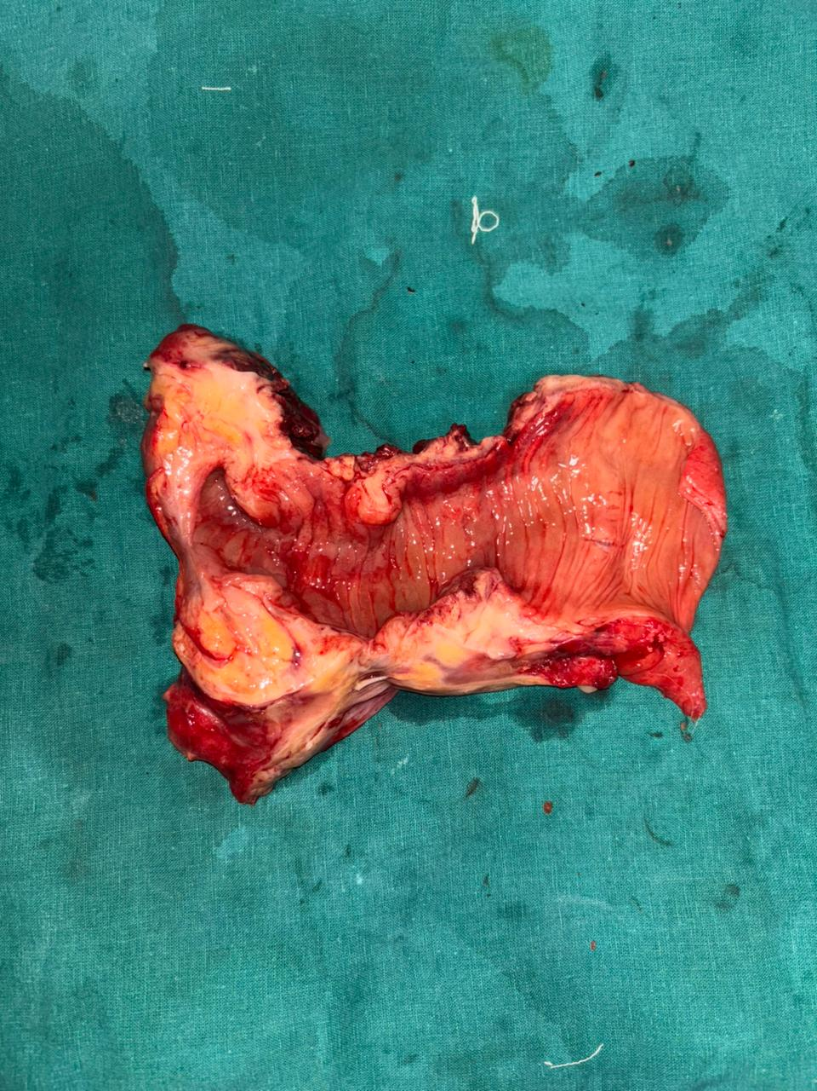
Figure 5: the resected specimen of the ileum showing patent lumen with mass in the wall of the bowel. There was no infiltration of the mass into the lumen

HISTOPATHOLOGY REPORT:
On examination of the resected specimen, it was noted that the lumen of the bowel was intact. There was no polypoidal or any lesions seen in the lumen at the site of the mass. Histopathology report was suggestive of ACUTE ON CHRONIC INFLAMMATION WITH DENSE FIBROBLASTIC PROLIFERATION AND COLLAGENISATION INVOLVING GUT WALL AND HERNIAL SAC. Testis and epididymis was reported to be normal. No special staining was done.

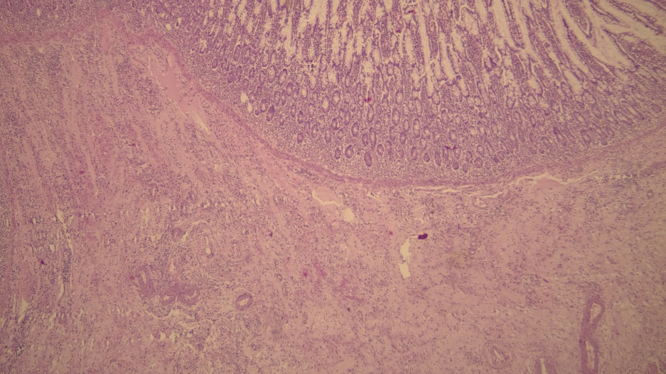
Figure 6: Ileal section showing proliferation of collagen and lymphoplasmacytic infiltrate of lamina propria
DISCUSSION:
Ileal mass presenting as the content of inguinal hernia is rare. Since there is no invasion of the basement membrane of the gut nor lumen nor testis, the mass is considered to be of benign nature.
The histopathology diagnosis of the lesion is a rare entity which we don’t come across often. Even though the tumor is benign in nature, it is advised for the patient to follow-up regularly.
A similar case is being published by Ismini Kountouri et al, where the patient presented with complaints of left obstructed inguinal hernia. Perioperative findings was sigmoid mass as the content of indirect hernia infiltrating the testis. There was no luminal invasion. Resection of the sigmoid segment with left orchidectomy and colostomy was done. Bowel anastomosis was done a year later. The histopathology of the specimen was reported as REACTIVE NODULAR FIBROUS PSEUDOTUMOUR (RNFP)^{[4]}
The above mentioned RNFP is a benign tumor commonly involving the gastrointestinal tract, and this tumor shares many features like the case presented in this article. Histology of RFNP involves proliferation of spindle cells with keloid like appearance in dense collagenous background, accompanied by lymphoplasmacytic infiltration. IHC is positive for vimentin and SMA, negative for CD34 and S100.^{[4]}
To confirm the diagnosis of the lesion of our case , further evaluation of the tumor is required. IHC makers are useful in diagnosing such cases.
There are possibility of the mass like lesions presenting as incarcerated hernia to be of malignant in nature. Hence surgeons operating on such cases must be vigilant and get necessary preoperative investigations such as CT scan, preoperatively and intraoperatively frozen section if available.

CONCLUSION:
Incarcerated hernia usually present with gangrenous bowel or edematous bowel as the content. Here the findings of the hernia is unique and rare consisting of mass infiltrating the testis. Even though the final result is of benign mass, still one should always be vigilant as sometimes malignant tumors may also present as incarcerated hernia. Hence appropriate measures should be taken in case of any patient presenting obstructed hernia or incarcerated hernia.
CONSENT
As per international standards or university standards written ethical approval has been collected and preserved by the author(s).
ETHICAL APPROVAL
As per international standards or university standards written ethical approval has been collected and preserved by the author(s).

REFERENCES
1.Williams NS, O'Connell PR, McCaskie AW, editors. Bailey & Love's Short Practice of Surgery. 28th ed. Boca Raton: CRC Press; 2022.
2. Brunicardi FC, Andersen DK, Billiar TR, Dunn DL, Kao LS, Hunter JG, et al. Schwartz's Principles of Surgery. 12th ed. New York: McGraw Hill Education; 2022.
3. Townsend CM, Beauchamp RD, Evers BM, Mattox KL, editors. Sabiston Textbook of Surgery: The Biological Basis of Modern Surgical Practice. 21st ed. Philadelphia: Elsevier; 2022.
4.Kountouri I, Katsarelas I, Chatzinas D, Chandolias M, Dimasis P. An Incarcerated Inguinal Hernia Masking a Reactive Nodular Fibrous Pseudotumor: A Case Report. Cureus. 2024 Nov 4;16(11):e73027. doi: 10.7759/cureus.73027. PMID: 39640101; PMCID: PMC11618021.
5. Ramsey, W. A., Huerta, C. T., O’Neil Jr, C. F., Taylor, R. R., Saberi, R. A., Gilna, G. P., ... & Perez, E. A. (2024). Timing of pediatric incarcerated inguinal hernia repair: a review of nationwide readmissions data. Journal of Surgical Research, 295, 641-646.
6. Zubaidi, S. A., Ezrien, D. E., Chen, Y., & Nah, S. A. (2023). Laparoscopic versus open incarcerated inguinal hernia repair in children: a systematic review and meta-analysis. European Journal of Pediatric Surgery, 33(05), 414-421.
7. Ferranti, F. (2023). Incarcerated Inguinal Hernia in the Elderly: Surgical Implication. In Hernia Updates and Approaches. IntechOpen.
8. Gogna, S., Gachabayov, M., & Latifi, R. (2021). Incarcerated Inguinal Hernia in Elderly. Emergency General Surgery in Geriatrics, 447-455.

