*Case report*

Intersecting Risks: Acute Coronary Syndrome and Anomalous Circumflex coronary Artery

.

ABSTRACT

|  |
| --- |
| Acute Coronary Syndrome (ACS) and coronary artery anomalies are both major contributors to cardiovascular morbidity and mortality. While ACS is commonly due to atherosclerotic processes, coronary artery anomalies (CAA) are relatively rare, occurring in approximately 0.6–1.3% of patients undergoing coronary angiography, but can lead to significant complications such as myocardial ischemia, arrhythmias, and sudden cardiac death. The intersection of these two conditions presents unique diagnostic and therapeutic challenges.  We report the case of a 56-year-old patient, who presented with chest pain and ECG changes consistent with an ST-elevation myocardial infarction (STEMI), and upon further investigation, Coronary angiography revealed a dominant right coronary artery and a retroaortic anomalous LCx originating from the right coronary sinus. The patient underwent successful PCI and was discharged in stable condition with long-term follow-up.  This article underscores the importance of considering coronary anomalies in patients presenting with ACS, while shedding light on the complexity of managing such intersecting risks, it also reviews the current literature on the coexistence of ACS and coronary artery anomalies, highlighting recent developments in diagnosis and treatment strategies. |

Keywords: Coronary artery anomalies, acute coronary syndrome, left circumflex artery congenital anomaly

1. INTRODUCTION

ACS encompasses a spectrum of conditions that include unstable angina, non-ST-segment elevation myocardial infarction (NSTEMI), and ST-segment elevation myocardial infarction (STEMI). It results primarily from the rupture of an atherosclerotic plaque, leading to coronary thrombosis and myocardial ischemia. Recent studies suggest that approximately 3 million people annually experience ACS worldwide (Sankaranarayanan et al., 2023).

In contrast, coronary artery anomalies (CAA) are less frequent, affecting approximately 1-2% of the general population (Angelini et al., 2022). Anomalies involving the left circumflex artery (LCx), such as anomalous origin or course, are rarer and can cause significant ischemia, especially when there is mechanical compression or other forms of obstruction. CAA may predispose individuals to arrhythmias, ischemic events, and sudden cardiac death (Liu et al., 2023).

Diagnosing ACS in the presence of CAA requires careful consideration. While ACS management traditionally focuses on medical therapy (antiplatelet agents, anticoagulation, and statins) and interventional procedures (such as PCI), CAA may necessitate additional surgical interventions such as coronary artery bypass grafting (CABG) or other corrective measures to alleviate mechanical compression. Moreover, the presence of a coronary anomaly may alter the approach to revascularization and long-term management, making it a critical factor in determining patient prognosis and therapeutic outcomes (Bennett et al., 2023).

Recent advances in imaging modalities, such as coronary computed tomography angiography (CTA), have improved the ability to detect CAA early, even in asymptomatic individuals. However, the role of imaging in acute settings such as ACS remains an area of ongoing research. The increasing use of invasive coronary angiography remains essential in evaluating the full extent of the coronary anatomy, including the identification of anomalies that may require surgical intervention.

2. Presentation of Case

A 56-year-old male with a history of hypertension, Diabetes, and a 40-pack-year smoking history presented to the emergency department (ED) with an acute onset of severe, crushing chest pain. The symptoms began approximately 2 hours prior to his arrival and were associated with shortness of breath, nausea, and profuse sweating. The patient also reported lightheadedness and mild dizziness, His family history was significant for coronary artery disease in his father, who had a myocardial infarction at the age of 62.

#### **🡺 Physical Examination:**

The patient appeared distressed and was visibly diaphoretic. His vital signs were:

* Blood pressure: 150/90 mmHg
* Heart rate: 50 bpm (sinus Bradycardia)
* Respiratory rate: 22 breaths/min
* Oxygen saturation: 97% on room air
* Temperature: 37°C

The physical exam was otherwise unremarkable, with no signs of heart failure. S1 and S2 were heard without murmurs, gallops, or rubs.

**🡺 Initial Workup:**

* 12-lead Electrocardiogram: ST-segment elevation in leads II, III, aVF, V5, and V6, indicating a STEMI affecting the lateral inferior wall of the left ventricle (Fig.1).

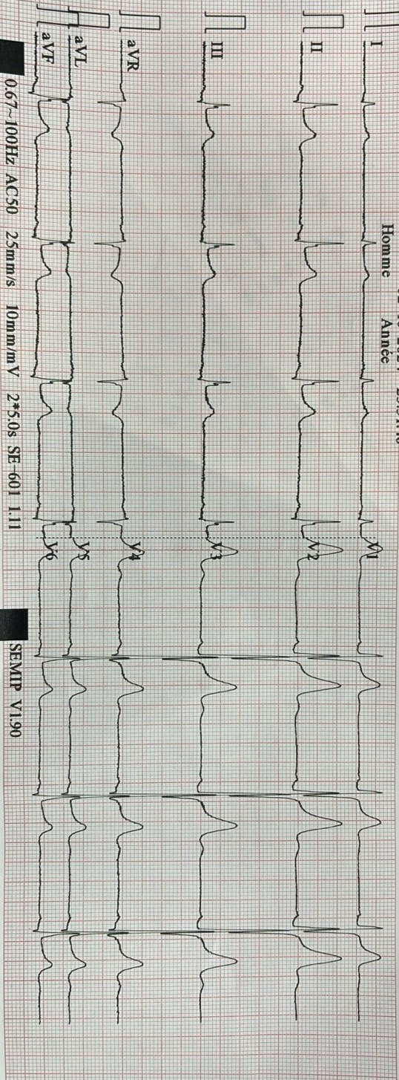

Fig. 1: the initial electrocardiogram of the patient

* Cardiac Troponins:5.12 ng/mL (elevated, normal range < 0.04 ng/mL)
* Creatine kinase-MB (CK-MB): Elevated at 220 U/L (normal range 0-25 U/L)
* Complete Blood Count, Electrolytes, and Renal Function: All within normal limits.
* Chest X-ray: No evidence of heart failure or acute pulmonary pathology. The heart size was within normal limits.

**🡺 Immediate Diagnosis and Treatment:**

The ECG and elevated troponin levels confirmed the diagnosis of **STEMI**. The patient was started on the following:

* Oxygen (2 L/min via nasal cannula)
* Aspirin (325 mg, chewed)
* Clopidogrel (600 mg loading dose)
* Unfractionated heparin (IV bolus followed by continuous infusion)
* Nitroglycerin (IV for pain control and blood pressure management)
* Morphine (IV, for pain and anxiety relief)

The patient was also monitored in the ED with continuous ECG telemetry. After initial stabilization, he was transferred to the cardiac catheterization laboratory for immediate coronary angiography.

Upon coronary angiography, an unexpected finding was revealed:

* **Anomalous origin of the left circumflex coronary artery (LCx):** was found to originate from the right coronary cusp of the aortic root, a rare coronary anomaly. The artery then took a retroaortic course, a configuration that raised concern for mechanical compression of the artery during systole.
* **Significant occlusion of the LCx:** The LCx, in addition to its anomalous origin, showed a complete occlusion at the junction where it passed behind the aorta. This narrowing was likely exacerbating ischemia in the lateral and inferior walls of the left ventricle.

Given the acute nature of the STEMI and the anomalous LCx, a decision was made to proceed with primary percutaneous coronary intervention (PCI).

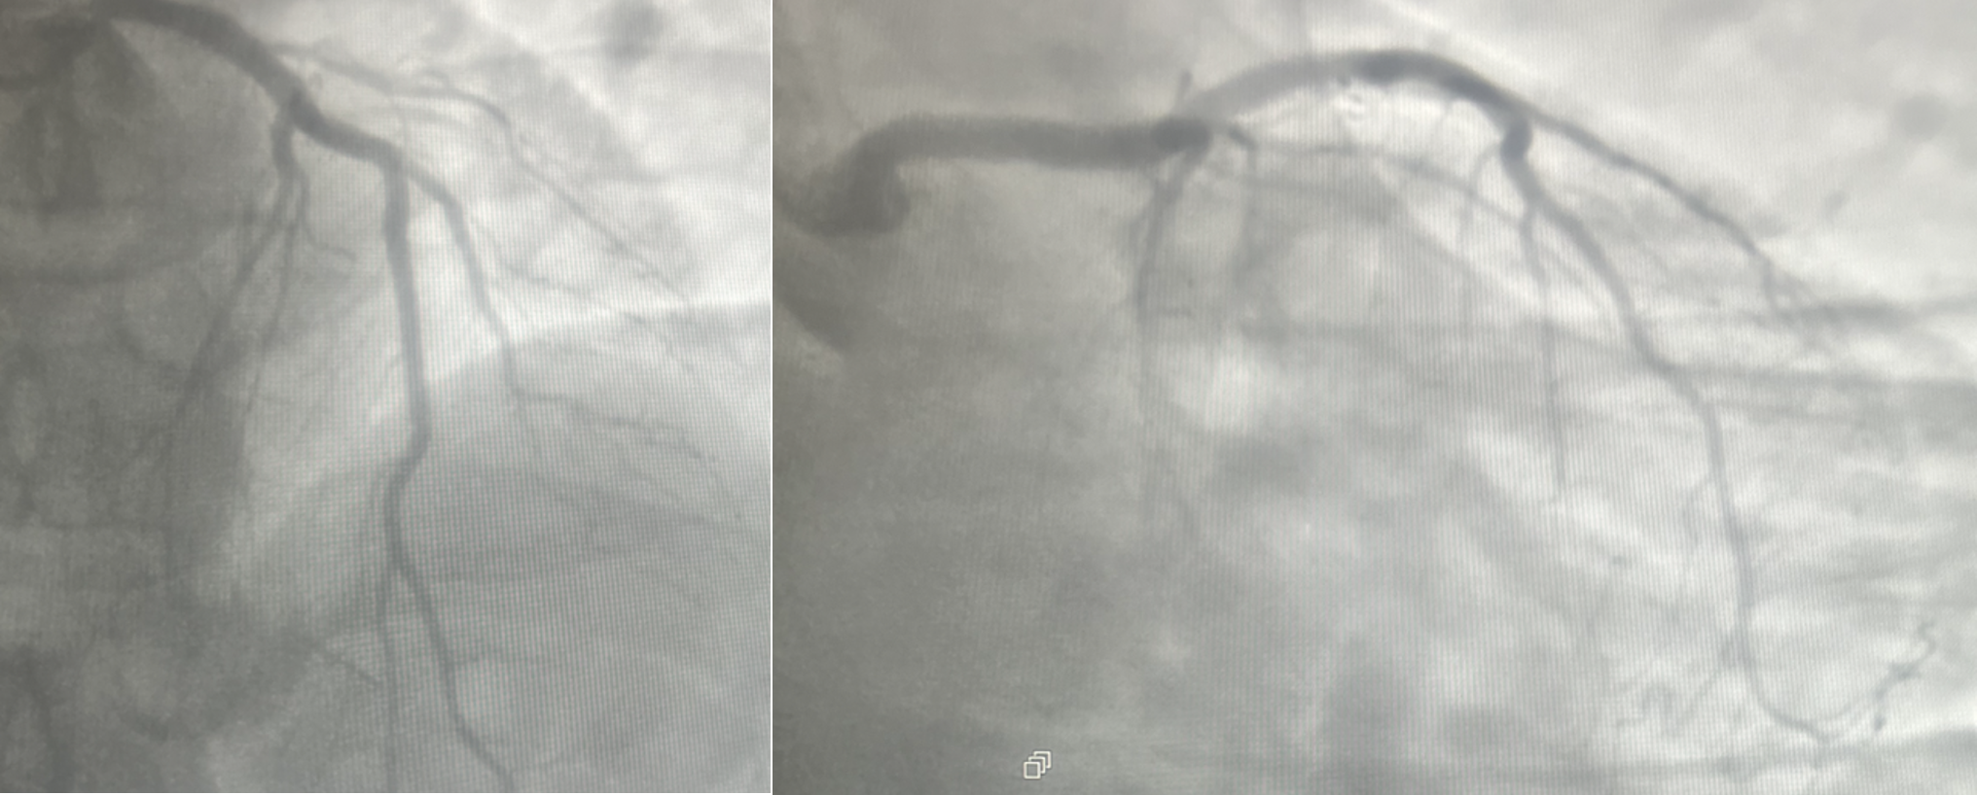

Figure 2: Anterior interventricular artery during opacification of the Common coronary artery.

**Primary PCI** was performed, with careful attention to the anomalous anatomy.

Guidewire and balloon catheter were advanced into the LCx, and an attempt was made to cross the stenosis.

After pre-dilation with a balloon, a drug-eluting stent (DES) was successfully deployed across the stenotic segment of the LCx, ensuring adequate blood flow to the lateral wall of the left ventricle.

The procedure was completed without complications, and angiographic follow-up demonstrated successful stent placement with restoration of flow in the LCx.

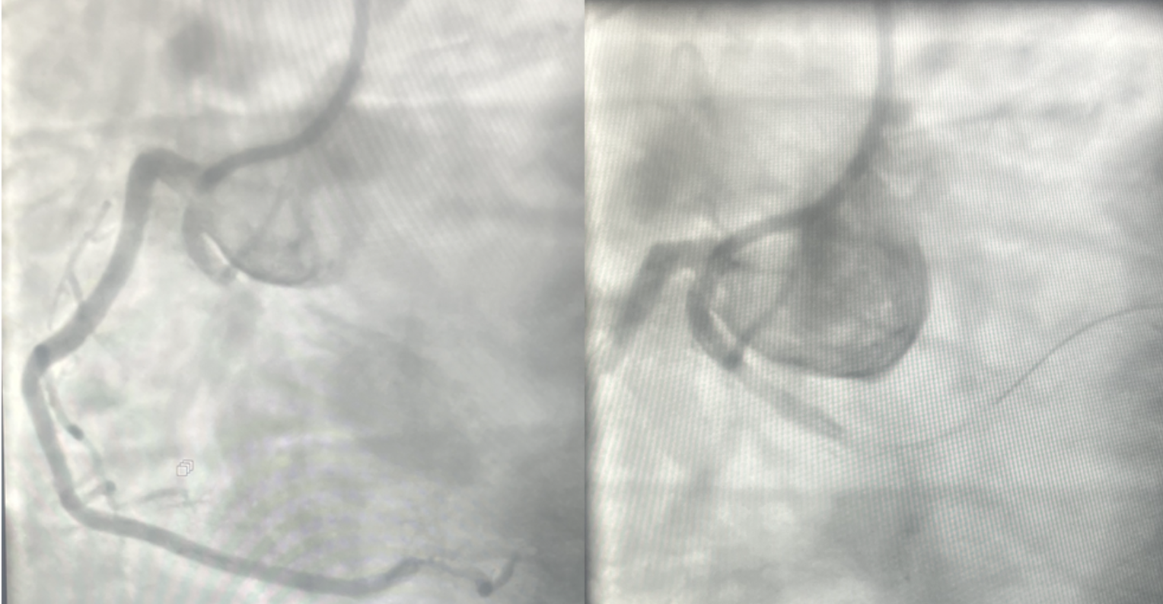

Figure 3: Obstruction of the proximal circumflex artery during opacification of the right coronary artery.

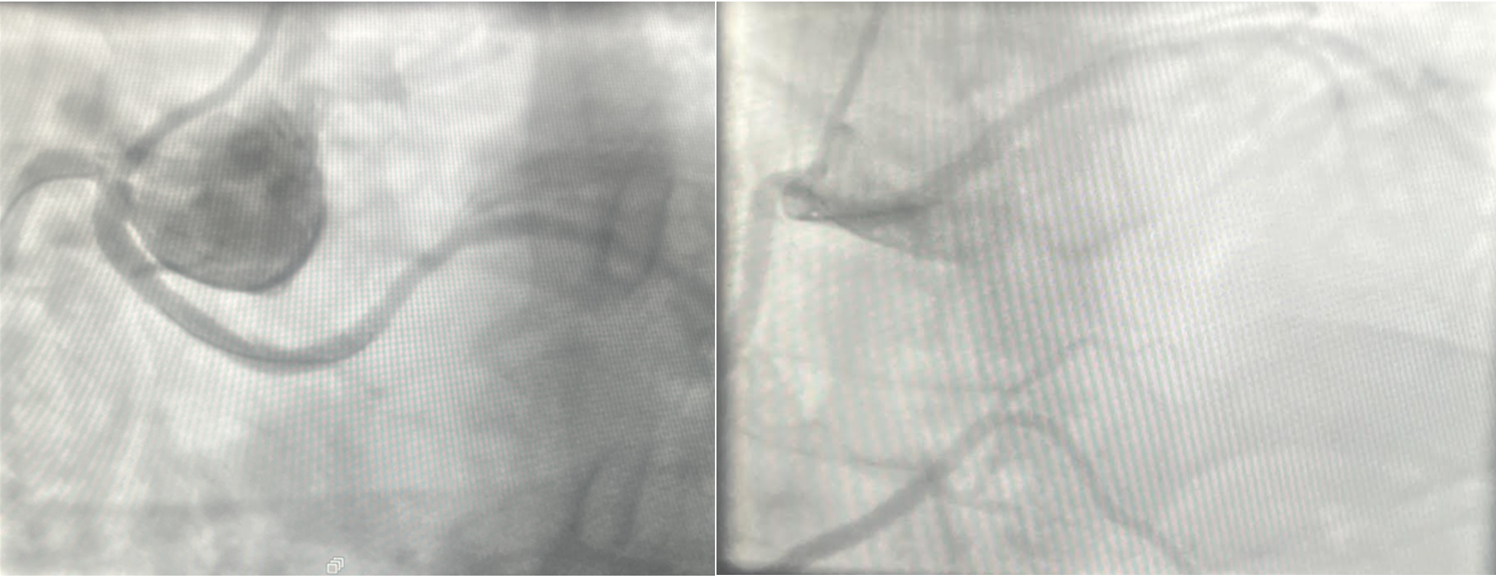

Figure 4: Outcome after stenting of the proximal circumflex artery

We reviewed the case after with a multidisciplinary cardiology team due to the anomalous origin of the LCx, and the following recommendations were made:

**-Long-term follow-up**: with a focus on **secondary prevention** strategies for cardiovascular disease, including lifestyle modifications (smoking cessation, dietary changes) and rigorous control of hypertension and Diabetes.

**-Surgical evaluation**: Given the anomalous coronary anatomy, he was referred to a cardiothoracic surgeon for a discussion about the potential for surgical options in the future, including **coronary artery bypass grafting (CABG)** if recurrent ischemia occurs.

3. discussion

This case underscores the complex interplay between conventional atherosclerotic coronary artery disease and congenital coronary artery anomalies (CAA)—a rare but potentially high-risk combination that complicates both diagnosis and management. The co-occurrence of ST-Elevation Myocardial Infarction with an anomalous left circumflex coronary artery (LCx) originating from the right coronary cusp presents significant clinical challenges and requires a nuanced, multidisciplinary approach.

These anomalies can involve the origin, course, or structure of one or more coronary arteries and are often classified into:

* **Benign variants**, which are usually incidental findings without hemodynamic consequences.
* **Potentially malignant variants**, such as interarterial courses (between the aorta and pulmonary artery), which are associated with increased risk of ischemia, arrhythmia, or sudden cardiac death (SCD), particularly during exertion (Brothers et al., 2020).

In our case, the LCx originated anomalously from the right coronary cusp, following a retroaortic course, which is considered less malignant than an interarterial course, but not entirely benign, particularly when superimposed with atherosclerotic stenosis or under hemodynamic stress, as seen during AMI.

Our patient’s STEMI was attributed to both atherosclerotic occlusion and mechanical factors related to the anomalous anatomy:

* The hemodynamic compromise likely occurred due to fixed atherosclerotic stenosis in the anomalous LCx, compounded by potential dynamic compression in its retroaortic course.
* The curved and narrowed takeoff angle of the anomalous vessels may contribute to endothelial dysfunction, disturbed laminar flow, and also plaque vulnerability, which increases the risk for thrombosis (Cheezum et al., 2017).

These patients may also experience underperfused myocardial territories, especially during stress, where increased cardiac output may accentuate any dynamic extrinsic compression of the anomalous segment. In this case, it is plausible that exertional stress or an acute plaque rupture within the stenosed segment of the anomalous LCx initiated the ischemic cascade, resulting in a STEMI.

In the acute settings, prompt identification of an anomalous coronary artery is difficult due to the urgency of revascularization. Standard ECG findings may not distinguish ischemia due to an anomalous artery from classic atherosclerotic events. However, certain clues can guide suspicion, such as:

* Incongruent ST elevations or atypical infarct patterns on ECG.
* Angiographic difficulties in cannulating the ostium of the expected vessel, which can delay diagnosis.
* Visualization of the vessel arising from an unexpected location during catheterization.

In our case, the anomalous LCx was discovered during emergent coronary angiography, which is the gold standard in ACS. However, non-emergent imaging modalities such as coronary computed tomography angiography (CCTA) and cardiac MRI are increasingly used for evaluating the course and morphology of anomalous arteries, especially in stable patients or post-infarct evaluation (Liu et al., 2023).

#### As for therapeutic Approach: Primary PCI remains the treatment of choice for STEMI and was successfully performed in this patient. However, navigating anomalous coronary anatomy poses several procedural challenges:

* The cannulation of the anomalous ostium may be technically difficult, requiring the use of non-standard catheters or access routes.
* Tortuous vessel courses can increase the risk of guidewire complications, dissection, or stent malpositioning.
* Anomalous LCx arteries may also arise in close proximity to the right coronary artery (RCA), increasing the risk of ostial crossover or iatrogenic injury.

In this patient, a drug-eluting stent (DES) was successfully placed in the LCx, resolving the obstructive lesion and restoring perfusion. Nevertheless, long-term success depends on careful dual antiplatelet therapy (DAPT), aggressive risk factor control, and possibly further imaging to evaluate the full course of the anomalous vessel.

Although PCI resolved the acute ischemic event, surgical revascularization may be considered in selected patients, particularly those with:

* Recurrent ischemia despite PCI,
* High-risk anatomical features (e.g., interarterial course, slit-like ostium),
* Extensive myocardial territory at risk,
* Coexisting multivessel coronary artery disease.

Coronary artery bypass grafting (CABG) is also a reliable option in patients with high-risk CAA features and obstructive lesions. Grafting the anomalous vessel with the internal mammary artery (IMA) or saphenous vein graft (SVG) bypasses both the anatomical anomaly and the diseased segment, ensuring long-term patency and reducing ischemic recurrence.

Long-term prognosis is variable. In isolated coronary anomalies without ischemia, outcomes are in general favorable. However, in cases complicated by ACS, prognosis is driven by the extent of myocardial damage, completeness of revascularization, and presence of high-risk anatomical features. Ongoing registry data and case series support close follow-up and lifestyle modification, including smoking cessation and exercise prescription under monitored settings.

4. Conclusion

This case highlights the importance of recognizing the potential contribution of coronary artery anomalies to acute coronary syndromes, particularly in patients presenting with STEMI. In this patient, the anomalous LCx likely exacerbated the ischemic event, leading to myocardial injury. Successful treatment with primary PCI and drug-eluting stenting restored coronary flow; however, the patient remains at risk for future events, and careful long-term management, including consideration of surgical revascularization, is essential. Early identification of coronary anomalies in patients with ACS is crucial for optimizing patient outcomes.

DISCLAIMER (ARTIFICIAL INTELLIGENCE)

Author(s) hereby declare that NO generative AI technologies such as Large Language Models (ChatGPT, COPILOT, etc) and text-to-image generators have been used during writing or editing of this manuscript.

ETHICAL APPROVAL

As per international standards or university standards written ethical approval has been collected and preserved by the author(s).

Consent

As per international standards or university standards, patient written consent has been collected and preserved by the author.

References

1. Angelini, P., et al. (2022). Coronary artery anomalies: A comprehensive review. Journal of the American College of Cardiology, 79(7), 1443-1459
2. Liu, X., et al. (2023). Anomalous coronary arteries: Clinical implications and management strategies. Cardiovascular Research, 118(4), 1261-1274.
3. Bennett, R. M., et al. (2023). Surgical revascularization for coronary artery anomalies: Outcomes and considerations. Annals of Thoracic Surgery, 115(1), 78-85.
4. Sankaranarayanan, R., et al. (2023). Long-term outcomes in patients with coronary anomalies and acute coronary syndrome. Journal of Clinical Cardiology, 42(3), 512-520.
5. Angelini, P., et al. (2022). Coronary artery anomalies: A comprehensive review. J Am Coll Cardiol, 79(7), 1443–1459
6. Cheezum, M. K., et al. (2017). Anomalous aortic origin of a coronary artery from the inappropriate sinus of Valsalva. Circulation, 135(6), 566–579.
7. Liu, X., et al. (2023). *Multimodality imaging in the evaluation of coronary artery anomalies*. *Cardiovasc Res*, 118(4), 1261–1274.
8. Brothers, J. A., et al. (2020). *Expert consensus guidelines for management of anomalous coronary arteries in adults*. *J Thorac Cardiovasc Surg*, 160(5), e1–e29.

ABBREVIATIONS

ACS : Acute Coronary Syndrome

LCx : left circumflex

CABG : coronary artery bypass grafting (CABG

PCI : Percutaneous coronary intervention (PCI)

CAA : coronary artery anomalies

**STEMI :** ST-ELEVATION MYOCARDIAL INFARCTION

**CTA** : COMPUTED TOMOGRAPHY ANGIOGRAPHY

**DES** : DRUG-ELUTING STENT

**SCD** : SUDDEN CARDIAC DEATH

**RCA** : RIGHT CORONARY ARTERY