***Case report***

**Unusual Neurological manifestations in Systemic Lupus Erythematosus on the background of Acute Flare**

**Abstract**

Neuropsychiatric manifestations in systemic lupus erythematosus are uncommon and present a broad spectrum of clinical symptoms, complicating the diagnosis and treatment. This report discusses a case involving a 58-year-old female patient who experienced an acute flare of systemic lupus erythematosus with multisystem involvement. Initial treatment with methylprednisolone did not alleviate her neurological symptoms. Antiphospholipid antibody syndrome was ruled out, and neuroimaging studies were normal. After excluding non-systemic lupus erythematosus causes, the patient was diagnosed with a rare combination of neuropsychiatric systemic lupus erythematosus, presenting with both focal and diffuse symptoms, including peripheral neuropathy and cognitive and behavioral impairment. The patient's neurological symptoms significantly improved with cyclophosphamide treatment, and she continues to be managed with mycophenolate mofetil. This case underscores the complexity of neuropsychiatric systemic lupus erythematosus and the necessity of thorough evaluation to exclude other potential causes. Additionally, it highlights the potential effectiveness of cyclophosphamide in managing refractory neuropsychiatric symptoms in systemic lupus erythematosus patients.

Key words : SLE, Refractory neuropsychiatric symptoms, NPSLE, Aggressive immunosuppression

**Introduction:**

Systemic lupus erythematosus (SLE) is a chronic autoimmune disorder characterised by multisystem involvement, predominantly affecting young women. Neuropsychiatric SLE (NPSLE) occurs in approximately 5-10% of patients, significantly increasing mortality rates and decreasing quality of life. The variability in neuropsychiatric manifestations arises from differing definitions, inconsistent attributions, and the inclusion of subtle or uncertain diseases.

This report highlights the case of a 58-year-old female presenting with a flare of SLE involving multiorgan involvement. Despite initial treatment for the lupus flare and other contributing aetiologies such as sepsis and acute kidney injury, she continued to experience neuropsychiatric manifestations. The persistent symptoms compounded the complexity and treatment challenges associated with SLE.

**Presentation of Case:**

A 58-year-old female presented with a two-year history of a reddish, scaly rash with photosensitivity affecting her face, ears, and trunk, accompanied by recurrent episodes of fever over the past year. Two months prior to admission, she experienced tingling and numbness in her lower limbs, which progressed to distal muscle weakness and impaired mobility. Additionally, she noted coldness and blackening of the tip of her left index finger, along with joint pain in the small joints and bilateral wrist and elbow pain, with morning stiffness lasting approximately an hour. Her family reported mood depression, anxiety, forgetfulness, and a reduced attention span during the preceding two months. Her responsiveness significantly decreased two days before admission. Notably, her medical history included a first-trimester miscarriage 20 years earlier.

Upon admission, the patient was conscious but disoriented and irritable, with stable vital signs. A physical examination revealed pallor, an erythematous malar rash, crusted plaques on the chest and back (Figure 1), digital gangrene affecting the left index finger, and multiple oral ulcers. The neurological assessment showed a Glasgow Coma Scale score of E4V4M5. The motor examination identified distal muscle atrophy, absent bilateral ankle reflexes, and a flexor plantar response. Sensory evaluation was inconclusive due to the patient's non-responsiveness. Other systemic examinations were normal.

The differential diagnosis for her neurological manifestations included stroke due to antiphospholipid antibody syndrome, SLE-associated vasculitis, sepsis-associated encephalopathy, bacterial meningoencephalitis, and atherothrombotic stroke.

**Investigations:** Laboratory tests revealed anaemia (haemoglobin 7.6 gm/dL), leukocytosis (11.74 × 103/μL), and thrombocytopenia (1.5 × 103/μL), accompanied by an elevated immature platelet fraction (15.4%) and a positive direct Coomb's test. Inflammatory markers included an elevated erythrocyte sedimentation rate (ESR; 27.6 mm/hr) and C-reactive protein (26 mg/L). Renal impairment was evident from raised blood urea (100.9 mg/dL), serum creatinine (3.06 mg/dL), and a high spot urine protein-to-creatinine ratio (5801 mg/g). Serum procalcitonin levels were elevated at 15.28 ng/mL. Microbiological analysis of an ear swab identified *Pseudomonas aeruginosa,* confirming otitis externa. Immunological tests were positive for antinuclear antibodies at a titre of 1:3200 with a homogeneous and speckled pattern, along with the detection of anti-dsDNA and SS-A antibodies.

According to the ACR/EULAR criteria, the patient was diagnosed with SLE with lupus nephritis and a high disease activity score (SLEDAI-2K: 24). Analysis of cerebrospinal fluid showed the absence of cells, normal protein, and sugar levels, with negative results for bacterial culture and acid-fast bacilli. Serological testing ruled out infections such as malaria, dengue, typhus, hepatitis B/C, and HIV. Magnetic resonance imaging (MRI) of the brain showed a calcified granuloma in the right occipital lobe with no other significant abnormalities (Figure 2).

**Treatment:** The initial treatment for sepsis included intravenous Meropenem. The patient was subsequently administered oral hydroxychloroquine (400 mg daily) and intravenous methylprednisolone (1 g daily for three days), followed by oral prednisolone. After one week, her condition showed improvement, with the resolution of skin lesions (Figure 3), oral ulcers, and improved renal function. However, her neurological symptoms persisted, and a repeat MRI displayed no changes compared to the previous imaging.

After ruling out the non-SLE causes, NPSLE was considered as the primary cause of her persistent neurological deficits. Treatment was escalated in accordance with NPSLE management protocols, with biweekly intravenous cyclophosphamide administration. Quetiapine was also prescribed for psychiatric support. Over the course of a month, significant clinical improvement was observed, with the mini-mental state examination score rising from 18/25 to 23/25. Nerve conduction studies confirmed bilateral sensorimotor axonal polyneuropathy, which improved gradually, allowing the patient to regain independent ambulation upon completion of the treatment. Maintenance therapy with oral mycophenolate mofetil was started, and the patient maintained remission during follow-up visits.

**Discussion:**

Neuropsychiatric manifestations of SLE are heterogeneous, complicating both diagnosis and treatment of SLE[1].

In this case, the patient presented with classic symptoms of SLE, including arthralgia, fever, photosensitive skin rashes, and lupus nephritis. However, the neuropsychiatric and cognitive symptoms were intriguing. She exhibited peripheral neuropathy, cognitive decline, and behavioural abnormalities.Excluding other causes on investigations, diagnosis of NPSLE was confirmed.

The first patient diagnosed with NPSLE was recorded in 1945, and since then, the understanding and diagnosis of NPSLE have evolved. The ACR nomenclature for NPSLE provides case definitions for 19 neuropsychiatric syndromes associated with SLE, along with reporting standards and recommendations for laboratory and imaging tests. Neuropsychiatric manifestations are broadly categorised into focal (e.g., stroke, seizures, myelopathy, and neuropathy) and diffuse neuropsychological syndromes (e.g., mood disorders, cognitive impairment, psychosis, movement disorders, and headaches). Patients may present with peripheral neuropathy, including polyneuropathy and mono-neuritis multiplex, as well as cranial neuropathy, with the eighth cranial nerve being most commonly affected, followed by the second, fourth, and sixth cranial nerve palsies. Neuromuscular involvement, like myasthenia gravis, may also occur. Additionally, conditions like neuromyelitis optica or non-compressive myelopathy have been reported[2]. Rare NPSLE manifestations, including posterior reversible encephalopathy syndrome, myopathy, and manic episodes, have also been documented[3]. In the present case, the patient exhibited both focal and diffuse manifestations, specifically peripheral neuropathy, mood disturbances and cognitive impairment.

The prevalence of NPSLE varies widely, ranging from 17% to 44.5%[4]. In some patients, NPSLE serves as the initial presentation of SLE. The patient under consideration showed severe cognitive decline, a condition observed in less than 5% of SLE cases, along with symmetrical polyneuropathy, which occurs in nearly 8% of patients. Mortality rates in NPSLE can reach up to 10%[5].

The pathogenesis of NPSLE is complex and multifactorial. Evidence suggests that specific antibodies contribute to the disruption of the blood-brain barrier through inflammatory processes. Other mechanisms include microangiopathy, atherosclerosis, and direct neuronal cell damage mediated by autoantibodies, complement proteins, and cytokines[6]. Genetic studies indicate that mutations in *TREX1*, which encodes the three-prime repair exonuclease 1 (DNase III), may also play a role in NPSLE. Activation of microglia via autoantibodies, interferon-∝, or other immune reactants amplifies the inflammatory response, potentially leading to neuronal damage. Emerging inflammatory pathways, such as TWEAK/Fn14, Bruton's tyrosine kinase, Nogo-A and ACE, have been identified as promising therapeutic targets. Furthermore, the presence of antibodies like anti-ribosomal protein, anti-NR2, and antiphospholipid antibodies is associated with NPSLE. Elevated concentrations of S-100 protein in serum are usually observed in individuals with this condition. Inflammatory markers like CRP or ESR may not show elevated levels in NPSLE[7].

Imaging features of NPSLE are highly heterogeneous. MRI findings in the brain in SLE often reveal white matter hyperintense lesions and brain atrophy; however, these are not specific to NPSLE. Advanced imaging techniques, including diffusion tensor imaging, fluorodeoxyglucose positron emission tomography, and resting-state functional MRI, have shown promise in identifying changes in regional brain microstructure, function, resting-state networks, node functional connectivity, and neuronal activity associated with task performance in SLE. The effective applications of these techniques are essential for developing objective biomarkers to facilitate the diagnosis and characterisation of specific neuropsychiatric syndromes, as well as to evaluate responses to targeted therapies[8]. Spinal cord involvement may show central cystic degeneration along with bilaterally symmetrical high signal intensity in the anterior horn of the spinal cord on axial T2-weighted MR imaging. This distinctive appearance, known as the 'night owl sign,' is exceedingly rare[9].

The primary treatment for NPSLE involves immunosuppression. Cyclophosphamide remains the only therapy tested in a small, randomised, controlled clinical trial for this condition. Studies have indicated that combining cyclophosphamide with steroids offers clinical benefits. For nonresponders, treatment options include immunoglobulins or plasmapheresis. In cases of resistance, rituximab, a chimeric monoclonal antibody directed against the B-cell-specific antigen CD20, may be administered. Maintenance therapy involves oral administration of mycophenolate mofetil, azathioprine, or cyclosporin. In patients with antiphospholipid antibodies, the use of antiplatelet agents and anticoagulation is recommended. Emerging therapeutic strategies focus on targeting anti-endothelial antibodies affecting the blood-brain barrier, B-cell lymphocyte stimulators, and alternative complement pathway inhibitors. Autologous hematopoietic stem cell transplantation has emerged as an effective treatment modality for intractable SLE and has been tried in a few patients with severe NPSLE[10].

**Conclusion:**

The patient presented with an acute flare of SLE, which responded to methylprednisolone pulse therapy. However, neuropsychiatric symptoms, including cognitive dysfunction and peripheral neuropathy, persisted. No alternative cause was identified, leading to the diagnosis of NPSLE. Aggressive immunosuppression with cyclophosphamide resulted in complete recovery. NPSLE presents with a diverse clinical spectrum and can escalate the complexities of SLE, complicating both diagnosis and treatment and often leading to a poorer prognosis. It is important to exclude non-SLE aetiologies for neurological manifestations. NPSLE requires aggressive immunosuppressive therapy.

* **Informed Consent** – Informed consent was obtained from the patient regarding the use of her case history and pertaining data for publication. No ethical concerns were raised.
* **Declaration of Interests** – The authors declare no conflicts of interest.

**References**

1. Emerson JS, Gruenewald SM, Gomes L, Lin MW, Swaminathan S. The conundrum of neuropsychiatric systemic lupus erythematosus: Current and novel approaches to diagnosis. Front Neurol. 2023 Mar 21;14:1111769. doi: 10.3389/fneur.2023.1111769. PMID: 37025200; PMCID: PMC10070984.
2. The American College of Rheumatology nomenclature and case definitions for neuropsychiatric lupus syndromes. Arthritis Rheum. 1999 Apr;42(4):599-608. doi: 10.1002/1529-0131(199904)42:4<599::AID-ANR2>3.0.CO;2-F. PMID: 10211873.
3. Islam R, Das S, Chattopadhyay S, Basu S. Neuropsychiatric lupus with posterior reversible encephalopathy syndrome: a rare presentation *BMJ Case Reports CP*2021;**14:**e241494, doi:10.1136/bcr-2020-241494
4. Unterman A, Nolte JE, Boaz M, Abady M, Shoenfeld Y,Zandman-Goddard G. Neuropsychiatric syndromes in systemic lupus erythematosus: a meta-analysis. Semin Arthritis Rheum. 2011;41(1):1–11.
5. Sommerlad A, Duncan J, Lunn MP, Foong J. Neuropsychiatric systemic lupus erythematosus: a diagnostic challenge. BMJ Case Rep. 2015 Mar 5;2015:bcr2014208215. doi: 10.1136/bcr-2014-208215. PMID: 25743864; PMCID: PMC4369033.
6. Feinglass EJ, Arnett FC, Dorsch CA, Zizic TM, Stevens MB. Neuropsychiatric manifestations of systemic lupus erythematosus: diagnosis, clinical spectrum, and relationship to other features of the disease. Medicine (Baltimore). 1976 Jul;55(4):323-39. doi: 10.1097/00005792-197607000-00004. PMID: 781466.
7. Nikolopoulos D, Fanouriakis A, Boumpas DT. Update on the pathogenesis of central nervous system lupus. Curr Opin Rheumatol. 2019 Nov;31(6):669-677. doi:10.1097/BOR.0000000000000655. PMID: 31415031.
8. Mackay M, Tang CC, Vo A. Advanced neuroimaging in neuropsychiatric systemic lupus erythematosus. Curr Opin Neurol. 2020 Jun;33(3):353-361. doi: 10.1097/WCO.0000000000000822. PMID: 32349105; PMCID: PMC7259387.
9. Hu B, Wu P, Zhou Y, Peng Y, Tang X, Ding W, Zhang M, Qi X. A case of neuropsychiatric lupus Erythematosus characterized by the Owl's eye sign: a case report. BMC Neurol. 2017 Jun 29;17(1):123. doi: 10.1186/s12883-017-0902-6. PMID: 28662631; PMCID: PMC5492281.
10. Magro-Checa C, Zirkzee EJ, Huizinga TW, Steup-Beekman GM. Management of Neuropsychiatric Systemic Lupus Erythematosus: Current Approaches and Future Perspectives. Drugs. 2016 Mar;76(4):459-83. doi: 10.1007/s40265-015-0534-3. PMID: 26809245; PMCID: PMC4791452.

**Legends for Figures**

**Figure 1: Erythematous rash, crusted plaques, and erosions distributed over the chest and back**

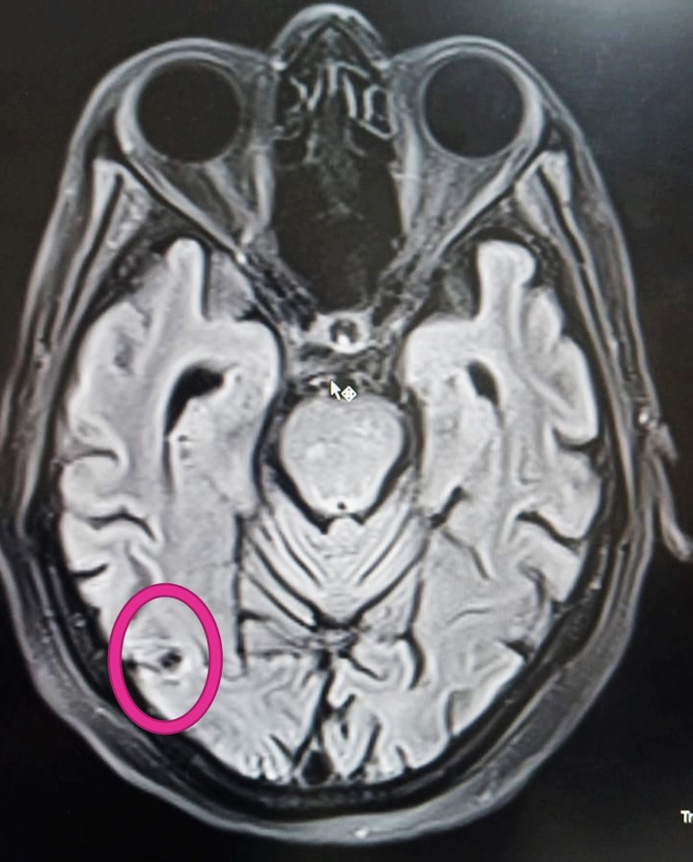**Figure 2: MRI of the brain showing a calcified incidental granuloma in the right occipital lobe**

**Figure 3: Post-steroid healing of cutaneous lesions over chest and back.**

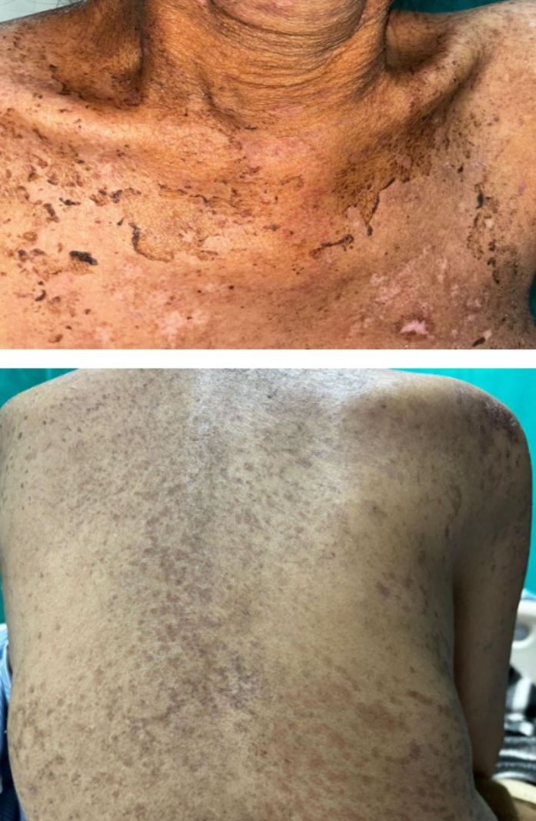

**Table No 1: Clinical Course and response to treatment**

|  |  |  |  |  |
| --- | --- | --- | --- | --- |
| **Period** | **Major Clinical Findings** | **Treatment** | **Evaluation** | **Response** |
| At presentation | Polyarthritis, Acute cutaneous flare, oral ulcers, Altered sensorium, Acute kidney injury | Intravenous Methyl Prednisolone pulse for 5 days, Fluids, antibiotics & supportive treatment | SLEDAI(2K) -24  Lupus workup, APLA, Vasculitis, Vitamin deficiencies, Metabolic causes,  MRI brain (Normal) | Partial : Cutaneous, renal symptoms resolved |
| Post Methylprednisolone Pulse | Diminished cognition, psychiatric symptoms, Depression, Peripheral neuropathy | Intravenous Cyclophosphomide biweekly | MMSE (18/25)  Nerve conduction studies (Bilateral sensorimotor axonal neuropathy)  MRI brain (Normal) | Neurological symptoms persisted |
| Post IV Cyclophosphomide | Significant improvement, Cognition improved, Neuropathic symptoms improved (Walked with support) | - | SLEDAI(2K) - 4  MMSE (23/25)  Renal functions improved, Proteinuria- minimal | Neurological and cognitive and psychiatric symptoms - improved |
| Remission | Cutaneous, neurological, renal symptoms resolved | Oral Mycophenolate Moeftil | Biochemical parameters – normal  CRP, C3, C4 levels normal | Sustained improvement |

Abbreviations : SLEDAI(2K)- Systemic Lupus Erythematosus Disease Activity Index (2000), APLA – Antiphospholipid Antibodies, MRI – Magnetic resonance imaging, MMSE – Minimental state examination, CRP – C reactive protein, C3-Complement 3, C4- Complement 4