Case report

Typical Observation for a Rare Neonatal Pustular Dermatosis

Abstract:
This case report discusses a rare presentation of transient neonatal pustular melanosis (TNPM) in a full-term newborn. The infant, born via vaginal delivery at [38 weeks], presented shortly after birth with characteristic pustular lesions that rapidly evolved into hyperpigmented macules, a hallmark of TNPM. The pustules, which appeared on the, neck, and other areas of the body, resolved spontaneously within 3 weeks, leaving behind the distinctive pigmentary changes without scarring. The mother had an uncomplicated pregnancy with a remarkable finding in the medical history, and the newborn showed no signs of systemic involvement. TNPM, while benign and self-limiting, can be clinically confused with other neonatal skin conditions, such as neonatal herpes or bacterial infections, which may lead to unnecessary interventions. This case highlights the importance of early recognition of TNPM and its typical clinical course, emphasizing the need for appropriate diagnosis and reassurance for both parents and healthcare providers. A review of the literature on TNPM, its pathogenesis, and management is also provided.

Introduction:
Transient neonatal pustular melanosis is an unusual, rare type of neonatal eruption. Suggested to be a form of toxic erythema of the newborn (1). Pustules in the first few days of life on non-erythematous base, the diagnosis is mainly clinical but some cases might need further investigations including skin biopsy (2). The condition is benign, self-resolving and not requiring active treatment. (3)

Case Presentation:
A full term female neonate was born normally via vaginal delivery. Crying with normal facial features, average weight 2.6 Kg, body temperature 35.4ºC. No history of consanguinity and no history of any inherited diseases in the family. The mother reported that she was infected with chickenpox virus during 30-32 weeks of gestation and received supportive treatment only. After the initial pediatric examination, the newly born baby was examined for further dermatological opinion. She had vesiculopustular rash grouped on the back, flanks, solitary no the neck, shoulders and thigh, yellowish pustules 2-3 mm on non-erythematous base. mucosae and conjunctivae were free. Systemically she was free and normal lactating immediately started. The blood investigations were unremarkable, swab for culture from the serous fluid of the pustules was taken, sent to cytology and turned to be sterile. Transient neonatal pustular melanosis was strongly suggested on the top of differential diagnosis supported by the stable, active state of the neonate and the negative blood tests. No further invasive intervention was suggested. Observation only was recommended.
On follow up, within few days on a second visit, the re-examination showed fading of some of the pustules leaving residual raw skin and hyper-pigmented macules with no evidence of new lesions. The mother was re-assured as the condition is totally benign and self-limited.

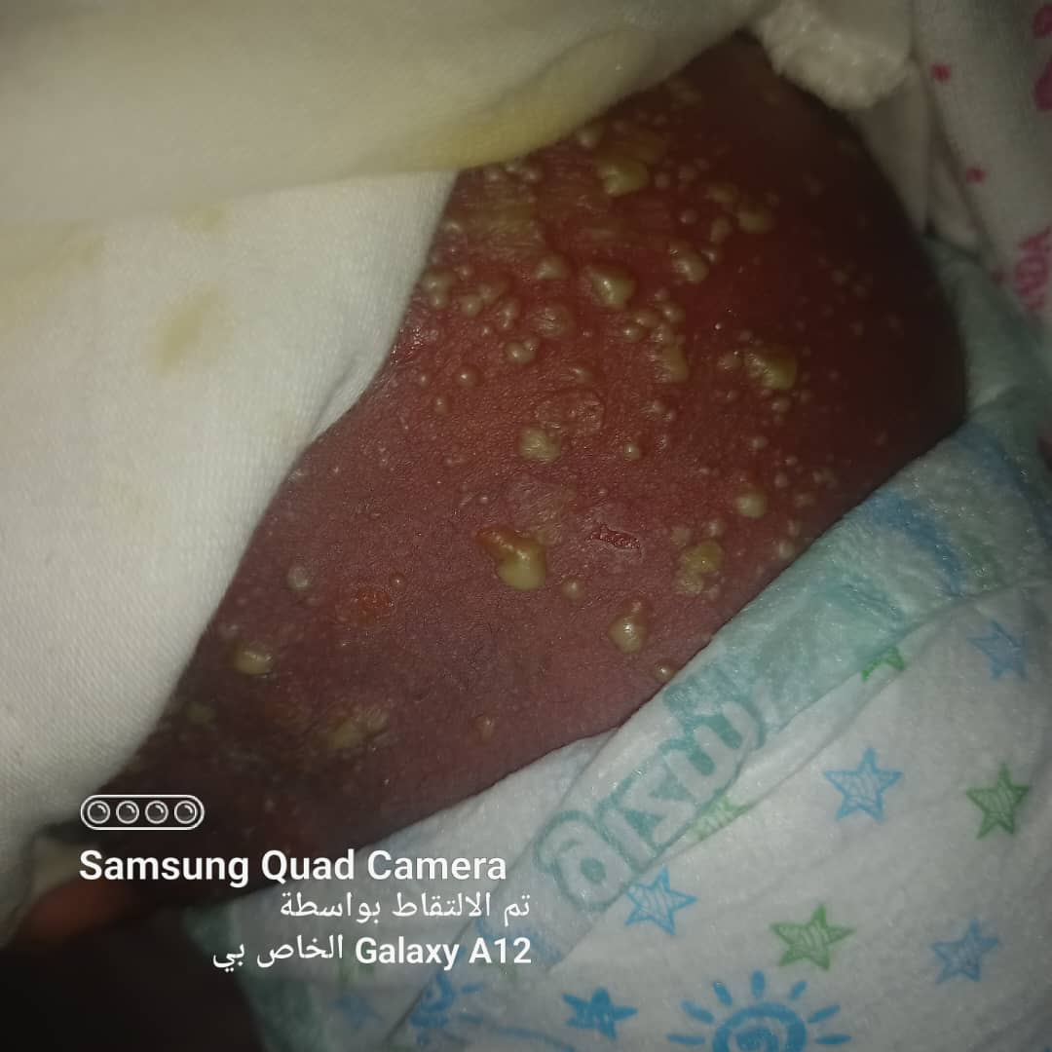
Figure no 1. Yellowish pustular lesions on the back.
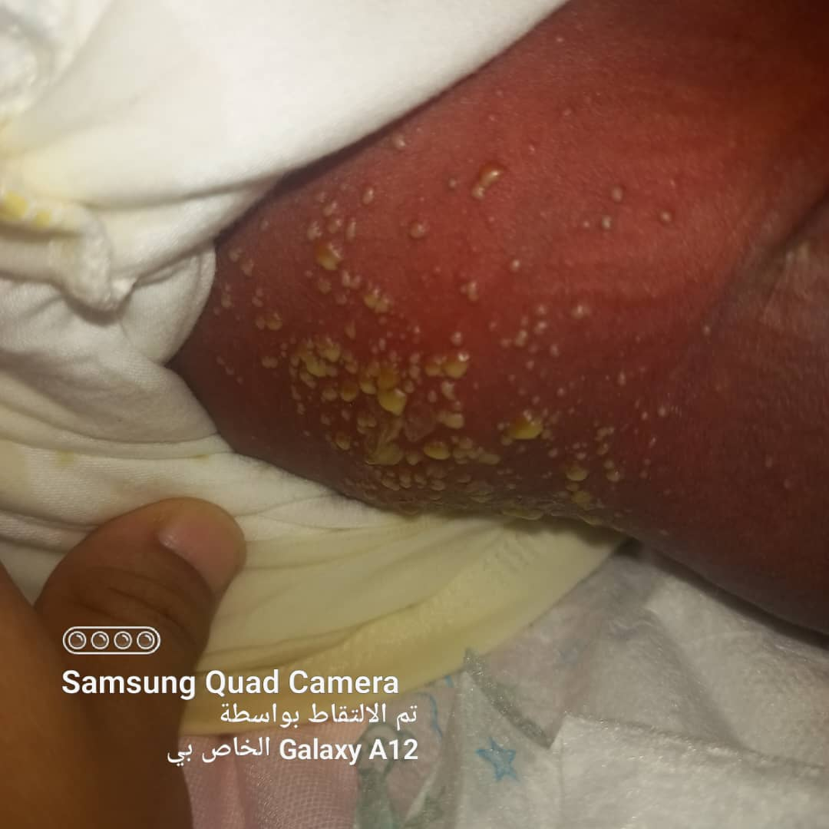
Figure no 2. Yellowish pustular lesions on flanks.

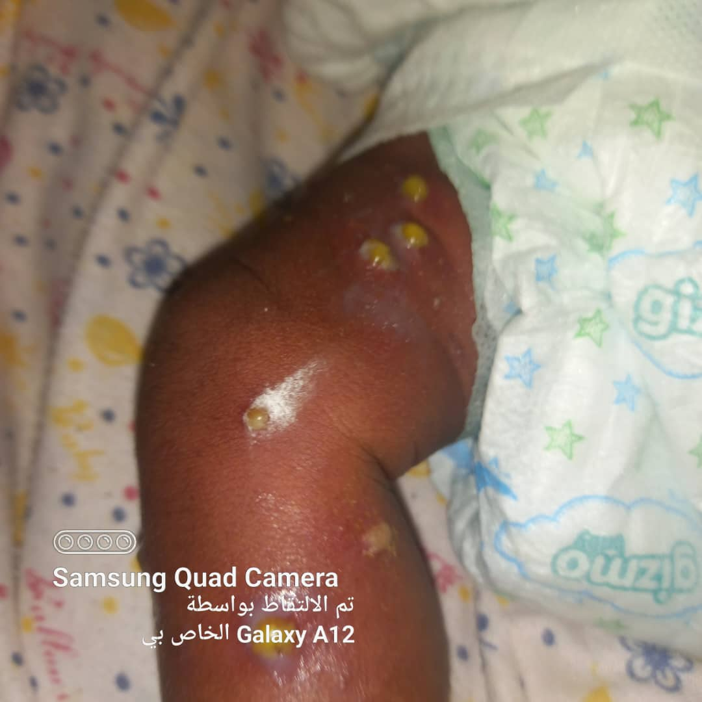
Figure no 3. Yellowish pustular lesions thigh and leg

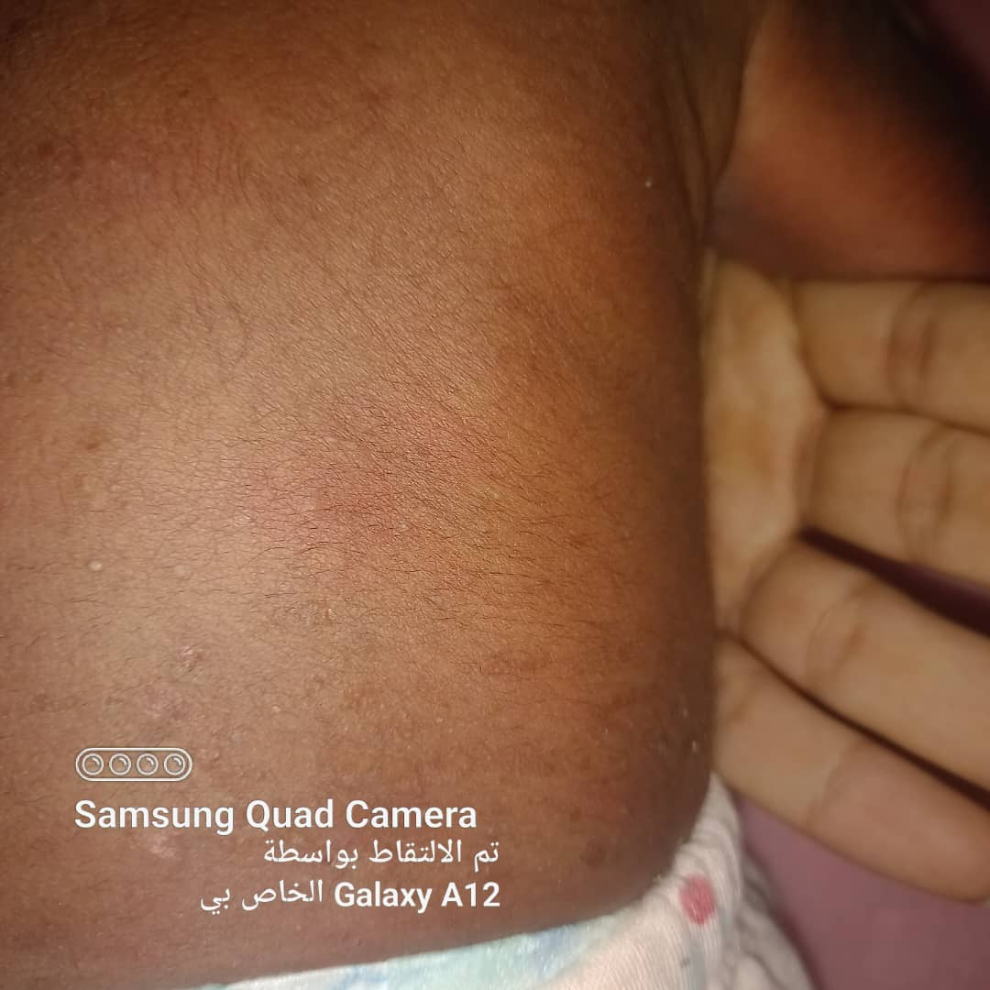
Figure no 4. After two weeks, the back is free of the lesion

Discussion:
Transient neonatal pustular melanosis is a benign skin disease that manifests at birth. The exact cause is still unknown and it is nether linked to family history nor correlated with exposure to medication (4). In our presented case it was reported that the mother was infected with chickenpox during the third trimester treated by supportive treatment (fluids and anti-pyretic only), fortunately the maternal illness didn’t have any serious complication for the fetus, a possible relation that should be studied in further researches. The disease is rare and has no sex preference, with an incidence that ranges from 0.6% in white infants to 4.4% in black infants. The eruption typically manifests as a widespread of sterile pustules (5) Initial skin lesions usually disappear spontaneously within the first 2 weeks, with the residual hyperpigmented scaly macules persisting for several weeks to months. (5)
The diagnosis is mainly clinical, in the presented case, the diagnosis was straight forward supported by the negative cytological examination of the aspirated fluid, fading of the rash in few weeks, absence of any systemic involvement and the excellent condition of the baby. The thoughtful judgment after detailed examination saved the case from invasive procedures, time and money consuming tests including the skin biopsy which must demonstrate subcorneal or intraepidermal pustules or vesicles (2). On the other hand, for uncertain cases screening for other pathologies might be needed as the neonatal rash could also be due to other pathologies, including active bacterial, viral or fungal infections (6). Other differential diagnosis for non-infectious pustular eruptions in neonate might include: Miliaria pustulosa, Infantile acropustulosis, Eosinophilic pustulosis and Acne neonatorum. (7).

The pathogenesis of Transient Neonatal Pustular Melanosis (TNPM) is not entirely understood, but it is thought to be related to the normal process of skin development in neonates. Here’s a summary of the key points regarding its pathogenesis:
- Development of Pustules: TNPM presents with the formation of small, sterile pustules shortly after birth. These pustules are typically located on the face, neck, and sometimes other parts of the body. The pustules contain neutrophils and are generally considered to result from the skin's response to a mild inflammatory process, which can occur in neonates due to their still-developing immune system.
- Keratinocyte Involvement: TNPM is believed to involve the epidermal layer, particularly keratinocytes, which undergo programmed cell death (apoptosis) as part of the skin's normal maturation process. These cells may accumulate and form the pustular lesions observed in TNPM. It is hypothesized that the pustules are a result of the accumulation of these cells and inflammatory mediators (e.g., neutrophils), though the exact immune pathways remain unclear.(8)
- Pigmentation: After the pustules rupture, they leave behind hyperpigmented macules, which are a key characteristic of TNPM. The pigmentation is likely due to the increased melanin production in the affected skin areas. Neonates with darker skin types may demonstrate more noticeable pigmentation changes. These macules gradually fade over time, typically within a few weeks, and are not associated with scarring.
- Immune System Maturation: The development of TNPM may also reflect the adaptation of the neonatal immune system. In a newborn, the immune system is still maturing, and mild inflammatory responses can be a part of this process. The presence of pustules and the subsequent pigmentation likely represents a transient immune reaction that is self-limited.
- Genetic and Ethnic Predispositions: There is evidence suggesting that TNPM may have a genetic component, as it is more common in certain ethnic groups, particularly those with darker skin tones, such as African and Asian infants. These genetic factors could influence the skin’s response to environmental stimuli and its ability to produce melanin after the pustules resolve. (8)

Conclusion:

Transient neonatal pustular melanosis is a benign, self-limiting neonatal dermatosis. A careful examination, monitor and follow up for the presenting cases can save effort and cost for the family and help to avoid unnecessary hospitalization. Although this kind of rash never been linked to any maternal illness, in our case, the mother reported history of chickenpox during gestation. A significant possible correlation that needs further researches.

Reference
- Ferrándiz C, Coroleu LW, Ribera M, Lorenzo JC, Natal A. Sterile transient neonatal pustulosis is a precocious form of erythema toxicum neonatorum. Dermatology 1992; 185: 18–22. DOI: 10.1159/000247396.
- Boffa MM, Borg J, Grech M-C, Pace D, Montalto SA. Transient neonatal pustular melanosis: An unusual and challenging eruption. Clin Case Rep. 2023;11:e8092.doi:10.1002/ccr3.8092
- Elder D, Elenitsas R, Jaworsky C, Johnson B Jr (eds). Lever’s histopathology of the skin, 8th edn. Philadelphia: Lippincott-Raven, 1997.
- Obu DC, Ezeanosike OB, Muojiuba KP, Daniyan OW, Onyire NB. Transient neonatal pustular melanosis: a possible cause of antibiotic misuse in neonates. Niger J Med. 2020;29(3):511.
- Agusti‐Mejias A, Messeguer F, Febrer I, Alegre V. Transient neonatal pustular melanosis. Actas Dermosifiliogr. 2013;104(1):84‐85.
- Chia P‐S, Leung C, Hsu Y‐L, Lo C‐Y. An infant with transient neonatal pustular melanosis presenting as pustules. Pediatr Neonatol. 2010;51(6):356‐358.
- Ghosh S. Neonatal pustular dermatosis: an overview. Indian J Dermatol. 2015 Mar-Apr;60(2):211. doi: 10.4103/0019-5154.152558. PMID: 25814724; PMCID: PMC4372928.
- Pérez-Pérez L, et al. Exantema fijo medicamentoso múltiple probablemente inducido por ácido mefenámico. Actas Dermosifiliogr.2013;104:85-7.

