Original Research Article

**ABSENCE OF VALIDATED ARTEMISININ COMBINATION THERAPY RESISTANCE MARKERS IN HIGH AND LOW MALARIA TRANSMISSION SEASONS IN KANO AND JIGAWA STATES, NIGERIA.**

ABSTRACT

|  |
| --- |
| I**ntroduction**: The first line treatment of uncomplicated malaria (ACT) is under threat due to evolution of drug resistant P. falcifarum species. Five aminoacid on pfk13 propeller domain has been established to account for ACT resistance alongside candidate mutations in some Asian countries. Nigeria is carrying the largest of burden of mortality and morbidity due to malaria despite huge investment in malaria control and treatment. Monitoring of these biomarkers in Pfk13 gene is paramount in understanding the extent at which the resistant species spread in the country.  Aim: This study aimed at surveying the presence of validated and candidate mutations in low and high malaria transmission seasons.  Method: P falcifarum clinical isolates were collected from malaria patients attending some public health facilities in Kano municipal, Kura and Hadejia LGAs. The propeller domain of Pfk13 genes were amplified by nested PCR and amplicons were sequenced to identify the validated, candidate and novel polymorphisms.  Results:None of the validated and candidate mutations conferring ACT resistance could be detected in all the Pf haplotypes.  Conclusion: Based on these results, it may be concluded that ACT treatment policy for uncomplicated malaria is not under immediate threat of resistance development in the states. |

*Keywords:*: *Malaria, transmission season, ACT, Pfkeclch13, Mutation*

1. INTRODUCTION

Malaria remains a universal health challenge affecting over 200 million of the world population annually, with the highest burden in Africa (93% malaria cases) (Adedeji et al., 2020).Despite huge investment in treatment and prevention, it is one of Nigeria leading cause of morbidity and mortality (NMIS, 2021). The 2022 world malaria report revealed that Nigeria still account for 27% of 247 million malaria cases worldwide and 31% of 619,000 malaria death in 2021 (WHO, 2022). Development of resistance among parasite and vectors to existing antimalarial drugs and insecticides may have hindered the progress in reducing malaria transmission through various malaria control strategies (Liu, 2015, Adedeji et al., 2022). Historically, drug-resistant *P. falciparum (Pf)* was first discovered in Asia and then much later in Africa. Resistant to antimalarial drugs has been documented with respect to chloroquine (CQ) (Awasthi and Das, 2013), sulfadoxinepyrimethamine (SP) (Maıga et al., 2007) and now artemisinin (ART) (Dondorp et al., 2009, St.Laurent et al., 2016). In Nigeria, following the spread of chloroquine resistance, ACT (artemether–lumefantrine) that was introduced in 2005 is still the first line treatment for uncomplicated malaria and Artesunate + Amodiaquine as the alternative (FMOH, 2005). However, report of Artemisinin resistant parasite in Asia which clinically resulted in delayed parasite clearance after treatment with ACT poses a major threat to malaria elimination goal. Possible dissemination of resistant parasites due to intercontinental travel necessitate the continual monitoring of Artemisinin resistant gene in order to promptly respond to emerging resistance and avoid the catastrophic consequences that followed chloroquine and sulphadoxine/pyrimethamine resistance in Nigeria. In addition to invitro and invivo drug sensitivity study, surveillance of genetic markers associated with resistance is invaluable tool to detect evolutionary pattern of resistance in parasite population. Polymorphisms in the Plasmodium falciparum kelch13 gene (Pfk13) gene encoding the propeller domain protein located in chromosome 13 of *P. falciparum* have served as a valuable molecular marker for tracking and monitoring artemisinin-resistant alleles (Miotto et al., 2013, Mohon et al., 2014). The gene carries several nonsynonymous point mutations (N458Y,Y493H, R539T, I543T, and C580Y) that have been validated to account for ART resistance (WHO, 2017; Daily, 2016). Other mutations (M476I, C469Y, C469F, M476I, K479I, A481V, R515K, S522C, and P527L) have been associated with *in vivo*/*in vitro* resistance and few others (P553L, F446I, and R561H) associated with delayed parasite clearance have been designated as candidate mutations of the *Pfk13* gene for ART resistance in *P. falciparum (*WHO, 2017). Surveillance of artemisinin resistance in Nigeria is an important global health issue that could prompt actions to deter resistance and will assist in promptly informing treatment policy. Kano and Jigawa are malaria endemic states, which despite achieving national target of 80% bed nets ownership, the states still account for 54 to 55% malaria prevalence in children (NMIS, 2021). In these parts of the country, speculations are high in the clinical cycles, on the failure of parasites clearance after ACT treatment especially during high transmission seasons. However, whether the failure is due to artemisinin resistance, recrudescence, mix infection or residual transmission is still ambiguous. WHO recommends monitoring the efficacy of first-line and second-line ACTs every two years in all falciparum-endemic countries. The aim of this study was to determine the seasonal variation in K13 polymorphism in *Plasmodium falciparum* isolates in Kano and Jigawa states, Nigeria.

2. material and methods

**2.1 Study area**

The study was conducted at Hadejia, Kura and Kano Municipal Local Government Areas of Jigawa and Kano states, Nigeria. Kano State is located within the Sudan Savannah zone of West Africa about 840 kilometers from the edge of the Sahara desert. The vegetation of Kano State is semi-arid Savannah sandwiched by the Sahel Savannah in the north and the Guinea Savannah in the south. The state has the largest irrigation projects in Nigeria, with six irrigation projects and more than twenty earth dams of various sizes. The project was precisely conducted at Kura which is located at Kadawa irrigation project within the catchment area of Tiga dam and non rice producing Kano Municipal LGAs (11°42′N, 8°33′E). Jigawa state is situated within the Sudan savannah vegetation zone, but there are traces of Guinea Savannah in the southern part of the state. The study was conducted in rice producing Hadejia LGA situated at Hadejia-Jama’are River Basin area

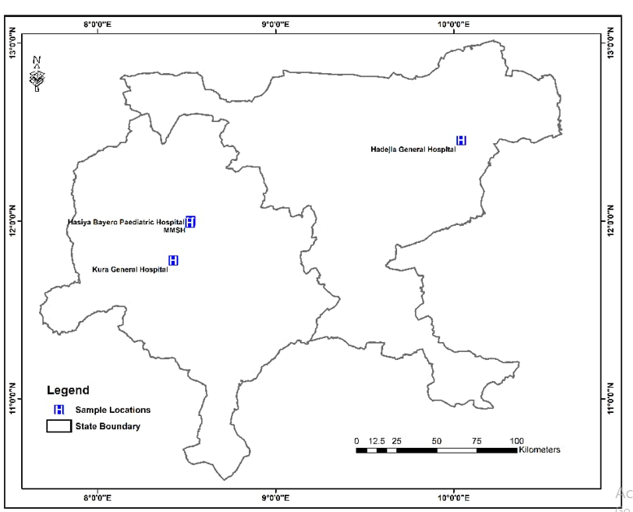

**Figure 1: Map of Kano and Jigawa states showing the study location**

# 2.2 Study subjects.

The study participants were patients complaining of clinical symptoms suggestive of malaria attending outpatients departments of Muratala Muhammad Specialist Hospital, Hasiya Bayero Paediatric Hospital, Kura General Hospital and Hadejia General Hospital in Kano and Jigawa States, Northwest Nigeria.

# 2.2 Ethical Approval.

The study protocol was independently reviewed and approved by the Ethics committees of Kano and Jigawa states Ministry of Health and were assigned Protocol number NHREC/17/03/2018 and MOH/SEC/1.5/235/009 respectively. A written informed consent was read and signed by all participants or their parents or guardians before any study procedure was performed

# 2.3 Inclusion and Exclusion criteria

Inclusion criteria are Patients presenting with uncomplicated *P. falciparum* malaria detected using microscopy, not on anti-malaria therapy and resident of Kano and Jigawa States. A total of three hundred (300) patients aged 1 to 45 years were recruited for the study. Fifty patients from each sites and from two transmission seasons were included as the minimum requirement for the study to be representative (n ≥ 50) (Thanh et al., 2017)..

**2.4 Sample Collection and microscopic examination**

Blood samples (3ml) from participants were collected and transported in ice to Department of Microbiology, Bayero University Kano and Aminu Kano Teaching Hospital (AKTH). Slides positivity were confirmed by two WHO certified laboratory Scientists using thin films. The films were fixed with methanol and stained with 3% Giemsa stain of pH 7.0 for 30 min as recommended by (WHO,2000), and examined microscopically using 100x (oil immersion objectives as described by (Cheesbrough, 2000).

2.5 **DNA Extraction**

DNA was extracted from the whole blood of microscopically confirmed *Plasmodium falcifarum* positive samples. This includes overall 100 samples each from high and low transmission period. DNA isolation was carried out using the QIAamp® DNA Mini Kit (QIAGEN, Hilden, Germany) according to the manufacturer’s instructions. The genomic DNA was eluted in 100 μL of nuclease-free water and its concentration measured using the Qubit 4.0 fluorometer (Invitrogen, Massachusetts, USA) and stored at −20 °C.

**2.6 Amplification of Propeller Domains of the Kelch13 Gene**

Samples with appreciable genomic DNA concentration were further processed for amplification of DNA fragments (849 nucleotides base pair) containing validated and candidates mutation of pfkelch13 gene using nested PCR protocol (Ariey et al., 2013). Published primers kelch-out-F (5CGGAGTGACCAAATCTGGGA3) and kelch-out- R (5GGGAATCTGGTGGTAACAG3) were used in the nest 1 reaction. kelch-IN-F (5 GCCTTGTTGAAAGAAGCAGA 3) and kelch-IN- R (5 GCCAAGCTGCCATTCATTTG 3) were used in the nest 2 reaction. The first step PCR was carried out in a 12.5μL final volume comprised of 1.25μl PCR buffer, 0.25 ul dNTPs, 0.13ul taq polymerase, 2.0μl genomic DNA, 0.43μL each of forward and reverse primers and 8.1ul nuclease free water. The cycling condition were 950c for 1mins followed by 35 cycles of 950C for 20sec, followed 570C for 1.5min and by a final extension at 600C for 5mins. The nested PCR was carried out in a final volume of 25μl comprised of 4μL of the genomic DNA, 2.5 μl PCR buffer, 0.26μl taq polymerase, 0.85μL each of forward and reverse primers and 16.2 μl of sterile water. Amplification was carried out using the following conditions: initial denaturation at 95 °C for 1 min, followed by 35 cycles each of 20 sec at 95°C (denaturation), 20 sec at 57 °C (primer annealing), 1 min at 60 °C (extension) was followed with a 3 min final extension at 60 °C. PCR products were separated in a 2% agarose gel stained with pEqGREEN and examined for bands.

**2.7 DNA purification and sequencing**

Successful PCR products showing single band in gel were purified using QIAquick® PCR Purification Kit (QIAGEN, Hilden, Germany) and DNA eluted in 30μl of nuclease-free water. The purified products were sent to Inqava for sequencing using Sangers approach. Isolates that shows multiple bands and/or those that could not be amplified were not sent for sequencing and this reduced the number of isolates. The sequence chromatogaram were manually examined using bioedit (Bioedit sequence alignment V.7.0.5..3) Aligned using CLC sequence viewer alongside reference pfk13 3d7 sequence (gene bank accession No pf3d7 1343700) to detect mutations in form of single nucleotide polymorphism (SNP). Genetic parameters such as haplotype diversity, number of SNPs, and Tajma’s D (TD) to test the hypothesis of neutral molecular evolution were determined with the aid of Omega 6 and Dnasp 5.1.0.

3. results and discussion

**3.1 Demographic characteristics of study participants**

Demographic of respondents are presented in Table1. On the basis of age and gender, Female represent (53%) and male represent (46.8%). Children between the age of 5-14 years accounts for the majority of the participants (33.9%). Most of the respondents are from KMC (41.0%), followed by Kura (31.6%) and then Hadejia. (27.3%) areas.

**Table 1: Demographic characteristic of study participants**

|  |  |  |  |
| --- | --- | --- | --- |
| Variables | Category | Frequency | Percentage |
| Site | KMC | 123 | 41.0 |
|  | Kura | 95 | 31.6 |
|  | Hadejia | 82 | 27.3 |
| Age | Under 5 | 85 | 28.3 |
|  | 5-14 | 102 | 33.9 |
|  | 15-24 | 52 | 17.3 |
|  | 25-40 | 28 | 9.4 |
|  | 41 and above | 09 | 3.1 |
| Sex | Male | 141 | 46.8 |
|  | Female | 160 | 53.2 |

**3.2 Nested PCR Product of *Plasmodium falciparum* K13 gene**

The representative result of nested PCR product of *plasmodium falciparum* K13 genes collected from low transmission seasons (Figure 2) and high transmission seasons (Figure 3). A total of fifty (50) isolates were successfully amplified and sequenced.

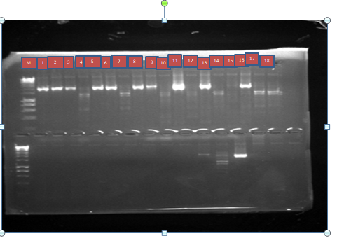**Figure2: Gel Chromatogram showing nested PCR of *Pfkelch13* gene of 849bp in low transmission season with lane M DNA ladder of 1000bp and lanes 1,2,3,,5,6,7, 8,9, 11, 13, 15, 16 indicate amplified K13 gene with 850bp while lane 4,10, 12, 13, 14, 17,18, show no amplification**

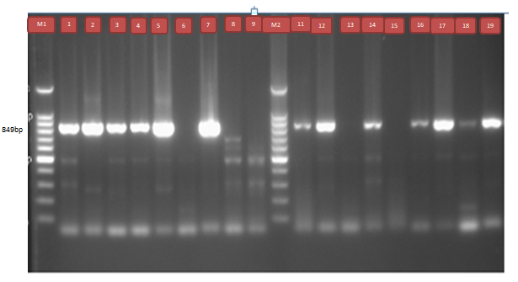

Figure 3: Gel chromatogm showing nested PCR of *PfKelch13* gene collected in high transmission season with lane M1 and M2 represent DNA ladder of 1500bp and lane 1,2,3,,5,,7, 10,11, 13,15,16,17,18 indicate amplified *PfKelch13* gene while lane 6,8,9, 12,14 show no amplification

3.3 Blast Result of one Representative Sample

Figure 4 presents the basic alignment search tool showing 99% degree of identity of one representative sample with those in NCBI data base

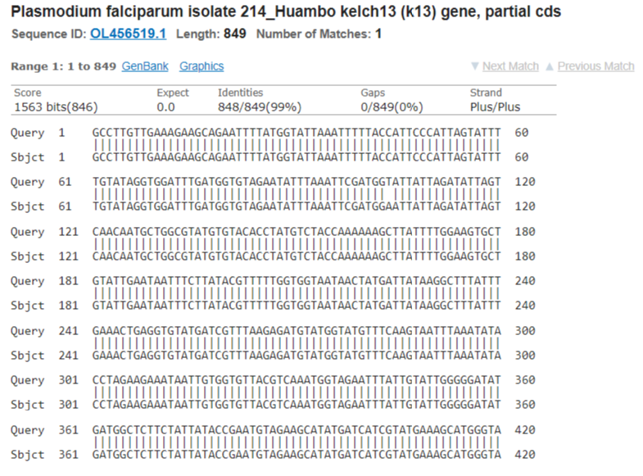

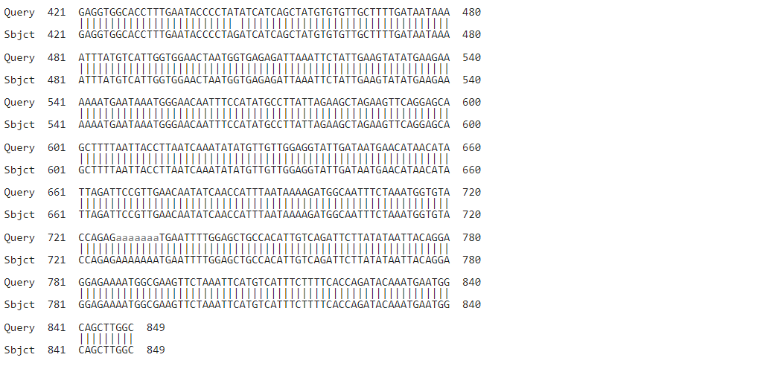**Figure 4: Basic Alignment search for one representative sample**

## 3.4Seasonal Variation in *Pfkelch13* Single Nucleotide Polymorphism

Fgure 5 represents single nucleotide polymorphism in pf isolates obtained in high and low transmission seasons. The isolates identified with single nucleotide polymorphism (SNP) were 48.5% and 25% and wild type were 42.4% and 67.9% in high and low transmission seasons respectively. The other isolates were invalid due to diminish clearity of sequence chromatogram

**Figure 5: Seasonal variation in Pfkelch13 single nucleotide polymorphism in high and low transmission**

**3.5 Mutation Types Variation in Low and High Transmission Seasons**

Figure 6 shows mutation type variation in pf isolates obtained in high and low transmission seasons. Synonymous mutation were more prevalent (53.3%) in high transmission season than 37.5% identified in low transmission season. Nonsynonymous mutations identified were low (46.7%) in high transmission compared to 62.5% obtained in low transmission season

**Figure 6: Mutation types variation in low and high transmission season**.

## 3.6 *Pfk13* Polymorphisms observed in Low and High Transmission Seasons.

Table 2 shows the polymorphism observed in pf isolates obtained in high and low transmission seasons. A total of 9 unique mutations were identified which include five non- synonymous and four synonymous. Five nonsynonymous mutations identified include E461V, V566L, R575I, D648Y in both seasons L598I identified only in low transmission season. E461V, L598I and D648Y were identified in KMC only. V566L was identified in both Kura and KMC. None of the nonsynonymous mutation was identified in HDJ. The four synonymous mutations identified include S485S, S549S in high transmission season and G592G, A626A in low transmission season.

**Table 2: *Pfk13* polymorphisms observed in KMC, Kura and Hadejia during low and high transmission seasons.**

|  |  |  |  |  |  |  |
| --- | --- | --- | --- | --- | --- | --- |
| **Subject** | **Mutation** | **Codon**  **position** | **Reference**  **Nucleotide** | **Mutant**  **nucleotide** | **Reference**  **Aminoacid** | **Aminoacid**  **substituted** |
| KmcH1 | Nonsynonymous | 461 | GAA | GTA | Glutamine | Serine |
| KmcH2 | Nonsynonymous | 575 | AGA | ATA | Argenine | Isoleucine |
| KmcH4 | synonymous | 485 | AGT | AGC | Serine | Serine |
| KmcH8 | synonymous | 485 | AGT | AGC | Serine | Serine |
| kmcH28 | synonymous | 549 | TCT | TCG | Serine | Serine |
| kmcH32 | nonsynonymous | 661 | CAA | TAA | Glutamine | Termination |
| kmcH33 | nonsynonymous | 648 | GAT | TAT | Aspartate | Tyrosine |
| HdjH10 | synonymous | 485 | AGT | AGC | Serine | Serine |
| HdjH13 | synonymous | 549 | TCT | TCG | Serine | Serine |
| kurH20 | nonsynonymous | 566 | GTA | TTA | Valine | Leucine |
| kurH21 | nonsynonymous | 566 | GTA | TTA | Valine | Leucine |
| kurH22 | nonsynonymous | 566 | GTA | TTA | Valine | Leucine |
| kurH23 | synonymous | 485 | AGT | AGC | Serine | Serine |
| kmcH24 | synonymous | 485 | AGT | AGC | Serine | Serine |
| kmcL34 | Nonsynonymous | 648 | GAT | TAT | Aspartate | Tyrosine |
| kmcL36 | nonsynonymous | 566 | GTA | TTA | Valine | Leucine |
| kmcL37 | synonymous | 485 | AGT | AGC | Serine | Serine |
| KurL48 | nonsynonymous | 598 | TTA | ATA | Leucine | Isoleucine |
| KurL49 | nonsynonymous | 598 | TTA | ATA | Leucine | Isoleucine |
| kurL50 | nonsynonymous | 566 | GTA | TTA | Valine | Leucine |
| HdjL42 | synonymous | 592 | GGA | GGC | Glycine | Glycine |
| HdjL44 | synonymous | 626 | GCA | GCG | Alanine | Alanine |

**Key: KmcH: High transmission seasan sample from Kano Municipal**

**KmcL: Low transmission season sample from Kano Municipal**

**KurH: High transmission season sample from Kura**

**KurL: Low transmission season sample from Kura**

**HdjH: High transmission season sample from Hadejia**

**HdjL: Low transmission season sample from Hadejia**

## 3.7 Percentage Frequency of *PfKelch13* Nonsynonymous Mutations.

Figure 7 represents the frequency of non synonomus mutations detected in the pf isolates. The nonsynonymous mutations were identified in eleven isolates and include E461V, V566L, R575I, L598I and D648Y. V566L account for the percentage frequency of 45.5%, D648Y and L598I account for 18.2% each and E461V, R575I represent 9.1% each

**Figure 7: Percentage frequency of Kelch13 nonsynonymous mutation observed in the study**

**3.8 Haplotype Diversity of *Pfkelch13 gene* Fragment**

The haplotype diversity **of *Pfkelch13* gene** fragments is presented in Table 3. The overall sequences consist of 11 haplotypes. Haplotype 1 is the predominant haplotypes comprises of 28 sequences out of 50. Next is the haplotype 2 which composes of 6 sequences followed by haplotype 4 comprising of 5 sequences and haplotype 8 with 2 sequences. The other haplotype consists of 1 sequence each.

**Table 3: Haplotype diversity of kelch13 gene fragment observed in the study**

|  |  |  |
| --- | --- | --- |
| Haplotypes | Frequency | Sequences |
| 1 | 2 8 | KmcH:1, 3, 4, 6,8, 25, 26, 27, 31,32,33. HdjH: 10, 11, 12, 13, 14, 15,  KurH: 21, 22,23. KmcL: 34, 37,38,39,40, hdjL: 42. |
| 2 | 6 | KmcH: 2,5,7,30, KurH: 19,20, |
| 3 | 2 | KmcH; 9,24 |
| 4 | 5 | HdjH: 16, KurH: 17,18,29, HdjL: 41 |
| 5 | 1 | KmcH28 |
| 6 | 1 | HdjL 43 |
| 7 | 1 | HdjL 44 |
| 8 | 2 | hdjL:45,46 |
| 9 | 1 | HdjL47 |
| 10 | 1 | KurL48 |
| 11 | 1 | KurL: 49,50. |

|  |  |  |  |
| --- | --- | --- | --- |
|  |  |  |  |

**Key: KmcH: High transmission seasan sample from Kano Municipal**

**KmcL: Low transmission season sample from Kano Municipal**

**KurH: High transmission season sample from Kura**

**KurL: Low transmission season sample from Kura**

**HdjH: High transmission season sample from Hadejia**

**HdjL: Low transmission season sample from Hadejia**

**3.9 Genetic tree**

Figure 8 is the phylogenetic relationship of the ***Pfkelch13*** field isoates and the wild type isolates. Sequence with same genetic makeup and lack of polymorphic site cluster around together and those with mutation cluster away from the wild type.

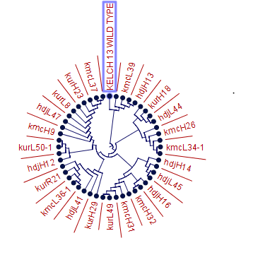

**Figure 8: Phylogenetic tree of fifty sequence field isolates and a wild type isolate**

## Genetic Polymorphism and Summary Statistics of the *Pfk13* gene

Table 4 represents **Genetic polymorphism and summary statistics of the *Pfk13* gene.** In the overall fifty sequences, eleven haplotypes with diversity of 0.6686 were identified. Nine polymorphic sites comprising of five nonsynonymous and four synonymous mutations were also identified. Tajima D statistical test show negative value of nonstatistical significance.

**Table 4: Identified Genetic polymorphism and summary statistics of the *Pfk13* gene**

|  |  |  |  |  |  |  |  |  |
| --- | --- | --- | --- | --- | --- | --- | --- | --- |
|  |  |  |  |  | Population genetic parameters | | | |
| N | S | H | Syn | Nonsyn | Hd | Qw | π | TD |
| 50 | 09 | 11 | 04 | 05 | 0.6686 | 09 | 0.8645 | -1.752ns |

**Key: N: Number of isolates, Syn: synonymous mutation; Nonsyn: Nonsynonymous mutation; Hd, haplotype diversity; Qw, number of segregating sites; π: average number of pairwise nucleotide differences; TD: Tajima’s D statistics**.

**Discussion**

Tracking mutation in *PfKelch13* gene associated with resistance to ART derivatives is an invaluable approach to detect the emergence and arrest the spread of parasite resistant species and assess the effectiveness of current control measures. This study investigated the seasonal variation in PfK13 gene polymorphism following suspected delay parasite clearance after ACT treatment in high transmission season in Kano and Jigawa states, Nigeria. Nine polymorphic sites were detected in this study and to the best of our knowledge, this has not been discovered elsewhere (Table 2). The identified mutations include five nonsynonymous E461V, V566L, R575I, D648Y and L598I. The four synonymous mutations identified are S485S, S549S, G592G, and A626A. Interestingly, none of the above mutations was among those validated (F446I, N458Y, M476I, Y493H, R539T, I453T, P553L, R561H, P574L and C580Y) to associate with ART resistance in Southeast Asia, South America and Rwanda in sub-Saharan Africa St.Laurent, et al., 2016; Mishra et al., 2016). This is not surprising in cognizance of the fact that no report of any of the above validated mutations from the neighboring countries including Cameroon, Benin, Niger and other sub-Saharan Africa. However some mutations of unknown significant epidemiological importance such as A575S, V566I, A569T, S576L, A578S and L589I were identified in sub-Saharan Africa (Taylor et al., 2015; Lu et al, 2017). The V566L identified in this study (Figure 7) may have similar or same unknown phenotypic effect with V566I identified in other studies from Africa owing to structural similarity and polarity of the substituted aminoacid Isoleucine and leucine. Recent studies from Northern part of Nigeria have not reported any of the validated or suspected mutations (Abubakar et al., 2020). The use of combined therapy in malaria treatment and short life of artemisinin is not favorable for the selection of resistant parasite. The results were consistent with other studies from Africa that reported no validated mutations after several years of ACT implementation (Torrentino-Madamet et al., 2024; .Ménard et al., 2016). The presence of dominant haplotype (Table 4) and very low diversity suggest that the gene either undergoing selection or the mutations are endogenous. Population genetic parameters and negative DTajima value suggest that the gene evolve under neutral model of molecular evolution and the detected mutations are not attracted by adaptive evolution model of natural selection in *P. falcifarum*.

**4.0 Conclusion**

Based on the results of this study, it may be concluded that ACT is still effective in the treatment of uncomplicated malaria and not under immediate threat of resistance

**REFERENCES**

Adedeji, E.O., Ogunlana, O.O., Fatumo, S., Beder, T., Ajamma, Y., Koenig, R. and Adebiyi, E., (2020). *Anopheles* metabolic proteins in malaria transmission, prevention and control: a review. *Parasites & vectors*, *13*(1), pp.1-30.

NMIS (2021). *Malaria Indicator Survey. National Malaria Elimination Program.* Abuja Nigeria *9-10*.

WHO (2022). World Malaria report. www. <http://www.who/int/teams/global> malaria programe

Liu, N. (2015). Insecticide resistance in mosquitoes: impact, mechanisms, and research directions. *Annual review of entomology*, *60*, 537-559.

Adedeji, E.O., Oduselu, G.O., Ogunlana, O.O., Fatumo, S., Koenig, R. and Adebiyi, E (2022). Anopheles gambiae Trehalase Inhibitors for Malaria Vector Control: A Molecular Docking and Molecular Dynamics Study. *Insects*, *13*(11), 1070.

Awasthi, G and Das, A (2013). Genetics of chloroquine-resistant malaria: a haplotypic view,” *Mem´orias do Instituto Oswaldo Cruz*, 108, 8, 947–961

Maıga, O., Djimde,A., Hubert V (2007). A Shared Asian Origin of the Triple-Mutant. *The Journal of Infectious Diseases*, 196,1,165–172.

Dondorp, MS., Nosten, F., Yi P (2009). Artemisinin resistance in *Plasmodium falciparum*,” in *The New England Journal of Medicine*, 361, pp. 361–455.

St.Laurent, B., Miller, B., and Burton TA (2016). Erratum: Artemisinin-resistant Plasmodium falciparum clinical isolates can infect diverse mosquito vectors of Southeast Asia and Africa (Nature Communications (2015) *Nature Communications*, vol. 7

FMOH (2005). Federal Republic of Nigeria. National Antimalarial Treatment Policy, Federal Ministry of Health National Malaria and Vector Control Division, Abuja- Nigeria

Miotto O, Almagro-Garcia J, Manske M (2013). Multiple populations of artemisinin-resistant Plasmodium falciparum in Cambodia. *Nat Genet*  **45**: 648–655.

Mohon A, Alam M, Bayih AG (2014).  Mutations in *Plasmodium falciparum* K13 propeller gene from Bangladesh (2009–2013). *Malaria Journal*  **13**: 431.

WHO (2017). World Health Organization, *Status Report on Artemisinin and ACT Resistance*.

Daily, JP (2016).“K13-Propeller Mutations and Malaria Resistance,” *The New England Journal of Medicine*, 374, 25, 2492- 2493.

Thanh, N.V., Thuy-Nhien, N., Tuyen, N.T.K., Tong, N.T., Nha-Ca, T.N., Dong, L. and Quang, H.H (2017). Rapid decline in susceptibility in Plasmodium Facifarum to dihydroartemisinin- piperaquine in the south of Vietnam. *Malaria Journal* 16(27): 1680- 8

Cheesbrough, M (2000). District Laboratory Practical Manual in tropical countries. Cambridge University press, Edinburgh, United Kingdom 239-242

Ariey, F.; Witkowski, B.; Amaratunga, C.; Beghain, J.; Langlois, A.-C.; Khim, N.; Kim, S.; Duru, V.; Bouchier, C.; Ma, L.; et al. (2013). A molecular marker of artemisinin- resistant Plasmodium falciparum malaria. *Nature*  *505*, 50 -55.

Mishra,N., Bharti, RS., Mallick P (2016). Emerging polymorphisms in falciparum Kelch 13 gene in Northeastern region of India,” *Malaria Journal*, 15, 1, 583.

Taylor, S.M., Parobek, C.M., DeConti, DK.., Kayentao, K., Coulibaly, S O., Greenwood, B.M. and Njie, F. (2015). Absence of putative artemisinin resistance mutations among *Plasmodium falciparum* in sub-Saharan Africa: a molecular epidemiologic study. *The Journal of Infectious Diseases.* 211(5): 680-688.

Lu, F., Culleton, R., Zhang, M., Ramaprasad, A., von Seidlein, L., Zhou, H., .Wang, W. (2017). Emergence of indigenous artemisinin-resistant *Plasmodium falciparum* in Africa. *New England journal of medicine. 376*(10): 991-993

Abubakar, U.F., Adam, R., Mukhtar, M.M., Muhammad, A., Yahuza, A.A. And Ibrahim, S.S (2020). Identification of Mutations in Antimalarial Resistance Gene Kelch13 from *Plasmodium falciparum* Isolates in Kano, Nigeria. *Trop Med Infect Dis, 5*(2):

Torrentino-Madamet M, Fall B, Benoit N (2014). Limited polymorphisms in k13 gene in Plasmodium falciparum isolates from Dakar, Senegal in 2012-2013. Malar J. 13:472. Ménard D, Khim N, Beghain J (2016). A worldwide map of Plasmodium falciparum K13- propeller polymorphisms. 374(25):2453–246