**Morphological, Elemental and Optical, properties of Sphalerite nanoparticle (ZnS) Doped with Neem leaf Extract.**

**Abstract**

This study investigated the properties of undoped Sphalerite nanoparticles and Neem leaf extract doped Sphalerite nanoparticles. The Sphalerite nanoparticle were prepared by ball milling technique and was doped with the Neem leaf extract using Doctors Blades method. The Morphological, elemental and optical properties of the nanoparticles were investigated using scanning electron microscopy (SEM), energy dispersed X-ray analysis (EDX), and UV spectrophotometer respectively. The SEM micrograph revealed significant change in the morphological structure of the Sphalerite nanaoparticle from being coarse, densely packed, well-formed flakes with uneven edged crystalline-structured to coarse, dispersed, grain-like crystalline structure after doping with Neem leaf extract. The EDX confirmed the presence of zinc, sulphide, calcium, phosphorous, iron, chromium, and selenium and trace of other elements. UV-Vis spectroscopy showed that the transmittance of both the doped and undoped Sphalerite increased as the spectrum wavelength moved from ultraviolet region to visible region at 94% and 88% respectively at the near-infrared region. The photon energy with respect to refractive index of both doped and the undoped Sphalerite was found to be 1.66eV – 2.64eV and 1.38eV to 2.45eV respectively which revealed that the doped Sphalerite nanoparticle is beneficial for higher non linear optical response for optoelectronic devices. The Bang gap of the doped Sphalerite nanoparticles was 2.52eV which is significantly better than 3.63eV obtained in undoped Sphalerite. This suggested that the Neem leaf extract introduced necessary impurities which enhanced the optoelectronic properties of the Sphalerite nanoparticles. Hence, Neem leaf-doped Sphalerite nanoparticles can be a potential enhanced material for optoelectronic devices with excellent performance in photovoltaic applications.

**1. Introduction**

One of the most popular basic materials for research throughout the past ten years are nanostructured materials. They gradually made their way into our daily lives through a variety of uses. Innovative optoelectronic devices and sensors can result from the unique features that nanomaterials can provide that their analogous bulk materials do not. It has been discovered that newly developed nanotechnologies for a range of device applications, including medication delivery, catalysis, and adsorption, are based on innovative functional nanomaterials (Bisauriya et al. 2017). This interest is spurred on by the multi-functional properties and applications of the nanoparticles (Onu et al. 2023).

However, these properties can be further enhanced by doping these nanoparticles as one such as Sphalerite.

Sphalerite, is a naturally occurring mineral composed primarily of zinc sulfide (ZnS) with a bandgap of 3.60eV – 3.77eV (Bisauriya et al. 2017; Chandra et al. 2020; Simon et al. 2023) because of its special electrical and optical characteristics, it is hence an essential component in many industrial applications, especially photovoltaics and photocatalysis. Sphalerite's band gap makes it a desirable option for semiconductor devices, particularly when considering renewable energy sources like solar cells (Simon et al. 2023; Walid et al. 2023). Studies have demonstrated that doping Sphalerite with various elements or compounds can greatly improve its functional characteristics, increasing its effectiveness for particular uses (Alireza and Hosein 2019, Maria et al. 2020; Anu et al. 2021; Jie et al. 2022). Therefore, doped ZnS nanoparticle have been be found to be a preferred choice for optoelectronic applications due to their great significant quantum size impact (Krsmanović et al. 2014).

Utilizing organic substances, such plant extracts, which are abundant in bioactive chemicals, is one novel method of doping. Of these, Azadirachta indica, popularly referred to as the Neem plant, has drawn interest because of its high antioxidant, vitamin, mineral content, phenolic chemicals, alkaloids, terpenoids, and their derivatives (Banerjee et al. 2014; Breda et al. 2015; Chandra et al. 2020).The extract from Neem leaves also contains bioactive compounds that can interact with the Sphalerite matrix. The two primary phytochemicals found in neem are terpenoids and flavones, which are essential for stabilizing the nanoparticle and serving as capping and reducing agents (Chandra et al. 2020). This potentially modifies its electronic structure and enhances its performance in photovoltaic applications (Amit et al. 2013; Mohammad 2016; Reshmi and Philominal 2022).

An important advancement in the search for high-performance and ecological materials is the doping of Sphalerite with Neem leaf extract utilizing the Doctor Blade method, which combines materials science and green chemistry. This strategy supports global sustainability goals by utilizing the special qualities of Neem while also using eco-friendly synthesis techniques (Ali et al. 2015; Reshmi and Philominal 2022).

The most popular solution processing method for low-cost, large-area thin film manufacturing is doctor blade coating, also known as tape casting (Yehao et al 2015). The production of thin sheets of capacitors and piezoelectric materials was particularly linked to the term "doctor blade" coating when it was first used in 1940. This method's basic principle is that the blade and substrate move in relation to each other continually, either by passing the blade over the substrate or by sliding the substrate below the blade. The produced slurry effectively spreads over the substrate surface once a relative motion between the blade and carrier surface is established, evaporating to form a film of different thicknesses. In this procedure, the substrate in front of the blade is covered with a thoroughly blended coating solution. The final thickness homogeneity and uniformity are greatly influenced by the viscoelastic behavior of the coating precursor and the doctor blade unit design, both of which need to be continuously monitored (Ganesh 2023)

When doping Sphalerite with Neem leaf extract, the Doctor Blade method offers several advantages. First, it allows for the homogeneous distribution of the organic dopant within the Sphalerite matrix, ensuring uniformity in the resulting film (Syed et al., 2024). Second, the method’s scalability makes it suitable for large-area coating processes, which is essential for industrial applications (Siew et al., 2012). Third, the method’s simplicity and low cost make it accessible for widespread use in research and development settings (Guoq et al. 2019).

Previous studies have demonstrated the efficacy of the Doctor Blade method in fabricating thin films for various applications, including solar cells and sensors (Chonsut et al. 2017; Nurul et al. 2020; Soonil et al. 2023; Syed et al. 2024). This study investigated the synergistic effects of the bioactive chemicals on the morphological, optical, and elemental properties of the doped Sphalerite by incorporating Neem leaf extract into the Sphalerite matrix in this manner. This strategy fits with the growing interest in green chemistry and environmentally friendly material synthesis in addition to utilizing the sustainable and renewable character of plant extracts (Ali et al. 2015; Reshmi and Philominal 2022).

Research has indicated that the bioactive compounds in plant leaf extract, such as flavonoids, phenolics, and vitamins, can act as reducing agents, facilitating the doping process and potentially leading to improved electronic and optical properties of the material they are doped with (Amit at al. 2013, Reshmi and Philominal 2022). Furthermore, the interaction between the bioactive molecules in the Neem extract and the Sphalerite lattice lead to the formation of unique structural configurations that enhanced the material’s functionality. This biogenic doping approach represents a fusion of traditional material science techniques with modern green chemistry principles, opening new pathways for the development of advanced materials with tailored properties (Reshmi and Philominal 2022).

Conventional doping techniques frequently call for the use of synthetic chemicals or heavy metals, which are not only expensive but also dangerous for the environment (Alireza and Hosein 2019, Mariaet al. 2020; Anu et al. 2021; Jie et al. 2022). Alternatively, environmental friendly doping techniques that adhere to the principles of green chemistry are therefore desperately needed. Because of its natural abundance, affordability, and low environmental impact, Neem leaf which is well-known for having a high concentration of medicinal compounds offers an environmentally friendly substitute (Ali et al. 2015).

Several research has been carried on several nano - metals doped with plant extra (Reshmi and Philominal 2022; Vindhya and Kavitha 2022; Gomathi et al. 2023; Anusuya et al. 2024) However, notwithstanding the possible advantages, there is a significant research vacuum concerning the doping of sphalerite with neem leaf extract. This approach is further enhanced by the use of the Doctor Blade technology, a scalable and reasonably priced thin-film production technique.

Hence, this study characterized the doped Sphalerite films through various analytical techniques, including scanning electron microscopy (SEM), energy dispersed X-ray analysis (EDX), and UV-Vis spectroscopy and compared the doped Sphalerite particle with the undoped Sphalerite particle. These techniques helped to elucidate the morphological, elemental and optical changes induced by the Neem leaf extract to Sphalerite matrix.

**2. Materials and methods**

**2.1 Material sourcing and pretreatment**

The Sphalerite was sourced from Wase Local Government Area of Plateau State Nigeria it was crushed manually into smaller particles because of its bulky nature and grinded to nanoparticle using ball milling technique at Mechanical Engineering Department in Nnamdi Azikiwe University Awka, Ananmbra State.

Neem Leaves: 20 grams of fresh Neem leaves was obtained from a Neem tree at Nnamdi Azikiwe University vicinity. It was washed with distilled water and was grinded into gel. The gel was mixed with 20ml of water in a beaker and was allowed to settle for 5 minutes, the mixture was filtered using Whatman filter paper and 2ml of the extract was collected. The extract was mixed with 2grams of Sphalerite nanoparticle in vigorous steering for 10mins. Then the slurry was coated on the ITO (Indium Titanium Oxide) substrate with a coating blade in a slide movement and was allowed to dry within 24 hours at room temperature.

**2.2 Characterization of Sphalerite doped with Neem leaf extract**

SEM was used to view the morphology of the nanoparticle samples. The image allowed for the identification of the crystal structure and size of the crystalline nanoparticle phase samples. A JOEL scanning electron microscope, type JSM 6400, was used to make the observation. Coated ITO samples were prepared for the observation by employing double stick carbon tape to position them on a brace stub sample holder. The samples were then covered with layers of gold using a Blazer sputtering coater that were between 20 and 25 A thick. The micrographs were captured at magnifications of 9000x, and 15 KV.EDX was used to obtain the elemental composition of nanoparticle and a Schimadzu UV-1800 visible spectrophotometer operating in the UV-visible spectrum was used to examine the optical properties of the nanoparticles.

**3.0 Result and Discussion**

**3.1 SEM-EDX Analysis of the Doped Sphalerite with Neem leaf extract and Undoped Sphalerite.**

The resolution was captured at a 9000× magnification using a scanning electron microscope (SEM). The morphology of the doped Sphalerite particles containing Neem leaf extract is displayed in Figure 1. It was found to be dispersed, coarse, having a grain-like crystalline structure (Alireza and Hosein 2019; Ali et al. 2023) reported a similar outcome. This outcome is comparable to the earlier undoped Sphalerite particle in figure 2, which showed that the Sphalerite particles were crystalline-structured, coarse, densely packed had well-formed flakes with uneven edges. According to (Granados et al. 2020; Simon et al. 2023; Onu 2023), the outcome was observed to have a comparable morphology. However, the Neem extract significantly modified the morphology of the undoped Sphalertite particle.

Using energy dispersive X-ray (EDX) analysis, elemental composition was determined (Dengo et al., 2020; Kang et al., 2022). It was predicated on the fact that incident beam electrons produced distinctive X-rays in the particle's atoms.

Figure 3 displays the EDX spectrum of the doped Sphalerite. The doped Sphalerite particle spectrum with Neem leaf extract verified that zinc, sulfur and oxygen were the main constituents (Chandra et al. 2020; Amrutha and Hebsur 2020; Gan et al. 2021). This is in addition to the elements calcium, phosphorous, iron, chromium, and selenium, among others. Additionally, some transition elements were found, including cadmium and manganese. The elements found were similar to the elements reported by (Shrirangasami et al. 2020; Reshu et al. 2022; Kumari et al. 2023).

When compared to the undoped Sphalerite, the spectrum of the latter in Figure 4 confirmed the presence of zinc, iron, and sulfur in the particle; however, other elements such as calcium, silicon, and aluminum were also detected, along with some transition elements such as cadmium, manganese, and germanium (Granados et al. 2020; Simon et al. 2023; Onu 2023)

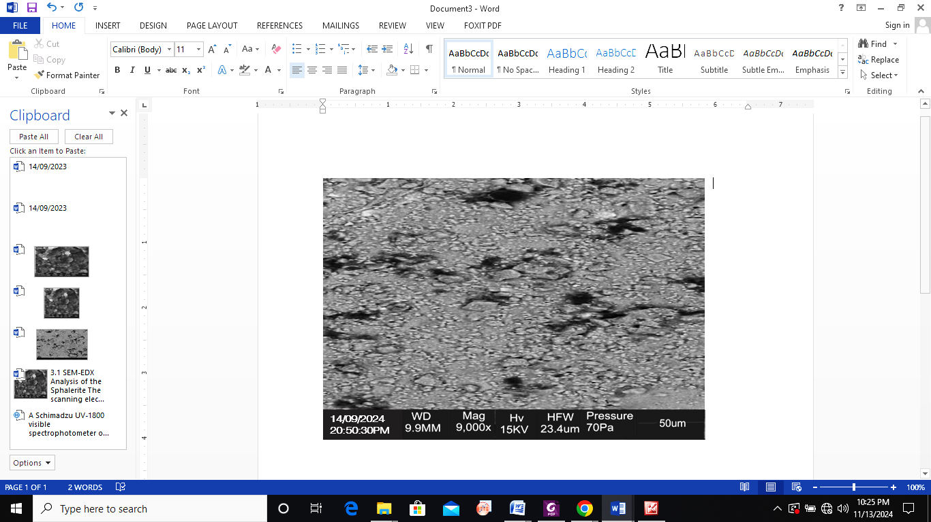

Figure 1. SEM Image of doped Sphalerite with Neem Leaf extract at 9000×

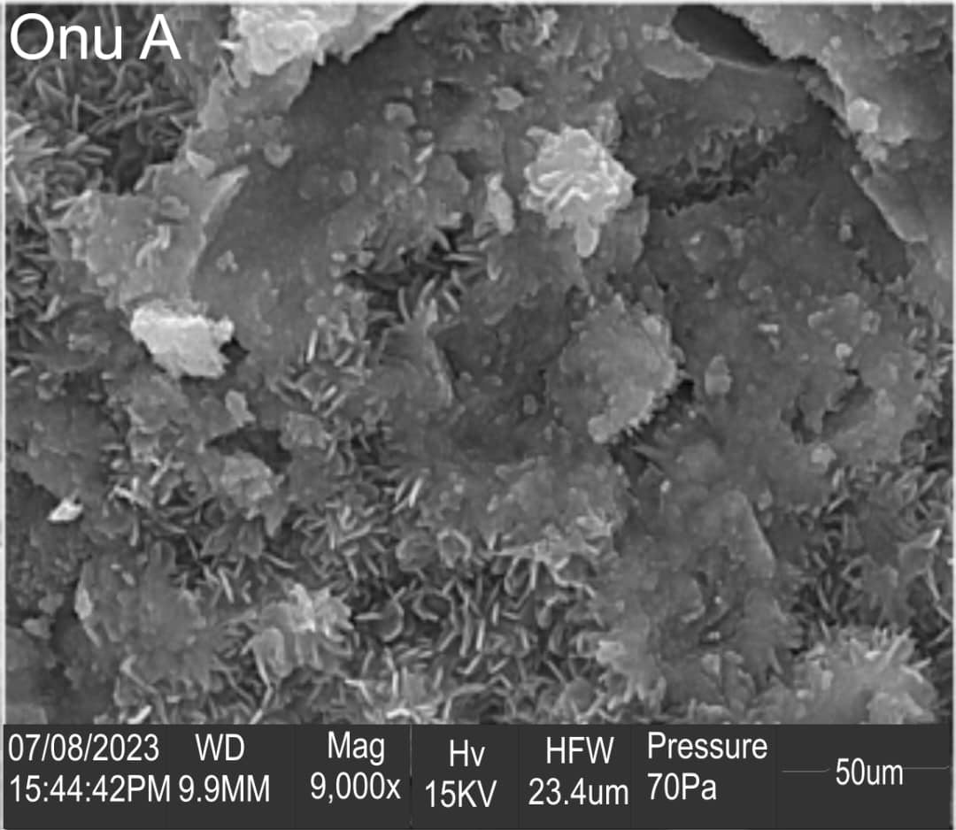

Figure 2. SEM Image of Sphalerite at 9000×

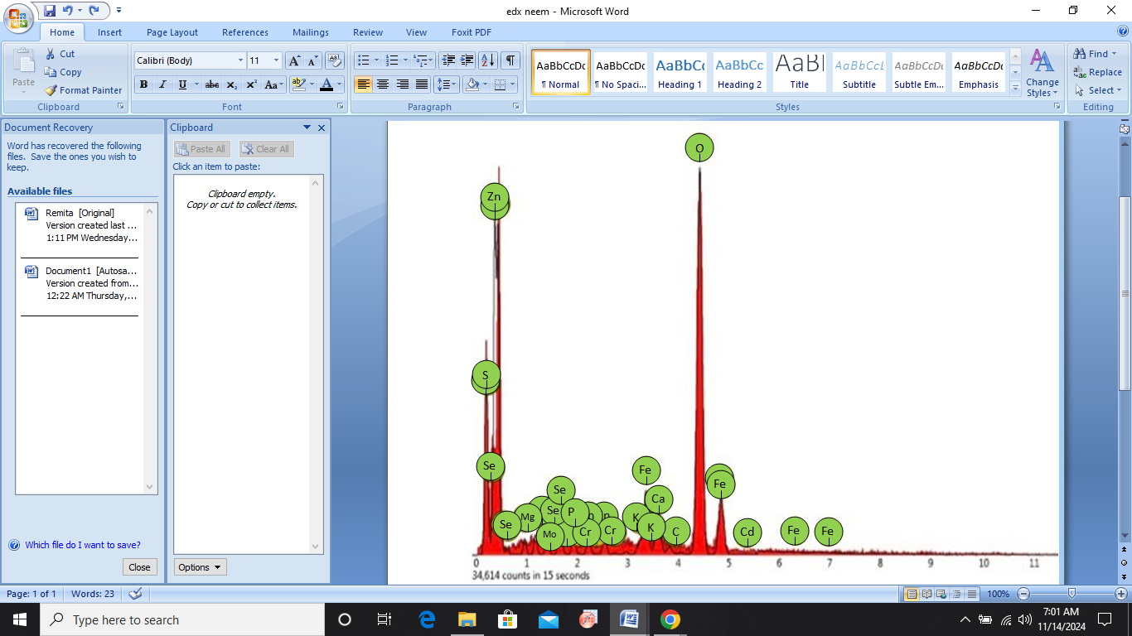

Figure 3. EDX Spectrum of Doped Sphalerite particles with Neem Leave Extract

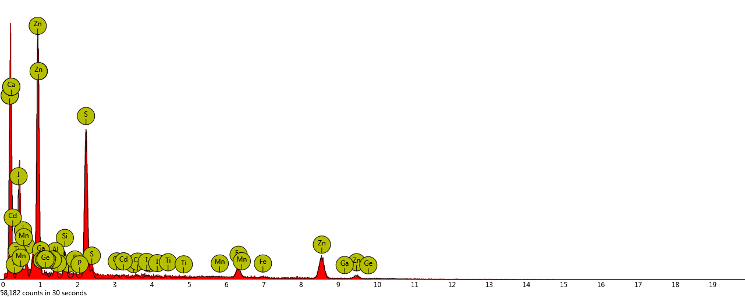

Figure 4. EDX Spectrum of undoped Sphalerite particles

**3.2 Absorption spectra**

The absorption spectrum of the doped Sphalerite particle containing Neem leaf extract can be seen in Figure 5. The sample exhibited a very high absorption value of 75 to 85% at ultraviolet wavelengths comparable to the undoped sphalerite particle in figure 6 which revealed absorbance value of (35 to 50%) at the wavelength of ultraviolet region, making the doped Sphalertite particle a more suitable material for use in optical materials like contact lenses (Kasap 2018). As the wavelength increases, a recurring irregular drop in absorbance was noted, similar trend was also observed for the undoped Sphalerite particle (Ezenwa and Ekpunobi 2011; Onu 2023). Additionally, there was an uneven decrease in the absorbance of the entire sample toward the visible and near-infrared areas for both the doped and the undoped Sphalerite particle. However, at the near-infrared wavelengths, the absorbance value of the doped Sphalerite was nearly zero (within 10% to 1%) compared to the the undoped Sphalerite which was within (10% to 5%). This demonstrated that in the near-infrared spectrum, the doped Sphalerite particles were more non-absorbing compared to the undoped Sphalerite. Similar trend was reported by (Carofiglio et al. (2021), Madkhali (2022) and Khalid et al. 2019).

Figure 5.Absorbance spectrum of the doped Sphalerite

Figure 6.Absorbance spectrum of the undoped Sphalerite

**3.3** **Transmittance spectra**

Figure 7 shows the transmittance spectrum of the doped Sphalerite particle with Neem leaf extract. The samples showed low transmittance value (of 1% to 20%) at the wavelengths of ultraviolet region compared to the undoped Sphalerite in figure 8 which was 31% to 45% , the lower transmittance value obtained from the doped Sphalerite particles makes it a good quality for application in optical material like contact lenses (Ahmet and Gona 2023). Similar trend was observed by (Ozobialu et al.2022). As the wavelength moved from the ultraviolet region to the visible region and then to the near-infrared region the transmittance value became 94% for the doped Sphalerite particle and 88% for the undoped Sphalerite, this implies that the neem leaf extract improved the transmittance value of the Sphalerite particle thereby leading to minimal absorption of light and giving rise to improved optical quality (Layth, 2014). The high transmittance value obtained from the doped Sphalerite particle in the visible region and near infrared region is also beneficial for biomedical applications (David et al. 2011). Also the high transmittance in the visible region indicates the potential easy photon passage and hence the likely applicability of the doped Sphalerite particles in electron transport layers of optical materials (Khalid et. al., 2017).

Figure 7. Transmittance spectrum of the doped Sphalerite

Figure 8. Transmittance spectrum of the undoped Sphalerite

**3.4 Reflectance**

Figure 9 shows the reflectance of the doped Sphalerite particle with Neem leaf extract. The reflectance value was found to be within (2 to 20%) at the ultra violet region and falls within (20 to 6%) at the visible region and reduced from (6 to 2.5%) at the near infrared region. This result is compared to that of the undoped Sphalerite in figure 10, which revealed a reflectance value of 17.1 to 19.9% in the ultra violet region to about 19% to 4.1% in the visible region and 4.1 to 3.9% was observed as it entered the near infrared region. This suggests that the Neem extract improved the reflectance value of the Sphalerite particle. According to Okafor et al., 2022 the visible region and near infrared region often exhibits low reflectance. And the poor reflectance observed throughout the regions of the spectrum suggests the possibility of the materials application in the window layer component of a solar cell. Hence, very low reflectance observed in the doped Sphalerite is highly desired for optical applications and optoelectronics devices such as photo detectors and optical switches (Wanjala et al., 2016; Kasap 2018).

Figure 9.Reflectance of the doped Sphalerite particles

Figure 10.Reflectance of the undoped Sphalerite particles

**3.5 Refractive index**

Figure 11depicted the refractive index of the doped Sphalerite with Neem leaf extract. The refractive index was found to increase from 1.4 to 2.6 when the photon energy increased from 1.66eV to 2.64eV and irregularly dropped down to 1.4 at photon energy of 3.45eV compared to the undoped Sphalerite in figure 12 which was 1.6 to 2.45 as the photon energy increased from 1.38eV to 2.45eV and remained steady throughout the spectrum.. The initial higher refractive index obtained in the doped Sphalerite particle could be as a result of the high absorbance value obtained in the absorbance spectrum. Hence, refractive index is a major physical parameters used to evaluate the quality of nanoparticle-based solids (Hiroshi et al. 2016).

Figure11.Refractive index of the doped Sphalerite particle

Figure 12.Refractive index of the undoped Sphalerite

**3.6 Optical conductivity**

The plot of the optical conductivity of the doped Sphaletite and the undoped Sphalerite against the photon energy was presented in Figure 13 and figure 14. The plot was determined as a function of absorption coefficient and the refractive index of the material (AL-Hammadi and Sadiq 2023). The optical conductivity of both the doped and the undoped Sphalerite experienced an almost linear increase as the photon energy increased from 1.5eV to about 3.9eV. At relatively higher photon energy of above 4.0eV, the increase of the optical conductivity with the photon energy was irregular. However, a higher optical conductivity was observed with the doped Sphalerite particle when comparing the same photon energies of the individual particles. This suggests that the Neem leaf extract enhanced the optical conductivity of the Sphalerite particle. Hence, optical conductivity plays a huge role in evaluating the particle’s atomic structure and connects the current density to the material's exposure to different wavelengths of light in the electric field. It also serves as the basis for determining the spectra of some nanoparticles (Koval, 2022).

Figure 13. The Optical conductivity of the doped Sphalerite particle

Figure 14. The Optical conductivity of the undoped Sphalerite particle

**3.7 Band energy gap**

The band energy gap is the minimum quantity of energy needed to excite an electron to a state where it can conduct in the condition band. It is a major parameter used in the design of optoelectronic instruments (AL-Hammadi and Sadiq 2023). This implies that it is a crucial parameter that directly pertains to the applicability of materials in optical, electrical, and energy applications (Sangtae et al. 2020). Figures 15 and 16 are the plots of plot of (αhν)2 versus photon energy for the doped Sphalerite particles and the undoped Sphalerite particle respectively . The band energy gap was determined by exploiting the tangential line of the plot of (αhν)2 versus photon energy (Faramawy et al. 2022). The band gap of the undoped Sphalerite particle which was 3.63eV agrees with the work done by (Edelbro et. al., 2003; Judy et al., 2014; Simon et al. 2022; Walid et al. 2023). According to Judy et al., 2014 ZnS (Sphalerite) serves as an effective photocatalyst; nevertheless, its excessively large band gap limits its efficiency under sunlight. Consequently, doping emerges as a viable technique to diminish the band gap, thereby enhancing visible-light absorption and photocatalytic activity. Hence, the band gap of the undoped Sphalerite particle was significantly enhanced when doped with Neem leaf extract which reduced the band energy gap of undoped Sphalerite particle which was 3.63eV to 2.52eV. According to Onsate et al., 2023, the noted decrease in the bandgap energy indicates an improvement in the optical properties of the material.

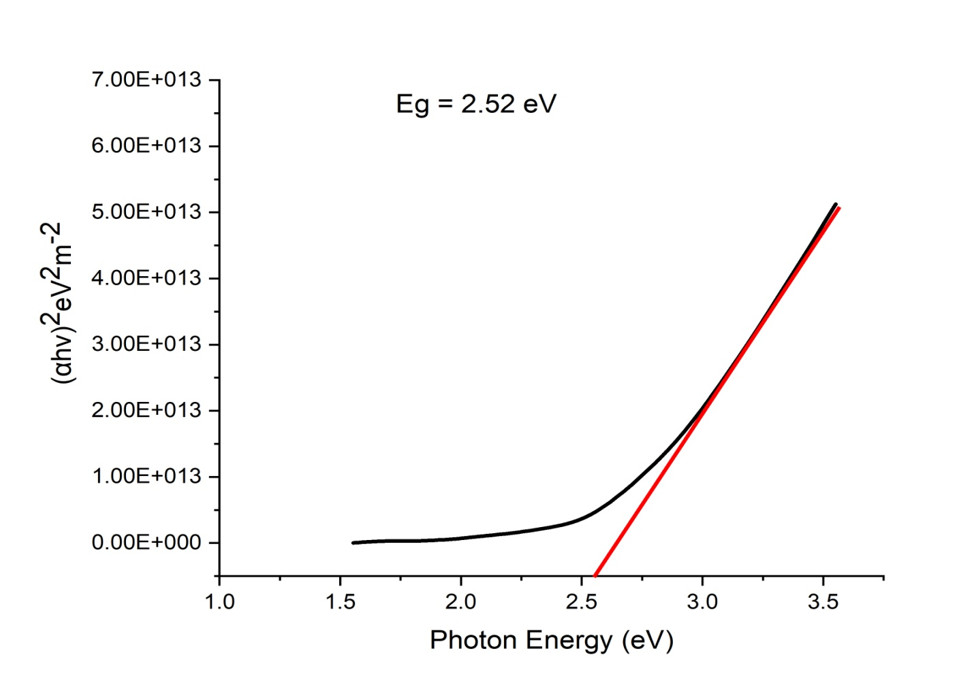

Figure15. Plot of the doped Sphalerite nanoparticle band energy gap

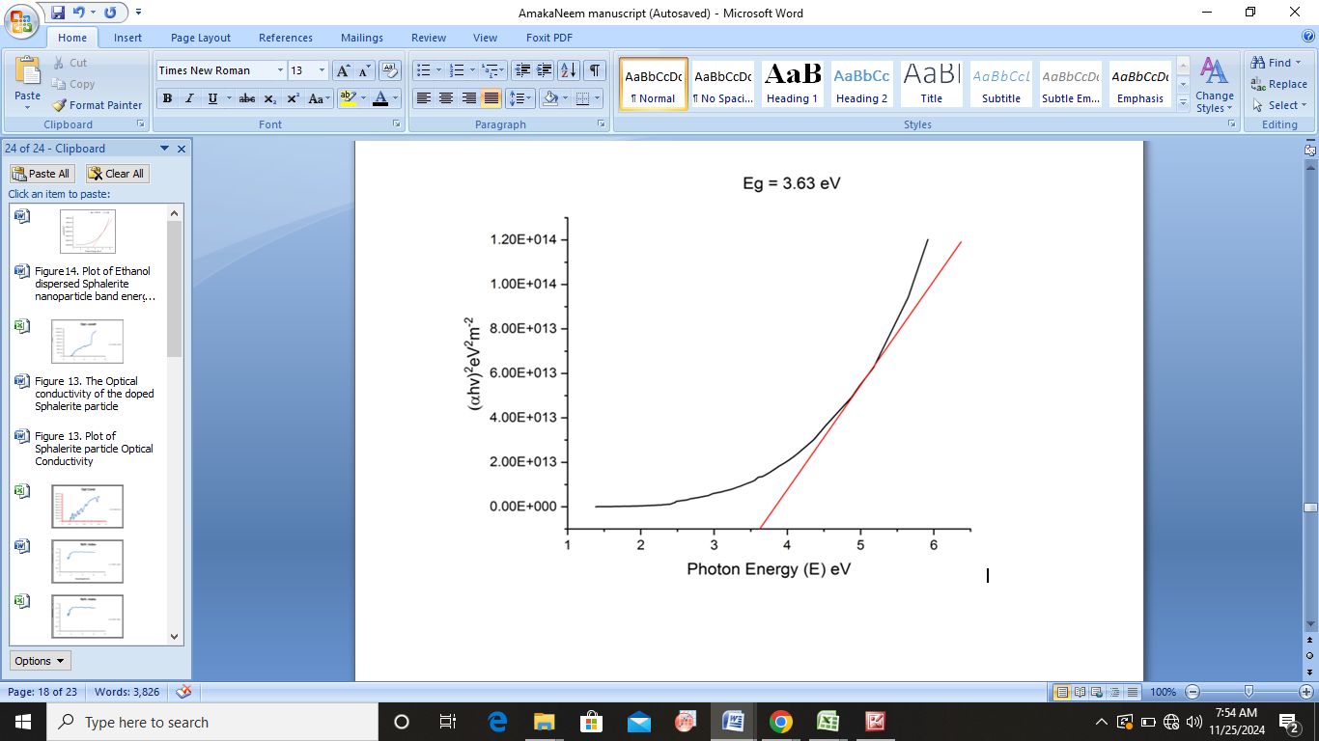

Figure16. Plot of the undoped Sphalerite nanoparticle band energy gap

**4. Conclusion**

Sphalerite (Zns) nano particle were doped with Neem leaf extract. Both the doped Sphalerite nano particle and the undoped Sphalerite nano particle were characterized. The morphological, elemental and optical properties of the nanoparticles were investigated using scanning electron microscopy (SEM), energy dispersed X-ray analysis (EDX), and UV spectrophotometer respectively. The SEM micrograph revealed significant change in the morphological structure of the Sphalerite nanaoparticle from being coarse, densely packed, well-formed flakes with uneven edged crystalline-structured to coarse, dispersed, grain-like crystalline structure after doping with Neem leaf extract. The EDX confirmed the presence of zinc, sulphide, calcium, phosphorous, iron, chromium, and selenium and trace of other elements. UV-Vis spectroscopy showed that the doped Sphalerite exhibited a very high absorption value of 75 to 85% at ultraviolet wavelengths comparable to the undoped sphalerite particle which revealed absorbance value of (35 to 50%) at the wavelength of ultraviolet region, making the doped Sphalertite particle a more suitable material for use in optical materials like contact lenses (Kasap 2018). Also, the doped Sphalerite particle showed low transmittance value (of 1% to 20%) at the wavelengths of ultraviolet region compared to the undoped Sphalerite which was 31% to 45% , the lower transmittance value obtained from the doped Sphalerite particles also makes it a good quality for application in optical material like contact lenses (Ahmet and Gona 2023). Furthermore, the transmittance of both the doped and undoped Sphalerite increased as the spectrum wavelength moved from ultraviolet region to visible region at 94% and 88% respectively at the near-infrared region. The band gap of the undoped Sphalerite particle was significantly enhanced when doped with Neem leaf extract which reduced the band energy gap of undoped Sphalerite particle from 3.63eV to 2.52eV. The noted decrease in the band gap energy indicates an improvement in the optical properties of the material thereby enhancing visible-light absorption, optoelectronic properties and photocatalytic activity (Onsate et al. 2023).

**Reference**

Ahmet B., Gonca A., (2023) Measurement of Ultraviolet Light Transmittance of Different Contact Lens Types. Turkish Journal of Science & Technology Research Paper 18(2), 379-378, <https://doi.org/10.55525/tjst.1314368>

## Al-Hammadi A. H., and Sadiq H. K., (2023) Investigations on Optical and Electrical Conductivity of Ba/Ni/Zn/Fe16O27 Ferrite Nanoparticles. Biointerface Research in Applied Chemistry. 13 (2) 168 https://doi.org/10.33263/BRIAC132.168.

Ali R., Hadia N., Saira R., and Shahzad N., (2023) Modifying the Optical Properties of ZnS for Optoelectronic Applications. Eng.Proc. 2023, 32(1), 18;  <https://doi.org/10.3390/engproc2023032018>

Ali, S. G., Ansari, M. A., Jamal, Q. M. S., Almatroudi, A., Alzohairy, M. A., Alomary, M. N., et al. (2021). Butea Monosperma Seed Extract Mediated Biosynthesis of ZnO NPs and Their Antibacterial, Antibiofilm and Anti-Quorum Sensing Potentialities. Arabian J. Chem. 14 (4), 103044. doi:10.1016/j.arabjc.2021.103044s

Alireza A., Hosein K., (2019) Al-doped ZnS thin films: Physical and electrochemical characterizations. Elsevier, Journal of alloy and compounds, Volume 779, pp 301 – 313, https://doi.org/10.1016/j.jallcom.2018.11.268

Amit K.M., Yusuf C., Uttam C.B., (2013) Synthesis of metallic nanoparticles using plant extracts. Elsevier, Biotechnological advances, [Volume 31, Issue 2](https://www.sciencedirect.com/journal/biotechnology-advances/vol/31/issue/2), Pages 346-356 <https://doi.org/10.1016/j.biotechadv.2013.01.003>

Amrutha S. A., and Hebsur N. S., (2020) Green Synthesis of Zinc Oxide Nanoparticles using Neem (Azadirachta indica) and Tulasi (Ocimum tenuiflorum) Leaf Extract and their Characterization. International Journal of Current Microbiology and Applied Sciences ISSN: 2319-7706, Volume 9, <https://doi.org/10.20546/ijcmas.2020.902.035>

Anu D., Suresh K., Hardeep S.T., Anil K.S., Vandana S., Jatinder K.S., (2021) In‑doped ZnS nanoparticles: structural, morphological, optical and antibacterial properties. Springer, Material science and Processing, Applied Physics A, 127:26 <https://doi.org/10.1007/s00339-021-04425-9>

[Anusuya M](https://pubmed.ncbi.nlm.nih.gov/?term=Mariappan+A&cauthor_id=38530961)., [Leelavathi H](https://pubmed.ncbi.nlm.nih.gov/?term=Harikrishnan+L&cauthor_id=38530961)., [Jayanthi E](https://pubmed.ncbi.nlm.nih.gov/?term=Eswaran+J&cauthor_id=38530961)., [Nagaveni A](https://pubmed.ncbi.nlm.nih.gov/?term=Arumugham+N&cauthor_id=38530961)., [Yogeswari B](https://pubmed.ncbi.nlm.nih.gov/?term=Balasubramaniam+Y&cauthor_id=38530961)., [Santhanaraj D](https://pubmed.ncbi.nlm.nih.gov/?term=Daniel+S&cauthor_id=38530961)., [Rajakumar K](https://pubmed.ncbi.nlm.nih.gov/?term=Kanthapazham+R&cauthor_id=38530961)., (2024) Green Synthesis of Metal-Doped ZnO Nanoparticles Using Bauhinia racemosa Lam. Extract and Evaluation of Their Photocatalysis and Biomedical Applications. Journal of Applied Bio – Materitals,7(4):2519-2532DOI: [10.1021/acsabm.4c00132](https://doi.org/10.1021/acsabm.4c00132)

Banerjee P., Satapathy M., Mukhopahayay A., Das P., (2014), Leaf extract mediated green synthesis of silver nanoparticles from widely available Indian plants: synthesis, characterization, antimicrobial property and toxicity analysis. Bioresources and Bioprocessing. 1: 1-10.

Bisauriya R., Verma D., Goswami Y., (2017), Optical important ZnS semiconductor nanoparticles synthesized using organic waste banana peel extract and their characterization. J. Mater. Sci: Mater. Electron. 29: 1868– 1876, https://doi.org/10.1016/j.matpr.2023.02.113.

Breda N., Tea Z., Janez Š., Radmila M., (2015)Content of trace elements and chromium speciation in Neem powder and tea infusions. Elsevier, Chemical Physics, Volume 31, Pg 36 – 106. https://doi.org/10.1016/j.jtemb.2015.04.003

Carofiglio, M., Laurenti, M., Vighetto, V., Racca, L., Barui, S., Garino, N., Gerbaldo, R., Laviano, F., and Cauda, V., (2021). Iron-Doped ZnO Nanoparticles as Multifunctional Nanoplatforms for Theranostics. Nanomaterials 11, 2628. https://doi.org/10.3390/nano11102628.

Chandra T. S., Zubko M., Kusz J., Bhattacharjee A., Structural, morphological and optical characterization of green synthesized ZnS nanoparticles using Azadirachta Indica (Neem) leaf extract (2020). Int. J. Nano Dimens., ; 11 (2): 99-111., <http://hdl.handle.net/20.500.12128/17713>.

Chonsut T, Rangkasikorn A, Wirunchit S, Kaewprajak A, Kumnorkaew P, Kayunkid N and Nukeaw J (2017) Rapid convective deposition; an alternative method to prepare organic thin film in scale of nanometer Materials Today: Proceedings 4 6134-9

David A.B., Constantinos P., and Nimmi R. (2011), Handbook of Biomedical Optics CRC Press, Taylor and Francis Group, Boca Raton, London, New York, 2011 ISBN: 978-1-4200-9036-9 (Hardback), 787 pages

Dengo, N., Vittadini, A., Natile, M. M., and Gross, S. (2020). In-depth study of ZnS nanoparticle surface properties with a combined experimental and theoretical approach. *The Journal of Physical Chemistry C*, *124*(14), 7777-7789.

Ezenwa I.A, Ekpunobi A. J. (2011) Optical properties and band offsets of cds/zns super lattice deposited by chemical bath. Journal of Non-Oxide Glasses 3 (3), 77-87

Faramawy, A., Elsayed, H., Scian, C., and Mattei, G., (2022). Structural, Optical, Magnetic and Electrical Properties of Sputtered ZnO and ZnO:Fe Thin Films: The Role of Deposition Power. Ceramics, 5, 1128–1153. <https://doi.org/10.3390/ceramics5040080>.

Gan I.N., Vincent O., Akpan U.G, Ijeoma A., Synthesis and characterization of Neem based zinc oxide photocatalyst (2021) 36(1): 9 – 15. DOI: 10.51975/LNDP7232

Ganesh C.P., (2023) Doctor Blade: A Promising Technique for Thin Film Coating. Springer, Pp 509 – 530, https://link.springer.com/chapter/10.1007/978-981-99-0961-2_12#

Gomathi M.R., Kuppusamy K. A., Sridhar T.M., (2023) Preparation of metal doped nanoparticles using flower extract of Piper betle and its anti-bacterial investigations. MaterialToday: Processings.<https://doi.org/10.1016/j.matpr.2023.02.113>

Granados J.A., Reyez M,P., Teja A.M., Palacois E.G., Perez M.L., Barrientos F.R., Juarez J.C., and Cobos J.A., (2020). Characterization by FTIR of Sphalerite obtained in the floatation without collector in the presence of Ferric Iron. The Minerals, Metals and Material Society. DOI : http//doi.org/10.007/978-3-030-36628-5_44.

Guoqi J., Wenchao Z., Junfeng W., Lingpeng Y., Yunfei H., Qun L., Shangfeng Y., Jianhui H., and Chang-Q. M., (2019) 12.88% efficiency in doctor-blade coated organic solar cells through optimizing the surface morphology of a ZnO cathode buffer layer. [J. Mater. Chem. A](https://doi.org/10.1039/2050-7496/2013), 19, 7, 212-220, DOI: [10.1039/C8TA08873J](https://doi.org/10.1039/C8TA08873J)

Hiroshi K., Ayumu I., Katja O., Ilpo N., (2016) Refractive index measurement of nanoparticles by immersion refractometry based on a surface plasmon resonance sensor. [Chemical Physics Letters](https://www.sciencedirect.com/journal/chemical-physics-letters), (654, 72-75. <https://doi.org/10.1016/j.cplett.2016.05.013>

Jie S, Quanjun L, Jingshen D, Subhonqulov S.H., Yalong G, Meilin L (2022) Mechanism of germanium doping in Sphalerite on copper ion activation: A DFT study. Elsevier, [Volume 562](https://www.sciencedirect.com/journal/chemical-physics/vol/562/suppl/C), <https://doi.org/10.1016/j.chemphys.2022.111667>.

Judy N.H., Michele C., Neil L. A., (2014) Band gap modification of ZnO and ZnS through solid solution formation for applications in photocatalysis. Energy Procedia 60 ( 2014 ) 32 – 36, https://doi.org/10.1016/j.egypro.2014.12.338

Kang, X., Yirong, X., Xuyang, C., Hao, X., and Yufang, L.,  (2022). Advanced characterization of membrane surface fouling. Principles, New Materials, Modelling, Characterization, and Applications 499-532. <https://doi.org/10.1016/B978-0-323-89977-2.00022-1>.

Khalid N.R., Hammad A., Tahir M.B., Rafique M., Iqbal, T., Nabi, G., and Hussain M.K., (2019) Enhanced photocatalytic activity of Al and Fe co-doped ZnOnanorods for methylene blue degradation. Ceramics International (45) 21430–21435, https://doi.org/10.1016/j.ceramint.2019.07.132.

Koval, A. O. (2022) Optical Conductivity of Spherical Metal Nanoparticles Taking into Account the Size Dependence of the Fermi Energy. Journal of nano and electronic physics. 14 (2) doi: 10.21272/jnep.14(2).02013

Krsmanović W. R.M.,Jovanović D.J., AntićŽ., Bártová  B., MilivojevićD.,Dramićanin M.D, Brik M.G., (2014)Structural, optical and crystal field analyses of undoped and Mn2+-doped ZnS nanoparticles synthesized via reverse micelle route. Elsevier, Volume 146, https://doi.org/10.1016/j.jlumin.2013.09.032

[Kumari, R.,](https://ui.adsabs.harvard.edu/search/q=author:%22Kumari%2C+Reshu%22&sort=date%20desc,%20bibcode%20desc) [Dwivedi, A.,](https://ui.adsabs.harvard.edu/search/q=author:%22Dwivedi%2C+Abhishek%22&sort=date%20desc,%20bibcode%20desc) Kumar, R., [Gundawar, M. K.,](https://ui.adsabs.harvard.edu/search/q=author:%22Gundawar%2C+Manoj+Kumar%22&sort=date%20desc,%20bibcode%20desc); Rai, A. K., (2023) Optical characterization of Azadirachta Indica (Neem) leaves using spectroscopic techniques. Journal of Optics, Volume 52, Issue 2, pp. 548-563. DOI: [10.1007/s12596-022-01020](https://ui.adsabs.harvard.edu/link_gateway/2023JOpt...52..548K/doi:10.1007/s12596-022-01020-w)

Layth, M.A., (2014) Study the Effect of Annealing on Optical and Electrical Properties of ZnS Thin Film Prepared by CO2 Laser Deposition Technique. Iraqi J. Laser, (13), pp. 29-35.

Madkhali, N., (2022). Analysis of Structural, Optical, and Magnetic Properties of (Fe,Co) Co-Doped ZnO Nanoparticles Synthesized under UV Light. Condens. Matter, 7, 63.  
https://doi.org/10.3390/condmat7040063.

Maria N., Mubushra U., Sunaina R., Malika R., (2020) Optical Properties of ZnS and Effect of Doping with Transition Elements*.* Journal of Nanoscope, DOI: 10.13140/RG.2.218536.29444

Mohammad A.A (2016) Therapeutics Role of Azadirachta indica (Neem) and Their Active Constituents in Diseases Prevention and Treatment. Evid Based Complement Alternat Med. doi: [10.1155/2016/7382506](https://doi.org/10.1155/2016/7382506)

Nikolay D. T., Alexander L. T., Boris R. T., Olga N. F., Polina V. E., Dmitriy A. C., Kristina O. K., and Maximilian S. N., (2020) The State of Trace Elements (In, Cu, Ag) in Sphalerite Studied by X-Ray Absorption Spectroscopy of Synthetic Minerals. Minerals, 10(7), 640; <https://doi.org/10.3390/min10070640>

Nurul H. K., Hasiah S. , Ahmad N. D., Mohd S. M. G. , Nurhayati I., Zakiyah A., (2020) Optimization of Titanium Dioxide Layer Fabrication Using Doctor Blade Method in Improving Efficiency of Hybrid Solar Cells. Journal of Physics: Conference Series , doi:10.1088/1742-6596/1535/1/012025

Okafor C. E., Okoli N. D., Imosobomeh L. I. (2022) Effect of Doping and Co-sensitization on the Photovoltaic Properties of Natural Dye-sensitized Solar Cells. SSRG International Journal of Applied Physics 9 (3), 44-54, https://doi.org/10.14445/23500301/IJAP-V9I3P105

Onsate, W. N., Mugwang’a, F. K., and Karanja, J. M. (2023). Effect of Blending Baobab and Neem Leaves Extract on Optical Band Gap Energy for Solar Cell Applications. European Journal of Applied Sciences, Vol - 11(6). 395-402. DOI:10.14738/aivp.116.16021

Onu, C. P (2023). Processing and Characterization of Sphalerite and Monazite Nanoparticles using Ball milling technique ( Unpublished thesis).

Onu, C. P., Ekpunobi, A. J.,Okafor, C. E., Ozobialu, L. A., (2023) Optical Properties of Monazite Nanoparticles Prepared Via Ball Milling. Asian Journal of Research and Reviews in Physics 7(4) 17-29, 2023;. DOI: 10.9734/AJR2P/2023/v7i4146

Ozobialu, L. A., A. J. Ekpunobi, D. M. Jeroh (2022) Effect of Time on the Optical and Structural Properties of Tin Oxide Thin Films as an Electron Transport Layer for Perovskite Solar Cell. SSRG International Journal of Applied Physics 9 (3), 37-43. https://doi.org/10.14445/23500301/IJAP-V9I3P104

Reshmi A. P., Philominal A., (2022) Green Synthesis of Pure and Silver Doped Copper Oxide Nanoparticles using Moringa Oleifera Leaf Extract. Elsevier, Volume 13, <https://doi.org/10.1016/j.mlblux.2022.100122>

Reshu K., Abhishek D., Rohit k., Manoj K. G., (2022) Optical characterization of Azadirachta Indica (Neem) leaves using spectroscopic techniques. Journal of Optics, DOI: [10.1007/s12596-022-01020-w](http://dx.doi.org/10.1007/s12596-022-01020-w)

Sangtae Kim., Miso L., Changho H., Youngchae Y., Hyungmin A., Dongheon L., Wonseok J., Dongsun Y., Youngho K., Yong Y., and Seungwu H., (2020) band-gap database for semiconducting inorganic materials calculated with hybrid functional. Springer nature, Data science, https://doi.org/10.1038/s41597-020-00723-8.

Shrirangasami S.R., Murugaragavan R., Rakesh S. S., Ramesh P.T. (2020) Chemistry behind in neem (Azadirachta indica) as medicinal value to living forms-A review. Journal of Pharmacognosy and Phytochemistry 9(6):467-469 DOI: 10.22271/phyto.2020.v9.i6g.12936

Siew-L. L., En-C. C. b., Chun-Y. C. b., Kok-H. O., Zhi-K. C., Hsin-F. M., (2012) High performance organic photovoltaic cells with blade-coated active layers. Elsevier, Solar Energy Materials & Solar Cells, [Volume 107](https://www.sciencedirect.com/journal/solar-energy-materials-and-solar-cells/vol/107/suppl/C), Pages 292-297, <https://doi.org/10.1016/j.solmat.2012.06.049>

Simon K. O, Azubuike J.E, Imosobomeh L.I (2022) Synthesis and characterization of ZnS, Nanoparticle by Ball Milling Technique.SSRG international journal of Material Science and Engineering Volume 8 Issue 3,6 – 13. ISSN: 2394 – 8884. DOI: 10.14445/2398884/IJMSE-V8I3P102

Soonil H., Byoungwook P., Chandran B., Jinho L., Sooncheol K., (2023) Impact of solvents on doctor blade coatings and bathocuproine cathode interlayer for large-area organic solar cell modules. Elsevier, [Volume 9, Issue 7](https://www.sciencedirect.com/journal/heliyon/vol/9/issue/7), <https://doi.org/10.1016/j.heliyon.2023.e18209>

Syed S.S., Falak N., Muhammad A. E., Himadri T.D., Muhammad Y., Amir S. K., Haroon U.R., Abu N.S.M., Munetaka O., Abdul A.M., (2024) Advanced strategies in electrode engineering and nanomaterial modifications for supercapacitor performance enhancement: A comprehensive review

Vindhya P S., Kavitha V. T., (2022) Leaf extract-mediated synthesis of Mn-doped CuO nanoparticles for antimicrobial, antioxidant and photocatalytic applications. Chemical Papers, DOI:10.1007/s11696-022-022631-0

Walid T.M., Hajar A., Pawan F., Eshan S., Mahin N., Majid R. A., Nooshin H., Siavash I., Abduladheem T.J., Marwan M.S., Amirhossein F., Mehrdad K., (2023) Plant-mediated synthesis of sphalerite (ZnS) quantum dots, Th1-Th2 genes expression and their biomedical applications. Elsevier, Volume 155,https://doi.org/10.1016/j.sajb.2023.01.041

Wanjala, K. S., Njoroge, W. K., and Ngaruiya, J. M. (2016). Optical and electrical characterization of ZnS: Sn thin films for solar cell application. Int. J. Energy Enginneering, 6(1).

Yehao D., Qi W., Yongbo Y., Jindong H., (2015) Vivid Colorful Hybrid Perovskite Solar Cells by Doctor-Blade Coating with Perovskite Photonic Nanostructures. Material Horizion 2 (6).DOI: 10.1039/C5MH00126A