Original Research Article

RESEARCH ON THE IMPACT OF INERT AND HYDRAULIC ADDITIVES ON SELF-COMPACTING CONCRETE UTILIZING BRICK AGGREGATE.

# ABSTRACT

Self-compacting concrete (SSC) is a novel concrete capable of flowing under its own weight without the need for concrete vibration, capable of achieving full compaction and filling the formwork despite the presence of packed reinforcement. Ongoing research is focused on substituting different components of concrete to develop stronger and more cost-effective alternatives. This study explores the replacement of natural stones with brick aggregate, while also partially substituting ordinary Portland cement (OPC) with stone dust and low-grade recycled fines (LRF), which are byproducts from the steel manufacturing industry. The coarse aggregate utilized in this research was derived from high-quality, readily available GAS-burned brick. The fineness of the coarse aggregate was assessed using ASTM C136 (2019), a widely recognized testing method. The ASTM C127 (2015) standard testing procedure was employed to determine the absorption capacity of the coarse aggregate. A feasibility study was carried out to assess the production of self-compacting concrete (SCC) utilizing brick aggregate. The incorporation of marble dust consistently improves workability, particularly at the 10% level, which aids in the handling and placement of SCC while meeting EFNARC criteria for self-compacting characteristics. Low-grade recycled fines (LRF) contributes to an increase in flowability and workability to a moderate extent when used at 5% to 10%. Marble dust proves to be a more effective option for enhancing the modulus of elasticity in SCC, as evidenced by the reduction in modulus of elasticity across all levels of LRF replacement.

**Keywords:** *SSC, LRFS, construction industry, high-rise buildings, mineral admixtures,*

*environmental contamination, sustainable alternatives*

# INTRODUCTION

Self-compacting concrete (SCC) is defined as concrete that can flow and fill formwork solely under its own weight, without the need for mechanical vibration or consolidation (Zaidi et al., 2022). This innovative approach to concrete construction has gained popularity due to its improved working conditions and the enhancement of concrete quality. For concrete to achieve greater strength and longevity, it is essential to minimize porosity, prevent honeycombing, and eliminate segregation. The production of high-quality concrete necessitates effective placement of fresh material, which relies on proper vibration and compaction techniques. The presence of densely packed reinforcement can complicate the placement of concrete. SCC effectively addresses these challenges by facilitating accurate placement, compaction, and vibration. The development of SCC began in Japan in 1980, and it was first implemented in Swedish transportation infrastructure during the mid-1990s. Self-compacting concrete (SCC) is composed of coarse and fine aggregates, cement, admixtures, water, and additional materials. The incorporation of powder, which includes fillers and other cementitious substances, can enhance the volumetric and deformable properties of the paste, thereby improving its stability and cohesion. Additionally, aggregates, which constitute over 60% of the concrete's volume, play a crucial role in determining both the mechanical and fresh properties of the concrete. It is essential to meticulously evaluate the shape, texture, maximum size, and grading of the aggregates prior to their use in SCC, as these characteristics are particularly sensitive to variations in SCC. Ongoing research is focused on substituting different components of concrete to develop stronger and more cost-effective alternatives. The depletion of natural stone resources is a growing concern due to societal infrastructure expansion. This study explores the replacement of natural stones with brick aggregate, while also partially substituting ordinary Portland cement (OPC) with stone dust and low-grade recycled fines (LRF), which are byproducts from the steel manufacturing industry.

___________________________________

**PROBLEM STATEMENTS**

The rapid growth of structural activities in Nepal is notable. This situation has led to a scarcity of natural stone and an urgent requirement to meet existing demand. In this context, crushed bricks are commonly employed as an alternative to natural stone aggregate. Brick aggregates are generally more cost-effective than stone aggregates in the local market. Ensuring the proper placement and compaction of concrete is essential for enhancing the expected mechanical properties. In our country, there is a lack of skilled labor, and the expenses associated with skilled workers are considerable. Even with experienced personnel and appropriate tools, achieving correct compaction and placement can sometimes be challenging. Self-Consolidating Concrete (SCC) presents a viable solution to mitigate this issue. SCC utilizing brick aggregate can serve as an effective construction material to tackle these challenges, and it is imperative to leverage these innovative materials to gain their advantages.

Additionally, waste generated from steel industries, known as Ladle Refining Furnace (LRF) slag, is utilized as an additive to decrease the excessive consumption of natural resources by the construction sector. Once regarded as waste, slag was typically disposed of in landfills adjacent to industrial sites. However, in many developed nations, including the United States, Japan, Germany, and France, slag is fully utilized. It replaces various products, such as concrete aggregates, asphalt, fertilizers, and roofing aggregates.

Moreover, the process of crushing and grinding rocks for construction and other industries produces a byproduct known as stone dust. This byproduct poses risks to the environment, human health, and air quality. Utilizing stone dust for alternative applications, such as in concrete or as a base material for roads, can help reduce waste in construction. Researchers have explored the use of various aggregates and waste materials, including dust or other waste products, as substitutes for cement to investigate the properties of Self-Consolidating Concrete (SCC).

## METHODOLOGY

The selection of materials with fewer emissions and environmental sustainability is aided by quality control. The following methodology is included in this research program, step-by-step:

* Selection and gathering of the materials
* Material preparations
* Assessing the physical and chemical qualities
* Designing and balancing the materials for trial mixes
* Assessing the fresh properties of SCC
  + - Slump flow
    - T50 slump flow time
    - V- funnel test
    - L- box test
* The cylindrical specimen's preparation (Ø 100 mm × 200 mm)
* Assessing the mechanical properties of strengthened SCC
  + - Compressive Strength (fʹc)
    - Splitting Tensile Strength (fsp)
    - Modulus of Elasticity (Ec).
* Analysis of the results and conclusions.

All testing procedures employed in this study program adhered to established standards and guidelines.

## MATERIALS

The coarse aggregate utilized in this research was derived from high-quality, readily available GAS-burned brick. The components employed in the formulation of the concrete included potable water, easily obtainable coarse sand as the fine aggregate, Ordinary Portland Cement (OPC) as the binding agent, and a chemical additive that serves as a water-reducing agent. A laboratory analysis was conducted to assess the properties of each of these materials, all of which were locally sourced, to determine the parametric requirements for Self-Compacting Concrete (SCC).

**Gradation:** The fineness of the coarse aggregate was assessed using ASTM C136 (2019), a widely recognized testing method. A mechanical sieve shaker was employed for a duration of fifteen minutes to classify the aggregate through a series of sieves, specifically sized at 16, 8, 4, 3/8 inch, ¾ inch, 50, 30, 16, 8, and 1.5 inches.

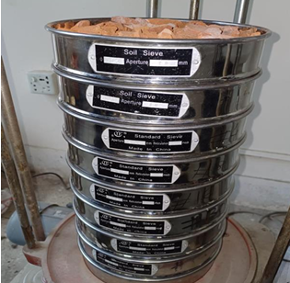

Figure 1: Sieve analysis of coarse aggregate

Table 1: Gradation of Coarse Aggregate

|  |  |  |  |  |  |
| --- | --- | --- | --- | --- | --- |
| **Sieve Size (mm)** | **Individual Weight Retained (gm)** | **Cumulative Weight Retained (gm)** | **% Cumulative Weight Retained** | **% Finer** | **Fineness Modulus (FM)** |
| 75 | 0 | 0 | 0 | 100 | 6.83 |
| 38 | 0 | 0 | 0 | 100 |
| 19 | 214.7 | 21.47 | 21.47 | 78.53 |
| 9.5 | 531.1 | 53.11 | 74.58 | 25.42 |
| 4.75 | 176.6 | 17.66 | 92.24 | 7.76 |
| 2.36 | 62.3 | 6.23 | 98.47 | 1.53 |
| 1.18 | 4.1 | 0.41 | 98.88 | 1.12 |
| 0.6 | 0.8 | 0.08 | 98.96 | 1.04 |
| 0.3 | 0.4 | 0.04 | 99.00 | 1.00 |
| 0.15 | 0.6 | 0.06 | 99.06 | 0.94 |
| Pan | 0.00 |  |  |  |
| Total | 1436.30 |  | 682.66 |  |  |

**Tests for Coarse Aggregate:** Particles exceeding 4.75 mm are classified as "coarse aggregates." The standard diameter range for these aggregates is between 4.75 mm and 19 mm. They serve to improve the material's strength, ensure even load distribution, and occupy space within the concrete without compromising its integrity.

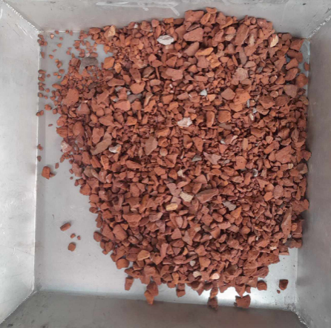

Figure 2: Preparation of coarse aggregate

**Unit Weight:** In various processes, it is essential to select the proportions for the concrete mixture based on the unit weight of the coarse aggregates. This method can also be utilized to determine the mass-to-volume relationship of the aggregates. This testing procedure adheres to the ASTM C 29 (2017) standard specification, which outlines the requirements for measuring the unit weight of coarse aggregates. Aggregate computation,

Dry bulk density, M = $\frac{G-T}{V}$

Here,

G = Measure plus aggregate mass

T = Mass of the measure

V = Volume of the measure

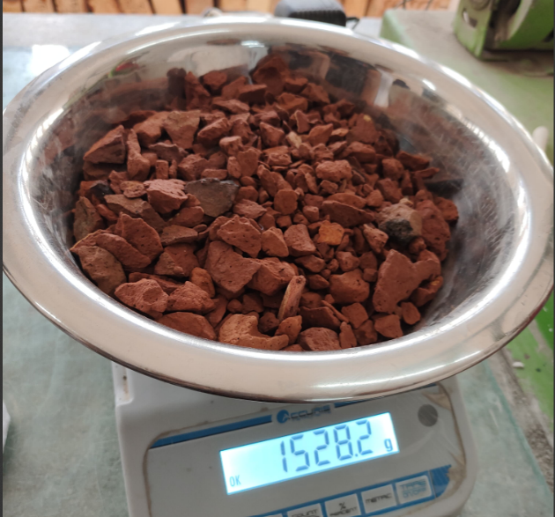

Figure 3: Unit weight analysis of coarse aggregate.

**Absorption Capacity:**The ASTM C127 (2015) standard testing procedure was employed to determine the absorption capacity of the coarse aggregate. A summary of the absorption capacities of the coarse aggregates can be found in Table 1 of Chapter IV. The appendix includes the calculations related to this test. The absorption capacity is represented as.

Percentage of absorption capacity = $\frac{B-A}{A}*100$

Here,

A = Oven dry test sample weight in the air

B = Saturated surface dry test sample weight in air

Figure 4: Water absorption capacity analysis of coarse aggregate

**Bulk Specific Gravity:** This testing procedure adheres to the ASTM C 127 (2015) standard specification. Chapter IV provides a compilation of specific gravity values for coarse aggregates. Additionally, the appendix includes the calculations relevant to this test. The bulk specific gravity is determined as follows. Bulk specific gravity (SSD basis) = $\frac{B}{B-C}$

Here,

B = Weight of SSD test sample in air

C = Weight of saturated test sample in air

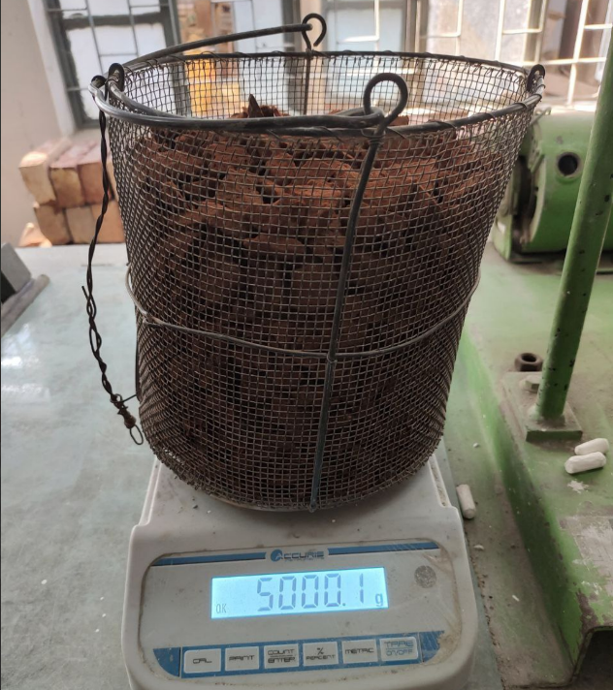 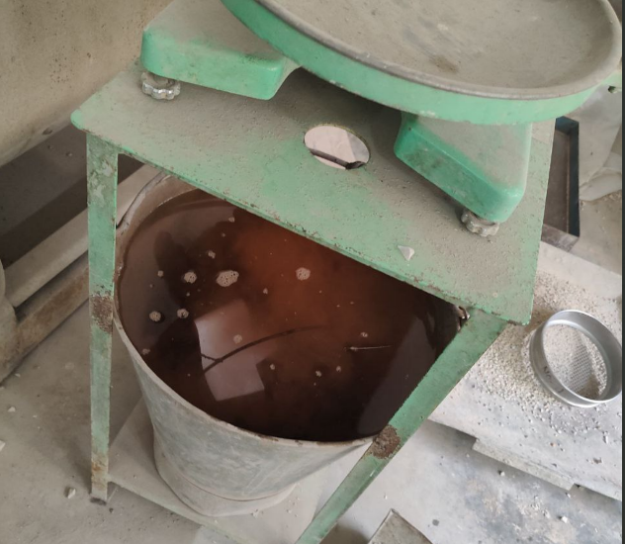

Figure.5 Bulk specific gravity analysis of coarse aggregate

**Tests for Fine Aggregate**: Fine aggregate is defined as any material that can pass through a No. 4 sieve. River sand, a specific type of fine aggregate, is in river streams and along riverbanks, and it is created through the erosion caused by water currents.

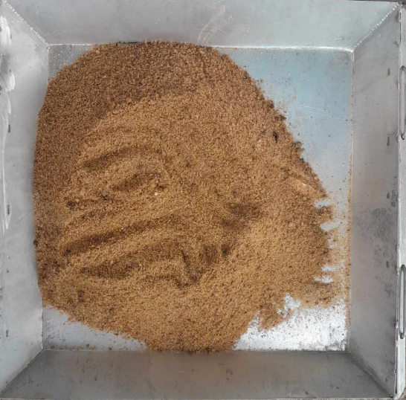

Figure 6: Preparation of fine aggregate

**Fineness Modulus**: The ASTM C136 specification requires that the fineness modulus (FM) of river sand be maintained within the range of 2.3 to 3.2. This range is essential for effectively filling the voids between coarse aggregates, thereby facilitating the workability of high-strength concrete. To evaluate the fineness of the sand, standard sieve sizes including No. 4, No. 8, No. 16, as well as Nos. 30, 50, and 100 were employed. Furthermore, the calculation for fine aggregate is presented below.

FM = $\frac{( sum of cummulative weight of retained )}{100}$



Figure 7: Sieve analysis of fine aggregate

Table 2: Fineness Modulus of Fine Aggregate

|  |  |  |  |  |  |
| --- | --- | --- | --- | --- | --- |
| **Sieve Size (mm)** | **Individual Weight Retained (gm)** | **Cumulative Weight Retained (gm)** | **% Cumulative Weight Retained** | **% Finer** | **Fineness Modulus (FM)** |
| 4.75 | 9 | 9 | 1.02 | 98.984 | 2.912 |
| 2.36 | 38.9 | 47.9 | 5.40 | 94.594 |
| 1.18 | 132.8 | 180.7 | 20.39 | 79.605 |
| 0.6 | 477.7 | 658.4 | 74.31 | 25.688 |
| 0.3 | 140 | 798.4 | 90.11 | 9.887 |
| 0.15 | 87.6 | 886 | 100.00 | 0.85 |
| Pan | 0 |  |  |  |
| Total | 886 |  | 291.23 |  |  |

**Tests for Cement:** The duration for which cement remains workable when incorporated into a concrete mixture is referred to as its setting time. The assessment of normal consistency and setting times was conducted utilizing the Vicat apparatus, following the testing protocols established by the ASTM specifications C187 (ASTM C187, 2016) and C191 (ASTM C191, 2019), respectively.

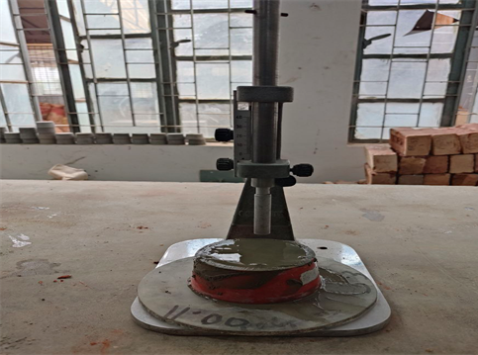 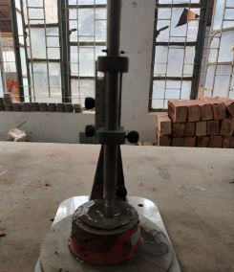

Figure 8: Setting time of OPC

**Water:** Contaminants present in water can negatively impact the setting time, strength, and durability of concrete. To achieve optimal results, it is essential to use clean water that is devoid of harmful concentrations of oils, alkalis, salts, organic substances, or other impurities in the concrete mixing process. In this research, potable tap water was employed in the concrete mixture. According to established regulations and standards, the typical water-cement ratio ranges from 0.4 to 0.45. For this study, a water-cement ratio of 0.45 by weight has been adopted, while ensuring that all other materials are maintained in a saturated surface dry (SSD) condition.

**Superplasticizer:** High-range water reducers, commonly referred to as superplasticizers (SP), serve as additives that enhance the strength of concrete. These plasticizers are chemical agents that enable the formulation of concrete with approximately 15% less water. The incorporation of supplementary cementitious materials is recognized for the numerous advancements in concrete composites it facilitates, as well as for its economic benefits (Hiroshi Uchikawa, 1995). When compared to concrete composed solely of cement, the inclusion of these mineral admixtures can improve the fluidity of the concrete and diminish the requirement for superplasticizers to achieve a similar slump flow (Yun-Xing Shi, 2004).

Figure 9: Superplasticizer Con-Lub SP

## PREPARATION OF SPECIMEN

A feasibility study was carried out to assess the production of self-compacting concrete (SCC) utilizing brick aggregate. This involved the preparation of trial mixes for concrete casting, incorporating crushed brick as the coarse aggregate, along with fine aggregate, cement, water, and a high-range water-reducing agent. The subsequent sections will detail the production of all concrete mixtures and outline the various stages involved in the casting of the test specimens.

**Batching of Materials:** Every component utilized in the formulation of concrete was meticulously and accurately measured. It is essential to maintain uniformity in the ratios and aggregate grading of future batches. This study employed gravimetric batching to quantify the materials.

**Mixing of Concrete:** T The purpose of the mixing process is to achieve a uniform mixture of all components of the concrete and to ensure that the cement paste coats each aggregate particle. In this study, a tilting mixer was employed for concrete mixing. The mixer operated at a speed of 15 to 20 revolutions per minute. Initially, only the aggregates were mixed for a duration of 30 seconds. Following this, cementitious materials were introduced, and the mixture was stirred for an additional minute after the water was added and mixed for five minutes with 75% of the total mixing water. Subsequently, the mixture was agitated for another fifteen minutes while incorporating the high-range water-reducing agent (HRWRA) and the remaining water. The mixing continued until the bubbles on the surface began to dissipate, with a total mixing time of approximately 22 to 25 minutes.

**Testing of Fresh Properties:** To ascertain the fresh properties of self-compacting concrete (SCC), various tests were conducted, including the slump flow method, T50 time, V-funnel, V-funnel at T5 minutes, L-box, and J-ring. These assessments were employed to evaluate the flowability, passing ability, filling capacity, and segregation resistance of the freshly mixed concrete shortly after its preparation. Additionally, unit weight tests were performed on the fresh concrete in the laboratory.

**Placing of Fresh Concrete:** The uniformity, density, and functionality of concrete are greatly influenced by the methods employed during its placement in the designated area. To evaluate the mechanical properties, including compressive strength, tensile strength, and elastic modulus, a cylindrical mold measuring Ø100 mm by 200 mm was filled with concrete.

**Removal of Mold:** After a casting period of 48 hours, the hardened cylindrical concrete specimens were extracted from the mold. Following this, a permanent marker pen was utilized to level the surfaces of the specimens, ensuring distinct separation. Considerable caution was exercised during the removal of the mold to prevent any adverse effects on the specimens.

**Curing of Concrete:** The physical characteristics of concrete are primarily influenced by the extent of cement hydration and the microstructure formed because of this hydration. The hydration of cement commences upon the introduction of water, which underscores the necessity for concrete to undergo curing. In this investigation, the method of curing concrete through immersion in water was employed. Test specimens were submerged in standard water within a curing tank for a duration of 28 days.

**Testing of Hardened Concrete:** T The modulus of elasticity, splitting tensile strength, and compressive strength of the cylindrical concrete specimens were assessed through testing procedures. The findings of this study are presented through the analysis of these test results.

## TEST SETUP

**Compressive Strength:** Concrete cylinders measuring 100 mm in diameter and 200 mm in height were produced utilizing experimental self-compacting concrete (SCC) mixes combined with brick material. A compressive strength test was performed using the Universal Testing Machine (UTM), following the guidelines set forth in ASTM C39 (2002). The compression force was applied incrementally until the specimens failed, at which point the maximum load that each specimen could withstand was recorded. The compressive strength was calculated based on the cross-sectional area of the cylinders and the ultimate load, with the results averaged across three specimens. The compressive strength testing results are illustrated in Figure 10.

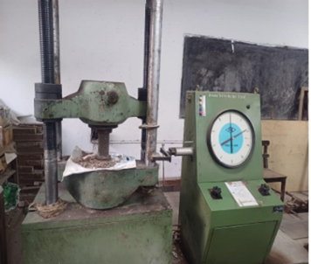 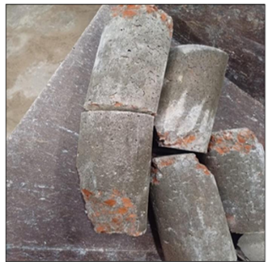

Figure 10: Testing of compressive strength

Calculation for compressive strength, $f_{c}^{'}$ = $\frac{P}{Ac}$

Here, P = Crushing load

Ac = Contact area of the cylinder

**Splitting Tensile Strength**

The splitting tensile test was carried out in compliance with ASTM C496 (2004). Concrete cylinders measuring 100 mm in diameter and 200 mm in height were subjected to the splitting tensile test utilizing universal testing apparatus after the designated curing period. For each replacement, three specimens were tested in duplicate, and the average values of the splitting tensile strength were recorded for each specimen. The results of the splitting tensile strength testing for self-consolidating concrete (SCC) are illustrated in Fig. 11.

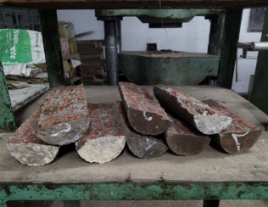

Figure 11: Testing of splitting tensile strength

Splitting tensile strength, $f_{sp}$ = $\frac{2P}{πlD}$

Here, P = Maximum applied load

l = Length of cylinder

D = Diameter of cylinder

**Modulus of Elasticity:** The stress-strain relationship of concrete exhibits a non-linear behavior. According to ASTM C 469-02 (2002), compressive strength is essential for determining Ec. This standard specifies that the modulus of elasticity is typically calculated within a working stress range of 0 to 40% of the concrete's ultimate strength. In the present study, cylindrical specimens composed of brick aggregate underwent a 28-day evaluation of their modulus of elasticity. A compressometer was utilized to assess the specimens, as illustrated in Fig. 12. For this assessment, three molds were tested for each type of mortar, and the molds yielding the highest values were chosen for each sample.

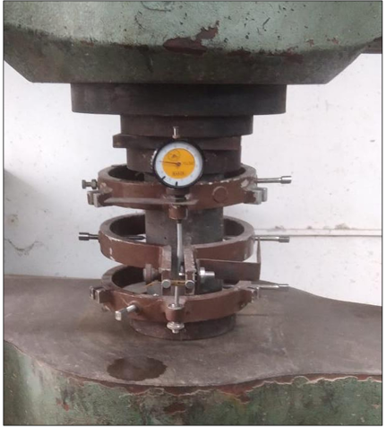

Figure 12: Testing of modulus of elasticity

## RESULTS AND DISCUSSIONS

**Compressive Strength of SCC:** In this research, the newly mixed SCC mortar was poured into molds and allowed to set at ambient temperature for a duration of 24 hours. The mortar was extracted from the molds and subjected to curing at room temperature (20 °C) until the time of evaluation. The compressive strength of the hardened concrete was measured at intervals of 14, 28, and 56 days. The minimum compressive strength required for concrete used in earthquake-resistant structures is 20 MPa; however, this requirement may be relaxed to 17 MPa for buildings that are up to four stories tall.

Table 3: Compressive Strength of Normal vs Partial Replacement of Cement in SCC in MPa.

|  |  |  |  |
| --- | --- | --- | --- |
| **Concrete with** | **14 Days** | **28 Days** | **56 Days** |
| Normal SCC without LRF & Marble dust | 20.55 | 28.03 | 31.62 |
| 5% LRF | 24.57 | 28.77 | 24.79 |
| 10% LRF | 23.72 | 29.75 | 25.56 |
| 15% LRF | 24.23 | 28.56 | 30.67 |
| 5% Marble dust | 39.59 | 40.86 | 31.51 |
| 10% Marble dust | 35.14 | 40.11 | 34.33 |
| 15% Marble dust | 35.79 | 44.37 | 30.51 |

The compressive strength of each mortar combination was determined by averaging the results from four specimens. Measurements of compressive strength were taken at 14, 28, and 56 days. Additionally, Figure 13 provides a graphical illustration of the compressive strength outcomes for the mortar samples. The percentage of LRF slag replacement demonstrates superior compressive strength during both the 14-day and 28-day testing periods when compared to the control mix. Conversely, the compressive strength of the control mortar shows an increase in the figure. While strength improved from 14 to 28 days, a decline in strength was observed for nearly all tests at 56 days, with a few exceptions in the sample tests.

Figure 13: Compressive strength at different ages for marble dust

Table 4: Percentage of Change in Compressive Strength for Marble Dust

|  |  |  |  |
| --- | --- | --- | --- |
| **Percentage of Change in Compressive Strength (%)** | | | |
| **Concrete with** | **14 Days** | **28 Days** | **56 Days** |
| Normal SCC with 0% Marble Dust | - | - | - |
| 5% Marble Dust | 92.7 | 45.8 | -0.4 |
| 10% Marble Dust | 71.0 | 43.1 | 8.6 |
| 15% Marble Dust | 74.2 | 58.3 | -3.5 |

The graphical data presented in Figure 13 clearly indicates that the strength of self-compacting concrete (SCC) incorporating marble dust improved over the 14 to 28-day period across all tested scenarios, including normal concrete and cement replacement ratios of 5%, 10%, and 15%. Specifically, at the 14-day mark, the strength achieved was 92.8% and 74.2% for the 5% and 15% marble dust replacements, respectively. Subsequently, at 28 days, these strengths increased by an additional 45.8% and 58.3%, respectively. However, a notable decline in strength was observed by day 56, with reductions ranging from 3.5% to 0.4%. In contrast, the 10% marble dust replacement demonstrated a strength increase of approximately 71% at 14 days, followed by an additional 43.1% gain at 28 days. While other replacement ratios exhibited strength loss at 56 days, the 10% marble dust scenario showed an 8.6% strength gain. The graphical representation of this data is also available in Table 4. Therefore, it can be concluded that the use of 10% marble dust, as opposed to 5% and 15% replacement ratios, yields slightly better compressive strength results in SCC without the inclusion of normal concrete.

Figure 14: Compressive strength at different ages for LRF

Table 5: Percentage of Change in Compressive Strength for LRF

|  |  |  |  |
| --- | --- | --- | --- |
| **Percentage of Change in Compressive Strength (%)** | | | |
| **Concrete with** | **14 Days** | **28 Days** | **56 Days** |
| Normal SCC with 0% LRF | - | - | - |
| 5% LRF | 19.6 | 2.7 | -21.6 |
| 10% LRF | 15.8 | 6.2 | -19.2 |
| 15% LRF | 17.8 | 1.9 | -4 |

The results of utilizing LRF in SCC concrete, with normal concrete and cement replacement ratios of 5%, 10%, and 15%, exhibit variations as depicted in the graphical data presented in Figure 14 Specifically, the strength achieved at the 5%, 10%, and 15% LRF replacement ratios does not match the performance observed with standard SCC. Conversely, there is a notable increase in strength at 14 to 28 days for the 5% and 10% LRF ratios. According to Table 6, a significant decline in strength is reported at 56 days. Consequently, it is evident from Table 4 and Figure 14 that the 15% LRF combination shows a slight improvement over regular concrete. In this context, while regular concrete demonstrates superior compressive strength, the 15% LRF option can be employed to achieve comparable strength levels.

**Splitting Tensile Strength of SCC:** The splitting tensile strength (fsp) is generally greater than the direct tensile strength but less than the flexural strength. It is commonly expressed as a function of the square root of the compressive strength (fʹc). In the design of structural concrete components, the splitting tensile strength serves to evaluate the shear resistance provided by the material and to determine the duration required for reinforcement to develop effectively.

Table 6: Splitting Strength of Normal vs Partial Replacement of Cement in SCC

|  |  |  |  |
| --- | --- | --- | --- |
| **Splitting Tensile Strength of SCC (MPa)** | | | |
| **Concrete with** | **14 Days** | **28 Days** | **56 Days** |
| Normal SCC without LRF & Marble dust | 2.27 | 2.69 | 2.96 |
| 5% LRF | 2.23 | 2.57 | 2.30 |
| 10% LRF | 2.09 | 2.71 | 2.37 |
| 15% LRF | 1.98 | 2.55 | 3.13 |
| 5% Marble dust | 3.11 | 2.54 | 2.45 |
| 10% Marble dust | 2.93 | 2.93 | 1.85 |
| 15% Marble dust | 2.86 | 3.03 | 3.16 |

An analysis of standard SCC concrete at 14 and 28 days reveals that it possesses a greater tensile strength compared to the alternative LRF and marble dust mortars. Nevertheless, at the 56-day mark, concrete incorporating 15% LRF slag and marble dust demonstrates superior strength compared to conventional SCC concrete. Additionally, Figures 15 and 16 illustrate the splitting strength outcomes for the mortar samples. When evaluating the replacement ratios of LRF slag and marble dust against the control mix throughout the 14-day, 28-day, and 56-day testing intervals, a reduction in tensile strength is observed.

Figure 15: Splitting Tensile Strength at different ages for marble dust

Table 7: Percentage of Change in Splitting Tensile Strength for Marble Dust

|  |  |  |  |
| --- | --- | --- | --- |
| **Percentage of Change in Compressive Strength (%)** | | | |
| **Concrete with** | **14 Days** | **28 Days** | **56 Days** |
| Normal SCC with 0% Marble Dust | - | - | - |
| 5% Marble Dust | 37.19 | -5.40 | -17.16 |
| 10% Marble Dust | 29.07 | 8.98 | -37.4 |
| 15% Marble Dust | 26.11 | 12.96 | 6.6 |

As illustrated in Figure 16 and Table 7, standard self-compacting concrete (SCC) exhibits a significant enhancement in splitting tensile strength over time. However, the strength improvements observed with the incorporation of 5%, 10%, and 15% marble dust are minimal. Specifically, the strength gains for the 5% and 10% mixtures during the initial 14 days were recorded at 17.16% and 37.4% by the 56-day mark, respectively. While the 15% marble dust mixture does demonstrate a marginal increase in strength, it remains insignificant when compared to standard SCC. In this context, both the 15% mixture and plain concrete yielded anticipated outcomes.A graph of different age and age

Figure 16: Splitting Tensile Strength at different ages for LRF

Table 8: Percentage of Change in splitting tensile strength for LRF

|  |  |  |  |
| --- | --- | --- | --- |
| **Percentage of Change in Splitting Tensile Strength (%)** | | | |
| **Concrete with** | **14 Days** | **28 Days** | **56 Days** |
| Normal SCC with 0% LRF | - | - | - |
| 5% LRF | -1.5 | -18.77 | -22 |
| 10% LRF | -7.98 | 1.01 | -20 |
| 15% LRF | -12.53 | -5.07 | 6 |

The incorporation of 5%, 10%, or 15% LRF slag into the mixture results in a reduction of the splitting tensile strength of self-compacting concrete (SCC) at various ages when compared to standard SCC. Specifically, there is a decrease of approximately 1.5% after 14 days, 4.32% after 28 days, and 22% after 56 days when evaluating the tensile strength with the addition of 5% LRF. In the case of a 15% LRF addition, the strength diminishes by 12.53% after 14 days but experiences a 6% increase after 56 days relative to the control mix. The variations in percentage increases and decreases across different ages and LRF percentages are illustrated in Table 7 and Figure 17.

**Modulus of Elasticity of SCC:** The modulus of elasticity is commonly expressed as a function of the square root of compressive strength. Several codes have established a few empirical relations to determine the concrete's modulus of elasticity. The unit weight, aggregate type and content, additive type, and compressive strength of concrete all affect its modulus of elasticity. The results of the elastic modulus tests are listed in Table 8, and Figure 17 shows representative graphs of the hardened concrete stress-strain diagram.

Table 9: Changes in the modulus of elasticity for various SCC mixes

|  |  |
| --- | --- |
| **Percent Replacement (%)** | **Modulus of Elasticity, Ec (GPa)** |
| Normal SCC without Replacement | 21.51 |
| 5% LRF | 14.12 |
| 10% LRF | 17.14 |
| 15% LRF | 14.46 |
| 5% Marble Dust | 13.61 |
| 10% Marble Dust | 15.19 |
| 15% Marble Dust | 25.91 |

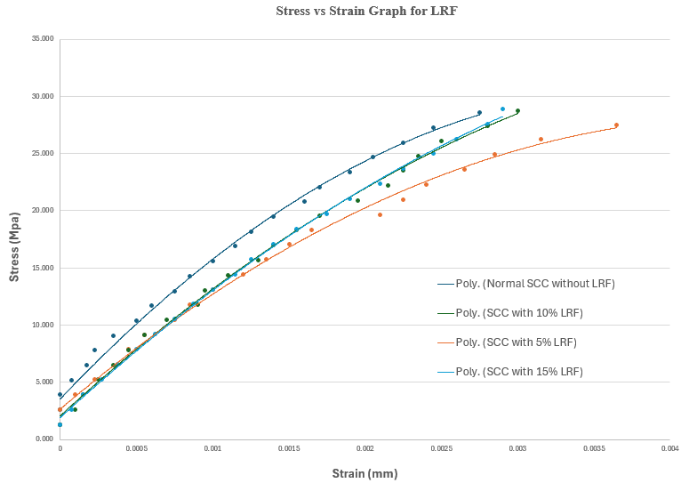

Figure 17: Stress – Strain curve for LRF

Table 8 indicates that the modulus of elasticity for standard concrete reached a maximum of 21.51 GPa and a minimum of 14.12 GPa for mixed concrete incorporating 5% LRF. It was observed that the static elastic modulus values for SCC mixes with 5% LRF were the lowest. In comparison, the modulus of elasticity for standard SCC was greater than that of LRF by 10%, 15%, and 5%. The stress-strain curve for both conventional SCC and SCC with partial replacement by LRF is illustrated in Figure 17.

According to Table 8 and Figure 18, the minimum modulus of elasticity for concrete mixed with 5% marble dust is recorded at 13.61 GPa, whereas the maximum modulus of elasticity for concrete containing 15% marble dust reaches 25.91 GPa. In comparison, standard concrete has a modulus of elasticity of 21.51 GPa, and concrete with a 10% marble dust mixture shows a modulus of 15.19 GPa.

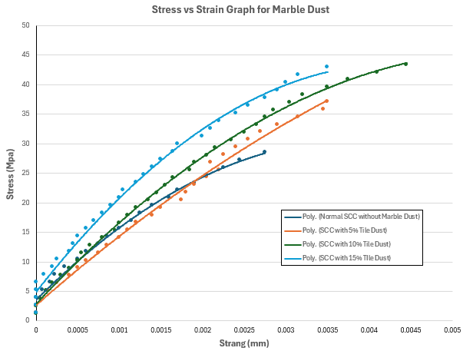

Figure 18: Stress – Strain curve for marble dust

This data suggests that conventional concrete offers more advantages than concrete with 5% or 10% marble dust. However, the concrete incorporating 15% marble dust demonstrates enhanced performance, indicating its potential for producing higher quality concrete.

## CONCLUSION

The primary objective of the experiment was to assess the impact of self-compacting concrete, which predominantly replaces cement with marble dust and LRF, on the mechanical and fresh properties of the material. From the analysis and test outcomes, several conclusions can be derived.

**Fresh Properties of SCC**

* Marble dust is utilized to replace 5%, 10%, and 15% of the cement in SCC, enhancing flowability, with the 10% substitution demonstrating optimal performance in accordance with EFNARC flow spread standards.
* The incorporation of marble dust consistently improves workability, particularly at the 10% level, which aids in the handling and placement of SCC while meeting EFNARC criteria for self-compacting characteristics.

* LRF contributes to an increase in flowability and workability to a moderate extent when used at 5% to 10%; however, at a 15% level, these advantages start to decline, necessitating careful adjustments to the mix to adhere to EFNARC standards.
* Both marble dust and LRF achieve a satisfactory level of possibility; nonetheless, at 10% and higher, marble dust enhances flow through reinforcement, thereby fulfilling EFNARC requirements.
* Across all replacement percentages, marble dust effectively maintains segregation resistance; however, a higher LRF content (15%) elevates the risk of segregation, underscoring the importance of an optimal mix design.

**Mechanical Properties of SCC**

* When cement is partially replaced with 15% marble dust, there is a significant enhancement in compressive strength at both 14 and 28 days, achieving a peak strength of 44.37 MPa at 28 days.
* The incorporation of 15% marble dust also leads to improved splitting tensile strength at 28 and 56 days, with a maximum value of 3.16 MPa recorded at 56 days, which exceeds the performance of conventional SCC.
* The influence of LRF replacement on splitting tensile strength is inconsistent; the highest strength of 3.13 MPa was observed at 15% LRF by 56 days.
* The introduction of 15% marble dust elevates the modulus of elasticity to 25.91 GPa, representing a substantial increase in stiffness compared to the standard 21.51 GPa of SCC.
* Marble dust proves to be a more effective option for enhancing the modulus of elasticity in SCC, as evidenced by the reduction in modulus of elasticity across all levels of LRF replacement, which ranged from 14.12 to 14.84 GPa, indicating a decrease in stiffness relative to normal SCC.

**Ethical Consideration:** Ethical issues (Including Plagiarism, Data Fabrication, and Double Publication) have been completely observed by the authors.

## REFERENCES

ACI 237R-07 (2007). Self-Consolidating Concrete. American Concrete Institute, Farmington Hills, Mich.

Ankica RaZenoviT, J. M. a. T. S., 2013. Characterization of Ladle Furnace Slag from Carbon Steel. Hindawi Publishing Corporation, 2013(Article ID 198240), p. 6.

ASTM C128 (2015). Standard Test Method for Density, Relative Density (Specific Gravity), and Absorption of Fine Aggregate. ASTM International, West Conshohocken, PA, USA.

ASTM C136 (2019). Standard Test Method for Sieve Analysis of Fine and Coarse Aggregates. ASTM International, West Conshohocken, PA, USA.

ASTM C138 (2001). Standard Test Method for Density (Unit Weight), Yield, and Air Content (Gravimetric) of Concrete. ASTM International, West Conshohocken, PA, USA.

ASTM C191 (2019). Standard Test Method for Time of Setting of Hydraulic Cement by Vicat Needle. ASTM International, West Conshohocken, PA, USA.

ASTM C29 (2017). Standard Method of Test for Bulk Density (Unit Weight) and Voids in Aggregate. ASTM International, West Conshohocken, PA, USA.

ASTM C39 (2002). Standard Test Method for Compressive Strength of Cylindrical Concrete Specimens. ASTM International, West Conshohocken, PA, USA.

ASTM C469-02 (2002). Standard Test Method for Static Modulus of Elasticity and Poisson’s Ratio of Concrete in Compression. ASTM International, West Conshohocken, PA, USA.

Billberg, P. (1999). Self-Compacting Concrete for Civil Engineering Structures the Swedish Experience.

Brough, C., Garside, R., Staniforth, B., Garner, C., Fletcher, J. and Strongman, J., Framboidal pyrite in concrete block: Reassessing EN 12620 in light of the degradation observed across the Republic of Ireland.

EFNARC (2002). Specification and Guidelines for Self-Compacting Concrete February, 1–32.

EN 197-1 (2011). General rules and rules for buildings, Part 1-2; General rules- Structural file design. In: Eurocode 2: Design of Concrete Structures Part 1 –1.

Ferraris, C.F. (1999). Measurement of the Rheological Properties of High Performance Concrete: State of the Art Report. J. Res. Natl. Inst. Stand. Technol. 104, 461–467.

G. S. Islam, S. A. a. T. B. R., 2022. Sustainable high-performance, self-compacting concrete using ladle slag,. Cleaner Engineering and Technology, 7(100439).

Ganesan, A. G., Reddy, A. K. M., & Kumar, K. S. (2013). "Properties of Self-Compacting Concrete with Partial Replacement of Cement by Marble Powder," International Journal of Engineering Research and Applications.

Grdic, Z., Despotovic, I., Toplicic-Curcic, G. (2008). Properties of self-compacting concrete with different types of additives. Facta Univ. - Ser. Archit. Civ. Eng. 6, 173–177.

Gupta, V. K., Agrawal, R. K., & Jain, A. K. (2013). "Effect of Marble Dust on Concrete Properties," Journal of Civil Engineering and Construction Technology.

Irem Zeynep Yildiri, M. P., 2011. Chemical, Mineralogical, and Morphological Properties of Steel Slag. Advances in Civil Engineering, 2011(463638 ), pp. 1-13.

J. M. Manso, M. L. J. A. P. a. J. J. G., 2005. Ladle furnace slag in construction. Journal of Materials in Civil Engineering, Volume 17, pp. 513-518.

J. M. Manso, V. O.-L. J. A. P. a. J. S., 2013. The use of ladle furnace slag in soil stabilization. Construction and Building Materials, Volume 40, pp. 126-134.

J. M. Montenegro, D. P. J. C. D. P. J. S. a. D. P., 2013. Ladle Furnace Slag in the Construction of Embankments: Expansive Behavior Ladle Furnace Slag in the Construction of Embankments. Expansive Behavior, Journal of Materials in Civil Engineering, Volume 25.

J. Setién, D. H. a. J. J. G., 2009. Characterization of ladle furnace basic slag for use as a construction material. Construction and Building Materials, Volume 23, pp. 1788-1794.

Japan Society of Civil Engineers (JSCE) (2007). Standard Specification for Concrete Structures - 2007. Materials and Construction.

Kandemir, A., Türkel, S. (2010). Fresh and Hardened Properties of SCC Made with Different Aggregate and Mineral Admixtures. J. Mater. Civ. Eng. 22, 1025–1032.

O. Najm, H. E.-H. a. A. E.-D., 2021. Ladle slag characteristics and use in mortar and concrete: a comprehensive review. Journal of Cleaner Production, 288(125584).

Okamura, H. (1986). Waiting for innovation in concrete materials, Cement and Concrete. Cem. Concr. Japan. 475.

Ouchi, M. (2001). Current Condition of Self-Compacting Concrete in Japan. In: Proceedings of the Second International Symposium on SCC. Tokyo, japan, pp. 63–68.

Ozawa, K., Maekawa, K., Okamura, H. (1992). Development of High Performance Concrete. J. Fac. Eng. Univ. Tokyo Volume-XLI, 381–432.

Rao, S. S., Gopalan, R. P., & Reddy, K. V. (2013). "Effect of Marble Powder on Durability Properties of Self-Compacting Concrete," Construction and Building Materials.

Rashid, M.A., Salam, M.A., Shill, S.K., Hasan, M.K.(2012). Effect of replacing natural coarse aggregate by brick aggregate on the properties of concrete. DUET J. 1, 17– 22.

Shi, C., 2004. Steel Slag—Its Production, Processing, Characteristics, and Cementitious Properties. TECHNICAL PAPERS, p. vol 3.

Skarendahl (2001). Market Acceptance of Self- Compacting Concrete, the Swedish Experience. In: Proceedings of the Second International Symposium on SCC. Tokyo, Japan, 1–12.

Standard Test Method for Density, Relative Density (Specific Gravity), and Absorption of Coarse Aggregate. ASTM International, West Conshohocken, PA, USA.

Uomoto, T., Ozawa, K. (1999). Recommendation for Self-Compacting Concrete. JSCE 1–19.

Yadav, D. K., & Kumar, M. K. (2014). "Rheological Properties of Self-Compacting Concrete with Marble Dust," Journal of Building Performance.

Zaidi, F. H. A., Ahmad, R., Abdullah, M. M. A. B., Abd Rahim, S. Z., Yahya, Z., Li, L. Y., & Ediati, R. (2021). Geopolymer as underwater concreting material: A review. *Construction and Building Materials*, *291*, 123276.