**Smart Irrigation in Nigeria: a panacea to curbing food insecurity and hunger.**

**Abstract:**

In Nigeria, conflict and insecurity, poor farming practices, unpredictable weather patterns, inadequate water management strategies, poor infrastructures, government policies, poor investment in agriculture, poverty and inequality, food waste, and post-harvest losses are the primary causes of famine and food insecurity. With an area of over 923,768 square kilometers—roughly three times the size of Germany—and a variety of temperature zones, Nigeria offers tremendous agricultural potential. Even though Nigeria's economy still primarily relies on agriculture and petroleum, poverty and hunger exist. This study examines how a solar-powered smart irrigation system can revolutionize agricultural productivity, maximize water use and combat hunger and food insecurity in Nigeria. The project recommends the design of a lithium battery, ESP8266 Wi-Fi module, solar panel, DHT11 moisture sensor and the Blink smartphone app. The solar panel charges the lithium battery that powers the system, and the charge controller regulates it safely. The ESP8266 microcontroller microprocessor determines whether to activate the DC pump to irrigate the area by analyzing the real-time data gathered from the soil by the moisture sensor. The device's ability to irrigate crops properly, depending on monitored moisture levels, saves water and raises agricultural productivity.

***Keywords****: Smart Irrigation, Solar energy, Water Conservation &* IoT*.*

**1. Introduction**

One of Nigeria's biggest problems is still food insecurity, as millions of people struggle every day to obtain enough wholesome food. Food insecurity affected more than 19 million Nigerians in 2021, according to the Food and Agriculture Organization (FAO, 2021). This condition was made worse by several socioeconomic and environmental variables. Nigeria's enormous agricultural potential is still mostly unrealized because of limited finance for the agricultural sector, unstable rainfall, poor road networks, insecurity and inadequate irrigation systems (Adesina, 2020). Due to its reliance on rain-fed agriculture and traditional agricultural practices, Nigeria's vast amount of fertile land—more than 923,768 square kilometers—is only partially exploited (Nwafor & Eboh, 2019). These issues may be resolved with the help of smart irrigation technology, which guarantees effective water management and higher agricultural output.

The introduction of smart irrigation—leveraging real-time data, sensors, automated water delivery systems, and precision agriculture—can greatly increase food production and decrease hunger in Nigeria, where farmers are vulnerable to climate variability and unpredictable weather patterns due to the country's largely rain-dependent agriculture (Oluwatayo & Ojo, 2018). Despite water shortages, nations like Israel and India have effectively used smart irrigation to increase agricultural productivity (Patel et al., 2021). Nigeria lacks an effective irrigation system, which results in seasonal farming and lower agricultural yields even though the country has an abundance of water sources, including the Niger and Benue Rivers (Eze et al., 2020).

Aside from irrigation issues, Nigeria's insecurity has a major negative impact on agricultural output. Due to conflicts between farmers and herders in the central area, armed banditry in the northwest, and the escalating insurgency in the northeast, many farmers have been forced from their farms, which has decreased food production (Adebayo, 2021). The full potential of smart irrigation cannot be realized if security issues are not resolved. However, Nigeria may still increase food production while addressing insecurity-related losses by encouraging climate-resilient crops and introducing regulated irrigation in safer places.

The inadequate road system that impedes food distribution throughout the nation is another major obstacle to food security (Yusuf *et al.*, 2021). According to World Bank research from 2022, over 57% of Nigeria's rural roads are in poor condition, making it challenging for farmers to deliver their goods to markets. Food costs rise, and post-harvest losses occur as a result of inadequate infrastructure. Modern storage facilities, enhanced transportation networks, and smart irrigation may all help to alleviate food shortages and guarantee that food reaches customers effectively (Okeke & Ogundele, 2019).

Furthermore, the agriculture sector's lack of investment prevents the use of smart irrigation and other advanced technology. Nigeria's agriculture industry contributes significantly to the country's GDP, yet government investment in it is still low compared to other industries (CBN, 2021). With the right funding, smart irrigation may transform agriculture by precisely managing water, decreasing reliance on rainfall, and raising crop yields. Many farmers cannot get credit facilities and use antiquated farming methods, which lowers production.

**2. Challenges of Traditional Agriculture in Nigeria**

* 1. **Poor Infrastructure:**

Bad road networks play a significant role in causing food insecurity and famine in Nigeria by disrupting the agricultural supply chain. Poor roads make it difficult for farmers to transport their produce to markets, leading to high post-harvest losses, especially for perishable goods like fruits, vegetables, and dairy products (Yusuf, Elijah & Nimlan, 2021). The increased cost of transportation due to bad roads raises food prices, making essential commodities unaffordable for low-income households. Additionally, poor infrastructure limits farmers’ access to necessary agricultural inputs, such as fertilizers, seeds, and modern equipment, reducing food production.

In rural areas, where farming is a major livelihood, bad roads prevent farmers from reaching profitable markets, discouraging large-scale agricultural investment and leading to food shortages. During natural disasters like floods, already fragile road networks collapse, further cutting off food supply chains and worsening hunger. To address these challenges, Nigeria must invest in road infrastructure improvements to enhance food distribution, reduce costs, and ensure stable food availability for all citizens (Anthony, Chukwudi, Ejem & Chinebuli, 2024).

* 1. **Unreliable Irrigation Systems:**

Unreliable irrigation systems contribute significantly to food insecurity and famine in Nigeria by limiting agricultural productivity. Since a large percentage of Nigerian farmers rely on rain-fed agriculture, inconsistent water supply leads to low crop yields and frequent crop failures. When irrigation systems fail, farmers cannot provide adequate water to their crops, resulting in poor harvests, reduced food availability and higher food prices (Oriola, 2009). This makes staple foods unaffordable for many, increasing the risk of hunger and malnutrition.

By reducing agricultural output, unreliable irrigation systems in Nigeria greatly increase food insecurity and famine (Bashir & Choi, 2018). Low agricultural yields and frequent crop failures are caused by an irregular water supply, as a significant portion of Nigerian farmers depend on rain-fed agriculture (Oriola, 2009). Farmers are unable to provide their crops with enough water when irrigation systems malfunction, which leads to subpar harvests, less food available, and increased food costs. This raises the danger of hunger and malnutrition by making essential foods costly for many (Adadu & Eyoma, 2024).

* 1. **Government Policies:**

Poor government policies on agriculture significantly contribute to food insecurity and famine in Nigeria. One major issue is inadequate investment in agricultural infrastructure, such as roads, storage facilities, and irrigation systems, leading to high post-harvest losses and reduced productivity. Additionally, inconsistent agricultural policies, including the sudden removal of subsidies on fertilizers and seeds, make essential inputs unaffordable for small-scale farmers (Gyang, Ogoh & Ekpa, 2017).

Limited access to credit further worsens the situation, as farmers struggle to expand or modernize their operations. Moreover, land ownership challenges due to inefficient land tenure policies prevent many from securing land for farming (Abubakar, Gambo & Umar, 2021). Security issues, including farmer-herder conflicts and banditry, disrupt agricultural activities and displace farmers, reducing food production (Ayantoye, Akinwole & Alabi, 2015).

The government’s reliance on food imports instead of supporting local farmers weakens domestic agriculture and makes Nigeria vulnerable to global food price fluctuations. Furthermore, poor environmental policies and a lack of climate adaptation strategies contribute to land degradation and lower yields (Ayantoye, Akinwole & Alabi, 2015). Corruption and mismanagement of agricultural funds also hinder development efforts, leaving farmers without much-needed support.

As a result, poor policies lead to low food production, high prices, and widespread hunger, increasing the risk of famine (Ayantoye, Akinwole & Alabi, 2015). To address this crisis, the government must implement sustainable policies that enhance agricultural productivity, improve infrastructure, and support local farmers. (Abubakar, Gambo & Umar, 2021)

**3.0 Smart Agriculture**

* 1. **The Role of Smart Agriculture**

To improve food production, smart agriculture incorporates cutting-edge technology, including automated irrigation, machine learning and the Internet of Things (IoT). The following elements are necessary:

* **IoT Sensors**: Devices that monitor soil moisture, temperature, and weather conditions.
* **Automated Systems**: Drip and sprinkler irrigation systems equipped with timers and controls.
* **Data Analytics**: Platforms for analyzing environmental data to inform irrigation schedules.

**3.2 Benefits of Smart Irrigation**

1. **Water Efficiency**: Reduces water wastage by targeting the root zones of crops.
2. **Increased Crop Yields**: Maintains optimal soil moisture for improved plant health.
3. **Cost Savings**: Lower labor costs and minimize water expenses.
4. **Climate Resilience**: Adapts to changing weather patterns and mitigates climate risks.

**4.0 System Design and Implementation**

**4.1 Components of the circuits:** The proposed smart irrigation system consists of the following:

* **ESP8266 Wi-Fi Module:** Acts as the central processing unit, collecting and transmitting data. This system utilizes the ESP8266 microcontroller, soil moisture sensors and relays to automate water supply to crops.
* **Soil Moisture Sensor:** Detects soil dryness and activates the water pump when needed.
* **DHT11 Sensor:** It measures temperature and humidity to provide insights into crop health. This sensor provides real-time temperature and humidity data to optimize farming conditions.
* **0.96″ I2C OLED Display:** It shows real-time sensor data for farmers' monitoring. Also, the OLED displays and the cloud-based data storage help farmers make informed decisions based on real-time environmental parameters.
* 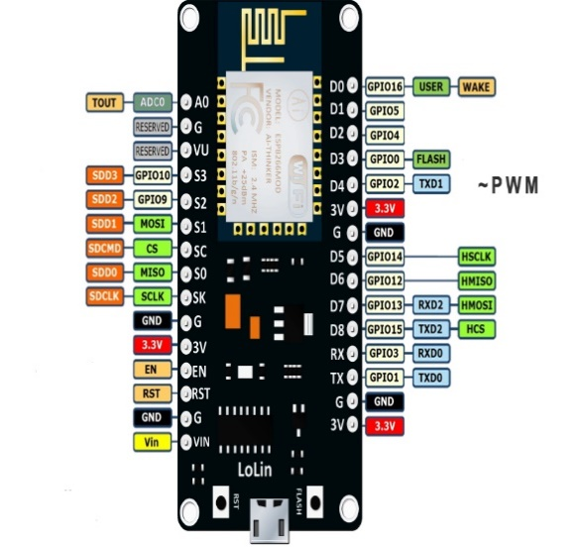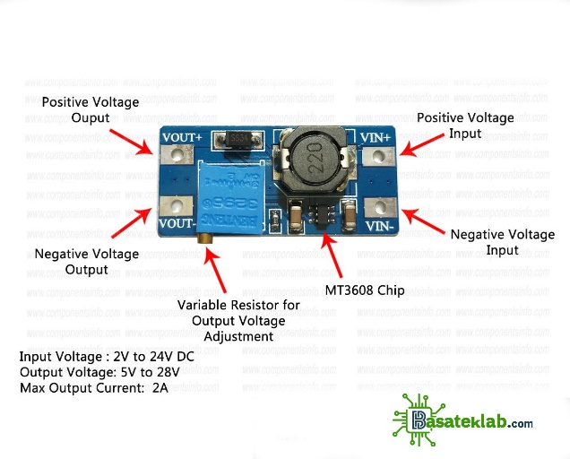**Relay-Controlled Mini Water Pump:** It automates irrigation based on soil moisture levels

**Fig 1.0 0.96″ I2C OLED Display Fig 2.0 DHT11 (digital temperature and humidity sensor modu**

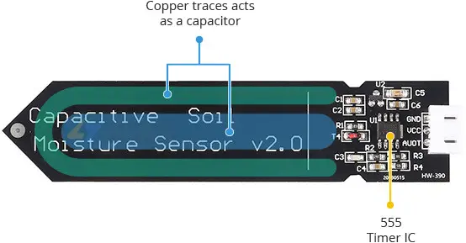 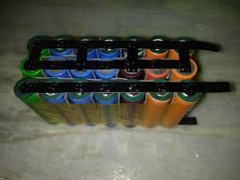

**Fig 3.0 Capacitive Soil Moisture Sensors Fig 4.0 lithium battery**

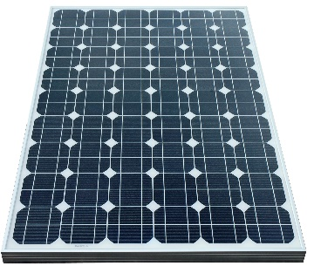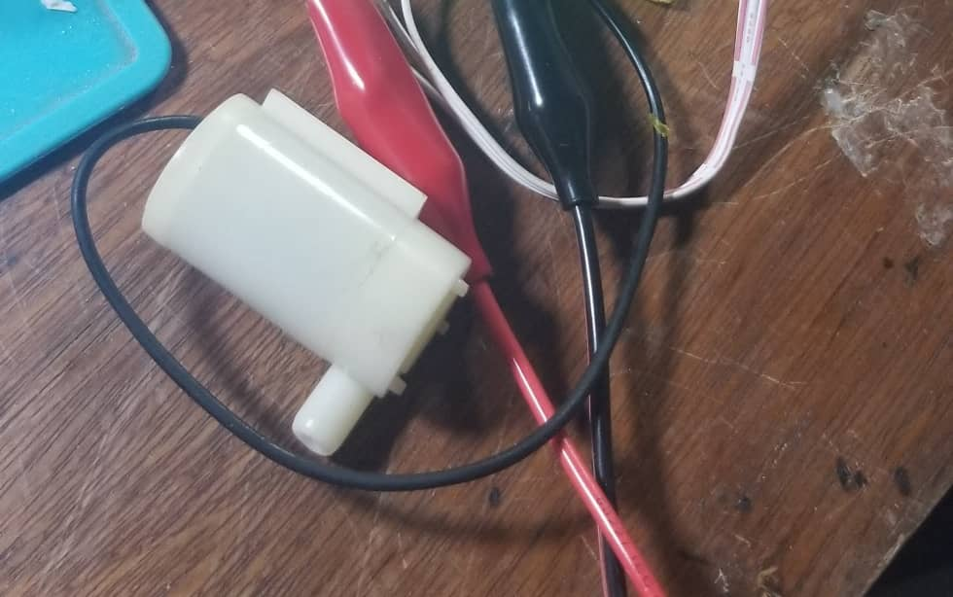

**Fig 5.0 Monocrystalline solar panel Fig 6.0 Block Diagram Smart Irrigation System**

**4.2 Methodology**

Several techniques are used in the design of irrigation systems, and the method used for this design is a capacitive measurement technique based on capacitance technology. These techniques can be categorized as resistive or capacitive, depending on the purpose of the sensor. Its foundation is capacitive measuring, which has several benefits over resistive measurement. With only one probe and no exposed metal to rust, these sensors do not damage plants by putting electricity into the ground (Salamat, 2015).

**Soil Moisture Sensor**

**OLED Display**

**WIFI Module (ESP8266)**

**Relay Module**

**DC water Pump**

**Temp/Humidity Sensor (DHT11)**

**Power Supply**

**Fig. 7.0 Block Diagram of a Smart Irrigation System**

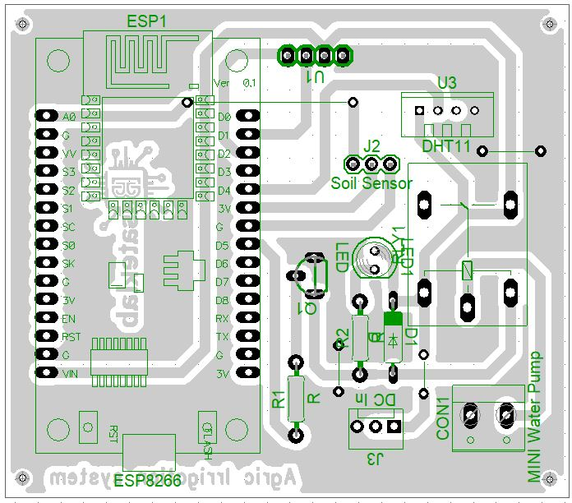

**Fig. 8.0 Layout Diagram of Smart Irrigation System**

**4.3 Software and Programming**

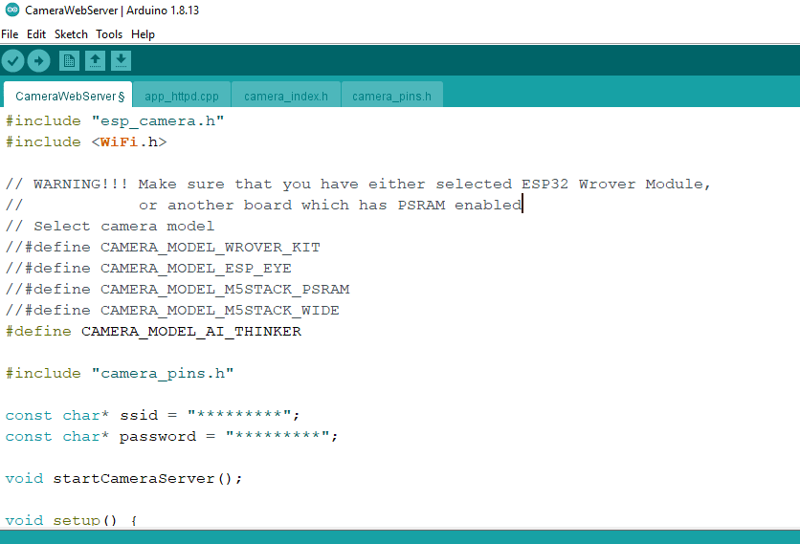

**Fig. 9.0 Programming using Arduino IDE**

The ESP8266 controller Firmware code was developed using the Arduino IDE, which was used to write the necessary firmware for the ESP module. The firmware program enables control commands to be sent to the cloud server (Thingspeak), and the application was written in C++. A screen grab of the application is shown in Fig 9.0.

**4.4 Setting up the Blynk web dashboard and Mobile App**



**Fig. 10.0 BlynkCloud Server Environment**

A remote server was set up to enable communication between the user and the device from a distance to track the system's status and performance. To do this, a cloud account was created using Blynk. To accomplish this, the account that would be linked to the device was created by visiting https://blynk.io./. A new template was established once the account was created by clicking "add new template" and entering the template's information as indicated in fig xx below.

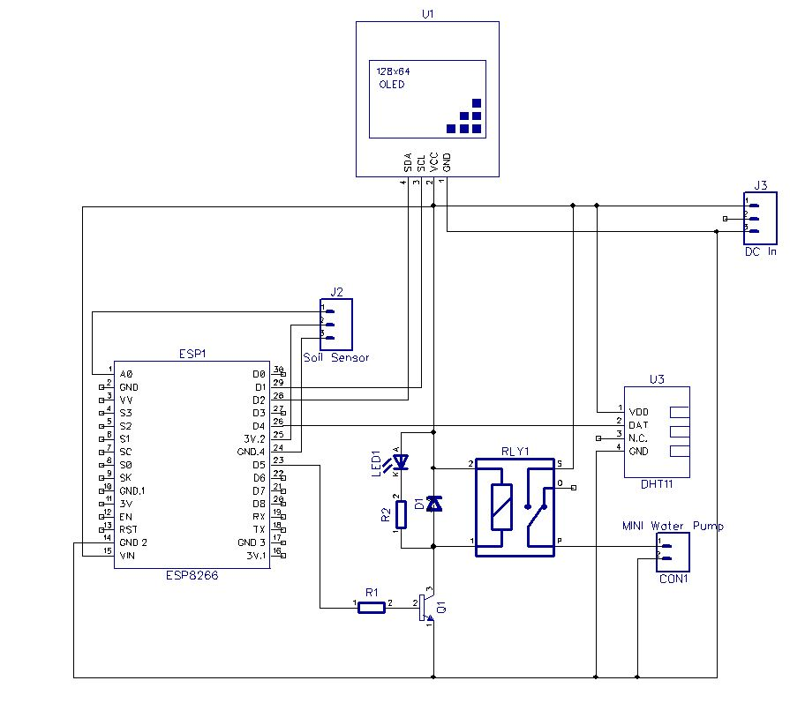

**Fig. 11.0 Circuit Diagram of a Smart Irrigation System**

Fig. 11.0 displays the full circuit diagram for the IoT-based agricultural irrigation system. The control system is based on an Espressif ESP8266 WI-FI module, which enables remote monitoring and control of the device. The ESP8266 module connects to the WI-FI network and serves as a server, while the mobile phone running the web-based user interface serves as the client. The web-based user interface can be accessed through a web browser on the user's laptop or mobile device using an IP address.

Every time one of the application's control buttons is pressed, the corresponding data is sent via a cloud environment to the server (ESP8266). The ESP module further processes this data before sending it to the relay driver circuit, which regulates the electric motor that pumps water for the plant. Power supply for the system is generated from a 9V DC source using DC-DC converter module voltage regulators attached to J3. The controlled output from the regulator is then supplied to the power pins of the ESP8266’s $V_{CC}$ and GND pins. The ESP modules' Digital Pins D5 are set up as output and are utilized to turn on the relays.

**5 Testing and Results**

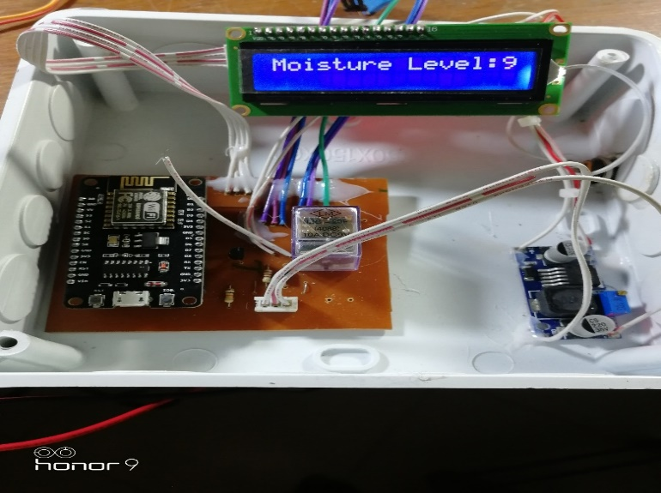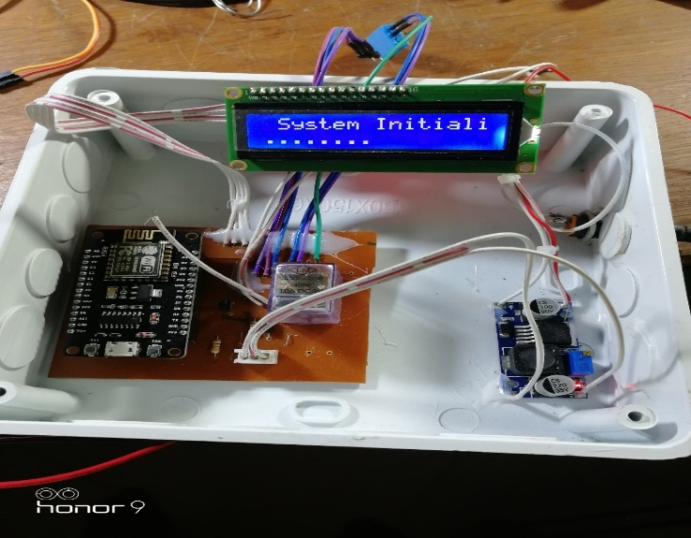

**Fig 12a: Powering on the system Fig. 12b: Testing the sensitivity of the moisture sensor**

The IoT-based system is seen turning on in Figure 12a. The 0.96-inch I2C OLED display displayed "system initialization," which is the word for the system starting up, as seen in the diagram. To test the capacitive soil moisture sensor, it was buried in the farm's soil (Fig. 2b). The water pump was completely submerged in water during the project's testing. The irrigation outlet pipe was kept in a field. Additionally, the moisture sensor was submerged in the ground. The LCD initialized and began displaying the soil moisture level and water pump status information as soon as it was turned on.

**6. Conclusion**

Smart irrigation is a promising solution to Nigeria's persistent hunger and food insecurity issues (Balogun, Ayantoye, Akinwole & Alabi, 2025). By leveraging advanced technologies such as automated drip irrigation, IoT-based sensors and AI-driven water management systems, smart irrigation maximizes water use, boosts agricultural output and ensures year-round food production. In a country grappling with climate change, unpredictable rainfall and shrinking arable land, smart irrigation can significantly increase food supply, reduce post-harvest losses and increase farmers' incomes (Balogun, Ayantoye, Akinwole & Alabi, 2025).

However, the full implementation of smart irrigation in Nigeria necessitates concerted efforts from the public and private sectors, as well as research institutions. Policy should encourage investments in smart agricultural infrastructure, grants for smallholder farmers and capacity-building initiatives (Touil, Richa, Fizir, Gracia, & Gomez, 2022). Incorporating renewable energy sources, such as solar-powered irrigation systems, can also reduce operational costs and increase sustainability (Sudharshan, Karthik, Kiran, & Subbiah, 2019).

In the end, smart irrigation is more than just a technical development; it is essential to attaining food security, promoting economic expansion and guaranteeing a robust agricultural industry. Nigeria may become more self-sufficient in food production and build a future where hunger is no longer a problem for the country but rather a thing of the past by adopting this invention (Pratama & Mandela, 2024).

**7. Recommendations**

Here are some suggestions for policy:   
• Government incentives for smart farming equipment policies should promote farmers' adoption of contemporary technology (Abdulahi & Eyoma, 2024).   
• The delivery of agricultural products will be made easier by investments in rural infrastructure that enhance road networks (Leonard & Abimaje, 2024);   
• Public-private collaborations between the government and digital businesses can foster innovation in agriculture;

• Training initiatives that educate farmers about IoT-based agricultural technology are essential for successful deployment (Jabbari et al, 2023)

**References**

(1) Abubakar, A., Gambo, J. & Umar, S. (2021). An overview of the Effect of some Agricultural Policies in Nigeria -1960-2020. Nigeria Agricultural Journal, 52(3), pp 151-162.

(2) Adadu, A. & Eyoma, F. (2024). Assessing the Impact of Solar-Powered Irrigation Systems on Water Availability For Crop Production In Abuja. IOSR Journal of Humanities and Social Science, vol 28, issue 12, series 4, pp 1-10.

(3) Adebayo, T. (2021). "Impact of Insecurity on Agricultural Development in Nigeria. African Journal of Development Studies, 10(2), 45-58.

(4) Adesina, A. (2020). "Agriculture and Economic Growth in Nigeria: Challenges and Prospects." *Nigerian Economic Review*, 12(1), 87-102.

(5) Anthony, O., Ibe, C., Ejem, E. & Uzondu, C. (2024). Estimating the Direct Economic Impacts of Poor Road Infrastructure Disruptions on Road Freight Systems in Nigeria. International Journal of Traffic and Transportation, 13(1):1-5. DOI:10.5923/j.ijtte.20241301.01

(6) Balogun, O., Ayantoye, K., Akinwole, O. & Alabi, O. (2015). Leadership and Governance: Dilemma of Agricultural Development in Nigeria. The Nigerian Journal of Sociology and Anthropology, vol 13, no. 1, 2015.

(7) Bashir, A. &Choi, K. (2018). A review of the evaluation of irrigation practice in Nigeria: past, present and prospects. African Journal of Agricultural Research, vol 13(40), pp 2087-2097. DOI: 10.5897/AJAR 2018-13.403

(8) CBN. (2021). *Annual Report on the Nigerian Agricultural Sector.* Central Bank of Nigeria.

(9) Eze, C., Nwankwo, P., & Adeola, S. (2020). "Water Resource Management and Agricultural Sustainability in Nigeria." *Journal of Environmental Science*, 15(3), 66-81.

(10) FAO. (2021). The State of Food Security and Nutrition in Nigeria. Food and Agriculture Organization.

(11) Franke, T. (2024). Smart Irrigation: Revolutionizing Water Management in Agriculture. International Research Journal of Plant Science (ISSN: 2141-5447) Vol. 15(3) pp. 01-2. DOI: http:/dx.doi.org/10.14303/irjps.2024.39

(12) Gyang, T., Ogoh, A & Ekpa, D. (2017). Poor Governance and Agricultural Development in Nigeria. Innovative Techniques in Agriculture, vol 1, issue 5, pp 246-255.

(13) Jabbari, A., Humayad, A., Reegu, F., Uddin, M., Gulzar, Y.& Majid, M. (2023). "Smart Farming Revolution: Farmer’s Perception and Adoption of Smart IoT Technologies for Crop Health Monitoring and Yield Prediction in Jizan, Saudi Arabia" Sustainability, 15(19): 14541.DOI: [10.3390/su151914541](http://dx.doi.org/10.3390/su151914541)

(14) Leonard, J & Abimaje, F. (2024). Optimizing Nigerian Road Reliability by Defining Poor Road Causes, Maintenance Strategies and Application. Engineering Science and Technology Journal, 15(7). DOI: 10.51594/estj/v5i7.1290

(15) Nwafor, J., & Eboh, E. (2019). "Land Utilization and Agricultural Productivity in Nigeria." *African Development Journal*, 7(4), 99-113.

(16) Oluwatayo, I., & Ojo, A. (2018). "Rain-Fed Agriculture and Food Security in Nigeria: Challenges and Solutions." *Journal of Agricultural Science and Technology*, 6(1), 27-41.

(17) Okeke, K., & Ogundele, B. (2019). "Transportation and Food Distribution Challenges in Nigeria." *Nigerian Journal of Infrastructure and Development*, 5(2), 112-130.

(18) Oriola, E. (2009). Breaking the Vicious Cycle of Irrigation Farming System for Sustainable Food Security in Nigeria. African Research Review, vol 3, no 1. DOI: 10.4314/afr rev.v3il.43570.

(19) Patel, H., Singh, R., & Kumar, D. (2021). "Smart Irrigation and Sustainable Agriculture: A Global Perspective." *International Journal of Smart Agriculture*, 9(3), 74-89.

(20) Pratama, A. & Mandela, R. (2024). Evaluating the Effectiveness of Smart Irrigation Systems in Improving Agricultural Productivity. Agricultural Power Journal, vol 1, no 4. https://doi.org/10.70076/apj.v1i4.43

(21) Salamat, A. (2015). A Comparative Study of Resistive and Capacitive Humidity Sensors. Journal of Emerging Technologies and Innovative Research, vol 2, issue 6. ISSN-2349-5162

(22) Touil, S., Richa, A., Fizir, M., Gracia, J. & Gomez, A. (2022). **"A Review on Smart Irrigation Management Strategies and Their Effect on Water Savings and Crop Yield"** Irrigation and Drainage, vol 7, pp 1.21. DOI: [10.1002/ird.2735](http://dx.doi.org/10.1002/ird.2735)

(23) World Bank. (2022). *Nigeria Rural Road Network and Agricultural Growth Report.*

(24) Yusuf, I. & Nimlan, R. (2021). Asian Journal of Advanced Research and Reports, pp 29-42, vol 15, issue 11.

(25) Sudharshan, N., Karthik, AVS, Kiran, JS & Subbiah, G. (2019).Renewable Energy-Based Smart Irrigation System. Procedia Computer Science, 165(2), pp 615-623. DOI: 10.1016/jprocs.2020.01.055