Original Research Article
Constraints Faced by NGO Workers in Agriculture & Rural Development: Insights from Jaunpur District of Uttar Pradesh, India

Abstract:
NGO workers in agriculture and rural development sectors face a wide range of constraints worldwide and India is not an exception in this case. This research study highlights the key constraints faced by NGOs as identified by 120 NGO workers in Jaunpur district of Uttar Pradesh, India and provide suggestions for improvement. The data analysis revealed the following constraints and their respective percentages: undemocratic behavior of the boss (95.5%), lack of sound planning (95.83%), absence of united synchronized efforts (87.5%), absence of incentives for good work (79.16%), non-availability of experts for consultancy (62.5%), lack of proper evaluation of the program (54.16%), low support from agriculture and other government departments (45.8%), unavailability of training facilities (97.5%), non-availability of inputs such as seeds and fertilizer (93.33%), lack of mobility/communication (89.16%), inadequate funds for carrying out activities (85%), non-availability of educational materials (79.16%), inadequate demonstrations (70.83%) and lack of housing facilities at the work site (65%). To improve NGOs should focus on fostering a democratic and inclusive organizational culture, implementing effective planning processes, encouraging collaboration and teamwork, providing incentives for performance, seeking expert guidance, conducting regular evaluations, enhancing government partnerships, investing in training and resources, improving communication infrastructure, diversifying funding sources and addressing housing needs. These steps will help NGOs overcome the identified constraints and achieve greater effectiveness in their mission.
[Key words: constraints, NGO, training facilities, inadequate demonstrations, collaboration and teamwork]

Introduction:
In a democratic nation like India, a strong focus is given on the development of rural and agricultural sector. The role of the state and central government is primary and most crucial on formulating and implementing the social and economic development programs in rural societies. However, in the contemporary society, the problems that people have been facing, especially the poorer section are much more complex. This is especially true in a country like India where a large number of vulnerable sections are experiencing inequalities at all the levels. Non-Governmental Organizations (NGOs) in India have long historical legacies as voluntary action has been an integral part of our national life and character. Voluntary action has been in existence through centuries in Indian subcontinent. World non-government organization date back to at least the late 18th century, NGO’s have a long history in India. In the past, people in this country have been found to have provided help to others in trouble. Since centuries, there exists the tradition of voluntary service to the needy and helpless in this country. In the previous time, these services were rendered by people motivated by their religious feelings. They believed that service to people would be the service to God and, therefore, would be a means to attain spiritual salvation and sometimes to atonement for any sinful act. Spirit of charity and altruism guided the voluntary action in the past, which had found expression in diverse forms even outside the formal established religious channels. Many people including rulers have trod the path of service to their fellow beings and adopted it as their life mission, floods, fires, earthquakes, epidemic outbreaks and other kinds of calamities were the occasions which motivated people to voluntary help those who were trapped in disastrous situations. Community life was very strong in India previously, and people were guided by the ‘we’ feeling and selflessness in extending their individual support.
The help and support used to be individual, spontaneous and transitory. It is around the late 18th and early 19th century that associations and organizations were being formed to render such activities in a more organized and permanent profile. The reform movements of the 19th century were perhaps the first organized forms of voluntary action in the service of society. This was the period when the caste rigidities were strong, untouchability was in practice, and other social evils like child marriage, cursed status of widow’s were prevalent in the Indian society against which voluntary organizations came forward to launch reform movements. These organizations were liberal and cut across caste and creed lines and worked purely as a liberal and secular body. NGOs in India have long historical legacies as voluntary action has been an integral part of our national life and character. Voluntary action has been in existence through centuries. In order to achieve these goals, several NGOs were formed under the influence of the ideals of Mahatma Gandhi. A few of them are sewa, eklavya, disha etc., which were instituted in Gujarat and some others might have been formed in other states also. A significant growth of NGO’s started after India achieved independence. Democracy was established and people had started understanding the meaning of freedom of speech, the charm of equality and the value of humanity and brotherhood. Also, on the other hand, the government started planning for development and in this effort, launched inter alia the schemes of community development program and later the green revolution. Over one million NGOs are pursuing their economically gainful activities. The achievements of the schemes were assessed were found to be unsuccessful in providing for the minimum necessary requirements and reducing the gap between the rich and the poor in rural areas, instead rather increasing it. India has already celebrated 77th years of independence, but still not considered in the list of developed countries. We are not able to make a poverty free rural society restore human dignity self-respect to raise moral, spirituals, economic and social standard of livelihood to our countrymen. Development does not only mean economic development but also includes promoting social equality, gender equality improving quality of life etc. It is not possible for government alone to effectively undertaking such complex development activities, so there is essentiality of other groups or organization to support the government on various fronts. This essentially paved way for the emergence of NGOs being a major arm of civil society and they have a crucial role in the country’s development process. According to the great Indian leader Mahatma Gandhi, "If the villages perish, India will perish too. It will be no more India. Her own mission in the world will get lost". So, rural development is necessary for the holistic development of the country. Since independence, our central and state governments have implemented programs for rural development and poverty alleviation but failed to deliver its good, desired extent. But the Government has not able to solve all the rural issues of the country and the support from various NGOs is become imperative at this stage to make the process much smoother. NGOs have significantly started intervening in agriculture and rural development sector of India, particularly since the beginning of 21st century. The functioning of the NGOs is not always smooth in farm and rural development sectors but the NGO workers face a wide range of constraints in their ways.
There have been multiple research studies investigating the challenges and constraints faced by the NGO workers in India and beyond. Dash (2001) highlighted several major constraints faced by NGO workers, including inadequate training and knowledge, insufficient salaries, lack of necessary inputs, political interference, absence of incentives, minimal departmental support, and career uncertainty. Similarly, Ahmad (2002) found that field workers encountered challenges in external relationships, such as suspicion, resistance, or a lack of cooperation from religious leaders and local elites. Additionally, they faced issues related to time and resources, competition for clients, and the tendency of intended beneficiaries to seek financial or material benefits rather than genuine assistance. Lalrinliana and Kanagaraj (2004) identified key constraints for NGO personnel, such as inadequate government attention (39.00%), high bank interest rates on loans (33.00%), and rising input costs. Nayak (2004) attributed the failure of the Tribal Sub-Plan (TSP) in Koraput district, Odisha, to a lack of commitment. Furthermore, Padminidevi (2004) emphasized that NGO personnel struggled with insufficient funds, limited awareness of funding agencies, and inadequate efforts to mobilize resources. Schwartz (2004) identified several major constraints faced by NGO personnel in China, including reliance on government funding, a shortage of human capital, insufficient well-trained staff, low enthusiasm, and limited access to data. Similarly, Das (2006) concluded that NGOs encountered challenges such as the poor purchasing power of tribal communities, inadequate funding, illiteracy, lack of government assistance, unfavorable working conditions, excessive regulations, and a lack of commitment. Swathi (2008) highlighted financial instability, inefficiency among employees, poor infrastructure, government interference, and delays in receiving critical information as key obstacles for NGO personnel. Jain (2008) observed that NGOs struggled with a shortage of dedicated and qualified human resources, lack of cooperation from government agencies, financial constraints, and political pressure. Aryal (2011) also pointed out poor financial sustainability and inadequate staffing as significant challenges. Additionally, Chang et al. (2011) found that NGOs faced resource competition, limited local transportation, a low capacity for supply, insufficient government support, and minimal community participation.
Basantia (2011) identified several key constraints faced by NGO workers. Technological challenges included a communication gap between farmers and NGO personnel, concerns about the adverse effects of technology, and high technology costs. Personal constraints were attributed to a lack of rewards and training, while social barriers stemmed from farmer illiteracy, poor living conditions, risk aversion, and insufficient cooperation and communication. Similarly, More (2011) highlighted issues such as the poor purchasing power of tribal communities, inadequate transportation, lack of commitment, insufficient funding, and a shortage of staff as major difficulties encountered by NGO personnel. Hasnain & Jasimuddin (2012) found that religious fundamentalism was the most significant obstacle in technology transfer, alongside other challenges such as distrust between NGOs and beneficiaries, beneficiary superstitions, limited training and knowledge, duplication of NGO activities, low absorptive capacity due to literacy and education levels, and the inflexibility of both NGO employees and beneficiaries. Furthermore, Batti (2014) emphasized donor dependency for funding, human resource management challenges, and a lack of staff skills as key constraints faced by NGO personnel. Jailobaeva (2014) identified key constraints faced by NGO personnel, including insufficient funds, high staff turnover, and a lack of coordination among NGO members. Similarly, Suneetha (2014) highlighted several challenges, such as lack of awareness (90.00%), inadequate funding (80.00%), lack of professional competence (70.00%), insufficient trained workers (60.00%), shortage of technical staff (50.00%), poor coordination (40.00%), long distances between hometowns and offices (30.00%), limited knowledge and skills (20.00%), unavailability of NGO staff (17.00%), and fund misuse (13.00%). More et al. (2014) emphasized financial constraints, lack of government support, transportation difficulties, tribal farmers' lack of commitment, insufficient field staff, and political interference as significant barriers for NGO personnel. Aruna & Thanasundari (2015) found in their study that NGOs faced challenges such as inadequate staffing, poor training, exclusion of field-level staff from decision-making, lack of support for field staff, limited funding, and restricted institutional capacity. Additionally, Mohammed et al. (2016) pointed out that unfamiliarity of NGOs with local communities and destructive competition among NGOs were major obstacles encountered by NGO personnel. The primary objective of this research study is to understand as well as prioritize the constraints faced by the current NGO workers in Uttar Pradesh, India.
Research Methodology:
The research study aimed to identify and analyze the constraints faced by NGO workers operating in Jaunpur district of the state of Uttar Pradesh, India and dealing with various rural as well as agricultural development issues. Uttar Pradesh is one of the biggest states in Indian subcontinent and largest producers of various food grains. This district was selected for this study purposively as the primary researcher has his origin in this district. The main objective was to gain an understanding of the challenges inhibiting the effectiveness of NGOs in the region and rank those challenges quantitatively based on the perceived importance by the respondents. The NGO workers from 19 blocks in Jaunpur district were selected for this study.

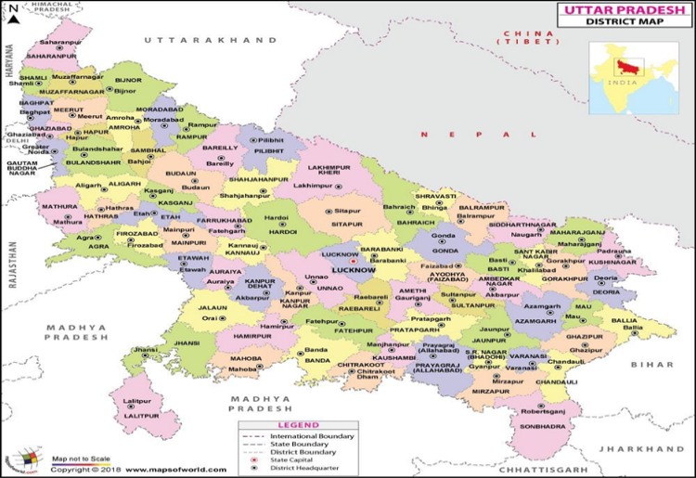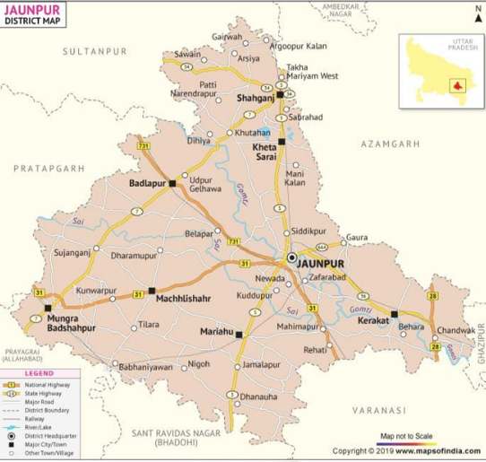
Fig. 1. Locale of the study
The study acknowledged the limitations of time and resources, leading to the selection of a sample of 120 respondents (NGO workers) for data collection using non-probability sampling like purposive and snowball sampling. A survey instrument was prepared beforehand to collect the data from the potential respondents. All the constraints were broadly categorized into 2 groups viz. administrative constraints and infrastructural constraints. The data collected through the in-person survey were analyzed using descriptive statistics such as frequency, percentages and ranks. The survey instrument was developed for collecting data from the NGO workers and pilot tested before the original data collection. Besides, the survey instrument was tested for content validity (particularly face validity). The major constraints in individual categories were ranked based on the frequency and percentage.
Results and Discussion:
Various constraints faced by the NGO workers
1. Administrative constraints
It was revealed from table 1 that out of total 120 NGO Workers, Undemocratic behavior of the boss (95.5 per cent), lack of sound planning (95.83 per cent), Absence of united synchronized efforts (87.5 per cent), Absence of incentives for good work (79.16 per cent), Non-availability of experts for consultancy (62.5 per cent), Lack of proper evaluation of the program (54.16 per cent), lack of support from agriculture and other Govt. department (45.83 per cent) respectively were major administrative constraints faced by the farmers. These findings support with the study of Singh (2012).

Table: 1 Distribution of administrative constraints based on degree of respondents’ indications
Sr. no. | Constraints | Frequency (f) | Percent (%) | Rank
1. | Undemocratic behavior of the boss | 117 | 95.50 | I
2. | lack of sound planning | 115 | 95.83 | II
3. | Absence of united synchronized efforts | 105 | 87.50 | III
4. | Absence of incentives for good work | 95 | 79.16 | IV
5. | Non-availability of experts for consultancy | 75 | 62.50 | V
6. | Lack of proper evaluation of the program | 65 | 54.16 | VI
7. | Lack of support from agriculture and other Govt. Department | 55 | 45.83 | VII

Fig. 2 Distribution of administrative constraints based on degree of respondents’ indications
2. Infrastructural constraints
It was revealed from table 2 that out of total 120 NGO Workers, training facilities are not available (97.5 per cent), non-availability of inputs i.e. seeds/fertilizer (93.33 per cent), lack of mobility/communication (89.16 per cent), inadequate funds for carrying out the activities (85 per cent), non-availability of the educational materials (79.16 per cent), inadequate demonstration (70.83 per cent), lack of housing facility at the work site (65 per cent) were major infrastructural constraints faced by the farmers.

Table: 2 Distribution of infrastructural constraints based on degree of respondents’ indications
Sr. No | Infrastructural constraints | Frequency (f) | Percent (%) | Rank
1. | Training facilities are not available | 117 | 97.50 | I
2. | Non-availability of inputs i.e. seeds/fertilizer | 112 | 93.33 | II
3. | Lack of mobility/communication | 107 | 89.16 | III
4. | Inadequate funds for carrying out the activities | 102 | 85.00 | IV
5. | Non-availability of the educational materials | 95 | 79.16 | V
6. | Inadequate demonstration | 85 | 70.83 | VI
7. | Lack of housing facility at the work site | 78 | 65.00 | VII

Fig. 3 Distribution of Infrastructural constraints based on degree of respondents’ indications
It can be inferred from the above findings that the target could not be achieved due to lack of funds. Similarly poor organization, poor leadership quality and lack of support from various agencies, non-availability of necessary inputs are the other constraints faced by the workers of the NGOs.
Conclusion & Recommendations:
The NGO workers revealed several significant constraints faced by NGOs, including undemocratic behavior of the boss, lack of sound planning, absence of united synchronized efforts, absence of incentives for good work, non-availability of experts for consultancy, lack of proper evaluation of programs, low support from agriculture and government departments, unavailability of training facilities, non-availability of inputs such as seeds and fertilizer, lack of mobility/communication, inadequate funds, non-availability of educational materials, inadequate demonstrations and lack of housing facilities. To address these constraints and enhance NGO effectiveness, it is necessary promoting democratic values, implementing sound planning processes, fostering collaboration and teamwork, providing incentives, seeking expert consultations, conducting thorough evaluations, strengthening partnerships, investing in training and resources, improving communication, diversifying funding sources, ensuring educational materials availability, enhancing demonstrations and providing suitable housing. NGOs working in the agriculture and rural development sectors should strategically prepare a specific roadmap to deal with these constraints. Addressing the various constraints will enable the NGO workers perform in a much smooth manner and serve their target communities of Jaunpur, Uttar Pradesh in a better way.
COMPETING INTERESTS DISCLAIMER:
Authors have declared that they have no known competing financial interests OR non-financial interests OR personal relationships that could have appeared to influence the work reported in this paper.

References:
Ahmad, M. M. (2002). Who cares? The personal and professional problems of NGO field workers in Bangladesh. Development in Practice, 12(2), 177-191.
Aryal, N. (2011). Changing Strategies of Non-Government Organizations: Slogan shouting or income-generating programmes-case studies from Gandhian NGOs of North India. Fukino project. pp.26.
Aruna, R., & Thanasundari, T. (2015). Organizational problems non-governmental organization (NGOs). International Journal of Home Science Extension and Communication Management, 2(1), 58-62.
Basantia, D. (2011). Impact of NGOs in bringing socio-economic development of tribal farmers through agricultural activities in Koraput district. M.Sc.(Ag) thesis, Orissa University of Agriculture and technology, India.
Batti, C. R. (2014). Human resource management challenges facing local NGOs. Humanities and Social Sciences, 2(4), 87-96.
Chang, Y., Wilkinson, S., Potangaroa, R., & Seville, E. (2011). Donor-driven resource procurement for post-disaster reconstruction: Constraints and actions. Habitat International, 35(2), 199-205.
Das, K. P. (2006). Role of an NGO in socio-economic upliftment of tribal farmers of shevaroyan hills of Tamilnadu. M.V.Sc thesis. National Dairy Research Institute, Karnal, India.
Dash, M. (2001). Role of NGOs in Agricultural Development. M.Sc.(Ag.) thesis. Orissa University of Agriculture and Technology, Orissa, India.
Gunjakar, V. P. (2005). Empowerment opportunities for farm women in Gorwaha village under IVLP. MSc Thesis (Unpub) Dr.PDKV, Akola
Hasnain, S. S., & Jasimuddin, M. S. (2012). Barriers to Knowledge transfer Empirical evidence from NGO (non-governmental organizations)-sector in Bangladesh. World Journal of Social Sciences, 2(2), 135-150.
Jain, R. B. (2008). NGOs in India: the role, influence and problems in Non–Governmental Organizations in Development. New Delhi: Kanishka Publisher, pp. 40-52.
Jailobaeva, B. K. (2014). A new look: professionalization of NGOs in Kyrgyzstan. Central Asian Survey, 33(3), 360-374.
Lalrinliana, J., & Kanagaraj, E. (2004). SHGs and Tribal Development in Mizoram. Kurukshetra, 54(3), 37-48.
Mohammed, P. N., Josiah, P. B., & Bangura, T. E. (2016). Problems faced by beneficiaries participation in, and NGOs implementing NGO-led food security in Bo district southern Sierra Leone. Global journal of Bio-science and Bio technology, 5(1), 70-77.
More, B. D. (2011). Role of an NGO in sustainable livelihood generation in tribal dairy farmers in Nandurbar district of Maharashtra. M.V.Sc. thesis. National Dairy Research Institute, Karnal, India.
More, B. D., Kale, B. R., Singh, K., & Avhad, S. (2014). Constraints faced by the tribal dairy farmers and NGO Personnel for sustainable Livelihood generation in Nandurbar district of Maharashtra, India. Agric. Sci. Digest, 35(1), 63-65.
Nayak, R. (2004). National Conference on Tribes, State Policies and NGOs, Indian Anthropological Association (abstracts).
Padminidevi, G. (2004). Role of voluntary organizations in rural development in Andhra Pradesh. A Critical Analysis. M.Sc.(Ag) thesis, Acharya N.G. Ranga Agricultural University, Hyderabad, India.
Schwartz, J. (2004). Environmental NGOs in China: Roles and Limits. Pacafic affairs, 77(1), 28.
Singh, G. (2012). Importance of education in the changing scenario. Kurukshetra, A journal on rural development, 60(11), 32-34.
Sivamurgan, C., & Anbumani, V. (2008). Broadband services in rural areas. Kurukshetra, A journal on rural development. 57(1), 9-12.
Sonawane, H. P., Khalache, P. G., & Gaikwad, J. H. (2008). Information seeking behaviour of the beneficiaries of BAIF from Rural Maharashtra. Agriculture Update, 3(3/4), 332-334.
Suneetha, B. (2014). Role of Non–Governmental Organizations in women development-Acritical analysis in Andhra Pradesh. PhD thesis, Acharya N.G. Ranga Agricultural University, India.
Swathi, J. (2008). Impact of non- government organizations in agriculture and allied enterprises development in villages of Jabalpur district. M.Sc.(Ag.) thesis. Jawaharlal Nehru Krishi Vidyalaya, India.
VidyaTayde (2006). Empowerment of rural women in Marathwada region of Maharastra state. Ph.D. Thesis (Unpub), MAU, Parbhani, India

