Integrating agriculture with eco-tourism in Rajasthan: Prospects and challenges

Abstract:
Ecotourism involves environmentally conscious tours to natural environment, promoting local communities and fostering educational experiences. Integrating agriculture with eco-tourism, also known as agro-ecotourism or agri-ecotourism, combines agricultural experiences with sustainable travel practices. Agri-ecotourism refers to a business model that combines agricultural activities with tourism, drawing visitors to farms, ranches, and other agricultural enterprises for entertainment or educational purposes. This approach helps to generate income for the owners (Dercan et al., 2023). It also includes heritage tourism, village tourism, farm tourism, pilgrim tourism, adventure tourism, nature tourism, which lead to development of community, eradication of poverty and protection of cultural heritage (Saxena, 2022). The diverse landscape and rich cultural heritage of Rajasthan make the state an ideal destination for tourists. Agri-ecotourism offers significant potential by combining sustainable agriculture with tourism, promoting rural development and environmental conservation. Supportive government policies provide a strong basis for agri-ecotourism development. The government encourages farmers and promoters to practice agri-ecotourism as one of the pivotal verticals of the tourism industry by offering subsidies and schemes at the state level that benefit agri-tourism promoters. The global shift towards experiential tourism during post-pandemic has further boosted the potential of agri-ecotourism model, which also aligns with sustainable development goals. (Augustyn, 1998; Brune et al., 2023). Djuwendah et al. (2023) evaluated the sustainability of agro-ecotourism in five rural villages across six dimensions using Multi-Dimensional Scaling (MDS). Despite overall sustainability, it stands out for its exceptional community engagement but falls short in technological advancement due to inadequate infrastructure. Key factors include tourist visits, waste management, and cultural preservation. The study offers insights for improving sustainable agri-ecotourism and guidance for rural development policies.
Keywords: Agri-eco tourism, Sustainability, Agriculture, Rural Economy

1. Introduction:
India happens to be the second most populous country on the earth with more than 17% of the World population. About 61.5% of the 130 crores plus population in India is dependent on agriculture. Indian agriculture is characterized by small farm holdings. The average farm size is only 1.57 hectares. Around 93 per cent of farmers have land holdings smaller than 4 ha and they cultivate nearly 55 per cent of the arable land. On the other hand, only 1.6% of the farmers have operational land holdings above 10 ha and they utilize 17.4 % of the total cultivated land. Due to diverse agro climatic conditions in the country, a large number of agricultural items are produced. India is an agrarian economy, green revolution and smaller plot holdings as witnessed by the Asian countries has led to rapid forward strides being made in the agriculture in the last few years. In spite of this, India faces several challenges arising from socio-economic, demographic and institutional sectors that affect its basic survival. In India 85% of the population is directly or indirectly dependent upon agriculture and a vast majority is based in the rural belt. 90 million farmers are dwelling in 6.25 lakh villages producing more than 200 MT of food grains feeding the country. Considering the topography of India, in the last few years have seen the concept of rural tourism gaining momentum as an allied area of revenue generation. Realizing this government is encouraging active rural tourism in order to increase revenue generations options for the rural segment. Agri-tourism or agro-tourism involves agriculturally-based operation or activity that brings visitors to a farm or ranch. Agri-tourism includes the wide variety of activities, including buying produce direct from a farm stand, navigating a corn maze, slopping hogs, picking fruit, feeding animals, or staying at a bed and breakfast on a farm. Since 2004 Agriculture Tourism is operational, it started in Baramati Agri-Tourism Center.
For achieving a goal number 8, 12 and 14 of sustainable development goals, (SDGs) World Tourism Organization (WTO) proposes tourism activities and facilities as an instrument (Suwanna & Pisitsenakul, 2019)
Agro-eco- tourism is the latest concept in the Indian tourism industry, which normally occurs on farms. It is the symbiotic association of farming sector, tourism industry and farm business. It is indeed, the economic activity that occurs when people link travel with agricultural products, services or experiences to cater to the needs of mutual demands. It gives the opportunity to experience the real enchanting and authentic contact with the rural life, taste the local genuine food and get familiar with the various farming tasks during the visit. It provides you with the escape from the daily hectic life in the peaceful rural environment. Agri-tourism would also provide tourists with an opportunity to be close to where the 75 per cent of Indians live. A concept, agri-eco- tourism entails visiting a working farm or any agriculture, horticulture or agribusiness operation, for the purpose of enjoyment, education or active involvement in the activities of the farm or operation. Agro-eco- tourism is the new value added agricultural business, for improving the incomes and potential economic viability of small farms and rural communities. Agri-tourism can take many forms like roadside stands or on farm-direct sales, which can offer farm-fresh produce to travelers as well as interaction with growers. Agritourism ends farmer’s isolation and offers the opportunities to make new friends and build stronger links to the community. Social skills and a scenic, clean, attractive farm are crucial for success in agri-tourism and can make the farms more ideal location for tourists. Agro eco-tourism would secure a multifunctional, sustainable and competitive agriculture, maintain the landscape and the countryside, contribute to the vitality of rural communities, respond to consumer concerns and demands regarding food quality and safety, environmental protection, animal welfare, etc. Agro-eco tourism will provide an opportunity to develop tourism in ways that provide agro based products among the consumers of the nation as well overseas.
The Indian Agriculture and Tourism Industry Scenario India is known as “Land of villages”. More than 11 crore farmers dwelling in 6.25 lakhs of the village and cultivating 40 crore acres of land feeding to more than 125 crores of population. Agriculture contributed about 18.5 % of the national income (2006-07) as compared to a high 50 per cent in 1950. Even now 60 per cent population of India depends on Agriculture hence Agriculture is not a mere business, but is still the “True Culture of India”.
Looking through the tourism sector, India is poised to emerge as the 2nd fastest growing (8.8%) tourism economy in the world over 2010-17 according to the World Travel and Tourism Council. India’s Travel and Tourism sector ranks 7th in the world in terms of its total contribution to the country’s GDP, shows a new report by the World Travel and Tourism Council (WTTC). According to the new data, Travel and Tourism generated INR14.1 trillion (USD 208.9 billion) in 2016, which is the world’s 7th largest in terms of absolute size, the sum is equivalent to 9.6 per cent of India’s GDP. Additionally, the sector supported 40.3 million jobs in 2016, which ranks India 2nd in the world in terms of total employment supported by Travel and Tourism. The sector accounts for 9.3 per cent of the country’s total jobs. India’s Travel and Tourism sector was also the fastest growing amongst the G20 countries, growing by 8.5 per cent in 2016. A further 6.7 per cent growth is forecast for 2017. India’s strong Travel and Tourism figures are predominantly generated by domestic travel, which accounts for 88 and of the sector’s contribution to GDP in 2016.
Travel and tourism have been going on since time immemorial, and for the ‘twentieth-century tourist, the ‘world has become one large department store of countryside and cities’. By the 21st century, travel has become a new economy - tourism - available to all with enough money. The United Nations (UN) General Assembly has approved the adoption of the year 2017 as the “International Year of Sustainable Tourism for Development”. This new tourism phenomenon is not only influenced by economic factors but also by new cultures and a new generation of tourists. India happens to be one of the fastest developing economies of the world, but still, if we look at India, a major part of the population is living in villages. Although being a fast-growing economy, India has been much concerned due to the growing rate of population and increasing demand for basic amenities. Hence there is an urgent need to develop rural India, with a focus on available natural and cultural resources leading to sustainable development. Usually in rural India varieties of products are available viz., historical, heritage, natural based, medication based, religious based, culture based and man-made which have got a great potential with respect to the development of tourism.
India exhibits a diverse form of art and culture entrenched through a rich heritage, which makes India a hot global tourist destination. India has a thriving tourism industry, which contributes over 6% to the national GDP and 8% of the total employment. It is thus, capable of offering a wide variety of entertainment for the discerning tourists and has the capacity to diversify into a new arena of agro-tourism. Agro-tourism offers an opportunity to experience the real enchanting and authentic contact with the rural life, taste the local genuine food and get familiar with the various farming tasks. It also provides a welcome escape from the daily hectic life in the peaceful rural environment and to relax and revitalize in the pure natural environment, surrounded by magnificent landscape. Agro-tourism can contribute to a green economy transition through investments leading to energy and water efficiency, waste reduction, biodiversity and cultural heritage conservation and the strengthening of linkages with local communities.
Action Planning: Enhancing the shared understanding and dialogue, the community collectively identifies priority issues and development objectives. Through a participatory approach, they create action plans that outline specific steps and activities to address the identified challenges in agri tourism. (Sisodiya & Shekhawat, 2023).
1.1) Agri-tourism and its components: Phillip et al. (2010) proposed a definition of agritourism through the development of an activity-based taxonomy. Arroyo et al. (2013) defined Agri-tourism non-working farm agritourism (NWF) refers to activities where the non working farm only serves for scenery purposes (e.g., bird watching on an old mill),Working Farm, Passive Contact agritourism (WFPC) refers to activities that do not require great interaction between the visitor and the working farm site, allowing for farmers to continue their agricultural activities without having interferences (e.g., attending a wedding in a vineyard),Working Farm, Indirect Contact agritourism (WFIC) comprises activities that are more directly related to farm functions, although the contact with the visitor focuses more on the agricultural products rather than the practice of farming itself (e.g., enjoying fresh produce or meals on site), Working Farm, Direct Contact, Staged agritourism (WFDCS) refers to activities through which visitors experience agricultural operations but through staged scenarios and predetermined tours (e.g., touring an operating cider mill) and Working Farm, Direct Contact, Authentic agritourism (WFDCA) refers to the direct participation of the visitor in agricultural activities in which often the recreational activity is the farm “profit” obtained in the form of labour in exchange for food and accommodations (e.g., harvesting berries or milking a cow).
1.2) Agri-tourism includes:– Farm-tourism: Tourism on the farms enables farmers to diversify their activities while enhancing the value of their products and property. Farm tourism also helps to reconcile farming interests and environmental protection through integrated land management in which farmers continue to play a key role. Modern times we have almost forgotten these simple joys of life and above all enjoy homemade food and drinks.
1.2.1) Heritage and cultural tourism: This tourism in rural areas comes in a wide range of forms most of which are unique to an individual local and a valuable component of the rural tourism product. Heritage and cultural tourism includes temples, rural buildings but may be extended to local features of interest including war remnants, monuments to famous literary, artistic or scientific people, historic remains, archaeological sites, traditional parkland etc.
1.2.2) Eco-tourism: Many tourists visit rural areas for the purpose of bird and animal watching and learning about local flora and fauna.
1.3) Unique experiences provided by agro-tourism to urban traveler: Tourists opting for agro-tourism are attracted towards agro-tourism because of a variety of innovative products which they cannot enjoy with traditional tourism. Thus, agro-tourism is getting a very good response from urbanites.
1.3.1) The innovative products provided by agro-tourism are:
- Farm stay and farm tours
- Cow milking
- Rural art and craft
- Various farm rides and animal rides like – bullock cart, tractor, horse etc.
- Visiting a dairy, piggery, poultry, sweetwater fishing etc.
- Processing of farm products
- Demonstration of farm activities
- Special events and festivals like music festivals, harvest festivals and other rural festivals (Jatra, Mela etc.).
1.4) Positive economic and socio-cultural impacts: Rural tourism can create positive economic impacts in the rural areas by providing employment for rural people and generating income there by bringing societal developments. The rural people can be brought to the mainstream population with financial empowerment, societal and cultural upliftment with the following set of benefits from rural tourism.
- Income and employment: Creation of employment opportunities especially for rural youth. Rise in the Income level. Agri-tourism creates employment opportunities for farmer’s family members. Diversify and increase income sources of the family.
- Business and cultural exchange: Generates foreign exchange. The local small businessman will be benefited. Demand for other goods and services will increase. Cultural understanding through fairs and festivals. Exchange of cultural beneficial for both. Foreign tourist will bring cultural change faster. The market for agro products and handicrafts will develop in rural areas Farmers and artisans will develop a direct contact with the customers.
- Other impacts: Leads to improvement in public services. Generate revenue for the government. Modernization of agriculture and other rural activities. Education and health of the rural community will improve. One of the most rewarding aspects of Agri-tourism for many farmers is the opportunity to provide the public with a better understanding of what agriculture is really about.
2) Agri-ecotourism in India – Bottlenecks and challenges ahead:
- Financial and economic bottlenecks: Insufficient financial support from the lending agencies and marginal or small farmers cannot afford to pay out of their limits. Lack of rural investment and insufficient government concern paving way for financial bottlenecks.
- Technical bottlenecks: Poor infrastructure and a shortage of trained manpower for business management. Lack of Basic Education to farming community leading to an inferiority complex. Need of special marketing approaches and higher government legislation, including documentation and proper licensing of the venture. Quality and complexity of services to be maintained.
- Psychological bottlenecks: Skeptic involvement of the local people due to trust issues and the threat of exploitation by city people. Inferiority complex among rural people. Communication difficulties.
3) Agri-ecotourism parks in Rajasthan:
- The country retreat Pali – is situated in Bankali, Sumerpur tehsil of Pali district of Rajasthan. its spread over 130 acres of lush farmland. Its owner has a vast knowledge of agriculture. People can find here Activities like –bird watching, animal herding, cycling village tour, dance program, farm activities, safari camel riding, cooking lessons on Rajasthan food, etc. also they have fully air conditioned rooms attractively furbished with a royal touch.
- Jor ki Dhani innovation house Sikar – is situated at Katrathal in Sikar district of Rajasthan. This region called Shekhawati it includes three or four districts Churu, Jhunjhunu, and Sikar. Inn Shekhwati jor ki Dhani means the first settlement. Its owner Mr. Kaan Singh Nirwan Ji has a very deep love for cows and the nature of the earth .they offer products like ghee. Spices clothes toys etc. and have hutts maid with shrubs and soil to stay .they provide satwik bhojan .activities like –horse riding fair roaming, watching the natural beauty and participate in their daily routine.
- Ikki bagh Jaipur – situated in Jheejha village of Moondli tehsil of Jaipur district of Rajasthan. Ikaki bagh is a vision of Jaidev Rathore who lives in Jaipur. this place is registered as an individual producer by the ROCA. This place is associated with some NGOs that have international volunteers who provide products from their manufacturing. Activities here are; camel or horse riding, safari, watching natural beauty, dining, fair or festival celebration, and farm stay. they are also supported by TERI, RSOCA and USDA.
- Green world foundation Jaipur – is a farm stay and organic farming place started by Indraj Jaat in 2017 at Chirada, Khora Shyam Das in Jaipur district. They offer natural produces to visitors they have farms to stay and participate in their activities. camel or horse riding, they have natural swimming pools mud houses, cattle herding, bird, animals etc. they also produce organic fruits, and veggies and offer them to visitors.
Table-I: Agro-Tourism is a way towards sustainability (Khangarot, G., & Sahu, P. (2019) :
Social | - Experience of village life  - Know about agriculture and dairy activities  - Enjoying rural activities and games  - Development of social skills and relationships
Economic | - Buying organic foods  - Sell of handmade gift items  - Attend villages fairs and festivals  - Diversification of farms activities
Environmental | - Impetus for sustainable tourism  - Sensitize towards nature  - Pollutions free environment
4) AGRO TOURISM DEVELOPMENTCORPORATION (ATDC):
Mr. Pandurang Taware father of the Agri-tourism concept in India and founder of Agri Tourism Development Corporation (ATDC), 2005 in Maharashtra and also Winner of the Global Responsible Tourism Award in 2011 for the ‘Best contribution to conserving cultural heritage’
4.1) ATDC is main promoter to encourage tourism in rural Maharashtra. ITS aims are:
- Prepare agro projects and help farmers to execute them
- To help farmers financial support from nationalized banks
- To conduct training for this tourism
- To conduct seminars and conferences on agri-ecotourism and educate organizers
- To provide sales support and marketing support
- To arrange national and international tourist to come to India for agro tourism
- To link urban and rural folks to meet and mix their culture
Figure 1: Model of ATDC
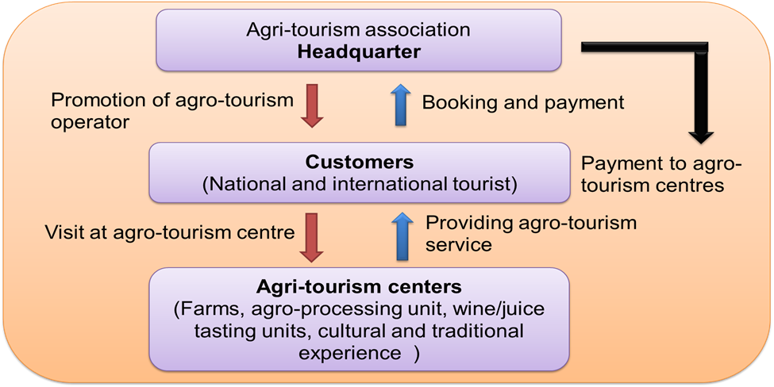
5) Infrastructure required:
- To provide lodging facility to tourists
- To provide water fresh farm produce to customers
- To give cooking facilities to the tourists
- To provide first aid box in case of emergency
- To provide bullock carts horse ride to visitors
- To give information about sericulture
- To give jungle animals to entertain visitors.
- To provide authentic food items of rural taste for breakfast lunch and dinner
- To provide about the culture festivals of that area
- To offer rural special items as a commercial venture
- To provide safety to tourist in case of animal attack or terror threat
- To sale the handicrafts prepared by villagers
- To offer pollution free environment to them
- To make tourist busy and enjoy village arts
- To provide logistic facility to visitors if they are in remote places
5.1) Benefits of Agri-ecotourism:
- Employment facilities to be given to villagers as additional income
- Farmers can improve their standard of living
- To boost economic development and improve skill of rural people
- To give special attention to the lodges new look to comfort homely feel
5.2) Major findings in promotion of Agri-ecotourism:
- Lack of perfect knowledge about the agro tourism
- Weak communications skill and lack of commercial approach of the small farmers
- Lack of capital to develop basic infrastructure for agro tourism
- Ignorance of farmers regarding to the such type of activities
- Presence of unorganized sector in the agro tourism industry
- Ensuring hygiene and basic needs considering urban visitors
- 80% farmers have small holdings and their job is hand to mouth cannot give more to visitors as per their expectations
- Many of our farms face drought almost every year and sometimes excessive rains causing even more hardship and cannot think to earn extra money by agro tourism is the real fact.
5.3) Suggestions for promotions in Agri-ecotourism:
- Small farmers with small holdings can form cooperative society to establish agro tourism center
- Give a wide publicity in media print and electronic so as to get more tourists.
- Develop contacts with schools colleges NGOs clubs union etc.
- Train your staff or family members for receptions and hospitability
- Assess the needs of customers what they want and expect from visitors
- Charge rent or facilities reasonably and affordable
- Train educated farmers on development of IT and innovations and websites
- Develop good relations between customers and hosts farmers • Develop agro tourism package for different types of people
- Preserve address book notes comments tourists etc. for record
- Behave well with customers as farmers are not so educated.
6) Initiatives to boost agro-ecotourism in Kerala:
6.1) Kerala has taken several initiatives to boost agro-tourism, including:
Responsible Tourism (RT) Mission: This initiative aims to integrate local communities and promote sustainability. The RT Mission has developed packages like "Village Life Experience at Kumarakom" and "A Day with Farmers". These packages offer tourists the chance to experience village life and farm activities.
6.2) Kerala Agri Tourism Network:
This network aims to blend agriculture and tourism activities without harming farming practices. The network plans to set up 500 farm tourism units and 5,000 homestay farms.
6.3) Subhiksha Keralam project:
This project aims to encourage self-sufficiency in farming and bring about food security.
6.4) Concessions for the tourism sector: These concessions include subsidies for project reports, investment subsidies, incentives for training local manpower, and allocation of land at concessional rates.
Agri-tourism is a unique blend of agriculture and tourism that allows visitors to connect with the land and learn about native agricultural practices. It can also be a vital source of income for farms.
7) Agriculture Extension in South Asia model on Agri-tourism:
The benefits of tourism are well known as it boosts regional development by developing infrastructure, increasing government earnings and revenues through foreign exchange, providing employment to local population, besides enabling lasting peace in conflict ridden areas. Therefore, governments should take up agritourism as a new thrust area and all the stakeholders should take responsibility to promote agritourism. The following steps are critical.
- Agripreneurs should join hands with tourism industry for services;
- Efforts should be made to train local manpower to enter this industry in large numbers;
- Better sharing and dissemination of information on Agritourism through internet and satellite channels;
- Offers made available through major tour operators. They sell it along with other holiday packages;
- The Department of Tourism promoting India as an Agritourism destination in the international market.
The capacities of Extension and Advisory Services (EAS) in this area need to be considerably enhanced in order to identify, encourage, and support farmers and agripreneurs who could potentially initiate agrotourism enterprises. We need specific training modules and programmes for training of trainers in this area so that EAS providers can organize training and capacity building of farmer groups. When this happens we can look forward to an exciting journey where farmers become agripreneurs offering agritourism that can enhance the tourism potential of India to its fullest in a sustainable manner. This is a win-win for both the economy and society as a whole.
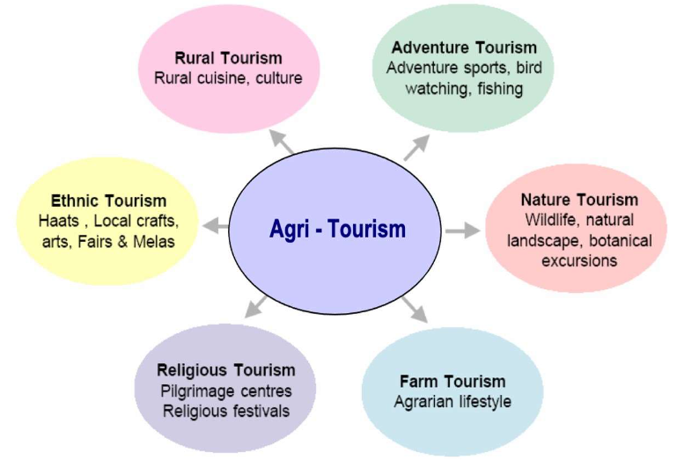
Figure 2: Agri-tourism components
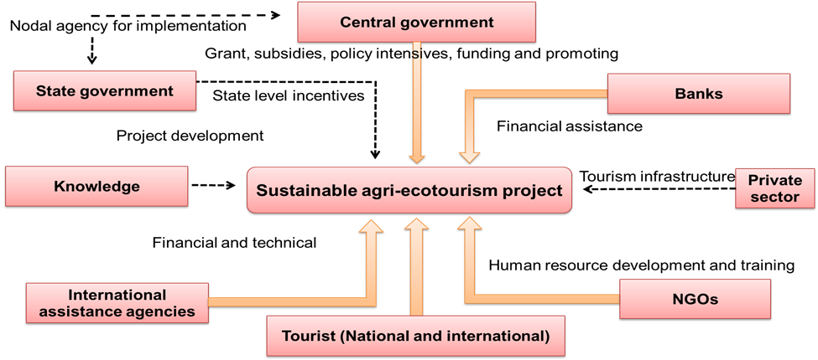
Figure 3: Conceptual framework of Agri-tourism by AESA
8) Learning about Agri-ecotourism through the Dale’s cone of experience:
Edgar Dale's Cone of Experience is a visual model that illustrates how learning experiences progress from concrete to abstract. It's also known as the "Cone of Learning" or the "Learning Pyramid".
The Cone of Experience is based on the idea that people retain more information by doing things than by hearing, reading, or observing. The model's stages are arranged from the most concrete experiences at the bottom to the most abstract at the top.
- Concrete experiences
At the bottom of the cone, these are experiences that involve seeing, handling, tasting, touching, feeling, and smelling.
- Verbal symbols
At the top of the cone, these are highly abstract experiences that involve words, speech, or auditory language.
The Cone of Experience is a useful tool for instructional designers and L&D professionals to incorporate the right audiovisual materials into their teaching. For example, study trips are a level on the cone that allow learners to observe real-world situations and activities.

Figure 4: Dales cone of experience
9) Annual tourist visits in India and Rajasthan:
- India
According to the World Economic Forum's Travel and Tourism Development Index (TTDI) 2024 report, India is ranked 39th out of 119 countries. In 2021, India was ranked 54th.
- Rajasthan
In 2023, Rajasthan saw 179 million domestic tourists and 1.7 million international tourists. This is a significant increase from 2020, when 15.1 million domestic tourists visited the state. The number of foreign tourists has also increased since the pandemic.
Rajasthan's tourism sector contributes about 12% to the state's GDP. The state is a popular tourist destination for both Indians and foreigners, and is known for its many famous temples and Sufi shrines.
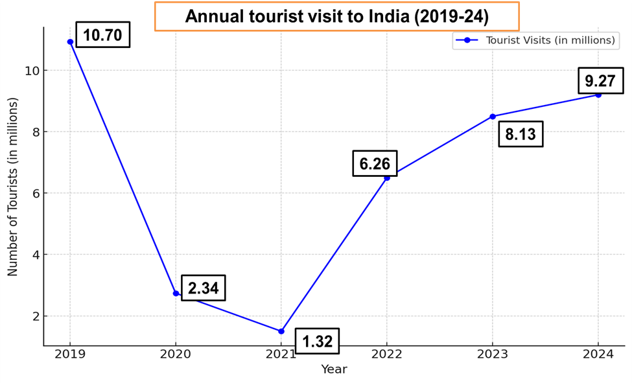
Figure 5: Annual tourist visit graph to India

Figure 6: Annual tourist visit in Rajasthan

Figure 7: Annual agriculture tourist visit in Rajasthan
10) Geographical Indication (GI) Tags of Rajasthan:
A Geographical Indication (GI) tag is a name or symbol given to a product by the government that indicates its origin or geographical location. GI tags are used to certify that a product is made using traditional methods, has specific qualities, or has a reputation based on its geographical origin.
10.1) GI tags can be used for a variety of products, including:
- Agricultural products
- Foodstuffs
- Handicrafts
- Industrial products
- Musical instruments
- Manufactured items.
10.2) Notable GI Tags of Rajasthan:
A) The Geographical Indication (GI) tag for Sojat mehndi is a form of intellectual property that protects the product, its producers, and the region's cultural heritage:
- Product protection
The GI tag ensures that only henna produced in the Sojat region using traditional methods can be labeled as Sojat mehndi. This protects the product from surrogate products.
- Producer protection
The GI tag gives producers a premium price and protects their ownership rights.
- Cultural heritage
The GI tag symbolizes the connection between the region and its traditional practices.
- Economic development
The GI tag promotes economic development in the local community.
- Consumer protection
The GI tag provides consumers with a guarantee of authenticity and quality.
Sojat mehndi is a world-famous henna product from Rajasthan that's known for its deep, burnt-red stain. It's used by women on their hands and men on their fingertips for weddings, festivals, and other special occasions.
The GI tag for Sojat mehndi was registered by the Mehndi Vyapar Sangh Samiti, Sojat, Rajasthan, and the state's Department of Science and Technology. The tag is valid for 10 years and can be renewed.
B) The Geographical Indication (GI) tag for Bikaneri bhujia was granted in 2008 or 2010 to ensure that only authorized users or people living in the geographic territory can use the name:
- What it means
The GI tag protects the distinctiveness of the product name.
- Who applied
The Bikaneri Bhujia Udhyog Sangh of Bikaner, Rajasthan applied for the GI tag.
- How it's made
Bikaneri bhujia is made from moth beans, gram flour, spices, and oil, and is often served with tea. The groundnut oil used to cook it is made from groundnuts grown in Bikaner.
- History
The first batch of bhujia was made in 1877 during the reign of Maharaja Shri Dungar Singh.
- Significance
Bikaneri bhujia is a popular snack and calling card of the city of Bikaner.
11) Role of Extension Advisory System in Promotion of Agri-ecotourism:
The Extension Advisory System (EAS) play a significant role in promoting agri-ecotourism by connecting agricultural knowledge and resources with tourism opportunities, thereby fostering sustainable rural development. Here are some key ways in which the EAS contributes to agri-ecotourism:
- Awareness and Training: The EAS can educate farmers and rural communities about agri-ecotourism, helping them understand its potential as an income source. Through workshops and training sessions, extension advisors can teach local farmers about hosting visitors, showcasing traditional agricultural practices, and promoting the area's natural and cultural heritage.
- Capacity Building: Extension advisors can train local farmers in skills such as hospitality management, eco-friendly practices, and marketing. They can guide farmers on how to improve basic amenities and develop activities like guided farm tours, nature walks, animal feeding sessions, and hands-on agricultural experiences for tourists.
- Sustainable Practices: EAS can support agri-ecotourism by promoting sustainable farming practices that align with environmental conservation. By introducing organic farming, water conservation, crop diversification, and soil preservation, extension advisors help maintain the natural resources essential for sustainable tourism.
- Marketing and Partnerships: Extension services can assist farmers in establishing partnerships with local tourism boards, travel agencies, and online platforms to promote their offerings. They can also guide them on using social media and other online platforms to reach wider audiences, which is vital for attracting tourists.
- Infrastructure Development: EAS can work with local governments and organizations to improve infrastructure in rural areas, such as roads, signage, and basic facilities that enhance the visitor experience. Improved infrastructure can make agri-ecotourism sites more accessible and comfortable for tourists.
- Cultural Preservation and Interpretation: Extension advisors can help farmers incorporate their local traditions, agricultural practices, and cultural heritage into the tourism experience. This not only enhances the tourist’s experience but also preserves and promotes the unique cultural identity of the rural community.
- Economic Diversification and Income Generation: Through EAS, farmers learn to diversify their income sources beyond traditional agriculture by adding agri-ecotourism. This creates a sustainable economic model that reduces their dependency on crop yields alone, which can be especially valuable in areas facing climate change impacts.
- Support in Policy and Financial Access: Extension advisors can also provide information on available government schemes, grants, or loans that support agri-ecotourism ventures. They can assist farmers in understanding policies or in preparing applications to access financial support.
12) Funding agencies in Promotion of Agri-ecotourism:
Various funding agencies at national and international levels support the promotion of agri-ecotourism. These agencies provide financial assistance, technical support, and resources to help farmers and rural communities develop sustainable tourism ventures. Here are some key agencies involved in promoting agri-ecotourism:

12.1) Government Schemes and Agencies
- Ministry of Tourism (India): Through schemes like the Swadesh Darshan and Prashad (Pilgrimage Rejuvenation and Spiritual, Heritage Augmentation Drive) schemes, the Ministry of Tourism provides financial assistance to states and Union Territories for developing sustainable tourism infrastructure, including agri-ecotourism.
- Ministry of Agriculture & Farmers Welfare (India): Through programs such as the National Rural Livelihood Mission (NRLM) and schemes aimed at rural entrepreneurship, the Ministry supports rural communities and encourages farm-based tourism.
- National Bank for Agriculture and Rural Development (NABARD): NABARD offers grants and loans for rural development projects, including agri-ecotourism. It funds initiatives that diversify income sources for farmers and promote sustainable development in rural areas.
- Small Farmers’ Agribusiness Consortium (SFAC): SFAC provides financial support to farmer producer organizations (FPOs) and agri-entrepreneurs. Through its Venture Capital Assistance Scheme, it offers funds to farmers for setting up agri-businesses that include agri-tourism components.

12.2) International Funding Agencies and Development Banks
- World Bank: Through its Rural Development Program and eco-friendly tourism projects, the World Bank supports rural communities in developing tourism-related initiatives, including agri-ecotourism. It provides technical assistance, infrastructure funding, and loans to help develop sustainable tourism.
- Asian Development Bank (ADB): ADB funds projects related to rural development, environmental sustainability, and eco-tourism. It supports local and state governments in developing infrastructure for sustainable tourism and provides financial and technical assistance.
- International Fund for Agricultural Development (IFAD): IFAD supports smallholder farmers and rural entrepreneurs through grants and loans, encouraging projects that link agriculture with tourism. IFAD’s programs emphasize sustainable development and poverty alleviation, often integrating eco-tourism elements.
- United Nations Development Programme (UNDP): Through its Sustainable Tourism and Biodiversity projects, UNDP funds ecotourism initiatives worldwide. In rural areas, it promotes community-based tourism by providing grants, technical training, and project management support.

12.3) Private Sector and Non-Governmental Organizations (NGOs)
- WWF (World Wildlife Fund): WWF funds ecotourism projects that aim to conserve biodiversity, often working with local communities to promote sustainable tourism that includes agri-ecotourism components.
- The Nature Conservancy (TNC): TNC supports sustainable tourism projects that preserve ecosystems and biodiversity. It provides grants and expertise to rural communities, including those interested in developing agri-tourism as part of eco-tourism ventures.
- Global Environment Facility (GEF): GEF provides funding for projects that focus on environmental sustainability and biodiversity conservation, which often includes eco-tourism and agri-ecotourism initiatives. It partners with UNDP, the World Bank, and other agencies to support these projects.
- International NGOs (e.g., Oxfam, CARE): These organizations fund rural development projects that promote sustainable livelihoods, including agri-ecotourism. They often focus on supporting women and marginalized communities in rural areas.

12.4) Corporate Social Responsibility (CSR) Initiatives
- Many corporations support agri-ecotourism through CSR initiatives, especially those in the agriculture, travel, and hospitality sectors. Companies may fund training programs, infrastructure development, or marketing campaigns for agri-ecotourism as part of their CSR commitments to sustainable development.

12.5) Crowd funding and Philanthropic Platforms
- Platforms like Kiva, GoFundMe, and Kickstarter: These platforms allow rural entrepreneurs and communities to raise funds for agri-ecotourism projects. Crowdfunding can be an effective way for communities to secure small investments for eco-friendly projects or to create partnerships with socially conscious travelers and investors.

12.6) Regional Development Agencies and Tourism Boards
- State and Regional Tourism Boards (e.g., Maharashtra Tourism Development Corporation, Kerala Tourism): Many tourism boards at the state and regional levels fund agri-ecotourism initiatives to attract tourists to rural areas, offering grants and promotional support to local agri-ecotourism ventures.
- European Union (EU) Rural Development Program: The EU funds rural tourism and agri-ecotourism projects as part of its rural development policy. It provides financial assistance for sustainable tourism infrastructure and community development in rural areas within EU member countries.

12.7) Academic and Research Grants
- Universities and Research Institutes: Some academic institutions provide research grants and technical support for projects that explore sustainable tourism, rural development, and agri-ecotourism. These grants support pilot projects and feasibility studies, often leading to further funding from larger organizations.
13) Contribution of state tourism development in Promotion of Agri-ecotourism:
State tourism development plays a crucial role in promoting agri-ecotourism by creating supportive infrastructure, policy frameworks, and marketing initiatives that encourage tourists to explore rural and agricultural areas. Here are the key contributions of state tourism development in promoting agri-ecotourism:

13.1) Policy and Regulatory Frameworks
- Incentives for Rural Tourism: Many state governments implement policies that offer tax breaks, subsidies, or financial incentives to rural communities and farm owners who develop agri-ecotourism ventures. This support encourages local stakeholders to diversify into tourism and ensures tourism aligns with sustainable practices.
- Zoning and Land Use Regulations: State tourism departments collaborate with local authorities to designate areas suitable for agri-ecotourism, ensuring that tourism activities do not negatively impact agricultural lands or ecosystems.

13.2) Development of Infrastructure
- Transportation and Connectivity: State tourism development bodies often invest in road infrastructure, signage, and public transportation routes that connect urban areas to rural destinations. Improved connectivity makes it easier for tourists to visit agri-ecotourism sites.
- Basic Amenities and Facilities: State tourism departments frequently fund the development of essential amenities such as clean water, sanitation, waste disposal, and electricity at agri-tourism sites. These improvements ensure a comfortable and enjoyable experience for visitors.

13.3) Training and Capacity Building
- Hospitality and Customer Service Training: State tourism bodies organize workshops and training sessions for local farmers and rural communities to help them learn hospitality skills, safety standards, and customer service. This capacity building enhances their ability to host tourists and manage their facilities effectively.
- Sustainable Agricultural Practices: Training on sustainable and eco-friendly agricultural practices helps farmers align their operations with ecotourism principles. This may include organic farming, water conservation, and responsible waste management, making the farm experience more authentic and attractive for eco-conscious visitors.

13.4) Marketing and Promotion
- State Tourism Campaigns: Many state tourism boards, such as Kerala, Maharashtra, and Himachal Pradesh in India, promote agri-ecotourism destinations through official campaigns, digital platforms, and advertisements. They highlight the unique experiences that agri-ecotourism offers, such as farm stays, hands-on farming, and nature-based activities.
- Collaborations with Travel Platforms: State tourism boards partner with travel agencies, websites, and online booking platforms to create tour packages that feature agri-ecotourism activities. These collaborations increase visibility for rural destinations and make it easier for tourists to discover and book agri-ecotourism experiences.

13.5) Financial Support and Incentives
- Funding and Grants: Many state governments provide financial grants or low-interest loans to local entrepreneurs, farmers, and cooperatives looking to develop agri-ecotourism ventures. This financial assistance helps cover initial costs such as infrastructure, marketing, and operational expenses.
- Insurance and Risk Management: Some states offer subsidized insurance options to rural tourism operators, reducing the financial risks associated with new tourism ventures. This enables farmers to feel more secure when investing in agri-ecotourism.

13.6) Promotion of Cultural Heritage and Traditional Knowledge
- Preservation of Local Culture: State tourism development promotes local crafts, cuisine, and folk traditions as part of the agri-ecotourism experience. This preserves the region’s cultural heritage while offering visitors a unique experience.
- Support for Agri-based Events and Festivals: Many states organize or sponsor local agricultural fairs, harvest festivals, and rural tourism events, which showcase traditional farming methods, local cuisine, and artisan products. These events draw tourists to rural areas and contribute to the promotion of agri-ecotourism.

13.7) Sustainability Initiatives
- Environmental Standards and Certification: Some state tourism boards implement certification programs for agri-ecotourism providers that follow eco-friendly practices. By setting and enforcing sustainability standards, they encourage responsible tourism that preserves rural landscapes and ecosystems.
- Promotion of Responsible Tourism Practices: State tourism boards often encourage responsible tourism practices, such as waste reduction and conservation efforts, among visitors to agri-ecotourism sites. They might provide educational materials or guidelines to ensure that tourists respect the environment.

13.8) Public-Private Partnerships
- Collaboration with Private Sector and NGOs: State tourism departments often collaborate with private companies, NGOs, and cooperatives to promote and support agri-ecotourism initiatives. These partnerships bring in resources, expertise, and marketing power that benefit both the rural community and tourism industry.
- Promotion of Cooperative Models: By supporting cooperative models, state tourism boards encourage local farmers to pool resources, share knowledge, and collectively manage tourism activities. This collaboration helps reduce individual costs and enables a more cohesive tourism experience.

13.9) Digital and Technological Support
- Digital Marketing and Online Presence: Many state tourism bodies assist rural tourism providers in establishing an online presence through websites, social media, and e-marketing platforms. These initiatives help rural agri-ecotourism sites attract a broader audience, including international tourists.
- Smart Tourism Tools: Some states promote the use of mobile applications, QR codes, and virtual tours to enhance the tourist experience. These tools offer additional information about agri-ecotourism activities, history, and local practices, enriching the visitor experience.

13.10) Examples of State Contributions to Agri-Ecotourism
- Maharashtra (India): The Maharashtra Tourism Development Corporation (MTDC) has pioneered agri-tourism in India with its Agri-Tourism Development Program, which provides financial incentives, training, and marketing support to farmers. It also conducts the annual Agri-Tourism Festival to promote rural tourism.
- Kerala (India): Kerala Tourism promotes "Responsible Tourism" initiatives, which link local agriculture with tourism. The state’s focus on sustainability has led to programs where tourists can engage in traditional farming practices, enjoy local food, and explore eco-friendly accommodations.
- Himachal Pradesh (India): The state tourism department actively supports agri-ecotourism through schemes that promote farm stays and orchard tours in its rural areas. Himachal Pradesh Tourism focuses on using digital platforms to attract tourists interested in mountain farming and organic produce.
State tourism development agencies thus play a foundational role in shaping agri-ecotourism through policy support, infrastructure development, and innovative marketing. Their involvement ensures that agri-ecotourism grows as a sustainable, inclusive, and economically beneficial sector, bringing new opportunities to rural communities.
14) Case Study- I: Community-Based Agro-Ecotourism Sustainability in West Java, Indonesia (Djuwendah et al., 2023)
14.1) Objective of the study: Assessing sustainability, identifying sensitive attributes and contributing to policy development in the context of community based agro-ecotourism
14.2) Materials and methods:
- Survey method: 237 respondents, including stakeholders - tourism village officials, community leaders, homestay owners, artists, culinary business groups, and local farmers
- Sampling done by Survey and Strategic zoning in West Java
- Analysis techniques used:
- Multi-Dimensional scaling (MDS)
- Monte carlo simulations
14.3) Conceptual framework by author:
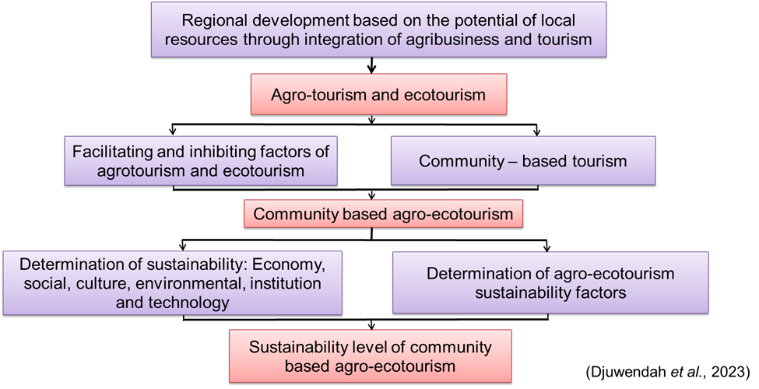
Figure 8 : Conceptual framework
14.4) Result:
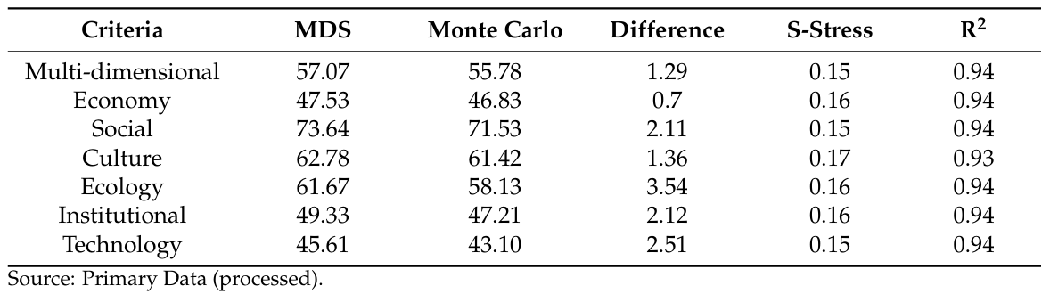
Table 2: Community-based agro-ecotourism sustainability in West Java
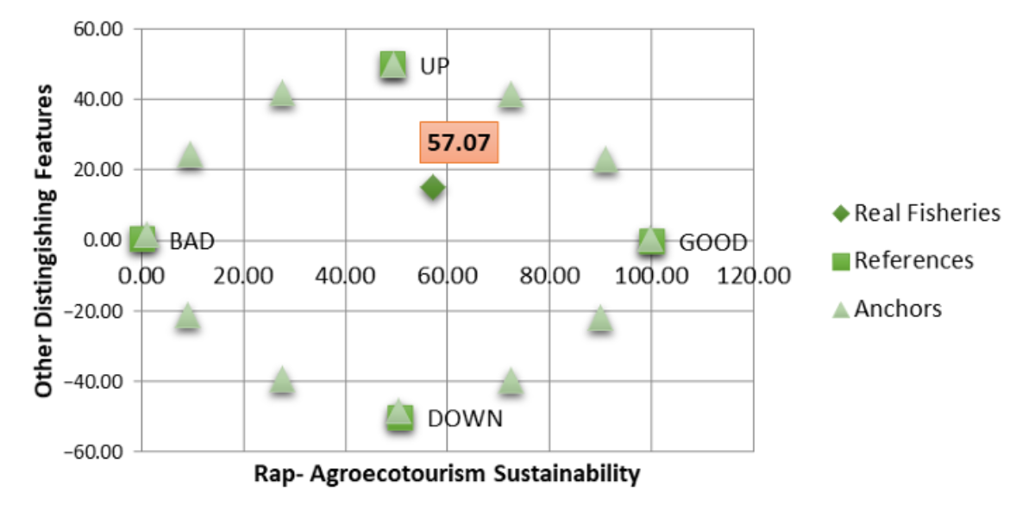
Figure 9: Community based Rap-agroecotourism sustainability index

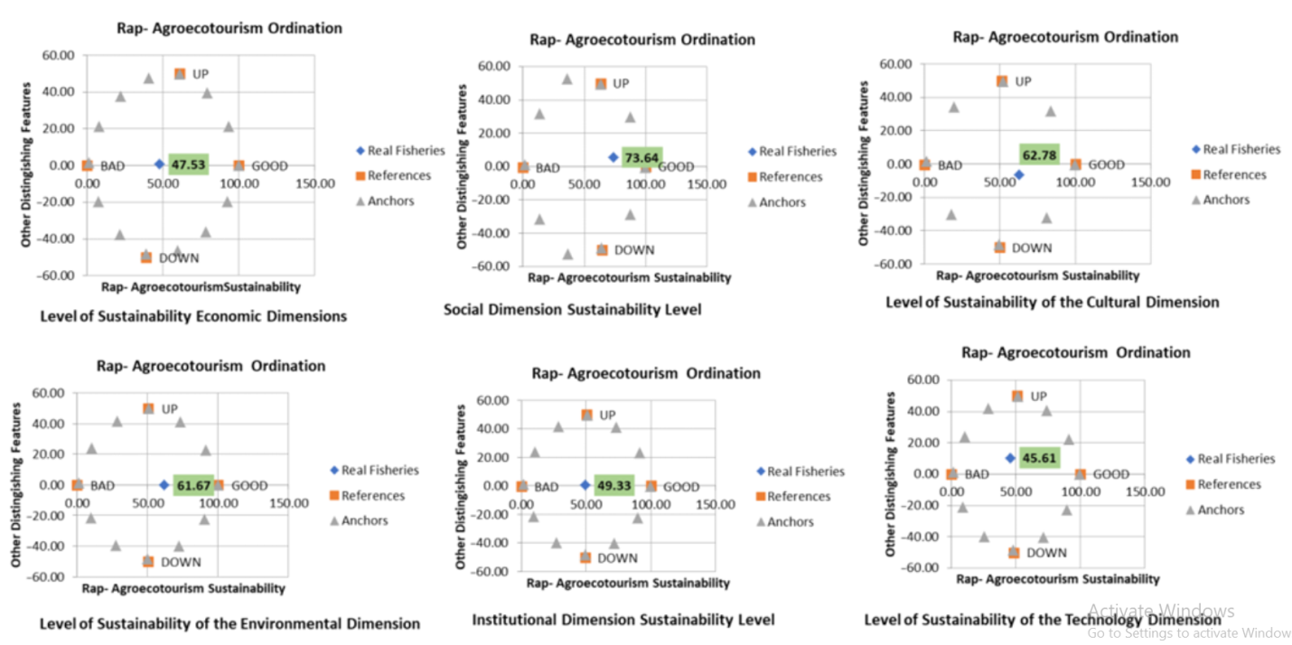
Figure 10: Community based agro-ecotourism sustainability index
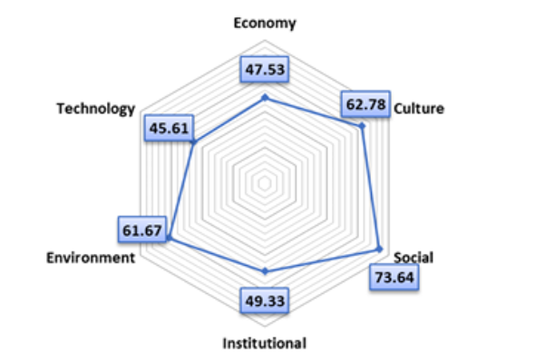
Figure 11: Result outcome

14.5) Conclusion:
- Community-based agro-ecotourism in West Java is moderately sustainable, with key areas for improvement in technology, economy, and institutions
- Critical factors include transportation, waste management, external partnerships, and cultural preservation
- Policy efforts should prioritize eco-friendly agriculture, cultural traditions, and enhanced technological infrastructure for long-term sustainability
15) Case Study-II: Assessing Sustainable Ecotourism Opportunities in Western Rajasthan, India, through Advanced Geospatial Technologies (Chandel et al., 2023)
15.2) Objective of the study: Using advanced geospatial technologies to assess sustainable ecotourism opportunities identify and evaluate potential sites for ecotourism development in western Rajasthan
15.3) Materials and methods:
Study area: Western part of Rajasthan-
- Jodhpur
- Jaisalmer
- Bikaner
- Barmer
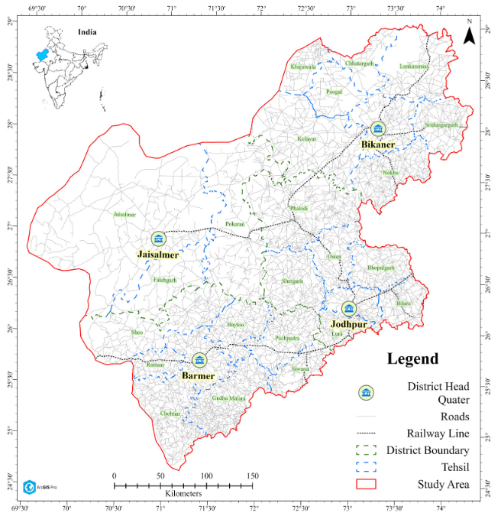
Figure 12: Map of locality
These 4 major districts cover around 1lakh 18 thousand 5 hundred 82 meter square of area in Western Rajasthan.
Software Utilization:
- Arc GIS 10.8
- ERDAS Imagine 2015 software for data processing and analysis
15.4) Data collection and their sources:
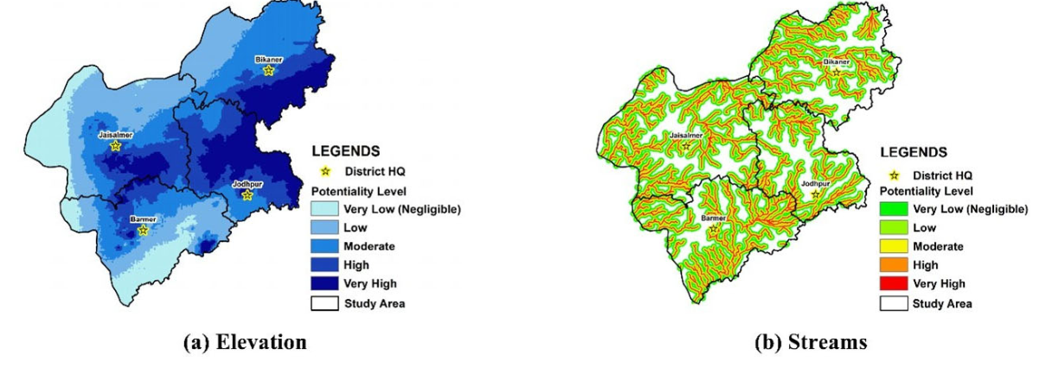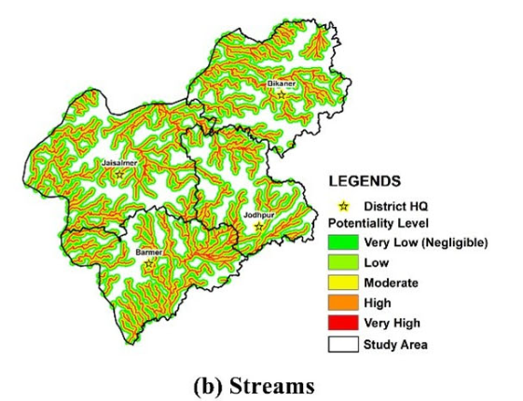
DEM (SRTM) (30 × 30 m) resolution
U.S. Geological Survey
Theme weightage
Figure 13: Data collection sources U.S. Geological survey & Theme weightage
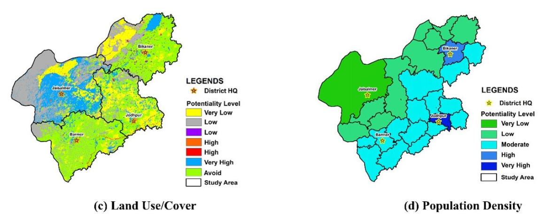
Census of India, 2011
ERDAS Imagine 2015 and Arc GIS 10.8 software
Figure 14: Data collection sources ERDAS Imagine 2015, Arc GIS 10.8 software & Census of India

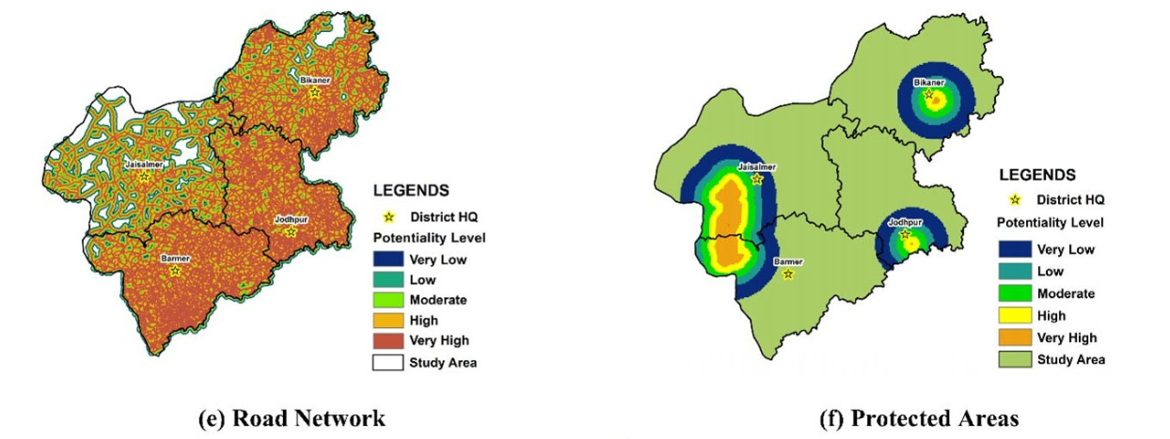
ENVIS centre of wildlife and protected areas
Theme weightage
Figure 15: Data collection sources Theme weightage & ENVIS

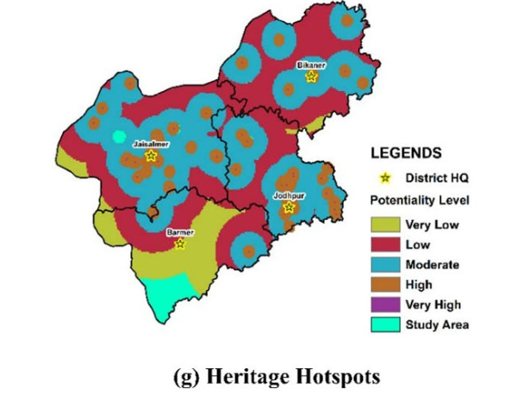
Field Survey with GNSS
Figure 16: Data collection sources Field survey with GNSS

15.5) Result:
The study "Assessing Sustainable Ecotourism Opportunities in Western Rajasthan, India, through Advanced Geospatial Technologies" concludes that Western Rajasthan has substantial potential for sustainable ecotourism. Using geospatial techniques like GIS and weightage sum overlay analysis, the study identified five classes of suitability for ecotourism: very high, high, moderate, low, and very low suitability. The regions with very high suitability (37.31%) are mainly in Bikaner and Jaisalmer, while areas with high suitability (26.85%) are in Jodhpur, Barmer, and Bikaner. Moderate and low suitability areas are concentrated in Barmer and Jaisalmer, affected by factors such as infrastructure limitations and extreme weather.
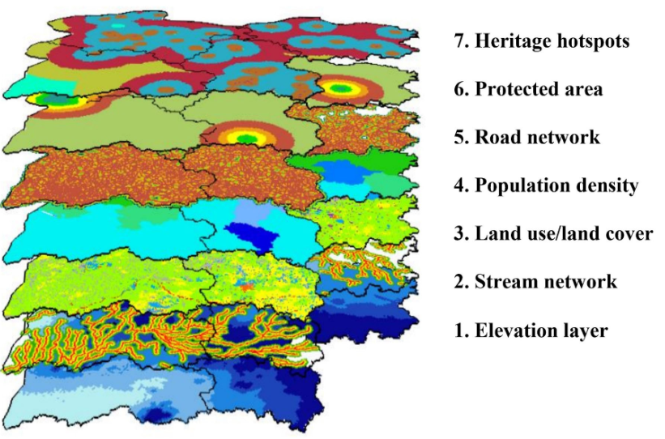
Weightage sum overlay analysis
Figure 17: Result weightage sum overlay analysis
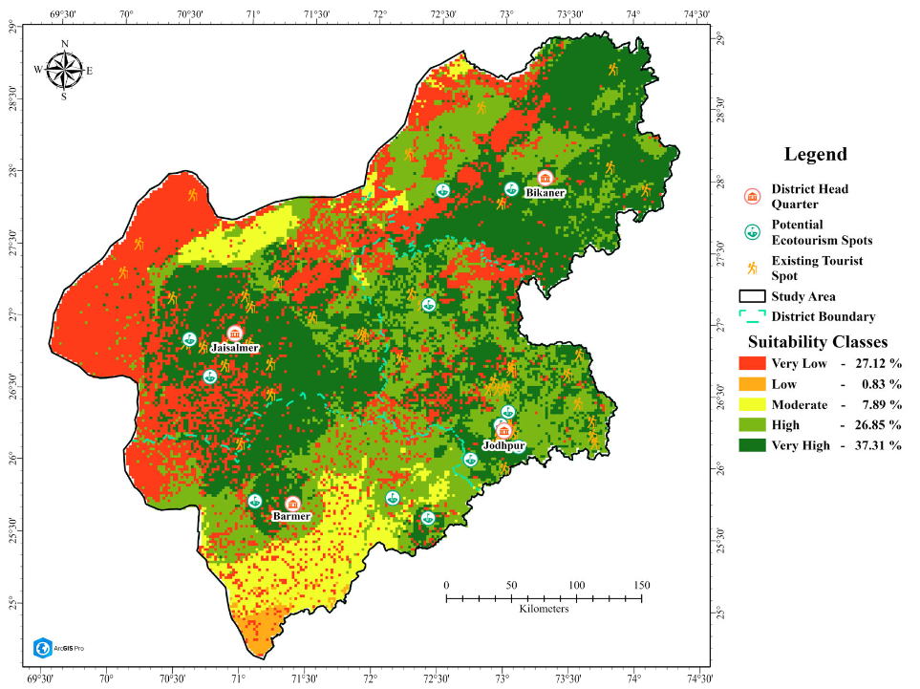

Figure 18: Suitability Map

16) Conclusion:
The conclusion highlights the importance of sustainable ecotourism management to ensure minimal environmental impact and to foster socioeconomic benefits for local communities. Recommendations include developing infrastructure, promoting cultural heritage, creating eco-friendly transport options, and ensuring local community involvement in tourism activities. This integrated approach aims to balance tourism growth with environmental conservation, thereby supporting long-term sustainability in ecotourism. The study suggests that such geospatial assessments can inform policy and investment decisions to boost sustainable tourism in regions with similar ecological and cultural richness​

Agri-ecotourism offers substantial socio-economic benefits, particularly in rural areas, by providing alternative sources of income and supporting local economic development. By integrating agriculture and tourism, it creates new opportunities for small-scale farmers, artisans, and local businesses, helping to diversify income streams and reduce economic vulnerability. Additionally, agri-ecotourism plays a crucial role in preserving cultural heritage and traditional practices, as it allows visitors to engage with local customs, cuisine, farming techniques, and crafts, thereby maintaining the region's cultural identity. Beyond its economic and cultural advantages, agri-ecotourism also promotes environmental sustainability. It encourages responsible travel practices, raising awareness among tourists about the importance of preserving natural landscapes, biodiversity, and agricultural ecosystems. The implementation of sustainable practices, such as organic farming, water conservation, and waste management, aligns with the broader goals of environmental protection, making agri-ecotourism a model for sustainable rural development. However, to maximize the benefits of agri-ecotourism and ensure its long-term viability, a balanced approach is essential. Active stakeholder engagement is crucial, involving local communities, government bodies, and tourism operators in the planning and development processes. This collaborative approach helps align the interests of different groups and ensures that the benefits of agri-ecotourism are equitably distributed. Furthermore, investing in infrastructure improvements, such as better road access, accommodation facilities, and communication networks, is vital to enhance the overall visitor experience and increase the sector's appeal. The development of sustainable policies is another critical aspect of a successful agri-ecotourism strategy. These policies should focus on preserving the environment, protecting cultural heritage, and promoting inclusive growth. By setting clear guidelines and standards, policymakers can help maintain the quality and integrity of agri-ecotourism experiences, preventing issues like over-tourism and environmental degradation. In conclusion, agri-ecotourism presents a unique opportunity to drive socio-economic development, cultural preservation, and environmental sustainability in rural areas. A holistic approach that prioritizes stakeholder collaboration, infrastructure development, and sustainable policy-making is key to unlocking its full potential. By doing so, agri-ecotourism can provide a resilient and sustainable path for rural communities, ensuring that the benefits are shared widely while safeguarding the cultural and natural resources that make these destinations unique and attractive to visitors.

COMPETING INTERESTS DISCLAIMER:
Authors have declared that they have no known competing financial interests OR non-financial interests OR personal relationships that could have appeared to influence the work reported in this paper.
17) Reference:
- Arroyoa, Claudia Gil, Barbieri, Carla and Rich, Samantha Rozier (2013). Defining agritourism: A comparative study of stakeholders’ perceptions in Missouri and North Carolina, Tour. Mgmt., 37: 39-47.
- Augustyn, M. 1998. National strategies for rural tourism development and sustainability: The polish experience. J. Sustain. Tour. 6(3): 191–209.
- Brune, S., Knollenberg, W., and Vila, O. 2023. Agritourism resilience during the COVID-19 crisis. Ann. Tour. Res. 99: 103538.
- Budeanu, A. (2015). Sustainable tourism, progress, challenges, and opportunities: introduction to this special volume. Journal of Cleaner Production. https://doi.org/10.1016/j.jclepro.2015.10.027.
- Chandel, R. S., Kanga, S., Singh, S. K., Durin, B., Orsulic, O. B., Dogancic, D., and Hunt, J. D. 2023. Assessing sustainable ecotourism opportunities in Western Rajasthan, India, through advanced geospatial technologies. Sustainability 15: 11473.
- Chandel, R.S.; Kanga, S. Sustainable Management of Ecotourism in Western Rajasthan, India: A Geospatial Approach. Geo-J. Tour. Geo-Sites 2020, 29, 521–533.
- Chandel, R.S.; Kanga, S.; Singh, S.K. Impact of COVID-19 on Tourism Sector: A Case Study of Rajasthan, India. AIMS Geosci. 2021, 7, 224–243.
- Chavan, R. R., Bhola, S. S. (2015). Indian Tourism Market: An Overview of Emerging Trends and Development Indian Tourism Market: An Overview of Emerging Trends and Development. Global Journal of Commerce and Management Perspective. 3(4). Pg. 113–122.
- Dercan, B., Gataric, D., Bubalo Zivkovic, M., Belij Radin, M., Vukoicic, D., and Kalenjuk Pivarski, B., et al. 2023. Evaluating farm tourism development for sustainability: A case study of farms in the peri-urban area of Novi Sad (Serbia). Sustainability 15: 12952.
- Djuwendah, E., Karyani, T., Wulandari, E., and Pradono, P. 2023. Community-based agro-ecotourism sustainability in West Java, Indonesia. Sustainability 15: 10432.
- Ficci (2017). Report on Agro tourism advantages in Rajasthan. 14. https://www.tourism.rajasthan.gov.in/annual-progress-report.html/ .Accessed/.Accessed 31 August 2022.
- Ghatage, D. L. N., Kumbhar, V. M. (2015). Growth and Performance of Tourism Industry in India. Hameed, B., Khalid, A. (2018). Impact of Ecotourism in Ensuring the Sustainable Development of Tourism Industry in India. International Journal of Recent Research Aspects. 5(2). Pg. 46–50.
- Gossling, S. (1999). ‘Ecotourism: a means to safeguard biodiversity and ecosystem functions?’, Ecological Economics, 29, 303-320.
- https://timesofindia.indiatimes.com/city/jaipur/Rajasthanto-promote-agri tourism-in-bigway/articleshow/55390155.cms/.Accessed 3 September 2022.
- https://www.researchgate.net/publication/352166661_Agrotourism_in_Rajasthan_A_way_to_bring_down_issues_in_our_surrounding_ environment/.Accessed 1st September 2022.
- https://www.statista.com/statistics/1026993/india-tourist-arrivals-in rajasthan-by/Acse/. Accessed 1 September 2022.
- Ingavale, D. (2015). Agri Tourism – A Business Model of Agri Tourism Development Corporation. PARIPEX-INDIAN JOURNAL OF RESEARCH. 4(1). Pg. 76–77.
- Jagtap, M. D., Nichit, M. B., Benke, S. R. (2010). Agrotourism: The performance, problems, and prospects for the farmers in Maharashtra. International Journal of Commerce and Business Management. 3(1). Pg. 153–156.
- Kapoor, Bharat., Chauhan, Parminder. (2017). Opportunities and Challenges of Rural Tourism in Rajasthan. International Journal of Research in Economics and Social Sciences. 7(1). Pg. 1–13.
- Khangarot, G., & Sahu, P. (2019). Agro-Tourism: A dimension of sustainable tourism development in Rajasthan. JIMS 8M, 24(4), 21. https://doi.org/10.5958/0973-9343.2019.00030.9
- McLaren, D. Rethinking Tourism and Ecotravel; Kumarian Press: West Hartford, CT, USA, 1998.
- Phillip, Sharon, Hunter, Colin and Blackstock, Kirsty (2010). A typology for defining agritourism. Tour. Mgmt., 31(6):754 758 .
- Saxena, G. 2022. Rural tourism in India - A Perspective on the role of rural middle class in engendering the experience economy. In: Indian Tourism. Emerald Publishing Limited, 143-156p.
- Sharma, K.K. & Mehra, S.P. (2009). ‘The Thar of Rajasthan (India): Ecology and Conservation of a desert ecosystem’, in C. Sivaperuman, Q.H. Baqri, G. Ramaswamy, & M. Naseema (eds.), Faunal Ecology and Conservation of the Great Indian Desert, pp. 1-11, Springer-Verlag Berlin Heidelberg.
- Sisodiya, M. S., & Shekhawat, S. (2023). Participatory Extension Approaches: Engaging Farmers in the Extension Process. International Year of Millets 2023, 77.
- Srivastava Surabhi. (2016). Agritourism as a Strategy for the Development of Rural Areas Case Study of Dungrajya Village, Southeast Rajasthan, India. Journal of Medical and Dental Science Research, 3(6), 35–39.
- Suwanna, A., Pisitsenakul, S., & Passadee, L. (2019). Participatory Research in Preparing Sustainable Tourism Strategy Plan in Head Watershed of Chiang Mai, Thailand (pp. 0–16). (conference paper)
- Working plan Jodhpur, 2013-14 to 2022-23, Forest Division Jodhpur, Prepared by M.S. Rathore, Directed by S.K. Jain & A.K. Singh, Project advisor A.C. Chaubey, State Government of Rajasthan.
- www.researchgate.net/figure/Districts-of-Rajasthan-having-potential-of Agro-tourism-Development-Author_fig2_338481029/. Accessed 3 September 2022. https://www.researchgate.net/publication/352166661_Agrotourism_in_Rajasthan_A_way_to_bring_down_issues_in_our_ surrounding_/.Accessed 3 September 2022.

