Original Research Article

A study on labour utilisation patterns in private unorganised swine farms of Andhra Pradesh

ABSTRACT

The current study was aimed at knowing the labour use patterns in private unorganised swine farms of Andhra Pradesh and estimating the optimum human resource requirements for them. It was conducted at the S.N.G Pork centre and V.Y.N Agro Farm located in Tirupati, Andhra Pradesh, India. Unlike the orgnaised farms, the cleaning of pens (performed on alternate days) and feeding (done twice a day) were the only activities performed in the private unorganised swine farms. The total cleaning activity required 3.37 to 5.85 man-minutes/pen and the labour time required for cleaning of passage alley was 1.49 ± 0.13 and 1.16 ± 0.05 man-min in S.N.G Pork centre and V.Y.N Agro Farm, respectively. The time spent on feeding activities as a whole was 1.46 to 1.62 man-minutes/pen/day. It was concluded that cleaning and feeding require 3.37 to 5.85 man-minutes/pen and 1.46 to 1.62 man-minutes/pen/day, respectively. Comparative production and economic studies are needed to justify the high expenditure on labour for scientific management in the organised swine farms.
Keywords: Labour, man-minute, swine, unorganised.

1. INTRODUCTION
The India had around 9.06 million pigs (Anonymous, 2019) which are equivalent to 0.92% of world pig population i.e 979 million (Anonymous, 2024). Despite having restrictions in some religions such as Judaism and Islam, the global pork consumption has increased by 77%, rising from 63.5 million tons in 1990 to 113 million tons in 2022 (Boakye, 2025). Pork contributes to 34% of all meat consumed worldwide and it is second only to the chicken which accounts for 40% (Kim et al., 2024). Around 0.9% of Indian families consume pork and they are concentrated in the sates of Nagaland, Mizoram and Meghalaya (Anonymous, 2014). Pork had a distinct nutrient profile of quality protein, B-complex vitamins, and essential minerals such as Iron and Zinc (Vicente and Pereira, 2024). It is an established fact that the Vitamin B1 (Thiamine) content in pork is higher than that in other meats (Lombardi-Boccia et al., 2005). Pig farming in India is mostly practiced by socio-economically weaker sections (Rajak et al., 2024). Therefore, it can be said that swine farming had the potential to increase nutritional security of India (Reddy et al., 2024) and to improve the economic condition of weaker sections.
Most of the pigs in India are maintained in unorganised sector (Rajak et al., 2024). Payeng et al. (2013) reported that income from piggery in organized sector was higher than that in unorganized one due to less mortality and efficient utilization of resources including labour in the organized sector. Labour is one of the four factors of production, and it is critical for any enterprise including piggery. Present study was designed to know the labour use patterns in private unorganised swine farms of Andhra Pradesh and to estimate the optimum human resource requirements for the farms.

2. MATERIALS AND METHODS
The present study entitled ‘A study on labour utilisation patterns in private unorganised swine farms of Andhra Pradesh’ was conducted at the S.N.G Pork centre and V.Y.N Agro Farm located in Tirupati, Andhra Pradesh, India to know the optimum human resource requirements for various activities in unorganised swine farms.
Both crossbreds and non-descriptive pigs were maintained on the farms. The animal pens of different types such as farrowing, grower and adult animal pens were covered with roof (single slope) made up of asbestos sheets, and they had black marble or concrete flooring. Each pen had water trough and are provided with freshwater throughout the day. The average floor space of a pen was 11.25 m² and 18.2 m² in S.N.G Pork centre and V.Y.N Agro Farm respectively. Only one labour was employed in each farm and he/she was responsible for daily activities like cleaning and feeding operations.
The cleaning (Fig 1) was done once in alternate days. The cleaning activity included cleaning of the floor, water trough, passage alley using water pipe and broom stick. Feeding (Fig 2) was done twice daily i.e. morning and evening and were fed with concentrate mixture and garbage waste. The feed was offered on the floor itself.
No labour was required for breeding activity as the natural service (pen mating) was followed and males and females present in a pen naturally mate when the female is in heat. No special care was given to newborns in the private unorganised farms. There was no weighing balance or weighing room to weigh the animals, the owners roughly estimate the weight based on the size of animal during sale.
The data collected in the present study was subjected to standard statistical techniques such as Mean and Standard Error as per Snedecor and Cochran (1994).
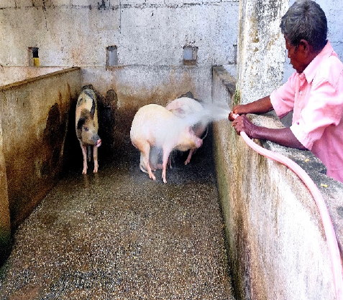 | 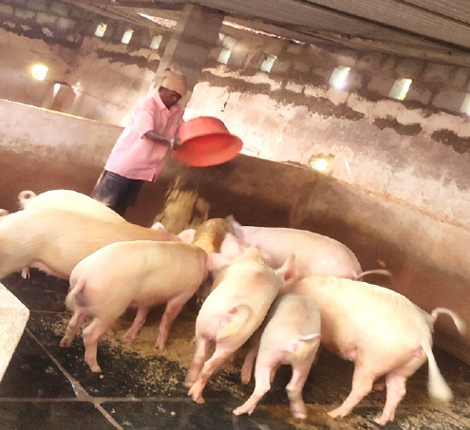
Fig.1 Cleaning of pen | Fig.2 Feeding

3. RESULTS AND DISCUSSION

The present study revealed that cleaning and feeding were the only routine activities in the private unorganised swine farms.
The mean time (man-minutes) spent on cleaning of pens in the private unorganised swine farms was given in Table 1. The average time taken for washing of floor was ranged from 2.88 to 5.53 man-minutes per pen, or from 0.25 to 0.30 man-minutes/m². Reddy et al. (2023) reported similar values of man-min./m². However, Kaswan et al. (2018), Singh et al. (2018) and Greeshma (2023) reported lower values of man-minutes per pen in organised swine farms which might be due to the fact that the labourers in present study applied broom along with water pipe. Also, the cleaning activity in unorganized farms was done in alternate days, so, the degree of faecal contamination was higher. The housing density also might be higher in unorganized farms when compared to the organised ones. The cleaning of water trough took 0.32 to 0.48 man-minutes/pen. The total cleaning activity required 3.37 to 5.85 man-minutes/pen in the private unorganised swine farms. The labour time required for cleaning of passage alley was 1.49 ± 0.13 and 1.16 ± 0.05 man-min in S.N.G Pork centre and V.Y.N Agro Farm, respectively.
Table 1. Mean time (man-minutes) spent on cleaning of pens
Farm | Washing of floor  (man-minutes per pen) | Washing of floor  (man-minutes/m²) | Cleaning of water trough  (man-minutes per pen) | Total  (man-minutes per pen)
S.N.G Pork centre | 2.88 ± 0.18 | 0.25 ± 0.02 | 0.48 ± 0.02 | 3.37 ± 0.17
V.Y.N Agro Farm | 5.53 ± 0.23 | 0.30 ± 0.01 | 0.32 ± 0.01 | 5.85 ± 0.23

The mean time (man-minutes) spent on feeding activity in the private unorganised swine farms was presented in Table 2. The time spent on fetching of feed ranged from 0.66 to 0.75 man-minutes/pen/day, while the distribution of feed required 0.80 to 0.85 man-minutes/pen/day. The time spent on feeding activities as a whole was 1.46 to 1.62 man-minutes/pen/day. Blumauer (2006) and Greeshma (2023) reported lower values in organised swine farms which might be due to use of wheel borrow for fetching of feed in their studies. The present study revealed that there was no difference between morning and evening values of labour time requirements for feeding activities. It was supported by the report of Greeshma (2023) in an organised swine farm. Both cleaning and feeding operations collectively took 4.99 and 7.31 man-minutes/pen/day in S.N.G Pork centre and V.Y.N Agro Farm respectively.
Table 2. Mean time (man-minutes) spent on feeding activity
Farm | Activity | Time spent
Farm | Activity | Morning  (man-minutes/pen) | Evening  (man-minutes/pen) | Total  (man-minutes/pen/day)
S.N.G Pork centre | Fetching of feed | 0.38 ± 0.02 | 0.38 ± 0.02 | 0.75 ± 0.02
S.N.G Pork centre | Distribution of feed | 0.43 ± 0.17 | 0.42 ± 0.02 | 0.85 ± 0.03
S.N.G Pork centre | Total | 0.82 ± 0.24 | 0.80 ± 0.27 | 1.62 ± 0.03
V.Y.N Agro Farm | Fetching of feed | 0.33 ± 0.02 | 0.34 ± 0.03 | 0.66 ± 0.03
V.Y.N Agro Farm | Distribution of feed | 0.40 ± 0.02 | 0.40 ± 0.02 | 0.80 ± 0.37
V.Y.N Agro Farm | Total | 0.73 ± 0.02 | 0.73 ± 0.03 | 1.46 ± 0.04

4. CONCLUSIONS
From the results of the present study, it can be concluded that cleaning (performed on alternate days) and feeding (done twice a day) were the only activities in the unorganised swine farms, and they require 3.37 to 5.85 man-minutes/pen and 1.46 to 1.62 man-minutes/pen/day, respectively. In the view of limited number of activities and less expenditure on labour in the unorganised swine farms when compared to organised ones, comparative production and economic studies are needed to justify the high expenditure on labour for scientific management in the organised swine farms.

DISCLAIMER (ARTIFICIAL INTELLIGENCE)
Authors hereby declare that NO generative AI technologies such as Large Language Models (ChatGPT, COPILOT, etc) and text-to-image generators have been used during writing or editing of this manuscript.

REFERENCES

Anonymous. (2014). Level and Pattern of Consumer Expenditure 2011-12. National Sample Survey Office, Ministry of Statistics & Programme Implementation, Government of India, New Delhi.
Anonymous. (2019). 20th Livestock Census. Department of Animal Husbandry, Dairying and Fisheries, Ministry of Fisheries, Animal Husbandry & Dairying, Government of India, New Delhi.
Anonymous. (2024). Basic Animal Husbandry Statistics 2024. Department of Animal Husbandry, Dairying and Fisheries, Ministry of Fisheries, Animal Husbandry & Dairying, Government of India, New Delhi.
Blumauer, E. (2006). Influence of technology on the working time requirements in the breeding sow husbandry. Diploma thesis, University of Natural Resources and Life Sciences, Vienna.
Boakye, A. J. (2025). An overview of the world’s growing pig population. https://globalsouthworld.com/article/an-overview-of-the-world-s-growing-pig-population (Accessed on 26th March, 2025)
Greeshma, P. (2023). A comparative study on time and manpower utilization of various managemental activities in organized and unorganized swine farms, M.V.Sc. Thesis, Sri Venkateswara Veterinary University, Tirupati, India.
Kaswan, S., Patel, B. H. M., Mondal, S. K., Kumar, S., Bharti, P. K., & Upadhyay, D. (2018). Economic analysis of crossbred (Landrace× Desi) pig reared under different floor space allowances. Indian Journal of Animal Sciences, 88(4), 484-487.
Kim, S. W., Gormley, A., Jang, K. B., & Duarte, M. E. (2023). Current status of global pig production: an overview and research trends. Animal bioscience, 37(4), 719.
Lombardi-Boccia, G., Lanzi, S., & Aguzzi, A. (2005). Aspects of meat quality: trace elements and B vitamins in raw and cooked meats. Journal of food Composition and Analysis, 18(1), 39-46.
Payeng, S., Borgohain, A., & Bora, J. R. (2013). Economics of pig production in organized and unorganized sectors. Indian research journal of Extension Education, 13(1), 101-106.
Rajak, S.K., Kumar, S., Bharati, J., Kumar, A., Sharnam, K.S., & Rani, D. (2024). Pig Production and Livelihood Security. In: Good Practices and Principles in Pig Farming. Livestock Diseases and Management. Springer, Singapore. https://doi.org/10.1007/978-981-97-4665-1_5
Reddy, B.N., Rao, M.V.D., Rangamma, B., & Kumari, B.P. (2023). Labour requirements for animal management and fodder production in an organised dairy farm. Journal of Veterinary and Animal Sciences, 54(4), 1015-1021.
Reddy, D. A., Sreedhar, S., Babu, D. S., Devi, K. S., & Reddy, B. N. (2024). Effect of Housing Management Interventions on Microenvironment, Growth, Physiological and Serum Biochemical Parameters of Large White Yorkshire Crossbred Weaner Pigs in Summer. Indian Journal of Veterinary Sciences and Biotechnology, 20(4), 110-114.
Singh, A. K., Patel, B. H. M., Singh, M., Gaur, G. K., Verma, M. R., Dutt, T., & Carolina, P. (2018). Assessment of autoflush machine for cleaning of toilet area/elimination area in weaner pen. Indian Journal of Animal Sciences, 88(11), 1316-1319.
Snedecor, G. W., & Cochran, W. G. (1994). Statistical methods. 8th edition. Affiliated East West Press, New Delhi.
Vicente, F., & Pereira, P. C. (2024). Pork Meat Composition and Health: A Review of the Evidence. Foods. 13, 1905.

