***Original Research Article***

**Effect of carrier agents and inlet temperature on physicochemical properties of encapsulated carrot coagulum powder**

**Abstract**

**Aim:** Carrots are nutritious and mainly rich in carotenoids. Often, very high losses are incurred during post-harvesting operations. A significant proportion of carrots are rejected due to bad aesthetics. Therefore, the objective of the study was to utilize such non-commercial carrot out-grades to recover carotenoids and produce encapsulated powder using spray drying.

**Methodology:** The process of spray drying of enzymatically extracted carrot coagulum was standardized by varying carrier agents (maltodextrin and gum arabica) concentration and at different inlet temperatures.

**Results:** All physicochemical properties were significantly affected by the carrier agents and temperature. Carotenoid content was highest (9.80%) at an inlet temperature of 170 °C with MD100. Overall moisture content was reduced, while other physical properties were enhanced when the temperature increased. Increasing the gum Arabica content showed a significant increase in moisture content and wettability time, as well as poorer physical properties. Results showed that the physicochemical and microstructural properties of encapsulated carrot coagulum powder (ECCP) were affected by inlet temperatures and carrier agents.

**Conclusion:** Among all the spray-dried powders, the powder dried at 170°C using maltodextrin at 15% alone had comparatively lower moisture content, good flowability, higher solubility, and less wetting time compared to other combination treatments and inlet temperatures, and thus fulfills the requirement of good quality spray-dried powders.

**Keywords**: *Enzyme extraction; Encapsulation; Maltodextrin; Gum Arabica; Spray drying*

**1. INTRODUCTION**

In developing countries, much of the food loss occurs during post-harvesting storage, grading, cleaning, processing, transportation, and packaging**.**According to the United Nations, Food and Agricultural Organization, every year one-third of food produced in the world is lost or wasted (evaluated as 1.3 billion tons per year).1 Among these foods, fruits and vegetables are the major contributors due to their composition and lack of proper utilization during the season, and many of these have been rejected purely for aesthetic reasons and not meeting the standards set by the retail buyer. In the overall production of Fruits and vegetables, 76% is consumed, only 4% goes for processing, and waste accounts for 20-22%.2

Fruit and vegetable residues are abundantly generated in large quantities during the normal season of cultivation. After harvesting and post-harvesting operations, economic and edible parts of the plants are considered as waste and are left on the plants or dumped on-field side due to defects or damage (abrasion, bruising, scrapes, and skin break) or not meeting the specifications making them unsellable or due to the price being so low that it is not profitable to sell those.3 Out-grades are produced that do not meet retailer standards on shape or size and are rarely seen on shelves of supermarkets, which tend to buy the most cosmetically pleasing crops.

Carrots in primary production are generally rejected for many reasons. In a survey, it was found that 50% of the out-grades were at field and packing houses, considered highly edible, were rejected for being the wrong size-too big, too small, or suffered some form of damage during harvesting, and had no problems with nutritional value. Generally, these losses can be avoided.4

The carrot (*Daucus carota*L.) is a popular root vegetable grown throughout the world*.* Carrots are inexpensive and highly nutritious. They are an important source of bioactive compounds like carotenoids, phenolics, flavonoids, vitamins, minerals, dietary fibers, and various other functional components.5, 6 Carotenoids are important plant pigments that impart a distinctive yellow, orange, and red color to various fruits and vegetables apart from their importance in human health and disease.7 Carrots and the consumption of their value-added products is increasing steadily due to their antioxidant and nutritional properties. There are very few studies on the utilization of such carrot waste to make use of its nutritional quality.

Enzyme-assisted extraction methods are gaining more attention due to the demand for eco-friendly extraction methods and technologies.8 It results in an enhanced end product quality by enabling the use of milder processing conditions, such as the use of water instead of organic chemicals and lower extraction temperature.9 Cellulose and pectin form the major components of many fruits and vegetables, which hinder juice extraction; therefore, enzymes like cellulase and pectinase are often used to aid enzyme-assisted extraction. Pectinase and cellulase not only soften the plant tissue but also increase juice recovery and high-quality products.10

Spray drying is a dehydration technique used extensively in food-related industries for a wide range of products to produce as powders and agglomerates.11 It is an effective drying process to extend the shelf life of the final product and is cost-effective, flexible, and produces products of good quality.12

Encapsulation employing the spray drying technique is an efficient and most commonly used method for the preservation of natural colorants, flavors, and bioactive compounds by entrapping the ingredient in a coating with the help of carrier agents.13,14 It is defined as the entrapment of one substance (active agent) within another substance (Carrier agent). Carrier agents used for spray drying influence the process parameters and physicochemical properties. Carrier agents solve the problem of stickiness and hygroscopicity and prevent the degradation of bioactive components.15 Maltodextrins are commonly used in materials that are difficult to dry, such as fruit juices, flavorings, and sweeteners, and to reduce stickiness and agglomeration problems during storage, thereby improving product stability.16,17The addition of maltodextrin before spray drying has been reported to be effective in preserving compounds in guava juice.18  Gum Arabic has been used as a carrier material, mainly because of its good emulsifying capacity and low viscosity in aqueous solution, which aids the spray drying process. In addition, it provides good retention of volatile substances and confers effective protection against oxidation.19,20Different inlet air temperatures, types, and concentrations of carrier agents such as maltodextrins and gum Arabic, when added to the feed solution, influence the physicochemical properties and stability of the powder. The same core powder shows differences in yield, bulk density, chemical stability, water solubility, hygroscopicity, flow properties, wettability, etc. when coated with different carrier agents.

In the present study, an attempt was made to use the carrot out-grades which are purely rejected for aesthetic reasons, not meeting the standards based on size and shape. Further enzymes (Pectinase and Cellulase) are used to extract the carrot coagulum from carrot outgrades. Maltodextrin (MD100) alone and maltodextrin along with (GA) gum Arabic in two ratios (MD75: GA25, and MD50: GA50) were mixed into carrot coagulum and spray dried at three different inlet air temperatures (160, 170, and 180 °C) to encapsulate enzyme-extracted carrot coagulum. The objective of this work was to evaluate the effect of spray drying on encapsulated carrot coagulum powders using different carrier agents and inlet temperatures to get the desirable physicochemical and microstructural properties of encapsulated carrot powder.

**2. MATERIAL AND METHODS**

Carrots outgrades (market rejects) due to wrong size (too big, too small), damaged during harvesting, misshape, and discolored carrots, which were otherwise edible, were obtained from the local market in Yelhanka, Bangalore, India. Pectinase (Pectinex Ultra SPL from *Aspergillus saculeatus* aqueous solution, ≥3,800 units/mL) and cellulose (Celluclast 1.5L from *Trichoderma reesei* aqueous solution, ≥700 units/g) were obtained from Novozymes, Bangalore. The maltodextrin DE 20 and Gum Arabic (Gum Acacia) were obtained from Himedia Pvt Ltd., Mumbai, and were used as carrier agents. Trans-β-carotene used in the study was obtained from Sigma Chemical Company.All other chemicals used were of analytical grade. The experiments were performed immediately after procurement.

**2.1 Preparation of enzyme-extracted carrot coagulum**

Extraction of carrot coagulum from outgraded carrots was followed according to the methods 21, 22, 23 with a little modification. Carrot out-grades were immediately processed after procurement. Carrot out-grades were cleaned thoroughly to remove dirt and insecticide residue. Carrots that were spoilt were discarded. Carrots were washed under running potable water. After this, they were surface-dried with a clean dry cloth to blot out the water that adhered to the surface. They were then peeled and cut into small pieces (approx. 0.5 cm diameter). Carrots were blanched at 80 °C for 7 min in 2 parts (1:2) of boiling acidified water containing 0.2 % of citric acid and cooled. Blanched carrots were further pulped by a domestic grinder (Philip), then a press cloth was used to extract the juice from the pulp. The extracted carrot juice was treated with enzymes pectinase (200 ppm) and cellulase (200 ppm) and kept in dark conditions at 40 °C for 4 hours for sedimentation. The enzymatic reaction was terminated at 90 °C for 1 min. The supernatant was removed, and then the enzymatically extracted carrot coagulum was collected. The carrot coagulum was analyzed for total carotenoids, pH, and TSS. Erma hand refractometer was used in the range of 0 to 32 °Brix to measure the TSS of carrot and carrot coagulum.

**2.2 Encapsulation of carrot coagulum by spray drying**

The total soluble solids and pH content of the carrot coagulum were approximately 8.00±0.11 °Brix and 4.50±0.10, respectively. The TCC of carrot coagulum is 13.23±0.62 (mg/100g). Encapsulation was prepared by mixing the carrot coagulum with 15 g of MD100, MD75: GA25, and MD50: GA50 and making the volume 100 ml. Before feeding the mixture to the spray drier, the mixture was stirred approximately for 20 min to homogenize the mixture and to reduce its viscosity. Then these mixtures were fed to the spray drier. The mixtures were constantly and thoroughly stirred under magnetic stirring to ensure homogeneity during the drying process. Lab-scale spray dryer JSIL LSD-48 (Mumbai) with a 0.7 mm diameter nozzle and co-current flow was employed to prepare the spray-dried powders. Spray drying was carried out at a constant aspirator rate of 90%, a feed pump of 12%, and a pressure of 1.5-2.0 kg cm-2. Three inlet air temperatures were investigated, i.e., 160 °C, 170 °C, and 180 °C, and the outlet air temperature for each of the corresponding inlet air temperatures was 80, 86, and 92±5 °C. Initial trial runs were performed to select different inlet air temperatures and concentrations, and types of carrier agents. The dried powders were collected and packed in metalized polyester and stored in desiccators containing silica gel for further analysis.

**2.3 Physicochemical properties of encapsulated carrot coagulum powder**

The prepared carrot juice powder was analyzed for its physicochemical properties. Additionally, microstructures of encapsulated powder were observed with scanning electron microscopy.

**Moisture content**

Moisture contents of the powders were dried at 105 °C. The samples were removed from the oven, cooled in a desiccator, and weighed. Drying was continued till constant weights were recorded. Samples were worked in triplicates, and the mean was recorded.24

Moisture content (%) = $\frac{initial weight - final weight }{weight of sample}×100$

**Total carotenoid content (mg/100g)**

Total carotenoids from carrots and carrot coagulum were analyzed according to the following method 25. About 2 g sample was mixed with 5 mL of acetone. The mixture was shaken on a vortex for 10 min. The filtrate was poured into a separating funnel, and 15 ml of petroleum ether was added and then washed repeatedly with distilled water to remove residual acetone. The lower aqueous phase was discarded. Filter paper (Whatman No. 1) covered with anhydrous sodium sulfate (10 g) was used to remove residual water. The extract volume was adjusted to 25 ml using petroleum ether containing 3% acetone, followed by absorbance estimation at 452 nm using a spectrophotometer.

**Tapped bulk density (g/ml)**

To determine the bulk density (g/mL), a standard graduated cylinder with a 10 mL volume was used. Initially, the empty measuring cylinder was weighed, then the powder was added and gently tapped 20-25 times at a vertical distance of 10 cm, and the volume of the weighed sample was recorded. The measurement was done in triplicate at ambient temperature.26

Bulk density (g/mL) = $\frac{weight of sample at recorded volume (g)}{volumeofsample (ml)}$

**Determination of loose bulk density**

The loose density of the powder was determined by pouring the powder sample into a 100 mL glass cylinder. The weight of the sample was measured when the sample volume reached 1 ml.13

Loose density (g/mL) = $\frac{weight of sample at 1 mL }{volume of sample}$

**Flowability (Carr index)**

The flowability of powder was expressed as the Carr index (CI) in terms of tapped density (ρT) and bulk density (ρB).27

CI=

**Cohesiveness (Hausner ratio)**

The cohesiveness of the powders was evaluated in terms of the Hausner ratio (HR). It is calculated from the bulk density (ρB) and tapped density (ρT).27

HR =

**Wettability**

The wettability was evaluated according to the method.28 The time required for 1 g of powder deposited on the liquid surface to become completely submerged in 100 ml of distilled water at 25 °C without agitation.29

**Solubility**

The water solubility index (WSI) was determined using the following procedure.27 The dry powder 1 g was added to 30 ml of water at 30 °C in a 50 ml centrifuge tube, stirred in a vortex for a minute, and then the solution was incubated at 37 °C for 30 min and centrifuged for 10 min at 9500 rpm. The supernatant was carefully poured off into a petri dish and oven-dried at 105 °C until it reached a constant weight. The amount of solids in the dried supernatant as a percentage of the total dry solids in the original sample indicated the solubility. The solubility (%) was calculated based on the weight difference and was expressed as a percentage.

Water solubility index (%) = $\frac{Dried supernatant weight}{Initial sample weight}$*×100*

**Hygroscopicity**

Hygroscopicity was determined according to the method suggested by13,with some modifications. One gram of powder was spread evenly on Petri dishes to allow for a high surface area between humid air and powder. Samples of powder in the dish were placed in a desiccator containing sodium chloride (NaCl) saturated solution at 25 °C and sealed. The samples were weighed after 1 week, and hygroscopicity was expressed as grams of adsorbed moisture per 100 g dry solids of powder (g/100 g).

**Scanning electron microscopy**

A scanning electron microscope (SEM) (Hitachi, Model: TM3030Plus, Tabletop Microscope, Japan) was used to study the morphological properties of the spray-dried powders. An acceleration potential of 15kV was used during the micrograph. The instrument was accessed at the SAIF laboratory of IIHR, Bangalore. Finally, samples were transferred to the microscope. Powder particles were attached to the aluminum stub using a two-sided adhesive copper tape and placed in a metal microscope slide; the samples were then coated with a very thin layer of gold under high vacuum conditions. The samples were systematically examined at 500×, 1000×, and 1500× magnifications. The microparticle size was analyzed with SEM micrographs using ImageJ analysis software.

**Statistical analysis**

All analyses were performed in triplicate and data were reported as mean ± standard deviation (SD). Data were subjected to analysis of variance (ANOVA) using software SPSS version 22 (IBM). Statistical difference was determined using Duncan’s multiple range test at p≤0.05. All the data were expressed as the mean and standard deviation.

**3. RESULTS AND DISCUSSION**

Initially, carrot out-grades were analysed with chemical properties. The chemical properties of carrot out-grades were presented in the Table 1.

**Table 1: Chemical properties, carotenoid and total polyphenol content of carrot out-grades**

|  |  |
| --- | --- |
| **Nutrients** | **Values** |
| pH | 6.03±0.05 |
| Titratable acidity (g/100 ml) | 0.18±0.05 |
| Total soluble solids (°Brix) | 5.10±0.25 |
| Reducing sugars (%) | 1.120±0.09 |
| Non-reducing sugars (%) | 3.35 ±0.09 |
| Total sugars (%) | 4.47±0.16 |
| Total carotenoids (mg/100 g) | 12.35±0.45 |
| Total polyphenol content (mg GAE/100 g) | 1.17±0.32 |

*Mean± standard deviation

**3.1 The moisture content of encapsulated carrot coagulum powder**

Moisture content is an important powder property, related to drying efficiency, powder flowability, stickiness, and storage stability.30 Table 2 shows the percentage moisture content of carrot powder after spray drying. The moisture content of the powder varied from 4.10% to 5.75%. Inlet temperature and carrier agents significantly influenced the moisture content of the spray-dried powders. An increase in inlet temperature led to low moisture content due to the increasing rate of water evaporation during the spray-drying process.31 As a result, carrot coagulum powder spray-dried at 160 °C resulted in higher moisture content in all carrier agents; while the powder dried at 180 °C had the lowest value using maltodextrin or a combination of maltodextrin and gum Arabic as a carrier agent. A similar trend, that by increasing temperature, the moisture content of spray-dried black carrot, tomato powder, gac fruit aril powder, and watermelon powder significantly decreased, was revealed by previous publications.14,26,31,32 The low moisture content of powder prevents powder deterioration.

Maltodextrin alone had a significantly higher loss of moisture content in comparison with other combinations used. Similar findings were observed in spray-dried gac oil powder33 and spray-dried drumstick oil powder.30 Further in experiment 34, it was observed that as maltodextrin concentration increased from 3% to 10%, it resulted in a powder with low moisture content. Similar results were observed in the present study. The reason could be explained by the fact that the addition of maltodextrin increased feed solids. With an increase in the gum Arabic in the ratio from 25 to 50%, resulted in, an increase in moisture content as powder produced with gum Arabic tends to absorb more water from the surrounding environment.35Treatments with gum Arabic had higher moisture content compared to maltodextrin while producing apple juice concentrate powder due to the higher water retention capacity of hydrocolloids compared to starch derivatives.36 Similar results were obtained while producing lemongrass leaf extract powder and instant soluble sage powder, respectively.35,37

**3.2 Total carotenoid content of encapsulated carrot coagulum powders**

The TCC of encapsulated carrot coagulum powder was estimated and is depicted in Table 2. Total carotenoid was found in the range of 5.67 to 9.80 mg/100g. The processing of carrot coagulum showed that total carotenoids were decreased in encapsulated carrot coagulum powders during the spray drying process due to heating at high temperatures and exposure to oxygen over the carrot out-grades and carrot coagulum. In one experiment 26, it was concluded that in the spray drying process, the product was converted to droplets, and hence the larger surface area was exposed to air, which enhanced pigment oxidation and further led to lycopene degradation and a concomitant loss of its health-related properties.

As the inlet temperature increased from 160 to 180 °C, the total carotenoid content was significantly reduced in all the combinations of carrier agents. The spray-dried watermelon powder decreases the lycopene and β-carotene content at higher inlet temperatures during the spray-drying process.32 In another publication, similar findings were reported.38

There existed a highly significant difference between the treatments. The highest total carotenoid content (9.80 mg/100g) was found in encapsulated powder spray-dried at 170 °C with maltodextrin alone as a carrier agent (MD100) whereas the lowest total carotenoids (5.67 mg/100g) was found in a powder dried with a combination of maltodextrin and gum Arabic (MD50:GA50) in the ratio of 50:50. In their study38 demonstrated that highest amount of total phenolic content (TPC) was in eggplant peel extract microencapsulated with MD at 170 °С. But the replacement of MD with GA reduced the TPC. This can be attributed to better entrapment of polyphenols in the MD structure than in GA. At a lower temperature of 160 °C, the deposition to the drying chamber is observed, hence, carotenoid retention was low. Therefore, encapsulation using maltodextrin at 170 °C was considered suitable for further experiments. Operating temperatures are very important for spray drying of heat-sensitive nutrients.39

**Table 2: Effect of inlet temperature and carrier agent on moisture content and total carotenoid content of encapsulated carrot coagulum powder**

|  |  |  |  |
| --- | --- | --- | --- |
| **Carrier agents** | **Inlet Temperature (°C)** | **Moisture content (%)** | **Total carotenoid content (mg/100g)** |
| **MD100** | **160** | 4.52±0.11e | 8.57±0.10b |
|  | **170** | 4.16±0.11g | 9.80±0.20a |
|  | **180** | 4.10±0.01g | 7.79±0.36c |
| **MD75:GA25** | **160** | 5.08±0.01c | 7.38±0.05d |
|  | **170** | 4.74±0.04d | 6.66±0.46e |
|  | **180** | 4.28±0.04f | 6.35±0.05e |
| **MD50:GA50** | **160** | 5.75±0.05a | 6.53±0.05e |
|  | **170** | 5.36±0.03b | 5.62±0.05f |
|  | **180** | 5.26±0.04b | 5.67±0.10f |
| **Mean ±SD** |  | 4.81±0.56 | 7.15±1.34 |
| **F value** |  | * | * |
| **SEm±** |  | 0.180 | 0.446 |
| **CD at 5%** |  | 0.112 | 0.370 |

*Significant at 5%,

* Mean± standard deviation of three replicates

*Values with different superscripts differ significantly

# MD100- 15% maltodextrin spray dried at 160, 170 and, 180 °C

MD75:GA25- 11.25 % maltodextrin and 3.75% gum Arabic (3:1) spray dried at 160, 170 and 180 °C

MD50:GA50- 7.50 % maltodextrin and 7.25% gum Arabic (1:1) spray dried at 160, 170 and 180 °C

**3.3 Physical properties of encapsulated carrot coagulum powder**

The effect of the carriers and inlet temperature used to produce the carrot coagulum powder on physical properties is illustrated in Table 2. Tapped and loose bulk density ranged between 0.40 to 0.55 and 0.32 to 0.45 g/cm3, respectively, and were significantly affected by the type of carrier agents and inlet temperature. As the temperature increased from 160 °C to 180 °C, the bulk density increased. With an increase in the inlet air temperature, there will be a formation of a dried layer on the droplet surface and which causes the skinning over or casehardening on the droplets, consequently, the droplet expansion at higher temperatures.40,41 Hence, the bulk density of spray-dried powder increases. The high values of bulk density were seen in the case of maltodextrin due to a more spherical and porous form of microcapsules, which gives rise to a higher surface area, resulting in greater bulk densities.42Similar results were found 26,43 while spray drying tomato juice and pineapple juice using maltodextrin because of an increase in concentration and particle size of the powder. A further higher bulk density indicates that a large quantity of powder can be stored in smaller containers. It was observed that as the concentration of gum Arabic increased, there was a decrease in bulk density, which may be due to its higher viscosity and structure.30 A similar result was reported12 that the lowest bulk densities were observed in anthocyanin spray-dried with Gum Arabic.

**Table 3: Effect of inlet temperature and carrier agent on physical and functional properties of encapsulated carrot coagulum powder**

|  |  |  |  |  |  |  |  |  |
| --- | --- | --- | --- | --- | --- | --- | --- | --- |
| **Carrier agents and ratio** | **Temp (°C)** | **Tapped bulk density (g/cm3)** | **Loose bulk density**  **(g/cm3)** | **Flowability /Carr Index** | **Cohesiveness/Hausner Ratio** | **Water solubility index (WSI)** | **Wettability (seconds)** | **Hygroscopicity (%)** |
| **MD100** | 160 | 0.49±0.00b | 0.40±0.00b | 17.74 | 1.21 | 93.68±0.02c | 312±4.00g | 12.70g±0.01 |
|  | 170 | 0.53±0.00a | 0.44±0.00a | 16.65 | 1.19 | 94.29±0.01a | 237±3.60h | 14.70e±0.26 |
|  | 180 | 0.55±0.02a | 0.45±0.00a | 17.25 | 1.20 | 94.17±0.02b | 229±5.29i | 15.28d±0.35 |
| **MD75:GA25** | 160 | 0.44±0.00d | 0.36±0.00d | 18.55 | 1.22 | 92.99±0.01f | 394±5.00d | 13.04f±0.12 |
|  | 170 | 0.46±0.01cd | 0.37±0.00cd | 19.81 | 1.24 | 93.56±0.05d | 378±4.00e | 15.19d±0.05 |
|  | 180 | 0.48±0.00bc | 0.38±0.01c | 19.45 | 1.24 | 93.15±0.04e | 353±3.00f | 16.40c±0.06 |
| **MD50:GA50** | 160 | 0.40±0.00e | 0.32±0.01e | 20.66 | 1.26 | 92.70±0.05i | 630±4.58a | 14.59e±0.15 |
|  | 170 | 0.41±0.01e | 0.33±0.00e | 20.41 | 1.25 | 92.90±0.01g | 589±3.60b | 17.33b±0.10 |
|  | 180 | 0.42±0.02e | 0.33±0.01e | 20.56 | 1.25 | 92.79±0.02h | 537±3.60c | 18.42a±0.06 |
| **Mean ± SD** |  | 0.46±0.05 | 0.38±0.04 | 19.01 | 1.23 | 93.36±0.56 | 406.5±141.4 | 15.29±1.79 |
| **F value** |  | * | * | - | - | * | * | * |
| **SEm±** |  | 0.01 | 0.01 | - | - | 0.18 | 47.1 | 0.59 |
| **CD at 5%** |  | 0.02 | 0.02 | - | - | 0.05 | 7.09 | 0.29 |

*Significant at 5%

*Mean± standard deviation

*Values with different superscripts differ significantly

# MD100- 15% maltodextrin spray dried at 160, 170 and, 180 °C

MD75:GA25- 11.25 %maltodextrin and 3.75% gum Arabic (3:1) spray dried at 160, 170 and 180 °C

MD50:GA50- 7.50 % maltodextrin and 7.25% gum Arabic (1:1) spray dried at 160, 170 and 180 °C

The Carr index and Hausner's ratio of spray-dried carrot coagulum powder ranged between 16.65 and 20.66 % and 1.19 and 1.26, respectively (Table 3). Both indicate the flow characteristics of spray-dried powders. Carr index and Hausner's ratio of powder spray dried with maltodextrin alone at 170 °C were 16.65 % and 1.19, which showed good flow characteristics. Similar results were observed in spray-dried watermelon powder32 and acerola powder with maltodextrin.19 In the present study, a combination of maltodextrin and gum Arabic in the ratio 75:25 and 50:50 had fair flow properties at different inlet temperatures.

The water solubility index for all treatments was more than 90%, which indicates, the encapsulation process improves solubility (Table 2). Solubility of powders affected by inlet temperature and carrier agents. The solubility of powder ranged from 92.70 to 94.29%. As the inlet temperature increased from 160 to 180 °C, the solubility also increased. Increasing the inlet temperature produces a powder with a larger particle size. Larger particles are heavier and thus may be easier to sink and get dissolved in water readily; whereas the smaller particles are lighter, tending to float on the water's surface, which causes uneven wetting, therefore, lowers the solubility of the powder.44 Higher solubility was achieved in MD100% followed by MD75: GA25 and MD50: GA50. Among all the treatments, the spray-dried powder obtained at 170 °C using maltodextrin showed higher solubility (94.29%). The mixture of both carrier agents in different proportions caused a decrease in the solubility because gum Arabic reduced the water solubility and requires high temperatures to achieve better solubility. The same was reported 45,46,47 to encapsulate β-carotene, bixin, and mango powder, respectively.

Similar to the solubility index wettability of spray-dried carrot coagulum powder was also influenced by carrier agents and different inlet temperatures. In this study time required to wet the powder ranged from 229 to 630 seconds. The powder produced using maltodextrin had the least wettability time (229 secs) at 180 °C; further wettability time reduces with an increase in inlet temperature (160 to 180 °C). Reduction in wettability time may be due to an increase in hydrophilic groups and also due to the lower moisture content of powders produced at a higher temperature. In another study,36 apple juice concentrate powders produced with maltodextrin showed the least wettability time and increased when maltodextrin was combined with WPC because of the formation of a complex structure and lower solubility. A similar observation was reported by48 in their study, maltodextrin showed the least wettability values in spray-dried tamarind powder. In the present study, all the combinations that were tried (MD50: GA50), dried at 160 ºC, showed high wettability time.

The Hygroscopicity of the powderranged from 12.70 to 18.42 %. The hygroscopicity values were close to those of most spray-dried powders. The hygroscopicity of encapsulated carrot coagulum powder was significantly influenced by carrier agents and different inlet temperatures. The highest value (18.42 %) was in the sample MD50:GA50 spray-dried at 180 ºC, and the lowest hygroscopicity value (12.70 %) was found in MD100 spray-dried at 160 ºC. The powder with the lowest hygroscopicity was obtained at low inlet air temperature. Microencapsulated powders loaded with eggplant peel extract using MD and GA presented hygroscopicity values in the range of 14.91 to 20.72%, which are similar to those in the present study. According to 44 hygroscopicity values, inversely increased with moisture content, such that lower powder moisture content indicated higher hygroscopicity. It also agrees with the spray drying of tomato pulp 49 and the encapsulation of anthocyanin pigment of banana bract 50. The higher the inlet temperature, the lower the moisture content of the powder; this results in higher hygroscopicity. Higher hygroscopicity with higher inlet temperatures was observed in blackberry fruit powder production.51

**3.4 Morphological properties**

Three encapsulated powders obtained at an inlet temperature of 170 °C using different proportions of carrier agents, such as MD100, MD75:GA25; MD50:GA50, were selected for photomicrographs to study the morphological properties. Fig. 1(a-c, d-f, g-i) presents the SEM photographs of microcapsules for the maltodextrin and a combination of maltodextrin and gum Arabic encapsulated powders containing carotenoids. Microparticles were poly-dispersed in size, regardless of the carrier agents. The microcapsules from encapsulated carrot coagulum using 15 % of maltodextrin (MD100) were more smooth, heterogeneous, larger in size, and more well-distributed (Fig. a-c) and showed fewer wrinkles and dents on their surfaces than a combination of carrier agents (MD75:GA25 and MD50:GA50), which matches the observation mentioned by 52 and 53 in the SEM analysis of microencapsulated barberry and black carrot anthocyanins respectively. According to 54**,** the smoother surface of MD-based microparticles compared to other carriers could be attributed to the difference in sugar composition, which can act as a plasticizer preventing surface shrinkage during spray drying. A combination of microcapsules MD75:GA25 and MD50:GA50 (Fig. d–f and g-i) had dents on the surface, showing irregular structures with shrinkage on the particle surface, and relatively deep dents were observed could be due to the gum characteristics.55 The formation of dents on the surface of spray-dried particles was attributed to the shrinkage of the particles during the drying process.56 Cracks or holes were not observed on the surface of any of the samples and powder particles showed a continuous wall, which indicates a resistant external physical structure regardless of carrier agents.

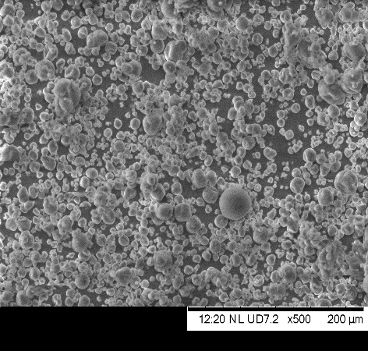 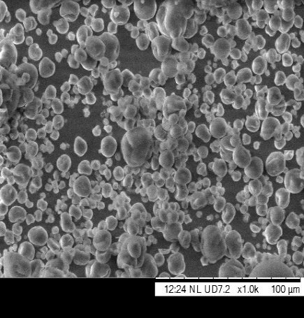 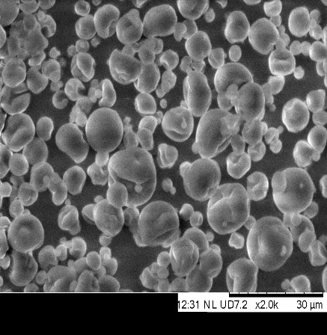

**B**

**C**

**A**

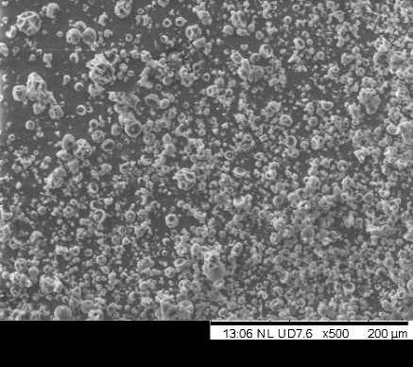 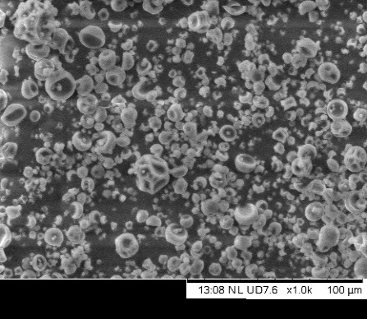 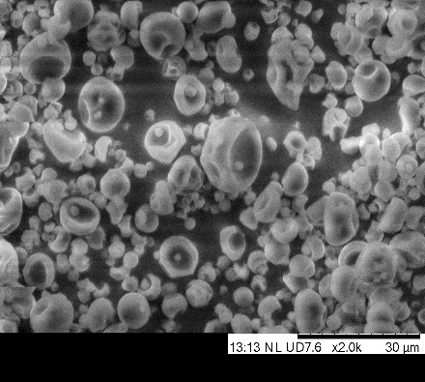

**E**

**F**

**D**

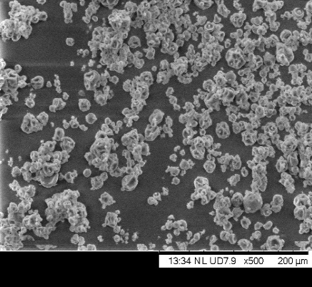 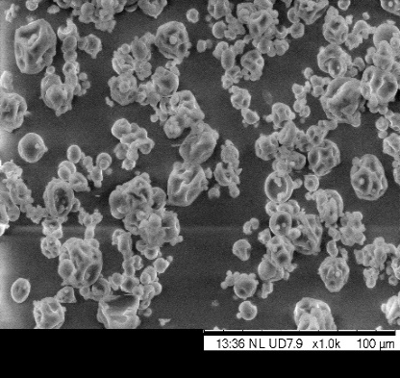 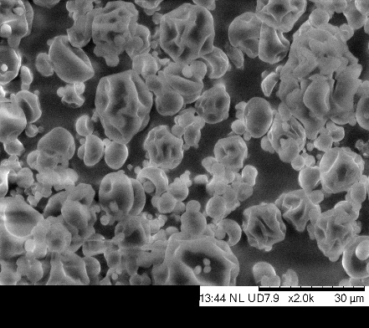

**I**

**H**

**G**

**Fig. 1**: **Morphology of microcapsules with magnification at A: 500x, B: 1000x and, 2000x and accelerating voltage 15 kV. Micrographs of microcapsules of encapsulated carrot coagulum containing carrier agents MD100 (A-C), MD75:GA25 (D-F), MD: GA50:50 (G-I)**

**CONCLUSION**

This study explored the use of encapsulation of carrot coagulum obtained from carrot waste with different carrier materials. The effect of inlet temperature and carrier agents alone or in combination with the physicochemical properties of carrot coagulum was investigated. Maltodextrin alone was an effective drying aid for spray-drying carrot coagulum. The addition of maltodextrin reduced the stickiness of the products and altered the physical properties of the spray-dried powders. The combination of gum Arabic and maltodextrin used in spray-drying carrot powder resulted in fairly good physical properties and higher moisture content compared to maltodextrin alone. However, maltodextrin alone at 15% concentration (MD100), spray-dried at an inlet temperature of 170 °C, resulted in powders with high content of encapsulated total carotenoids, good flow properties, and higher solubility, reasonably low moisture content, and higher bulk densities. The microstructure of carrot powder encapsulated with maltodextrin showed a smoother structure and fewer dents compared to the combination of carrier agents. Therefore, the spray drying of carrot coagulum at a constant inlet temperature of 170 °C and maltodextrin 15% as a carrier agent resulted in a powder with good physical properties. Certainly, carrot out grades have a significant content of total carotenoids that makes utilization of such material worthwhile for processing. Obtained encapsulated powder has potential applications for bakery or extruded cereal products, snacks, ice cream, yogurt, instant beverages, etc.

**CONFLICT OF INTEREST**

There are no conflicts of interest for the publication of this article.

Consent to Participate: All authors agree to participate in the current work.

Consent for Publication: The authors agree to publish the findings of the current research.

**REFERENCES**

1. Food and Agricultural Organization. Global food losses and food waste – Extent, causes and prevention. Rome, (2011).
2. Indian Horticulture Database. Indian Horticulture Board, Ministry of Agriculture, Government of India, India (2013).
3. Colbert E and Stuart T, Uncovering food waste in the horticultural export supply chain, Food waste in Kenya. Feedback Global (2015)
4. Bond R, Carrot loss during primary production: Field waste and pack house waste. M. Sc. Theses, Hedmark University of Applies Sciences, Nordic (2016).
5. Sharma KD Karki S Thakur NS and Attri S, Chemical composition, functional properties and processing of carrot—a review. *J Food Sci Technol* **49**(1):22–32 (2012). doi: 10.1007/s13197-011-0310-7.
6. Martinez-Flores HE Garnica-Romo MG Bermúdez-Aguirre D Pokhrel PR and Barbosa-Cánovas GV, Physico-chemical parameters, bioactive compounds and microbial quality of thermo-sonicated carrot juice during storage. *Food Chem* 172: 650–656 (2015).
7. Doymaz I and Pala M, The thin layer drying characteristics of corn. *J Food Eng* **60**(2):125-130 (2003). http://dx.doi.org/10.1016/S0260-8774(03)00025-6
8. Choudhari SM & Ananthanarayan L, Enzyme added extraction of lycopene from tomato tissues. *Food Chem* **102**(1):77-81 (2007).
9. Ramadan MF and Moersel JT, Impact of enzymatic treatment on chemical composition, physicochemical properties and radical scavenging activity of goldenberry (*Physalis peruviana* L.) juice. *J Sci food agricul* **87**:452-460 (2007).
10. Sharma HP Patel H and Sugandha, Enzymatic added extraction and clarification of fruit juices–A review. *Crit Rev Food Sci Nutr* **57**(6):1215-1227 (2017).
11. Sagar VR and Suresh Kumar P, Recent advances in drying and dehydration of fruits and vegetables: a review. *J Food Sci Technol* **47**(1):15–26 (2010).
12. Yousefi S Emam-Djomeh Z and Mousavi SM, Effect of carrier type and spray drying on the physicochemical properties of powdered and reconstituted pomegranate juice (*Punica Granatum* L.). *J Food Sci Technol* **48(6)**:677-684 (2011).
13. Cai YZ and Corke H, Production and properties of spray-dried Amaranthus Betacyanin pigments. *J Food Sci* **65** (7):1248–1252 (2000).
14. Ersus S and Yurdagel U, Microencapsulation of anthocyanin pigments of black carrot (*Daucuscarota L*.) by spray-dryer. *J Food Eng* **80**:805–812 (2007).
15. Ferrari CC Germer SPM and DE Aguirre JM, Effects of spray-drying conditions on the physicochemical properties of blackberry powder. *Dry Technol* **30**:154–163 (2012).
16. Reineccius GA, The spray-drying of food flavors. *Dry Technol* **22**(6):1289–1324 (2004). DOI: [10.1081/DRT-120038731](https://doi.org/10.1081/DRT-120038731)
17. Gabas AL Telis VRN Sobral PJA and Telis-Romero J, Effect of maltodextrin and Arabic gum in water vapor sorption thermodynamic properties of vacuum dried pineapple pulp powder. *J Food Eng* **82:**246–252 (2007).
18. Chopda CA and Barrett DM, Optimization of guava juice and powder production. *J Food Process preserv* **25**(6):411-430 (2001).
19. Righetto AM and Netto FM, Effect of encapsulating materials on water sorption, glass transition and stability of juice from immature acerola. *Int J Food Prop* **8**:337–346. (2005).
20. Daza LD Fujita A Fa´Varo-Trindade CS Rodrigues-Ract JN Granato D Genovese MI, Effect of spray drying conditions on the physical properties of Cagaita (*Eugenia dysenterica DC*.) fruit extracts. *Food Bioprod Process* **97**:20–29 (2016).
21. Wagner LA and Warthesen J, Stability of spray-dried encapsulated carrot carotenes. *J Food Sci* **60**(5):1048–1053 (1995).
22. Stoll T Schweiggert U Schieber A and Carle R, Process for the recovery of a carotene-rich functional food ingredient from carrot pomace by enzymatic liquefaction. *Inn Food Sci Emerging Tech* **4**(4):415-423 (2003).
23. Darshan MB, Encapsulation of β-carotene with natural polysaccharides using spray freeze drying technique. Ph. D Thesis, Post-Harvest Technology ICAR-Indian Agricultural Research Institute, New Delhi (2015).
24. AOAC, Official Methods of Analysis. The Association of Official Analytical Chemists, 17th edn. Washington, D.C. (2000).
25. Ranganna S, Handbook of analysis and quality control for fruits and vegetable products, 2nd edn. Tata Mc Graw-Hill Pub Co Ltd, New Delhi, pp. 1152 (1986).
26. Goula AM Adamopoulos KG and Kazakis NA, Influence of spray drying conditions on tomato powder properties. *Dry Technol* **22**(5):1129–1151 (2004).
27. Jinapong N, Suphantharika M and Jamnong P, Production of instant soymilk powders by ultrafiltration, spray drying and fluidized bed agglomeration. *J Food Eng* **84**(2):194–205 (2008), DOI: 10.1016/j.jfoodeng.2007.04.032.
28. Vissotto FZ Jorge LC Makita Gt Rodrigues Mi and Menegalli FC, Influence of the process parameters and sugar granulometry on cocoa beverage powder steam agglomeration*. Food Eng* **97**:283-291 (2010).
29. Fuchs M Turchiuli C Bohin M Cuvelier ME Ordonnaud C Peyrat-Maillard MN Dumoulin E, Encapsulation of oil in powder using spray drying and fluidised bed agglomeration. *J Food Eng* **75**:27-35 (2006),
30. Premi M and Sharma HK, Effect of different combinations of maltodextrin, gum Arabic and whey protein concentrate on the encapsulation behaviour and oxidative stability of spray dried drumstick (*Moringa oleifera*) oil. *Int J Biolo Macromol* **105**: 1232–1240 (2017). doi: 10.1016/j.ijbiomac.2017.07.160. Epub 2017 Jul 27. PMID: 28757420.
31. Kha TC Nguyen MH and Roach PD, Effects of spray drying conditions on the physicochemical and antioxidant properties of the Gac (*Momordica cochinchinensis*) fruit aril powder. *J Food Eng* **98**(3):385–392 (2010), <https://doi.org/doi:10.1016/j.jfoodeng.2010.01.016>
32. Quek SY Chok NK and Swedlund PJ, The physicochemical properties of spray dried watermelon powders. *Chem Eng Process* **46**:386–392 (2007).
33. Nhu Quynh NT Hai TC Vanman P Thanh LT, Effect of wall material on the property of gac oil spray-dried powder. *J Nutr Food Sci* **6**(5):544–548 (2016).
34. Oberoi DPS and Sogi DS, Effect of drying methods and maltodextrin concentration on pigment content of watermelon juice powder. *J Food Eng* **165:**172–178 (2015).
35. Tran TTA and Nguyen HVH, Effects of Spray-Drying Temperatures and Carriers on Physical and Antioxidant Properties of Lemongrass Leaf Extract Powder. *Beverages* **4**:84 (2018), doi:10.3390/beverages4040084
36. Sarabandi K Peighambardoust SH Sadeghi Mahoonak AR and Samaei SP, Effect of different carriers on microstructure and physical characteristics of spray dried apple juice concentrate. *J Food Sci Technol* **55**(8):3098–3109 (2018).
37. Nadeem HS Dincer C and Ozdemir F, Influence of inlet air temperature and carrier material on the production of instant soluble sage (*Salvia fruiticosa Miller*) by spray drying.  *LWT-Food Sci Technol* **52**:31–38. (2013),
38. Sarabandi K Jafari SM Mahoonak AS and Mohammadi A, Application of gum Arabic and maltodextrin for encapsulation of eggplant peel extract as a natural antioxidant and color source*. Int J Bio Macromol* **140**:59–68 (2019).
39. Fang Z & Bhandari B, Effect of spray drying and storage on the stability of bayberry polyphenols. *Food Chem* **129**(3):1139-47 (2011).
40. Chegini GR and Ghobadian B, Effect of spray-drying conditions on physical properties of orange juice powder. *Dry Technol* **23**(3):657- 668 (2005).
41. Leon-Martinez [FM Mendez](https://www.sciencedirect.com/science/article/abs/pii/S0144861710002419#!)-Lagunas LL & Rodriguez-[Ramirez](https://www.sciencedirect.com/science/article/abs/pii/S0144861710002419#!) J, Spray drying of nopal mucilage (*Opuntia ficus-indica*):Effects on powder properties and characterization. *Carbohydr Polym* **81**(4):864-870 (2010).
42. Kulthe AA Thorat SS and Mhalaskar SR, Physical stability of ability of ability of β-carotene encapsulated with different wall materials. *The Bioscan an Inter Quarterly J Life Sci* **11**(3):1577-1581 (2016).
43. Abadio FDB Domingues AM Borges SV and Oliveira VM, Physical properties of powdered pineapple (*Ananas comosus*) juice - effect of maltodextrin concentration and atomization speed. *J Food Eng* **64**(3):285-287 (2004).
44. Tonon RV Brabet C and Hubinger MD, Anthocyanin stability and antioxidant capacity of spray-dried acai (*Euterpe oleracea Mart*.) juice produced with different carrier agents. *Food Res Int* **43**:907–914 (2010).
45. Loksuwan J, Characteristics of microencapsulated β-carotene formed by spray drying with modified tapioca starch, native tapioca starch and maltodextrin. *Food Hydrocoll* **21**(5): 928-935 (2007).
46. De Marco R Vieira AMS Ugri MA Monteiro A and Bergamasco R, Microencapsulation of annatto seed extract: stability and application. *Chem Eng Trans* **32**:1777-1782 (2013), <https://doi.org/10.3303/CET1332297>
47. Cano-Chauca M Stringhet APC Ramos AM and Cal-Vidal J, Effect of the carriers on the microstructure of mango powder obtained by spray-drying and its functional characterization. *Innov Food Sci Emerg Technol* **6**(4):420–428 (2005) [10.1016/j.ifset.2005.05.003](http://dx.doi.org/10.1016%2Fj.ifset.2005.05.003)
48. Cynthia SJ Bosco JD and Bhol S, Physical and structural properties of spray dried tamarind (*Tamarindus indica L*.) pulp extract powder with encapsulating hydrocolloids. *Inter J Food Prop* **18**(8):1793-1800 (2015) DOI: [10.1080/10942912.2014.940536](https://doi.org/10.1080/10942912.2014.940536)
49. Goula AM and Adamopoulos KG, Stability of lycopene during spray drying of tomato pulp. *Lebens Wissen Technol* **38:**479-487 (2005).
50. Begum YA and Deka SC, Stability of spray-dried microencapsulated anthocyanins extracted from culinary banana bract. *Int J Food Pro* **20**(12):3135-3148 (2017), DOI: [10.1080/10942912.2016.1277739](https://doi.org/10.1080/10942912.2016.1277739)
51. Ferrari CC Germer SPM Alvim ID and Aguirre JM, Storage stability of spray-dried blackberry powder produced with maltodextrin or Gum Arabic. *Dry Technol* **31**(4): 470-478 (2013).
52. Mahdavi SA Jafari SM Assadpour E and Ghorbani M, Storage stability of encapsulated Barberry’s anthocyanin and its application in jelly formulation. *J Food Eng* **181**:59–66 (2016).
53. Murali S Kar A Mohapatra D and Kalia P, Encapsulation of black carrot juice using spray and freeze drying. *Food Sci Technol Int* **21**(8):604-12 (2014) doi: 10.1177/1082013214557843
54. Kalusevic AM Levic SM Calija BR Milic JR Pavlovic VB Bugarski BM and Nedovic VA, Effects of different carrier materials on physicochemical properties of microencapsulated grape skin extract. *J Food Sci Technol* **54**(11):3411-3420 (2017).
55. Kanakdande D Bhosale R and Singhal RS, Stability of cumin oleoresin microencapsulated in different combination of gum arabic, maltodextrin and modified starch. *Carbohydr Polym* **67**(4):536–541 (2007), DOI: 10.1016/j.carbpol.2006.06.023.
56. Rosenberg M Kopelman IJ and Talmon Y, Factor affecting retention in spray drying microencapsulation of volatile materials. *J Agric Food Chem* **38**(5):1288-1294 (1990).