Original Research Article

Development and Evaluation of Functional, Anti-Nutritional, and Sensory Properties of Complementary Food From Sorghum Blended With Peanut

Abstract

Background: Proper nutrition is essential for children's healthy growth and brain development, especially in the first five years of life, to help them reach their full potential. Objectives: This study evaluated the functional, anti-nutritional, and sensory properties of sorghum blended with peanuts. Methods: Sorghum and peanuts were purchased from the local market in Jigjiga, Somali Region, Ethiopia. Approximately 5 kg of each sample was collected. The raw materials were cleaned and dehulled before being milled. Results: The water absorption capacity of the composite flour in this study ranged from 128.15% to 133.96%. The results indicated that the mixture proportions of sorghum and peanut had a significant linear effect (P ≤ 0.01) on water absorption capacity. Conclusion: Based on the sensory evaluations of the SBP product's color, scent, taste, mouthfeel, and overall acceptability, the addition of peanut flour significantly altered the product's sensory attributes.

Keywords: Anti-Nutritional properties, Functional properties, Sensory properties, Sorghum, Peanut.

Introduction

Proper nutrition plays a critical role in supporting healthy growth and cognitive development in children, especially within their first five years, which is a pivotal period for achieving developmental potential (Motuma et al., 2016). However, in many developing nations, including Ethiopia, impoverished nursing mothers and caregivers often face challenges in providing adequate nutrition. This is frequently due to financial constraints and limited knowledge on how to use locally available foods for infant nourishment (Samuel et al., 2021). Consequently, rates of moderate to severe acute malnutrition are high, resulting in increased illness, mortality, and hospitalizations among young children (Michaelsen et al., 2009).
Recent studies suggest that traditional complementary foods commonly used in developing regions may significantly contribute to growth stunting and impaired cognitive development in children (Adesanmi et al., 2020). These complementary foods are typically introduced to infants between 6 months and 2 years of age, as breast milk alone becomes insufficient to fulfill their nutritional requirements (Taha et al., 2020).
In developing regions, fortified, nutritious, and commercially produced complementary foods are often unaffordable for low-income families. Groundnut (Arachis hypogaea L.), commonly known as peanut, is a legume widely cultivated in Ethiopia. Nutritionally, groundnut kernels are rich in essential oils, proteins, amino acids, fatty acids, and micronutrients (Sushma et al., 2021). Groundnut kernels are typically consumed as snacks or used in cooking to enhance protein content and flavor (Rossi-Márquez et al., 2021).
The processing methods used to prepare complementary foods for infants should aim to separate and purify the edible parts of raw materials, while also improving nutritional quality by enriching the food and inactivating anti-nutritional factors. However, many mothers with low socioeconomic status lack sufficient knowledge about the nutrients and anti-nutritional factors present in raw materials (Oluwajuyitan et al., 2020).
Porridges made from cereals tend to have high viscosity and low energy density, making them less nutritious as complementary foods. Therefore, it is important to propose a processing method that combines cereals and peanuts in a way that reduces labor, cost, energy, and nutrient loss that may result from separate processing. This study aimed to evaluate the functional, anti-nutritional, and sensory properties of sorghum blended with peanuts.

MATERIALS AND METHOD

Raw Materials and sample preparation, Blending Ratio based complementary food

Sorghum and peanuts were purchased from the local market in Jigjiga, Somali Region, Ethiopia. Approximately 5 kg of each sample was collected. Sorghum flour was prepared following the method developed by Almeida-Dominguez et al. (1993), while peanut flour was prepared according to the method developed by Arab et al. (2010). A D-optimal mixture design with seven total formulations was used for the experiment. The formulation included a range of sorghum from 70 to 100 g and peanuts from 0 to 30 g.

Functional Properties

Water absorption capacity

The WAC was determined according to the method described by Akubor (2005). One-gram sample was mixed with 10-mL distilled water (specific gravity 0.904 kg/m3) and allowed to stand at ambient temperature (31 ± 2ºC) for 30 min and then centrifuged at 3,000 rpm for 30 min using centrifuge model 800-1D. WAC was determined by the following formula:
$WAC=\frac{Weight of water bound}{Weight of sample (dry basis)}x100\% (1)$

Water absorption index

The Water Absorption Index (WAI) was evaluated according to the method by Anderson et al. (1969). A 3 g portion of each flour sample was suspended in 30 mL of distilled water within a tared 60-mL centrifuge tube. The mixture was stirred with a glass rod for one minute at room temperature (25°C), followed by centrifugation at 3000 × g for 10 minutes. After centrifugation, the supernatant was discarded, and WAI was determined based on the weight of the gel remaining, expressed as grams of gel per gram of dry flour.

$WAI=\frac{weight of sediment (g)}{weight of the sample (g)} (2)$

Determination of ant-nutrient properties of SBP flour

Tannins

Tannin content was measured following the procedure outlined by Maxson and Rooney (1972). About 1.000 g of the sample was accurately weighed and combined with 10 ml of 1% HCl in methanol in a screw-cap test tube. The mixture was then shaken on a mechanical shaker and allowed to sit at room temperature for 24 hours. After this period, the solution was centrifuged at 3000 rpm for 30 minutes. Subsequently, 1 ml of the supernatant was transferred to a new test tube and mixed with 5 ml of vanillin-HCl reagent, prepared by mixing equal parts of 8% HCl in methanol and 4% vanillin in methanol. Catechin standards, prepared in concentrations ranging from 0.5 to 12 mg/100 ml, were used to generate a calibration curve. A standard curve with an R² value of 0.993 was constructed by plotting absorbance against concentration. The slope and intercept of this curve were applied to calculate the condensed tannin content using the following formula:
$$Tannin in mg/100g=\frac{Absorbance-Intercept}{Slope x Density x weight of the sample } (3)$$

Phytate content

The determination of phytate content was carried out using the method described by Vantraub and Lapteva (1988). Approximately 0.5 g of the sample was extracted with 10 ml of 2.4% HCl using a mechanical shaker (Eberbach) for 1 hour at room temperature. The clear supernatant was then used for phytate estimation. To 3 ml of the supernatant, 1 ml of Wade reagent (containing 0.03% FeCl₃·6H₂O and 0.3% sulfosalicylic acid in water) was added. The mixture was vortexed for 5 seconds, and the absorbance was measured at 500 nm using a UV-VIS spectrophotometer (Beckman DU-64, USA). A standard curve was generated by plotting the absorbance against concentration, with the slope and intercept used for the calculation. The sodium salt of phytic acid was used as a standard to construct the calibration curve. The phytate content was then calculated using the following formula:
$$Phytate in mg/100g=\frac{Absorbance-Intercept}{Slope x Density x weight of the sample } (4)$$

Sensory analysis of sorghum blended with peanut flour

The sensory evaluation of the sorghum blended with peanut (SBP) formulated from sorghum and peanut flour was conducted using 10 untrained panelists. The selection and screening of panelists were based on their interest in participating and evaluating the SBP product. Participants were informed in advance about the evaluation process and the purpose of assessing the product's sensory attributes. The evaluation occurred in a quiet room, free from distracting fragrances, and under natural daylight to ensure optimal conditions. Using a five-point hedonic scale, panelists were asked to assess the SBP samples based on appearance, aroma, taste, texture, and overall acceptance. After testing each sample, panelists rinsed their mouths with water between tastings. For each attribute, samples were rated on a five-point hedonic scale (1 = dislike very much; 5 = like very much).

Data analysis

All analyses were performed in duplicates (unless stated otherwise) and results are presented as means. The statistical significance of the data will be analyzed and modeled using Design Expert® version 13. A level of significance was accepted at p ≤ 0.01 and p ≤ 0.05.).

- RESULTS AND DISCUSSION

Functional properties of SBP flour

The functional properties, including bulk density, water absorption capacity, and oil absorption capacity, of both the composite flour and each ingredient are outlined in Table 1. The ANOVA (analysis of variance) outcomes are also displayed in Table 1. Models were fitted for each functional property, revealing that the lack-of-fit p-values were not significantly different at the 5% level (P < 0.05). Diagnostic assessments, such as residual normality plots, showed that residuals for all measured responses followed a normal distribution.

Table 1. Functional properties of SBP flour samples
Std | Run | Block | SBP |  | Functional properties
Std | Run | Block | A: | B:
Std | Run | Block | Sorghum  (g) | Peanut (g) | Bulk Density (g/ml) | Water Absorption Capacity (%) | Water Absorption Index (g)
7 | 1 | Block 1 | 70 | 30 | 0.68 | 133.95 | 3.71
3 | 4 | Block 1 | 85 | 15 | 0.62 | 131.17 | 3.68
6 | 3 | Block 1 | 100 | 0 | 0.59 | 128.46 | 3.63
2 | 2 | Block 1 | 70 | 30 | 0.67 | 133.96 | 3.72
5 | 5 | Block 1 | 77.5 | 22.5 | 0.63 | 132.99 | 3.70
1 | 6 | Block 1 | 100 | 0 | 0.60 | 128.15 | 3.62
4 | 7 | Block 1 | 92.5 | 7.5 | 0.61 | 129.97 | 3.65
SBP= Sorghum Blended peanut, A= Sorghum, B= Peanut

Bulk Density

Table 1 shows that sorghum blended with peanut flour has a highly significant effect (P ≤ 0.01) on bulk density. The functional properties of bulk density ranged from 0.59 to 0.68 g/ml. The bulk density observed in this study is lower than the values reported by Alemayehu (2014), who found bulk density values ranging from 0.81 to 0.84 g/ml. As illustrated in Figure 1, the bulk density of SBP flour samples increased with the higher proportions of sorghum and peanut flour. This result is consistent with the findings of Masood, Butt, and Rizwana (2010), who reported an increase in bulk density in composite flour containing soybean protein. Similarly, Jenfa et al. (2024) noted that the bulk density of sorghum-orange‐fleshed sweet potato composite flour increased as the sorghum content increased. High-energy foods typically have low density, while high-density foods tend to have low energy. The lower bulk density in this study may be attributed to the higher protein and fat content in peanut flour compared to sorghum. The low bulk density of these blends is advantageous in the formulation of complementary foods, as noted by Akubor and Ukwuru (2003). The regression model for bulk density is presented in Equation 1, which indicates a quadratic model with two variables.

$$Y={0.67}_{x_{1}}+{0.59}_{x_{2}}-{0.06}_{x_{1}x_{2}}………………………………………………..eq.1$$
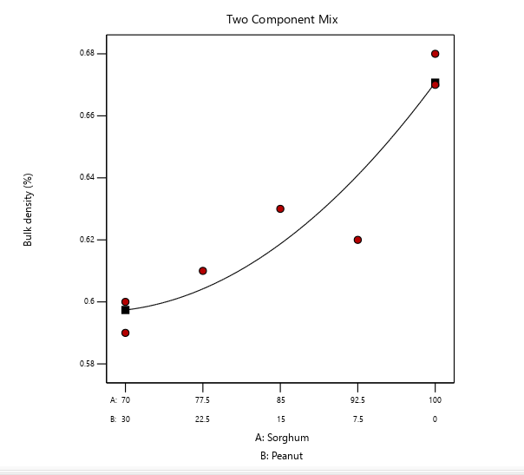
Where Y= Bulk density, X₁= Sorghum, X₂=Peanut, X₁X₂=Sorghum and Peanut

Figure 1. The contour line shows the bulk density while the black points show the treatment formulations of the SBP flour

Figure 1 shows that the bulk density of the two-component mixture increased as the peanut ratio decreased. This trend is consistent with the findings reported by Chen et al. (2023), who observed that the bulk density of complementary foods increases with higher proportions of maize flour, which has a greater bulk density than soybean flour.

Water absorption capacity

Water absorption capacity (WAC) measures the amount of water needed to achieve the right consistency for gruel, making it suitable for feeding infants. It depends on the availability of hydrophilic groups to bind water molecules and the ability of macromolecules to form gels (Onweluzo & Nwabugwu, 2009). WAC also indicates the amount of water available for gelatinization. In the present study, the WAC of the composite flour ranged from 128.15% to 133.96% (Table 1). As shown in Table 2, the results reveal a strong linear significance (P ≤ 0.01) of the mixture proportions of sorghum and peanut on WAC. The highest WAC, 133.96%, was observed with 70 grams of sorghum and 30 grams of peanut flour, while the lowest, 128.15%, was recorded with 100 grams of sorghum and 0 grams of peanut flour. As shown in Figure 2, WAC increases with higher proportions of peanut flour, likely due to the higher protein content in peanuts. Low WAC values are typically associated with mostly intact starch granules, while high values result from protein denaturation, starch gelatinization, and fiber swelling. Damaged or transformed starches exhibit high WAC and can form paste at room temperature through gelatinization (Nwabueze, 2006). The regression model for WAC is presented in Equation 2, which follows a quadratic model with two variables.
$$Y={128.30}_{x_{1}}+{134.01}_{x_{2}}+{0.94}_{x_{1}x_{2}}…………………………………………………..eq.2$$
Where Y= Water absorption capacity, X₁= Sorghum, X₂=Peanut, X₁X₂=Sorghum and Peanut

According to Figure 2, the contour line indicates that water absorption capacity (WAC) increased as the proportion of peanut flour increased. This suggests that peanuts have a high protein content. Proteins possess both hydrophilic and hydrophobic properties, enabling them to interact with water in foods. Additionally, the high-fat content in peanuts can also contribute to an increase in WAC. These findings are consistent with the study by Sobowale et al. (2024), which reported that the WAC of sorghum flour increased when blended with Bambara groundnut flour. Furthermore, the results of the present study indicate that peanuts have higher protein and fat content than sorghum, which may reduce the hydration capacity of sorghum (Olurin et al., 2021).
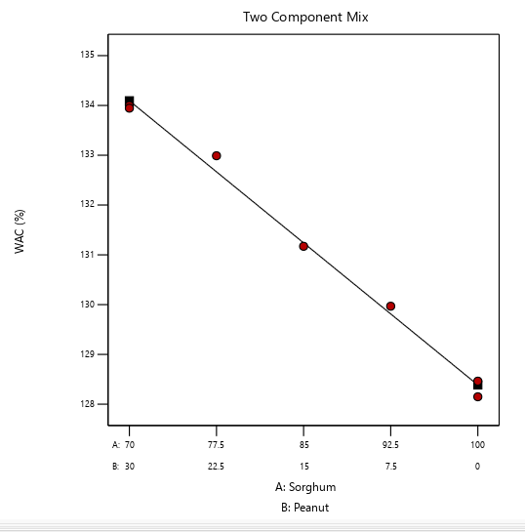
Figure 2. The contour line shows the water absorption capacity while the black points show the treatment formulations of the SBP flour

Water Absorption Index

As indicated in Table 2, the mixture proportions of sorghum and peanut flour show a strong linear significance (P ≤ 0.01) on the water absorption index (WAI). The WAI measures the volume occupied by a substance after swelling in an excess of water. Table 1 shows that the WAI of the sorghum-peanut blend (SBP) sample flour increases as the proportion of peanut flour increases, enhancing the WAI of sorghum. The highest WAI was observed in run-1 and run-2, which used 70 grams of sorghum and 30 grams of peanuts, respectively. Conversely, the lowest WAI was recorded in run-3 and run-6, with 100 grams of sorghum and no peanut flour.
The WAI results from this study are consistent with previous studies on extruded sorghum and legumes (Pelembe et al., 2002). This increase in WAI may be attributed to the partial gelatinization of starch, which enhances the availability of hydrophilic groups in the food matrix, and to the increased gel-forming capacities of other macromolecules, such as dietary fiber and proteins (Andersson & Hedlund, 1990). Figure 3 illustrates that the WAI increases as the proportion of peanut flour increases. The regression model for WAI, presented in Equation 3, indicates a quadratic relationship with two variables.
$$Y={3.62}_{x_{1}}+{3.72}_{x_{2}}+{0.02}_{x_{1}x_{2}}………………………………………..eq.3$$
Where Y= Water absorption index, X₁= Sorghum, X₂=Peanut, X₁X₂=Sorghum and Peanut
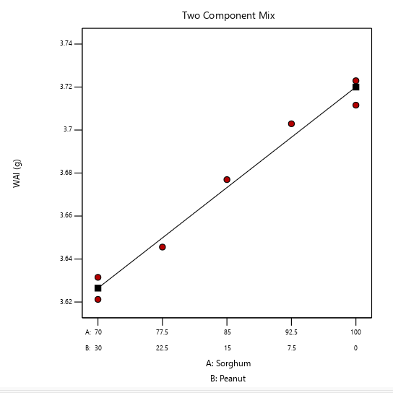
Figure 3. The contour line shows the water absorption index while the black points show the treatment formulations of the SBP flour

Table 2. The regression coefficient of a quadratic polynomial, R2, and lack of fit for functional properties of SBP flour
Source | Bulk Density (%) | Water Absorption Capacity (%) | Water Absorption Index (g)
Model | 0.93* | 36.71** | 0.01**
Linear mixture | 0.93** | 36.65** | 0.01**
A | 5.39* | 128.30 | 3.62**
B | 6.29* | 134.01 | 3.72**
AB | -0.05 | 0.94 | 0.02
Adj. R² | 0.97 | 0.99 | 0.97
Lack of fit | 0.45 | 0.32 | 0.64
Std. Dev. | 0.07 | 0.20 | 0.01
C.V. % | 1.25 | 0.15 | 0.18
Mean | 5.83 | 131.24 | 3.67
A= Sorghum, B= Peanut, *Significant at P≤ 0.05 level, **Significant at P≤ 0.01

Major anti-nutritional contents

The analysis of anti-nutritional components (tannin and phytate) in the individual ingredients and the composite flour (SBP) samples yielded the results presented in Table 3. At a 5% probability level (P ≤ 0.05), the fitted models for anti-nutritional factors showed that the lack-of-fit p-values were not significantly different, indicating a good model fit. A normality plot of the residuals, used as a diagnostic technique, confirmed that the residuals of all response variables were normally distributed.
Table 3. Major anti-nutritional contents of porridge and ingredients flour samples
Std | Run | Block | SBP |  | Anti-nutritional
Std | Run | Block | A: | B:
Std | Run | Block | Sorghum (g) | Peanut (g) | Phytate (%) | Tannin (%)
7 | 1 | Block 1 | 70 | 30 | 98.84 | 0.20
2 | 2 | Block 1 | 85 | 15 | 122.45 | 0.31
6 | 3 | Block 1 | 100 | 0 | 143.95 | 0.45
3 | 4 | Block 1 | 70 | 30 | 99.79 | 0.21
5 | 5 | Block 1 | 77.5 | 22.5 | 117.03 | 0.30
1 | 6 | Block 1 | 100 | 0 | 146.97 | 0.45
4 | 7 | Block 1 | 92.5 | 7.5 | 129.70 | 0.33
Std= Standard, SBP= Sorghum Blended peanut, A= Sorghum, B= Peanut

Phytate contents

As shown in Table 3, the linear model for sorghum blended with peanut flour demonstrated strong linear significance (P ≤ 0.01). The analysis revealed that the phytate content in the SBP sample flour ranged from 98.84% to 146.03%. These results indicate that the anti-nutritional factors in the SBP sample flour increased as the proportion of peanut flour decreased, suggesting that sorghum has higher levels of anti-nutritional factors compared to peanuts. Thus, increasing the proportion of peanut flour can be a beneficial strategy to reduce phytate levels. The effect of the blending ratio on phytate content is depicted in the mixture contour graph (Figure 4), and the regression model, represented in Equation 4, indicates a quadratic relationship between the two variables.
$$Y={144.36}_{x_{1}}+{100.52}_{x_{2}}+{2.61}_{x_{1}x_{2}}…………………………………………………..eq.4$$
Where Y= Phytate content, X₁= Sorghum, X₂=Peanut, X₁X₂=Sorghum and Peanut
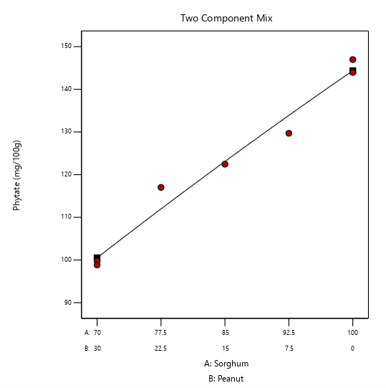
Figure 4. The contour line shows the phytate content while the black points show the treatment formulations of the SBP flour

This study aligns with findings from research conducted by Alemayehu (2014), which reported that the phytate content increased from 95.94 to 115.13 mg/100g as the proportion of sorghum flour in the composite flour increased from 40% to 55%. As illustrated by the curve in Figure 4, the results of this study indicate that the phytate content increased with a higher proportion of sorghum in the blend. The lowest phytate content was observed at a blending ratio of 70:30 grams of sorghum to peanut flour, respectively.

Tannin contents

As indicated in Table 3, the tannin content for sorghum blended with peanut flour exhibited a strong linear relationship (P ≤ 0.01) within the linear model. The data reveal that the tannin level in the SBP sample flour increased as the proportion of peanut flour decreased, implying that sorghum has a naturally higher tannin content than peanuts. Figure 5 illustrates that raising the proportion of peanut flour can effectively help lower the tannin content in the composite flour. The tannin content in the SBP samples ranged from 0.20% to 0.45%, which reflects sorghum’s inherently higher tannin content in comparison to peanuts.
These findings align with prior studies that identified a higher tannin concentration in local red sorghum, ranging from 1.29 mg/100g to 3946.94 mg/100g, compared to the Meko variety. Specifically, tannin levels in Meko sorghum flour were recorded at 1.29 mg/100g, while Shimelis and Rakshit (2005) reported that the Meko variety had tannin levels below the detectable limit in their study aimed at enhancing the energy and nutrient density of sorghum-based complementary foods. The regression model for tannin content, given in Equation 5, is a quadratic model involving two variables.

$$Y={0.44}_{x_{1}}+{0.22}_{x_{2}}-{0.07}_{x_{1}x_{2}}…………………………………………………..eq.5$$
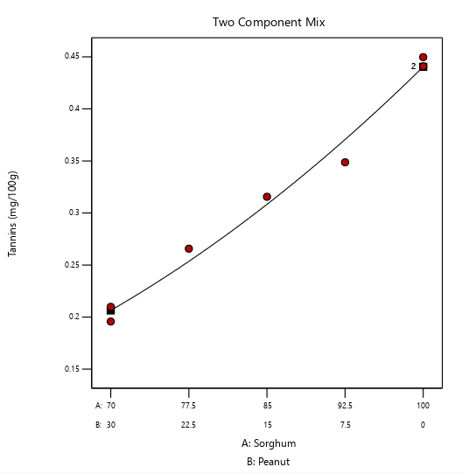
Where Y= Tannin content, X₁= Sorghum, X₂=Peanut, X₁X₂=Sorghum and Peanut
Figure 5. The contour line shows the tannin content, while the black points show the treatment formulations of the SBP flour

Evaluation of the sensory properties of SBP products by untrained panels

The results of the sensory evaluation are presented in Table 4. The average sensory assessments of the SBP product’s color, scent, taste, mouthfeel, and overall acceptability showed that the inclusion of peanut flour significantly influenced the sensory attributes of the product.
The mean scores for sensory characteristics ranged from 3.40 to 4.71 for color, 3.40 to 4.70 for scent, 4.15 to 4.84 for flavor, 4.34 to 4.87 for mouthfeel, and 4.50 to 4.83 for overall acceptability, indicating a general preference for the porridge. Achieving a product that satisfies all five sensory attributes is challenging in most cases; thus, the optimal formulation should aim to maximize consumer satisfaction (Moskowitz, 1994).

Table 4. Sensory mean scores for the SBP sample evaluated by untrained panels
Std | Run | Block | SBP |  | Sensory Properties
Std | Run | Block | A: | B:
Std | Run | Block | Sorghum (g) | Peanut (g) | Color | Aroma | Taste | MF | OA
7 | 1 | Block 1 | 70 | 30 | 4.71ª | 4.70ª | 4.84^{b} | 4.80^{b} | 4.83^{b}
2 | 2 | Block 1 | 85 | 15 | 4.27^{d} | 4.27^{d} | 4.65^{d} | 4.69^{d} | 4.73^{d}
6 | 3 | Block 1 | 100 | 0 | 3.40^{g} | 3.40^{g} | 4.15^{g} | 4.43^{f} | 4.50^{g}
3 | 4 | Block 1 | 70 | 30 | 4.63^{b} | 4.63^{b} | 4.88ª | 4.87ª | 4.86ª
5 | 5 | Block 1 | 77.5 | 22.5 | 4.47^{c} | 4.47^{c} | 4.71^{c} | 4.72^{c} | 4.75^{c}
1 | 6 | Block 1 | 100 | 0 | 3.55^{f} | 3.551^{f} | 4.16^{f} | 4.34^{g} | 4.59^{f}
4 | 7 | Block 1 | 92.5 | 7.5 | 4.20e | 4.20e | 4.57e | 4.46e | 4.70e
Means with the same superscript letters are not significantly different (p<0.05). MF = Mouth feel, OA= Over all acceptability. The values indicated that 1. Dislike Very Much, 2. Dislike, 3. Neither Like or Dislike 4. Like 5. Like Very Much

- Conclusion

This study analyzed the functional, anti-nutritional, and sensory properties of sorghum blended with peanut flour. The results indicated that sorghum blended with peanut flour had a highly significant effect (P ≤ 0.01) on bulk density. The highest water absorption capacity (WAC) was observed in the sample containing 70 grams of sorghum and 30 grams of peanut flour, while the lowest WAC was recorded for the sample with 100 grams of sorghum and no peanut flour. The findings also showed that increasing the proportion of peanut flour led to a decrease in anti-nutritional elements, thereby enhancing the nutritional quality of the products.
The sensory evaluation results revealed that the color, scent, taste, and mouthfeel of the SBP products significantly improved with higher amounts of peanut flour, which in turn increased the overall acceptability of the products. To optimize the physicochemical properties and sensory acceptance, the composition of the SBP sample flours was numerically optimized based on the study’s findings.

Ethics Approval and Consent to Participate

This study was conducted in accordance with ethical standards and received approval from the Institutional Review Board at the Somali Region Pastoral and Agropastoral Research Institute. All participants provided written informed consent before their inclusion in the study. The research adhered to ethical guidelines to ensure the confidentiality and rights of the participants.

Consent for Publication

All authors have agreed to the submission and publication of this manuscript. We confirm that the manuscript, including any identifiable information, does not violate any confidentiality agreements and that consent for publication has been obtained from all relevant parties.

Availability of Data and Materials

The data generated and analyzed during this study are available from the corresponding author upon reasonable request.

Competing Interests

The authors declare that they have no competing interests.

Reference

Sushma Tiwari, T. A., M. K. Tripathi, N. G., Ritu Sastya, R. S. S., & Gupta, V. (2021). Assessment for Yield and Nutritional Profiling of Groundnut with the Help of Allele Specific Markers for Desirable Fatty Acids. International Journal of Current Microbiology and Applied Sciences, 10(2), 1625–1637. https://doi.org/10.20546/ijcmas.2021.1002.193
Akubor, P. I., & Ukwuru, M. U. (2003). Functional properties and biscuit making potential of soybean and cassava flour blends. Plant Foods for Human Nutrition, 58(3), 1–12. https://doi.org/10.1023/b:qual.0000040344.93438.df
Alemayehu, E. (2014). Complementary food product development from sorghum enriched with chickpea and orange fleshed sweet potato: the case of dawuro zone, south western ethiopia.
https://repository.ju.edu.et/handle/123456789/2292.
Adesanmi, A. R., Malomo, S. A., & Fagbemi, T. N. (2020). Nutritional quality of formulated complementary diet from defatted almond seed, yellow maize and quality protein maize flours. Food Production, Processing and Nutrition, 2(1). https://doi.org/10.1186/s43014-020-00037-7
Andersson, Y., & Hedlund, B. (1990). Extruded wheat flour: Correlation between processing and product quality parameters. Food Quality and Preference, 2(4), 201–216. https://doi.org/10.1016/0950-3293(90)90012-j
Butt, M. S., & Batool, R. (2010). Nutritional and Functional Properties of Some Promising Legumes Protein Isolates. Pakistan Journal of Nutrition, 9(4), 373–379. https://doi.org/10.3923/pjn.2010.373.379
Chen, P., Chen, N., Zhu, W., Wang, D., Jiang, M., Qu, C., Li, Y., & Zou, Z. (2023). A Heat and Mass Transfer Model of Peanut Convective Drying Based on a Two-Component Structure. Foods, 12(9), 1823. https://doi.org/10.3390/foods12091823
Sobowale, S. S., Bamidele, O. P., & Adebo, J. A. (2024). Physicochemical, functional, and antinutritional properties of fermented Bambara groundnut and sorghum flours at different times. Food Chemistry Advances, 4, 100729. https://doi.org/10.1016/j.focha.2024.100729
Jenfa, M. D., Adelusi, O. A., Aderinoye, A., Coker, O. J., Martins, I. E., & Obadina, O. A. (2024). Physicochemical compositions, nutritional and functional properties, and color qualities of sorghum–orange‐fleshed sweet potato composite flour. Food Science &amp; Nutrition, 12(4), 2364–2378. Portico. https://doi.org/10.1002/fsn3.3922
Olurin, T. O., Abbo, E. S., & Oladiboye, O. F. (2021). Production and evaluation of breakfast meal using blends of sorghum, bambara nut and date palm fruit flour. Agro-Science, 20(3), 30–36. https://doi.org/10.4314/as.v20i3.5
Maxson, E. D., & Rooney, L. W. (1972). Two Methods of Tannin Analysis for Sorghum Bicolor (L.)Moenchgrain1. Crop Science, 12(2), 253–254. Portico. https://doi.org/10.2135/cropsci1972.0011183x001200020035x
Michaelsen, K. F., Hoppe, C., Roos, N., Kaestel, P., Stougaard, M., Lauritzen, L., Mølgaard, C., Girma, T., & Friis, H. (2009). Choice of Foods and Ingredients for Moderately Malnourished Children 6 Months to 5 Years of Age. Food and Nutrition Bulletin, 30(3_suppl3), S343–S404. https://doi.org/10.1177/15648265090303s303
Abeshu, M. A., Lelisa, A., & Geleta, B. (2016). Complementary Feeding: Review of Recommendations, Feeding Practices, and Adequacy of Homemade Complementary Food Preparations in Developing Countries – Lessons from Ethiopia. Frontiers in Nutrition, 3. https://doi.org/10.3389/fnut.2016.00041
Moskowitz, H. R. (1994). Product optimization: approaches and applications. Measurement of Food Preferences, 97–136. https://doi.org/10.1007/978-1-4615-2171-6_5
Nwabueze, T. U. (2006). Gelatinization and viscosity behavior of single-screw extruded african breadfruit (treculia africana) mixtures. Journal of Food Processing and Preservation, 30(6), 717–731. https://doi.org/10.1111/j.1745-4549.2006.00100.x
Oluwajuyitan, T. D., Ijarotimi, O. S., & Fagbemi, T. N. (2020). Nutritional, biochemical and organoleptic properties of high protein-fibre functional foods developed from plantain, defatted soybean, rice-bran and oat-bran flour. Nutrition &amp; Food Science, 51(4), 704–724. https://doi.org/10.1108/nfs-06-2020-0225
Onweluzo, J. C., & Nwabugwu, C. C. (2009). Development and Evaluation of Weaning Foods from Pigeon Pea and Millet. Pakistan Journal of Nutrition, 8(6), 725–730. https://doi.org/10.3923/pjn.2009.725.730
Rossi-Márquez, G., Helguera, M., Briones, M., Dávalos-Saucedo, C. A., & Di Pierro, P. (2021). Edible Coating from Enzymatically Reticulated Whey Protein-Pectin to Improve Shelf Life of Roasted Peanuts. Coatings, 11(3), 329. https://doi.org/10.3390/coatings11030329

Samuel, F. O., Akintayo, B., & Eyinla, T. E. (2021). Complementary Feeding Knowledge and Practices of Caregivers in Orphanages Improved after Nutrition Education Intervention in Ibadan, Nigeria. Open Journal of Nursing, 11(07), 642–652. https://doi.org/10.4236/ojn.2021.117054
Shimelis, E. A., & Rakshit, S. K. (2005). Proximate composition and physico-chemical properties of improved dry bean (Phaseolus vulgaris L.) varieties grown in Ethiopia. LWT - Food Science and Technology, 38(4), 331–338. https://doi.org/10.1016/j.lwt.2004.07.002
Taha, Z., Garemo, M., & Nanda, J. (2020). Complementary feeding practices among infants and young children in Abu Dhabi, United Arab Emirates. BMC Public Health, 20(1). https://doi.org/10.1186/s12889-020-09393-y

