**COMPARATIVE EVALUATION OF PRESERVATION METHODS ON THE MICROBIOLOGICAL AND PROXIMATE INDICES OF ONIONS (*ALLIUM CEPA* L.)**

**Abstract**

This study evaluated the effects of different preservation methods on the proximate composition and microbial characteristics of onions (*Allium cepa*). Onions were processed into four types: raw, frozen, dried and salted. The proximate composition was analyzed, while microbial analysis was performed using serial dilution and various biochemical tests. Results showed that moisture content significantly decreased in dried onions (9.18%) compared to raw onions (87.32%), while frozen and salted onions retained higher moisture. Protein content was highest in dried onions (2.38%) and lowest in salted onions (1.64%). Ash and fat levels were mostly the same across all onion types, but drying caused a small increase in ash. Dried onions had the most carbohydrate, while raw onions had the least. Raw onions also had the highest viable counts of bacteria, including coliforms, which can be harmful. Frozen and salted onions had no coliforms, showing that those methods helped keep the onions safer. Yeast and mold were found in all samples but stayed at low levels, with frozen onions showing the most. Biochemical tests found Pseudomonas bacteria in raw, frozen, and powdered onions, while only salted onions had Staphylococcus. Overall, salting followed by drying worked the best for keeping onions clean and safe for long-term storage. **Keywords:** Onion preservation, freezing, drying, salting

**Introduction**

Onions (Allium cepa L.) are grown all over the world and are a key part of many dishes. They’re often called the "Kitchen Queen" because they’re used so widely and are a favourite in cooking. Onions are packed with nutrients like protein, carbs, and minerals such as calcium, phosphorus, and iron. They also contain fibre and vitamins B and C (Bal et al., 2019). Another big plus is that onions are a natural source of quercetin, a compound that may help lower cholesterol, fight inflammation, act as an antioxidant, and even reduce the risk of cancer (Bal et al., 2019). On top of that, onions are important for the economy in many countries since they bring in income through exports (Bal et al., 2020). However, onions can get damaged easily during handling, storage, and transport. Things like bad storage conditions, poor temperature or humidity control, and rough handling can lead to bruising, rot, sprouting, and weight loss (Petropoulos, 2016). Solving storage problems is a big deal because it helps cut down on waste and keeps onions in better shape. When onions are stored properly, farmers and sellers can make more money too (Madhu et al., 2020). In this study, we looked at how salting, drying, and freezing change the nutrition and quality of onions.

**2.1 Materials and Methods**

**2.1.1 Sample Preparation**

Fresh, mature onions (Allium cepa) were bought from a local market in Ile-Ife, Nigeria, and divided into four parts for processing. The first portion was frozen at -18°C, following the method described by El-Hadidy et al. (2014). The second was kept at room temperature (around 27–28°C). The third portion was dried in a cabinet dryer at 60°C for 10 to 15 hours, then ground into a fine powder using a Waring blender, and stored at room temperature, based on the method by Koménan et al. (2020). The last part was made into salted onion by mixing 19–20% onion powder with 78% refined table salt, according to Pruthi (1987), and stored at room temperature.

**2.1.2 Proximate analysis**

Moisture content, protein, crude ash, crude fiber, and fat were measured using the methods outlined by AOAC (2010).

**2.1.3 Microbial analyses**

Serial dilution was done following according to the method described by Pitt and Hocking’s 2022. The pour plate technique was used to count live microorganisms. Total viable counts (TVC), yeast and mould counts, and total coliform counts were measured using procedures from Harrigan and McCance 1976 and Adeniran et al. 2020. To identify the microorganisms, several tests were used including Gram staining, catalase, oxidase, methyl red, and Voges Proskauer tests, along with additional methods from Harrigan and McCance 1976 and Adeniran et al. 2020.

**3.1 Results and Discussion**

The moisture content of the raw and treated onion samples before and after storage is shown in Tables 1 and 2. The moisture levels varied (9.18% to 87.32% before storage and 79.94% to 89.04% after storage). Raw onions had the highest water content (87.32%) and dried onions had the lowest (9.18%) before storage. Freezing reduced moisture because it caused ice crystals to form in the onion cells, which broke when thawed and let moisture escape (Paciulli et al., 2015). The moisture reduction showed that drying removed a lot of water, but the loss was balanced, and the moisture content of salted and frozen onions remained above 10%, which could lead to microbial growth (Hafez et al., 2019). The moisture levels found in this study were higher than those in Sorour and Mesery’s (2014) study, which measured onion powder moisture at 7.00% to 7.30%. However, frozen onions lost some moisture after thawing due to freezing effects (Paciulli, 2015). Dried onions might have lost more water due to storage conditions like room temperature and packaging. During storage, the salt in the onions attracted water to the surface, and when the moisture levels in the onion layers balanced out, the overall moisture content decreased in the salted onions.

The protein content of onions ranged from 1.58% to 2.29% after storage, compared to 1.64% to 2.38% before preservation. Dried onions had the highest protein content among all treatments. Freezing didn’t have much effect on protein levels, with only a small amount lost due to water-soluble proteins leaking out during thawing. This supports Paciulli et al. (2015), who found that freezing doesn’t significantly affect protein content. Drying, however, increased the protein concentration by removing moisture, which is why dried onions had more protein. This agrees with Demissew et al. (2018), who found drying increased protein levels. A similar study by Wijewardana 2016 found that drying Gynandropsis leaves increased their protein content. Salting caused some changes to the protein structure and led to a slight protein loss, probably because some of it leaked into the brine, as reported by Hafez et al. 2019. In frozen onions, the small drop in protein was probably due to oxidation and enzyme activity during storage. Al Rubai et al. 2020 also pointed out that storage conditions contributed to the decrease in protein content in dried onions. In salted onions, the non-significant protein loss may have been caused by changes in protein structure and some of it leaking into the brine. Overall, both frozen and dried onions showed a drop in protein content after storage.

**Table 1. Proximate composition of raw and processed onion samples at the beginning**

|  |  |  |  |  |  |  |
| --- | --- | --- | --- | --- | --- | --- |
| Sample | Moisture  % | Protein  % | Nutrients  Ash  % | Fat  % | Fibre  % | Carbohydrate  % |
| RO | 87.32±0.11a | 2.12±0.03b | 2.46±0.03c | 0.94±0.04a | 1.74±0.04b | 5.48±0.01d |
| FO | 82.56±0.15c | 1.89±0.04c | 2.39±0.03c | 0.60±0.05b | 1.69±0.03c | 10.90±0.01c |
| OP | 9.18±0.01d | 2.38±0.03b | 2.93±0.02a | 0.36±0.10c | 3.23±0.05a | 81.95±0.02a |
| SO | 80.68±0.03b | 1.64±0.02a | 2.52±0.03b | 0.90±0.21a | 1.70±0.01b | 12.58±0.01b |

*Samples: RO- Raw onion; FO- frozen onion; OP- Onion powder; SO-Salted onion*

*Nutrients: Moisture, Protein, Ash, Fat, Fibre, Carbohydrate*

*Values are mean±SD (n=3). Means with different superscript letters (a-c) in the same row are significantly different (p<0.05) by Duncan’s multiple range test.*

**Table 2 Proximate composition of raw and processed onion samples after storage**

|  |  |  |  |  |  |  |
| --- | --- | --- | --- | --- | --- | --- |
| **Sample** | Moisture  % | Protein  % | **Nutrients**  Ash  % | Fat  % | Fibre  % | Carbohydrate  % |
| RO | 85.14±0.03a | 1.97±0.05c | 2.39±0.03c | 0.90±0.04a | 1.69±0.11b | 7.93±0.07c |
| FO | 79.94±0.11b | 1.80±0.04d | 1.98±0.03d | 0.53±0.02b | 1.69±0.06b | 14.06±0.04b |
| OP | 9.04±0.04d | 2.29±0.05b | 2.84±0.02a | 0.28±0.01c | 3.00±0.05a | 82.59±0.03a |
| SO | 78.22±0.10c | 1.58±0.04a | 2.65±0.01b | 0.82±0.05a | 1.63±0.10c | 15.14±0.03a |

*Samples: RO- Raw onion; FO- frozen onion; OP- Onion powder; SO-Salted onion*

*Nutrients: Moisture, Protein, Ash, Fat, Fibre, Carbohydrate*

*Values are mean±SD (n=3). Means with different superscript letters (a-c) in the same row are significantly different (p<0.05) by Duncan’s multiple range test.*

The ash percentage in onions ranged from 2.39% to 2.93% before storage and from 1.98% to 2.84% during storage. Freezing had little effect on the ash content because some materials leached into the water during thawing. Drying, however, reduced moisture content, which led to higher levels of ash and minerals, supporting the findings of Wijewardana (2016). While some minerals leached into the brine during storage, salting had a bigger impact on the ash content, as certain minerals react with salt, adding to the mineral content (Rouphael et al., 2018; Hafez et al., 2019). During the drying process, some minerals may have been lost, causing a slight reduction in ash content, but the decrease was not significant (Gandotra et al., 2013). Overall, the results for dried onions align with the findings of Agu et al. (2016).

The fat content in onions ranged from 0.36% to 0.94% before storage and from 0.28% to 0.90% after storage, showing some variation between samples. Since fat tends to be stable and onions have low fat content, freezing had little impact on the fat levels (Pacuilli et al., 2015). While there was a small reduction in fat during drying, fats remained stable due to the drying process (Gandotra et al., 2013). Similar to the findings of Rouphael et al. (2018), salting had no noticeable effect on fat content which was what was observed in curry powder. Dried onions might have experienced slight oxidation, which could have caused a small increase in fat content. However, the storage conditions and oxidation rate led to some fat loss, as noted by Al-Rubai et al. (2020), and the small increase in fat content during storage is consistent with findings in curry powder (Abioye et al., 2014).

Before storage, the fibre content in onions ranged from 1.69% to 3.23%, and after storage, it ranged from 1.63% to 3.00%. Since insoluble fibre generally remains undissolved during freezing, there was no noticeable change in fibre content. However, during thawing, some soluble fibre was released, leading to a reduction compared to the raw onion. Drying concentrated the fibre due to significant water loss, and the high temperature may have allowed some fibre flexibility, supporting the observations of Salve et al. (2020). The results here align with Agu et al. (2016), who noted higher fibre content in dried ginger. Rouphael et al. (2018) also found that salted onions had lower fibre content. While there were no significant changes in fibre content in frozen and dried onions during storage, slight decreases were observed due to the natural breakdown of fibre.

The carbohydrate content in the onion samples ranged from 5.48% in raw onions to 81.95% in dried onions, with dried onions having the highest carbohydrate content and raw onions the lowest. After storage, carbohydrate levels ranged from 7.93% to 82.59%. A large portion of the carbohydrates in vegetables is made up of fibre, such as cellulose, and small amounts of sugars like fructose and glucose, along with starch. This contributed to the high carbohydrate content in dried onions, which is also reflected in the fibre levels. However, the decrease in fibre may cause digestible carbohydrates to appear higher, and the reduction in water during storage leads to an increase in carbohydrate concentration (Hervik and Svihus, 2019).

In summary, most nutrients are preserved during freezing, though some slight losses, especially of water-soluble substances, may occur when thawing. Drying, which removes moisture and concentrates nutrients, notably affects components like proteins, fibres, and lipids, supporting the findings of Salve et al. (2020). Salting increased the ash content, while reducing the water and protein levels. It was observed that salting lowered moisture and mineral content, drying concentrated nutrients, and freezing had a minimal effect during storage (Paciulli et al., 2015; Rouphael et al., 2018).

**3.2 Microbial Characteristics of samples**

Both Figure 1 and Table 3 shows the Total Viable Count (TVC) and Coliform Count for both raw and processed onion samples. In the preserved samples, TVC ranged from 1.8 × 10⁴ to 24.5 × 10⁴ CFU per gram, as shown in Figure 1. After three weeks of storage, the microbial load in raw onions increased from 12.3 × 10⁴ to 17.0 × 10⁴ CFU per gram. At the start of storage, onion powder had the highest viable count, followed by frozen onions. This difference is likely due to factors related to the processing equipment and environment, such as the milling machine, freezer, and dryer, as noted by Nnenna 2020.

The Total Viable Count (TVC) changed across the samples during storage. By the third week, untreated raw onions had the highest microbial counts, while the salted and dried onion samples had the lowest. This implies that two common methods, such as salting and drying are effective methods for preserving onions. These findings agree with earlier studies by Debs Louka et al. 2013 and Salari et al. 2012, which reported TVC values between 10⁵ and 10⁶ CFU per gram in spices. This implies that the effect of preservation had influence on the microbial counts as observed in this study.

According to Table 3, samples kept at room temperature had total coliform counts ranging from 0.00 to 24.0 x 10⁴ CFU/g. The coliform count in onion powder stayed constant during weeks two and three, however it slightly increased for raw onions. The fact that no coliform development was seen in frozen or salted onions indicates that the processing techniques utilised to increase shelf life were successful. These findings are in compliance with the FAO's and the Codex Code of Hygiene Practice's (1995) tolerable coliform limits for spices, which are 10⁵ to 10⁶ CFU/g, 10³ to 10⁴ CFU/g, and 10³ CFU/g, respectively. Based on these standards, all samples in this study met international acceptable levels, even though raw and powdered onions had relatively high bacterial counts.

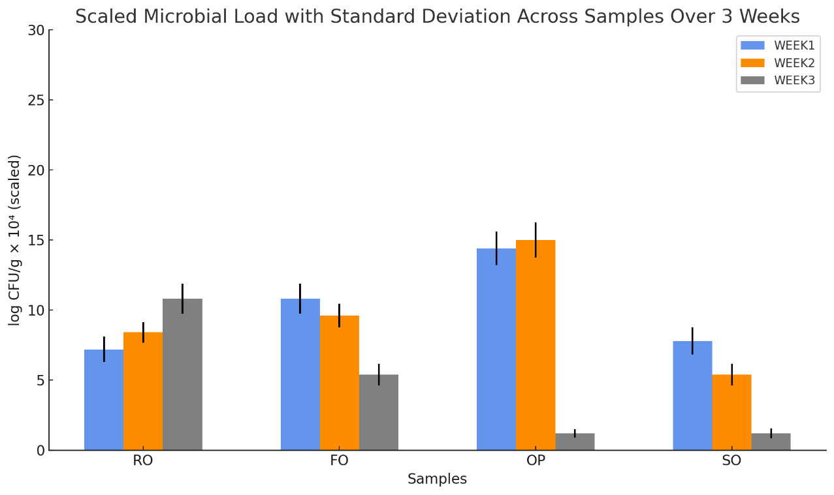

*KEYS: RO- Raw onion; FO- frozen onion; OP- Onion powder; SO-Salted onion*

*Values are mean±SD (n=3). Means with different superscript letters (a-c) in the same row are significantly different (p<0.05) by Duncan’s multiple range test.*

**Figure 1: Total Viable Count (cfu/g) of Raw and Processed Onion Samples during and after Storage**

**Table 3**: **Coliform bacteria Count (cfu/g) or Raw and Processed Onion Samples stored at different temperatures**

|  |  |  |  |
| --- | --- | --- | --- |
| Sample | Week 1 | Week 2 | Week 3 |
| RO | 12.5 x 104 | 13.3 x 104 | 13.0 x 104 |
| FO | 0.00 | 0.00 | 0.00 |
| OP | 24.0 x 104 | 24.5 x 104 | 24.0 x 104 |
| SO | 0.00 | 0.00 | 0.00 |

*RO- Raw onion; FO- frozen onion; OP- Onion powder; SO-Salted onion*

*Values are mean±SD (n=3). Means with different superscript letters (a-c) in the same row are significantly different (p<0.05) by Duncan’s multiple range test.*

At the beginning of storage, the onion samples' yeast and mould counts varied from 1.6 × 10⁴ to 44.0 × 10⁴, as seen in Figure 2. These numbers dropped to between 1.2 × 10⁴ and 17.0 × 10⁴ by week three. According to the findings of this study, which indicate a low prevalence of moulds and yeasts in the onion samples, yeasts are often uncommon in spices and herbs (Adu-Gyamfi, 2007).

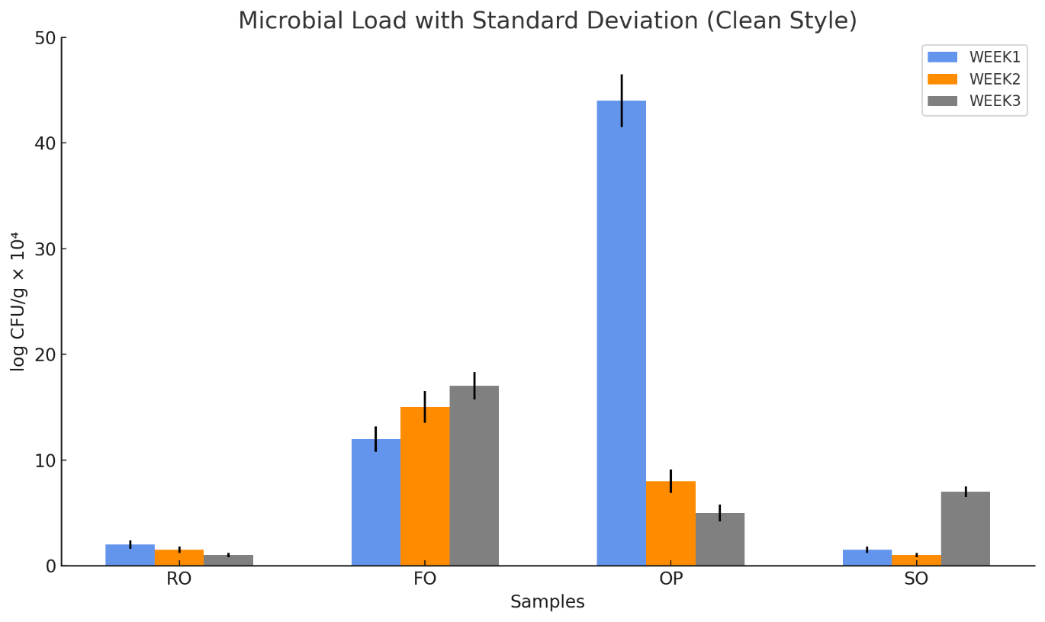

*KEYS: RO- Raw onion; FO- frozen onion; OP- Onion powder; SO-Salted onion*

*Values are mean±SD (n=3). Means with different superscript letters (a-c) in the same row are significantly different (p<0.05) by Duncan’s multiple range test.*

**Figure 2: Yeast and Mold Count (cfu/g) of raw and processed Onion sample stored at Different Temperatures**

According to Table 4, the fungus colonies that were separated from the solid culture were determined to be *Penicillium, Aspergillus, and Rhizopus*. Interestingly, when compared to raw and other processed samples, frozen onions showed the greatest levels of mould and yeast. Furthermore, over the course of storage, frozen onions' yeast and mould counts rose while those of other samples fell. This implies that irregular freezing temperatures might have produced circumstances such as partial thawing and refreezing that facilitated the growth of mould and yeast

**Table 4: Characteristics and Biochemical Test of Fungal Isolates from Raw and Processed Onion samples during storage**

|  |  |  |  |  |
| --- | --- | --- | --- | --- |
| **Characteristics/Tests** | **RO** | **FO** | **OP** | **SO** |
| **Appearance of Colonies on PDA plates**  **Reverse side appearance on PDA plate**  **Morphology** | Greenish to blue-green with a fuzzy texture  Pale yellow, smooth with dark pigment  Septate hyphae, blue green conidia in three sets | Black, fuzzy colonies, cottony growth  pale white, smooth with rhizoids visible  Non-septate hyphae, black, rhizoidal structures | Black powdery texture  Sulfur-yellow, smooth with separations between colonies  Radiated, black, septate hyphae with conidial heads | Greenish colonies  Pale yellow, smooth with dark pigment  Septate hyphae, blue-green phialides |
| **Cell Morphology** | Filamentous | Coenocytic | Filamentous | Filamentous |
| **Type of fertile hyphae** | Conidiophore | Sporangiospore | Conidiophore | Conidiophore |
|  |  |  |  |  |
| **Conidia/Sporangia position** | Exposed | Enclosed in sporangium | Exposed | Exposed |
| **Arrangement of Conidia** | Clustered | Clusters | Radiated from conidiophore | clustered |
| **Probable Identity** | *Penicillium* sp | *Rhizopus* sp | *Aspergillus* sp | *Penicillium* sp |

*KEYS: RO- Raw onion; FO- frozen onion; OP- Onion powder; SO-Salted onion*

and helped these organisms endure. The observed growth of moulds and yeasts was also influenced by the frozen onions' moisture content. These findings are consistent with Salari et al. (2012), who reported fungal counts ranging from 10⁴ to 10⁵ CFU/g, although our results were slightly lower.

The characteristics of the microorganisms recovered from raw and processed onion samples throughout storage are shown in Table 5. The raw, frozen, and onion powder samples contained blue-green colonies, whereas the salted onions had yellow colonies. The raw, frozen, and powdered onion samples included gram-positive bacteria with short rod-like shapes, according to Gram staining, whereas the salted onion samples had gram-positive bacteria clustered in grape-like patterns.

**Table 5: Characteristics and Biochemical Test of Bacterial isolates from Raw and Processed Onion samples during storage**

|  |  |  |  |  |
| --- | --- | --- | --- | --- |
| **Characteristics/Tests** | **RO** | **FO** | **OP** | **SO** |
| **Appearance of Colonies on Media plates** | Blue green colonies with characteristic odour | Blue green colonies with characteristic odour | Blue green colonies with characteristic odour | Compact yellow colonies |
| **Cell Morphology** | Short rods | Short rods | Short rods | Cocci arranged in clusters |
| **Gram’s Reaction** | -ve | -ve | -ve | +ve |
| **Catalase test** | +ve | +ve | +ve | +ve |
| **Oxidase test** | +ve |  |  |  |
| **Methyl Red** | -ve | -ve | -ve | +ve |
| **Voges-Proskauer Test** | -ve | -ve | -ve | +ve |
| **Oxidative/**  **Fermentative** | Oxidative | Oxidative | Oxidative | Fermentative |
| **Indole Test** | -ve | -ve | -ve | +ve |
| **Citrate Utilization** | +ve | +ve | +ve | -ve |
| **Probable Identity** | *Pseudomonas* sp | *Pseudomonas* sp | *Pseudomonas* sp | *Staphyloccus* sp |

*KEYS: RO- Raw onion; FO- frozen onion; OP- Onion powder; SO-Salted onion; -ve: negative; +ve: positive*

With the exception of the onion powder, every onion sample tested positive by the catalase test. All samples had Pseudomonas sp., which is known to soften onions, with the exception of the salted onions, which had Staphylococcus sp. These outcomes align with those of Agi et al. (2020), who also discovered Staphylococcus and Pseudomonas in onions. In order to improve shelf stability and reduce weight, drying is primarily used to eliminate moisture from food, which bacteria require to flourish. Reduced moisture content aids in preventing the development of harmful and spoiling microbes (Boyer & Huff, 2008; Nnenna, 2020).

One popular technique for increasing the shelf life of herbs and spices is to dry them. According to this study, the best way to preserve onions is to salt them, then dry and grind them into a powder.

**Conclusion**

According to this study, the best methods for preserving onions are salting, drying, and freezing. Salting preserved higher quality and reduced microbiological counts. While freezing initially retained moisture, subsequent temperature fluctuations led to increased growth of mould and yeast. Drying eliminated moisture, which increased protein and fat levels. The investigation revealed that the methods' moisture, protein, and fat contents varied significantly, with salting producing the highest overall outcomes. These results aid in the improvement of onion preservation methods to preserve quality and increase shelf life.

**References**

Abioye, V. F., Adejuyitan, J. A., & Idowu, C. F. (2014). Effects of different drying methods on the nutritional and quality attributes of drumstick leaves (*Adansonia digitata*). *Agricultural and Biological Journal of North America, 5*(3), 104-108.

Adeniran, H. A., Adeniyi, D. M., & Taiwo, K. A. (2020). Microbiological properties of probioticated “kununzaki” drink enriched with cocoa powder. *European Journal of Agricultural and Food Sciences, 2*(6), 1-9.

Adu-Gyamfi, A. (2007). Effect of storage time on microbial quality of some spices and dried seasonings. *Ghana Journal of Agricultural Science, 39*, 93-101.

Agu, C. S., Igwe, J. E., Amanze, N. N., & Oduma, O. (2016). Effect of oven drying on proximate composition of ginger. *American Journal of Engineering Research, 5*(8), 58-61.

Al-Rubai'y, H. H., Hassan, K. H. A., & Eskannder, M. Z. (2020). Drying and salting fish using different methods and their effect on the sensory, chemical, and microbial indices. *Multidisciplinary Review, 3*, e2020003.

Association of Official Analytical Chemists (AOAC). (2010). *Official methods of analysis* (18th ed., Rev. 3). Association of Official Analytical Chemists.

Bal, S., Maity, T. K., Sharangi, A. B., & Maji, A. (2019). Screening of onion (*Allium cepa* L.) germplasm against purple blotch disease. *Journal of Pharmacognosy and Phytochemistry, 8*(6), 546-548.

Bal, S., Maity, T. K., Sharangi, A. B., & Majumdar, A. (2019). Quality assessment in association with yield attributes contributing improved yield in onion (*Allium cepa* L.). *Journal of Crop and Weed, 15*(3), 107-115.

Corrêa, N. S., Bandeira, J. M., Marini, P., Gouvea de Borba, I. C., Lopes, N. F., & Munt de Moraes, D. (2013). Salt stress: Antioxidant activity as a physiological adaptation of onion cultivars. *Acta Botanica Brasilica, 27*(2), 394-399.

Debs-Louka, E., El Zouki, J., & Dabboussi, F. (2013). Assessment of the microbiological quality and safety of common spices and herbs sold in Lebanon. *Journal of Food and Nutritional Disorders, 2*(4), 1-6.

Dirección de Información y Estadística Agropecuaria (DIEA). (2010). *Encuestas hortícolas 2009, zona sur y litoral norte*. Ministerio de Ganadería, Agricultura y Pesca, DIEA, Montevideo.

El-Hadidy, E. M., Mossa, M. E. A., & Habashy, H. N. (2014). Effect of freezing on the pungency and antioxidants activity in leaves and bulbs of green onion in Giza 6 and Photon varieties. *Annals of Agricultural Science, 2-7*.

Gandotra, O., Gupta, S., Koul, M., & Gupta, V. (2013). Effect of freezing on the proximate, biochemical and microbial quality of fish muscle (*Tor tor*). *International Journal of Recent Scientific Research, 4*(6), 782-786.

Harrigan, W. F., & McCance, E. M. (1976). *Laboratory methods in food and dairy microbiology*. Academic Press.

Kakade, S. R., Kad, V. P., Shelke, G. N., Yenge, G. B., & Kamble, K. J. (2023). Different onion storage structures: Dimensions, materials, and effects on the quality of onions: A review. *Pharma Innovation Journal, 12*(8), 1969-1983.

Koménan, A. C. A., Bamba, B. S. B., N’gouin, J. A., & Soro, A. Y. R. (2020). Effects of drying methods and onion bulb variety on physicochemical and functional properties of onion powder. *Asian Food Science Journal, 19*(4), 42-54.

Madhu, B., Mudgal, V. D., & Champawat, P. S. (2019). Storage of garlic bulbs (*Allium sativum* L.): A review. *Journal of Food Processing Engineering, 42*(6), 1-6.

Nnenna, O. (2020). Effect of different storage conditions on the microbial profile of some commonly used spices in Nigeria. *Journal of Multidimensional Research and Reviews, 1*(2), 91-104.

Pal, S., Sharma, H. R., & Yadav, N. (2017). Evaluation of cucumber genotypes for yield and quality traits. *Journal of Hill Agriculture, 8*(2), 144-150.

Petropoulos, S. A., Ntatsi, G., Fernandes, S., et al. (2016). Long-term storage effect on chemical composition, nutritional value, and quality of Greek onion landrace “vatikiotiko.” *Food Chemistry, 201*, 168-176.

Pitt, J. I., & Hocking, A. D. (2022). Methods for enumeration, isolation and identification. In *Fungi and Food Spoilage* (pp. 87-120). Springer.

Salari, B., Habibi-Najafi, M., Boroushaki, M. T., Mortazavi, S. A., & Fathi Najafi, M. (2012). Assessment of the microbiological quality and mycotoxin contamination of Iranian red pepper spice. *Journal of Agricultural Science and Technology, 14*, 1511-1521.

Salve, R. V., Syed, H. M., More, S. G., & Shinde, E. M. (2020). Effect of different drying treatments on composition, nutritional, and phytochemical content of curry leaves. *Pharma Innovation Journal, 9*(7), 584-589.

Sangwan, A., Kawatra, A., & Sehgal, S. (2010). Nutritional evaluation of onion powder dried using different drying methods. *Journal of Dairying, Foods, and Home Science, 29*(2), 151-153.

Wijewardana, R. M. N. A., Nawarathne, S. B., & Wickramasinghe, I. (2016). Effect of various dehydration methods on proximate composition and retention of antioxidants in different fruit powders. *Journal of Food Science and Technology, 23*(5), 2016-2020.

Demissew, A., Meresa, A., & Temesgen, K. (2018). Evaluation of drying methods on some nutritional and volatile components of Bombay Red onion (*Allium cepa* L.). *Preprints*, 2018030101.

Paciulli, M., Ganino, T., Pellegrini, N., Rinaldi, M., Zaupa, M., Fabbri, A., & Chiavaro, E. (2015). Impact of the industrial freezing process on selected vegetables — Part I. Structure, texture, and antioxidant capacity. *Food Research International, 74*, 329-337.

Rouphael, Y., Petropoulos, S. A., Cardarelli, M., & Colla, G. (2018). Salinity as eustressor for enhancing the quality of vegetables. *Scientia Horticulturae, 234*, 361-369.

Hafez, N. E., Awad, A. M., Ibrahim, S. M., Mohamed, H. R., & El-Lahamy, A. A. (2019). Effect of salting process on fish quality. *Nutrition and Food Processing, 2*(1).

Hervik, A. K., & Svihus, B. (2019). The role of fiber in energy balance. *Journal of Nutrition and Metabolism*, 4983657.