Original Research Article
Development and standardization of a Ready-to-Serve (RTS) beverage infused with Ashwagandha (Withania somnifera) and Shatavari (Asparagus racemosus)

ABSTRACT
The present study was undertaken to develop and standardize a Ready-To-Serve (RTS) functional beverage infused with Ayurvedic herbs aimed at enhancing the overall well-being of individuals. Kokum juice (Garcinia indica), ashwagandha (Withania somnifera), shatavari (Asparagus racemosus) and jaggery powder were used for the preparation of the ready-to-serve beverage. To analyse the impact of varying concentrations of ayurvedic herbs (Ashwagandha and shatavari), three formulations were prepared of 0.5%, 1.0% and 1.5% while maintaining constant quantities of the other ingredients. Sensory evaluation was conducted using a 9-point hedonic scale by a semi-trained panel to assess colour, mouthfeel, aftertaste, flavour and overall acceptability. Among the three samples, 0.5% concentration of ayurvedic herbs (Ashwagandha and shatavari) was rated the highest for overall sensory appeal and selected for further analysis. The ready-to-serve beverage showed a moisture content of 90% and ash content of 2.10% reflecting the mineral composition. The total soluble solids measured 11°Bx suggesting a moderate sugar level. pH of 3.5 and titratable acidity of 0.2% indicated a mildly acidic nature helps in preservation and balancing flavour. Additionally, the microbial analysis showed negative results for coliforms, reflecting no microbial growth and suggesting good shelf stability of the product.

Keywords: Ashwagandha; Shatavari; ready-to-serve; kokum juice; beverage; ayurvedic herbs.

1. INTRODUCTION
The kokum fruit (Garcinia indica) is one of the most renowned fruits and is grown in various states of Maharashtra, Karnataka and Kerala. The dried fruit rind of kokum which is widely used in many food preparations adds a sour and tangy flavour to many dishes and beverages. Kokum has a long history in Ayurvedic medicine as it was traditionally used for treatment of different health related problems like sores, dermatitis, diarrhoea, dysentery, ear infection and to facilitate digestion (Chate et al., 2019). The fruit contains a huge variety of bioactive components and pigments like anthocyanin responsible for the characteristic red and purple colour of the kokum fruit. Even though the kokum fruit has such excellent benefits, very few processed products can be seen in the market making it a potential to process and make value added products out of it. Thus, incorporation of such a fruit pigments the beverage along with maintaining its acidity.

Due to the changing lifestyle of many individuals and a step towards natural health solutions, traditional systems of medicine, particularly Ayurveda have been an interest and have been adapted by us. The use of ayurvedic herbs in the Ready-To-Serve (RTS) beverage shows synergistic effects to promote overall well-being. Ashwagandha (Withania somnifera) is often referred to as the “Indian Ginseng” a powerful rasayana known for its ability to combat stress, improve cognitive function and support immune health (Singh & Gilca, 2010) .Ashwagandha is a real potent regenerative tonic (Rasayana of Ayurveda), due to its multiple pharmacological actions like anti-stress, neuroprotective, antitumor, anti-arthritic, analgesic and anti-inflammatory etc and is useful for different types of diseases like Parkinson, dementia, memory loss, stress induced diseases, malignoma and others (Singh et al., 2011) .(Shatavari (Asparagus racemosus) is also one of the most used ayurvedic herbs by Indians due to its various health benefits. It was known that shatavari was traditionally revered as a tonic for the female reproductive system. The plant possesses various properties like ageing, increases endurance, provides immunity, enhances mental function and adds spunk to the body and it's also utilized in mental disorders, heartburn, cancer, irritation, neuropathy, hepatopathy etc (Thakur et al., 2021). The integration of ashwagandha and shatavari not only enriches the nutritional and functional profile of the beverage but also aligns with the growing demand for natural, health enhancing products rooted in traditional wisdom.

Ready-To-Serve (RTS) beverages are widely available in the market among all age groups because of their convenience and refreshing nature. In recent years, there has been a growing interest in using ayurvedic products in the food industry. There is also a growing demand to produce beverages with ayurvedic and indigenous ingredients. Ready-To-Serve (RTS) is a type of beverage containing at least 10% fruit juice besides less than 0.3% acid according to the Food Safety Standards Authority of India and it is normally not diluted before serving and hence known as RTS beverage.

This Ready-To-Serve (RTS) beverage is a unique blend of taste and wellness, combining the tangy flavour and vibrant colour of kokum fruit with benefits of ayurvedic herbs (Ashwagandha and shatavari).

2.MATERIALS AND METHODS
2.1 Materials
Ashwagandha powder (Withania somnifera) and Shatavari powder (Asparagus racemosus) were purchased from a Prasanna Ayurvedalaya shop in Bibwewadi, Pune, Maharashtra, India both certified as food grade. The kokum rinds (Garcinia indica) and jaggery powder were purchased from the market of Loni-Kalbhor, Pune, Maharashtra, India. Potable water was used for the preparation of the beverage and was sourced from the water filtration system at MIT ADT University, Maharashtra, India. This research has been carried out in the research laboratory of Food Process and Product Technology, MIT School of Food Technology, MIT ADT University, Maharashtra, India.

2.2 Preparation of kokum juice
The kokum rinds were washed thoroughly and submerged in water overnight till their fibres softened and were blended in an electric mixer (Preethi, 230V- 50Hz). The extracted juice was filtered by passing through a sterile muslin cloth.

2.3 Preparation of ready-to-serve beverage
Each formulation was prepared by initially dissolving the required amounts of Ashwagandha and Shatavari powders in lukewarm water. Jaggery powder and kokum juice were then added according to the formulation and the mixture was gently stirred until all ingredients were dissolved thoroughly. To remove the sediments of the kokum juice, the prepared beverage was filtered through four folds of sterile muslin cloth. The filtrate was subjected to pasteurization at 72°C for 15 seconds, immediately cooled and filled into sterilized glass bottles. All the samples were stored at refrigerated conditions (4°C).

Dissolving
(Ashwagandha and shatavari in water)
↓
Addition
(jaggery powder and kokum juice)
↓
Stirring
↓
Filtering
↓
Pasteurization
(72°C for 15 seconds)
↓
Filling into sterilized glass bottles
↓
Storage at refrigerated temperature (4°C)
Fig. 1. Flow chart for ready-to-serve beverage production

2.4 Product Development Trials
Three trial samples were prepared sample A, B and C with different concentrations of ayurvedic herbs (Ashwagandha and shatavari) to understand the impact of the samples on the sensory and functional properties of the formulated product. The concentration of ayurvedic herbs (Ashwagandha and shatavari) was adjusted to 0.5%, 1.0%, and 1.5% and other ingredients were kept constant to isolate the impact of the ayurvedic concentrations. The composition and differentiation of the trial samples are presented in Table 1. A panel of 25 semi-trained members were considered for the sensory evaluation of sample A, B, C and control sample, which used a 9-point hedonic scale to rate all the samples based on colour, mouthfeel, aftertaste, flavour and overall acceptability. Sample A (0.5% concentration of ayurvedic herbs) was selected based on the sensory evaluation due to its optimal balance between sensory quality and herbal inclusion.

Table 1. Formulations of the samples with varying concentrations of ayurvedic herbs
 | Control sample | Sample A | Sample B | Sample C
Kokum juice | 20 ml | 20 ml | 20 ml | 20 ml
Water | 94 ml | 94 ml | 94 ml | 94 ml
Jaggery powder | - | 3.3 g | 3.3 g | 3.3 g
Ashwagandha | - | 0.5 g | 1.0 g | 1.5 g
Shatavari | - | 0.5 g | 1.0 g | 1.5 g
Sodium benzoate | 0.03 g | 0.03 g | 0.03 g | 0.03 g

2.5 Chemical Analysis
2.5.1 Moisture content
The moisture content was determined using the method described by (Horwitz, 2005).A clean, dry and empty petri dish was first weighed, and its initial weight was recorded. Then 5 ml of sample was weighed and placed in the petri dish. The petri dish was then placed into a hot air oven (i-therm AI-7981, India) at 105°C for 3 hours. After drying the petri dish was placed in the glass desiccator to cool and once cooled to room temperature the weight of the petri dish along with the dried sample was measured. The percentage of the moisture content was calculated using the formula:

…..(1)

2.5.2 Ash content
Ash content was estimated using a muffle furnace (i-therm AI-7481, India). A 5 ml sample was weighed and was taken into crucibles, burnt on a hot plate and finally placed into the muffle furnace at 600°C for 4 hours to obtain a light grey coloured ash (Ranganna, 1986). After complete burning the percent ash content was calculated using the following formula:
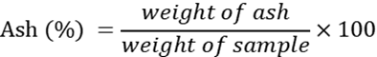

…..(2)

2.5.3 Anthocyanin Content
Anthocyanin content was estimated using the method of (Swain & Hillis, 1959). Known weight of the ready-to-serve beverage was mixed with alcohol and the extract was filtered. 1 ml of the extract was mixed with 3 ml of 0.5N HCl in 80-85% methanol, followed by addition of 1 ml anthocyanin reagent (prepared by mixing 1 ml of 30% H2O2 with 9 ml methanolic HCl). A blank was prepared using methanolic HCl instead of anthocyanin reagent. After 15 minutes of dark incubation, absorbance was measured at 525 nm using a colorimeter (MAX ME-51, India). Anthocyanin concentration was calculated using a standard curve of cyanin hydrochloride.

2.6 Physicochemical Analysis
2.6.1 pH
The pH values were measured using a digital pH meter (LABMAN LMPH-10, India). The pH meter was calibrated using the buffer solution before calculating the value.

2.6.2 TSS
Total soluble solids (TSS) were determined using a handheld refractometer (ERMA INC, India) at 20°C ranging up to 55°Bx. The prepared ready-to-serve beverage is placed on the prism surface of the hand refractometer and by looking through the eyepiece, results were taken. The results were expressed as °Brix.

2.6.3 Titratable Acidity
Titratable acidity was assessed using a standard alkali solution (0.1N NaOH) with phenolphthalein as indicator, and the results were presented as a percentage. Three readings were taken and accordingly their mean was calculated using the following equation:

$$Percentageofacid\left(\%\right)=\left(VolofNaOHused×0.1NNaOH×milliequivalentfactor×100\right)$$

$$Sample\left(ml\right)$$

…..(3)

2.6.4 Antioxidant activity (DPPH)
The sample's antioxidant activity was estimated using DPPH (2,2-diphenyl-1-picrylhydrazyl) reagent. Different volumes of standards and samples were pipetted, addition of 2.8 ml of methanol and 0.2 ml of DPPH (50µM) reagent to each were followed. The mixture was homogenized and left in the dark for 20 minutes and absorbance at 517 nm was measured using a UV-Visible 1800 spectrophotometer (Benchtop LABINDIA, India). The antioxidant activity of the sample was evaluated based on its ability to inhibit DPPH radical absorption. The readings were taken and calculated using the following equation (Adebiyi et al., 2017) :

DPPH Activity (%) = (A₀- A₁)/ A₀ x 100 …..(4)
where, A₀ is the absorbance of the control and A₁ is the absorbance of the sample

2.6.5 Viscosity (cP)
The viscosity of the ready-to-serve beverage was measured using an Ostwald viscometer (J-SIL Borosilicate, India). The sample was filled up to the mark and allowed to flow through the capillary under gravity. The time taken for the liquid to pass was recorded using a stopwatch. The viscosity was calculated by comparing the flow time of the sample with that of distilled water at the same temperature using the formula:

$η$₁= $η$₂ / (t₁x$ρ$₁/ t₂x $ρ$₂) …..(5)
where,
$η$₁= viscosity of sample
$η$₂ = viscosity of water
t₁, t₂= flow time of sample and water, respectively
$ρ$₁,$ρ$₂ = density of sample and water, respectively

2.7 Microbial Analysis

2.7.1 Total Plate Count (TPC)
To assess the overall microbial load in the ready-to-serve beverage the Total Plate Count method was conducted. Nutrient Agar was prepared and sterilised, then poured into sterile petri plates and allowed to solidify. Serial dilutions of the beverage samples were prepared, and 1 ml aliquots were plated onto three separate petri dishes. The plates were incubated at 37°C for 24 hours in a bacteriological incubator (LABiN LI-90, India). After incubation, the number of colony forming units (CFUs) was counted manually, and results were expressed as CFU/ml by the using the formula:

No of cells/ml= No of colonies x Dilution factor/ weight of sample
Dilution factor= Reciprocal of the dilution …..(6)

2.7.2 Most Probable Number (MPN)
The Most Probable Number method was conducted to estimate the presence of coliform bacteria. Serial dilution tubes of 10ml (sample along with double strength lactose broth), 1 ml (sample along with single strength broth) and 0.1 ml (sample along with single strength lactose broth) were prepared and inoculated into bacteriological incubator (LABiN LI-90, India) for 48 hours. The tubes were observed for gas production and colour change.

2.7.3 Coliform Test
To assess the overall microbial load in the ready-to-serve beverage the Total Plate Count method was conducted. MacConkey Agar was prepared and sterilised, then poured into sterile petri plates and allowed to solidify. Serial dilutions of the beverage samples were prepared, and 1 ml aliquots were plated onto three separate petri dishes. The plates were incubated at 37°C for 24 hours in a bacteriological incubator (LABiN LI-90, India). After incubation, the number of colony forming units (CFUs) was counted manually, and results were expressed as CFU/ml by the using the formula (6):

3.RESULTS AND DISCUSSION

3.1 Moisture content
The moisture content of the ready-to-serve beverage was lesser in sample A was 90% compared to the control sample which was 92%. The slight reduction in moisture content in sample A may be due to the incorporation of additional ayurvedic ingredients. Although the variation is minimal, it could contribute to improved shelf stability by reducing the microbial growth.

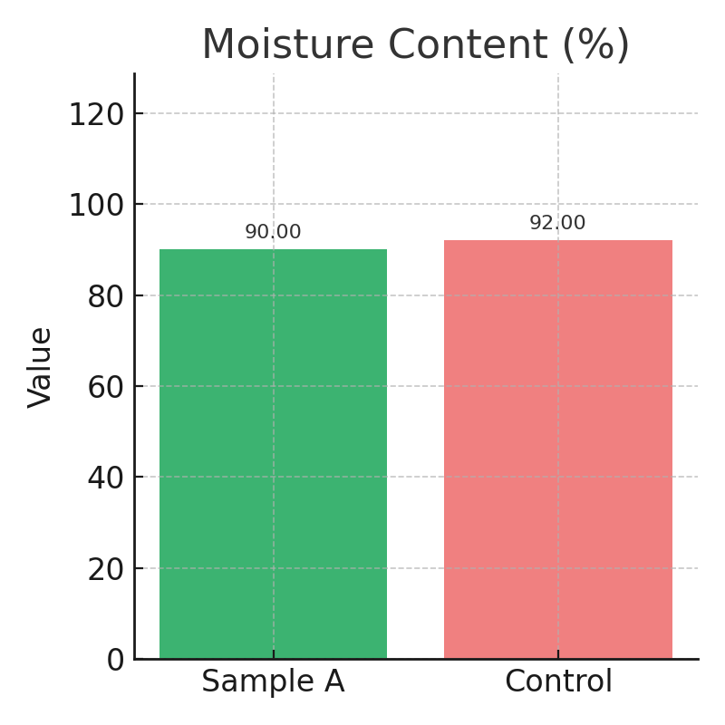
Fig. 2. Moisture content of Sample A and Control Sample
3.2 Ash content
The ash content of the ready-to-serve beverage was higher in sample A was 2.10% compared to the control sample, which was 1.40%, indicating a greater mineral appearance. This increase may be due to the addition of ayurvedic herbs like ashwagandha and shatavari, which are naturally rich in minerals. The elevated ash content enhances the nutritional value of the beverage while remaining within acceptable limits.

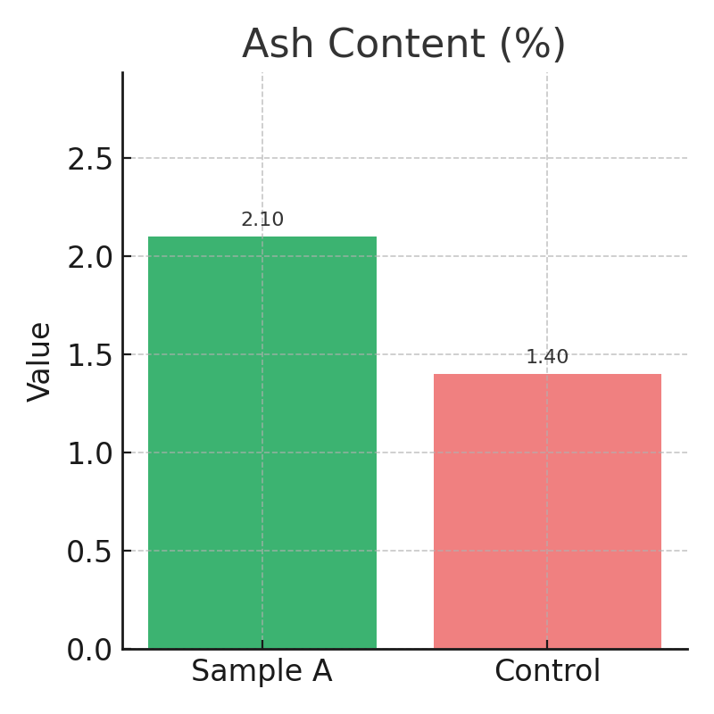
Fig. 3. Ash of Sample A and Control Sample

3.3 Total Soluble Solids
The TSS measurement for the ready-to-serve beverage reached 11° Brix thus demonstrating its high concentration of dissolved sugars and solids. The increased dissolved solids and sugars in the beverage produce natural sweetness while improving its texture and consistency. The TSS measurement of the ready-to-serve beverage at 11° Brix produces enhanced flavour and substance compared to typical kokum beverages that usually contain 9° Brix. Jaggery together with ayurvedic herbs (Ashwagandha and shatavari) raises the TSS levels in this beverage without requiring additional sugar additions.

3.4 pH
The pH measurement for the ready-to-serve beverage reached 3.5 and categorized it as mildly acidic for beverages based on fruit composition. The beverage maintains an optimal acidity that allows flavour production and protects against microbial growth. Standard kokum drinks exhibit a more intense acidic profile because they maintain a pH reading of approximately 3.2 although the ready-to-serve beverage shows a slightly less acidic character with a pH of about 3.5. Moderate pH level results in increased drinkability, longer shelf life, and safety.

3.5 Titratable acidity
The titratable acidity measurement for the ready-to-serve beverage showed a value of 0.2% when expressed as citric acid equivalent. It possesses a gentler acidic level compared to classic kokum beverages that stands at approximately 0.25% which creates a smoother tart taste beneficial for maximizing consumer acceptance. Ayurvedic herbs help to minimize natural acidity and produce a smooth flavour that appeals to consumers despite maintaining its preservation quality.

3.6 Antioxidant level
The antioxidants level for the ready-to-serve beverage reached a valuable 10.5% strength during the DPPH antioxidant measurement. Regular kokum-based beverages typically provide an average antioxidant activity of 5.8% whereas the ready-to-serve beverage reached 10.5%. The ayurvedic herbs in the product demonstrate a robust antioxidant function because they efficiently counteract radicals while helping users manage their stress levels. The antioxidant functionality offers special appeal to people who combine health concerns with beverage consumption.
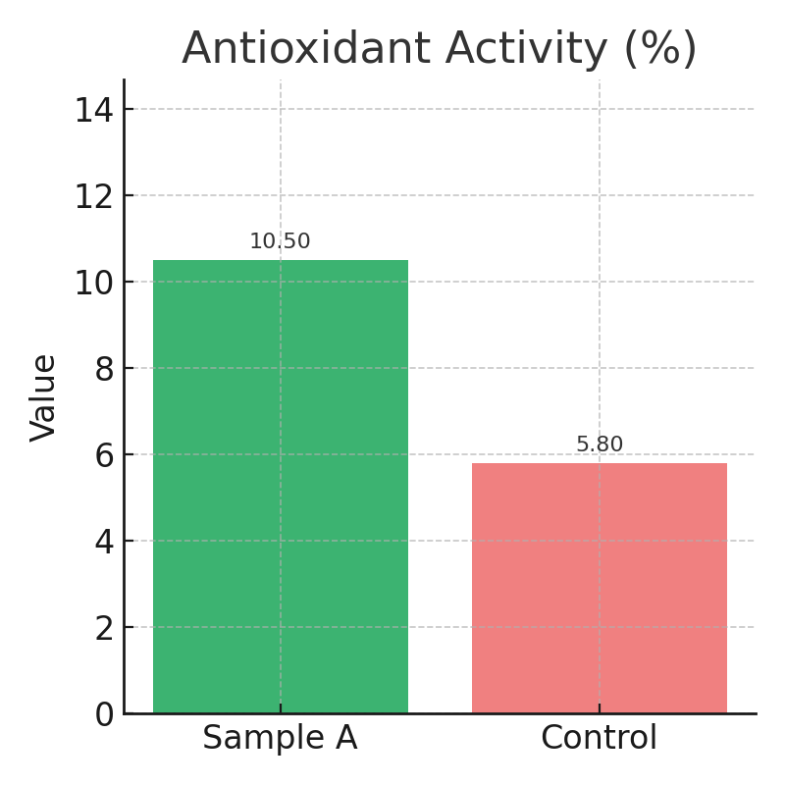
Fig. 4. Antioxidant activity of Sample A and Control Sample

3.7 Viscosity
The viscosity of the ready-to-serve beverage reached 1.198 centipoise (cp) above ordinary plain kokum beverages while maintaining similar drinkability. The faint viscosity increase delivers a silky mouthfeel which produces better satisfaction levels without decreasing beverage drinkability. The herb extracts together with jaggery solids amplify the thickness of the ready-to-serve beverage to create a smooth and satisfying mouthfeel that deepens the sensory experience.

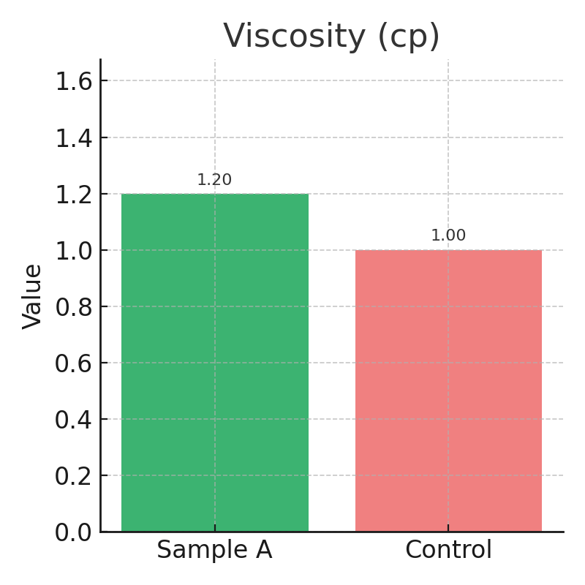
Fig. 5. Viscosity of Sample A and Control Sample

3.8 Anthocyanin content
The anthocyanin component found in kokum determines both beverage functionality and appeal by contributing antioxidant characteristics and visual appearance. The scientific research by (Hegde et al., 2018) established kokum extract demonstrates 3.12 mg/100 ml anthocyanin content which indicates its valuable natural pigment and health-enhancing bioactive potential. The juice blends contained 2.00 mg/100 ml anthocyanins during preparation for both visual cornucopia and antioxidant attributes but measured 1.20 mg/100 ml anthocyanins after 50 days of storage owing to temperature changes, oxygen exposure, and organic pigment instability. The International Journal of Chemical Studies​ along with other research confirm that anthocyanins show sensitivity to storage environment conditions. A reduction of anthocyanin content during shelf-life storage is expected as part of both formulation development and packaging methodology.

3.6 Sensory Analysis-
The sensory evaluation determined how varying Ayurvedic herb concentrations affected the
sensory properties of the beverage formula. Three separate samples focused on this experiment using identical beverage bases in all samples and steadily raising the ayurvedic herbal concentrations. The sample without any ayurvedic herbs served as the control in the evaluation. The sensory evaluation used a group of 25 semi-trained evaluators to assess taste along with colour, mouthfeel, aftertaste, flavour and overall acceptability. During testing of the products, the sample A formulation received the highest assessment scores from panellists. Panellists expressed positive feedback regarding the balanced flavour together with pleasing colour aspects, smooth mouthfeel and the pleasant aftertaste of the product. The results led to adopting the sample A formulation as the standardized base for future development of the product. The results showed no major difference between the control sample and sample A even though sample A provided the therapeutic properties from ayurvedic herbs.

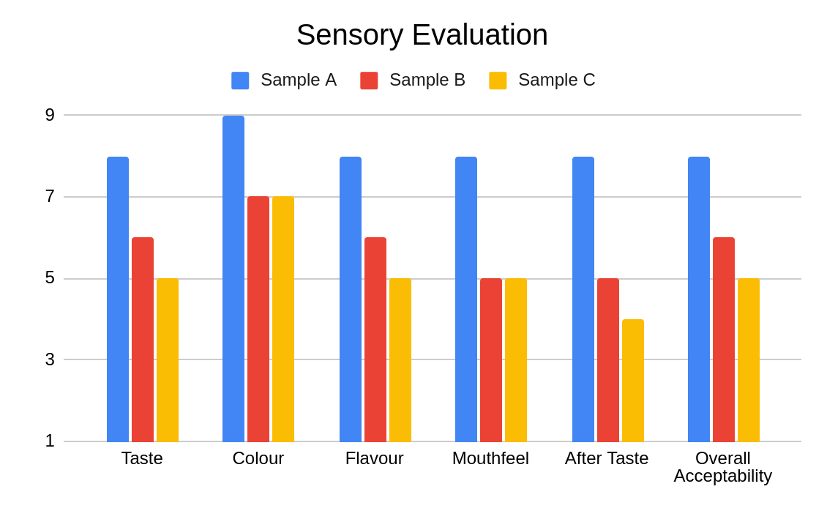
Fig. 6. Sensory Evaluation during final product formulation

3.7 Microbial Analysis -
Microbiological analysis for ready-to-serve beverage was conducted using the Total Plate Count (TPC) to determine the presence of aerobic bacteria, Coliform Test to check the safety after consumption of the product, and Most Probable Number (MPN) to estimate the number of coliform bacteria and to ensure the safety and quality of the product. The results obtained for the respective tests were, TPC using the pour plate method showed 0 cfu/mL, indicating the absence of viable aerobic bacteria. The Coliform Test, conducted using MacConkey broth, had negative results. The MPN test, showed no gas generation or colour change, verified the absence of coliforms. Hence, in conclusion the ready-to-serve beverage was hygienically prepared, free from contamination, and is microbiologically safe for consumption. The usage of sodium benzoate (0.03 g per 100 mL), as a preservative, is effective to enhance the shelf life of the product which is projected to be 6 months. The shelf life can be further increased by keeping the beverage refrigerated.

4.CONCLUSION
The Ready to Serve ayurvedic beverage was prepared using kokum juice, shatavari,
ashwagandha and jaggery. The infusion of ayurvedic herbs showed nutritional and
medicinal potential. These improved the palatability and health benefits of the beverage while also enriching it with natural antioxidants and adaptogens. Microbial analysis demonstrated that the ready-to-serve beverage may have a shelf life of 3 months with safety & stability within the permissible limits, while the chemical analysis verified the presence of crucial bioactive compounds. The preservative added to the beverage was sodium benzoate that showed effective results and prevented the growth of microorganisms. The preservative added were within the limits of Food Safety Standards Authority of India. Also the sensory evaluation assessed that this beverage provides a healthy & natural substitute that is appropriate for contemporary consumers looking for beverages focused in the functional category. The absence of coliforms confirms the quality and safety of the ready-to-serve beverage. More research work would be needed to increase the shelf life up to 6 months.

REFERENCES
Adebiyi, O. E., Olayemi, F. O., Ning-Hua, T., & Guang-Zhi, Z. (2017). In vitro antioxidant activity, total phenolic and flavonoid contents of ethanol extract of stem and leaf of Grewia carpinifolia. Beni-Suef University Journal of Basic and Applied Sciences, 6(1), 10–14. https://doi.org/10.1016/J.BJBAS.2016.12.003
Chate, M. R., Kakade, S. B., & Neeha, V. S. (2019). Kokum (Garcinia indica) Fruit: A Review. In Asian Journal of Dairy and Food Research (Vol. 38, Issue 4, pp. 329–332). Agricultural Research Communication Centre. https://doi.org/10.18805/ajdfr.DR-1493
Hegde, P. P., GK, S., KN, S., TH, S., K, C., GS, M., H, M. T., & Masoumi, A. (2018). Development of healthy kokum blended RTS beverage using aonla and ginger. Journal of Pharmacognosy and Phytochemistry, 7(3S), 323–325. https://www.phytojournal.com/special-issue/2018.v7.i3S.4824/development-of-healthy-kokum-blended-rts-beverage-using-aonla-and-ginger
Horwitz, W. and L. G. W. L. (2005). Of fi cial Methods of Anal y sis of AOAC IN TER NA TIONAL 18th Edi tion, 2005. Of Fi Cial Methods of Anal y Sis of AOAC IN TER NA TIONAL 18th Edi Tion, 2005, d, 4–5. https://www.researchgate.net/publication/292783651_AOAC_2005
Ranganna, S. (1986). Handbook of Analysis and Quality Control for Fruit and Vegetable Products. Tata McGraw-Hill Publishing Company. In Tata McGraw-Hill Publishing Company.
Singh, N., Bhalla, M., de Jager, P., & Gilca, M. (2011). An Overview on Ashwagandha: A Rasayana (Rejuvenator) Of Ayurveda. Afr J Tradit Complement Altern Med, 8(S), 208–213. https://doi.org/10.4314/ajtcam.v8i5S.9
Singh, Narendra., & Gilca, Marilena. (2010). Herbal medicine : science embraces tradition : a new insight into ancient Ayurveda. 640. https://search.worldcat.org/title/720150926
Swain, T., & Hillis, W. E. (1959). The phenolic constituents of Prunus domestica. I.—The quantitative analysis of phenolic constituents. Journal of the Science of Food and Agriculture, 10(1), 63–68. https://doi.org/10.1002/JSFA.2740100110
Thakur, S., Kaurav, H., & Chaudhary, G. (2021). Shatavari (Asparagus Racemosus)-The Best Female Reproductive Tonic. International Journal of Research and Review (Ijrrjournal.Com), 8(5), 73. https://doi.org/10.52403/ijrr.20210511

