Integrated Herbicide-Hand-Weeding Practices and Nitrogen Rates Enhance Weed Control and Seed Yield of Sesame (Sesamum indicum L.) under Semi-Arid, Loamy-Sandy Soils

Abstract
A field experiment was conducted on loamy-sandy soil during the kharif season. The factorial RBD trial comprised seven weed-management treatments: weedy check; one hand-weeding (HW) at 20 DAS; two HW at 20 & 40 DAS; alachlor 1.5 kg ha⁻¹; alachlor 1.5 kg ha⁻¹ + HW 30 DAS; imazethapyr 0.15 kg ha⁻¹; and imazethapyr 0.15 kg ha⁻¹ + HW 30 DAS, combined with three nitrogen rates (0, 20, 40 kg N ha⁻¹), each treatment replicated thrice. Pre-emergence imazethapyr 0.15 kg ha⁻¹ + one HW at 30 DAS and two HW at 20 and 40 DAS gave the greatest weed suppression, lowering weed density and dry matter by approximately 82 % at harvest and achieving the highest weed-control efficiency among all treatments. The imazethapyr + HW package also produced the tallest plants and the maximum seed yield (855 kg ha⁻¹), significantly surpassing all other weed-control options. Nitrogen nutrition further enhanced crop performance: raising the dose to 40 kg N ha⁻¹ delivered the tallest plants and the highest mean seed yield (787 kg ha⁻¹), demonstrating that adequate N amplifies the benefits of effective weed management in sesame.
Keywords: Imazethapyr; Integrated weed management; Sesame; Nitrogen fertilization; Seed yield; Weed control efficiency
Introduction
Sesame (Sesamum indicum L.), commonly referred to as "til" in India, is one of the most ancient oilseed crops cultivated for its high-quality edible oil and protein-rich cake. India ranks among the leading producers of sesame globally, with major cultivation occurring in the states of Uttar Pradesh, Rajasthan, Madhya Pradesh, Maharashtra, Gujarat, and West Bengal (FAO, 2021). Despite its economic and nutritional importance, sesame productivity in India remains relatively low, primarily due to poor crop management practices, with weed infestation being a major yield-limiting factor (Singh et al., 2020).
Weed competition in sesame is particularly severe during the initial stages of crop growth due to its slow germination and poor early canopy coverage, which allows rapid weed emergence and dominance (Kumar et al., 2018). Weeds compete with the crop for essential resources such as light, water, and nutrients, especially nitrogen, an element crucial for plant growth and development. If not controlled timely, weeds can cause yield losses ranging from 30% to 70% in sesame, depending on the intensity and spectrum of weed flora (Choudhary et al., 2019).
Traditional methods such as hand weeding are still widely practiced in India due to their effectiveness and affordability in smallholder systems. However, these methods are labour-intensive and increasingly constrained by rising wage rates and labour shortages (Patel et al., 2020). In this context, the integration of chemical weed management strategies, particularly the use of pre-emergence herbicides such as alachlor and imazethapyr, has gained attention for their potential to provide early-season weed control and reduce labour dependency (Yadav et al., 2021). Previous studies have shown that alachlor effectively controls broad-leaved and grassy weeds in oilseed crops when applied at appropriate doses (Balyan et al., 2017), while imazethapyr has been reported to offer broad-spectrum control with a favourable environmental profile (Verma and Singh, 2022).
Nitrogen availability further influences weed-crop competition, as weeds often outcompete crops for available nutrients under nitrogen-rich conditions (Pandey et al., 2019). The interactive effects of weed management practices and nitrogen levels on weed dynamics are therefore critical to understand, especially in low-input systems like sesame cultivation. However, comprehensive studies investigating this interaction in sesame are limited in the Indian context. Additionally higher nitrogen levels are linked to greater weed biomass and density if not managed properly (Sharma et al., 2020), emphasizing the need for synchronized weed and nutrient management approaches.
Given this background, the present study was undertaken to evaluate the effect of different weed management practices and varying nitrogen levels on weed dynamics and weed control efficiency in sesame.
Materials and methods
The experiment was conducted during rainy season (kharif) of 2018 at Agronomy Farm, College of Agriculture and Research, Maharaja Jyoti Rao Phoole University, Achrol, Rajasthan.The area falls in agro-climatic zone-IIIa (Semi-arid eastern plain zone of Rajasthan). The average weekly rainfall received during the experimental period was 30 mm. Weekly mean maximum temperature varied between 30°C and 37°C, while minimum temperatures was 27.5°C to 19°C. Relative humidity ranged from 54% to 86%, with higher values observed during wetter weeks and a noticeable decline during drier periods. The soil of the experimental field was loamy sand in texture, alkaline in reaction, poor in organic carbon (0.18%) with low available nitrogen (127.14 kg ha⁻¹), medium in available phosphorus (16.38 kg ha⁻¹) and potassium (156.68 kg ha⁻¹).
The experiment was laid out in a factorial randomized block design (FRBD) with first factor involving seven weed management treatments (W₁: weedy check, W₂: one hand weeding (HW) at 20 DAS, W₃: two hand weeding at 20 and 40 DAS, W₄: pre-emergence application (PE) of Alachlor @ 1.5 kg a.i./ha, W₅: of Alachlor @1.5 kg a.i./ha (PE) + HW at 30 DAS, W₆: imazethapyr @ 0.15 kg a.i./ha (PE), W₇: imazethapyr @ 0.15 kg a.i./ha (PE) + HW at 30 DAS) and three nitrogen levels (N₀: control, N₁:20 kg N ha⁻¹, N₂: 40 kg N ha⁻¹) as second factor.
The herbicides were applied 1 day after sowing (DAS) of the crop using a knapsack sprayer. Hand weeding was done manually using khurpi. A uniform dose of 25 kg P₂O₅ ha⁻¹ was drilled in furrows at the time of last ploughing through SSP. Urea was used as the source for nitrogen, which was applied as basal as per treatment. Weed density was taken at 50 DAS and at harvest stage from three random spots in each plot using a quadrate of 0.25 m².
Results and discussion

Weed density and infestation
Data on weed density and weed infestation is presented in Table 1. Weed management treatments significantly influenced the weed density throughout the experimental period. At 50 DAS and harvest stages, the minimum weed density (5.78 and 4.33 m⁻²) was obtained when two hand weeding were done at 20 and 40 DAS. However, it was found at par with pre-emergence application of imazethapyr at 0.15 kg ha⁻¹ + HW at 30 DAS that exhibited weed densities of 5.89 and 4.56 m⁻² at these stages. These two treatments resulted 91.9 and 91.7 % reduction in weed density at 50 DAS and 92.4 and 92.0 % at harvest stages, respectively in comparison to weedy check plots. This finding is supported by the work of Singh et al. (2018) and Joshi et al. (2022) where Hand weeding and imazethapyr recorded significant reduction in weed density. Pre emergence application of alachlor at 1.5 kg ha⁻¹ + HW at 30 Das, one HW at 20 DAS and imazethapyr at 0.15 kg ha⁻¹ also recorded 89.9, 88.3 and 87.4 % lower weed population at 50 DAS and 90.9, 87.3 and 86.4 % at harvest stages, respectively than weedy check treatment. Similar findings were reported by Sujithra et al. (2018). Throughout the experiment, the highest weed density was reported in Dhaka et al. (2014). Nitrogen levels did not produce any significant result in terms of weed density at 50 DAS. However, at harvest stage, application of N at 40 kg ha⁻¹ recorded the highest weed density of 14.60 m⁻² that was 25.4 % higher than control. However, it was found statistically similar with 20 kg N ha⁻¹. Similar findings were reported by Kamani et al. (2022).
The perusal data on weed infestation as influenced by weed management treatments and nitrogen levels is presented in Table 1. Two hand weeding at 20 and 40 DAS witnessed the lowest weed infestation (40.68 and 34.82%) at 50 DAS and harvest stages. It was very closely accompanied by pre-emergence application of imazethapyr at 0.15 kg ha⁻¹ + HW at 30 DAS (40.94 and 35.70 %). These two-treatment recorded 49.6 and 49.3 % lower weed infestation at 50 DAS and 54.7 and 53.7 per cent at harvest stage than weedy check wherein, the maximum weed infestation of 90.28 and 89.47 % was obtained at these stages. Reducing the weed infestation by 44.7, 40.3 and 39.4 % at 50 DAS and 50.7, 41.9 and 40.9 per cent at harvest stage, alachlor at 1.5 kg ha⁻¹ + HW at 30 DAS, one HW at 20 DAS and imazethapyr at 0.15 kg ha⁻¹ were found to be the next better treatments. In case of nitrogen levels, the maximum weed infestation of 55.39 and 51.36 % at 50 DAS and at harvest stages was noted with 40 kg N ha⁻¹ that was 4.1 and 4.5 % higher than control. However, it was found statistically at par with 20 kg N ha⁻¹.
Weed dry weight and weed control efficiency
Data on weed dry weight and weed control efficiency is presented in Table 1 and 2 respectively. Significant influence of the weed management treatment and nitrogen level could be observed at both stage of observation. At 50 DAS the lowest weed dry matter was recorded with imazethapyr @ 0.15 kg ha⁻¹ + one HW at 30 DAS (34 g m⁻²), closely followed by the two-hand weeding at 20 + 40 DAS (35 g m⁻²). Both treatments were statistically at par and provided weed control efficiencies (WCE) of 85.2 % and 83.9 %, respectively, representing 84–85 % reduction in biomass relative to the weedy check (218 g m⁻²). Das et al. (2022) reported similar finding where double-HW or a PE imazethapyr spray combined with one HW produced the lowest weed biomass and the highest seed yields, with WCE values above 80 %. Pre-emergence application of alachlor at 1.5 kg ha⁻¹ + HW at 30 Das came next (44 g m⁻², WCE - 80.2 %). Similar trend was also observed at harvest stage where, imazethapyr @ 0.15 kg ha⁻¹ + one HW at 30 DAS recorded weed dry weight of 48 g m⁻² and WCE of 82.9 %. Weedy check resulted in the highest dry weight (218.45 and 265.15 g m⁻²) and lowest WCE (71.58 and 72.22%) at 50 DAS and harvest, respectively.
Under nitrogen levels, increase in weed dry weight was observed during both days of observation, with the increase in N level. The highest dry weight at 50 DAS (81.29 g m⁻²) and harvest (101.38 g m⁻²) was recorded under 40 kg N ha⁻¹. No significant effect of nitrogen level was observed under WCE during both days of observation. Similar finding was reported by Daniya et al. (2014) where higher N levels stimulate nitrophilous weed species more than the sesame crop itself.
Growth and yield parameters
Data on plant height and seed yield is presented in Fig. 1 and 2., respectively. At 50 DAS, the weedy check (W₁) produced the shortest sesame plants (86.09 cm). weed management treatments significantly influenced the plant height, with imazethapyr @ 0.15 kg ha⁻¹ + one HW at 30 DAS (W₇) recording the tallest plant (143.05 cm), which was approx. 60 % gain over W₁ (fig. 1). This was followed by W₃ (139.27 cm) and W₅ (128.07 cm). Similarly, at harvest stage, the same trend was observed where, W₇ and W₃ maintained the tallest height 155.84 and 146.86 cm, respectively. This could be due to the early season height boosts under effective weed control have been reported by Singh et al. (2019) and Joshi et al. (2021), who attribute the response to reduced early competition. These increments align with Sujithra et al. (2020), who found that integrated weed management in sesame extended internode length and accelerated node production, culminating in a 30–40 cm height advantage.
Nitrogen level also significantly influenced the plant height of sesame. It was observed throughout the experimental period that higher rates of nitrogen correspond to increased plant height. Application of 40 kg N ha⁻¹ resulted in the tallest plant height both at 50 DAS (129.32 cm) and harvest (139.70 cm). These findings align with the work of Kamani et al. (2022), where they observed linear 10–15 cm increase in sesame height for each additional 20 kg N ha⁻¹ up to 40 kg N ha⁻¹, likely due to augmented chlorophyll production and leaf-area expansion.
Weed management treatment and nitrogen level also significantly influenced the seed yield (Fig. 2). Effective weed suppression translated directly into higher seed yield. The weedy check produced only about 520 kg ha⁻¹, whereas the highest yield of 855 kg ha⁻¹ was recorded with imazethapyr @ 0.15 kg ha⁻¹ + one HW at 30 DAS, followed by two-hand weeding at 20 and 40 DAS (818 kg ha⁻¹). These treatments resulted in 50–70 % yield increases reported for similar integrated or double-hand-weeding schedules in field studies by Singh et al. (2019) and Sujithra et al. (2020). Higher yields in W₇ and W₃ could be attributed to the early weed suppression, reduced below-ground competition and cleaner canopies which synergistically delay leaf senescence 6–8 days, lengthening the photosynthetic period and capsule filling, ultimately resulting in increased seed yield (Ghosh and Pal, 2017; Rahman et al., 2021; El-Naim et al., 2012).
Nitrogen level also significantly influenced the seed yield. The highest seed yield of 787 kg ha⁻¹ was recoded with the application of 40 kg N ha⁻¹ (N₂), followed by N₁ (729 kg N ha⁻¹) and control (613 kg ha⁻¹). Nitrogen is a key component of chlorophyll and amino acids, which are essential for photosynthesis and protein synthesis. Adequate nitrogen promotes vigorous plant growth, leading to increased leaf area and higher photosynthetic capacity. The higher seed yield with increased rate of nitrogen could be attributed to the role of nitrogen in enzymatic and protein synthesis (Sehgal et al., 2021). Additionally, Increased nitrogen generally leads to more total biomass, and a higher portion of that biomass can be partitioned to economic yield (Reddy et al., 2022).
Conclusion
The integrated weed management practice involving the application of Imazethapyr @ 1.5 kg ha⁻¹ + hand weeding at 30 DAS proved to be the most effective in suppressing weed growth. This treatment significantly reduced weed density, weed infestation, and weed dry matter accumulation compared to other treatments. The enhanced weed suppression led to the highest weed control efficiency, thereby minimizing crop-weed competition during the critical growth stages of sesame, ultimately leading to the highest seed yield. In terms of nutrient management, the application of 40 kg N ha⁻¹ recorded the tallest plants and highest seed yield among the nitrogen levels tested. The synergistic effect of effective weed control and optimum nitrogen nutrition contributed to improved crop growth and productivity in sesame.
Acknowledgements
The author extends his gratitude to the MJRP College of Agriculture and Research, for providing the essential resources and support for this research. Additionally, the collaborative efforts of all contributing authors are acknowledged for their valuable contributions to this study, enhancing the quality of the forthcoming journal publication.
Competing interests
Authors have declared that no competing interests exist
References
Balyan, R.S., Malik, R.K., Panwar, R.S., & Yadav, A. (2017). Integrated weed management in oilseed crops. Indian Journal of Weed Science, 49(3), 245–251.
Choudhary, J., Meena, B.L., & Kumar, S. (2019). Yield loss due to weed competition in oilseed crops: A review. Agricultural Reviews, 40(3), 223–229.
Daniya, E., Dadari, S. A., Ndahi, W. B., Kuchinda, N. C., & Babaji, B. A. (2015). Effect of seed rate and nitrogen fertilizer on weed species composition, density and diversity in two sesame varieties. Archives of Agronomy and Soil Science, 61(4), 553-567.
Das, S., Dolai, A. K., Ghosh, P., Mandi, A., & Aktar, S. (2022). Productivity improvement of sesame by weed management through plastic mulch and herbicides. International Journal of Advanced Chemistry Research, 4(2), 83-86.
Dhaka, A. K., Kumpawat, B. S., & Mahajan, G. (2014). Weed interference and its management in irrigated sesame. Journal of Oilseeds Research, 31(2), 76-80.
El-Naim, A. M., Ahmed, E. M., Abdullah, M. & Ibrahim, M. E. (2012). Weed management–induced delay of leaf senescence and its impact on yield components in sesame. International Journal of Agronomy and Plant Production, 3 (5), 189 – 195.
FAO. (2021). FAOSTAT: Crop Production Statistics. Food and Agriculture Organization of the United Nations. Retrieved from https://www.fao.org/faostat/
Ghosh, R. K. & Pal, S. K. (2017). Integrated weed-management effects on leaf-area index, radiation interception and productivity of sesame (Sesamum indicum L.). Journal of Crop and Weed, 13 (2), 124 – 129.
Joshi, A., Kumawat, N. K., & Rawat, L. (2022). Performance of imazethapyr-based weed-control schedules in rain-fed sesame. International Journal of Current Microbiology and Applied Sciences, 11(4), 453-461.
Joshi, L., Meena, R. S., & Kant, A. (2021). Effect of two-stage hand-weeding and herbicide integration on growth parameters of sesame. Asian Journal of Agricultural Research, 15(3), 125-131.
Kamani, M. M., & Patel, P. K. (2022). Nitrogen fertilisation effects on sesame height and canopy attributes. Research Journal of Agricultural Sciences, 13(2), 332-336.
Kamani, M. M., Patel, P. K., & Desai, L. J. (2022). Interaction of nitrogen and weed management on weed flora and nutrient uptake in sesame (Sesamum indicum L.). Agricultural Science Digest, 42(1), 12-17.
Kumar, P., Singh, R.K., & Verma, R. (2018). Weed flora and its management in sesame (Sesamum indicum L.). Journal of Pharmacognosy and Phytochemistry, 7(5), 1298–1301.
Pandey, A., Tiwari, R.K., & Singh, B. (2019). Nutrient management in relation to weed dynamics in field crops. Indian Journal of Agronomy, 64(4), 433–440.
Patel, J.J., Thakur, T.C., & Chaudhary, P. (2020). Constraints in adoption of herbicides in smallholder oilseed farming. Indian Journal of Extension Education, 56(1), 90–93.
Rahman, M. A., Islam, M. S., Hossain, M. M. & Ali, M. (2021). Improved ¹⁵N recovery and nitrogen-use efficiency in sesame through combined chemical and mechanical weed control. Agronomy Journal, 113 (6), 5024 – 5033.
Reddy, V. H., Dawson, J., Srinu, K., & Sai, G. D. (2022). Effect of different levels of nitrogen and potassium on growth and yield of Sesame (Sesamum indicum L.). The Pharma Innovation Journal, 11(4), 969-972.
Sehgal, A., Smith, C. A., Walne, C. H., Chastain, D., Shankle, M., & Reddy, K. R. (2021). Developing functional relationships between sesame growth, development, and nitrogen nutrition during early season. Agrosystems, Geosciences & Environment, 4(3), e20198.
Sharma, V., Meena, R.S., & Saha, S. (2020). Influence of nitrogen and weed management practices on weed dynamics and productivity of oilseed crops. Legume Research, 43(5), 711–716.
Singh, G., Mishra, J.S., & Yadav, R.K. (2020). Agronomic strategies to improve productivity of sesame (Sesamum indicum L.): A review. Oilseeds Research, 37(2), 139–144.
Singh, P., Bhatia, A., & Singh, H. (2019). Influence of integrated weed management on growth and yield attributes of sesame in north-west India. Journal of Pharmacognosy and Phytochemistry, 8(5), 1911-1914.
Singh, S., Sharma, R. K., & Verma, R. K. (2018). Effect of integrated weed-management practices on weed dynamics and seed yield of sesame (Sesamum indicum L.). Indian Journal of Weed Science, 50(2), 168-173.
Sujithra, R., & Somasundaram, E. (2020). Integrated weed management boosts plant height and yield in sesame. Plant Archives, 20(Supplement 2), 1902-1906.
Sujithra, R., Somasundaram, E., & Chandrasekaran, B. (2018). Comparative efficacy of herbicides and hand-weeding on growth and productivity of sesame under southern Indian conditions. Madras Agricultural Journal, 105(1-3), 27-31.
Verma, K., & Singh, A.K. (2022). Herbicide use in oilseed crops: Trends, efficacy, and environmental considerations. Indian Journal of Weed Science, 54(2), 125–133.
Yadav, D.S., Kumar, A., & Chaudhary, S. (2021). Weed control strategies in oilseed crops under Indian conditions. Agricultural Reviews, 42(4), 314–319.

Table 1. Effect of weed management and nitrogen levels on total weed density and weed infestation
Treatment | Total Weed density (no. m⁻²) |  | Weed infestation (%)
Treatment | 50 DAS | Harvest | 50 DAS | Harvest
Weed management
Weedy check | 8.47  (71.22) | 7.56  (56.67) | 90.28 | 89.47
One HW at 20 DAS | 2.97  (8.33) | 2.67  (7.17) | 49.96 | 47.54
Two HW at 20 & 40 DAS* | 2.51  (5.78) | 2.20  (4.33) | 40.68 | 34.82
Alachlor @ 1.5 kg ha⁻¹ | 3.33  (10.61) | 2.98  (8.39) | 55.27 | 50.11
Alachlor @ 1.5 kg ha⁻¹ + HW at 30 DAS | 2.77  (7.17) | 2.38  (5.17) | 45.63 | 38.74
imazethapyr @ 0.15 kg ha⁻¹ | 3.08  (9.00) | 2.87  (7.72) | 50.88 | 48.53
imazethapyr @ 0.15 kg ha⁻¹ + HW at 30 DAS | 2.53  (5.89) | 2.25  (4.56) | 40.94 | 35.70
SEm+ | 0.12 | 0.10 | 1.14 | 1.13
Cd (P = 0.05) | 0.35 | 0.29 | 3.26 | 3.22
Nitrogen levels (kg ha⁻¹)
0 | 3.99  (15.43) | 3.48  (11.64) | 51.09 | 47.11
20 | 4.21  (17.19) | 3.81  (14.05) | 53.66 | 49.34
40 | 4.30  (17.95) | 3.89  (14.60) | 55.39 | 51.36
SEm+ | 0.08 | 0.07 | 0.81 | 0.80
Cd (P = 0.05) | NS | 0.21 | 2.31 | 2.28
Square root transformation ($\sqrt{x+0.5}$) was applied. Data in parentheses indicate the original value.
Table2. Effect of weed management and nitrogen levels on weed dry weight and weed control efficiency
Treatment | Weed dry weight (g m⁻²) |  | Weed control efficiency (%)
Treatment | 50 DAS | Harvest | 50 DAS | Harvest
Weed management
Weedy check | 218.45 | 265.15 | 71.58 | 72.22
One HW at 20 DAS | 56.81 | 64.97 | 73.91 | 72.85
Two HW at 20 & 40 DAS* | 35.28 | 49.64 | 83.89 | 82.16
Alachlor @ 1.5 kg ha⁻¹ | 62.10 | 76.24 | 75.57 | 74.03
Alachlor @ 1.5 kg ha⁻¹ + HW at 30 DAS | 43.58 | 58.49 | 80.15 | 77.78
imazethapyr @ 0.15 kg ha⁻¹ | 59.55 | 69.64 | 77.78 | 75.98
imazethapyr @ 0.15 kg ha⁻¹ + HW at 30 DAS* | 33.99 | 47.86 | 85.21 | 82.85
SEm+ | 2.73 | 3.57 | 0.311 | 0.31
Cd (P = 0.05) | 7.82 | 10.21 | 0.89 | 0.89
Nitrogen levels (kg ha⁻¹)
0 | 63.23 | 78.9 | 78.21 | 76.70
20 | 73.95 | 90.58 | 78.14 | 76.88
40 | 81.29 | 101.38 | 78.54 | 76.94
SEm+ | 1.93 | 2.52 | 0.20 | 0.20
Cd (P = 0.05) | 5.53 | 7.22 | NS | NS

PH 50 DAS- Plant height at 50 DAS; PH HR- Plant height at harvest stage
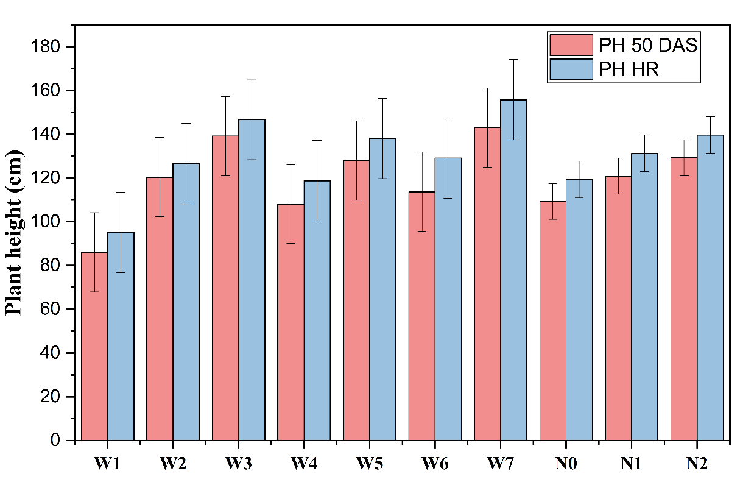
Fig. 1. Effect of weed management treatments and nitrogen levels on plant height (cm) of sesame.

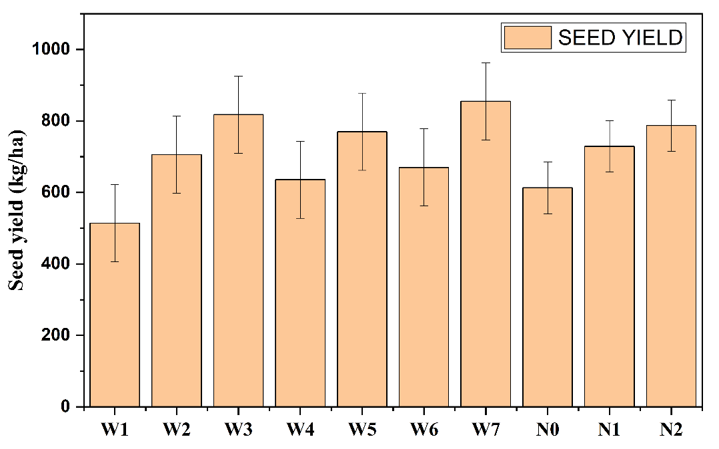
Fig. 2. Effect of weed management treatments and nitrogen levels on seed yield (kg ha⁻¹) of sesame.

