RESPONSE SURFACE OPTIMIZATION OF THE TREATMENT OF PHARMACEUTICAL WASTEWATER USING SNAIL SHELL POWDER AS A NATURAL COAGULANT.

ABSTRACT
This study investigated the treatment of pharmaceutical wastewater from an industry in New Owerri, Imo State, using snail shell powder as a natural coagulant. The wastewater, characterized at the National Soil, Plant, and Water Laboratory, Federal Ministry of Agriculture and Rural Development, Umuahia, Abia State, was treated to reduce turbidity and enhance environmental safety. Chitosan extracted from snail shell was characterized using Energy-Dispersive X-ray Spectroscopy (EDX) and served as the bio-coagulant, leveraging its cost-effectiveness, local availability, and biodegradability. The EDX analysis of the snail powder reveal a calcium carbonate-dominated composition (48.87 wt% Ca, 18.45 wt% O), this indicate that snail shell is suitable additive for bio-coagulant. Response surface methodology optimized the coagulation process, evaluating pH (2–6), coagulant dosage (0.1–2.0 g), and stirring time (5–60 minutes). The highest turbidity removal of 69.7% was achieved at pH 6, 0.1 g coagulant, and 60 minutes, transforming the wastewater from dark brown to light brown. The quadratic model adequately Predicted the Response and the considered factors. These findings demonstrate snail shell’s potential as an eco-friendly alternative to chemical coagulants, supporting sustainable wastewater management in Nigeria’s pharmaceutical sector.

Keywords: Turbidity removal, Optimization, Response Surface Methodology, pharmaceutical wastewater, Coag–flocculation

1. INTRODUCTION
According to (Anyakora, et al., 2011), there is already a surge in the demand for drugs globally. This has made the pharmaceutical industry fall into one of the major actors in environmental pollution. Statistics revealed that about half of the pharmaceutical effluents are indiscriminately dumped into water bodies without appropriate and recommended treatments (Osaigbovo and Orhue 2006; Anetoret al. 1999). With the frequent release of these effluents, there is an increase in the level of non-biodegradable organic matter (reproductive hormones, steroids, antibiotics, drugs, metabolites, etc.), heavy chemicals (mercury, lead, nickel, and chromium), and other pollutants (Babaahmadiet al. 2017; The main aim of Monitoring and Evaluation of Air Pollution is to measure the concentrations of gases which include CO2, CO, NOx, SOx and thermal radiation and carry out an analysis of the measured data.This experiment was scheduled to take place at Egbema flow station which is managed by NPDC (Nigerian Petroleum Development Commission) Shell location 2 in Obiakpu, Ohaji Imo state. The bad effects of these pollutant gases on the community can include cause of diseases to plants and animals, causes of physical ailments in the respiratory tract of humans, death and degradation of the surrounding environment.(Anyikwa, S . O, et al 2022). Ramola and Singh, 2013; Vuppalaet al. 2012; Chelliapanet al. 2011). Pharmaceutical effluents are known to contain toxic and hazardous materials. The effects of these effluents can be seen in acute toxicity which includes genotoxicity and mutagenic potential (Nadal et al. 2004; Akintonwaet al. 2009; Bakare et al. 2009; Adeoye et al. 2015). These wastes introduce foreign microorganisms, organic and inorganic matter, in addition to indigenous micro flora, (Anyikwa S. O. et al 2019).
The management of expired drugs especially in developing countries is usually below standards. Their excessive presence in the environment such as wastewater makes the water toxic to both human and aquatic life. Also, discharged toxicants present in wastewater body tend to accumulate in aquatic bodies, soil and other biological systems. These usually go beyond the critical threshold levels (Hernandoaet al. 2006; Larsson et al. 2007). Several research to identify specific chemicals in pharmaceutical effluents and their toxic effects in living organisms have been carried out (Daughton and Ternes, 1999; Jones et al. 2001; Larsson et al. 2007; Idris et al. 2013). Water is an essential ingredient in drug making and also in the manufacturing plant. It acts as a coolant, solvent in several industrial and manufacturing processes. Production and post-production processes generate liquid effluents referred to as wastewater for disposal. These effluents combine mixtures of toxic and non-toxic materials (99.9 % water and 0.1 % dissolved solids). Pharmaceutical effluents are primarily treated before disposal or recycled for subsequent reuse. Different techniques have been employed to approach and solve this problem among which include the use of bio coagulants. Bio coagulants are alternatives employed in wastewater treatment. It originates from living organisms' parts as it is totally organic, environmentally friendly and biodegradable.
Coag–flocculation process has been used in the removal of these suspended solid particles causing turbidity as well as some metals from wastewater. This process is achieved by the addition of coagulants to wastewater in order to cause destabilization of the colloid dispersion and subsequent agglomeration of the resulting individual colloidal particles. Among other factors, temperature, pH, effluent quality, concentration and type of coagulant influence the coag–flocculation process. Coag–flocculation process using inorganic coagulants has been well documented, but recently attention has been shifted to the use of natural organic derivatives like snail shell powder (SSP). The high cost, post usage handling and health issues associated with inorganic coagulants like alum among other things have been identified as a major environmental and health challenges in recent times. It has been reported that extensive dosage of alum causes Alzheimer’s disease. Consequently, researchers now direct their interest in the use of natural organic derivatives like oxidized starch, Momordica charantia, periwinkle shell, Detariummicrocarpum seed powder etc., for the treatment of waste water. This search for better alternative to conventional coagulants, such as those of biological origin has become extremely vital, considering their environmental friendliness. These natural organic derivatives are non-toxic and biodegradable, making their application to waste water treatment a distinct possibility. Snail shell powder our area of interest belongs to the class Gastropods in phylum mollusca includes the groups pertaining to snails and slugs. In African countries, particularly Nigeria, snail shell is found virtually in all the regions.
The prime commercial applications for chitosan currently is in industrial wastewater treatment since chitosan carries a partial positive charge and binds to metal ions, thus makes the
metal ions removal from waste streams or contamination sites easier (Asano, 1978). In terms of
Utilization, snail shell chitosan as a coagulant for recovery of organic compounds in wastewater
was demonstrated to be equivalent, or superior to, the commercial chitosan from shrimp and
crab waste shell and synthetic polyelectrolyte’s in turbidity reduction (No and Meyers, 1992).
Snail shells which represent the bio-shell waste of snails' remnants constitute a serious degree of environmental threat with little or no economic value. Their effective utilization can bring immense economic prosperity. They are very useful raw materials in the treatment of wastewater and the purification of aqueous solutions. They can also be used in the production of naturally based materials and for the preparation of calcium for medicinal purposes. Snail shells can be used as fillers in the paper industry to improve the paper capacity and cosmetic industry as face powder. In this study, the snail Shell is used as a bio-coagulant to treat pharmaceutical wastewater before disposal.
Chitosan (an amino-polysaccharide obtained from deacetylation of chitin, the major constituent of crustaceous shells and insect cuticles) presents a cationic character in acidic and basic media allowing its dissolution, it’s shaping and possible ion-exchange interactions with anionic compounds (a property applied in adsorption and coagulation/flocculation processes). This is extracted from the snail shell.
2.0 Experimental Method
2.1 Materials
All the chemicals used was of analytical grade, the extracted chitosan from Snail shell was used as a natural coagulant to evaluate its potency in wastewater treatment. The chitosan was extract with Acetone and Bleaching with 0.315% NaCl (w/v) for 5 min at room temp, solid: solvent (1:10, w/v).
2.2 Collections of pharmaceutical effluent and method of analysis
The pharmaceutical effluent sample was collected from a pharmaceutical industry located in new Owerri Imo state, Nigeria. The characterization and analyses of the effluent presented in Table 1 was determined at National Soil, Plant and water Laboratory, Federal Ministry of Agriculture and Rural Development. Umuahia, Abia State, Nigeria. The pH, electrical conductivity and turbidity were determined using Mettler Toledo Delta 320 pH Meter, EI Digital Conductivity Meter (model number 161) and EI Digital Turbidity Meter (model no. 337), respectively.

Table 1. Characterization of Pharmaceutical wastewater.
Parameters | Pharmaceutical Wastewater
pH | 5.5
Turbidity (NTU) | 158.50
Colour (mg/L) | 1740.82
Baron(mg/L) | 1.735
Nickel (mg/L) | 4.849
Cadmium (mg/L) | 0.381
Copper (mg/L) | 2.033
BO₃ (mg/L) | 159.768
Phosphate (mg/L) | 31.958
Dissolved oxygen (mg/L) | 4.226
COD (mg/L) | 6124.23
2.3 Preparation of Snail shell powder, Chitin and Chitosan
Snail shell was collected from a daily market of Ogwumebiri Ntueke in Ideato south LGA Imo State, Nigeria. The snail shell was washed dried properly and homogenized, sieved cloth was used to sieve into fine powder to ensure large surface area.
There are four basics stages involved in production of chitosan. The stages are: deproteination, demineralization, depigmentation or decolorization and deacetylation. The first stage in Chitosan production is Demineralization stage. The methods employed for the production of chitin from snail shell was as described by. 500g of the sieved sample was weighed and put into a beaker. 2500 ml of 3.25M of HCl solution was added (1:5w/v). The mixture was stirred using a griffin shaker at 30oC, for 2hours to avoid effervescence and to remove carbonate and phosphate content. The resulting solution was washed with distilled water and filtered with Whatman filter paper. The residue was scraped into petri dish and dried in an oven at 105oC for 2 hours. In the deproteinization process, the demineralized chitin was soaked in 870ml of 2.39M of sodium hydroxide (NaOH) solution (1:15w/v). The mixture was stirred and boiled in a water bath at 70ºC for 2 hours. The resulting solution was filtered with Whatman filter paper and washed with distilled waterand decolorized with acetone and more water until the pH of the filtrate is neutral. After washing the mixture was filtered and the residue put in an oven 105 ºC for 2hrs to dry. The resultant product was chitin.
The obtained chitin was soaked in 750 mL of 50wt/wt% NaOH, and heated at 85ºC for 2 hours, 30mins in a water bath and cooled for 30 min at room temperature. The mixture was placed on a magnetic stirrer at 30ºC for 4 hours. The mixture was washed and the pH of the filtrate was constantly checked until it is neutral. Thereafter, the mixture was filtered using Whatman filter paper to retain the solid matter. The chitosan thus produced was dried in an oven at 105ºC for 2 hours. This process of converting chitin to Chitosan by removal of acetyl groups is generally achieved by treatment with concentrated sodium hydroxide solution is known as deacetylation. All the samples (Snail shell, Chitin and Chitosan) were characterized.
2.4 Jar test
The conventional jar test procedure was employed using 5 min of rapid mixing at 300 rpm, followed by 20 min of slow mixing at 50 rpm. The volume of wastewater used for the study was 300 mL. The solution was poured into 500 mL cylinder after stirring and allowed to settle for 30 min. A 20 mL of the supernatant was pipetted at 2 cm depth at 3, 5, and thereafter, 5 min intervals. The turbidity of the supernatants was measured and recorded. The concentrations of 100, 200, 300, 400, 500, SSP were used for the process. The variation of pH of the pharmaceutical effluent between 2, 4, 6, 8 and 10 was achieved using sulphuric acid and sodium hydroxide
2.5 Design of experiments
The experimental conditions for optimum conditions were obtained via response surface methodology (RSM). Table 2, show the experimental design matrix. Subsequent runs were carried out at these optimum conditions to obtain the samples that would be used for the water treatment experiment. the percentage of SSP gotten from the extracted chitin for the treatment was analyzed using the method for each of the models, the model equation was obtained and the analysis of variance (ANOVA) was carried out to ascertain the statistical significant of the model and the experimental factors based on their p- values, the determination coefficients of the model.
Table 2. Design of experiment for snail shell power in pharmaceutical wastewater.
RUN | FACTOR 1  DOSAGE G/L | FACTOR 2  pH | FACTOR 3  STIRRING TIME | FACTOR 4  TEMP⁰c | %TURBIDITY  ROMOVAL
1 | 2 | 6 | 30 | 40
2 | 1.05 | 6 | 20 | 40
3 | 1.05 | 6 | 20 | 40
4 | 1.05 | 6 | 20 | 40
5 | 0.1 | 10 | 20 | 40
6 | 2 | 2 | 20 | 40
7 | 1.05 | 2 | 10 | 40
8 | 2 | 6 | 20 | 25
9 | 1.05 | 10 | 10 | 40
10 | 2 | 6 | 20 | 55
11 | 1.05 | 10 | 30 | 40
12 | 0.1 | 6 | 20 | 25
13 | 2 | 10 | 20 | 40
14 | 1.05 | 10 | 20 | 55
15 | 0.1 | 6 | 20 | 55
16 | 1.05 | 10 | 20 | 25
17 | 1.05 | 6 | 10 | 55
18 | 2 | 6 | 10 | 40
19 | 1.05 | 6 | 10 | 25
20 | 1.05 | 2 | 20 | 25
21 | 1.05 | 2 | 30 | 40
22 | 0.1 | 6 | 10 | 40
23 | 1.05 | 2 | 30 | 55
24 | 1.05 | 6 | 30 | 55
25 | 1.05 | 6 | 20 | 40
26 | 0.1 | 6 | 30 | 40
27 | 0.1 | 2 | 20 | 40
28 | 1.05 | 6 | 20 | 40
29 | 1.05 | 6 | 30 | 25
3.0 Result and discussion
3.1 SEM-EDX analysis of snail shells
Tables 3, 4, 5 and Figure 1 - 3 provide EDX analyses of snail shell powder used as a natural coagulant for pharmaceutical wastewater treatment. Table 3 shows a calcium carbonate-dominated composition (48.87 wt% Ca, 18.45 wt% O), Table 4 has higher oxygen (37.36 wt%) and moderate calcium (38.01 wt%), and Table 5 includes organic (8.17 at% N) and silicate (31.09 wt% Si) components, reflecting sample heterogeneity. Tellurium’s presence (6.68–32.68 wt%). The CaCO₃ matrix and chitosan (inferred from N) validate snail shell’s potential as a cost-effective, eco-friendly coagulant.

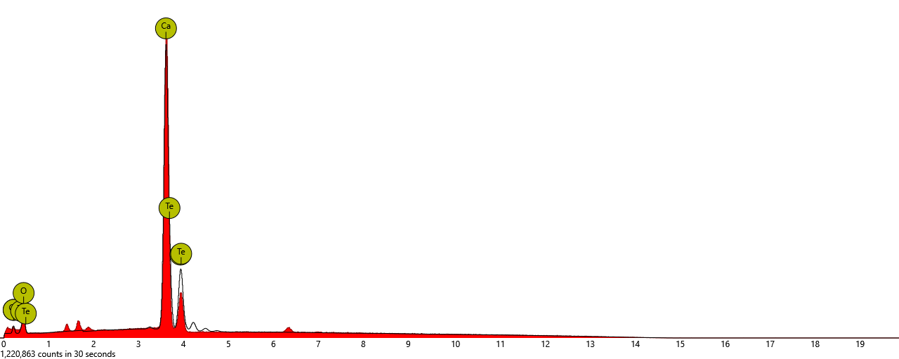
Figure 1. Graphical form of the EDX result of Snail shell
Table 3. EDX result analysis of Snail shell
Element  Number | Element  Symbol | Element  Name | Atomic  Conc | Weight  Conc
20 | Ca | Calcium | 46.39 | 48.87
8 | O | Oxygen | 43.86 | 18.45
52 | Te | Tellurium | 9.74 | 32.68

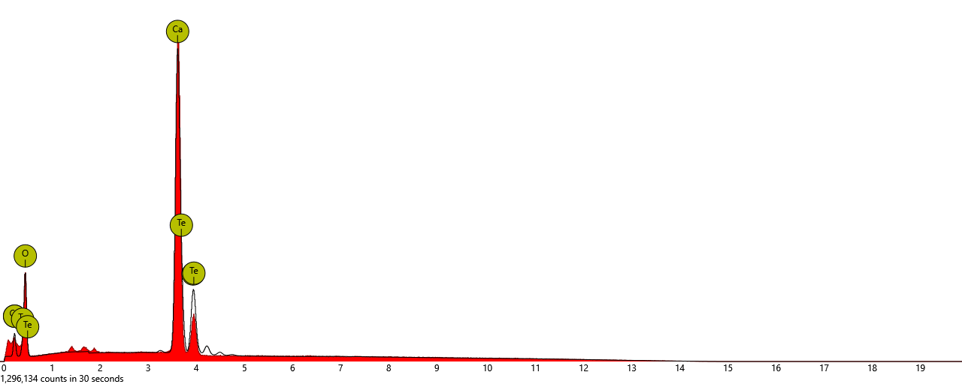
Figure 2. Graphical form of the EDX result of Snail shell
Table 4. EDX result analysis of Snail shell
Element  Number | Element  Symbol | Element  Name | Atomic  Conc | Weight  Conc
8 | Ca | Calcium | 67.16 | 37.36
20 | O | Oxygen | 27.28 | 38.01
52 | Te | Tellurium | 5.55 | 24.63

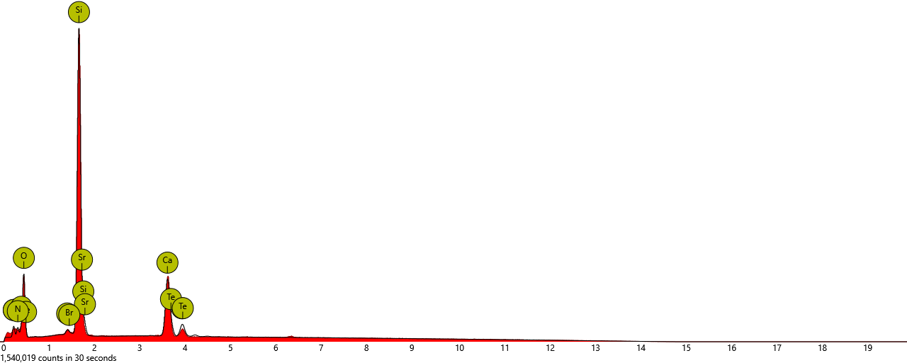
Figure 3. Graphical form of the EDX result of Snail shell
Table 5. EDX result analysis of Snail shell
Element  Number | Element  Symbol | Element  Name | Atomic  Conc | Weight  Conc
8 | O | Oxygen | 55.84 | 38.62
14 | Si | Silicon | 25.61 | 31.09
7 | N | Nitrogen | 8.17 | 4.95
20 | Ca | Calcium | 7.77 | 13.45
52 | Te | Tellurium | 1.21 | 6.68
38 | Sr | Strontium | 1.10 | 4.18
3.2 % Turbidity Removal of kinetic parameter using snail shell powder
Tables 6–10 demonstrate that snail shell powder effectively reduces turbidity in pharmaceutical wastewater, with optimal removal of 69.7% at pH 6, 0.1 g, 60 min, and 69.8% at pH 10, 0.1 g, 60 min. The 0.1 g dosage and longer stirring times maximize efficiency, particularly at pH 6, which aligns with NESREA standards. Table 11 confirms rapid coagulation kinetics at pH 6 (high K₁₁, R²), driven by chitosan and CaCO₃.These findings validate snail shell powder as a sustainable coagulant but underscore the need for process optimization to meet regulatory requirements.
Table 6. % Turbidity Removal of kinetic parameter at pH2 Using Snail Shell Powder on Pharmaceutical Wastewater.
Time(mins) | 0.1g | 0.5g | 1.0g | 1.5g | 2.0g
5(mins) | 41.88 | 39.12 | 36.87 | 30.38 | 28.63
10 | 46.63 | 48.18 | 51.94 | 53.18 | 55.12
15 | 53.18 | 55.93 | 58.49 | 60.96 | 61.82
20 | 56.88 | 57.97 | 60.87 | 63.67 | 65.62
30 | 57.92 | 60.49 | 63.25 | 66.47 | 67.52
40 | 60.18 | 65.43 | 66.43 | 67.62 | 79.27
50 | 62.67 | 65.62 | 66.38 | 68.47 | 71.13
60 | 65.62 | 67.94 | 70.94 | 72.17 | 75.21
Table 7. % Turbidity Removal of kinetic parameter at pH4 Using Snail Shell Powder on Pharmaceutical Wastewater.
Time(mins) | 0.1g | 0.5g | 1.0g | 1.5g | 2.0g
5(mins) | 43.73 | 35.5 | 38.17 | 41.95 | 45.95
10 | 48.26 | 50.89 | 54.46 | 56.67 | 58.67
15 | 54.94 | 57.30 | 58.78 | 61.82 | 63.91
20 | 53.57 | 55.57 | 57.78 | 59.93 | 65.61
30 | 61.93 | 63.91 | 63.93 | 68.76 | 72.39
40 | 65.36 | 66.24 | 68.34 | 71.29 | 70.18
50 | 68.76 | 70.87 | 67.77 | 67.29 | 69.92
60 | 75.39 | 93.48 | +76.76 | 80.65 | 81.91
Table 8. % Turbidity Removal of kinetic parameter at pH6 Using Snail Shell Powder on Pharmaceutical Wastewater.
Time(mins) | 0.1g | 0.5g | 1.0g | 1.5g | 2.0g
5(mins) | 31.67 | 30.25 | 31.36 | 35.93 | 37.73
10 | 37.21 | 38.49 | 40.19 | 42.25 | 43.75
15 | 47.30 | 45.73 | 48.50 | 50.28 | 52.98
20 | 52.76 | 55.75 | 57.67 | 61.21 | 64.41
30 | 58.66 | 58.52 | 60.15 | 62.99 | 65.62
40 | 64.91 | 67.18 | 68.67 | 71.16 | 72.58
50 | 72.58 | 71.44 | 71.87 | 70.99 | 74.28
60 | 76.84 | 75.28 | 78.55 | 79.68 | 84.16
Table 9. % Turbidity Removal of kinetic parameter at pH8 Using Snail Shell Powder on Pharmaceutical Wastewater.
Time(mins) | 0.1g | 0.5g | 1.0g | 1.5g | 2.0g
5(mins) | 6.28 | 9.44 | 10.71 | 13.39 | 15.40
10 | 19.42 | 18.88 | 22.83 | 32.95 | 39.45
15 | 34.39 | 35.56 | 37.50 | 38.91 | 40.32
2021 | 39.51 | 40.92 | 43.00 | 44.13 | 45.67
30 | 47.68 | 49.29 | 51.57 | 55.59 | 55.32
40 | 53.91 | 55.72 | 56.43 | 53.47 | 53.58
50 | 57.73 | 59.87 | 63.29 | 64.96 | 65.50
60 | 66.97 | 67.71 | 70.32 | 72.40 | 74.48
Table 10. % Turbidity Removal of kinetic parameter at pH10 Using Snail Shell Powder on Pharmaceutical Wastewater.
Time(mins) | 0.1g | 0.5g | 1.0g | 1.5g | 2.0g
5(mins) | 3.56 | 3.74 | 9.48 | 7.61 | 10.04
10 | 9.73 | 11.85 | 13.78 | 14.97 | 16.28
15 | 18.77 | 18.77 | 23.83 | 25.15 | 25.67
20 | 30.69 | 31.25 | 35.55 | 36.93 | 40.86
30 | 38.56 | 39.98 | 41.92 | 44.97 | 48.09
40 | 41.29 | 43.10 | 44.91 | 48.15 | 52.40
50 | 54.33 | 55.52 | 56.89 | 58.64 | 59.82
60 | 62.94 | 64.94 | 66.81 | 68.91 | 69.36
3.3 Kinetic Parameters for Treatment of pharmaceutical wastewater using snail shell powder
Table 11 shows the Kinetic Parameters for Treatment of pharmaceutical wastewater using snail shell powder. R² values of 0.8214–0.9956 indicate the kinetic model accurately describes coagulation. pH 6 at 0.1 g/L has the highest R² (0.9956), confirming optimal conditions.
Rate Constants K₁₁ is highest at pH 6, 0.1 g/L (7.981e-3 L/g·s) confirming fast coagulation, consistent with Table 8’s 69.7% removal. Half-Life Shorter τ½ at pH 4 (121.2–124.1 s) and pH 6 (140.8–149.6 s) indicate faster reactions, while pH 8’s longer τ½ (up to 381.2 s) suggests slower kinetics. Lower dosages (0.1 g/L) often have higher K₁₁ and better R², aligning with higher turbidity removal in Tables 6–10, due to efficient chitosan utilization.
Table 11. Kinetic Parameters for Treatment of pharmaceutical wastewater using snail shell powder
Parameters 0.1g/l 0.5g/l 1.0g/l 1.5g/l 2.0g/l
pH2
R² 0.9586 0.9286 0.9811 0.8972 0.8675
AdjR² 0.9599 0.9468 0.924e⁻⁵ 0.862e⁻³ 0.8621
SSE 0.8777 0.8622 0.862e⁻⁴ 0.726e⁻⁵ 0.771e⁻⁴
RMSE 0.1466 1.6421 1.822e⁻⁵ 1.662e⁻⁴ 0.721e⁻⁵
K₁₁(L/g.S) 6.986e⁻³ 6.786e⁻⁵ 5.745e⁻³ 5.489e⁻⁴ 4.757e⁻³
K_{R} 5.754e⁻⁴ 5.968e⁻⁵ 5.575e⁻⁴ 4.897e⁻⁵ 4.219e⁻⁴
Ʈ ½ 186.2 188.4 182.0 176.4 168.3
pH4
R² 0.9296 0.9162 0.9212 0.8682 0.8247
AdjR² 0.9298 0.9431 0.9541 0.8912 0.865e⁻⁵
SSE 0.8892 0.862e⁻⁴ 0.8462 0.814e⁻³ 0.751e⁻⁴
RMSE 0.1168 2.726e⁻⁵ 2.632e⁻³ 2.142e⁻⁴ 2.612e-3
K₁₁(L/g.S) 6.519e⁻³ 7.526e⁻³ 6.718e⁻⁴ 7.614e⁻⁵ 6.792e⁻⁵
K_{R} 5.676e⁻⁴ 5.863e⁻⁴ 4.619e⁻⁵ 5.982e⁻³ 5.916e⁻³
Ʈ ½ 121.2 124.1 122.4 123.1 121.2
pH6
R² 0.9956 0.9164 0.8214 0.8842 0.8671
AdjR² 0.9834 0.9421 0.8426 0.843e⁻⁵ 0.8562
SSE 0.8880 0.817e⁻⁵ 0.756e⁻³ 0.762e⁻⁴ 0.786e⁻²
RMSE 0.2449 0.712e-3 2.642e-4 2.753e-5 2.644e-3
K₁₁(L/g.S) 7.981e⁻³ 7.514e⁻³ 7.851e⁻⁵ 6.573e⁻⁵ 6.492e⁻⁴
K_{R} 6.554e⁻⁴ 6.825e⁻⁴ 6.824e⁻³ 5.793e⁻⁴ 5.812e⁻⁵
Ʈ ½ 144.6 145.2 146.8 140.8 149.6
pH8
R² 0.9422 0.9622 0.9684 0.8266 0.8714
AdjR² 0.9228 0.8559 0.8452 0.8379 0.8364
SSE 0.8990 4.268e⁻⁵ 4.807^{e-5} 9.781^{e-5} 8.615^{e-5}
RMSE 0.1668 2.468e⁻⁵ 2.451e⁻³ 3.297e⁻³ 3.282e⁻³
K₁₁(L/g.S) 4.372e⁻⁵ 1.922^{e-4} 2.096^{e-4} 2.010^{e-4} 2.718^{e-4}
K_{R} 2.186^{e-3} 9.610e⁻⁵ 1.048e⁻⁴ 1.005^{e-4} 1.359^{e-4}
Ʈ ½ 381.2 86.72 79.6 82.9 61.3
pH10
R² 0.9788 0.9828 0.9497 0.9697 0.9228
AdjR² 0.9799 0.9809 0.9434 0.9663 0.9132
SSE 0.8808 1.324e⁻⁶ 2.045^{e-5} 7.066e⁻⁶ 5.174^{e-6}
RMSE 0.1888 3.836e⁻⁴ 1.599^{e-3} 8.861^{e-4} 8.042^{e-4}
K₁₁(L/g.S) 1.076e⁻⁴ 7.312^{e-5} 1.252^{e-4} 1.262^{e-4} 6.964^{e-4}
K_{R} 5.380e⁻⁵ 3.656e⁻⁵ 6.260e⁻⁵ 6.310^{e-5} 3.482e⁻⁵
Ʈ ½ 155.0 227.9 133.1 132.0 239.3

3.4 Definition Of 3d Plot Of Pharmaceutical Waste Water Using Varying Dosage Of Snail Shell Powder
The removal of turbidity from pharmaceutical waste water using varying dosage of snail shell powder of different pH was investigated. The result obtained was presented in Figures 4 to 7
The figures revealed a sharp increase in the turbidity removal from 0 to 35/40NTU in the first 3mins for all dosages at pH2, 4 and 6 than pH8 and 10. This is an indication of better performance at lower pH values, which is constant with previous study (Nnaji et al., 2020; Menkiti et al, 2018). The turbidity removal continued over time. It was observed that pH2, 4 and 6 recorded more than 60% removal from 30mins with the highest removal efficiency of 75.21% 93.48% and 84.16%for pH2 with 2.0g, pH4 withy 0.5g, and pH6 with 2.0g of snail shell, respectively after 60 mins settling time. However, for pH8 and pH10, only dosages of 1.0g. 1.5g and 2.0g at pH8 recorded above 50% turbidity removal after 30mins settling time, but the highest turbidity removal of 74.48% and 69.36% for pH8 with 2.0g and for pH10 with 2.0g of snail shell neutralize the negatively charged pollutant/particles of the pharmaceutical wastewater.
From the forgoing, the best turbidity removal of 93.48% was recorded at pH4 dosage of 0.5g after 60 mins settling time.
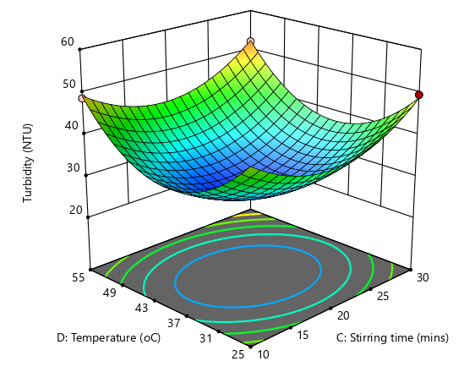

Figure 4. A 3-D plot of Temperature and stirring time against percentage turbidity removal values

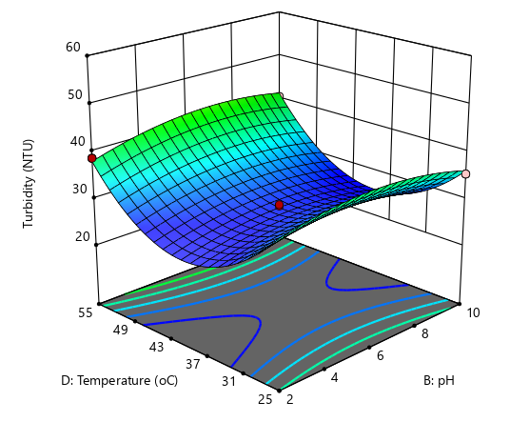

Figure 5. A 3-D plot of Temperature and stirring time against percentage turbidity removal values
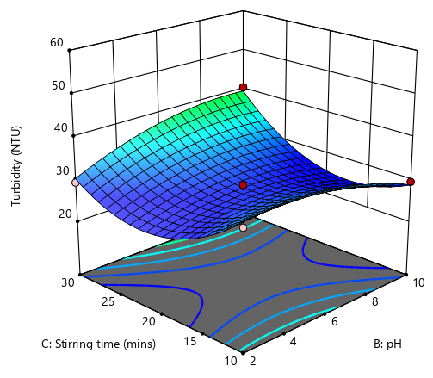
Figure 6. A 3-D plot of Temperature and pH against percentage turbidity removal values

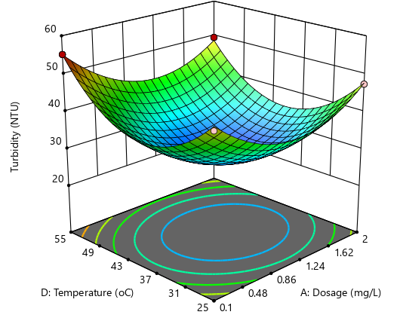

Figure 7. A 3-D plot of Temperature and pH against percentage turbidity removal values
3.5 Coag–flocculation Response Surface Plots of Suspended Solid Particle (SSPT) removal at varying pH and Settling time at Constant dosage, using Snail shell powder as a Natural Coagulant.
The turbidity removal from snail shell at different pH and varying dosage of was investigated. The results obtained were presented in figures 8 – 12. Figure 8 indicated the plot of turbidity removal at pH 2 and varying snail shell dosages. From the graph, dosages 0.1, 0.5, and 2.0g revealed sharp turbidity removal within the first 5 minutes subsequently gradual removal up to the highest of 78.43, 75.81, and 76.18%, respectively. The negative values observed with 1.0 and 1.5 g dosages could be attributed to either human or machine error. Similar trend were observed for pH4 – 10, with the highest recorded turbidity removal after 60 min settling time of 77.74% for pH4 and 0.5g snail shell, 95.17% for pH 6 and 0.1g snail shell, 91.52% for pH 8 and 0.1g snail shell, and 73.69% for pH 10 and 2.0g snail shell, respectively. The results indicated good performance of snail shell in removing turbidity from leachate especially at lower pH values.

FIG 12
FIG 11
FIG 10
FIG 9
FIG 8
Figure 8 – 12 shows the Coag–flocculation response surface plots of suspended solid particle (SSPT) removal at varying pH and settling time at constant dosage, using snail shell powder as a natural coagulant.
3.6 Plot of Kinetics Parameters for treatment of Pharmaceutical Wastewater using Snail shell powder as Natural Coagulant.
Similarly, the kinetic plots of coagulation-flocculation performance of Snail Shell Powder in pharmaceutical wastewater for removal of turbidity were presented in figures 4.3a – 4.3e. The plots are based on I/$√N1$ against time will produce a linear graph with kinetic rate constant as the slope. From the above graph, the kinetic parameters obtained and calculated are presented in tables 11 and 4.34, respectively. The kinetic constant, K_{II}, rapid coagulation constant, Kr, degree of freedom adjusted R² adjR² sum or square error, SSE and root mean square error, RMSE, were recorded in the tables. For leachate, the coagulation –flocculation rate constant, K_{II}, ranges from 6.786E-5 to 4.757E-3 for PH2; 7.614E-5 to 6.519E-3 for PH4; 7.851E-5 to 7.981E-3, for PH6; 4.372E-5 to 1.922E-4 for PH8; and 7.312E-5 to 1.252E-4 for Ph10; respectively. While the minimum half time, t½ was observed at PH8 and 2.0g/c, as 61.3 mins. The coefficient of determination, R² adjR², SSE and RMSE are the statistical parameter used to determine the adequacy of the kinetic models. The results revealed that most of the model has R²> 0.8 that the best kinetic model with the highest R2 and SSE & RMSE is with PH6 and 0.1g /c mc, with R² or o.9956, SSE or 0.8880 and RMSE or 0.2449.
Similar trend was observed using mc on pharmaceutical wastewater. The best R² recorded at PH2 and 0.1g/c mc, at 0.9910, with SSE and RMSE of 0.8816 and 0.1660, respectively. The lowest half time, t½ was recorded at PH2 and 0.5/c or 10.4 mins.
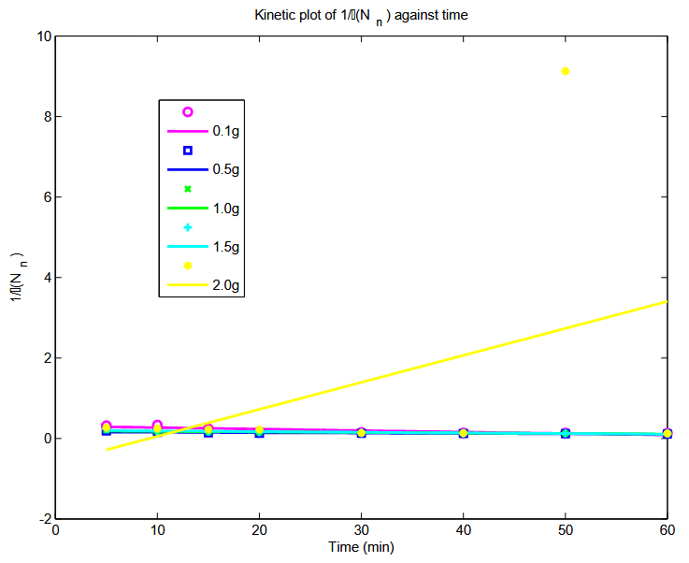
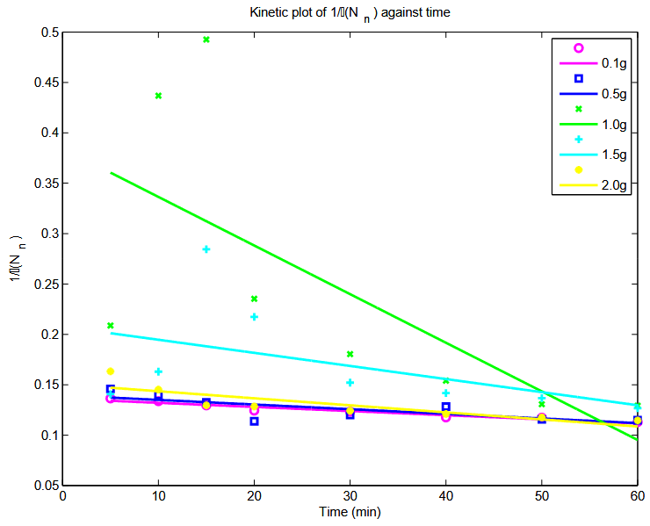
FIG 14
FIG 13
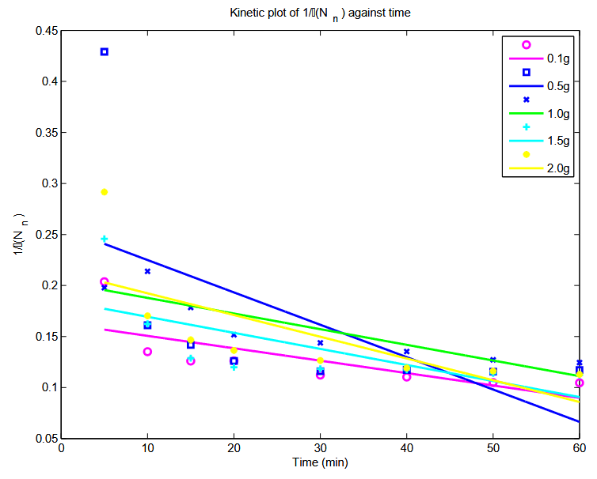
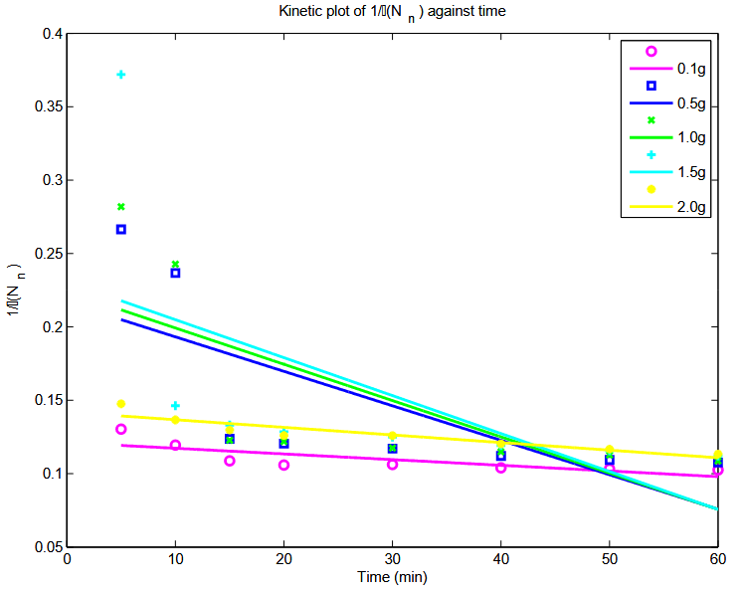
FIG 16
FIG 15
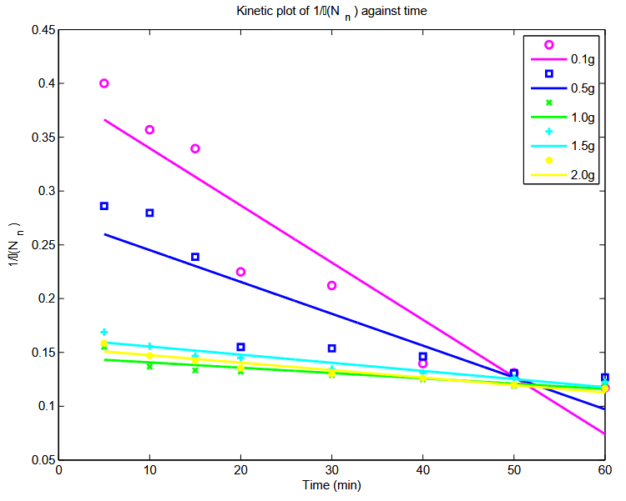
FIG 17

Figure 13 – 17 shows the Plot of kinetic parameters for treatment of Pharmaceutical wastewater using snail shell powder as a natural coagulant.
4. CONCLUSION
This study explores the use of snail shell powder (SSP) as a natural coagulant for treating pharmaceutical wastewater. The coagulation-flocculation process achieved a significant reduction in suspended solids, lowering the concentration from 728.3 mg/L to 699.66 mg/L, corresponding to a turbidity removal of 69.7% under optimal conditions of pH 6, 100 mg/L coagulant dosage, and 60 minutes of stirring time (Table 8). Comparable performance was observed at pH 8 (69.4%) and pH 10 (69.8%) with the same dosage and time, highlighting SSP’s versatility across neutral to alkaline conditions. The calcium carbonate matrix (48.87 wt% Ca, 18.45 wt% O and chitosan’s positively charged amine groups (8.17 at% N), facilitated effective particle binding, as confirmed by EDX analysis. Kinetic analysis revealed rapid coagulation at pH 6 (K₁₁ = 7.981e-3 L/g·s, R² = 0.9956,), with a half-life of 144.6 seconds, underscoring efficient floc formation. These findings confirms SSP’s potential as a locally sourced, biodegradable coagulant for pharmaceutical wastewater treatment, reducing reliance on chemical alternatives.
REFERENCE
Anyakora C, Nwaeze K, Awodele O, Nwadike C, Arbabi M, Coker H (2011) Concentrations of heavy metals in some pharmaceutical effluents in Lagos, Nigeria. J Environ Chem Ecotoxicol 3(2):2531 Gorax in Minna, Niger State, Nigeria. BEPLS 2(3):4549.
Anetor jI . et al., African Journal of Medicine and Medical Sciences, 01 Mar 1999,28(1-2):107- 112 PMID; 12953998.
Osaigbovo AE, Orhue ER (2006) Influence of pharmaceutical effluents on some soil chemical properties and early growth of maize (Zea mays L.). Afr J Biotechnol 5(12):16121618.
Abioye O. P., Afolayan E. O. and Aransiola S. A. (2015). Research Journal of Environmental Toxicology, Volume 9(4):188-195.
Aboua F. (1995). Proximate analysis and mineral contents of two giant African snails consumed in Ivory Coast, Tropical science England. 220-222
Ademoroti C.M.A. (1996). Enviromental chemistry and Toxicolgy. Foludex Press Ltd. Ibadan, Nigeria 20-30
Anyikwa, S. O., Ngolube, C. B., Nzeoma, C., Umeojiakor, C. T., Edo, F. A., Nmecha, M. I., Okereke, C. J. (2019) Effect of Brewery Effluent on Surface Water Quality of Ikpoba River, Benin City, Edo State. International Journal of Science and Engineering Investigations (IJSEI), 8(91), 130-134. http://www.ijsei.com/papers/ijsei-89119-16.pdf
Ademoroti C.M.A. (1996). Standard methods for waste and effluent analysis. Foludex Press Ltd. Ibadan, Nigeria.55-70.
Altman,S.J, Parizek,R.R Dilution of andoa MD, Mezcua M, Fernandez-Alba AR, Barcelo D (2006) Environmental risk assessment of pharmaceutical residues in wastewater effluents, surface diments. Talanta 69(2):334342
Cataldo, S.; Muratore, N.; Orecchio, S.; Pettignano, A. (2015). Enhancement of adsorption ability of calcium alginate gel beads towards Pd(II) ion. A kinetic and equilibrium study on hybrid Laponite and Montmorillonite-alginate gel beads. Appl. Clay Sci. 118, 162170.
Cheremisinoff, N.P. (2002). Handbook of Water and Wastewater Treatment Technologies; Butterworth-Heinemann: Woburn, MA, USA.
Chi F. H. & Cheng W. P. (2006). Use of chitosan as coagulant to treat wastewater from milk processing plant. Journal of Polymers and the Environment 14(4), 411417.
Das, N.; Karthiica, P.; Vimala, R.; Vinidhini, V. (2008). Use of natural products as biosorbent of heavy metals, An overview. Nat. Prod. Radiance. 7, 133138.
C. Nnaji Patrick, I. Okolo Bernard, M. Matthew Chukwudi, Ume Cyril Sunday, ChizobaChinelo Agu, Kinetics and particle removal profile of pulverized snail shell—alum induced coag– flocculation of quarry effluent, Br. J. Appl. Sci. Technol. 5 (6) (2015) 621–632.
P.C. Nnaji, B. Okolo I, M.C. Menkiti, Nephelometric performance evaluation of oxidized starch in the treatment of coal washery effluent, Nat. Resour. 5 (2014) 79–89. http://www.scirp.org/journal/nr.
Anyikwa, S.O., Ndukwe, O.C., Umeojiakor, T.C., Nnaji, P.C. and Amadi, N.M. (2022) Monitoring and Evaluation of Air Pollution at Ohaji/Egbema Flow Station and Its Environs via GPS in OhajiEgbemaLga, Imo State Nigeria. Detection, 9, 37-49.
https://doi.org/10.4236/detection.2022.94004
Menkiti, M.C., Nnaji, P.C., Nwoye, O.D. and Onukwuli, O.D. (2010) Coa-Flocculation Kinetics and Functional Parameters
Menkiti, M.C., Nnaji, P.C. and Onukwuli, O.D. (2009) Coa-Flocculation Kinetics and Functional Parameters Response of Periwinkle Shell Coagulant (PSC) to pH Variation in Organic Rich Coal Washery Effluent Medium. Nature and Science, 7, 1-18.
Menkiti, M.C., Osoka, E.C. and Onukwuli, O.D. (2008) Perikinetics Coagulation/Flocculation of Coal Washery Effluent Colloid with high Suspended Particle: Using Periwinkle Shell Coagulant (PSC). Journal of the Nigeria Society of Chemical Engineers, 23, 38-52.
Nnaji, P.C. (2012) An Investigation of the Performance of Various Coagulants/Flocculants in Removing the Turbidity
of Coal Washery Effluents. M. Eng. Thesis, Federal University of Technology, Owerri.

P. C. Nnaji1*, B. I. Okolo1, M. C. Menkiti2
Nephelometric Performance Evaluation of Oxidized Starch in the Treatment of Coal
Washery Effluent, Scientific Research Publishing Inc.

