A review on Climate-smart organic agriculture: Climate Change Resilience, Role of Technology and Future Directions of Sustainable Agriculture

Abstract
Climate change presents a serious risk to worldwide food security, farming and sustainability. Organic farming, focusing on ecological principles and minimizing the use of synthetic inputs, has emerged as a viable method to alleviate the effects of climate change. This review paper explores the concept of Climate smart organic agriculture (CSOA), which integrates climate-smart practices into organic farming systems. By combining the strengths of Climate-smart agriculture and organic farming, CSOA offers a holistic solution to address the challenges of climate change and food security. This review paper gives valuable insights into the potential of CSOA, it’s importance, status of organic farming on both a global scale and within India, exports and consumption of organic products, conviction, nutrient management, problems and future synergies and approach that can be made to help foster a more sustainable and robust environment and agricultural future.

Keywords: Smart agriculture, scenario, organic farming, climate, sustainable, nutrient, artificial intelligence

1.Introduction
Climate smart agriculture is characterized as “agriculture that sustainably boosts productivity, improves resilience (adaptation), minimizes/removes greenhouse gas (GHG) emissions whenever feasible, and promotes the attainment of national food security and development objectives,” according to the Food and Agricultural Organization of the United Nations (The Asia Foundation 2022). The framework for climate-smart agriculture is built upon three primary pillars: productivity, mitigation, and adaptation. These three elements are intricately linked to (Sustainable development goals) SDG1-No Poverty, SDG2-Zero Hunger, and SDG13-Climate Action, as part of the Sustainable Development Agenda. India boasts a unique and enduring traditional agricultural system, extensive dry-lands, and minimal reliance on chemical pesticides and fertilizers. In addition, the nation's northeastern hilly regions see abundant precipitation as well as naturally occurring organic soil, with relatively little minor chemicals employed over an extended period of time. The soil fertility maintenance practice of traditional Indian peasants are characterized by a deep perspective, extensive study, tenacity, and application of pesticides that effectively improve organic output and contribute to the country's economic progress.
The field of organic farming has made remarkable progress. India, with 1.78 million hectares of organic farming, placed ninth in 2017 and is currently the world's largest manufacturer of organic products (Madhavi 2021). Food and nutritional insecurity arises from climate change's impact on agricultural productivity and the increased variability in crop yields, disrupting the global food supply. Specifically, issues like droughts, pest infestations, and soil degradation caused by climate change adversely affect food production, leading to significant reductions in crop yields and serious challenges for global food security (Zizinga et al. 2022, Miron et al. 2023). As per UN projections, the global population is expected to reach 9.7 billion by 2050. To meet the rising food demands of this growing population, the output of food calories will need to rise by 70% (United Nations, 2021). Therefore, it is critical to promote effective mitigation techniques that offset the adverse effects of climate change and improve smallholder agricultural systems' adaptability and response time.
Globally, sustainability is becoming a buzzword in every industry, and organic farming is one of the main advocates of agriculture. The 21st century is quickly turning into the age of organic living. The goal of organic farming is to improve both the environment and human health. According to Elayaraja et al. (2020), switching to organic farming is essential if you want to stay away from fertilizers and pesticides with chemical bases. The method puts a focus on using natural techniques to eradicate pests and weeds. Chemical residues can be found in food and other items, potentially leading to harmful consequences for both the environment and human health. Additionally, Kumari et al. (2020) makes the case that switching to organic farming is a good way to preserve the ecosystem. The more significant worldwide problem of climate change illustrates the damage that is imminent to our ecosystem and calls for actions to guarantee that nature endures. Therefore, compared to traditional production methods, ecological production practices greatly maintain the spread of biodiversity. Furthermore, Karunakaran (2021) highlights that using organic farming rather than conventional farming could improve the nutritional value of meals and food products. Organic farming eliminates the possibility of experiencing negative effects on the environment and human health by using organic methods in place of genetically modified organisms. Thus, there are additional benefits to organic farming for both the environment and people. As a result, it ought to be broadly embraced to promote sustainable living (Roshan et al. 2023).
In order to address the problems posed by climate change, Climate smart agriculture pledges to restructure and reposition agricultural development. The CSA framework offers a framework for evaluating livelihood assets' functions and the ways in which structures and procedures of policy influence them, together with the technologies required for restorative agricultural transformation. CSA aims to strengthen connections between global, national, and local agricultural players by speeding up the synergies for adaptation and mitigation across different scales. Consequently, CSA provides a triple win effect that can consistently boost agricultural productivity, incomes, and climate change resilience while reducing or even eradicating greenhouse gas emissions. This supports the achievement of national food security and sustainable development objectives and presents a strategy for addressing challenges in global agricultural development (Thornton et al. 2018).

2.Organic agriculture
Organic farming is a comprehensive management system that reduces pollution in the air, soil, and water, avoids synthetic fertilizers, pesticides, and genetically modified organisms, and enhances the health and productivity of interconnected communities of plants, animals, and humans. To accomplish these aims, farmers who engage in organic farming must implement various strategies that optimize nutrient and energy flows while mitigating risks (FAO 2017). These strategies encompass crop rotation, increased crop diversity, mixed plant and livestock combinations, the use of legumes for nitrogen fixation, the application of organic fertilizers, and natural pest management.
However, at the moment, the high input of conventional agriculture has created serious risks to ecological balance and human health, making it extremely susceptible to the effects of climate change, pest outbreaks, and other biotic and abiotic events, highlights that there are serious doubts about the sustainability of the current crop production systems. There are now serious environmental risks as a result of the rising use of inorganic fertilizers and agrochemicals in agriculture, particularly in developing nations. The main problems that result from it are soil deterioration, water pollution, and biodiversity loss. Human health is now at risk due to this circumstance (Padmajani et al. 2014). Governments from various nations, as well as international organizations like The Food and Agriculture Organization (FAO) of the United Nations, along with the Consultative Group on International Agricultural Research (CGIAR) and various non-governmental organizations (NGOs), has made considerable strides in promoting and implementing Climate-Smart Agriculture (CSA) due to its numerous benefits. For example, civil society organizations across Africa, Asia, and Latin America (Waters et al. 2015, Brown 2016), as well as climate-smart villages in India, have taken initiatives in this regard. Alam and Sikka (2019) and Hariharan et al. (2020) have established programs aimed at reducing information barriers and addressing financial access challenges to motivate farmers to embrace sustainable agricultural practices, such as CSA. Furthermore, agricultural training initiatives in Ghana have been employed to enhance farmers' understanding of the technology and facilitate their adoption of CSA practices (Zakaria et al. 2020, Martey et al. 2021).

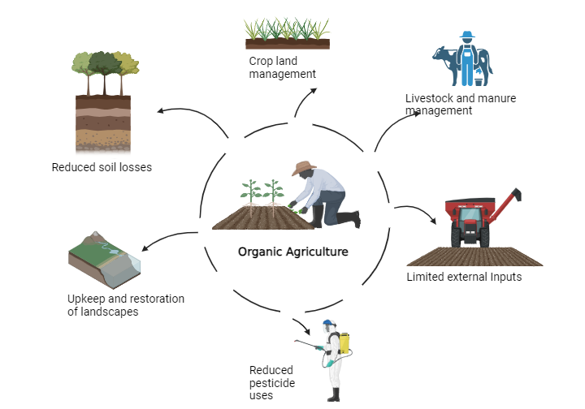
Figure 1: Aspects of organic agriculture

3.Principles of Organic Farming
One of the main tenets of organic agriculture is to operate in a closed environment and depend as much as possible on local services like to Maintain the soil's long-term fertility, eliminate any sources of farming-related pollution, generate enough nutrient-dense, high-quality food. Reduce the amount of fossil fuels used in farming practices. Providing living conditions for animals that meet their physiological requirements. To enable farmers to fulfill their human potential and support themselves via their labour (Madhavi et al. 2021). Adhere to organic farming's three foundations (Figure 2):

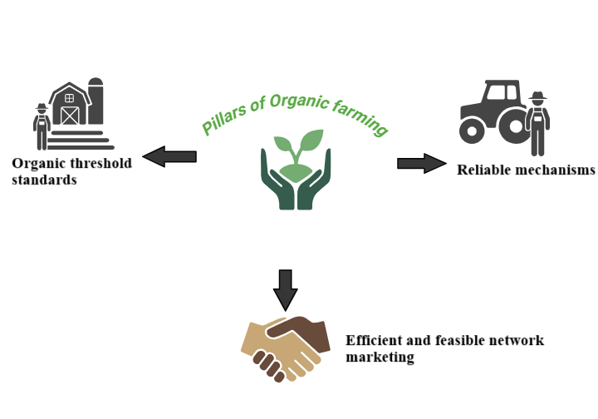
Figure 2: Pillars of Organic farming

4.Pillars of climate smart agriculture
Productivity: The goal of the CSA is to raise agricultural incomes and output in a sustainable manner without putting the environment in jeopardy. This covers animals, fisheries, and farming. Everyone on the earth will have more access to food and nutrition as a result of this. Growth is one of the core concepts of productivity (Lipper et al. 2014, Chandra et al. 2018).
Adaptation: Reducing reliance on specific risks for farmers while simultaneously enhancing their resilience to better withstand shocks and long-term pressures is one of the main objectives of community supported agriculture (CSA). Protecting ecosystems is of utmost importance since farmers and other stakeholders depend on them for a range of benefits. These services are necessary for both maintaining output and adjusting to climate change (Chandra et al. 2018, Molua 2012).
Mitigation: As production resources decrease, the demand for agricultural products rises globally. Additional issues are brought forth by climate change. A more productive, ecologically friendly, and input-efficient production system is necessary for agricultural sustainability. Changes to national and local governments, as well as to institutions and policies, are necessary to reform the entire system. We investigated the potential benefits of Climate-Smart Agriculture (CSA) for India's efforts related to food security, adaptation, and mitigation. As a method of incorporating CSA into development planning, we suggested Climate-Smart Villages (CSVs). On-farm action research in India's CSVs demonstrated the benefits of CSAs for productivity, adaptation, and mitigating climate change. Our findings indicate that Climate Smart Agriculture can contribute to addressing climate change adaptation, mitigation, and food security (Chandra et al. 2018).
Organic farming is gaining popularity across the globe, and its proportion of land continues to expand each day. Its market value is consistently on the rise. According to IFOAM (World of Organic Agriculture - Statistics and Emerging Trends, 2015), there are approximately 43.1 million hectares of certified organic farmland across 170 nations, up from 160 million hectares in 2010. The largest areas for organic farming are in Europe (11.5 million hectares) and Oceania (17.3 million hectares). In addition, Latin America has 6.6 million hectares, Asia has 3.4 million hectares, North America has 3 million hectares, and Africa has 1.2 million hectares. Australia, the US, and Argentina are the nations with the biggest organic areas. Nearly 80% of the markets and output of organic agriculture are located in developing nations, as is a fifth of all agricultural land. The area of land used for organic farming has increased significantly in North America, Europe, Asia, and Oceania in recent years. The USDA and the Euro Zone have acknowledged that the NPOP's production and certification guidelines for raw plant products are comparable to their own (Kumar, 2019).

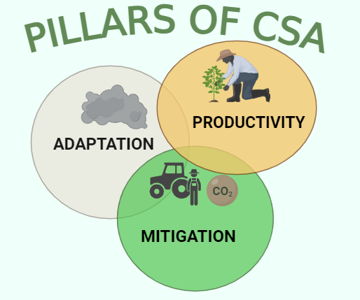
Figure 3: Pillars of Climate smart agriculture

5.Scenario of organic farming at the global level
Organic farming is gaining popularity across the globe, and its proportion of land continues to expand each day. Its market value is consistently on the rise. According to IFOAM (World of Organic Agriculture - Statistics and Emerging Trends, 2015), there are approximately 43.1 million hectares of certified organic farmland across 170 nations, up from 160 million (hectares) in 2010. The largest areas for organic farming are in Europe (11.5 million hectares) and Oceania (17.3 million hectares). In addition, Latin America has 6.6 (million hectares), Asia has (3.4 million hectares), North America has (3 million hectares), and Africa has (1.2 million hectares). Australia, the US, and Argentina are the nations with the biggest organic areas. Nearly 80% of the markets and output of organic agriculture are located in developing nations, as is a fifth of all agricultural land. The area of land used for organic farming has increased significantly in North America, Europe, Asia, and Oceania in recent years. The USDA and the Euro Zone have acknowledged that the NPOP's production and certification guidelines for raw plant products are comparable to their own (Kumar, 2019).

Figure 4: Global Organic Farmland Area

Table 1: Countries with the largest numbers of organic producers

Countries | Number of Producers | Percentage (%)
India | 582,200 | 32.92
Ethiopia | 203.602 | 11.51
Mexico | 200,039 | 11.31
Uganda | 190,670 | 10.78
Phillipines | 165,958 | 9.38
Tanzania | 148,610 | 8.40
Peru | 96,857 | 5.48
Turkey | 69,967 | 3.96
Paraguay | 58,258 | 3.29
Italy | 52.609 | 2.97
TOTAL | 1,768,770 | 100.00

The top ten nations with the highest proportion of organic producers worldwide (Table 1). In this regard, India has the largest percentage of organic producers among the top ten countries (32.92%), followed by Mexico with a moderate level (11.31%) and Italy with the lowest percentage (2.97%) of organic farmers nationwide (Sankar et al. 2020).
6.Present status of India’s organic farming
Organic farming has been around for a very long time in India. Organic farming enabled the great Indian civilization to thrive and become one of the wealthiest nations in the world (Deshmukh and Babar 2015). In organic farming, crop production depends on natural biological processes combined with the use of organic waste, including farm, animal, and crop residues. Before the initial certified organic crop is harvested through organic methods, the land must be cultivated for three years in compliance with organic standards. This phase is known as the adjustment period, during which both the soil and management practices adapt to the new system. Throughout this duration, plants, rodents, and insects all undergo a process of adaptation. Therefore, it appears that organic farming is a viable option for long-term sustainability. India is a leading nation in organic production, encompassing approximately 1.49 million hectares of organic land and producing over 1.70 million MT (2015–16) of certified organic products (World of Organic Agriculture - Figures & Emerging Trends 2018).
According to the most current data, India holds the top position for producers and ranks eighth globally for organic agriculture acreage in 2018 (2018 FIBL and IFOAM Year Book). India ranks 11th globally in terms of export prices, making it a major exporter of organic goods. The Indian government has also created a National Organic Production Program (NPOP). The objectives of this program are to create, advance, and accredit organic agriculture across the nation. The 2018 global statistics on organic agriculture and emerging trends reported findings from a survey. In India, there are around 1.78 million hectares dedicated to organic farming. Roughly 1.70 million metric tons of certified organic products are produced, including oilseeds, sugarcane, cereals and millets, cotton, pulses, tea, functional food products, organic cotton yarn, among other items that extend beyond the food sector. The top producing states are presented in Table 2.

Table 2: Major organic food producing states in India (Sankar et al. 2020)

Top 10 States | Area Inclusive Wild  (million hectare) | Share (%)
Madhya Pradesh | 1.93 | 39.4
Himachal Pradesh | 1.37 | 28
Rajasthan | 0.48 | 9.9
Maharashtra | 0.22 | 4.4
Uttar Pradesh | 0.11 | 2.2
Andhra Pradesh | 0.10 | 2.1
Uttarakhand | 0.09 | 1.9
Karnataka | 0.09 | 1.9
Odisha | 0.09 | 1.9
Sikkim | 0.08 | 1.6
(Source: Sankar et al. 2020)

7.Effects of climate change in the agriculture sector of India
Climate variations, including global rainfall, the ongoing rise in carbon dioxide, and average temperature, have increased the frequency of extreme events that result in flood and drought disasters in the agriculture sector by providing a serious danger to productivity of cereals and crops worldwide(Hussain M et al. 2019, Duchenne et al. 2021) . Crop growth and maturity time are directly impacted by temperature and precipitation variations, which puts the crops at risk from a variety of biotic and abiotic stresses (Chaudhry et al. 2022). A recent study found that 30–50% of global agricultural output losses are caused by these biotic and abiotic pressures(Rajput et al. 2021). Climate change poses a threat not just to this decline in productivity but also to a substantial increase in the range of pathogens and pests that may cause plant diseases to occur more frequently and worsen(Yang et al. 2023, Harvey et al. 2023, Au et al. 2022).
In the last five years, the agriculture sector in India has experienced several changes and groundbreaking initiatives aimed at tripling the incomes of farmers (Chand 2017). The agricultural industry in India saw significant growth in 2020. The Economic Survey Report for 2020–21 indicates that the agriculture sector grew by 3.4% at constant prices during 2020-2021 (first advance estimate), highlighting its increased resilience despite the challenges posed by COVID-19 lockdown measures (The Economic Survey, 2020-2021). As a result of agriculture's capacity to mitigate some of the effects of the Covid-19 pandemic, its contribution to India's GDP rose from 17.8% in 2019–20 to 19.9% in 2020-21. During 2020-2021, agriculture was the only area of the GDP that performed well, with its share reaching nearly 20% for the first time in the previous 17 years. The Economic Survey report highlights the paradigm shift in the perception of agriculture, characterizing it as a contemporary business enterprise rather than a rural subsistence sector, and emphasizes the need for reforms in this area. It queries the place of women in the purportedly "modern business enterprise" that agriculture aspires to be. The Economic Survey draws attention to the obstacles that Indian women farmers confront as well as the tactics that must be used to give them more control (The Asia Foundation, 2022).

In India, women and smallholder farmers are disproportionately affected by climate change in terms of their lifestyles and means of subsistence. According to the 2011 Census, 65% of female workers contribute between 55% and 66% of total agricultural production, and 80% of rural female workers are engaged in agriculture. A recent study by the McKinsey Global Institute (2020) indicates that India's GDP may suffer a loss of US$200 billion by 2030 due to the increasing challenges associated with climate change. The report classifies India as being particularly vulnerable to these effects. The complex issues resulting from climate change are significantly affecting crop yields in India, where approximately two-thirds of the cultivated land relies on rain-fed agriculture. A recent report from the Center for Climate Change Research highlights strong evidence that aerosol forcing, human-induced greenhouse gas emissions, and alterations in land use and coverage have led to more frequent climatic extremes in India (Press Information Bureau, 2021). The Indian Council of Agricultural Research (ICAR) reports that 151 districts, around 20% of all districts in India, may see crops, plantations, and livestock affected by climate change. The Economic Survey of 2018 estimated that the adverse effects of climate change resulted in annual losses ranging from US$9 to 10 billion.

8.Indian organic food exports and consumption
People tend to think that the term "organic food" is only misleading and that its main purpose is to help underdeveloped countries. Furthermore, the majority of organic food is only meant for export, despite India's greater efforts. But that's not the case. Although 50% of India's organic food production is exported, a large number of individuals are searching for organic food to meet domestic demand (Madhavi et al. 2021). One of the main reasons that the general public has been reluctant to eat organic food is the health of the children. In India, the cost of organic food is more than 25% more than that of conventional food. However, since organic food is regarded as completely safe for consumption in the home, many families are now able to spend more money thanks to the nutritional advantages of organic fruit (Madhavi et al. 2021). The mushrooming of organic food stores across India is indicative of the country's growing demand for organic goods. Organic food is becoming a staple in a lot of grocery stores and eateries. India differs from emerging nations in terms of the amount of organic food consumed. However, Indian consumers of organic food must be educated. Many consumers are unaware that natural and processed foods are different. Many buyers of natural products mistakenly purchase organic products. Furthermore, clients are unaware of the credential method. Since a certificate isn't strictly required in India for the domestic market, the industry is primarily home to a number of fake organic products. The production of organic food in India is increasing due to farmers switching to organic agriculture, which has a positive impact on exports of organic goods. India is currently a significant producer of organic spices, herbs, basmati rice, and other products as represented in Figure 5.

Figure 5: India's export potential of organic food products

9.Conviction regarding organic agriculture
According to Gunmala (2021), the health of the soil, plant, animal, person, and planet should all be preserved and enhanced by organic agriculture. The idea of sustainability is based on a cycle and live ecological systems, and it ought to cooperate with, respect, and support these systems in their upkeep. The principle of equity, the foundation of organic agriculture ought to be just relationships with the shared environment and chances for life. It is essential to manage it carefully and responsibly to protect the environment, as well as the health and welfare of both current and future generations (Gunmala 2021).

Figure 6: General beliefs of organic agriculture

10.Comparing conventional and organic food
Prices for organic food are more than those for conventional food because the organic price tag more fairly reflects the true costs of food production, which include the high usage of additives and replacement labor, both of which have social and environmental consequences associated with them. These costs include eliminating pesticide residue and purifying water. The costs of producing, harvesting, storing, and shipping organic produce are included. When it comes to packaged items, manufacturing and service expenses are additionally applied. Compared to conventional foods, organic foods are subject to stricter regulations governing any of these processes (Figure 7). Organic farming always requires rigorous management and labor, but organic farming is often less expensive than conventional farming when it comes to pesticides. There is mounting evidence that, if the full cost of traditional food processing were factored into food pricing, organic goods would either be more affordable or cost no more than traditional foods (Nielsen 2018).

Figure 7: Comparison of organic and conventional foods in terms of price factor

11.Methods for managing nutrient in organic agriculture
11.1 Providing sufficient nutrients from organic sources
There is sufficient space in India for the production of organic inputs (Nirjharnee et al. 2023). Among the several sources of nutrients, livestock accounts for the lion's share (40%), with crop residues coming in second at 30% and other sources at 15%, including vermi-compost, rural compost, and agricultural wastes. The issue of an adequate supply of nutrients under an organic agricultural system can be addressed with the use of integrated organic farming practices, rotational manuring in cropping systems, and a variety of sources.

11.2 Blending different organic nutrition sources
Since it is hard to obtain all of the nutrients that crops need from a single organic source, it has been found that combining many of these sources is quite beneficial. To meet its nutrient needs, a rice-wheat system, for example, requires roughly 30 tons FYM annually. This can be easily handled by using cropping systems strategies that include legumes, green manures, and the combination application of FYM + vermin-compost + neemcake. It has been demonstrated that adding neem cake to the soil works extremely well, and this kind of management also helps to reduce the number of insects and diseases. Certain mixtures can be used to meet the nutrient requirements of crops, such as FYM (partially composed dung, urine, bedding and straw), oil cakes (both edible and inedible), enhanced composts, and effective microorganisms (Nirjharnee et al. 2023)
Reducing losses and optimizing the use of agricultural resources are the two main objectives of nutrient management in organic systems. Part of the "feed the soil, not the plants" tenet is returning to nature what has been taken from it. Plants use mineralization, which is facilitated by soil bacteria, to absorb nutrients that are obtained organically. These organisms are essential to the mobilization of nutrients in the soil and greatly aid in the upkeep of a healthy soil system, which in turn promotes the health of Nitrogen (N) supply is a key factor that restricts productivity in organic farming (Nirjharnee et al. 2023).

11.3 Controlling weeds in organic agriculture
In organic agriculture, weeds pose a major problem. According to almost 43% of organic growers, finding free and inexpensive weed control solutions is crucial to the practice's success. It is necessary to slash weed in between the plants. The weeds surrounding the plant bases can be pulled up and turned into mulch. The items that have been weeded out should be applied directly to the ground as mulch. Stale seedbeds, hand weeding, and mechanical weeding are some other strategies for controlling weeds in an organic garden. Intercropping, varied farming practices, and efficient crop rotation are also essential for weed management (Nirjharnee et al. 2023).

12.Future directions of climate smart organic farming
12.1 Ensuring agricultural information security through the use of advanced technology.
12.1.1 Utilizing remote sensing methods
Remote sensing techniques are widely used across various domains because of their ability to observe large areas quickly, dynamically, in real-time, and at a lower cost. Remote sensing, which collects information from satellites or unmanned aerial vehicles, can be used to identify and track the physical features of the earth's surface. The geographical resolution, spectral resolution, and temporal resolution are the three most frequently occurring characteristics of remote sensing data (Meier et al. 2020). The pixel size of a picture determines its spatial resolution, which impacts object detection through photography. Remote sensing has emerged as a crucial tool for various applications in regional-scale Climate Smart Agriculture (CSA), thanks to ongoing advancements in the temporal, spatial, and spectral resolutions of remote sensing observations, along with the evolution of remote sensing inversion algorithms and products (Padua et al. 2019, Jurado et al. 2020). Accurate crop management has been achieved for many years with the use of image-based remote sensing. The detection and differentiation of agricultural nutrients, pathogens, and canopy structures have significantly advanced due to hyperspectral imaging.
12.1.2 Artificial intelligence applications
Future directions for CSA involve incorporating artificial intelligence. Artificial intelligence (AI) refers to the replication, enhancement, and expansion of human cognitive abilities using digital computers or other controlled technologies to perceive their environment and collect relevant information. AI has already demonstrated numerous advantages across various fields (Subeesh et al. 2021). Recent advances in big data and computing technology have paved the way for AI's application in agriculture. Currently, AI is utilized in numerous agricultural sectors to achieve objectives such as plant identification, weed forecasting, crop yield estimation, greenhouse gas emissions prediction, climate forecasting, pest management, and risk evaluation for crop planting (Jha et al. 2019, Hamrani et al. 2020). AI can process and synthesize information from diverse agricultural domains. In particular, AI can enhance crop yields by reducing agricultural input costs like fertilizers, pesticides, and water usage, as well as by accurately determining optimal planting and harvesting times and monitoring crop health. Consequently, agricultural risks can be mitigated by addressing challenges such as insufficient rainfall, weed infestations, and losses due to disasters.
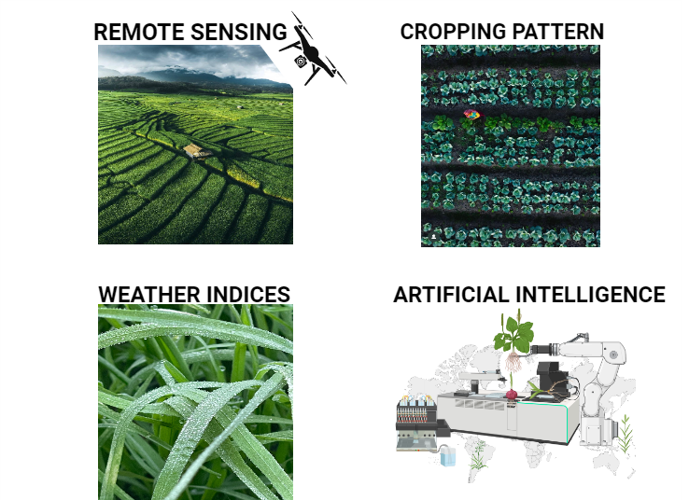
Figure 8: Advanced technologies used in smart farming

12.1.3 Enhancement of management approaches and cropping patterns
Multiple cropping patterns, crop diversification methods, and no-till farming practices, such as the rice-wheat rotation and rice-potato-sesame systems, can enhance agricultural productivity while reducing greenhouse gas emissions. The introduction of suitable dry-land crops can minimize the duration of submergence in the annual planting cycle. It is common to use a combination of inorganic fertilizers and organic amendments to boost crop yields and improve soil health, especially in areas with low fertility (Mi et al. 2018). For example, bio-char is considered an effective synergist when utilized as a soil amendment due to its significant potential for carbon sequestration, soil restoration, and enhancement of both crop productivity and soil health (Purakayastha et al. 2019). Incorporating bio-char may impact the soil's carbon-nitrogen cycle and the release of nutrients, which may have an impact on farmland's greenhouse gas emissions (El-Naggar et al. 2019). Certain soil conservation techniques, such utilizing agricultural leftovers, increasing nitrogen use efficiency, and lowering planting, are advised in order to lower CO₂ emissions. Crop production can be increased by applying crop wastes because they increase soil organic carbon. Implementing these attainable measures can improve water conservation, support the elemental cycle, boost agricultural productivity, and reduce greenhouse gas emissions (Arunrat et al. 2020). It's important to note that various agricultural systems have notably different rates of soil carbon storage and depletion. Additionally, because of its unique role in environmental protection, the cultivation approach of conservation agriculture is commonly used in agricultural production and is acknowledged as a vital strategy for sustainable agriculture.
12.1.4 Insurance based on agricultural weather indices
Natural disasters can diminish or entirely negate the adverse impacts on agricultural production when agro-meteorological indicators are used as trigger mechanisms in agricultural insurance, a method referred to as agricultural weather index-based insurance. Should it over the pre-established threshold, the insurer bear the responsibility for payments. Analyzing and calculating the loss from door to door is unnecessary since it has no bearing on the real circumstances surrounding agricultural damage after the disaster. Agricultural weather index-based insurance presents a new approach to risk transfer for farmers, utilizing financial instruments to manage the risks associated with natural disasters and leveraging social funds to help distribute agricultural-related risks. Claims can be settled easily, and simple to advocate, circumventing the moral hazard and adverse selection of conventional insurance, and lowering operating expenses (Abdi et al. 2022).

13.Conclusion: A synergistic approach to climate-smart organic agriculture
The convergence of climate-smart agriculture and organic farming offers a promising pathway to tackle the intertwined issues of climate change and food security. Although each approach has distinct advantages, their combined efforts can enhance their beneficial effects. Climate-smart agriculture emphasizes boosting productivity and resilience in response to shifting climatic conditions, which complements the core principles of organic farming. Organic methods like crop rotation, cover cropping, and minimizing synthetic inputs foster soil health, biodiversity, and carbon sequestration key factors for both climate mitigation and adaptation. Merging climate-smart and organic practices can result in more sustainable and robust agricultural systems.. By adopting climate-smart techniques within organic frameworks, farmers can enhance their ability to cope with climate-related challenges, increase their yields, and reduce their environmental footprint. However, the successful implementation of climate-smart organic agriculture requires a holistic approach that addresses various factors, including policy support, access to resources, and knowledge sharing. Governments, research organizations, and development agencies should allocate resources towards research, education, and extension services to encourage the uptake of climate-smart organic methods. In summary, climate-smart organic agriculture presents a viable option for developing sustainable and resilient food systems. By merging the strengths of both approaches, we can address climate change, improve food security, and foster a more sustainable future for future generations.

REFERENCES

- Madhavi, R., Vijaya, G. S., & Malathi, H. (2021). A paper on sustainable organic farming in India. International Journal of Modern Agriculture, 10(2), 1080-1088
- Abdi, M. J., Raffar , N., Zulkafli, Z., Nurulhuda, K., Rehan, B. M., Muharam, F. M. et al. (2022). Index-based insurance and hydroclimatic risk management in agriculture: A systematic review of index selection and yield-index modelling methods. International Journal of Disaster Risk Reduction, (67), 102653.
- Alam, M. F., & Sikka, A. K. (2019). Prioritizing land and water interventions for climate-smart villages. Irrigation Drain, (68), 714–728. https://doi.org/10.1002/ird.2366
- Arora, N. K. (2019). Impact of climate change on agriculture production and its sustainable solutions. Environmental Sustainability, (2),95–96. https://doi.org/10.1007/s42398-019-00078-w
- Arunrat, N., Sereenonchai, S., Chaowiwat, W., Wang, C., & Hatano, R. (2020). Soil Organic Carbon in Sandy Paddy Fields of Northeast Thailand: A Review. Agronomy, (10), 1061.
- Nirjharnee Nandeha, Trivedi, A., Neelendra, S.,Verma., Kushwaha, N., & Satish, K. S. (2023). Benefits and Challenges of Indian Organic Farming: A Comprehensive Review. International Journal of Environment and Climate Change, 13(9), 2142-2151.
- Brown, T. (2016). Civil society organizations for sustainable agriculture: negotiating power relations for propoor development in India. Agro-ecological Sustainable Food System, (40), 381-404. https://doi.org/10.1080/21683 565.2016.1139648
- Chand, R. (2017). Doubling Farmer’s Income-Rationale, Strategy, Prospects and Action Plans. Indian Journal of Agricultural Economics, 72(1),1-23.
- Chandra, A., McNamara, K. E., & Dargusch, P. (2018). Climate-smart agriculture: perspectives and framings. Climate Policy,18 (4),526-41.
- Elayaraja, M., & Vijai, C. (2020). Organic farming in India: Benefits and Challenges, European Journal of Molecular and Clinical Medicine, 7(1), 3021-3029.
- ElNaggar, A. H., Shaheen, S. M., Sarkar, B., Chang, S. X., & Tsang, et al. (2019) Biochar composition dependent impacts on soil nutrient release, carbon mineralization, and potential environmental risk: A review. Journal of Environmental Management, 1(241), 458-467.
- Sankar, C., & Aruna, J., (2020). Exports and Imports of Organic Products in India-An Overview. International Journal of All Research Education and Scientific Methods (IJARESM), 8(12), 2455-6211.
- FAO. (2013). Climate smart agriculture sourcebook. Food and agriculture organization of the United Nations.
- Food and Agriculture Organisation of the United Nations (FAO). (2007). Adaptation to Climate Change in Agriculture, Forestry and Fisheries: Perspective, Framework and Priorities. FAO, Rome, Italy.
- Hamrani, A., Akbarzadeh, A., & Madramootoo, C. A. (2020). Machine learning for predicting greenhouse gas emissions from agricultural soils. Science of Total Environment, (741), 140338
- Hariharan, V. K., Mittal, S., Rai, M. et al. (2020). Does climate-smart village approach infuence gender equality in farming households. A case of two contrasting ecologies in India. Climate Change, (158),77–90. https:// doi.org/10.1007/s10584-018-2321-0
- Jha, K., Doshi, A., Patel, P.,& Shah, M. (2019). A comprehensive review on automation in agriculture using artificial intelligence. Artificial Intelligence in Agriculture, (2), 1–12
- Jurado, J.M., Ortega, L., Cubillas, J. J., & Feito, F.R. (2020). Multispectral mapping on 3D models and multi-temporal monitoring for individual characterization of olive trees. Remote Sensing, (12), 1106.
- Nielsen, K., M. (2018), Organic farming, Encyclopedia of Ecology,(2)4. https://is.muni.cz/el/fss/podzim2019/ENSb1302/um/Nielsen_organic_farming.pdf?studium=489585;kod=MTVU;predmet=997643;lang=en;stahnout=1;dk=6JzMi_An
- Karunakaran, N. (2021). Status, benefits, and future prospects of organic farming in India: A review. Journal of Management Research and Analysis, 8(3), 103-111.
- Elayaraja, M., & Vijai, C. (2020). Organic farming in India: Benefits and Challenges, European Journal of Molecular and Clinical Medicine, 7(1),3021-3029.
- Kumari, S., V., & Raj, S. (2020). Organic Farming: Path for Sustainable Ecosystem, Discussion Paper 17, National Institute of Agricultural Extension Management (MANAGE), 1-102. https://www.manage.gov.in/publications/discussion%20papers/MANAGE_Discussion%20Paper%2017.pdf

- Laderach, P., Ramirez,V. J., Navarro, C ., Carlos, Z., Armando M. V., & Andy, J. (2017) Climate change adaptation of coffee production in space and time. Climate Change (141), 47–62. https://doi.org/10.1007/
- Martey, E., Etwire, P.,M., & Mockshell,J. (2021) Climate-smart cowpea adoption and welfare effects of comprehensive agricultural training programs. Technology in Society,(64),101468. https://doi.org/10.1016/j.techsoc. 2020.101468
- McKinsey Global Institute Report on Climate Risk and Response, 2020 https://www.mckinsey.com/
- Meier, J., Mauser, W., Hank, T., & Bach, H. (2020). Assessments on the impact of high- resolution-sensor pixel sizes for common agricultural policy and smart farming services in European regions. Computers and Electronics in Agriculture,(169), 105205.
- Mi, W., Sun, Y., Xia, S., Zhao, H., Mi, W., Brookes, P. C. et al. (2018). Effect of inorganic fertilizers with organic amendments on soil chemical properties and rice yield in a low-productivity paddy soil. Geoderma, (320), 23–29.
- Miron, I. J., Linares, C., & Diaz, J. (2023). The influence of climate change on food production and food safety. Environmental Research,( 216),114674. https://doi.org/10.1016/j.envres.2022.114674
- Molua, E. L. (2012). Gendered response and risk‐coping capacity to climate variability for sustained food security in Northern Cameroon. International Journal of Climate Change Strategies and Management, ,4(3):277-307.
- Roshan, R. B.,& Joshi, H.G. (2023).Organic Agriculture in India: A Review of Current Status, Challenges, and Future Prospects. Universal Journal of Agricultural Research 11(2), 306-313. http://www.hrpub.org. DOI: 10.13189/ujar.2023.110208
- Padua, L., Marques, P., Adao, T., Guimaraes, N., Sousa, A., Peres, E., et al. (2019). Vineyard variability analysis through UAV-based vigour maps to assess climate change impacts. Agronomy, (9), 581.
- Press Information Bureau (2021). Assessment of Climate Change over Indian Region. Ministry of Earth Science.
- Purakayastha, T. J., Bera, T., Bhaduri, D., Sarkar, B., Mandal, S., Wade, P., et al. (2019). A review on biochar modulated soil condition improvements and nutrient dynamics concerning crop yields: Pathways to climate change mitigation and global food security. Chemosphere,( 227), 345–365.
- Subeesh, A., & Mehta, C.R. (2021). Automation and digitization of agriculture using artificial intelligence and internet of things. Artificial Intelligence in Agriculture,( 5), 278–291.
- The Asia Foundation (2022). India’s Experience with Climate Smart Agriculture: Opportunities for Triangular Cooperation in the Indo-Pacific. New Delhi: The Asia Foundation. https://asiafoundation.org/publication/indias-experience-with-climate-smart-agriculture-opportunities-for-triangular-cooperation-in-the-indo-pacific/
- The Economic Survey (2020-2021). Statistical Appendix and Volume II - State of the Economy 2020-21, 01 A Macro View https://www.indiabudget.gov.in/economicsurvey/doc/Statistical-Appendix-in-English.pdf
- Thornton, P.K., Whitbread, A., Baedeker, T., Cairns, J., Claessens, L., Baethgen, W., et al. (2018). A framework for priority-setting in climate smart agriculture research. Agricultural System, (167), 161–175.
- United Nations (2021) Economic and social council: population, food security, nutrition and sustainable development. Oxford Handbook of United Nations 1–20. https://www.un.org/development/desa/pd/sites/ www.un.org.development.desa.pd/files/undesa-pd-2021-e-cn.9-2021-2-advanceunedited.pdf. Accessed 1 Feb 2024
- Ann,W. B., Patti, K., Chesha, W., Laurens, v. V., Gabriela, Q., Kees, S. et al. (2015) Exploring the impact of farmer-led research supported by civil society organizations. Agriculture and Food Security, (4),1-7. https://doi.org/10.1186/ s40066-015-0023-7
- Zakaria, A., Azumah, S. B., Appiah, M., & Dagunga, G. (2020). Adoption of climate-smart agricultural practices among farm households in Ghana: the role of farmer participation in training programmes. Technology in Society, (63),101338. https://doi.org/10.1016/j.techsoc.2020.101338
- Zizinga, A., Himanshu, P., Tietjen, B., Geofrey, G., Bobe, B., & Dennis, B. (2022). Climate change and maize productivity in Uganda: simulating the impacts and alleviation with climate smart agriculture practices. Agricultural System ,(199),103407. https://doi.org/10.1016/j.agsy.2022.10340
- Hussain, M., Butt, A. R., Uzma, F., Ahmed, R., Irshad, S., Abdul, R. et al. (2019). A comprehensive review of climate change impacts, adaptation, and mitigation on environmental and natural calamities in Pakistan. Environmental Monitary and Assessment,(192), 48.
- Duchenne, M.,& Neetoo, R., A., H. (2021). Climate Change and Emerging Food Safety Issues: A Review. Journal of Food Protection, (84), 1884-1897. https://doi.org/10.4315/jfp-21-141
- Chaudhry, S., & Sidhu, G., P., S. (2022). Climate change regulated abiotic stress mechanisms in plants: A comprehensive review. Plant Cell Reports,( 41), 1–31.
- Rajput, V. D., Minkina, T., Kumari, A., Singh, H., Verma, V., Mandzhieva, K. K. S. et al. (2021). Coping with the Challenges of Abiotic Stress in Plants: New Dimensions in the Field Application of Nano-particles. Plants, (10), 1221.
- Yang, Q., Du, T., Li, N., Liang, J., Javed, T., Wang, H. et al. (2023). Bibliometric Analysis on the Impact of Climate Change on Crop Pest and Disease. Agronomy, (13), 920.
- Harvey, J.A., Tougeron, K., Gols, R., Heinen, R., Abarca, M., Abram, P.K., et al. (2023) Scientists’ warning on climate change and insects. Ecological Monographs, (93),1553.
- Au, A., Lee, H., Ye, T., Dave, U., Rahman, A. (2022). Bacteriophages: Combating Antimicrobial Resistance in Food-Borne Bacteria Prevalent in Agriculture. Microorganisms, (10), 46.

