Type of Article: Original Research Article

ASSESSING IMPACT OF SOIL PHYSICAL AND CHEMICAL PROPERTIES ON ERODIBILITY STATUS IN UKPOM ABAK RIVER CATCHMENT OF AKWA IBOM STATE, NIGERIA.

ABSTRACT
The study was conducted in Ukpom Abak River Catchment of Akwa Ibom State, Nigeria to examine the impact of soil physical properties and organic matter on erodibility status of the soils. Data for the study were collected using the systematic belt transects and the random sampling technique. Quadrats of 5m X 120m dimensions were established with twenty-four (24) quadrats of 5m by 5m. Thereafter 20 quadrats were randomly selected. Soil samples were collected from each steam order at a depth of 0-20 cm and were taken to the laboratory for analysis of some soil physical properties and organic matter content. Pearson’s product correlation, stepwise multiple regression and ANOVA were the analytical tool employed for data analysis. The results revealed that soils of Ukpom Abak drainage basin are basically sandy. The soil is moderately acidic (pH: 5.73) with relative medium mean value of organic matter of 1.36% (critical limits: low: ˂ 1%, medium:1 – 2 % and high: ˃ 2 %) while the bulk density (1.45 g/cm³) is optimal indicating less compaction. Ukpom Abak drainage basin has low erodibility status (0.0109). There was a positive correlation between organic matter and K-factor (r = 0.942, p<0.05); positive associations between sand (r = 0.081, p>0.05), silt (r = 0.158, p>0.05), particle density (r = 0.336, p>0.05), porosity (r = 0.361, p>0.05), hydraulic conductivity (r = 0.207, p>0.05), water aggregate stability (r = 0.005, p>0.05) and K-factor, while negative association exist between clay content (r = -0.246, p>0.05), bulk density (r = -0.308, p>0.05), soil moisture (r = -0.258, p>0.05) and K-factor.
Keywords: Catchment area; soil physical properties; organic matter content; erodibility indices; stepwise multiple linear regression.

INTRODUCTION
Soil erosion is linked to the influence of soil properties on several processes, such as aggregate breakdown (Essien and Ogban, 2018), sediment detachment and transportation (Peters, 1994; Ogban and Essien, 2016). The term soil erodibility described soil susceptibility to erosion processes (Sheridan, 2000; Essien et al., 2019). Soil Erodibility is a function of complex interactions of a considerable number of physical and chemical properties of soil, which frequently vary within a standard texture class (Wischmeier and Smith, 1978). There are several definitions of soil Erodibility, it can also include the relative term that can be dependent on soil characteristics.
Consequently, soil erodibility accounts for the influence of the intrinsic soil properties on soil erosion (Wang et al., 2001; Ogban et al., 2022). Accordingly, it is possible to measure soil erodibility by investigating selected soil properties. However, since rainfall characteristics can noticeable alter the hydraulic characteristics of soils, soil erodibility cannot be considered entirely indepndent from the effect of the environmental factors.
Deterioration of soil surface structure and surface seals that could occur during a rainstorm can lead to considerable variation in soil erodibility. Soil erodibility is thus a dynamic and not a static property, so it may and vary over time as a result of changes and variations in soil properties (Essien et al., 2024a). Moreover, uncertainty can be expected in soil erodibility prediction when soil erodibility is considered as a constant over time (Wang, 2001). Sheridan et al. (2000) showed that the physical meaning of erodibility will be affected by the equation used to predict the value of the index. So, the values of erodibility have different physical meaning in each of the predictive equations used.
Wischmeier and Smith (1978) reported that the meaning of soil erodibility is distinctly different from that of the term soil erosion. Soil loss by erosion is also affected by other factors such as rainfall characteristics, slope percentage and length (Essien et al., 2024b; Essien, 2024c), plant cover and land management (Sam et al., 2025), in addition to the inherent soil properties that determine soil erodibility, soil found under similar environmental conditions can have varied amounts of soil loss depending on the variation of individual soil properties and differences in soil erodibility. Thus, soil erodibility needs to be estimated independently from the effect of other factors mentioned above. Therefore, there is need to determine effect of some soil physical properties and organic matter on erodibility status of soil in Ukpom Abak River Catchment Akwa Ibom State, Nigeria.

MATERIALS AND METHODS
Environment of the Study Area
The study was carried out in Ukpon Abak River Catchment Akwa Ibim State, Nigeria. Akwa Ibom State is situated between latitudes 4º 30¹ and 5º 30¹ N and longitudes 7º 30¹ and 8º 20¹ E. The study area is characterised by two seasons (dry and wet). The dry season last from November to March, while the rainy season from the months of April to October. Rainfall is heavy from 2,000 to 3,000 mm. Temperatures is uniformly high throughout the year with slight variation between 26º C and 32ºC. High relative humidity is common with a mean of 75%, while solar radiation ranges from 6 – 15 KJ per day (Petter et al., 1989, cited in Essien et al., 2024b).
The soils are derived from sandy parent materials and are highly weathered and dominated by low activity of clays. Sands cover a greater part of the state and constitute the Benin formation, also known as the coastal plain sands. They originated from the tertially sandstones with the low shale and Ameki formation (Petter et al., 1989 cited in Akpan eet al., 2024). The natural vegetation is mainly savannah with some of rainforest distribution in patches. The natural vegetation has been almost completely replaced by secondary forest of predominantly wild, oil palm, wood shrubs such as chromolaena odarata and various grasses under growth.
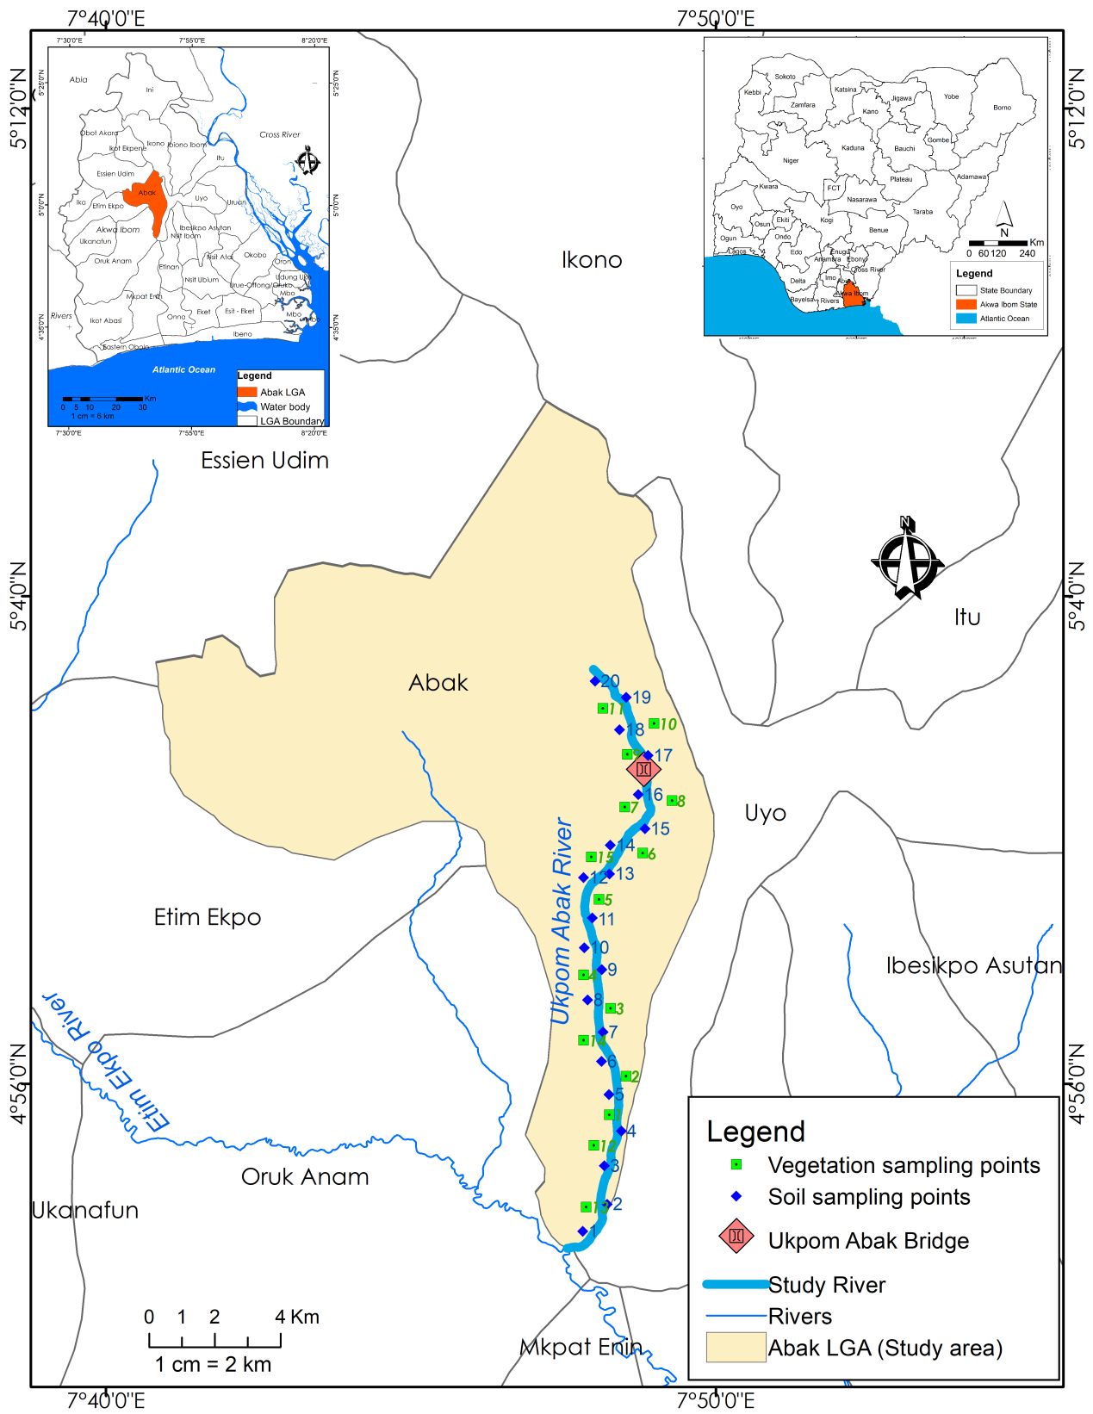
Fig 1: Map showing soil sample locations at Ukpom Abak River Catchment
Source: Akwa Ibom State Geographical Information Agency
Field Methods
The study was carried out in Ukpom Abak River Catchment, Akwa Ibom State, Nigeria.
Stream ordering
Stream ordering was done to know the extent of the Ukpom Abak River Catchment and to enable the researcher to partition it into sites for the study. The method adopted was first proposed by Strahler (1957). This method of stream ordering has it that each finger-tip tributary is designated a first order stream, two stream of the same order combine to give the next order stream such that two second order streams combine to give a third order stream and so on. Once this initial ordering has been completed the highest order stream was projected back to head waters along the stream which involved least deviation from the mainstream direction. To order the drainage network in two stages was complicated, as it entailed an additional subjective decision in projecting the order of streams head wards. And in addition, all small un-branched tributaries are not of the same order, as affirmed by Gregory and Walling (1973).

Sampling Techniques
Soil samples were taken with a soil auger at 0 - 20 cm depth from the two sites into which the River Catchment was divided during stream ordering. A total of 20 composite soil samples were collected and taken to the laboratory for analyses. The soil samples were air-dried, crushed and sieved with a 2 mm mesh sieve for the organic matter determination, by standard methods, as described by Udo et al. (2009). While samples for aggregate stability was sieve with 4 mm sieve size for determination of water stability aggregate. Core cylinders’ samples were used for the determination of bulk density, hydraulic conductivity and total porosity calculated.

Laboratory analysis
Soil samples were air-dried at room temperature, sieved with 2 mm sieve size for the determination of particle size distribution and chemical properties, also, soil core sampliers were used for determination of bulk density, hydraulic conductivity and total porosity calculated. While another set of samples were sieved through 4 mm sieved size for wet aggregate analysis, as follows: -
Soil physical properties
The proportions of sand, silt and clay particles (particle size distribution) in the soil samples were determined by the Bouyoucous Hydrometer method using sodium hexametaphospate (calgon) as the dispersing agent. The proportions of fine and very fine sand in each soil sample were determined by the sieving method, while the texture of each soil sample was determined using the soil textural triangle (Udo et al., 2009).
Bulk Density
Bulk density was determined using core sampler. Soil samples were oven dried at 105ºC to a constant mass and bulk density calculated.
Using the equation
ℓb = …………………………… Equation1
Where
ℓb = bulk density (Mgm⁻³)
Ms = mass of oven dry soil (mg)
Vt = Total volume of soil (m⁻³)
The total volume of soil was calculated from internal dimension of the scylinder.
Total porosity
Total porosity was calculated from particle size and bulk density relationship as state by Ogban et al. (2022)
f = ℓb
1 - ℓs …………………………… Equation 2

Where
f = Total porosity (m³m⁻³)
ℓb = bulk density (Mg m⁻³)
ℓs = particle density (Mg m⁻³)

Saturated Hydraulic Conductivity
Saturated hydraulic conductivity (Ksat) was determined using the constant head parameter as stated in Ogban et al. (2022). The core sample was placed in a basin of water and allowed to be saturated by capillary. The saturated core sample was then placed in a funnel and a cylinder head was held to core cylinder with a masking tape. The water passing through the soil column was collected into a measuring cylinder and the saturated hydraulic conductivity was calculated using the equation.
Ksat = …………………………… Equation 3
Where
Ksat = saturated hydraulic conductivity (cmhr⁻¹)
Q = Discharge rate (cm³ min⁻¹)
L = Length of soil column (cm)
= change in hydraulic head (cm)
A = Cross sectional area through which the flow takes place (cm²)
t = time (minutes)
Soil Moisture Content
Soil moisture content was done using gravimetric method, which involves oven-drying a sample to remove all the water
W_{2 –} W₃
× 100 ………………………………………. Equation 4
W₃ - W₁
Where
W₁ – weight of the container
W₂ – weight of wet soil
W₃ – constant dry weight
Water Stable Aggregate
Weight of the water stable aggregates
×100 ………………… Equation 5
Weight of the initial soil simple

Soil chemical properties
The pH of the soils was measured with a glass electrode pH meter at the soil/water ratio of 1: 2.5. The organic matter contents of the soils were determined by the Walkley-Black wet oxidation method. The Walkey-Black procedure measures active or decomposable organic matter in the soil. The reagents used were potassium dichromate (K₂Cr₂0₇), concentrated sulphuric acid (H₂S0₄) and ferous complex as indicator.
Determination of Soil Erodibility Status
The researcher used the Wischmeier and Smith (1978) nomograph model/equation to estimate the erodibillity staus (K-factor) of the soils studied. The following soil parameters were employed:
- Percentage silt + very fine sand;
- Percentage sand
- Organic matter content
- Soil structure grade
- Permeability class

As reported by Cassol et al. (2018), the nomograph model is mathematically expressed as follows:
K = 2.1 M^{1.14} (10⁻⁴) (12 - Y) + 3.25 (S – 2) + 2.5 (P – 3)/100…Equation 6
Where,
K = USLE soil erodibility (K-factor)
M = Product of (% silt + % fine sand) and (100 - % clay)
Y = Organic matter content in percentage
S = Soil structure class/grade (1 for very fine granular soil; 2 for fine granular soil; 3 for medium or coarse granular soil; 4 is for blocky, platy or massive soil) (Ibaje, 2016)
P = Permeability class (1 for very slow infiltration; 2 for slow infiltration;
3 for slow to moderate infiltration; 4 for moderate infiltration; 5 for
Moderate to rapid infiltration; 6 for rapid infiltration (Essien, 2013).

Expressing in the SI unit (t ha h ha⁻¹ MJ⁻¹ mm⁻¹), the K-value was multiplied by 0.1312 (Wischmiere and Smith, 1978; Cassol et al., 2018) after which it was rated, according to Ibaje (2016) thus: Very high > 0.45; high = 0.35 - 0.45; moderate = 0.25 - 0.35; low to very low = < 0.2. In addition to this classification, the study employed the standard erodibility indices in Table 3 (Emeka-Chris, 2014; Okorafor et al., 2018) to determine the status of K-factor.

Table 1: Standard erodibility indices
Group | K-value | Nature of soil
I | 0.0 – 0.1 | Permeable out wash well drained soil, slowly permeable substrata
II | 0.11 – 0.17 | Well grained soils in sandy gravel free material
III | 0.18 – 0.28 | Graded loams and silt loams
IV | 0.29 – 0.48 | Poorly graded moderately fine textured soil
V | 0.49 – 0.64 | Poorly graded silt, very fine sandy soil, well and moderately graded
Source: Emeka-Chris (2014) and Okorafor et al. (2018)
Data analysis
Data obtained were analyzed using tables, averages, Pearson Product Moment Correlation and stepwise multiple regression. Statistical analyses were performed using Statistical Package for Social Sciences (SPSS) Version (22.0) for Windows and excel spreadsheet.
Pearson Product Moment Correlation
The correlation coefficients determined were used to assess the relationships between soil erodibility status and vegetation components/selected soil properties. The correlation analysis was based on the following formula:
r = N∑XY - ∑X∑Y …………….. Equation 7
√n∑x² – (∑x)² n∑y² – (∑y)²
Where
r = Correlation coefficient
x and y = The two variables of interest
∑ = Summation
While the negative values indicated inverse relationships, the positive values indicated direct relationships.

Stepwise Multiple Linear Regression
The stepwise multiple linear regression is a method of regressing multiple variables while simultaneously eliminating insignificant variables. Multiple regression analysis is an extension of simple linear regression. It was used to predict the value of a variable based on the value of two or more other variables. This technique is appropriate because it shows us the relative effect the combination of sand, silt, clay and organic matter has on K-factor. The test identified the soil property that contributed most to the changes in K-factor in the study area. The multiple regression analysis was based on the relation mathematically defined as follows:
Y = a + b₁X₁ + b₂X₂…...........b₁₄X₁₄+ e ………. Equation 8
Where,
Y = Dependent variable (K-factor)
a = Y-intercept
X₁- X₁₄ = Independent variables
X₁ = Sand (%)
X₂ = Silt (%)
X₃ = Clay (%)
X₄ = Organic matter (%)
X₅ = Hydraulic conductivity (cm/sec)
X₆ = Water aggregate stability (%)
X₇ = Soil moisture (%)
X₈ = Bulk density (g/cm³)
X₉ = Particle density
X₁₀ = Porosity (%)
X₁₁ = Density of herbs
X₁₂ = Herbaceous cover (%)
X₁₃ = Shrub density
X₁₄ = pH
b₁– b₁₄ = Regression coefficients
e = Error term

Results and Discussion
Selected physical and chemical properties of soils in Ukpom Abak River Catchment
Physical properties of the soil
The physical properties of soils in Ukpom Abak River Catchment River are presented in Table 2. The soils are principally sandy; with sand accounting for more than 80 percent of the inorganic mineral fragment in the soil. The high sand content observed in the soil is expected as the study area is a part of the coastal plain of southern Nigeria, which is characterized by very sandy soils over wide expanses of land (Deekor et al., 2012; Aweto and Enaruvbe, 2010). The levels of silt and clay in the soils were low. The results in Table 2 therefore show that soils in the the study area are texturally similar, being loamy sand and having been derived from the same parent material (coastal plain sand) under the same climate and topography. The bulk densities of the soils ranged from 1.24 to 1.68 g/cm³ with the mean of 1.45 g/cm³.
The bulk density values recorded for the soils were within the normal range of 1.20 – 1.60 g/cm³ recommended for agricultural soils (Acquaah, 2005; Essien et al., 2025) and therefore suggested that the soils might not be highly eroded. This could be presence of organic matter in the soils, low degree of water erosion and absence of compaction among other factors. According to Brady and Weil (2007),
Table 2: Physical properties of soil in the study area
Soil | Soil depth (cm) | Particle size distribution |  |  | TC | BD  (g/cm³) | PD  (g/cm³) | Porosity  (%) | Moisture  (%) | WAS (%) | K x 10⁻⁴ (cm/Sec)
Soil | Soil depth (cm) | Clay | Silt | Sand
L1 | 0-15cm | 10.0 | 7.0 | 88.0 | LS | 1.52 | 2.42 | 37.0 | 17.09 | 35.10 | 42.5
L2 | 0-15cm | 6.0 | 8.0 | 85.0 | LS | 1.56 | 2.18 | 28.0 | 15.42 | 12.88 | 35.0
L3 | 0-15cm | 7.0 | 13.0 | 80.0 | LS | 1.49 | 2.70 | S45.0 | 13.97 | 54.94 | 51.2
L4 | 0-15cm | 11.0 | 6.0 | 83.0 | LS | 1.67 | 2.52 | 34.0 | 15.07 | 39.64 | 28.4
L5 | 0-15cm | 10.0 | 10.0 | 80.0 | LS | 1.53 | 2.35 | 35.0 | 6.66 | 20.10 | 39.5
L6 | 0-15cm | 11.0 | 8.0 | 81.0 | LS | 1.46 | 2.62 | 44.0 | 7.02 | 14.13 | 50.5
L7 | 0-15cm | 5.0 | 11.0 | 84.0 | LS | 1.38 | 2.60 | 47.0 | 8.69 | 12.75 | 50.2
L8 | 0-15cm | 2.0 | 13.0 | 85.0 | LS | 1.25 | 2.60 | 52.0 | 9.79 | 36.0 | 56.4
L9 | 0-15cm | 9.0 | 10.0 | 81.0 | LS | 1.34 | 2.52 | 47.0 | 6.70 | 15.76 | 55.2
L10 | 0-15cm | 11.0 | 9.0 | 80.0 | LS | 1.26 | 2.66 | 53.0 | 6.60 | 26.64 | 60.0
L11 | 0-15cm | 10.0 | 8.0 | 87.0 | LS | 1.54 | 2.41 | 36.0 | 17.08 | 36.9 | 43.4
L12 | 0-15cm | 7.0 | 9.0 | 86.0 | LS | 1.57 | 2.17 | 27.0 | 15.43 | 11.89 | 36.0
L13 | 0-15cm | 8.0 | 12.0 | 81.0 | LS | 1.48 | 2.71 | 45.0 | 13.98 | 55.93 | 50.3
L14 | 0-15cm | 10.0 | 7.0 | 84.0 | LS | 1.68 | 2.53 | 35.0 | 15.08 | 39.65 | 29.5
L15 | 0-15cm | 9.0 | 9.0 | 80.0 | LS | 1.54 | 2.34 | 34.0 | 6.68 | 21.09 | 38.6
L16 | 0-15cm | 11.0 | 10.0 | 82.0 | LS | 1.45 | 2.61 | 43.0 | 7.03 | 15.14 | 51.5
L17 | 0-15cm | 6.0 | 12.0 | 83.0 | LS | 1.39 | 2.61 | 48.0 | 8.68 | 13.75 | 50.3
L18 | 0-15cm | 2.0 | 9.0 | 84.0 | LS | 1.26 | 2.60 | 53.0 | 9.79 | 37.0 | 57.5
L19 | 0-15cm | 8.0 | 10.0 | 80.0 | LS | 1.24 | 2.53 | 48.0 | 6.71 | 14.77 | 55.3
L20 | 0-15cm | 10.0 | 8.0 | 81.0 | LS | 1.33 | 2.67 | 54.0 | 6.62 | 27.65 | 61.0
Mean |  | 8.15 | 9.45 | 82.75 |  | 1.45 | 2.52 | 42.25 | 10.70 | 27.09 | 47.12
L = Soil location, TC = Textural class, LS = Loamy sand , BD = Bulk density, PD = Particle density, WAS = Water aggregate stability, K = Hydraulic conductivity

Soil bulk density is affected primarily by texture as well as organic matter content. Such levels of soil bulk densities help improve air/water movement and root penetration. Sam (2025); reported that soils with high bulk densities inhibit water movement and root penetration; while Imoro et al. (2012) reported that as soil becomes more and more compact, its bulk density increases, meaning soil bulk density is an indicator of soil compaction. High bulk density is an indicator of low soil porosity and soil compaction, and affect available water capacity, root growth, and movement of air and water through soil (Monapatra et al., 2025). Therefore, the low bulk densities in the present study suggest low compaction and high soil porosity which can negatively impact on soil erodibility.
The particle densities of the soils were in the range of 2.17 – 2.71 g/cm³ with the mean value of 2.52 g/cm³. Particle density data are used to better understand the physical and chemical properties of the soil. These values fall within the common range of 2.55 to 2.70 g/cm³ among agricultural soils and this could mostly be due to low compaction.
The result of soil porosity is shown in Table 2. Soil porosity refers to that part of a soil volume that is not occupied by soil particles or organic matter. Large pore spaces are able to accommodate plant roots and the wide range of tiny animals that inhabit the soil (Brady and Weil, 2007). Large pore spaces permit fast infiltration and percolation of water through a soil or soil horizon. Small pores hinder percolation and infiltration. Table 2 showed that the mean value of porosity in the River Basin is 42.25%. This means that porosity levels of the studied soil is fairly high. The results obtained are consistent with the finding of Offiong and Iwara (2012); Paraji et al. (2024) that fallow soils are observed to improve the physical properties of the soil. It is worthy of note that the higher the bulk density, the lower the total porosity because bulk density and total porosity are inversely related. Relatively high porosity in all the succession stages, is attributed to the parent material and soil grain, being sandy. This is because, bulk density and porosity exhibits inverse association, as increase in one result is the decrease of the other and vice versa (Monapatra et al., 2025).
The mean content of soil moisture in the River Basin was 10.70 percent (Table 2). The high moisture content in the studied soil is low. In a related study, Aweto (1981) stated that increase in soil moisture may be attributed to increased organic inputs. Similarly, Akata et al. (2024); Akpan et al. (2025) stated that the increase in soil water-holding capacity depends primarily on organic matter acceleration. The low soil moisture in the River Basin could be attributed to the decrease in organic matter as a result of the intensive and continuous farming activities carried out in the area.
The mean content of water aggregate stability of soil in the River Basin was 27.09 percent. This value means that soil of the River Basin has high aggregate stability. The study stated that additions of organic matter in the soil increase aggregate stability (Essien et al., 2022). Aggregation affects erosion, movement of water, andplant root growth. Desirable aggregates are stable against rainfall and water movement and the value of aggregate stability of the studied soil could be said to be facilitating movement of water in the soil as well as encouraging plant root growth. The result of hydraulic conductivity of the River Basin is presented in Table 2. The mean content was 47.12 cm/sec. This means that the hydraulic conductivity of the soil is high. Soil hydraulic conductivity is the ability of a soil to transmit water. The high hydraulic conductivity in the soil may be attributed to the high soil porosity which makes it easier for water to infiltrate into the soil (Essien et al., 2024a).
Selected chemical properties of soils in Ukpom Abak River Catchment
The selected chemical properties of soils in Ukpom Abak River Catchment are presented in Table 3. Soil pH shows whether soil is acidic, neutral or alkaline and it gives useful information on the availabilities of cations. The pH values of the soils in the study area varied from 5.4 to 6.6 with the mean value of 5.7, indicating that most of the soils were moderately acidic (pH 5.5 – 6.0) and these were consistent with the findings of Agbede (2008) that the pH of soils in southern Nigeria is within the range of 4.5 – 6.5. The moderately acidic condition of soils in the river catchment revealed that there was a reduction in leaching and erosion.
The contents of organic matter (OM) in the soils (Table 3) ranged from 0.34 – 2.58% with the mean value of 1.36%, indicating low to moderate contents. Soil organic matter content could be affected by factors such as land management practices.

Table 3: Selected chemical properties of soils in the study area
Soil | Soil depth (cm) | pH | OM  (%)
L1 | 0-20cm | 5.6 | 0.34
L2 | 0-20cm | 5.7 | 1.37
L3 | 0-20cm | 5.5 | 1.55
L4 | 0-20cm | 5.7 | 1.20
L5 | 0-20cm | 5.9 | 1.03
L6 | 0-20cm | 5.8 | 1.37
L7 | 0-20cm | 5.8 | 1.89
L8 | 0-20cm | 6.0 | 2.06
L9 | 0-20cm | 5.7 | 1.20
L10 | 0-20cm | 5.7 | 1.72
L11 | 0-20cm | 5.7 | 0.86
L12 | 0-20cm | 5.6 | 1.20
L13 | 0-20cm | 5.4 | 1.03
L14 | 0-20cm | 5.8 | 1.87
L15 | 0-20cm | 5.8 | 0.86
L16 | 0-20cm | 5.7 | 0.86
L17 | 0-20cm | 6.0 | 1.37
L18 | 0-20cm | 5.6 | 1.03
L19 | 0-20cm | 5.8 | 2.58
L20 | 0-20cm | 5.7 | 1.89
Mean |  | 5.7 | 1.36

Key: L = Soil location, OM = Organic matter
Often directly related to organic matter changes. When organic matter increases, soil aggregate stability usually improves; consequently, more stable soil structure develops and promotes faster water movement thereby resisting erosion (Brady and Weil, 2007).

Erodibility status (K-factor) of soils in Ukpom Abak River Catchment
Erodibility status (K-factor) of soils in Ukpom Abak River Catchment. From the results shown in Table 4, the erodibility or K-factor values of soils in the study area ranged from 0.0309 to 0.0713 thahha⁻¹MJ⁻¹mm⁻¹ with the mean value of 0.0533 thahha⁻¹MJ⁻¹mm⁻¹ indicating low status (Chouliaras, 2000) and the permeably well-drained conditions of the soils. Similar K-factor values were reported by earlier researchers (Ibaje, 2016). According to Olson (1984) cited by Emeka-Chris (2014) and Okorafor et al. (2018), soils with K-factor values of 0.0 - 0.1 are regarded as permeable outwash well drained soils with permeable sub-strata.
The results (Table 4) show that soils across the sampled locations of the river catchment had similar K-factor of < 0.1. The availability of spore spaces and the presence of organic matter in soils help loosen the soils and allow water to seep through the soils rapidly.
Table 4: Erodibility (K-factor) status of soils in the study area

Soil | VFS  (%) | M | 2.1M^{1.14} | SG  (S) | PC  (P) | K-factor  (thahha⁻¹MJ⁻¹mm⁻¹)
L1 | 6.20 | 1188.00 | 6722.18 | 3 | 5 | 0.0521
L2 | 6.50 | 1363.00 | 7862.21 | 3 | 5 | 0.0483
L3 | 6.21 | 1786.53 | 5096.73 | 3 | 5 | 0.0699
L4 | 6.72 | 1132.08 | 6362.67 | 3 | 5 | 0.0469
L5 | 5.22 | 1369.80 | 7906.94 | 3 | 5 | 0.0564
L6 | 6.13 | 1257.57 | 7172.75 | 3 | 5 | 0.0509
L7 | 7.12 | 1721.40 | 10259.46 | 3 | 5 | 0.0653
L8 | 6.30 | 1891.40 | 11422.27 | 3 | 5 | 0.0705
L9 | 6.24 | 1478.75 | 8627.79 | 3 | 5 | 0.0598
L10 | 6.16 | 1349.24 | 7771.79 | 3 | 5 | 0.0529
L11 | 5.72 | 1234.80 | 3345.19 | 3 | 5 | 0.0309
L12 | 5.64 | 1361.52 | 7852.48 | 3 | 5 | 0.0554
L13 | 7.10 | 1757.20 | 10503.05 | 3 | 5 | 0.0713
L14 | 6.26 | 1193.40 | 6757.02 | 3 | 5 | 0.0486
L15 | 6.33 | 1395.03 | 8073.18 | 3 | 5 | 0.0582
L16 | 5.78 | 1404.42 | 8135.16 | 3 | 5 | 0.0476
L17 | 6.25 | 1715.50 | 10219.38 | 3 | 5 | 0.0679
L18 | 5.67 | 1437.66 | 8355.02 | 3 | 5 | 0.0590
L19 | 7.11 | 1574.12 | 9264.94 | 3 | 5 | 0.0567
L20 | 6.32 | 1288.80 | 5081.58 | 3 | 5 | 0.0378
Mean | 6.25 | 1515.23 | 7839.59 | 3 | 5 | 0.0553

Key: L = Soil location, VFS = Percentage of very fine sand, M = Product of (%Silt + %VFS) and (100 – %Clay), SG = Structure grade, PC = Permeability class, K = Soil erodibility

The finding further suggests that soils around Ukpom Abak River Basin are permeable, well drained soils with permeable sub-strata. This finding is a knowledge base for soil conservation and management practices within the study area (Essien et al., 2024b). The low K-factor further implies that soils Ukpom Abak River Basin are less erodible. This is because Emeka-Chris (2014) reported that low K index means the soil has a high cohesion and a good interlocking force which could resist weathering forces (detachment and transportation by water) (Ogban and Essien, 2016).
Relationships between soil properties and K-factor
The relationship between K-factor, organic matter, sand, silt, clay, porosity, hydraulic conductivity, water aggregate stability, bulk density, particle density and soil moisture. The results obtained are shown in Table 5. The Pearson’s correlation showed a positive and significant correlation between organic matter and K-factor (r = 0.942, p < 0.05). This result is consistent with those of Ibaje (2016); Bonilla and Johnson (2012) who reported a positive association between organic matter and K-factor. The positive association implies that increase in organic matter in the soil would result in a corresponding increase in K-factor. This suggests that the erodibility status of the soil is enhanced with the increase in the contents of organic matter. This is expected as presence of organic matter in the soil helps to lossen and increase the
Table 5: Pearson Correlations between soil properties and K-factor
Variables | K-factor |  | Multiple R (MCA)
Variables | r-values | Sig. | Multiple R (MCA)
OM (%) | 0.942* | 0.000 | 0.996*
Sand (%) | 0.081 | 0.758 | 0.996*
Silt (%) | 0.158 | 0.507 | 0.996*
Clay (%) | -0.246 | 0.296 | 0.996*
Bulk density (g/cm³) | -0.308 | 0.187 | 0.996*
Particle density (g/cm³) | 0.336 | 0.147 | 0.996*
Porosity (%) | 0.361 | 0.118 | 0.996*
Moisture (%) | -0.258 | 0.272 | 0.996*
Water aggregate stability (%) | 0.005 | 0.982 | 0.996*
Hydraulic conductivity (cm/sec) | 0.207 | 0.380 | 0.996*
OM = Organic matter, *Correlation is significant at the 0.05 level (2-tailed).
pore spaces which make it easier for rainwater to permeate or infiltrate the soil thereby reducing soil erosion and subsequent soil loss. This helps to reduce soil susceptibility to erosion. In line with this, Gyamfi et al. (2016) argued that soils with low organic matter content and least pores of soil textures are highly susceptibility to erosion. Also, positive and insignificant association was observed between sand and K-factor (r = 0.081, p > 0.05), silt and K-factor (r = 0.158, p > 0.05), particle density and K-factor (r = 0.336, p > 0.05), porosity and K-factor (r = 0.361, p > 0.05), water aggregate stability and K-factor (r = 0.005, p > 0.05) and between hydraulic conductivity and K-factor (r = 0.207, p > 0.05). The positive correlation signs suggest increase in the K-factor of soil around and within Ukpom Abak River Basin with the increase in the amount of sand and silt. This is expected as increase in sand makes the soil easily erodible and paves way for gullies, while the increase in silt content like organic matter loosens the soil and make it easily permeable (increases rate of infiltration).
In a related study, Ibaje (2016) reported a positive association between sand content and K-factor. In a related study carried out in Central Chile by Bonilla and Johnson (2012), soil erodibility was observed to increase with silt content (r = 0.607), and organic matter content (r = 0.086). Furthermore, the author observed that soils that contained predominantly silt are estimated to be vulnerable to water erosion. In addition, the result in Table 5 showed a negative and insignificant association between clay content and K-factor (r = -0.246, p > 0.05), bulk density and K-factor (r = -0.308, p > 0.05) and between soil moisture and K-factor (r = -0.258, p > 0.05). The positive correlation sign implies decrease in K-factor with the increase in clay content. This indeed is to be expected as soils with high clay contents are not easily erodible. This result agrees with those of Ibaje (2016) and Gyamfi et al. (2016) that found a negative association between clay and K-factor. This makes the soil not to be vulnerable to soil erosion and soil loss. In a related study, Diop, Stapelberg, Tegegn, stated that silts and certain clay textured soils are more susceptible to erosion than other textured soil types. The study further reveals that bulk density is inversely related to soil erodibility. Similar result was reported by Wang et al. (2016).
The negative association suggests that increase in bulk density brings about a substantial decrease in K-factor. This is expected as the bulk density of soil in Ukpom Abak River Catchment is low compaction with soil porosity which negatively impact on soil erodibility. This is seen in the low erodibility status of the soil. Since the soil is not compacted, it allows rainwater to infiltrate into the soil which reduces the rate of soil loss via erosion. The negative association also means that the low bulk density of soil in the river catchment improves water movement thereby minimizing soil loss. Furthermore, result of multiple correlation analysis (MCA) indicated that the relationship between K-factor, organic matter, sand, silt, clay, porosity, hydraulic conductivity, water aggregate stability, bulk density, particle density and soil moisture in Ukpom Abak River Catchment is significant (r = 0.996, p < 0.05). This gives answer to the first research hypothesis. The result obtained in this study is consistent with the finding of Gyamfi et al. (2016).
In addition, the associations between K-factor and soil properties are further shown in Figures 2 - 6. The association between sand content and K-factor revealed an increasing trend (Fig. 2), which implied that K-factor increased with the increase in sand content. This result affirms that of Pearson’s correlation and depicts the relationship between the two variables as positive. The R² result showa that sand contents of soils in Ukpom Abak River Catchment are responsible for about 0.6% of

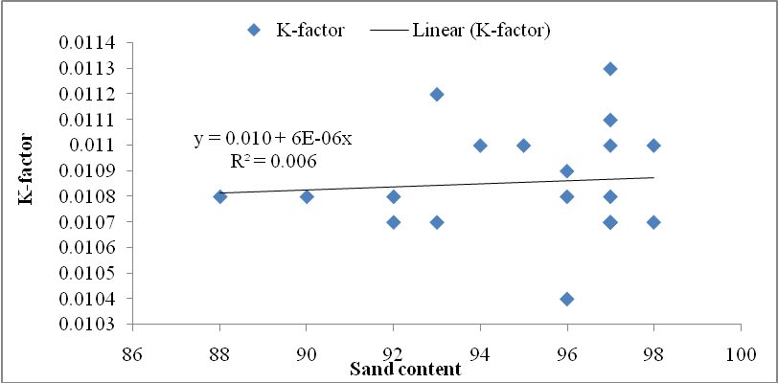
Fig 2: Sand-soil erodibility (K-factor) relationship
the changes in K-factor, while about 99.4% of the unexplained variances in K-factor were attributed to other parameters not necessarily sand contents. This goes to show that sand is not the only and principal factor that influences K-factor in the study area. A look at the information and pattern portrayed in Figure 2, reveals that most of the K-factors concentrate around sand content greater than 96%. This shows that increase in sand content above 96% brings about a corresponding increase in K-factor with the highest K-factor observed with sand content of 97%. This implies that the sand content in the study area does not help in reducing soil erodibility as the K-factor tends to increase with the increase in sand content.
The association between silt content and K-factor showed a direct association (Fig. 3), as the amount of K-factor increased with an increase in silt content. The R² result indicates that about 2.5% changes in K-factor is cased by silt content in the soil; and that 97.5% of the unexplained variances in K-factorare attributed to other factors not necessarily silt. A look at the Figure 3 also reveals that most of the K-factors concentrate around silt content < 4%. This shows that silt content of 3% brings about a corresponding increase in K-factor with the highest K-factor observed with silt content of 2%. In all, the pattern displayed on Fig. 3 is a positive association indicating the role of silt content in soil management and erosion control.
Furthermore, the pattern of association between clay content and K-factor indicated an indirect association (Fig. 4). The K-factor decreases with the increase in clay content. The R² result indicates that clay content in the soil of Ukpom Abak River Catchment is accountable for 6%decrease in K-factor, while 94% of the unexplained variance in K-factoris attributed to other factors. Fig. 4 shows that most of the K-factors concentrate around clay content of 2%. This shows that increase in clay content brings about a corresponding decrease in K-factor with the highest K-

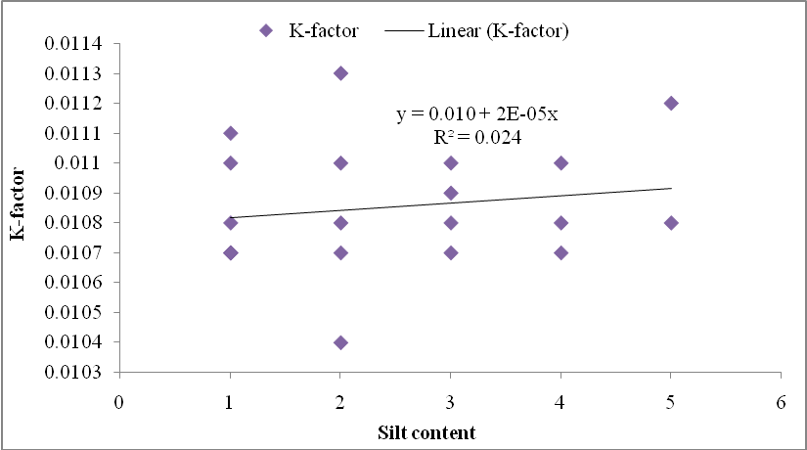
Fig. 3: Silt –soil erodibility (K-factor) relationship

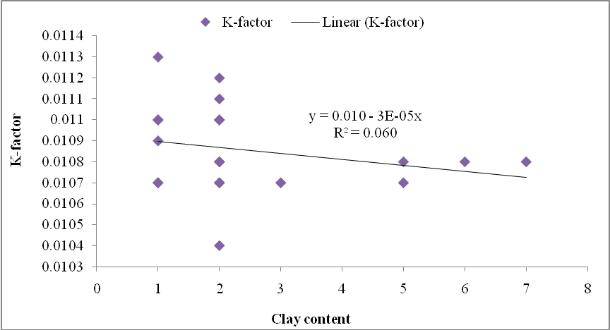
Fig. 4: Clay –soil erodibility (K-factor) relationship
Factor observed with clay content of 1%. This goes to show that increase in the amount of clay in the soil will not favour K-factor as the soil will not easily absorb water or water will not infiltrate the soil thereby increasing soil erosion. In all, the pattern displayed in Fig. 4 is a negative association indicating the role of clay content in soil erosion management. It goes to show soil erodibility is decreased with the increase in clay content.
The association between bulk density and K-factor showed an indirect relationship (Fig. 5). This means that the level of K-factor decreases with the increase in bulk density. The R² result indicates that 9.4% deduction in K-factor is caused by the level of bulk density in the soil. The pattern shown in Figure 3d further reveals that most of the K-factors concentrate around bulk density content of < 1.4 g/cm³. At this level of bulk density, a greater amount of rainwater is well controlled which makes the soil unsusceptible to soil erosion. It also shows that increase in bulk density values above 1.4 g/cm³ result in the deduction in K-factors. The decrease in soil erosion due to low soil compaction results in the decrease in the value of soil erodibility. The pattern displayed on Figure3d therefore portrays a negative association indicating the role of bulk density in soil management and erosion control.
Lastly, the association between organic matter content and K-factor revealed an increasing trend (Fig. 6), which implied that K-factor increased with the increase in the content of organic matter in Ukpom Abak River Catchment. This result reaffirms that of Pearson’s correlation and portrays the nature of relationship between the two variables as positive. The R² result indicates that organic matter contentin Ukpom Abak River Catchment is responsible for 88.7% of changes in K-factor, while
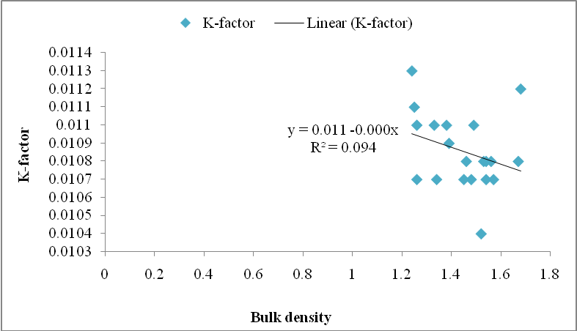
Fig. 5: Bulk density –soil erodibility (K-factor) relationship

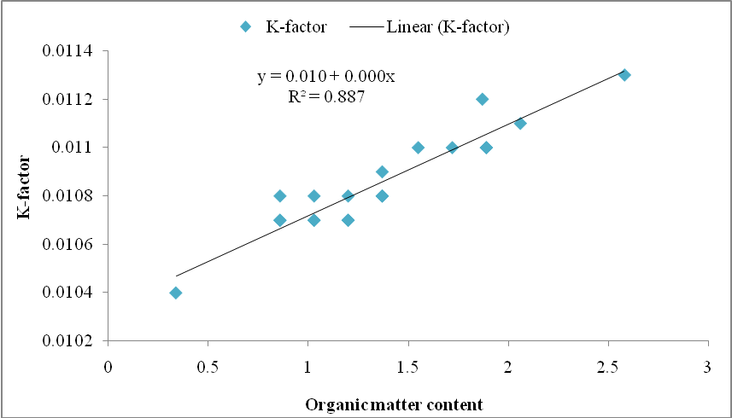
Fig. 6: Organic matter – soil erodibility (K-factor) relationship

Summary
The present study empirically determined the erodibility status of soils in Ukpom Abak River Catchment. In particular, the study determined selected physical and chemical properties of the soils and the erodibility status (K-factor) of the soils. Twenty composite soil samples were collected with a soil auger at 0 – 15 cm depth, ten each from the two sites of the river catchment, and analyzed using standard methods. Soil erodibility was estimated indirectly by the Wischmeier and Smith (1978) model/equation fed with data on selected properties of soils in the river catchment. Data obtained were analysed using average, correlations and stepwise multiple regressions at 5% significance level.
The result revealed that soils in Ukpom Abak River Catchment were generally sandy with sand accounting for more than 80% of the inorganic mineral fragments, also, the soils were moderately acidic with low to moderate organic matter contents.
The bulk densities of the soils were low indicating low compaction and presence of organic matter in the soils. Furthermore, the erodibility status of the soils were low indicating that the soils were well permeable and well drained and the soil of the area shows low K-factor. Positive significant correlation exists between organic matter and K-factor; positive and insignificant associations exist between sand, silt, particle density, porosity, hydraulic conductivity, water aggregate stability, particle density and K-factor, while negative and insignificant associations exist between clay content, bulk density, porosity and K-factor

Conclusion
It was therefore concluded that the erodibility status of soils in Ukpom Abak River Catchment was low implying that soils in the river catchment are permeable, well drained and susceptibility to impact of erosion.
REFERENCES
Acquuah, G. (2005). Principles of Crop Production: Theory, Techniques
and Technology. New Delhi, Prentice-Hall.
Agbede, O.O. (2008). Soil husbandry: Life for national food security and
economic empowerment. An Inaugural Delivered on March 19th,
2008 at Nasarawa State University Keffi, Nigeria.

Akata, O. R., Essien. O. A., Ben, F. E., Enyong, J. K. and Tochukwu, N. E. (2024). Effect
of different level of poultry manure on growth and yield of a maranthus
plant (Amaranthus hybridus) in Obio Akpa, Akwa Ibom State, Nigeria. Asian
Journal of Soil Science and Plant Nutrition, 10 (4); 744 – 751.

Akpan, E. A., Bernard, A. E., Essien, O. A., Akata, O. R., and Ben, F. E. (2025). Effect of
organic fertilizers on growth and Yield of garlic (Allium sativum L.) in Obio Akpa,
Akwa Ibom State. Asian Research Journal of Agriculture, 18 (1); 61 – 69.

Aweto, A.O. and Enaruvbe G.O. (2010). Catenary variation of soil properties
under oil palm plantation in southwestern Nigeria. Ethiopian Journal
of Environmental Studies and Management, 3(1), 1 – 7.
Aweto, A.O. (1981). Organic matter build-up in fallow soil in a part of south-western Nigeria and its effects on soil properties. Journal of Biogeography, 8, 76–74.
Bonilla, C. A. and Johnson, O. I. (2012). Soil erodibility mapping and its
correlation with soil properties in Central Chile.Geoderma, 189–190,
116–123.

Brady, N. C. and Weil, R. R. (2007). The nature and properties of soils, 14th edition. Prentice-Hall, Upper Saddle River, New Jersey.
Cassol, E. A., da Silva, T. S., Eltz, F. L. F. and Livien, R. (2018). Soil erodibility on natural rainfall conditions as the K-factor of the Universal Soil Loss Equation. And application of the Nomograph for a subtropical Ultisol. Revista Brasileira de Ciencia do Solo 42.
Deekor, T. N., Iwara, A. I., Ogundele F O., Amiolemen, S. O. and Ita, A. E. (2012) Changes in soil properties under different land use covers in parts of Odukpani, Cross River State, Nigeria. Journal of Environment and Ecology, 3(1), 86 – 99.
Diaz-Fierros, F. and Benito, E. (1996). Rainwash erodibility of Spanish soils. In Rubio, J. L. C., A. (ed), Soil degradation and desertification in Mediterranean environments. Logrono, Spain: Geoforma Ediciones, 91-105.
Emeka-Chris, C.C. (2014) Determination of erodibility index (K) of soil in
Michael Okpara University of Agriculture, Umudike. International Journal
of Engineering and Science, 3(12), 30-38.

Essien, O. A. and Ogban, P. I. (2018). Effect of slope characteristics on aggregate
size distribution in soils formed on coastal plain sands in Akwa Ibom State,
Nigeria. Card International Journal ogf Agricultural Research and
Food Production , 3 (1); 77-118.

Essien, O. A., Sam, I. J. and Umoh, F. O. (2019). Effect of raindrop impact and its
relationship with aggregate stability on sandstone/shale parent materials in
Akwa Ibom State, Nigeria. Nigerian Journal of Agricultural Technology, 16;
66 – 73.

Essien, O. A., Ogban, P. I., Arthur, G. J., Sam, I. J. and Edet, I. G. (2024a). Effect of
slope gradient on soil properties and organic matter quality in aggregate size
fraction on coastal plain sand soils southeastern Nigeria. Asian Journal of Soil
Science and plant Nutrition, 10 (4) : 480 – 492.

Essien, O. A., Sam, I. J. and Udo Inyang, U. C. (2024b). Gully category, slope positions
and soil depth studies of acid sand : Their effects upon soil physical properties
in Akwa Ibom State Southeastern, Nigeria. Asian Journal of Soil Science and
plant Nutrition, 10 (4) : 779 – 794.

Essien, O. (2013). Evaluation of potential erodibility of basin wetland using
soil particles distribution. IOSR Journal of Agriculture and
Veterinary Science, 4(4), 10-16.
Essien, O. A., Hogan, E. D., Akata, O. R., Enyong, J. K. and Ben, F. E. (2025). Assessing
spatial variability of soil physical and chemical quality as affected by slope
curvature and aspect in acid soils , Akwa Ibom State, Nigeria. Asian Journal
of Agricultural and Allied Sciences, 8 (1); 197 – 210.
Gregory, K. J. and Walling, D. E. (1973). Drainage basin form and process: Ageomorphological Approach. NewYork: Wiley; 456.
Gyamfi, C., Ndambuki, J. M. & Salim, R. W. (2016). Spatial variability modeling of soil erodibility index in relation to some soil properties at field scale. Environment and Natural Resources Research, 6(2), 16-27.
Ibaje, A. (2016) Evaluation of erodibility status of soils in some areas of Imo and Abiastates of Nigeria. The International Journal of Earth & Environmental Sciences, 1(1).1-9.
Imoro, Z. A., Tom-Dery, D., and Arnold, K. K. (2012). Assessment of soil quality improvement under Teak and Albizia. Journal of Soil Science and Environmental Management, 3 (4).
Monapatra, K. K., Patra, R. K., Nayak, A. K. Tripathi, R., Mishra, K. N., Satapathy, M., Rath, B. S. (2025). The study of soil physical properties of the rice-dominated cropping area of Tangi Choudwar. International Journal of Environment. Dec. 26 (cited 2025 may 12): 12 (12): 943 – 9. Available from : https://Journalijecc.com/index. Php/IJECC/ article/ view/1534.
Ogban, P. I. and Essien, O. A. (2016). Water-dispersible clay and erodibility in soils formedon different parent material in Southern Nigeria. Nigerian Journal of Soil and EnvironmentalResearch, 14; 26-40.

Ogban, P. I., Ibotto, M. I., Utin, U. E., Essien, O. A. and Arthur, G. A. (2022). Effect of
slope curvature and gradient on soil properties affecting erodibility of coastal
plan sands in Akwa Ibom State, Nigeria.Agro- Science, 21 (2); 12-23.

Offiong, R. A. and Iwara, A. I. (2012). Quantifying the stock of soil organic
carbon using multiple regression model in a fallow vegetation,
Southern Nigeria. Ethiopian Journal of Environmental Studies
and Management, 5/2, 166–172.
Okorafor O. O., Akinbile C. O. & Adeyemo A. J. (2018) Determination of soils erodibility factor (K) for selected sites in Imo State, Nigeria. Resources and Environment, 8(1), 6-13.
Olson, W.G. (1984). Standard erodibility indices. Dowden and Culver Inc.
Parai, N. S., Prajapati, P. J., Viradiya, M. B., Chaudhary, R. (2024). Delineation
of soil physical and chemical properties of Mahisagar District of Gujarat,
India. International Journal of Plant Soil Science (Internet). 2024
Jan. Available from: https// journalijpss.com/index. Php/ IJPSS/ article/
view/ 4366.
Petters, S. W. (1994). Akwa Ibom State the Land of Promise. A compendium.
Sam, I. J., Edet, I. G., Essien, O. A. and Thomas, U. F. (2025). Effect of agricultural land
use practices onsselected soil properties and macro- aggregate stability;
a case study of coastal plain sand, Akwa Ibom State, Nigeria. Asian Journal
of Soil Science and Plan. Nutrition, 11(1); 25 – 36.

Sheridan, G. J., So, H. B., Loch, R. J. and Walker, C. M. (2000). Estimation of erosion model erodibility parameters from media properties.Australian Journal of Soil Research, 38, 265-84.
Strahler, A. N. (1957).Quantitative analysis of watershed geomorphology.Trans. Am. Geophys. Union, 38(6), 913–920.
Udo, E. J., Ibia, T. O., Ogunwali, J. A., Ano, A. O. and Esu, I. E. (2009). Manual of soil, plant and water analysis. Sivon Books Limited, Lagos, Nigeria, pp.22.
Wang, G., Fang, Q., Teng, Y., and Yu, J. (2016). Determination of the
factors governing soil erodibility using hyperspectral visible and nea
-infrared reflectance spectroscopy.International Journal of Applied
Earth Observation and Geoinformation, 53, 48-63.
Wang, G., Gertner, G., Liu, X. and Anderson, A. (2001). 'Uncertainty assessment of soil erodibility factor for revised universal soil loss equation'.Catena, 46(1), 1-14.
Wischmeier, W. H. and Smith, D. (1978). Predicting rainfall erosion losses: a guide to conservation planning.USDA-ARS Agriculture Handbook N° 537, Washington DC., 58.

The reference section is disorganized and does not conform to the journal format. Therefore, it should be rearranged according to the journal format.

