**Performance of an Electrically Controlled Fertilizer Metering Mechanism for Horticultural Crops**

**Abstract:**

Sowing and fertilizer application to the both agricultural and horticultural crop is one of the most important operations in crop production that involves factors like correct seed rate, appropriate depth of placement and required fertilizer application for maximizing crop yield. The existing seeders and fertilizer applicators require high energy and produce more vibration during operation and are costly. An electrically controlled metering mechanism was developed aiming to ensure accurate and consistent fertilizer application to the horticultural crops. In a mini seed drill the spokes wheel has been replaced by a 24 V DC motor operating through pulse width modulation (PWM) voltage regulator. In the modified system fertilizer metering shaft, the rotation ranges between 80-120 RPM based on DC PWM voltage regulator. Maximum fertilizer deliver rate of 500 g. was obtained at 200 RPM, while the minimum delivery rate was observed at the 80 RPM. Similarly, the fertilizer rate variation was found to be 1.75±1.53% over the set values.

*Key words: Fertilizer applicator, Metering mechanism, Battery operated, DC Motor, PWM Voltage regulator, Fertilizer discharge.*

**1. INTRODUCTION**

The horticulture sector has become one of the major drives of growth in the agriculture sector. The horticulture crops include fruits, vegetables, spices, plantation crops and flowers. In the value of the total agriculture output, horticultural crops are represented with about 30%. The total horticultural production has increased from 21.2 metric tonnes (MT) in 2007-08 to 306.8 in 2017-18. It is a matter of pride that India is the second largest producer of vegetables and fruits in the world. The country ranks at the first place in production of banana, mango, lime,lemon, papaya, and okra. In India, the acreage under horticultural crops increases by 2.6 percent each year and annual production increased by 4.8% during 2017-18 period (Anonymous 2019). Fruits and vegetables account for nearly 90 per cent of total horticultural production in the country (Krishna, *et al.*2024).

The application of fertilizers on orchard trees is a demanding process. It includes digging a basin of proper dimensions and adding fertilizers in that basin in desired amount. This is an ancient method of fertilization. Advanced technologies do exist for this application, but they are used in a very limited scope mainly because of their high initial cost and non-affordable nature (Srinivas *et.al* 2020). Fertilizer is generally applied manually in circular basins around the base of the palm stem at a depth of 10 cm. The fertilizer rates applied to the young trees, 2-3 years old, are 100 grams of N, 100 grams of P and 100 grams of K. In some areas, formers used single super phosphate 14-35-35 and urea three times a year (Singh 2020). The fertilizer requirement and basin diameter increases according to the growth stages of an orchard (Anonymous 2016). Fertilizer drills facilitate line by line proper fertilizer applications in the field crops. In intercultural operations many types of fertilizer applications have been developed to save time, fuel and irrigation expenses. The problem with existing fertilizer is that they drawn power from ground wheel. The mechanism which distributes and delivers the fertilizer from the hopper to the specified place at selected rates. ***(Incomplete sentence. As is, it does not add anything to the paragraph.)***

Existing fertilizer metering units are not capable of efficient metering and placement of fertilizers at the required application rate. Once fixed, those units do not provide uniformity and consistency in fertilizer delivery throughout the field because of ground drive wheel skidding and inefficient metering mechanisms. The present practice of over fertilizing and subsequent need for thinning, leads to higher cost of production. The new approach is based on implamentation of an electronic metering mechanism. It was decided to develop an electronically controlled DC motor driven cup-type metering device to be used in planters for accurate placement of seed. This would also eliminate the mechanical power transmission system commonly used to drive the seed metering device from the lug wheel, thus, making the drills/planters simpler.

**2. MATERIALS AND METHODS**

Tractor battery operated fertilizer applicator was developed at the Department of Agricultural Engineering, Regional Agricultural Research Station Tirupati. The major component of the developed machine includes main frame, fertilizer hopper, edge cell type metering unit, two fertilizer conveying outlets, DC Motor, DC Voltage regulator, connected lines with clips and tractor battery.

**2.1 Fertilizer Hopper**

In this experiment, existing seed cum fertilizer drill with modified single fertilizer hopper with 2 delivery tubes can deliver fertilizer to the two adjacent sides of the plant. The vertical edge cell-type metering mechanisms were located on a meter drive shaft. The drill row spacing was 10 cm. The power for the seed meter drive shaft was provided by the drive from the DC motor.

**2.2 DC Motor**

A 12 V, 200 rpm geared DC motor was used to operate the fertilizer metering shaft. The DC motor was mounted on the frame. The wired connection accomplished from tractor battery through the DC Voltage regulator. The table below shows specifications of the DC motor.

(Singh *et al,* 2020). Table 1 shows specifications of the DC motor.

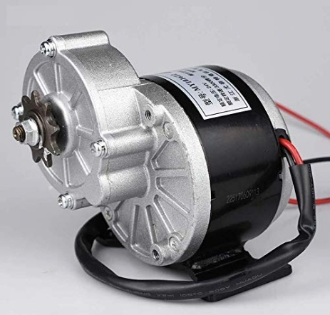

**Fig. 1. DC Motor for rotating the fertilizer metering shaft**

**Table.1 Specifications of DC motor**

|  |  |
| --- | --- |
| **Parameter** | **Description** |
| Name | xcluma |
| Type | Geared |
| Max RPM | 200 |
| Min RPM | 180 |
| Voltage | 12 V |
| Torque | 8.15 kg-cm |

**2.3 PWM DC Voltage Regulator and Auto timer cut off switch**

The PWM (Pulse Width Modulation) DC motor speed can be regulated using DC voltage regulator. The 20A PWM DC motor speed regulator module (100, 80, 60 and 40 %) is suitable for the DC motor. It comes with the metal shell and connective label, which makes it very easy to install and use. It has a potentiometer with an adjust speed switch function, and button switch function. Connection is made when the red and blue wire lines are connected to a tractor battery through auto timer cutoff switch, and black and green lines are connected to theDC Motor as shown in Fig.1.

The auto timer cutoff switch adjustable from 10 sec to 20 minutes with 12V used to operate the DC motor through PWM voltage regulator. Manually set times on a module allow for turning the DC motor on and off, as needed.

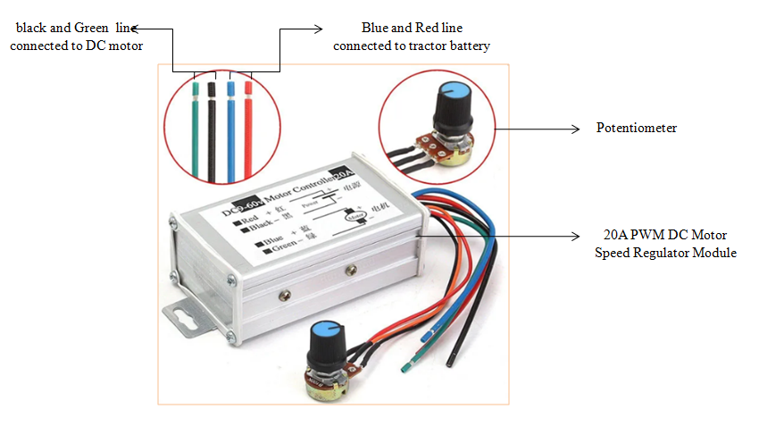

**Fig. 2. PWM DC Voltage regulator**

**2.4 Power Transmission to the Fertilizer Applicator**

The power is transmitted from battery to the fertilizer metering shaft through the DC Voltage regulator and DC motor. The power transmission of fertilizer applicator is shown in Fig.3. The Block Diagram of power transmission to the fertilizer applicator is shown in Fig.4.

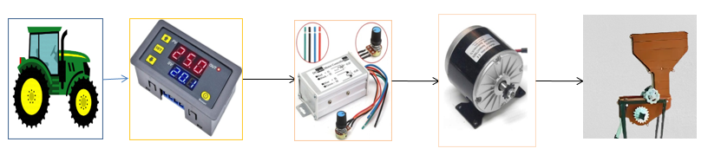

**Fig. 3. Power Transmission to the fertilizer applicator**

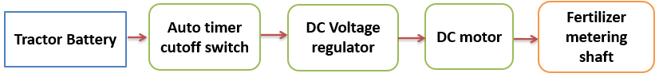

**Fig. 4 Block Diagram of power transmission to the fertilizer applicator**

**2.5 Calibration**

In order to study the effect on fertilizer discharge and variation between the fertilizer tubes of fertilizer metering shaft speed, DC motor speed, DC regulator, and different levels of fertilizer hopper filling, laboratory evaluations were carried out. The developed fertilizer applicator was tested at desired levels of operational parameters to determine the various factors affecting the performance. Based on the results and optimized values, a prototype round basin making cum fertilizer applicator was developed and was evaluated in the field with the optimized operational parameters. The operation of the developed unit was independent of forward speed of the primery mover. The detailed specifications of fertilizer application unit is shown in Table 2. (Tripathi A.K. 2025)

**Table 2 Specifications of Fertilizer application unit**

|  |  |
| --- | --- |
| **Parameters** | **Particulars** |
| Type of planting unit | Vertical rotar cell edge type |
| Volume of fertilizer box | 33750 cm3 |
| Power transmission | DC motor |
| Fertilizer carrying tube | 2 |
| Flow control device | PWM voltage regulator |
| Max Speed of DC motor | 200 rpm |

**2.6 Statistical Analysis**

The data obtained from the experiments of fertilizer applicator were statistically analysed by descriptive statistical analysis method using IBM SPSS 2022 (Statistical Package for Social Sciences) software. The effect of selected equipment parameters effecting the performance of laboratory model as well as final prototype are noted. The analysis of variance (ANOVA), mean tables, lack of fit and interactions between the subjects for different physical, biometric and performance parameters were tabulated and the level of significance was reported. The degree of freedom (df) and R squared values were reported.Different variables considered for optimization of fertilizer applicator shown in Table 3. (Tejaswini, *et al.*2025)

**Table.3 Different variables considered for optimization of fertilizer applicator**

|  |  |  |  |
| --- | --- | --- | --- |
| **S.No** | **Treatment** | **No. of levels** | **Particulars** |
| 1 | PWM DC regulator supplying voltage ( %) | 4 | 100, 80, 60 and 40 % |
| 2 | Metering shaft speed (RPM) | 4 | 80,120,160 and 200 |
| 3 | Level of fertilizer hopper filling | 4 | 1/4,1/2,1/3and hopper full Level |
| No. of replications | | | 3 |
| Total No. of experiments = 4*4*4*3 | | | 192 |

**3. RESULTS AND DISCUSSION**

**3.1 Laboratory Evaluation of Fertilizer Applicator**

The independent variables were selected for testing and optimization of fertilizer applicator. The experiments were carried out in the laboratory to examine the fertilizer delivery rate by keeping equipment stationary. The fertilizer applicator was tested at different fertilizer metering shaft revolutions at 80,120,160 and 200 RPM, and theamount of fertilizer delivered was measured. Measured DC motor speed at different voltages of PWM voltage regulator (i.e. 100, 80, 60 and 40 %). Using auto timer cutoff, switch time was fixed to 30 seconds. After 30 seconds, speed of fertilizer metering shaft was stopped due cutoff switch restrict passes of voltage.

**3.2 The effect of DC Regulator on Fertilizer Metering Shaft**

The speed of fertilizer metering shaft varies based on the DC regulator. The voltage ranges from 100, 80, 60 and 40 %. Average speed of fertilizer metering shaft was calculated and tabulated for different combinations. Based on the experimental results, the speed of the fertilizer metering shaft was recorded at 80 RPM when operating at 40 % of the DC voltage, and 200 RPM at 100 % of the DC voltage, as illustrated in Fig.5.

**Fig.5 The effext of DC regulator voltage on s fertilizer metering shaft speed**

**3.3**  **The fertilizer metering shaft speed and its effect on discharge rate**

The fertilizer discharge rate was influenced by speed of fertilizer metering shaft. The speed of metering shaft was 80, 120, 160 and 200 RPM. Average discharge of fertilizer was calculated and tabulated for different combinations. It was observed that the minimum weight 111.4 g and maximum weight 474 g was obtained at 80 and 200 RPM speed of fertilizer metering shaft respectively. The values were represented in Table 4. The effect of speed of a fertilizer metering shaft on discharge rate is shown in Fig.6.

**Fig.6 The fertilizer metering shaft speed and its effect on discharge rate**

**3.4 The Effect of Fertilizer Discharge Speed on Different Hopper Filling Levels**

The amount of fertilizer collected from two different rows, obtained different fertilizer hopper filling at different metering shaft speeds are shown in Figure 7. It is observed that low weight is obtained at 80 RPM with1/4th of hopper filling i.e., 70 g, and high weight of 500 g was obtained from hopper fully filled at 200 RPM.

**Fig.7 The effect of fertilizer discharge speed on different hopper filling levels**

**3.5 Conclusion from Laboratory Evaluation of Fertilizer Applicator**

From laboratory studies, the overall PWM voltage regulator, fertilizer metering shaft speed, and different hopper filling levels using 2 fertilizer discharge outlets were found satisfactory. Average recommended dose as fertilizers (Anonymous 2018). To grow horticultural crops, the fertilizers used were urea, rock phosphate and muriate of potash. Based on the requirements, the speed of fertilizer metering shaft through DC voltage regulator**.**

Results from laboratory evaluations indicate the performance of all the speeds under various experimental conditions. Operating the PWM voltage regulator at 40% DC voltage capacity, fertilizer metering shaft rotated at a rate of 79.67 RPM equivalent to 80 RPM, with a fertilizer discharge through two delivery tubes per 30 seconds at a rate of 111.74g min-1, with a coefficient of variation of 0.06%. The voltage increases PWM Voltage regulator at 100 % of DC voltage and fertilizer metering shaft will rotate through the DC motor speed of 198.67 RPM equal to 200 RPM with a fertilizer discharge per 30 second in two delivery tubes around 474 g min-1, coefficient of variation of 0.04 % In conclusion, the fertilizer discharge rate increases by increasing the voltage of the PMW voltage regulator, voltage and increasing the fertilizer metering shaft speed. The l fertilizer hopper filling level is also effected by fertilizer discharge rate.

**Table.4. Constrains data of laboratory evaluation of fertilizer applicator**

|  |  |  |  |  |  |  |
| --- | --- | --- | --- | --- | --- | --- |
| **DC Voltage (%)** | **DC Motor Speed RPM** | | | **Fertilizer discharge rate per 30 seconds in two delivery tubes** | | |
|  | **M** | **SD** | **CV** | **M** | **SD** | **CV** |
| **40** | 79.67 | 7.40 | 0.09 | 111.4 | 7.40 | 0.06 |
| **60** | 117.67 | 8.40 | 0.07 | 225 | 11.18 | 0.04 |
| **80** | 157.67 | 9.40 | 0.06 | 323 | 17.88 | 0.05 |
| **100** | 198.67 | 10.40 | 0.05 | 474 | 20.73 | 0.04 |

**CONCLUSION**

The optimal operational parameters, tests were conducted to assess the impact of a round basin maker combined with a fertilizer applicator.

*The results from laboratory evaluations show the metering mechanism performance at different speeds under various experimental conditions.*

The speed of the fertilizer metering shaft is 80 RPM at the PWM voltage regulator at 40% DC voltage capacity, and 200 RPM at PWM voltage regulator at 100 % of the DC voltage capacity respectively. The auto timer cutoff switch adjustable from 10 sec to 20 minutes with 12V used to operate the DC motor through PWM voltage regulator. Manually set times on a module allow for turning the DC motor on and off, as needed.

The maximum fertilizer discharge per 30 seconds time interval in two fertilizer delivery tubes around 474 g per 30 seconds, coefficient of variation of 0.04 %.

In conclusion, the fertilizer discharge rate increases by increasing the voltage of the PMW voltage regulator, voltage and increasing the fertilizer metering shaft speed. The fertilizer hopper filling level is also effected by fertilizer discharge rate.

Disclaimer (Artificial intelligence)

Option 1:

Author(s) hereby declare that NO generative AI technologies such as Large Language Models (ChatGPT, COPILOT, etc.) and text-to-image generators have been used during the writing or editing of this manuscript.

Option 2:

Author(s) hereby declare that generative AI technologies such as Large Language Models, etc. have been used during the writing or editing of manuscripts. This explanation will include the name, version, model, and source of the generative AI technology and as well as all input prompts provided to the generative AI technology

Details of the AI usage are given below:

1.

2.

3.

**References**

Anonymous. 2018. Horticultural statistics at glance 2017, Horticulture Statistics Division, Ministry of Agriculture and Farmers Welfare, Department of Agriculture, Cooperation and Farmers Welfare, Government of India. 9-10.

FAO Corporate Document Repository, Fertilizer Use by Crop in India, 2003. [Online]. Available: <http://www.fao.org/docrep/009/a0257e/a0257e05.htm>.

IS: 6316. 1993. Sowing equipment seed cum fertilizer drill. Indian Standards Institution, New Delhi.

Jafari. M., Hemmat .A, Sadeghi .M. (2010). Development and performance assessment of a DC electric variable-rate controller for use on grain drills. Computers and Electronics in Agriculture 73 (2010) 56–65.

Kalaivani G. and Manohar D.and Jesudas (2019). Performance Evaluation of Projected Seed Cell Vertical Rotor Device for Pelleted Rice. *Madras Agric. J.,*doi:10.29321/MAJ 2019.000285 106 | 4-6 | 420-424.

Krishna, V.S and Mathew, G. 2018. Development of a solar copra dryer incorporated with evacuated tubes. *Int J Curr Microbiol* *App Sci.* 7(6):2457-2465. DOI: 10.20546/ijcmas.2018.706.292.

Krishna, V.S and Pavani, J.2025. Development of a direct type solar dryer for preparation of mango leather. Int. J. Agric. Food Sci. 2025;7(5):173-178. DOI: <https://doi.org/10.33545/2664844X.2025.v7.i5c.393>.

Krishna, V.S, Jain, S.K, Panwar, N.L, Sunil, J and Wadhawan N, K.. 2024. Emergence of internet of things technology in food and agricultural sector: *A review. J Food Process Eng.*47(8).

Olajide, O. G. and Manuwa, S. I. 2014. Design, Fabrication and Testing of a Low-cost Row-Crop Planter for Peasant Farmers. Proceedings of the International Soil Tillage Research Organisation (ISTRO) Nigeria Symposium, Akure 2014 November 3 - 6, Akure, Nigeria, pp. 94–100.

Regatti Venkat.R, Pramod. M and Dharmendra. 2020. Performance Evaluation of Mini Tractor Operated Rotary Weeder Cum Fertilizer Drill. *International Journal of Current Microbiology and Applied Sciences.* 9(09): 2962-2974. doi: <https://doi.org/10.20546/ijcmas.2020.909.365>.

Singh. T. P., Mane D. M. (2011). Development and laboratory performance of an electronically controlled metering mechanism for okra seed. *Agricultural Mechanization in Asia, Africa & Latin America*. 42 (2) 63-69.

Singh.K, Dubey A K, Agrawal.K.N and Chandra, M.P.2012. Development of the controller based seed cum fertilizer drill. 12th international Conference Intellegent system design and applications (ISDA).978 1-4673-5119-5.369-374.

Srinivas, J. and Jayan, P.R. 2021. Fertilizer properties for design of tractor operated coconut basin lister cum fertilizer applicator. *Indian Journal of Ecology*. *48*(3): 818-820.

Tejaswini, V., Ravibabu, G., Kumar, H.V.H, Prasad, BVS. and Sujanirao, Ch. 2025. Water quality assessment in agricultural drains using PCA techniques. *International Journal of Advanced Biochemistry Research.* 9(5): 395-398.

Tripathi AK. 2025. Multi-objective optimization of a hybrid electricity generation system based on waste energy of internal combustion engine and solar system for sustainable environment. Chemosphere. Sep;336:139222.

Vinayak, M., Rahaman, S., Ramana, C. Hari Babu, B. and Madhusudhanareddy, K.2022. Development of tractor mounted FYM spreader. *Indian J. Ecol.,* 49(2): 405-409.