***Original Research Article***

**Effect of Phosphorus Levels and Foliar Application of Boron on Nutrient Content and Uptake in Summer Green gram (*Vigna radiata* L.)**

**Abstract**

~~A field experiment was conducted at Agronomy Research Farm, MJRP College of Agriculture and Research, Achrol, Jaipur, Rajasthan to understand the effect of phosphorus and boron application on enrichment of seed and straw of green gram during March-June, 2022 in FRBD design. Three levels of phosphorus (40, 50 and 60 kg ha~~~~-1~~~~) and 4 foliar applications of boron (0, 0.2% at 20, 0.2% at 35 and 0.2% at both 20 & 35 days after sowing) were applied~~. The results ~~of the study~~ revealed that application of phosphorus and boron have synergistic effect on P and B content in seed and straw of green gram. Highest content of P and B in seed and straw was found when 60 kg ha-1 P along with foliar application of boron at 0.2% at 20 and 35 DAS. Application of P and B also improve protein content but their interaction was found non-significant. The uptake of P and B increases with their successive P and B application level.

**Keywords**: Phosphorous, boron, green gram, ~~FRBD~~, foliar application

**Introduction**

*Vigna radiata* (L.) is commonly called as green gram or mungbean. It is a leguminous crop belongs to family *Leguminosae*. It has special importance for its short duration crop which responds well to added phosphorus (Kaur *et al*., 2023). Among the cultivated pulse crops, green gram is rich source of protein (24.5%), fat (1.3%), minerals (3.5%) and carbohydrates (56.7%). It also provides high quality of some essential amino acids like lysine (460 mg/g N) and tryptophane (60mg/g N). It can provide some of the antioxidant in the form of ascorbic acid when sprouted and also contains riboflavin (0.21 mg/100 gm) (Mekkara nikarthil Sudhakaran and Bukkan, 2021). As it has ability to fix atmospheric nitrogen with the help of root nodules, an adequate phosphorus supply must be satisfied for it, to fix nitrogen in soil (Guan *et al*., 2013). Phosphorus (P) is an essential plant nutrient required for optimum growth and production of crop plants. Plants need phosphorus for growth, utilization of sugar and starch, photosynthesis, nucleus formation and cell division (Atif *et al*., 2014). Whereas, Boron~~’s~~ (B) also plays an important role within the plant includes cell wall synthesis, sugar transport, cell division, differentiation, membrane functioning, root elongation, regulation of plant hormone levels and generative growth of plants (Shireen *et al*., 2018; Vera-Maldonado *et al*., 2024). Phosphorus deficiency causes yield reduction by limiting plant growth (Malhotra *et al*., 2018). It influences nutrient uptake by promoting root growth and nodulation (Sathiyavani *et al*., 2017; Liu *et al*., 2018).

~~Among the cultivated pulse crops, green gram is rich source of protein (24.5%), fat (1.3%), minerals (3.5%) and carbohydrates (56.7%). It also provides high quality of some essential amino acids like lysine (460 mg/g N) and tryptophane (60mg/g N). It can provide some of the antioxidant in the form of ascorbic acid when sprouted and also contains riboflavin (0.21 mg/100 gm) (Mekkara nikarthil Sudhakaran and Bukkan, 2021).~~

The response to a particular nutrient not only depends on its own level but also on the levels of other nutrients present in soil. Interaction occurs when the level of one production factor influences the response to another factor (Satya, 2020, Phogat *et al.*, 2020). These interactions may be synergetic (positive) leading to the increased availability of other plant nutrient or antagonistic (negative) in which availability of other plant nutrient adversely affected (Padbhushan and Kumar, 2015). Therefore, the present study was undertaken to see the interaction effect of P and B on the nutrient content and uptake in summer green gram.

**Materials and Methods**

Field experiment was conducted during summer season (March-June, 2022) at Agronomy farm, College of Agriculture & Research, (Mahatma Jyoti Roa Phoole University) Achrol, Jaipur (Rajasthan). The experimental site is located at 26053’29’’ N latitude, 75046’24’’ E longitude and at an altitude of above mean sea level. The soil of the experimental field was loamy sand in texture having alkaline pH (7.6), low in organic carbon (0.20%) and available nitrogen (127.23 kg ha-1), available phosphorus (18.21 kg ha-1) and available potassium (192.15 kg ha-1) and available sulphur in form of sulphate (8.0 ppm) content. A recommended green gram variety (RMG-268) was taken for the study. The experiment was laid out in Factorial Randomized Block Design (FRBD) with two factor different levels of phosphorus [20:40:20 kg ha-1 (P1), 20:50:20 kg ha-1 (P2), 20:60:20 kg ha-1 (P3)] and boron [no application, 20 & 35 DAS, 0.2 % foliar spray of borax] with twelve treatments combination on a plot size of 3 x 3 m2. Crop was sown in line and covered with the soil. The total quantity of nitrogen, phosphorus and potassium as per treatment in the form of urea, single super phosphate and MOP, respectively were applied below the seeds at the time of sowing. The initial B status was 498 ppm. Boron spray 0.2% solution of borax was prepared and spraying was done at 20, 35 and both 20 & 35 days after sowing. All the agronomic practices were carried out uniformly to raise the crop.

**Results and Discussion**

**Boron content**

The maximum boron content in seed and straw was observed when P was applied @ ~~20~~:60:~~20~~ kg ha-1 (P3) and B @ 0.2% foliar spray of borax at 20 and 35 days after sowing (DAS). The significant increase in boron content of seed and straw was ranges from 51.04 mg kg-1 and 52.72 mg kg-1 boron in control to 58.32 mg kg-1 and 58.91 mg kg-1 boron at P3. Similarly, with increasing level of boron application there was significant increase in boron content in seed and straw in plants from 36.99 to 43.68 mg kg-1 boron in control whereas, highest was observed in B @ 0.2% foliar spray of borax at 20 and 35 days after sowing (DAS) with 67.02 and 64.74 mg kg-1 boron at highest level of applied boron, respectively (Table 1). Our results are in line with the results of Singh *et al*., (2006) who found an increase in available P2O5 decreased the magnitude of B deficiency by 42% when available P2O5 was less than 30 kg ha-1, 38% when P2O5 ranging from 30-40 kg ha-1 and 29% above 40 kg P2O5 ha-1. The results of Kamboj and Malik, 2018 also supported the present study.

**Table 1. Effect of phosphorus and boron application on green gram seed and straw boron content**

|  |  |  |  |  |  |
| --- | --- | --- | --- | --- | --- |
| **Phosphorus levels** | **Boron levels** | | | | **Mean** |
| B1 | B2 | B3 | B4 |
| Boron content (mg kg-1) in Seed | | | | | |
| P1 | 36.12 | 49.61 | 56.27 | 62.18 | 51.04 |
| P2 | 37.21 | 53.72 | 60.52 | 67.01 | 54.61 |
| P3 | 37.65 | 56.57 | 67.18 | 71.89 | 58.32 |
| **Mean** | 36.99 | 53.30 | 61.32 | 67.02 |  |
| SE(m)± | P=0.39 | B=0.45 | PxB=0.78 |  |  |
| CD @ 5% | P=1.15 | B=1.33 | PxB=2.30 |  |  |
| Boron content (mg kg-1) in Straw | | | | | |
| P1 | 43.18 | 51.92 | 55.02 | 60.77 | 52.72 |
| P2 | 43.82 | 55.76 | 58.16 | 64.71 | 55.61 |
| P3 | 44.05 | 57.99 | 64.89 | 68.74 | 58.91 |
| **Mean** | 43.68 | 55.22 | 59.35 | 64.74 |  |
| SE(m)± | P=0.53 | B=0.62 | PxB=1.07 |  |  |
| CD @ 5% | P=1.59 | B=1.83 | PxB=3.18 |  |  |

**Phosphorus content**

The phosphorus (P) content in seed and straw of green gram plants significantly increases with application of graded level of phosphorus (Table 2). The maximum P content was found in P3 0.46% to 0.20% which was significantly higher than control P1 0.34% to 0.12%. Synergistic effect was of boron was also observed with phosphorous application and significantly maximum P content was found in 0.48% and 0.19% in seed and straw, respectively. In control, minimum P content was observed in both seed (0.28%) and straw (0.10%). The interaction was found significant at 5%CD. The present study was supported by the investigation of Kamboj and Malik, 2018 and Malhotra *et al*., 2018 who have showed the synergistic effect of P and B on availability of phosphorus content in plants.

**Table 2. Effect of phosphorus and boron application on green gram seed and straw phosphorus content**

|  |  |  |  |  |  |
| --- | --- | --- | --- | --- | --- |
| **Phosphorus levels** | **Boron levels** | | | | **Mean** |
| B1 | B2 | B3 | B4 |
| Phosphorous content (%) in Seed | | | | | |
| P1 | 0.28 | 0.31 | 0.38 | 0.39 | 0.34 |
| P2 | 0.34 | 0.37 | 0.48 | 0.52 | 0.42 |
| P3 | 0.36 | 0.43 | 0.51 | 0.55 | 0.46 |
| **Mean** | 0.32 | 0.37 | 0.45 | 0.48 |  |
| SE(m)± | P=0.008 | B=0.009 | PxB=0.016 |  |  |
| CD @ 5% | P=0.023 | B=0.027 | PxB=0.035 |  |  |
| Phosphorous content (%) in Straw | | | | | |
| P1 | 0.10 | 0.11 | 0.14 | 0.15 | 0.12 |
| P2 | 0.13 | 0.14 | 0.17 | 0.18 | 0.15 |
| P3 | 0.15 | 0.19 | 0.22 | 0.24 | 0.20 |
| **Mean** | 0.12 | 0.14 | 0.17 | 0.19 |  |
| SE(m)± | P=0.006 | B=0.007 | PxB=0.012 |  |  |
| CD @ 5% | P=0.018 | B=0.020 | PxB=0.036 |  |  |

**Boron uptake**

The data shown in fig. 1 highlighted that the boron uptake in seed increased from 393.18 µg kg-1 in control to 505.29 µg kg-1 when P was applied @ 20:60:20 kg ha-1 (P3). Likewise, with the increasing level of boron application from 0 to 2 foliar spray of borax (0.2%) at 20 and 35 days after sowing (DAS) it was observed that the uptake of boron also increases significantly from 240.17 to 510.51 µg kg-1. Similarly, significantly increase in uptake of boron was also observed in straw with 2872.16 to 3405.96 µg kg-1 when P was applied @ 20:60:20 kg ha-1 (P3) and 2001.12 to 3614.98 µg kg-1 when the increasing level of boron application from 0 to 2 foliar spray of borax (0.2%) at 20 and 35 days after sowing (DAS) (Fig. 1). These results are in line with the results of Kumar *et al*., (2009) who showed the increase in boron uptake up to application of 4 kg B ha-1 and 90 kg P2O5 ha-1 by grain and straw of lentil was noticed. This increase may be the result of increased grain and straw production with the addition B and P which enhance their availability in soil.

**Phosphorus uptake**

The data highlighted in fig. 2 indicated that the significant increase in phosphorous uptake by the green gram plants with the increase in both phosphorous as well as boron application and showed synergistic effect with each other. The highest phosphorous uptake in seed (38332.65 µg kg-1) was noticed when P was applied @ 20:60:20 kg ha-1 (P3) and minimum was observed in P1 (25501.21 µg kg-1) when P was applied @ 20:40:20 kg ha-1. Likewise, with the increasing level of boron application from 0 to 2 foliar spray of borax (0.2%) at 20 and 35 days after sowing (DAS) it was observed that the highest uptake of phosphorous in seed was 36489.22 µg kg-1. Moreover, highest phosphorous uptake was also noticed in straw of green gram plants treated with P3 applied @ 20:60:20 kg ha-1 (P3) with 1388.18 µg kg-1 and minimum was observed in P1 (880.94 kg ha-1). The same trend was observed in case of foliar application of borax (0.2%) at 20 and 35 DAS with 1199.90 kg ha-1. The results of Mallick and Raj (2015), indicated that phosphorus and boron application increased the seed uptake of P in rapseed and this increased in P uptake could be the response of variation in the availability of these nutrients in the soil and partly due to priming effect of one nutrient on the other on the uptake. The results of Rana *et al*. (2005), also supported the present investigation who reported the similar effect of nutrient application. YuFan *et al*. (2012) also observed that B application increased P uptake by plant. The interactive effect of P and B application on P uptake in seed of green gram was found significant.

**Seed protein content**

The crude protein content in seed of green gram increases significantly from 20.81 to 22.35% when P was applied @ 20:60:20 kg ha-1 (P3). Whereas, with the application of boron the crude protein content in seed of green gram increases significantly and maximum was found when B applied with a foliar spray of borax (0.2%) at 35 days after sowing (DAS) *i.e.* 24.93% and after that there was a decrease in crude protein content occur with further addition of boron fertilizer (Table 3). The results of present investigation in line with the outcomes of Deo and Khaldelwal (2009) found that application of P increased the number of nodules per plant of chickpea and protein content in grain. Ganie *et al*. (2014), also reported a significant increase in the crude protein content of French bean with graded level of boron application up to 1 mg B kg-1 which is statistically at par with 1.5 mg B kg-1 application.

**Table 3. Effect of phosphorus and boron application on seed protein content (%) of green gram**

|  |  |  |  |  |  |
| --- | --- | --- | --- | --- | --- |
| **Phosphorus levels** | **Boron levels** | | | | **Mean** |
| B1 | B2 | B3 | B4 |
| P1 | 19.16 | 21.08 | 22.12 | 20.89 | 20.81 |
| P2 | 20.72 | 21.65 | 24.01 | 20.62 | 21.75 |
| P3 | 20.93 | 22.42 | 24.93 | 21.12 | 22.35 |
| **Mean** | 20.27 | 21.71 | 23.68 | 20.87 |  |
| SE(m)± | P=0.27 | B=0.32 | PxB=0.55 |  |  |
| CD @ 5% | P=0.82 | B=0.94 | PxB=NS |  |  |

**Conclusion**

The application of phosphorous at ~~20:~~60~~:20~~ kg ha-1 along with the two foliar sprays of boron at 0.2% increases the nutrient content and uptake in the seed as well as straw which ultimately increases the production and productivity of green gram.

**References:**

Atif, M.J., Shaukat, S.A., Shah, S.Z.A., Choudhary, Y.A. and Shaukat, S.K. (2014) Effect of different levels of phosphorus on growth and productivity of pea (*Pisum sativum* L.) cultivars grown as offseason under rawalakot azad Jammu and Kashmir conditions. *Journal of Recent Advances in Agriculture*, 2: 252-257.

Deo, C. and Khaldelwal, R.B. (2009). Effect of P and S Nutrition on yield and quality of chickpea (Cicer arietinum L.). *Journal of the Indian Society of Soil Science*, 57: 352- 356.

Ganie Mumtaz, A., Akhter, F., Bhat, M.A. and Najar, G.R. (2014). Growth, yield and quality of French bean (*Phaseolus vulgaris* L.) as influenced by sulphur and boron application on inceptisols of Kashmir. *The Bioscan*, 9: 513-518.

Guan, S. H., Gris, C., Cruveiller, S., Pouzet, C., Tasse, L., Leru, A., Maillard, A., Medigue, C., Batut, J., Masson-Boivin, C. and Capela, D. (2013). Experimental evolution of nodule intracellular infection in legume symbionts. *The International Society for Microbial Ecology Journal*, 7(7): 1367-1377.

Jyothika, V., Dawson, J. and Krishna, C. V. (2023). Response of boron and biofertilizers on growth and yield of summer blackgram (*Vigna mungo* L.). *International Journal of Environment and Climate Change*, 13(4): 148-155.

Kamboj, N. and Malik, R. S. (2018). Influence of phosphorus and boron application on yield, quality, nutrientn content and their uptake by green gram (*Vigna radiate* L.). *International Journal of Current Microbiology and Applied Sciences*, 7(3): 1451-1458.

Kaur, M., Verma, R., Gupta, P. K. and Kushwaha, K. P. S. (2023). Forecasting models for forewarning anthracnose and web blight of mung bean (*Vigna radiata*) under Tarai Zone of Uttarakhand. *Journal of Agrometeorology*, 25(2): 320-325.

Kumar, S., Singh, V. and Solanki, V.P.S. (2009). Effect of boron and phosphorus application on yield and uptake of nutrients in lentil. *Annals of Agricultural Research New Series,* 30: 108-110.

Liu, A., Contador, C. A., Fan, K. and Lam, H. M. (2018). Interaction and regulation of carbon, nitrogen, and phosphorus metabolisms in root nodules of legumes. *Frontiers in Plant Science*, 9: 1860.

Malhotra, H., Vandana, Sharma, S. and Pandey, R. (2018). Phosphorus nutrition: plant growth in response to deficiency and excess. *Plant Nutrients and Abiotic Stress Tolerance*, 171-190.

Mallick, R.B. and Raj, A. (2015). Influence of phosphorus, sulphur and boron on growth, yield, nutrient uptake and economics of rapeseed (brassica campestris L. var. yellow sarson). *International Journal of Plant, Animal and Environmental Sciences*, 5: 22-27.

Mekkara nikarthil Sudhakaran, S. and Bukkan, D. S. (2021). A review on nutritional composition, antinutritional components and health benefits of green gram (*Vigna radiata* (L.) Wilczek). *Journal of Food Biochemistry*, 45(6): e13743.

Padbhushan, R. and Kumar, D. (2015). Yield and nutrient uptake of green gram (*Vigna radiata* L.) as influenced by boron application in boron-deficient calcareous soils of Punjab. *Communications in soil science and plant analysis*, 46(7): 908-923.

Phogat, M., Rai, A. P. and Kumar, S. (2020). Interaction effect of phosphorus and sulphur application on nutrient uptake, yield and yield attributing parameters of black gram [*Vigna mungo* (L.) Hepper]. *Legume Research-An International Journal*, 43(2): 212-220.

Rana, K.S., Rana, D.S. and Gautam, R.C. (2005). Influence of phosphorus, sulphur and boron on growth, yield, nutrient uptake and economics of Indian mustard (*Brassica juncea*) under rainfed conditions. *Indian Journal of Agronomy*, 50: 314-316.

Sathiyavani, E., Prabaharan, N. K. and Surendar, K. K. (2017). Role of mineral nutrition on root growth of crop plants–a review. *International Journal of Current Microbiology and Applied Sciences*, 6(4): 2810-2837.

Satya, M. S. (2020). Response of black gram (Vigna mungo L. Hepper) to phosphorus and boron fertilization in acidic soil of Meghalaya. *International Journal of Community Service*, 8(4): 3344-3348.

Shireen, F., Nawaz, M. A., Chen, C., Zhang, Q., Zheng, Z., Sohail, H. and Bie, Z. (2018). Boron: functions and approaches to enhance its availability in plants for sustainable agriculture. *International journal of molecular sciences*, 19(7): 1856.

Singh, A P., Singh, M.V., Sakal, R. and Choudhary, K. (2006). Boron nutrition of crops and soils of Bihar, IISS, Bhopal, RAU, Pusa, Bihar. Technical Bull. 9: 1-70

Vera-Maldonado, P., Aquea, F., Reyes-Díaz, M., Cárcamo-Fincheira, P., Soto-Cerda, B., Nunes-Nesi, A. and Inostroza-Blancheteau, C. (2024). Role of boron and its interaction with other elements in plants. *Frontiers in Plant Science*, 15: 1332459.

YuFan, H., LongBin, H., XiaoLong, Y. and Hong, L. (2012) Effects of phosphorus and boron coupled deficiency on soybean growth, phosphorus, boron uptake and the genetic variations. *Journal of South China Agricultural University*,33: 129-134.

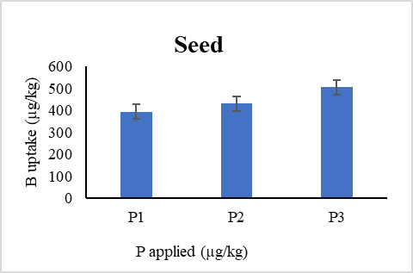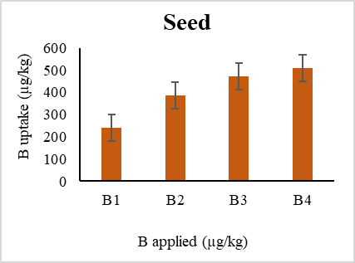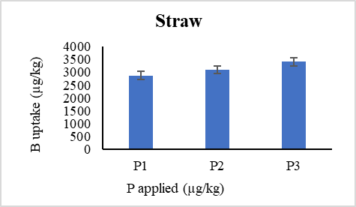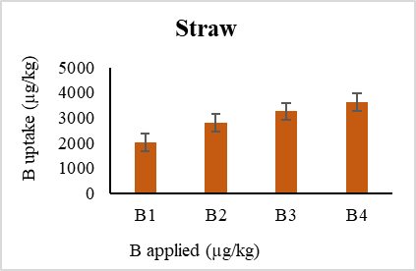

Fig. 1. Effect of phosphorous application on green gram seed and straw boron uptake

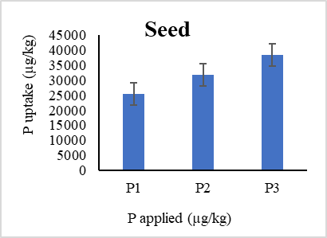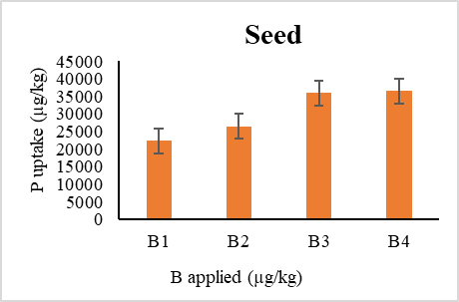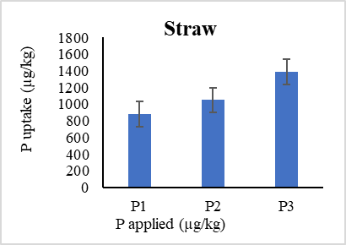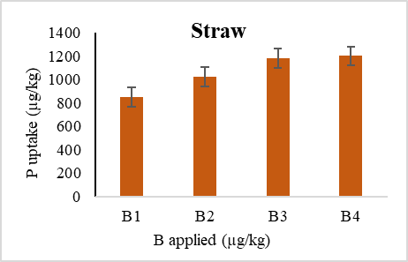

Fig. 2 Effect of phosphorous application on green gram seed and straw phosphorous uptake