Short communication

Reconstruction of the Cultivation Model for Mechanical Professional Degree Postgraduates Oriented Toward a Manufacturing Powerhouse

.

ABSTRACT

|  |
| --- |
| Under the backdrop of the Manufacturing Powerhouse Strategy and the Emerging Engineering Education Initiative, the cultivation of mechanical professional degree postgraduates must address issues such as excessive academic orientation, weak practical teaching, and insufficient industry-academia collaboration. This paper proposes a new model centered on practical innovation, with academic and industrial supervisors as dual cores, termed "One Core, Dual Centers." The model is built on systematic analysis of mechanical professional postgraduate education issues. The model was developed through a systematic four-phase process: diagnosis of prevailing issues in mechanical engineering education, framework design centered on practical innovation with academic-industrial dual supervision, decomposition into five measurable competency domains, and implementation of supporting mechanisms. This problem-driven model achieves deep industry-academia integration through its competency-outcome focus and systematic architecture. This model forms a closed-loop from problem diagnosis to solution design, emphasizing the practical and applied nature of professional degree education. The model emphasizes the cultivation of students' knowledge application, communication, project summarization, innovative development, and project cycle management abilities through multi-dimensional guidance. By optimizing the curriculum system, strengthening industry-education integration, and refining evaluation mechanisms, it aims to align mechanical professional degree postgraduate education with the demands of the smart manufacturing industry. The goal is to produce interdisciplinary, system-integrated, and innovative engineering talents to support the construction of a manufacturing powerhouse. |

*Keywords: Manufacturing Powerhouse; Mechanical Professional Degree; Comprehensive Literacy; Cultivation Mode.*

1. INTRODUCTION

With the advancement of internet technologies in the era of artificial intelligence and big data, the digital and intelligent transformation of manufacturing is essential for China's shift from low-end to high-end production. With the development of China's manufacturing industry, the shortage of talents has become a key bottleneck hindering high-quality development (Liu et al.,2025). Against the backdrop of profound global industrial changes, China's "Manufacturing Powerhouse" strategy positions the Emerging Engineering Education Initiative as a key breakthrough in higher education reform (Shen et al., 2020; Gumaelius et al., 2024; Dan et al., 2025). Building an engineering education system tailored to future industrial needs and cultivating interdisciplinary talents with outstanding engineering practice capabilities, systemic innovation thinking, and global competitiveness has become a pivotal pathway for implementing the national innovation-driven development strategy.

In the new era, supporting the growth of high-quality productive forces through skilled talent services holds significant importance: it fosters an innovation-driven environment conducive to the development of advanced productive forces; optimizes the allocation of productive resources, thereby providing the momentum needed for sustainable growth; promotes ecological development in alignment with the goals of high-quality development; and drives industrial upgrading, strengthening the foundation for long-term progress (HUANG Xiao-Tong et al., 2025). As a concentrated reflection of a nation's technological and comprehensive strength, the development level of mechanical engineering significantly influences China's transition from a manufacturing giant to a manufacturing and innovation powerhouse.

As the highest level of higher education, postgraduate education plays a strategic role in cultivating innovative talents, enhancing scientific and technological innovation capabilities, and advancing national governance modernization. Postgraduate education exerts a profound impact on national development through its three core mechanisms: the cultivation of innovative talent, knowledge production and transformation, and institutional governance support. Therefore, the cultivation program for mechanical professional degree postgraduates should align with the trends of mechanical discipline development and the demands of the national Manufacturing Powerhouse Strategy, constructing a "frontier-oriented, industry-driven, competency-based" cultivation system to ensure synchronization between talent cultivation and modernization efforts. To implement the reform requirements of postgraduate education in the new era and improve the quality of mechanical professional degree postgraduates, the fundamental task of fostering virtue through education must be upheld, with practical innovation as the core and academic and industrial supervisors as dual centers. This "One Core, Dual Centers" approach establishes a teacher-student interactive mechanism to motivate learning, focusing on developing students' research and development capabilities as well as engineering practice skills. This will drive comprehensive reform research and practice in mechanical professional degree postgraduate education under the "Manufacturing Powerhouse" context.

2. Current Status of Mechanical Professional Degree Postgraduate Education

With the continuous development of China's higher education, the Emerging Engineering Education Initiative has placed newer and higher demands on the cultivation of technical talents in the mechanical field. It calls for cultivating innovative and practical talents with strong competitiveness to support future emerging industries. Guided by the Ministry of Education's work priorities, China's postgraduate education is steadfastly pursuing high-quality development (Yang Sa,2022). In recent years, the scale of postgraduate education has experienced significant expansion, with tens of thousands of graduates from higher education institutions across the country entering the workforce annually, thereby providing robust support for national development (Yang Jing et al., 2025). Research and discussion on the cultivation model for mechanical professional degree postgraduates are effective ways for higher education to contribute to China's transition to a manufacturing powerhouse. They are also effective means to cultivate high-quality, high-competency, and interdisciplinary talents who can quickly integrate into enterprises, enhance independent innovation capabilities, and position enterprises as true subjects of technological innovation. This constitutes an essential part of China's engineering education.

China's mechanical postgraduate education is anchored in strategic requirements such as global technological frontiers, economic main battlefield, and major national needs. By dynamically optimizing the high-level talent cultivation system, it aims to cultivate strategic talents that meet the demands of the times and national development, effectively supporting the construction of an innovative nation and high-quality economic and social development. As the talent cultivation scale expands, the disciplinary and professional system with Chinese characteristics has also been continuously refined. Universities nationwide have adopted diversified and multi-directional cultivation models for mechanical professional degree postgraduates, providing strong talent support for technological R&D and application in manufacturing enterprises. Against the strategic backdrop of transitioning from a manufacturing giant to a manufacturing powerhouse, there is a significant demand for professional technical talents in related fields, making the cultivation of mechanical professional degree postgraduates critically important. Current pedagogical approaches for mechanical engineering postgraduates in China manifest three salient issues: (1) pronounced academic drift in degree theses, (2) fragmented implementation of practice-oriented instruction, and (3) underdeveloped industry-academia collaborative cultivation mechanisms. These core challenges are systematically illustrated in Fig 1.

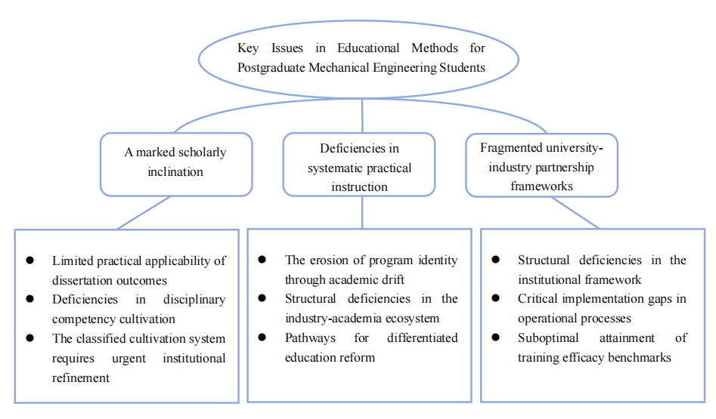

**Fig. 1. The key issues in educational methods for postgraduate mechanical engineering students**

In the cultivation process of mechanical professional degree postgraduates, the model must adapt to the characteristics of the times and evolve to meet national needs. However, the current cultivation approach in China faces the following shortcomings:

(1) Overemphasis on Academic Orientation in Theses:

Currently, the theses of mechanical professional degree postgraduates exhibit weak relevance to engineering practice, with topics insufficiently linked to real-world applications. This is a practical issue requiring attention in China's higher engineering education. The phenomenon stems from multiple underlying causes that need objective analysis. From the perspective of cultivation entities, mechanical professional degree postgraduates in universities nationwide generally lack sufficient engineering practical experience. Students have limited opportunities to engage in engineering practical activities, hindering the development of their innovative and practical capabilities. Simultaneously, theses for mechanical engineering degrees exhibit a significant academic trend that is less than optimal (Zheng Shiliang et al.,2019). Few topics originate directly from enterprise needs, and the conversion rate of research outcomes is low, reflecting a disconnect between talent cultivation and engineering practice. In terms of cultivation mechanisms, the current postgraduate evaluation system remains overly academic and monolithic. Thesis evaluation criteria overemphasize theoretical innovation and academic publications, while undervaluing engineering application significance.

Cultivation institutions should strengthen research and deployment on the classification of academic and professional degree postgraduate education, improving the differentiated development system to reduce the academic tendency of mechanical professional degree postgraduates.

(2) Unsystematic Practical Teaching:

China's postgraduate education focuses heavily on academic structures, with professional degree education increasingly resembling academic programs. Shortcomings exist in course design and assessment methods (Friesen et al.,2021). The curriculum for mechanical professional degree postgraduates remains dominated by traditional theoretical courses, while practical courses demanded by industries, such as smart manufacturing, industrial robotics, and digital twins, are underrepresented. External supervisors and joint cultivation bases should be treated as essential conditions for cultivating mechanical professional degree postgraduates. Strengthening ties with engineering enterprises and fostering students' innovative and practical abilities are crucial. The curriculum system should be optimized to enhance digital competency, incorporating real-world enterprise cases to cultivate practical application skills (Wang et al. ,2023).

The joint graduate cultivation model between enterprises and universities has demonstrated significant advantages in scientific research innovation and talent development. Take the collaboration between Tsinghua University and China Aerospace Science and Industry Corporation as an example. Joint cultivation has shortened the R&D cycle of key rocket engine components from 18 months to 12 months, improving efficiency by 33%; the patent conversion rate has increased from 30% to 65%, a growth of 117%; and the onboarding adaptation period for graduates has been reduced from 6 months to 3 months. Additionally, the targeted employment rate of joint-cultivated students (80%) far exceeds that of ordinary master's students (40%), and 85% of the students are evaluated by enterprises to have the ability to solve problems independently. The joint graduate cultivation project between Zhejiang University and Geely Automobile, through deep integration of industry and education, has reduced the welding time for a single vehicle body by industrial robots from 120 seconds to 90 seconds after trajectory optimization, increasing production efficiency by 25%; the application of the digital twin system has improved the fault prediction accuracy from 83% to 95%, reducing annual downtime losses by 8 million yuan. In terms of talent cultivation, participants in the program obtained an average of 2+ smart manufacturing-related certifications – representing a 55% increase compared to conventional training models. Additionally, their onboarding adaptation period at Geely was reduced by 40%.

(3) Underdeveloped Industry-Academia Collaborative Cultivation Mechanism:

Joint industry-academia cultivation is an effective way to enhance innovative practical abilities. However, the current training system for postgraduate students majoring in applied machinery has obvious flaws (Zhao et al.,2024). In organizational management, over half of collaboration agreements fail to clarify intellectual property ownership, leading to ambiguous responsibility delineation. In operational safeguards, only a few universities have established dedicated cultivation funds, and over half of industrial supervisors lack systematic training, compromising guidance quality. In quality monitoring, most projects lack mid-term evaluation systems, and assessments still over-rely on academic papers. These institutional shortcomings result in opaque enterprise demands, delayed university responses, and superficial student involvement, leading to a significant gap between cultivation outcomes and expected goals. Only a small fraction of students can genuinely address complex engineering problems, failing to ensure the quality of applied talent cultivation.

Therefore, to cultivate mechanical professional technical talents for a manufacturing powerhouse, it is essential to recognize the specificity of professional degree postgraduate cultivation, strengthen the classification of academic and professional degree education, reduce the academic tendency of mechanical professional degree postgraduates, enhance practical teaching, and cultivate high-level talents meeting enterprise innovation needs. Developing students' innovative practical abilities and core competitiveness, while refining the industry-academia collaborative cultivation mechanism, will explore new cultivation models under the Emerging Engineering Education Initiative, producing interdisciplinary engineering talents aligned with industrial demands. The solutions proposed for the main problems existing in the current education methods of postgraduate students majoring in mechanical engineering in our country are shown in Table 1.

**Table 1. The solutions proposed for the main problems existing at the present stage**

|  |  |
| --- | --- |
| **The issues manifest**  **at three distinct**  **levels** | **Solution** |
| A marked scholarly inclination | * Implement an engineering-application-oriented differentiated assessment framework; * Operationalize an industry-embedded thesis topic selection framework; * Implement standardized enterprise-academia co-guidance protocols; * Supporting measures such as school-enterprise joint laboratories and special funds for engineering practice |
| Deficiencies in systematic practical instruction | * Implement a tri-phase progressive practical pedagogy comprising:   Foundational competency training (campus laboratories);  Domain-specific skill development (industry-embedded workstations);  Integrated engineering application (authentic enterprise projects)   * Construct standardized practice course packages featuring; * Establish a quality monitoring platform for practical teaching to enable comprehensive digital evaluation across the entire process.; * Integrate resources within and beyond the school to create a systematic practical teaching chain spanning the entire training cycle; |
| Fragmented university-industry partnership frameworks | * Establish a school-enterprise joint management committee to clarify the rights and responsibilities of both parties and the ownership of intellectual property rights; * Design modularized courses rooted in real engineering projects, with enterprises actively engaged in the development of talent cultivation plans and course evaluations; * Collaboratively construct a teaching team with dual qualifications and institute the qualification certification system for enterprise mentors. |

3. results and discussion

**3.1 Practical Innovation Talent Cultivation Model**

In the rapidly evolving manufacturing era, the cultivation of mechanical professional degree postgraduates should align with contemporary characteristics and demands, producing technically oriented high-end talents needed by enterprises to support China's modernization as a powerhouse. Driven by a new global wave of technological revolution, mechanical engineering education is transitioning from traditional "mechanical manufacturing" to "smart system integration," requiring the cultivation of new engineering talents with interdisciplinary vision, digital competency, and innovative thinking. Centered on practical innovation and supported by academic and industrial supervisors as dual cores, the "One Core, Dual Centers" model cultivates students' knowledge application, communication, project summarization, innovative development, and project cycle management abilities through multi-dimensional guidance.

This study establishes a three-dimensional analytical framework to systematically deconstruct the core components of mechanical engineering professional degree graduate education systems. With in the "Educational Model" dimension, the analysis focuses on:

(1) Structural characteristics of curriculum systems (theory-practice credit ratio, interdisciplinary course proportion);

(2) Implementation pathways of practical training (duration of industrial internships, types of engineering training platforms);

(3) Operational mechanisms of the mentorship system (dual-supervisor ratio, university-industry collaboration modalities).

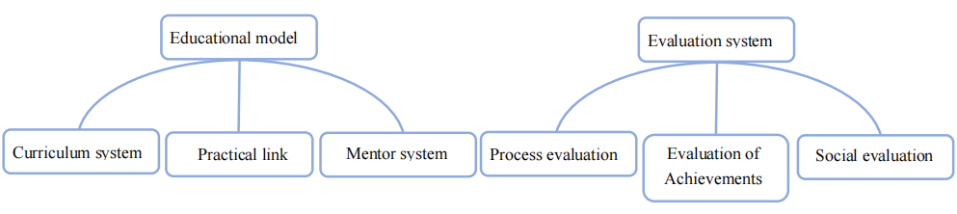

**Fig. 2. Analysis dimension**

To meet the strategic demands of a manufacturing powerhouse, mechanical professional degree postgraduates should possess the following core competencies.

**3.2 Professional Competency Literacy**

The cultivation of professional competency literacy for high-level mechanical professional degree talents should focus on two core dimensions: advanced manufacturing technology capability and system integration capability. In advanced manufacturing technology, postgraduates must master cutting-edge technologies in smart and green manufacturing, including digital twin modeling and application, data collection and analysis on industrial internet platforms, and green manufacturing technologies like lightweight design and low-carbon processes. Additionally, they should be proficient in modern industrial software tools (e.g., CAE/CAM/PLM) to translate theoretical knowledge into practical engineering solutions. In system integration, interdisciplinary system thinking and engineering practice skills are essential. Mechanical professional degree talents should integrate mechanical, electronic, and information technologies, leading the entire process of smart production line integration from planning to validation. This requires industry-education deep integration through practical training in real-world projects to solve complex engineering problems.

These two dimensions form the foundation of core talents for a manufacturing powerhouse, necessitating systematic reforms in curriculum restructuring, practical platform construction, and evaluation mechanisms to cultivate high-level talents with professional competency literacy.

**3.3 Engineering Practice Literacy**

Engineering practice literacy is a core element in cultivating mechanical professional degree postgraduates, requiring systematic training systems and practical platforms. It encompasses three dimensions:

(1) Complex problem-solving: Mastery of methodologies like TRIZ for full-process problem diagnosis and solution implementation.

(2) Lifecycle management: Familiarity with product R&D, manufacturing, maintenance, and recycling, with systematic thinking for quality-cost-efficiency optimization.

(3) Standardization awareness: Proficiency in applying international standards (e.g., ISO).

Implementation should be enterprise demand-driven, using project-based and virtual-real combined training methods with step-by-step cultivation. Evaluation must emphasize engineering effectiveness, adopting multi-dimensional metrics balancing process and outcomes. The goal is to cultivate applied engineering talents mastering modern methods, system thinking, and standards to address real manufacturing challenges, aligning with the "China Manufacturing 2025" strategy through multi-stakeholder collaboration.

**3.4 Innovation and Digital Literacy**

Innovation and digital literacy are critical for mechanical professional degree postgraduates to adapt to smart manufacturing. Core capabilities include:

(1) Innovation: Mastery from ideation to prototyping.

(2) Digital technology: Proficiency in industrial software, data analytics, and smart algorithms.

(3) System integration: Applying digital twins to reduce energy consumption and costs.

Implementation should align with industrial digital transformation, adopting the "One Core, Dual Centers, Five Competencies" model with end-to-end cultivation from foundational training to outcome translation. Evaluation should emphasize value creation, using patents and technology transfer as metrics. The aim is to cultivate talents adept in digital tech, innovation, and system integration to drive smart manufacturing, requiring deep synergy across education, innovation, and industry chains.

Cultivation methods include ethics case libraries, management simulations, and step-by-step paths from coursework to enterprise projects. The goal is to cultivate practical innovation-driven talents with dual supervisor guidance, leveraging the "One Core, Dual Centers " model to produce applied mechanical professionals with comprehensive competencies.

4. Opportunities and Challenges

Under the dual drivers of the Manufacturing Powerhouse Strategy and high-quality higher education policies, mechanical professional degree postgraduate cultivation faces unprecedented opportunities and transformation challenges. Policy-wise, "China Manufacturing 2025" and the Emerging Engineering Education Guidelines provide clear direction. The MOE's "Outstanding Engineers 2.0" plan invests over ¥2 billion annually in joint cultivation bases for smart manufacturing.

Industrial demands exhibit three trends:

(1) Digital transformation reshaping talent needs, creating multi-level interdisciplinary gaps.

(2) Regional clusters emphasizing localized cultivation (e.g., Yangtze River Delta Smart Manufacturing Zone partnering with 28 universities).

(3) Industry 4.0 acceleration causing rapid technological iteration, challenging cultivation content updates. Current trends characterized by rapid technological advancements, knowledge obsolescence, and skill degradation stand in stark contrast to traditional systems that evolve at a slower pace—namely, gradual curriculum updates, textbook revisions, and equipment enhancements. Only synchronized or ahead content update mechanisms can ensure education supports manufacturing powerhouse goals.

5. Conclusion

Under the Manufacturing Powerhouse vision, integrating Emerging Engineering Education concepts into talent cultivation necessitates reconstructing the mechanical professional degree postgraduate model. The "One Core, Dual Centers, Five Competencies" model emphasizes practical innovation, dual supervisory guidance, and the development of research and engineering skills. This approach aims to cultivate high-level talents suited for the new era.

Consent (where ever applicable)

Authors have declared that the content does not involve any issues of medical ethics.

Ethical approval (where ever applicable)

Authors have declared that they do not involve morality Ethical issues.

Disclaimer (Artificial intelligence)

Authors hereby declare that NO generative AI technologies such as Large Language Models (ChatGPT, COPILOT, etc.) and text-to-image generators have been used during the writing or editing of this manuscript.

References

Liu, Y., Li, L., & Liang, L. (2025). Skills Shortages in the Chinese Manufacturing Sector. In The Future of Work in the Asia Pacific (pp. 116-131). Routledge.

Shen, J., Li, T., & Wu, M. (2020). The new engineering education in China. *Procedia Computer Science*, *172*, 886-895.

Gumaelius, L., Skogh, I. B., Matthíasdóttir, Á., & Pantzos, P. (2024). Engineering education in change. A case study on the impact of digital transformation on content and teaching methods in different engineering disciplines. *European Journal of Engineering Education*, *49*(1), 70-93.

Dan, Z., Samuel, M., & Tan, S. Y. (2025). Emerging Engineering Education in China: A Systematic Literature Review. *International Journal of Engineering Pedagogy*, *15*(2).

HUANG Xiao-Tong, & CHEN Jing-Yi. (2025). The Development of High-Quality Productive Forces Driven by Skilled Talent: Significance, Challenges, and Pathways for Advancement. Journal of Yangtze Normal University, 41(1), 57–65. <https://doi.org/10.19933/j.cnki.ISSN1674-3652.2025.01.007>

Yang Sa. (2022). The past decade of graduate education: Breakthrough in scale and deepening of training mechanisms. Guangming Daily. <https://news.gmw.cn/2022-06/15/content_35810787.htm>

Yang Jing, & Zhang Wenying, & Wang Kai. (2025). Exploration of the training model for mechanical engineering graduate students under industry-education integration——A case study of Xi'an university of technology. Heilongjiang Education (Theory & Practice),79(1), 12-16.

Zheng Shiliang, & Li Dan. (2019). Academic drift in professional degree graduate education: Manifestations, causes, and governance. Graduate Education Research, (6), 54-59.

Friesen, S., & Jacobsen, M. (2021). Collaborative Design of Professional Graduate Programs in Education. International Journal of Designs for Learning, 12(1), 64-76.

Wang, M., & Zhou, C. (2023). How does graduate training promote sustainable development of higher education: evidence from China’s “double first-class” universities’ programs. Sustainability, 15(2), 944.

Zhao, X., Wang, L., & Chen, L. (2024, February). Industry and Education Integration for Chinese University of Applied Science and Technology, Based on the Triple Helix Theory. In 3rd International Conference on Education, Language and Art (ICELA 2023) (pp. 316-328). Atlantis Press.