Impact of Eurycoma longifolia (Physta®) on Gut Microbiome Composition: A Case Study Using Precision Microbiome Profiling

ABSTRACT
The gut microbiome plays a critical role in maintaining human health particularly via the gut-brain axis by regulating metabolic, immune and neuroendocrine functions. The supplementation of pro and prebiotics along with certain nutrition may benefit gut microbial diversity. Early clinical research of Eurycoma longifolia supplementation demonstrated physical and mental benefits. Subsequently, animal studies demonstrated improvement in gut of a single gut microbe accompanied with improvement in stress and sleep among farmed livestock. This preliminary case study aimed to investigate the effect of a standardized water extract of Eurycoma longifolia (Physta®) supplementation on gut microbiome composition using qPCR-based Precision Microbiome Profiling (PMP™) technology. The PMP™ quantifies 108 bacteria species categorized into five groups ie: Short-Chain Fatty Acid (SCFA)-producing bacteria, Firmicutes-to-Bacteroidetes ratio, Bifidobacteria and Lactobacilli, pathogenic bacteria, including Proteobacteria and was recorded pre and post- intervention. The supplementation of Physta® demonstrated improvements in diversity and Bifidobacteria and Lactobacilli and SCFA producing bacteriaFaecalibacterium prausnitzii while reducing pathogenic microbe Proteobacteria. The supplentation of Physta® may be beneficial for gut health with a potential of managing dysbiosis-related conditions and should be evaluated in a larger population.
Keywords: Eurycoma longifolia, microbiome, gut, pro and prebiotics
1. INTRODUCTION
The gut microbiome, a complex community of trillions of microorganisms, plays a critical role in maintaining human health by regulating metabolic, immune, and neuroendocrine functions. This intricate microbial ecosystem influences physiological processes such as digestion, nutrient absorption, immune modulation, and communication along the gut-brain axis. Emerging research underscores the importance of microbial diversity and the production of short-chain fatty acids (SCFAs) in maintaining gut homeostasis and overall health [1,2]. As such the supplementation of pro and prebiotics has far reach benefits in human health [3].
Kuroki et al. [4] demonstrated the beneficial effects of Physta®, a standardized water extract of Eurycoma longifolia, on the gut microbiota of pigs, indicating its’ potential in enhancing microbial diversity and reducing stress. Given that microbial diversity, often assessed through richness and evenness, is a critical indicator of gut health in humans, the use of Physta® may exert similar positive effects on human gut health. Reduced microbial diversity is consistently associated with gut dysbiosis, a condition linked to metabolic disorders such as obesity, type 2 diabetes, and cardiovascular diseases, as well as inflammatory conditions like inflammatory bowel disease (IBD) [5,6]. Conversely, increased microbial diversity is associated with enhanced resilience to pathogenic invasions, improved immune function, and favorable metabolic outcomes.
Short chain fatty acids (SCFA), including acetate, propionate, and butyrate, are vital metabolites produced by gut bacteria through the fermentation of dietary fibers. Key SCFA-producing microbial species, such as Faecalibacterium prausnitzii and Roseburia inulinivorans, contribute to gut barrier integrity, immune modulation, and inflammatory regulation. SCFAs also mediate gut-brain axis communication, influencing brain function and behavior through neuro-immunoendocrine pathways [2,6]. The gut microbiota plays an important role in the various stages of a a woman’s life from childhood right up to menopause. The study of the gut microbiota may be useful in the treatment of autoimmune disease which appear to plague the female population more than males, and metabolic diseases [7].
This study serves as a preliminary investigation into the effects of Physta®, a standardized water extract of Eurycoma longifolia (Tongkat Ali), on the female gut microbiome.. This case study aimed to investigate the effect of Physta® supplementation on gut microbiome composition in a healthy female adult using Precision Microbiome Profiling (PMP™) [8].

2. MATERIAL AND METHODS
2.1 Gut Microbiota Analysis
Subject was a 55 years old healthy female who was required to consume 100 mg standardized water extract of Eurycoma longifolia trademarked as Physta® after meals for 30 days. Physta® is standardized to contain 0.8–1.5% eurycomanone, no less than 22% total protein, no less than 30% total polysaccharide, and no less than 40% glycosaponin. It is available in a capsule form whereby the product is registered with the Ministry of Health Malaysia with the registration number MAL09051452T.
Stool collection was done prior and post treatment. Stool collection, DNA extraction, and microbiome analysis were conducted following previously established protocols [8,9]. Briefly, stool samples were collected on filter papers at the study center and subsequently shipped to Bio-Me (Oslo, Norway) for analysis.Three 6 mm discs were excised from each filter card and placed into designated wells of MagMAX™ 96 Deep Well Plates (Thermo Fisher Scientific, Waltham, USA). Microbial cell walls were lysed through bead-beating, and DNA was extracted using the Microbiome MagMAX Ultra Kit (Thermo Fisher Scientific) according to the manufacturer’s protocol on the KingFisher™ Flex platform (Thermo Fisher Scientific). DNA concentration was quantified using the Quant-iT™ PicoGreen™ dsDNA Reagent (Thermo Fisher Scientific).
Microbiome composition was subsequently assessed using a validated quantitative polymerase chain reaction (qPCR) approach, Bio-Me’s Precision Microbiome Profiling (PMP™), which utilizes TaqMan™ technology in an OpenArray® format (Thermo Fisher Scientific). This method targets 108 well-characterized taxa representative of the human gut microbiome categorized into 4 groups ie: SCFA-producing bacteria, Firmicutes-to-Bacteroidetes ratio, Bifidobacteria and Lactobacilli and pathogenic bacteria including Proteobacteria. Standard curves for qPCR assays were generated using reference materials quantified via fluorescence (Quant-iT™ PicoGreen™ dsDNA Reagent, Thermo Fisher Scientific). The absolute quantification of each target, expressed as the number of genomic copies per microliter (µL), was interpolated from the standard curves and subsequently normalized to the total DNA concentration of each sample, resulting in a standardized absolute quantification (number of genomic copies per nanogram of purified DNA). All assays were subjected to in silico and in vitro validation to confirm specificity and sensitivity, as well as in vitro assessment for dynamic range and standard curve precision.

2.2 Diversity Metrics and Quantification of Target Bacteria Group
The analysis was performed for two major endpoints: bacterial diversity and the quantification of target bacterial groups. The diversity was evaluated using richness and Shannon Index. Richness (number of detected species) and evenness (distribution of bacterial quantities) were analyzed as indicators of microbial diversity. Richness reflects the fraction of species detected above the threshold, while evenness, measured by the Shannon index, represents the uniformity of species distribution. Higher diversity generally indicates a robust microbiome associated with improved health outcomes, assuming pathogenic microorganisms are not contributing to this diversity [10].
The total sum of measured quantities within each target bacteria group, was recorded. The ratio of their respective sums between two bacterial groups was plotted ,. Additionally, the measured quantities for each bacterial group were presented. Bacteria with measured values below the detection threshold were reported as “below detection” threshold. All results are compared against a reference population established by Bio-Me and consist of healthy or self-proclaimed healthy individuals. The results are presented in a boxplot in comparison with this reference population, and at which fraction of the reference population is above or below the threshold (Fig.1).


Fig.1 A boxplot in comparison with reference population
2.3 Target Bacterial Groups and Health Implications
The analysis focused on the following:
- SCFA-producing bacteria (Faecalibacterium prausnitzii and Roseburia inulinivorans). Insufficient SCFA production compromises gut barrier integrity and contributes to inflammation [2,5].
- Firmicutes-to-Bacteroidetes ratio whereby low ratio suggests suboptimal metabolic function and an increased risk of metabolic conditions [11].
- Bifidobacteria and Lactobacilli which are considered health promoting bacteria, due to its’ contribution to digestive mechanisms by transforming foods into beneficial metabolites, as well as supporting a well-functioning immune system and creating a barrier against the establishment of potential pathogenic bacteria in the gut [12].
- Pathogenic bacteria, including Proteobacteria, are linked to inflammatory conditions [13].

3. RESULTS
3.1 Microbial Diversity
- Pre-Treatment: The baseline sample exhibited reduced diversity, characterized by fewer species detected and uneven species distribution. Reduced microbial diversity is associated with gut dysbiosis, metabolic disorders, and chronic inflammation (Fig.2)
- Post-Treatment: The sample showed increased richness and evenness, indicating improved microbial diversity. Enhanced diversity correlates with metabolic stability, immune support, and reduced inflammation (Fig.3).

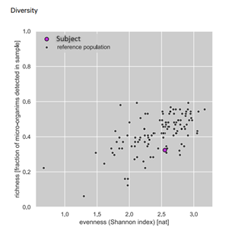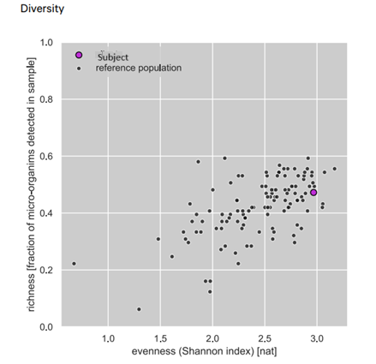

Fig. 2 - Diversity of microbes before treatment Fig. 3 - Diversity of microbes after treatment

3.2 Target Bacterial Group
Sum of bacterial groups on the PMP Gut comprehensive panel in the subject versus the known reference population at Bio-Me were observed (Table 1). Low levels of SCFA-producing bacteria, including F. prausnitzii and R. inulinivorans, were detected pre-treatment. Insufficient SCFA production compromises gut barrier integrity and contributes to inflammation. Sum of total short-chain fatty acid producing bacteria on the PMP Gut comprehensive panel in the subject vs the known reference population at Bio-Me showed an increase in SCFA-producing bacteria post-treatment, particularly F. prausnitzii, which is known for its anti-inflammatory properties. Elevated SCFA levels support gut-brain communication, metabolic health, and immune modulation. The F/B ratio was low pre-treatment, suggesting suboptimal metabolic function and an increased risk of metabolic conditions. Post-treatment saw a slight increase in the F/B ratio, reflecting improved metabolic efficiency and gut health. Low levels of Bifidobacterium and Lactobacilli beneficial bacteria which are essential for digestion, immune regulation, and protection against pathogens were observed pre-treatment. At post-treatment, significant increases in Bifidobacteria and Lactobacilli levels were noted, promoting gut health and potentially enhancing immune responses. At pre-treatment elevated Proteobacteria levels linked to inflammatory conditions and metabolic dysfunction were observed. At post-treatment a marked reduction in Proteobacteria levels was observed, indicating a decrease in gut inflammation and improved overall health. This is mainly due to the elimination of E. coli levels after treatment.
Table 1: Microbial Diversity of Gut Pre and Post treatment with Physta® extract after 4 weeks supplementation
 | Microbial Diversity | Pre-treatment | Post-treatment
a. | SCFA Producing bacteria (total) | 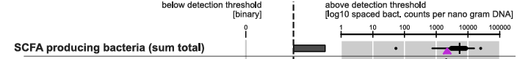 | 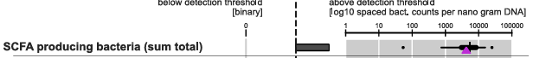
b. | Fermicutes to Bacteriodetes ratio | 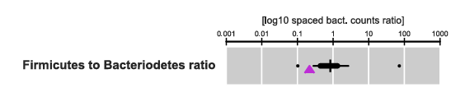 | 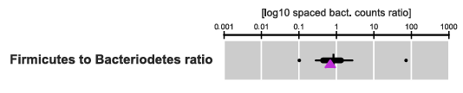
c. | Bifidobacteria and Lactobacilli (total) | 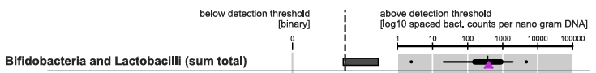 | 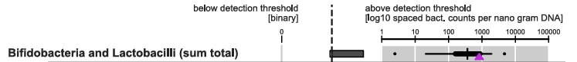
d. | Proteobacteria (total)  - Sutterella wadsworthensis  - Escherichia coli  - Heamophilus parainfluenzae | 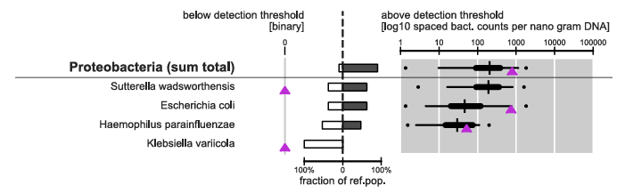 | 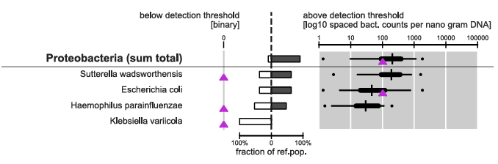

4. DISCUSSION
The post-treatment changes observed in the gut microbiome indicate significant improvements in gut health, metabolic function and immune regulation. Notably, the observed increases in microbial diversity and enhanced levels of SCFA-producing bacteria are critical for reducing inflammation, strengthening gut barrier function and supporting mental health through the gut-brain axis.
The increased abundance of beneficial bacteria such as Bifidobacteria and Lactobacilli, coupled with a reduction in Proteobacteria, underscores a shift towards a healthier gut environment. High microbial diversity is a well-established marker of gut health, as it correlates with increased resilience against infections, enhanced metabolic stability, and reduced risks of chronic diseases such as obesity, diabetes and autoimmune disorders. Conversely, low diversity is often linked to gut dysbiosis, which can predispose individuals to inflammatory diseases like inflammatory bowel disease (IBD) and other immune-mediated conditions. In this study, the post-treatment increase in microbial diversity aligns with prior evidence highlighting the health benefits of a robust and diverse gut microbiome.
The slight increase in the F/B ratio observed post-treatment is noteworthy, as this ratio is a recognized indicator of metabolic health. Earlier research showed that a higher F/B ratio was associated with obesity, while a lower ratio was linked to leanness and healthier metabolic profiles. However, the relationship between the F/B ratio and obesity is complex and not consistently observed across all studies. Some research has reported conflicting findings, indicating that the F/B ratio alone may not be a definitive marker of obesity [14]. Therefore, while the F/B ratio provides valuable insights into gut microbiota composition, it should be interpreted cautiously and in conjunction with other clinical parameters when assessing gut health and its implications for metabolic diseases [14-16].
Furthermore, one must consider the aim of the specific study in which the F/B ratio is being evaluated. Optimizing this ratio has been shown to enhance energy metabolism and aid in managing metabolic syndrome. The observed improvement supports the hypothesis that Physta® supplementation can contribute to a balanced gut ecosystem, potentially linked to improved health and strength. Previous studies have demonstrated that Physta® increases testosterone levels, resulting in enhanced muscle strength [17]. In addition, peri and menopause also affect microbiome’s composition, affecting oral, intestinal, and urogenital communities, potentially leading to disease. The changes in sex hormones highlights the bidirectional relationship between hormones and the microbiome [19]. This is further validated in a clinical study on peri and post menopausal women supplemented with Physta® which demonstrated improved reproductive hormone levels of testosterone and estradiol accompanied with the improvement in the menopausal quality of life [20]. The current improvement seen in the gastrointestinal tract could also be a contributing factor to the improvement in the quality of life.
The observed increase in SCFA-producing bacteria, such as Faecalibacterium prausnitzii and Roseburia inulinivorans, is particularly important. SCFAs including acetate, propionate, and butyrate are critical for maintaining gut barrier integrity, modulating immune responses and reducing inflammation. These metabolites also play a key role in the gut-brain axis, influencing cognitive function and behavior through neuro-immunoendocrine pathways. The positive modulation of SCFA-producing bacteria following Physta® supplementation aligns with prior findings showing its’ immunomodulatory effects in middle-aged adults [21]. Due to the potential imbalance of reproductive hormones in the 55-year-old subject evaluated in this case study, a restoration of hormonal levels may have improved SCFA-producing bacteria [17,18].
Additionally, the reduction in Proteobacteria post-treatment is highly significant. Elevated levels of Proteobacteria are often linked to inflammatory conditions such as Crohn’s disease and ulcerative colitis, as well as systemic inflammation that can exacerbate insulin resistance and cardiovascular risks [22-24]. These findings underscore the critical role of gut microbiota composition in modulating inflammatory responses and metabolic health. The proliferation of Proteobacteria not only serves as a marker for intestinal inflammation but also as a potential contributor to systemic inflammatory states, influencing the pathogenesis of metabolic disorders and cardiovascular diseases. The root extract of E. longifolia has demonstrated anti-inflammatory and anti-hyperglycaemic effect [25,26]. Hence, the observed decline in Proteobacteria suggests a shift toward a less inflammatory gut microbiome, contributing to improved long-term health outcomes. However, a more comprehensive study would be needed to verify this for Physta® supplementation.
The increase seen in Bifidobacteria and Lactobacilli post-treatment further emphasizes the potential health benefits of Physta® supplementation. Beneficial bacteria such as Bifidobacteria and Lactobacilli are considered health promoting bacteria, due to contributing to digestive mechanisms by transforming foods into beneficial metabolites, as well as supporting a well-functioning immune system and creating a barrier against the establishment of potential pathogenic bacteria in the gut[12]. These bacterial genera are well-documented for their roles in enhancing immune function, fermenting dietary fibers into SCFAs, and inhibiting harmful pathogens. [27,28]. Their presence strengthens the gut barrier, reduces inflammation, and supports overall digestive health, thereby reducing the likelihood of gastrointestinal disorders and infections. Physta® in addition, has been reported to possess immunomodulating properties in a clinical study among stressed adults [21] by elevating T and B cells necessary for adaptive immunity. Physta® has through past clinical studies shown improvements in testosterone, strength, immunity, reduction in stress (mood) and improvement in quality of life [29]. These improvement areas are also affected by gut microbiome especially via the gut-brain axis.
5. CONCLUSION
The results of this study show that Physta® supplementation may lead to favorable changes in the gut microbial diversity, higher SCFA production, and an improved balance of beneficial bacterial groups. These changes are known to be associated with enhanced metabolic health, reduced inflammation, and strengthened immune function. The findings highlight the therapeutic potential of microbiome-focused interventions in improving long-term health outcomes. The major limitations of conducting a case study is the lack of number of subjects to enable a collective observation of the study findings to generalize and establish cause-effect relationship. There is also the danger of over-interpretation due to limited data [30]. However, since this study is only a preliminary single-case design, a more comprehensive study would be needed to validate these initial findings.

COMPETING INTERESTS DISCLAIMER:
The authors Annie George and Sasikala M. Chinnappan are employees of Biotropics Malaysia Berhad who funded the study. Anne-Grethe G. Reichelt and Priya Kandanur are employees or Bio-Me AS which conducted the PMPTM analysis. All authors contributed to the design of the study and manuscript.

ETHICAL APPROVAL AND CONSENT
Ethical review and approval were waived for this study due to a preliminary internal case study aimed at exploring the potential effects of Physta® which has been sold in the market as supplements for the last twenty years and clinically validated in several studies. Hence the formal ethical approval was not sought. Informed consent was obtained from the subject to participate and disclose findings to provide for pre-liminary data and justification for future studies. Full ethical approval will be obtained prior to conducting the planned comprehensive clinical study to ensure compliance with ethical research standards.
Future studies with larger sample sizes and extended follow-up periods are recommended to validate these findings and further explore the potential of microbiome-targeted therapies in managing chronic diseases and promoting overall health.

DISCLAIMER (ARTIFICIAL INTELLIGENCE)
Author(s) hereby declare that NO generative AI technologies such as Large Language Models (ChatGPT, COPILOT, etc.) and text-to-image generators have been used during the writing or editing of this manuscript.

REFERENCES
- Peterson, C. T., Santiago, J. P., Lablokov, S. N., Chopra, D., Rodionov, D.A., Petersen, S. N. (2022). Short-Chain Fatty Acids Modulate Healthy Gut Microbiota Composition and Functional Potential. Current Microbiology,79(5), 128.
- Silva, Y. P., Bernardi, A., Frozza, R. L. (2020). The Role of Short-Chain Fatty Acids from Gut Microbiota in Gut-Brain Communication. Frontiers in Endocrinology (Lausanne), (11), 25.
- Sethuraman, V., Roshan, H. K. T., Shalini, Niharika, M., Sampath, V., Rajeshwar, J. R. et al. (2024). Role of Probiotics and Prebiotics in Human Health: A Review. Archives of Current Research International, 24(9), 14-25.
- Kuroki, Y., Tsuda, F., Tawara, F., Tsumagari, S. (2022). Inhibitory Effects of Tongkat Ali (Eurycoma longifolia) extract on lighting stress induced sleep disorders in pigs. Journal of Veterinary Malaysia, 34(1). X-X.
- Fusco, W., Lorenzo, M. B., Cintoni, M., Porcari, S., Rinninella, E., Kaitsa, F. et al. (2023). Short-Chain Fatty-Acid-Producing Bacteria: Key Components of the Human Gut Microbiota. Nutrients, 15(9), 2211.
- Meyers, G. R., Samauda, H., Bohn, T. (2022). Short Chain Fatty Acid Metabolism in Relation to Gut Microbiota and Genetic Variability. Nutrients, 14(24), 5361.
- Marano, G., Traversi, G., Gaetani, E., Gasbarrini, A., Mazza, M. (2023). Gut microbiota in women: The secret of psychological and physical well-being. World Journal of Gastroenterology, 29(45), 5945–5952
- Farup, P. G., Maseng, M. G. (2021). Are Faecal Microbiota Analyses on Species-Level Suitable Clinical Biomarkers? A Pilot Study in Subjects with Morbid Obesity. Microorganisms, 9(3), 664.
- Grahnemo, L., Nethander, M., Coward, E., Gabrielsen, M. E., Sree, S, Billod, J. M. et al. (2022). Cross-sectional associations between the gut microbe Ruminococcus gnavus and features of the metabolic syndrome. Lancet Diabetes and Endocrinology, (10), 481–483.
- Mosca, A., Leclerc, M., Hugot, J. P. (2016). Gut Microbiota Diversity and Human Diseases: Should We Reintroduce Key Predators in Our Ecosystem? Frontiers in Microbiology, 7, 455.
- Houtman, T. A., Eckermann, H. A., Smidt, H., de Weerth, C. (2022). Gut microbiota and BMI throughout childhood: the role of firmicutes, bacteroidetes, and short-chain fatty acid producers. Scientific Reports, 12(1), 3140.
- Saez-Lara., M. J., Gomez-Lorente, C., Plaza-Diaz, J., Gil, A. (2015). The role of probiotic lactic acid bacteria and bifidobacteria in the prevention and treatment of inflammatory bowel disease and other related diseases: a systematic review of randomized human clinical trials. BioMed Research International, 2015, 505878.
- Vester-Andersen, M. K., Mirsepasi-Lauridsen, H. C., Prosberg, M. V., Mortensen, C. O., Träger, C., Skovsen, K. et al. (2019). Increased abundance of proteobacteria in aggressive Crohn's seven years after diagnosis. Scientific Reports, 9(1), 13473.
- Pillai, S. S., Gagnon, C. A., Foster, C., Ashraf, A. P. (2024). Exploring the Gut Microbiota: Key Insights into Its Role in Obesity, Metabolic Syndrome, and Type 2 Diabetes. Clinical Endocrinology & Metabolism, 109(11), 2709–2719.
- Karasic, A., Ranko, I., Krznaric, Z., Klobucar, S., Prso, A. L. (2024). The Association between the Firmicutes/Bacteroidetes Ratio and Body Mass among European Population with the Highest Proportion of Adults with Obesity: An Observational Follow-Up Study from Croatia. Biomedicines, 12(10), 2263.
- Magne, F., Gotteland, M., Gauthier, L., Zazueta, A., Pesoa, S., Navarrete, P. (2020). The Firmicutes/Bacteroidetes Ratio: A Relevant Marker of Gut Dysbiosis in Obese Patients? Nutrients, 12(5), 1474.
- Henkel, R. R., Wang, R., Bassett, S. H., Chen, T., Liu, N., Zhu, Y., Tambi, M. I. et at. (2014). Tongkat Ali as a Potential Herbal Supplement for Physically Active Male and Female Seniors—A Pilot Study. Phytotherapy Research, 28(14).
- Shin, J. H., Park, Y. H., Sim, M., Kim, S. A., Joung, H., Shin., D. M. (2019). Serum level of sex steroid hormone is associated with diversity and profiles of human gut microbiome. Research in Microbiology, 170(4-5), 192-201.
- Nieto, M. L., Rus, M. J., Areal-Quecuty, V., Lubián-López, D. M., Simon-Soro, A. (2025). Menopausal shift on women’s health and microbial niches. NPJ Women's Health, 3(3).
- Chinnappan, S. M., George, A., Evans, M., Anthony, J. (2020). Efficacy of Labisia pumila and Eurycoma longifolia standardised extracts on hot flushes, quality of life, hormone and lipid profile of peri-menopausal and menopausal women: A randomised, placebo-controlled study. Food & Nutrition Research, 64, 10.29219/fnr.v64.3665.
- George, A., Suzuki, N., Abas, A., Mohri, K., Utsuyama, M., Hirokawa, K., Takara, T. et al. (2016). Immunomodulation in Middle-aged humans via the ingestion of Physta® Standardized Root Water Extract of Eurycoma longifolia Jack – A Randomized, double blind, placebo-Controlled parallel study. Phytotherapy Research, 30(4), 627-35.
- Hansen, J. J., Sartor, R. B. (2015). Therapeutic Manipulation of the Microbiome in IBD: Current Results and Future Approaches. Current Treatment Options in Gastroenterology, (13), 105–120.
- Vester-Andersen, M. K., Mirsepasi-Lauridsen, H. C., Prosberg, M. V., Mortensen, C. O., C Träger, C., Skovsen, K. et al. (2019). Increased abundance of proteobacteria in aggressive Crohn’s disease seven years after diagnosis. Scientific Reports, 9(1),13473.
- Puetz, A., Kappel, B. A. (2024). Gut Microbiome in Dyslipidemia and Atherosclerosis. In: Federici M, Menghini R. (eds). Gut Microbiome, Microbial Metabolites and Cardiometabolic Risk. Endocrinology. Springer Nature Link.
- Chaingam, J., Choonongv, R., Juengwatanatrakul, T., Kanchanapoom, T., Putalun, W., Yusakul, G. et al. (2022). Evaluation of anti-inflammatory properties of Eurycoma longifolia Jack and Eurycoma harmandiana Pierre in vitro cultures and their constituents. Food and Agricul Immnunology, 33(1), 530-545.
- Tsai, C. H., Fang, T. C., Liao, P. L., Liao, J. W., Chan, Y. J., Cheng, Y. W., Li, C. H. et al. (2020). The Powdered Root of Eurycoma longifolia Jack Improves Beta-Cell Number and Pancreatic Islet Performance through PDX1 Induction and Shows Antihyperglycemic Activity in db/db Mice. Nutrients, 12(7), 2111.
- Tan, J, K., Macia, L., Mackay, C. R. (2023). Dietary fiber and SCFAs in the regulation of mucosal immunity. Journal of Allergy and Clinical Immunology, 151(2), 361-370.
- Venegas, D. P., Fuente, M. K. D., Landskron, G., González, M. J., Quera, R., Dijkstra, G. et al. (2019). Short Chain Fatty Accids (SCFAs) – Mediated Gut Epithelial and Immune Regulation and its relevance for Inflammatory Bowel Disease. Frontiers in Immunology, (10), 277.
- George, A., Henkel, R. (2014). Phytoandrogenic properties of Eurycoma longifolia as natural alternative to testosterone replacement therapy. Andrologia, 46(7), 708-21.
- Nissen, T., Wynn, R. (2014). The clinical case report: a review of its merits and limitations. BioMed Central Research Notes, 23(7), 264.

