Antimicrobial Activities of Lactic Acid Bacteria Isolated From Fermented Food on Some Food Spoilage Organisms

.

ABSTRACT

Aims: To determine the antimicrobial potency of lactic acid bacteria isolated from fermented food products
Place and Duration of Study: Sample: Department of Microbiology, Michael Okpara University of Agriculture, Umudike, Abia State, Nigeria.
Methodology: Lactic acid bacteria were isolated using De Mann, Rogosa and Sharpe agar and identified using cultural, morphological and molecular techniques. Spoilage bacteria were isolated from spoiled tomatoes using standard microbiological methods. Isolated lactic acid bacteria were screened for antimicrobial activity. Crude bacteriocin of isolates which exhibited significant inhibition against food spoilage organisms were extracted and used for antimicrobial assay.
Results: Lactic acid bacteria which exhibited significant inhibitory activity against the test organisms were identified as Lactobacillus plantarum and Lactobacillus fermentum while spoilage bacteria isolated from spoiled tomatoes were Enterobacter aerogenes, Pseudomonas aureginosa and Bacillus cereus. Lactobacillus plantarum and Lactobacillus fermentum Crude Bacteriocin Extracts exhibited highest inhibition against Bacillus cereus. Both Crude Bacteriocin Extracts exhibited highest inhibitory activity against the spoilage organisms at 40ºC with zones of inhibition of 16mm and 15mm respectively against Bacillus cereus. There was significant difference in the inhibition of the test organisms at different temperatures (P = 0.05). Both Crude Bacteriocin Extracts exhibited maximum inhibitory activity at pH 4. There was significant difference in the inhibition of the test organisms at different pH 4 (P = 0.05). The inhibitory activity of the Crude Bacteriocin Extracts decreased with increased storage time at a constant temperature of 37ºC.
Conclusion: Bacteriocins produced by Lactobacillus plantarum and Lactobacillus fermentum exhibited significant inhibitory activity against food spoilage bacteria.

Keywords: Lactic Acid Bacteria, Antimicrobial, Bacteriocin, Fermented Foods

1. INTRODUCTION

“Food fermentation represents one of the oldest known uses of biotechnology. Fermented foods and beverages form a significant proportion of all diets worldwide; they are typically about one-third of the foods consumed globally. Fermentation of foods covering a wide range of microbial and enzymatic processing of foods and ingredients is used to achieve desirable characteristics such as prolonged shelf-life, improved safety, attractive flavour, nutritional enrichment and promotion of health” (Azam et al., 2017). “Fermentation is a slow decomposition process of organic substances induced by microorganisms or enzymes that essentially convert carbohydrates to alcohols or organic acids. In many instances, production methods of different traditional fermented foods were unknown and passed down to subsequent generations as family traditions. Drying and salting are common fermentation practices in the oldest methods of food preservation” (Kuley et al., 2020). “Fermentation processes are believed to have been developed in order to preserve fruits and vegetables for times of scarcity by preserving the food by organic acid and alcohols, impart desirable flavour, texture to foods, reduce toxicity, and decrease cooking time” (Azam et al., 2017).
“Lactic Acid Bacteria (LAB) are gram-positive, non-sporulating, facultatively aerobic bacteria which produce lactic acid during fermentation. LAB are most recognized for their use as starter cultures in the production of acidophilus milk, yogurt, buttermilk, cottage cheese, hard cheeses, and soft cheeses. In addition, they are also used in the processing of meats, alcoholic beverages, and vegetables such as sausage, cured hams, wines, beer, fortified spirits, pickles, sauerkraut” (Bao et al., 2020). “LAB also produces various metabolites such as bacteriocin or bactericidal proteins, organic acids, and vitamins during the fermentation process. Over the years, lactic acid bacteria have been explored on a large scale in several food industry segments occupying a central role in these niches. There are some reasons that explain their use in the food production industry. Among these are the production of antimicrobial substances such as bacteriocins which restrict the growth of harmful microorganisms, and the production of metabolites, which influence the nutritional, texture, and organoleptic qualities of food products” (Ge et al., 2020). The study of these traditional fermented foods allows for the identification of new bacteriocin producing bacterial strains that could lead be applied in several industries.
“A process or alteration that makes a product unpalatable or unfit for ingestion is referred to as food spoilage. Food becomes spoiled when microbiological, chemical, or physical changes take place that make the product unpleasant to consumers. The increase of microbes that create enzymes that result in unpalatable byproducts in the food is what causes microbiological food deterioration. Chemical food deterioration happens when different ingredients in the food react with one another or with an additional ingredient, changing the food's sensory properties. This can happen through enzymatic browning, or non-enzymatic browning and oxidation” (Garba et al., 2022). “Physical food degradation occurs when moist foods are overly dried out or when dry foods retain too much moisture. Since people began producing and storing food products, spoilage and food losses and waste became important issues for human with regards to food safety and security. These losses are the results of one or more problems occurring in the supply chain, from initial agricultural production down to the consumer level. Almost 25% of food spoiling is because of its packaging issues” (Di Bella et al., 2024). “Packaging has been found to be a great source of contamination in itself because of the migration of substances from the packaging into food. Suitable packaging is necessary for maintaining the basic characteristics of food such as color, taste, temperature, texture, etc. The most important function of packaging is maintaining food safety” (Fuste-Forne, 2021). “Thus, it becomes equally important that the material used for packaging is of good safety quality. The process of spoilage is largely influenced by microorganisms. Spoilage is a significant problem in the preservation of foods. Psychrophilic bacteria have been the subject of numerous studies, and it has been reported that Pseudomonas, Enterobacteriaceae, and Brochothrixthermosphacta are the most frequently found organisms linked to food spoilage” (Kumar et al., 2022). “These organisms usually cause slime which ruins food texture, bad odour, and offensive flavours, which can result in decreased food quality and reduce consumer acceptability.
Regulating temperature during food storage is one of the most significant factors that delay the spoilage of foods. Storage at low temperature slows the activity and growth of most spoilage microbes. After the contamination process, food spoiling microbes release enzymes which breakdown the food components and results in the start of the deterioration process. Enzymatic reactions take place between the enzymes and components of food like lipids, proteins, fats, vitamins, carbohydrates etc. which leads to other waste products develop. After a period of few hours or days the food product starts to decompose and many chemical changes are seen. These chemical changes involve: Degradation of carbohydrates, Degradation of N – compounds, Lipid degradation and Hydrolyses of pectin. The chemical changes lead to unpleasant taste and flavor as the process continues changes in texture, color and odor starts occurring and these changes ultimately lead to food spoilage” (Kumar et al., 2022). The food becomes unsuitable for human consumption and hence needs to be discarded immediately and leads to wastage of food. After a period of few hours or days the food product starts to decompose and many chemical changes are seen. These chemical changes involve degradation of carbohydrates, degradation of N – compounds, lipid degradation and hydrolysis of pectin. The food becomes unsuitable for human consumption and hence needs to be discarded immediately leading to wastage of food.

2. material and methods

2.1 Sample Collection
Maize grains (from two maize varieties: white and yellow) and freshly harvested cassava root tubers were purchased from a local market in Umuahia, Abia State, Nigeria. They were immediately processed and transported aseptically to the Microbiology laboratory, Michael Okpara University of Agriculture, Umudike for further analysis.
2.2 Sample preparation
The fermentation of maize grains and cassava tubers to produce Ogi and fufu, respectively, were carried out by simulating traditional methods.

2.3 Isolation and characterization of Lactic Acid Bacteria
Lactic acid bacteria were isolated and enumerated using De Mann, Rogosa and Sharpe (MRS) agar (HIMEDIA). 1g of each fermented product was aseptically transferred to 9ml of buffered peptone water and properly mixed with a sterile glass rod and 1ml of each sample serially diluted in ten folds. 0.1ml of the diluted sample was plated onto MRS agar to enumerate the Lactic acid bacteria population and incubated at 37ºC for 48 hours (Ayodeji et al., 2017). Distinct colonies were sub-cultured on MRS agar for purity. Lactic acid bacteria were characterized based on their morphological, biochemical and physiological properties. Isolates were confirmed using 16S rRNA method. DNA from isolated LAB was extracted with Zymo-Spin™ kits according to the manufacturer's instructions and the extracted DNA was separated on a 1% agarose gel electrophoresis. The 16S rRNA coding gene was amplified through polymerase chain reaction (PCR) using universal primers, 27F (5‟- AGAGTTTGATCMTGGCTCAG-3‟) and 907R (5‟- CCGTCAATTCMTTTRAGTTT-3‟). PCR amplifications were carried out in a thermal cycler (T Gradient model, Biometera, Germany) using the following steps: one cycle of denaturation for 5 min at 94°C followed by thirty-five cycles of 94°C for 30 seconds. Annealing was performed at 50°C for 30 seconds, extension at 68°C for 1 minute and final extension was done at 68°C for 10 minutes. The PCR products were kept at 4°C and the integrity of the PCR amplicons were separated on a 1% agarose gel electrophoresis (CSL-AG500, Cleaver Scientific Ltd) and visualized by staining with EZ-vision® Bluelight DNA Dye. PCR products were purified using ExoSAP Protocol and sequencing was done with the Applied Biosystems™ BigDye™ Terminator v3.1 Cycle Sequencing Kit using ABI 3500XL Genetic Analyser by Inqaba Biotec. The 16S rRNA gene sequences were analyzed in NCBI website using the Basic Local Alignment Search Tool (BLAST) Software in the GenBank to compare sequences and identification was performed on the basis of 16S rRNA sequence percentage similarity with the type strains.
2.4 Isolation and Identification of Spoilage Bacteria
Spoilage bacteria were used as test organisms for the determination of the antimicrobial activities of lactic acid bacteria and their crude bacteriocin extracts. They were isolated from spoiled tomato samples using standard microbiological methods. 10g of spoiled tomatoes were aseptically transferred to 90ml of buffered peptone water and homogenized in a blender for 90 minutes. 1ml aliquot of the blended sample was serially diluted in ten-folds and 0.1ml of the diluted sample plated onto Cetrimide agar, Eosin Methylene Blue (EMB) agar, MacConkey agar and Nutrient agar (HIMEDIA) respectively and incubated at 37ºC under aerobic condition for 24 hours. The isolates were identified using morphological, cultural and biochemical characterization (Holt, 1994). Each isolate was examined under light microscope using oil immersion objectives after Gram-staining and Spore staining for the purpose of identification. Isolates were subjected to oxidase test, catalase test, indole test, methyl red test, voges-proskauer test, citrate utilization test, motility test, nitrate reduction test, starch hydrolysis test and sugar fermentation tests.
2.5 Antimicrobial assay of lactic acid bacteria
“In the screening of the LAB cells for antimicrobial activity, the agar well diffusion method was used. Indicator lawns were prepared with 40 ml of Mueller Hinton Agar (MHA) seeded with 100 μL of an overnight culture of each test organism. With a sterile 5 mm diameter cork borer, wells were cut into the agar. 1 ml of each LAB culture was centrifuged and 75 μL of it was placed into each well. The plates were incubated at 30°C for 24 to 48 hours after which they were examined for probable zones of clearing” (Bali et al., 2011).
2.6 Extraction of Crude Bacteriocin
“Bacteriocin was extracted according to the following protocol: 0.1% inoculum of the lactic acid bacteria isolates were grown for 24 hours in 60 ml of MRS broth at 37ºC. The broth culture was centrifuged at 10,000× g for 30 minutes. The cell-free supernatant was treated with Chelaton-EDTA III and heated at 80ºC for 10 minutes to eliminate the other organic substances. The supernatant was filtered using a 0.22µm filter “(Laukova et al., 2023).
2.7 Evaluation of inhibitory activity of bacteriocin on spoilage bacteria
The inhibitory activity of the bacteriocin extracts were assayed against the different spoilage organisms using agar well diffusion method. 100μl of bacteriocin was added in 10mm wells on Mueller Hinton agar previously inoculated with 0.1ml of test organism’s suspensions. The plates were incubated at 37ºC for 48 hours and the zones of inhibition examined after (Tagg and Mcgiven, 1971).
2.8 Effect of pH on bacteriocin activity
“Bacteriocin produced by each lactic acid bacteria isolate was adjusted to pH range of 4 to 9 using diluted acid and base solutions and allowed to stand at room temperature for 2 hours” (Ohaegbu et al., 2022). Bacteriocin activity was determined against the test organisms using agar well diffusion method.
2.9 Effect of temperature on bacteriocin activity
Bacteriocin produced by each lactic acid bacteria isolate was subjected to different temperatures in a water bath (40ºC, 60ºC, 80ºC and 100ºC). The effect of the different temperatures on bacteriocin activity on the indicator organisms was determined using agar well diffusion method.
2.10 Effect of storage on bacteriocin activity
Bacteriocin produced by each lactic acid bacteria isolate was stored at 37ºC for 96 hours and the activity of the stored extract was determined every 24 hours against the test organisms using the agar well diffusion method.

2.11 Statistical Analysis
The experimental results were analyzed using R software. Analysis of variance (ANOVA) was conducted to test the significance (P = .05) of differences among groups, followed by Tukey's multiple comparisons test. All results are presented as mean ± SD.

3. results and discussion

3.1 Identification of Lactic Acid Bacteria
Lactic acid bacterial isolates which exhibited significant inhibitory activity against the spoilage bacteria were identified as Lactobacillus plantarum B19 (KY764327.1) and Lactobacillus fermentum HB3-3 (LC269382.1).The presence of Lactobacillus plantarum and Lactobacillus fermentum was similar to findings by Ohenhen et al., (2015), who isolated Lactobacillus plantarum and Lactobacillus fermentum amongst other lactobacilli from Ogi. The findings were also similar to that of Onwuakor et al., (2014) who isolated Lactobacillus fermentum and Lactobacillus plantarum amongst other lactobacilli from Ogi.

3.2 Identification of Spoilage Bacteria
Spoilage bacteria were identified as Enterobacter aerogenes, Pseudomonas aureginosa and Bacillus cereus.
3.3 Antimicrobial Assay of Lactic Acid Bacteria
The screening results of lactic acid bacteria isolates assayed using the agar well diffusion method against spoilage bacteria isolated from spoiled tomato samples indicate that two strains, L1 and L4 showed significant inhibition against the spoilage organisms (Figure 1). Isolate L1 exhibited highest activity against Bacillus cereus while isolate L4 exhibited highest activity against Pseudomonas aureginosa.
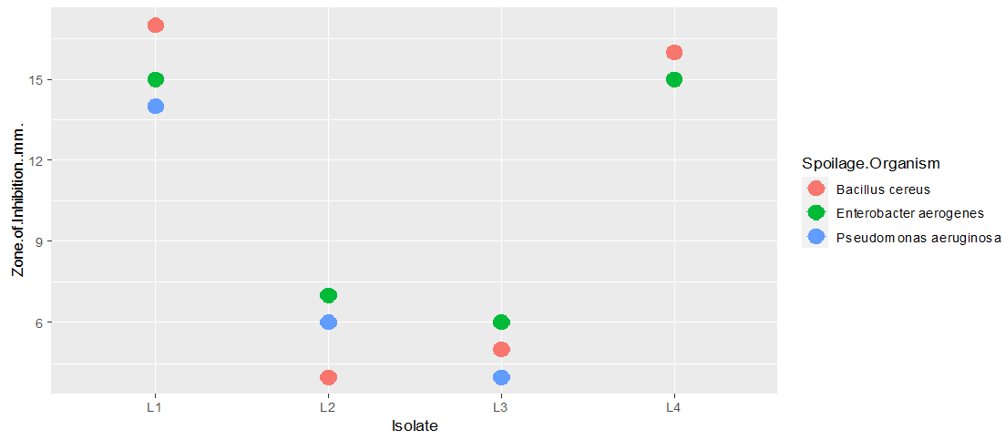
Figure 1. Screening of the lactic acid bacterial isolates for antimicrobial activity against spoilage organisms

3.4 Antimicrobial Activity of Crude Bacteriocin Extracts (CBE)
Crude bacteriocin extracts of Lactobacillus plantarum and Lactobacillus fermentum were assayed for antibacterial activity against the three test organisms. The antibacterial activity of the lactic acid bacteria isolates were more active against the test organisms than the crude bacteriocin extracts. This can be attributed to the presence of hydrogen peroxide and organic acids which also possess inhibitory properties. Lactobacillus plantarum CBE exhibited highest inhibitory activity against Bacillus cereus with an inhibition zone of 13mm. Lactobacillus fermentum CBE also exhibited highest inhibitory activity against Bacillus cereus with an inhibition zone of 12mm. Least antibacterial activity was shown by Lactobacillus plantarum CBE against Pseudomonas aureginosa while least antibacterial activity was shown by Lactobacillus fermentum CBE against Enterobacter aerogenes. This is shown in figure 2. Previous studies reported that the CBE of Lactobacillus plantarum at a concentration of 25% demonstrated an inhibition rate of less than 50% against E. coli (George-Okafor et al., 2020). Lactobacillus fermentum has also been reported to be effective against E. coli (Afdora et al., 2010). Lactobacillus fermentum crude bacteriocin extract has also been previously reported to be active against enteric bacteria such as E.coli as reported by Abdellatif and El-Deeb, (2017).
The higher inhibition exhibited against Bacillus cereus can be attributed to the closeness in evolution between the Lactobacilli and Bacillus species. Bacteriocins produced by bacteria have been reported to be more active against related species as reported by Abo-Amer, 2013. Lactobacillus fermentum CBE also exhibited highest activity against Bacillus cereus while it exhibited least activity against Enterobacter aerogenes. Gram negative bacteria have been reported to be resistant to bacteriocins produced by lactic acid bacteria (Pehrson and Periera, 2015). This is due to the presence of an external membrane which acts as a barrier to the passage of bacteriocins. However, Bacteriocins are able to permeate the cell membrane of gram-negative bacteria through the destabilization activity of lactic acid.

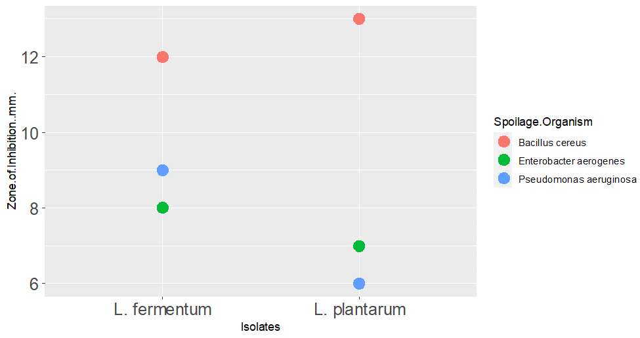Figure 2. Antibacterial activity of the Crude Bacteriocin Extracts (concentration 100µl) against spoilage organisms

3.5 Effect of pH on the Antimicrobial Activity of Crude Bacteriocin Extracts
The antibacterial activity of Lactobacillus plantarum and Lactobacillus fermentum CBEs were determined under different pH. Both CBEs exhibited highest activity against the test organisms at pH 4. Lactobacillus plantarum CBE exhibited highest activity against Bacillus cereus at pH 4 with a zone of inhibition of 13mm and there was significant difference in the inhibition exhibited against spoilage organisms at P=0.05. Lactobacillus fermentum CBE also exhibited highest inhibitory activity against Bacillus cereus. There was significant difference in the inhibition of the different spoilage organisms by Lactobacillus fermentum CBE under different pH at P=0.05. These are shown in figures 3 and 4. There was steady decline in inhibitory activity of both CBEs after pH 6.
Figure 3. Antibacterial activity of L.fermentum CBE under different pH

Figure 4. Antibacterial activity of L.plantarum CBE under different pH

3.6 Effect of Temperature on the Antimicrobial Activity of Crude Bacteriocin Extracts
The antibacterial activity of Lactobacillus plantarum and Lactobacillus fermentum CBEs were determined under different temperatures. Both CBEs exhibited highest activity against the test organisms at 40ºC. Lactobacillus plantarum CBE exhibited highest activity against Bacillus cereus at 40ºC with an inhibition zone of 16mm. Lactobacillus fermentum CBE also exhibited highest inhibitory activity against Bacillus cereus at 40ºC with an inhibition zone of 15mm. There was significant difference in the inhibition of the test organisms by both CBEs at P=0.05. The crude bacteriocin extracts exhibited least activity between 80ºC and 100ºC. The crude bacteriocin extracts of Lactobacillus plantarum and Lactobacillus fermentum exhibited highest inhibition against the test organisms at 40ºC. These are shown in figures 5 and 6. This can be attributed to the mesophilic preference of Lactobacilli.
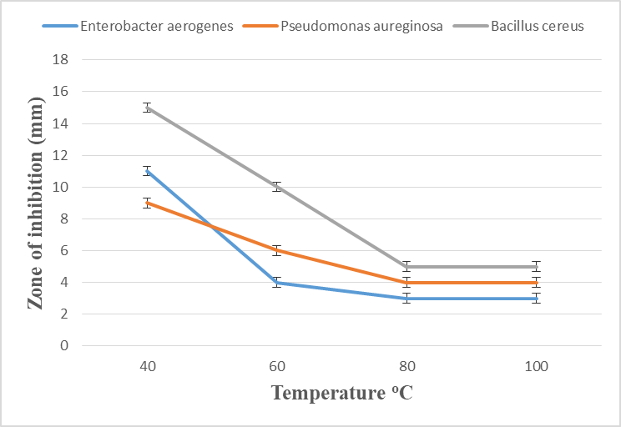
Figure 5. Antibacterial activity of L.fermentum CBE under different temperatures

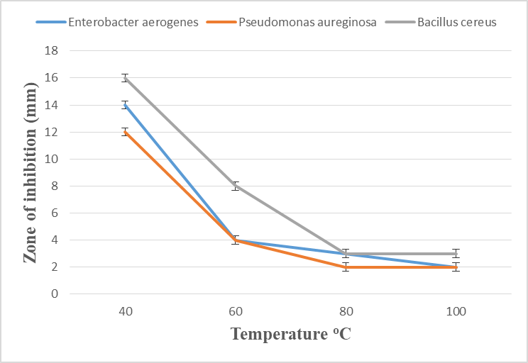
Figure 6. Antibacterial activity of L.plantarum CBE under different temperatures

3.7 Effect of Storage on the Antibacterial Activity of Crude Bacteriocin Extracts
The antibacterial activity of Lactobacillus plantarum and Lactobacillus fermentum CBEs were determined under different storage periods at 37ºC. Lactobacillus plantarum CBE exhibited highest inhibition against the test organisms at 0 hours with highest inhibition exhibited against Bacillus cereus at 16mm. Inhibition of bacterial growth decreased as the hours of storage increased. There was significant difference in the inhibition of the test organisms over 96 hours at P=0.05.
Lactobacillus fermentum CBE exhibited highest inhibition against the test organisms at 0 hours with highest inhibition exhibited against Bacillus cereus at 15mm. Inhibition of bacterial growth decreased as the hours of storage increased. There was significant difference in the inhibition of the test organisms over 96 hours at P=0.05.

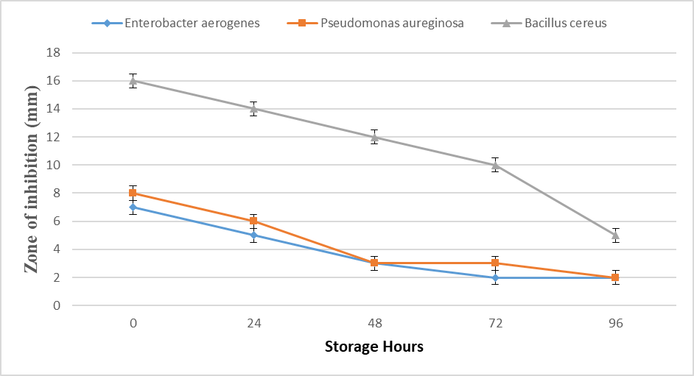
Figure 7. Antibacterial activity of L. plantarum CBE under different storage hours

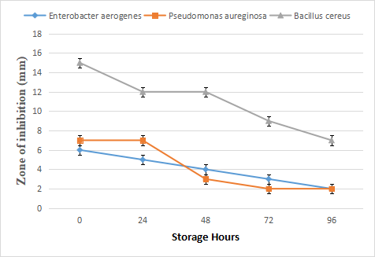
Figure 8. Antibacterial activity of L. fermentum CBE under different storage hours

4. Conclusion

The ability of bacteriocins produced by Lactobacillus plantarum and Lactobacillus fermentum to significantly inhibit the growth of both gram positive and gram negative spoilage bacteria makes them suitable for use in starter cultures in the fermentation of food products and in the preservation of food. The bacteriocin extracts can also be used for antimicrobial action in other industries asides from the food industry. The potential of using bacteriocins in other areas such as in waste treatment should be investigated.

Disclaimer (Artificial intelligence)

Option 1:

Author(s) hereby declare that NO generative AI technologies such as Large Language Models (ChatGPT, COPILOT, etc.) and text-to-image generators have been used during the writing or editing of this manuscript.

References

Azam, M., Mohsin, M., Ijaz, H., Tulain, U., Ashraf, M., & Fayyaz, A. (2017). Review-Lactic acid bacteria in traditional fermented Asian foods. Pakistan Journal of Pharmaceutical Science, 30:1803–1814.

Kuley E., Özyurt G., Özogul I., Boga M., Akyol I., & Rocha J. (2020). The role of selected lactic acid bacteria on organic acid accumulation during wet and spray-dried fish-based silages. Microorganisms 8:172. 10.3390

Bao, W., Huang, X., Liu, J., Han, B., & Chen, J. (2020). Influence of Lactobacillus brevis on metabolite changes in bacteria-fermented sufu. Journal of Food Science, 85:165–172.
Ge, Y., Zhang, J., Corke, H., & Gan, R. (2020). Screening and spontaneous mutation of pickle-derived Lactobacillus pliantarum with overproduction of riboflavin, related mechanism, and food application. Foods, 9:88.
Garba, M., Dandago, M. A., Igwe, E. C., & Salami, K. (2022). A review on microbiological safety of Ready-To-Eat Salads. Dutse Journal of Pure and Applied Sciences, 7(4a):38– 48.
Di Bella, S., Branciari, R., Scoppetta, F., Leo, A., Haouet, N., Scoccia, E., Framboas, M., Mercuri, M., Roila, R., Ranucci, D., & Valiani, A. (2024). Challenges in the use of natural flavorings and labeling compliance in meat preparations in the Umbria region (central Italy). Italian Journal of Food Safety, 6:65-74.
Fuste-Forne, F. (2021). Street food in New York City: Perspectives from a holiday market. International Journal of Gastronomy and Food Science, 24:100319.
Kumar, S., Yadav, M., Devi, A., Uniyal, M., Kumar, V., Sehrawat, N., & Singh, R. (2022). Assessment of Pathogenic Micro-organisms Associated with Vegetable Salads. Asian Journal of Biological and Life Sciences, 11(1): 01–07.
Ayodeji, B., Piccirillo, C., Ferraro, V., & Pintado, M. (2017). Screening and molecular identification of lactic acid bacteria from gari and fufu and gari effluents. Annals of Microbiology, 67:236-241

Holt, J. (1994). Bergey’s manual of determinative bacteriology. 9th Edition, Lippincott Williams and Wilkins, Baltimore.

Bali, V., Panesar, S., & Bera, B. (2011). Isolation, Screening and Evaluation of Antimicrobial Activity of Potential Bacteriocin Producing Lactic Acid Bacteria Isolate. Microbiology Journal 1(3):113-119.

Lauková, A.; Dvorož-náková, E., Vargová, M., & Pogány-Simonová, M. (2023). The Bacteriocin-like Inhibitory Substance Producing Lacticaseibacillus paracasei LPa 12/1 from Raw Goat Milk, a Potential Additive in Dairy Products. Applied Science, 13:12223-12229.

Ohaegbu, C., Ngene, A., Asuquo, U., Coulthard, O. & Nwachukwu, E. (2022). Characterization and antimicrobial activities of lactic acid bacteria isolated from selected Nigerian traditional fermented foods. African Journal of Biotechnology, 21(5):218-236.
Tagg, J., & McGiven, A. (1971). Assay system for bacteriocins. Applied Environmental Microbiology, 21:943-947.

Ohenhen, R., Isibor, J., Emonfonmwan, G., & Enabulele, S. (2015). Effects of PH and Storage Temperatures on Antibacterial Activity of Bacteriocin Produced by Lactic Acid Bacteria Isolated from OGI. British Microbiology Research Journal, 9(3): 1-9.

Onwuakor, C., Nwaugo, V., Nnadi, C., & Emetole, J. (2014). Effect of Varied Culture Conditions on Crude Supernatant (Bacteriocin) Production from Four Lactobacillus Species Isolated from Locally Fermented Maize (Ogi). American Journal of Microbiological Research, 2(5):125-130.

George-Okafor, U., Ozoani, U., Tasie, F., & Mba-Omeje K. (2020). The efficacy of cell-free supernatants from Lactobacillus plantarum Cs and Lactobacillus acidophilus ATCC 314 for the preservation of home-processed tomato-paste. Science Africa 8:00395.

Afdora, P., Ardiyati, T., Sjofjan O., & Kalsum, U. (2010). Potential antibacterial compounds of lactic acid bacteria (LAB) from quail intestine (Coturnix japonica) in inhibition growth of Escherichia coli and Salmonella typhimurium. Journal of Tropical Life Science 1: 28-31

Abdellatif, A., & El-Deeb, S. (2017). Antimicrobial activity of Lactobacillus fermentum against pathogenic bacteria. Journal of Food Science and Technology, 54(4), 1020–1028. doi: 10.1007/s13394-017-0233

Abo-Amer, A. (2013). Inhibition of foodborne pathogens by a bacteriocin-like substance produced by a novel strain of Lactobacillus acidophilus isolated from camel milk. Applied Biochemistry and Microbiology, 49:270–279.

Pehrson, M., & Pereira, C. (2015). Antimicrobial activity of probiotic Lactobacillus strains towards gram-negative entero-pathogens. European International Journal of Science and Technology, 4:136–149.

