***Case report***

**The cryptic infection by *Strongyloides stercoralis* and *Helicobacter pylori* mimicking malignancy: A Case report**

**ABSTRACT**

**Aim:** The aim of this case report is to emphasize on the importance of keeping parasitic infections as a differential diagnosis in cases clinically suspicious for gastrointestinal malignancies.

**Case presentation:** We report a case of 60-year-old male with a co-infection by *Strongyloides stercoralis* and *Helicobacter pylori*. The patient presented with the non-specific symptoms of epigastric discomfort, fatigue and unintentional weight loss over several months with no significant past medical history. This led to a suspicion of malignancy for which routine investigations along with upper gastrointestinal endoscopy with biopsy were performed. Subsequently, rhabditiform larvae of *Strongyloides stercoralis* and *Helicobacter pylori* were identified on gastric and duodenal biopsies.

**Discussion:** Strongyloidiasis is a parasitic infection caused by *Strongyloides stercoralis*; common in tropical and sub-tropical areas infecting about 600 million individuals globally. It usually targets immune-compromised hosts owing to hyper infestation but remains asymptomatic in healthy individuals usually. Moreover, there is limited availability of diagnostic modalities for such parasitic infections that hinders the way for early diagnosis, therefore leading to poor prognosis.

**Conclusion:** Due to the non-specific nature of the symptoms, it is difficult to reach the diagnosis though it is necessary to have a high degree of suspicion and make an early diagnosis in order to have better outcomes.

***Keywords****: Strongyloides, Strongyloidiasis, Case reports, Helicobacter, Parasites*

**INTRODUCTION**

Strongyloidiasis is one of the neglected tropical diseases caused by a soil transmitted parasite; *Strongyloides stercoralis* [Gordon et al., 2024; Pecorella et al., 2022]. It is estimated to affect about 600 million people across the globe; majorly Africa, South America and South-east Asia [Pecorella et al., 2022; Nosková et al., 2024]. India, being a tropical country is prone to many such infections but there is limited availability of data showing the prevalence of *Strongyloides stercoralis* infection. Although, a study conducted in South India shows the sero-prevalence to be 33% between 2013 and 2020 [Munisankar et al., 2022]. Low socio-economic status, lack of sanitation, poor personal hygiene, malnutrition, walking bare-foot are the common risk factors associated with aforementioned infection [Akanksha et al., 2023]. It usually affects humans but is also found to occur in dogs, cats and other primates [Carpio et al., 2023]. As far as humans are concerned, it covers the population that is immuno-compromised and creates a notion to include it as an opportunistic parasite [Chordia et al., 2011]. On the contrary, a recent study mentions that environmental, geographical and behavioral patterns are responsible for its higher prevalence[Akanksha et al., 2023]. Its clinical presentation varies from being asymptomatic, acute Strongyloidiasis or disseminated infection [Carpio et al., 2023].

It has characteristic life cycle patterns where the host gets infected by trans-dermal penetration of larvae present in the soil which migrate to alveoli, lungs and trachea. When the host coughs, they get swallowed and reach the small intestine. Further, parthenogenesis takes place and eggs are produced which mature into rhabditiform larvae in mucosal epithelium or intestinal crypts of leiberkuhn. These larvae are passed out in feces either maturing to form infective filariform larvae or adult male and female worms which mate to produce eggs. Many a times, delayed defecation or constipation may lead to formation of filariform larvae within the intestine resulting in re-infection [Pecorella et al., 2022; Buonfrate et al., 2023].

**PRESENTATION OF CASE**

A 60-year-old male, resident of Bihar, presented to our hospital with complaints of epigastric discomfort, fatigue and unintentional weight loss over several months. The symptoms gradually progressed and led to reduced appetite. He had no significant past medical history. On general examination, he appeared cachectic, moderately pale and afebrile. His pulse rate was 98 beats per minute, blood pressure 102/68 mm of Hg, respiratory rate 18 breaths per minute with normal SpO2 levels. There were no significant findings on cardiovascular, respiratory and abdominal examination except for mild epigastric tenderness.

On routine blood investigations, hemoglobin was found to be 8g/dl and total leukocyte count was raised along with eosinophilia. Iron profile was also done that gave the evidence of iron deficiency anemia with low serum iron and ferritin levels and high total iron binding capacity. This scenario raised suspicion for malignancy prompting for upper gastrointestinal endoscopy with biopsies. Endoscopy showed inflammation with no mass lesion (Fig.1). Hematoxylin and eosin-stained sections of the stomach biopsy showed normal gastric glands with chronic inflammation in the lamina propria. Notably, rhabditiform larvae of *Strongyloides stercoralis* were identified within some gastric glands (Fig.2). Duodenal biopsy revealed normal mucosal glands with the presence of *Helicobacter pylori*, and chronic inflammation in the lamina propria surrounding submucosal Brunner’s glands. Its presence was confirmed on Giemsa staining (Fig.4). Stool examination revealed traces of blood and rhabditiform larvae of *Strongyloides stercoralis*, further confirming the diagnosis of Strongyloidiasis.

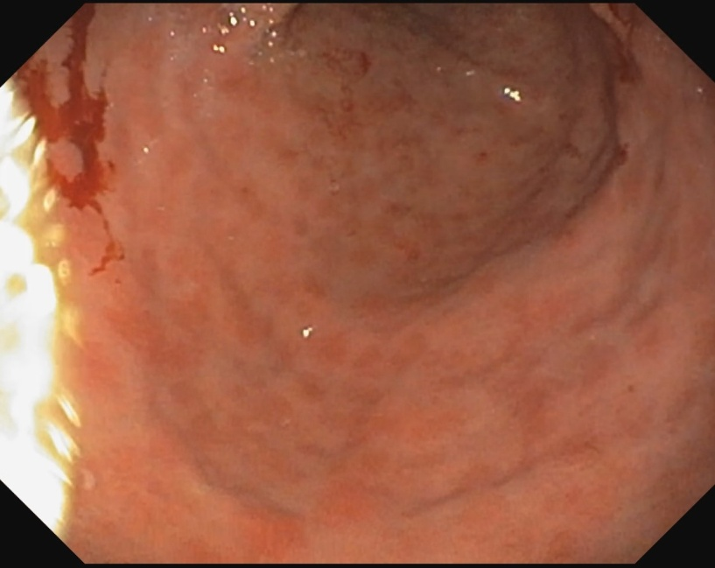

Figure 1: An image showing inflammation on upper gastrointestinal endoscopy with no mass lesion.

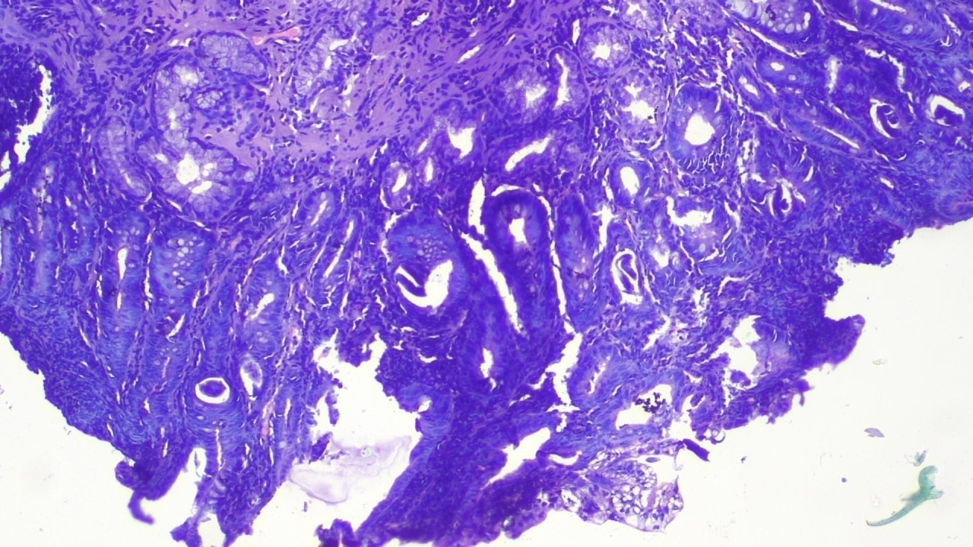

Figure 2: Hematoxylin and eosin-stained sections of the stomach with normal gastric glands with chronic inflammation in the lamina propria viewed at 10X. The arrow depicts the rhabditiform larvae of *Strongyloides stercoralis* in the gastric gland.

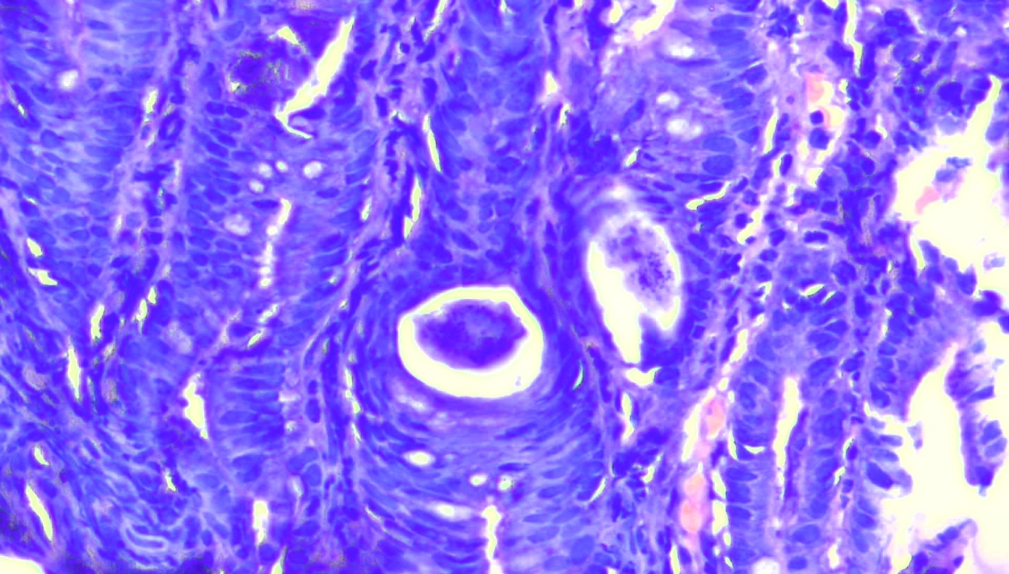

Figure 3: Hematoxylin and eosin-stained sections of the stomach with an arrow depicting the rhabditiform larvae of *Strongyloides stercoralis* in the gastric gland viewed at 40X.

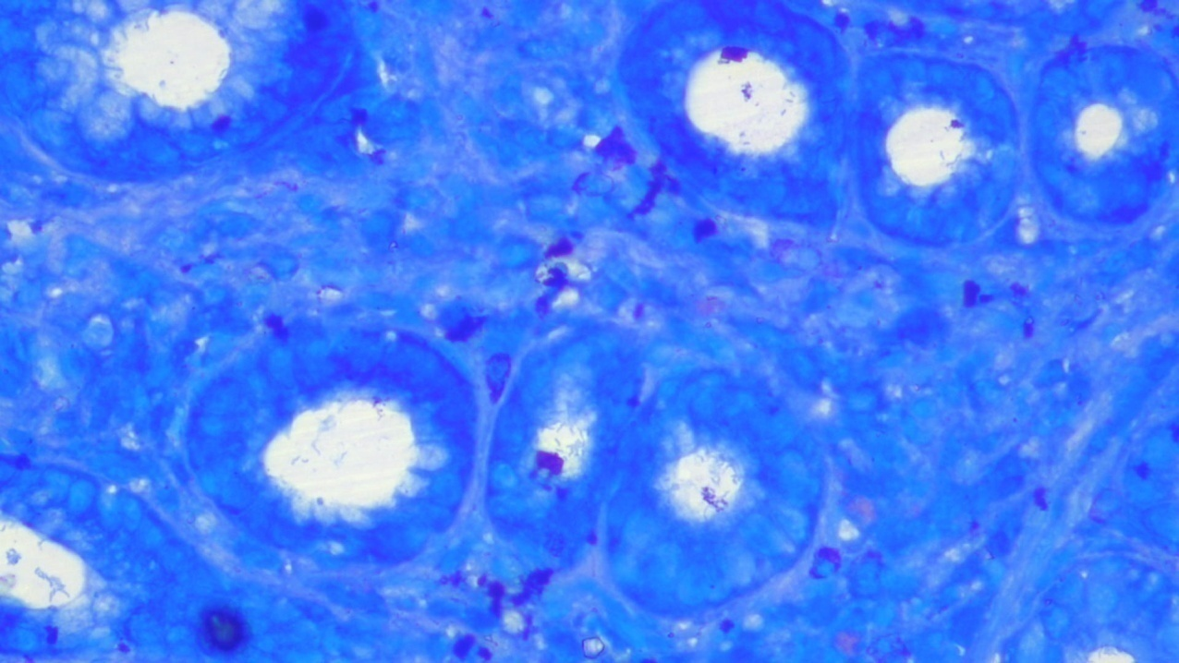

Figure 4: Geimsa stained duodenal biopsy sample revealed the presence of *Helicobacter pylori*(depicted by an arrow) and chronic inflammation in the lamina propria at 40X.

The patient was treated for both *Helicobacter pylori* and *Strongyloides stercoralis* infections.

Table 1: Treatment against *Helicobacter pylori* and *Strongyloides stercoralis* infections

|  |  |
| --- | --- |
| 1. *Helicobacter pylori* Treatment The patient was initiated on a 14-day triple therapy regimen. | Amoxicillin 1 g twice daily  Clarithromycin 500 mg twice daily  Proton pump inhibitor (Omeprazole) 20 mg twice daily |
| 1. *Strongyloides stercoralis* Treatment   (for two consequtive days) | Ivermectin at a dose of 200 µg/kg/day |

The patient responded well to the treatment. His symptoms of epigastric discomfort, fatigue, and reduced appetite gradually improved over the course of therapy. Follow-up evaluations after 4 weeks showed normalization of his hemoglobin levels, stool examination and a significant improvement in his overall health and nutritional status.

**DISCUSSION**

Strongyloidiasis is one of the neglected tropical diseases, caused by an intestinal nematode; most commonly *Strongyloides stercoralis*[Buonfrate et al., 2023]. A study suggests more than 2.6 billion individuals were at risk of developing Strongyloidiasis in 2020 based on the native environmental conditions of the parasite [Fleitas et al., 2022]. It is estimated to infect about 600 million people globally majorly from tropical and subtropical regions of Africa, Asia, South America, South-eastern United States [Pecorella et al., 2022; Nevin et al., 2024]. It also mentions that many studies associated with Strongyloidiasis showed prevalence of 6.6% and 11.2% in communitybased and hospital basedsurveys respectively in India [Pecorella et al., 2022]. Though there is limited data considering morbidity due to *Strongyloides stercoralis*, a review article clarifies a significant epidemiological relation between hookworms and *Strongyloides stercoralis*[Fleitas et al., 2020]. As it is a zoonotic nematode that affects dogs, cats, humans and other primates, it becomes essential to take precautions against the parasite as the fecal contamination can lead to spread of the disease. This also mandates the need for routine surveillance and awareness campaigns to keep the infection in check[Carpio et al., 2023; Tamponi et al., 2020].

*Strongyloides stercoralis* has the most characteristic life cycle amongst all the nematodes which infect human population. It includes the environmental cycle in which rhabditiform larvae passed in feces either molt directly into infective filariform larvae (homogenic cycle) or develop into adult male and female worms which mate and produce eggs (heterogenic cycle). The larvae penetrate into the skin and reach the alveoli, lungs and trachea. When the host coughs, they get swallowed and get embedded into the duodenal crypts. Moreover, the larvae can also get directly transferred into the duodenum via other tissues. The female worm produce eggs without the male worm that mature in intestinal crypts of leiberkuhn to form rhabditiform larvae. Also, when these matured eggs are not released into feces for a long time, they molt into filariform larvae in the intestine itself. This is called the auto-infective cycle that makes it difficult to reduce the burden of Strongyloidiasis[Pecorella et al., 2022; Buonfrate et al., 2023; Page et al., 2018].

A study conducted in Taiwan reviewed cases of Strongyloidiasis from 1988 to 2020. It states that the patient can either be asymptomatic or present with symptoms of anemia, fever, dyspnea, cough, diarrhea, skin rashes, leg edema and altered mental status. Also, corticosteroids, malnutrition and HTLV-1 (Human T-Lymphotropic Virus Type-1) can worsen the condition leading to hyper infection or disseminated Strongyloidiasis [Chen et al., 2023].

We present a case of 60-year-old male who presented with complaints of epigastric discomfort, fatigue, unintentional weight loss and reduced appetite over several months. On examination, he appeared cachectic, pale and had mild epigastric tenderness. His hemoglobin was found to be 8g/dl and further he was diagnosed with iron deficiency anemia based on his iron profile. Also, he had leucocytosis with eosinophilia. It raised suspicion for malignancy and upper gastrointestinal endoscopy with gastric and duodenal biopsy was performed. On stomach biopsy, rhabditiform larvae of *Strongyloides stercoralis* were identified within some gastric glands while duodenal biopsy showed *Helicobacter pylori* and chronic inflammation. Stool examination revealed rhabditiform larvae of *Strongyloides stercoralis*, further confirming the diagnosis of Strongyloidiasis.

A similar case of a 56-year-old male, chronic smoker with complaints of loss of appetite, post prandial fullness, epigastric discomfort, significant weight loss in past year presented with hematemesis, dysphagia and worsening post prandial abdominal pain. Laboratory tests revealed anemia and leukocytosis. Upper gastrointestinal endoscopy showed large gastric ulcer. Further, bronchoscopy was done that suggested squamous cell carcinoma of lung. Despite treatment, abdominal pain persisted for which gastric ulcer biopsy was done that unmasked *Strongyloides stercoralis* with no evidence of *Helicobacter pylori* [Costa Silva et al., 2021].

Studies suggest that gastric involvement by *Strongyloides stercoralis* is quite rare unless it is favoured by reduced gastric secretion or immune-compromised status of the host. In such situations, the worms migrate to the stomach in retrograde fashion from intestine or get swallowed via trachea-esophageal route leading to reactive changes [Pecorella et al., 2022; Costa Silva et al., 2021; Mohamed et al., 2017; Dhakal et al., 2023].

There are several diagnostic modalities available for parasitic infections like direct smear, stool examination, Baermann, Harada mori, Agar plate culture, ELISA and endoscopic evaluation. However, stool examination is the most common method for diagnosing Strongyloidiasis in spite of having low sensitivity. Moreover, it is not reliable as it causes delay in diagnosis due to low larval load; thereby increasing the risk of complications [Wang et al., 2023]. In selected cases with non specific symptoms like that in our case, early upper gastrointestinal endoscopy with histopathology can help in early diagnosis and prompt treatment [Topic et al., 2022].

**CONCLUSION**

Many a times, simple parasitic infestations may mimic malignancies clinically. Careful history, microbiological and pathological investigations need to be done in such cases to detect parasites and rule out malignancies especially in elderly patients.

**CONSENT**

All authors declare that written informed consent was obtained from the patient for publication of this case report and accompanying images.A copy of the written consent is available for review by the Editorial office/Chief Editor/Editorial Board members of this journal.

**ETHICAL APPROVAL**

Ethical approval for the case report has been applied for and is under review by the Institutional Ethics Committee.

**DISCLAIMER (ARTIFICIAL INTELLIGENCE)**

Author(s) hereby declare that NO generative AI technologies such as Large Language Models (ChatGPT, COPILOT, etc.) and text-to-image generators have been used during the writing or editing of this manuscript.

**REFERENCES**

* Akanksha K, Kumari A, Dutta O, Prasanth A, Deeba F, Salam N. Prevalence of soil-transmitted helminth infections in HIV patients: a systematic review and meta-analysis. Scientific reports. 2023 Jul 8;13(1):11055.
* Buonfrate D, Bradbury RS, Watts MR, Bisoffi Z. Human strongyloidiasis: complexities and pathways forward. Clinical microbiology reviews. 2023 Dec 20;36(4):e00033-23.
* Carpio AL, Meseeha M. Strongyloidiasis. InStatPearls [internet] 2023 Sep 4. StatPearls Publishing.
* Chen YA, Hsu HM, Wang H, Lan HH, Huang SH, Hung CC, Su KE. Epidemiology, clinical features, and outcomes of strongyloidiasis in Taiwan from 1988 to 2020: A case series and literature review. Journal of Microbiology, Immunology and Infection. 2023 Feb 1;56(1):172-81.
* Chordia P, Christopher S, Abraham OC, Muliyil J, Kang G, Ajjampur SS. Risk factors for acquiring Strongyloidesstercoralis infection among patients attending a tertiary hospital in south India. Indian Journal of Medical Microbiology. 2011 Apr 1;29(2):147-51.
* Costa Silva R, Carvalho JR, Crespo R, Martins JR, Zózimo N, Tato Marinho R. Strongyloidesstercoralis gastric ulcer: A rare cause of upper gastrointestinal bleeding. GE-Portuguese Journal of Gastroenterology. 2021 Jul 12;28(4):274-8.
* Dhakal B, Dawadi S, Pathak BD, Regmi BU, Sitaula D, Pudasaini P, Lamichhane S, Karki A, Simkhada N. Upper Gastrointestinal Bleeding Induced by Gastric Ulcer Secondary to Strongyloidiasis: A Case Report. JNMA: Journal of the Nepal Medical Association. 2023 Jan 31;61(257):80.
* Fleitas PE, Kehl SD, Lopez W, Travacio M, Nieves E, Gil JF, Cimino RO, Krolewiecki AJ. Mapping the global distribution of Strongyloidesstercoralis and hookworms by ecological niche modeling. Parasites & vectors. 2022 Jun 8;15(1):197.
* Fleitas PE, Travacio M, Marti-Soler H, Socias ME, Lopez WR, Krolewiecki AJ. The Strongyloidesstercoralis-hookworms association as a path to the estimation of the global burden of strongyloidiasis: A systematic review. PLOS Neglected Tropical Diseases. 2020 Apr 13;14(4):e0008184.
* Gordon CA, Utzinger J, Muhi S, Becker SL, Keiser J, Khieu V, Gray DJ. Strongyloidiasis. Nature Reviews Disease Primers. 2024 Jan 25;10(1):6.
* Mohamed R, Hamodat MM, Al-Abbadi MA. Gastric Strongyloidiasis: report of 2 cases and brief review of the literature. Laboratory Medicine. 2017 Feb 1;48(1):93-6.
* Munisankar S, Rajamanickam A, Balasubramanian S, Muthusamy S, Dolla CK, Menon PA, Chinnayan P, Whalen C, Gumne P, Kaur I, Nadimpalli V. Seroprevalence of Strongyloidesstercoralis infection in a South Indian adult population. PLOS Neglected Tropical Diseases. 2022 Jul 20;16(7):e0010561.
* Nevin WD, Melhuish J, Jones J, Cunningham L, Dodd J, Toriro R, Routledge M, Swithenbank L, Troth TD, Woolley SD, Fountain A. Chronic Strongyloidesstercoralis infection in Fijian migrants to the UK. Journal of medical microbiology. 2024 Nov 12;73(11):001925.
* Nosková E, Sambucci KM, Petrželková KJ, Červená B, Modrý D, Pafčo B. Strongyloides in non-human primates: Significance for public health control. Philosophical Transactions of the Royal Society B. 2024 Jan 15;379(1894):20230006.
* Page W, Judd JA, Bradbury RS. The unique life cycle of Strongyloidesstercoralis and implications for public health action. Tropical medicine and infectious disease. 2018 May 25;3(2):53.
* Pecorella I, Okello TR, Ciardi G, Ogwang DM. Is gastric involvement by Strongyloidesstercoralis in an immunocompetent patient a common finding? A case report and review of the literature. ActaParasitologica. 2022 Mar;67(1):94-101.
* Tamponi C, Knoll S, Tosciri G, Salis F, Dessì G, Cappai MG, Varcasia A, Scala A. Environmental contamination by dog feces in touristic areas of Italy: parasitological aspects and zoonotic hazards. The American journal of tropical medicine and hygiene. 2020 Jun 29;103(3):1143.
* Topić MB, Grubišić B, Kovačević E, Sviben M, Santini M. Strongyloidiasis–diagnostic and therapeutic dilemmas in hyperinfection patients: a case series. Journal of helminthology. 2022 Jan;96:e76.
* Wang Y, Zhang X. Gastroduodenal strongyloidiasis infection causing protein-losing enteropathy: a case report and review of the literature. Heliyon. 2023 Jul 1;9(7).