Image-Based Analysis of Biophysical Field Effects on Water Structure Under Corona Discharge Conditions

ABSTRACT
This study uses advanced image analysis techniques to investigate the effects of biophysical fields on the structural characteristics of distilled water under corona discharge conditions.
Corona discharge images of water drops were obtained using a patented device, and experimental and control samples were evaluated.
The analytical approach comprehensively integrates brightness histograms, color mapping, and heat mapping to assess discharge morphology. Quantitative metrics such as mean intensity, edge density, and total discharge area were computed.
The results show that water samples influenced by Anne Hübner and Tanja Aeckersberg exhibit significantly higher mean intensity and edge density values than controls, indicating enhanced energetic activity and more complex discharge structures. Branch length analysis further reveals extensive morphological branching, while normalized discharge area demonstrates a considerable spatial expansion.
Heat mapping effectively visualizes the spatial distribution of high-intensity regions, supporting the interpretation of charge dynamics.
The findings suggest that a biophysical influence can modulate influence the internal electric fields and structural organization of water during corona discharge. This interdisciplinary approach offers novel insights into the interaction between biophysical fields and matter, and may contribute to the development of analytical technologies based on image-based biophysical markers.

Keywords: Image analysis techniques, Biophysical fields, Corona discharge, Color mapping

1. INTRODUCTION
All cellular organisms have a molecular structure, and their living processes occur at the cellular and molecular levels. The living processes in them run on a cellular and molecular level.
Bioelectrical activity is one of the characteristics of living organisms. The nervous cell is a source of electric biocurrent. The generation of electric biocurrent in nerve cells is due to the movement of sodium (Na⁺) and potassium (K⁺) ions across the cell membrane, mediated by ion channels and the Na⁺/K⁺ pump. Calcium (Ca²⁺) ions play a key role in neurotransmitter release at synapses, enabling signal transmission between neurons.
Bioelectrical activity is used very often in medicine for diagnostic purposes. For example, the brain is diagnosed with an electroencephalogram (EEG), and the heart with an electrocardiogram (ECG). The pathological states of the visual analyzer are examined with an electrooculogram (EOG) and electroretinogram (ERG).
In 1983, the Russian scientists Gulyaev and Godik researched biophysical fields emanated by people [1, 2].
Essential components in biophysical fields are the electric and magnetic fields. Gulyaev and Godik use a common term physical fields of biological objects. The authors are utilizing the term biophysical fields of man [3-5].
The vital activity of man is realized at a temperature of 36.6 ºC. Temperature alterations signal disease. By thermovision, Gulyaev and Godik have registered infrared radiation from man [1, 2]. That radiation is then used in medicine for thermovisual diagnostics.
Russian scientists have proved that the human body emanates acoustic fields. They have also proved that skin emits light in the near-ultraviolet, optical, and infrared ranges. This phenomenon is called chemiluminescence [1, 2]. A radiothermal emanation from the internal organs has been proven.
The infrared thermal biophysical field is in the middle infrared range, with wavelengths between 8 and 14 µm. The peak infrared emission from the human body occurs at approximately 9.7 µm, corresponding to a body temperature of 36.6 ºC. At this temperature, human skin emission closely resembles that of a black body (ABB) at the same temperature.
Research of Gulyaev and Godik has determined that the skin’s sensitivity threshold for infrared radiation is approximately 10⁻¹⁴ W cm⁻².
Bioinfluence is with biophysical fields of man on model systems [1-3].
When bioinfluence is applied to the point of threshold skin sensitivity, there is a physiological reaction to the thermal flow. The intensity of the radiated thermal current from the skin is 2.6.10² W/cm².
In cases of bioinfluence, a vasodilatative effect is observed. Gulyaev and Godik have proved with thermovision that this effect occurs in the ZaharinHed zones [1, 2].
Skin receptors absorb the infrared thermal field. They increase the relatively weak thermal signal. No vasodilatative effect is observed when a screen for the infrared bioradiation is placed before the influenced tissue.
In medical practice, the registration of thermal flow from the human body is applied as a diagnostic method [6]. At the beginning of the 20th century, Gurwitsch redistricted UV light from onion bulbs [7]. Fritz-Albert Popp and co-authors developed a very sensitive method for registering biophoton emissions from living cells [7-12].
This study analyzes the effects of biophysical fields on distilled water. Using a patented device under corona discharge conditions, black-white images of water drops are obtained. To verify the impact of biophysical fields, water samples are used with control samples consisting of untreated water. For the analysis, histograms of brightness, developed by Pesotskaya, Glukhova, and co-authors, are applied.
The objective of this research is to present the results and analysis of black-white corona discharge images not only through brightness histograms but also using heat mapping and color mapping analyses. Combining these three analytical methods provides a more comprehensive and detailed picture of bioeffects achieved by Anne Hübner and Tanja Aeckersberg.

2. METHODOLOGY:
2.1. Electrical corona discharge
Parameters of the device for corona gas discharge
The device's parameters for registering a corona gas discharge on an X-ray film are presented in Supp 1 [13]. Pesotskaya, Glukhova, and co-authors develop the method for histogram analysis of water [14, 15].

Table 1. Instrument parameters for registration

Parameter, a unit of measurement | Value
The amplitude of the exposure pulse, kV | 3.0-5.0
Pulse duration, μs | 5.0-10.0
Number of exposure pulses | 1-10
Size of exposure electrode (working part of the device)  mm, width length | 90±0.5  130±0.5
Time of continuous work, hours, not less than | 8.0
Battery supply voltage | 3V
Average earnings per refusal, photographing cycles, not less than | 25100
Overall dimensions of the device, mm, no more than | 150 x 200 x 60
Power consumption, VA, no more than | 3

2.2. Histogram of brightness
The proposed information methodology is based on the calculation of median values [16]. It involves determining the medians of medians of 12 histogram columns and computing the differences between medians across brightness intervals. The brightness distribution in the discharge radiation image of water samples does not conform to the standard Gaussian distribution model. Therefore, median-based estimation determines the average pixel brightness within specific division intervals.

2.3. Color mapping
Color mapping is a technique used to transform pixel values in an image into color codes, enhancing the visualization of details and contrast. The method was applied for levitating water drops [17]. Color mapping is particularly effective for highlighting the intensity of specific phenomena, such as corona discharge, by clearly representing electrical activity distribution.

Mean intensity of color mapping
Mean intensity represents the average luminance value of the pixels within an image region corresponding to the corona discharge zone. It is a quantitative descriptor of the optical emission associated with the electrical discharge process [18].
The parameter is computed using the formula:
FORMULA
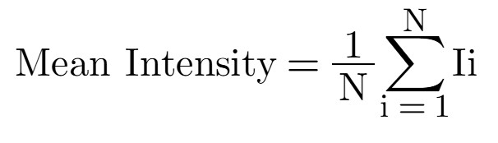
I_{i} is each pixel's intensity (brightness), typically ranging from 0 to 255 in 8-bit grayscale images.
N is the total number of pixels considered in the image analysis, excluding the background.
Corona discharges produce visible optical emissions, often recorded as bright regions in the captured images. The mean intensity reflects the:
1. Total energy content of the discharge;
2. Concentration of charge carriers;
3. Activity of electric interactions within the drop;
4. Spatial distribution of electric potential in the discharge zone.
Higher mean intensity indicates a stronger, more compact, and energy-dense discharge region.
Lower mean intensity suggests a weaker, diffuse, lower-energy discharge structure.

Edge density of color mapping
Edge density is a morphological metric used to quantify the structural complexity of the discharge region. This study defined the ratio between the number of edge pixels and the total number of pixels (i.e., the discharge area excluding the background).
The extracted edge features, grayscale images, were processed using the Canny edge detection algorithm [19], identifying high-gradient transitions corresponding to structural contours within the discharge pattern.
The edge density was calculated using the following formula:
Edge Density=N_{edge}/N_{total}
where:
N_{edge} is the number of pixels classified as edges.
N_{total} is the total number of pixels within the segmented object area (excluding background pixels).
This metric is dimensionless and ranges between 0 and 1.
Edge density for the corona discharge image serves as an indicator of:
- The degree of morphological branching and fragmentation in the discharge pattern.
- The complexity and irregularity of the emission structure.
- Positive microstructural effects due to variations in the electric field.
Higher edge density values reflect more intricate and spatially extended discharge structures, while lower values correspond to more diffusion patterns.

2.4. Heat mapping
By applying a structured color scale, the spatial distribution of discharge intensities can be visualized, allowing differentiation between high-intensity core zones and peripheral branching structures.
Heat mapping was employed as a visualization technique to enhance the spatial interpretation of corona discharge patterns. The grayscale images were first preprocessed and normalized to ensure consistent intensity scaling across all samples. A structured colormap (Jet) was applied to the normalized intensity values to generate color-encoded representations of the discharge zones. This allowed clear visual differentiation between high-intensity emission areas (e.g., red/yellow) and peripheral zones (e.g., blue/green).
The heat maps provided insight into the drop structure's spatial distribution of charge concentration and energy density. In addition, the method facilitated the identification of active regions, asymmetries, and structural irregularities in both control and treated samples.
Heat mapping thus served as a non-invasive, image-based diagnostic tool to support quantitative and morphological analysis of the corona discharge phenomena.

3. RESULTS and Discussion:
3.1. Histograms of brightness
The histograms of Anne Hübner and Tanja Aeckersberg were shown in the paper [20].
3.2. Color mapping
Fig. 1a shows the Hübner’s result with histogram of brightness according the control sample (Fig. 1b). Fig. 1c presents Aeckersberg’s result with histogram of brightness according the control sample (Fig. 1d).

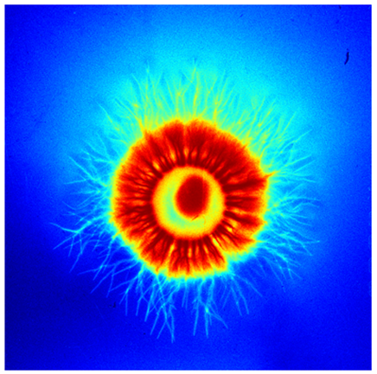

Fig. 1a Color mapping of Hübner’s sample

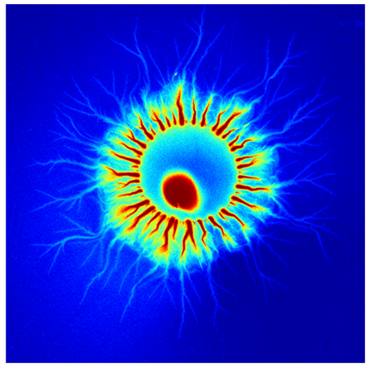

Fig: 1b Color mapping of Hübner’s control

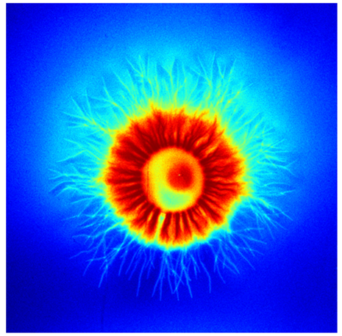

Fig: 1c Color mapping of Aeckersberg’s sample

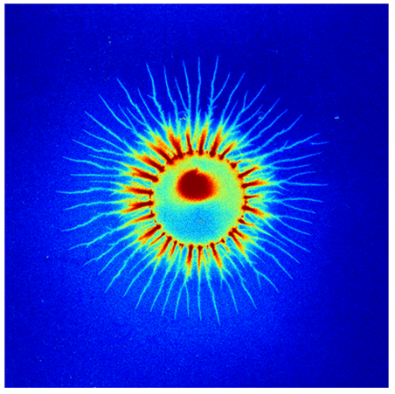

Fig: 1d. Color mapping of Aeckersberg’s control

Based on the analyses, the bioinfluences from Anne Hübner and Tanja Aeckersberg have caused significant changes in the structure of the color mapping of water drops. The following effects were observed in the samples according to the control samples:
- A broader and more stable central zone;
- An expanded radial distribution of branching structures;
- A more evenly distributed intensity, suggesting changes in charge distribution.
These differences result from alterations in the electric forces affecting molecular interactions within the drops during the corona discharge.
Table 2 shows the results of the branch length

Table 2. Results of the branch length

Name | Total Branch Length (px)  Sample | Total Branch Length (px)  Control Sample | Difference
Anne Hübner | 913952 | 407566 | 506386
Tanja Aeckersberg | 869235 | 361447 | 507788

The discharges in the samples are significantly more branched and complex, indicating the influence of Anne Hübner and Tanja Aeckersberg.
Table 3 displays the comparative discharge areas in the color mapping of the analyzed samples, expressed on relative units normalized to a base value of 100.

Table 3. Comparative discharge areas of the analyzed samples, expressed on relative units normalized to a base value of 100.

Name | Total Sample Area  (relative units) | Total Control Sample Area  (relative units)
Anne Hübner | 100 | 38.56
Tanja Aeckersberg | 100 | 42.21

The difference between the Total sample areas for Anne's results is 100-38.56=61.44. The difference between Tanja's results is 100-42.21=57.79.

Table 4 displays the mean intensity and edge density of color mapping results

Table 4. Mean intensity and edge density of color mapping results

Name | Mean Intensity  (Sample) | Mean Intensity  (Control Sample) | Edge Density  (Sample) | Edge Density  (Control Sample)
Anne Hübner | 88.67 | 52.80 | 0.266 | 0.121
Tanja Aeckersberg | 85.82 | 51.61 | 0.255 | 0.118

The difference between the Mean Intensities for Anne Hübner's results is 88.67-52.80=35.87. The difference between Tanja Aeckersberg's results is 85.82-51.61=34.21.
The difference between the Edge Densities for Anne Hübner's results is 0.266-0.121=0.145. The difference between Tanja Aeckersberg's results is 0.255-0.118=0.137.
The comparative analysis of the mean intensity and edge density parameters between the experimental and control samples reveals consistent structural differences induced by the
bioinfluence of Anne Hübner and Tanja Aeckersberg. In both cases, the samples exposed to biophysical fields exhibit substantially higher intensity values, indicating more pronounced and energetically active discharge areas.
The edge density in the bioinfluenced samples is also markedly greater, suggesting a more complex and branched discharge morphology. These findings imply that the applied biophysical fields affect the water drops’ internal electric charge distribution and structural organization during corona discharge, enhancing discharge complexity and energy density.

3.3. Heat mapping
Fig. 2 is connected with heat mapping. Fig. 2a shows the result of Hübner according control sample (Fig. 2b). Fig. 2c illustrates Aeckersberg’s results according control sample (Fig. 2d)

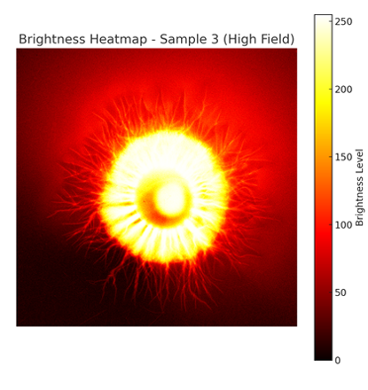

Fig. 2a. Color mapping of Hübner’s sample

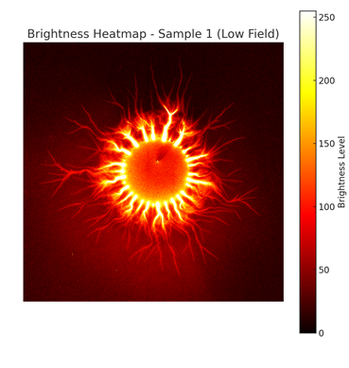

Fig. 2b. Color mapping of Hübner’s control

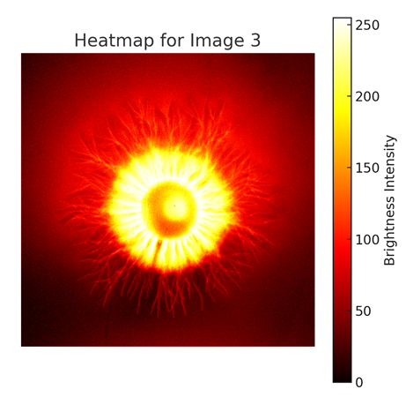

Fig. 2c. Color mapping of Aeckersberg’s sample

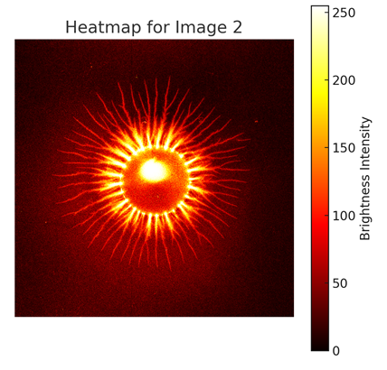

Fig. 2d. Color mapping of Aeckersberg’s control

The mean brightness intensity of heat mapping in the sample image of Anne Hübner (141.72) is significantly higher than the control image (118.67). The difference is 23.05.
The mean brightness intensity in the sample image of Tanja Aeckersberg (135.48) is significantly higher than the control image (112.90). The difference is 22.58.
This difference suggests that the samples are subject to enhanced internal electric field dynamics, likely induced by external biophysical fields, which result in a more energetically active discharge.
The elevated intensity in the sample correlates with visually observed features such as a broader central emission area and more developing branching structures, indicative of stronger ionization and increased streamer activity.
The mean brightness intensity of the discharge in the sample is significantly higher than the control, as confirmed by pixel-level analysis (Welch’s t-test) and simulation validation (bootstrapping). This provides strong evidence of the effect of external influence on the structure of the corona discharge.

4. CONCLUSIONS
The results of this study demonstrate that biophysical fields can influence measurable structural changes in water under corona discharge conditions. Quantitative image analysis revealed that droplets exposed to biophysical input exhibited increased mean intensity, higher edge density, and more extensive branching of discharge patterns compared to control samples. These findings enhanced charge concentration and morphological complexity within the discharge zones, suggesting modulation of the internal electric field structure of the drops.
Furthermore, heat mapping enabled the precise localization of high-intensity regions and provided additional insight into spatial energy distribution. The observed expansion in total discharge area and elevated fractal characteristics confirm the non-random nature of these effects.
Samples exposed to Anne Hübner and Tanja Aeckersberg's biophysical bioinfluence exhibited the following conclusions:
1. The discharges in the samples, as quantified by Total Branch Length in pixels, exhibit significantly better branching and structural complexity than the control samples. The difference between the sample and the control sample of Hübner is 506,386 px, and for Aeckersberg is 507,788 px.
2. The substantially larger discharge area in the control sample is 61.44 for Hübner and 57.79 for Aeckersberg. The results indicate a significant spatial expansion of corona activity likely induced by exposure to biophysical fields.
3. The samples influenced by Anne Hübner and Tanja Aeckersberg exhibited a substantial increase in total discharge areas, by 61.44 % and 57.79 % respectively, compared to the control samples. These results reflect the significant spatial expansion of corona discharge.
4. The experimental samples' higher mean intensity and edge density values indicate enhanced energy emission and more significant structural complexity, confirming the impact of the biophysical fields. The difference in mean intensity for Hübner is 35.87, and for Aeckersberg is 34.21. The difference in edge density for Hübner is 0.145, and for Aeckersberg is 0.137.
5. The significantly higher mean brightness intensities observed in the heat-mapped sample images of Hübner and Aeckersberg, compared to their respective control samples. Hübner 23.05 and Aeckersberg 22.08 results indicate intensified internal field dynamics and enhanced energetic discharge activity, likely driven by external biophysical influences.

The results were consistent across independent samples, reinforcing the biophysical field-induced modifications.
This interdisciplinary investigation bridges physics, biology, and image sciences, offering a
robust framework for assessing subtle, energetic interactions between living systems and matter.
The methodology presented here provides a non-invasive, image-based approach for quantifying and visualizing field-induced transformations at the microscale.

DISCLAIMER (ARTIFICIAL INTELLIGENCE)
Author(s) hereby declare that NO generative AI technologies such as Large Language Models (ChatGPT, COPILOT, etc.) and text-to-image generators have been used during the writing or editing of this manuscript.

References
1. Gulyaev, Yu. V.&Godik, E. E. (1984) On the possibilities of the functional diagnostics of the biological subjects via their temporal dynamics of the infrared images. USSR Academy Nauk Proceedings/Biophysics. 277, 1486-1491.
2. Gulyaev, Yu. V.& Godik, E. E. (1991) Functional imaging of human body. IEEE Eng. Med. Biol. 21-29. DOI: 10.1109/51.107165
3. Ignatov, I., Antonov, A.& Galabova T. (1998) Medical biophysics – biophysical fields of man. Gea Libris. 1-71.
4. Ignatov, I., Mosin, O. V., Niggli, H., Drossinakis, Ch. &Tyminsky, G. (2015) Methods for registering non-ionizing radiation emitted from human body. European Reviews of Chemical Research. 1(3), 4-24. https://doi.org/10.13187/ercr.2015.3.4
5. Ignatov, I., Antonov, A., Neshev, N., Niggli, H., Stoyanov, Ch.& Drossinakis Ch. (2021) Color coronal spectral analysis of bioelectrical effects of humans and water. Contemporary Engineer Sciences. 14(1), 61-72.
6. Brashevan, Yu. V., Zavadskii, Y. I., Zinis, K. A., et al. (1997) Optoelectronic system for dynamic monitoring of thermal fields in medical diagnostics. Proc. SPIE 3200, Third Conference on Photonic Systems for Ecological Monitoring. https://doi.org/10.1117/12.284731
7. Gurwitsch, A.G. (1923) Die natur des spezifischen erregers der zellteilung. Arch. Entw. Mech. Org. 100, 11–40.
8. Popp, F.A., Chang, J.J., Herzog, A., Yan, Z.& Yan, Y. (2002) Evidence of non-classical (squeezed) light in biological systems. Physics Letters A. 293 (1-2), 98-102. https://doi.org/10.1016/s0375-9601(01)00832-5
9. Cohen, S.& Popp, F. A. (1997) Biophoton emission of the human body. Journal of Photochemistry and Photobiology B: Biology. 40(2), 187–189. https://doi.org/10.1016/S1011-1344(97)00050-X
10. Edwards R, Ibison MC, Jessel-Kenyon J,& Taylor RB. (1989) Light emission from the human body. Complement Med. Res. 3, 16.
11. Choi, C.&Woo, W.M., Lee, M.B et al. (2002) Biophoton emission from the hands. J. Korean Physical. Soc. 41, 275–278.
12. Niggli H. (1993) Artificial sunlight irradiation induces ultraweak photon emission in human skin fibroblasts. Journal of Photochemistry and Photobiology B: Biology. 18 (2–3): 281–285. https://doi.org/10.1016/1011-1344(93)80076-L
13. Pesotskaya, L. A., Churilov, V. V., Glukhova, N. V., Gulevskaya, G. I.,& Ignatov, I. I. Device for Registration of Gas Discharge Glow of Various Objects “RGS-1”, Patent Ukraine. No. 37, 13.09.2023.
14. Pesotskaya, L. A., Glukhova, N. V. &Lapitskiy, V. N. (2013) Analysis of the images of the water drops Kirlian glow. Naukovyi Visnyk Natsionalnoho Hirnychoho Universytetu. 1, 91-96.

15. Glukhova, N. (2014) Development of express-evaluation method of water biological properties. East. -Eur. J. Enterp. 6, 18-25. doi:10.15587/1729-4061.2014.31546
16. Ignatov, I., Pesotskaya, L.; Glukhova, N. et al. (2025) Registration of different types of water with corona gas discharge effects and parameters of brightness. Port. Electrochim. Acta. 43(4), 217-224. https://doi.org/10.4152/pea.2025430401
17. Fujioka, S. (2021). An interactive art installation with waterdrop projection mapping. Proceedings of the ACM on Computer Graphics and Interactive Techniques. 4(2), 1-8. https://doi.org/10.1145/3465613
18. Borghei, M.& M. Ghassemi, M. (2021) A deep learning approach for discrimination of single- and multi-source corona discharges. IEEE Transactions on Plasma Science. 49 (9), 2936-2945. doi: 10.1109/TPS.2021.3102115.
19. Vigneshwaran, B., Subashini, M., Sobiya, A., Rubla, H., Vigneshwari, G.&Kumar, K. (2021). Dimensionality Reduction and Feature Extraction Using Image Processing Techniques for Classification of Single Partial Discharge Patterns. In: Kumar, S., Purohit, S.D., Hiranwal, S., Prasad, M. (eds) Proceedings of International Conference on Communication and Computational Technologies. Algorithms for Intelligent Systems. Springer, Singapore.
20. Ignatov, I., Pesotskaya, L. & Gluhchev, G. (2024) Biophysical results with liquid model systems. Contemporary Engineering Sciences. 17(1), 35-46.
21. Van Veldhuizen, E. M.&Rutgers, W.R. (2002) Pulsed positive corona streamer propagation and branching. Physics D: Applied Physics, 35(17), 2169. DOI 10.1088/0022-3727/35/17/313

