**Inverted Follicular Keratosis of the Eyelid mimicking as cutaneous horn**

**Abstract:**

Inverted follicular keratosis (IFK) is a rare benign tumour of skin characterized by exo-/ endophytic growth on the follicular infundibulum. Clinical as well as pathological resemblance between IFK and other cutaneous lesions commonly verruca vulgaris, actinic keratosis, seborrheic keratosis, and keratoacanthoma; less commonly between basal and squamous cell carcinoma; and most rarely with malignant melanoma is reported. IFK commonly occurs as a benign, solitary verrucous papule or nodule, predominantly on the skin of the face most often in elderly men. Clinically they are often considered to be viral warts. Rarely they present as 'cutaneous horns'.

Herein we present a case of inverted follicular keratosis of upper eyelid mimicking as cutaneous horn. Lesion was completely excised and histopathological examination revealed the diagnosis of IFK.

**Keywords:** benign eyelid tumour,Inverted follicular keratosis, cutaneous horn, filiform wart, seborrheic keratosis.

1. **INTRODUCTION**

Inverted follicular keratosis (IFK) is a rare benign tumour of the skin characterized by exo-/ endophytic growth of the follicular infundibulum. In 1954, Helwig first described IFK as an invaginating cup-shaped and finger-like tumor masses consisting of peripheral smaller basal cell-like cells and central more squamoid cells, the squamous eddies [1]. Its name is derived from the extension of the epidermis over the base and sides of the lesion, followed by an abrupt turn (or inversion) down and in towards the central epithelial mass. IFK commonly occurs as a benign, solitary verrucous papule or nodule, predominantly on the skin of the face most often in elderly men [2]. Eyelid lesions have a predilection for the lid margins. Clinically, they are often considered to be viral warts, rarely they present as cutaneous horns [3]. There is clinical and pathological resemblance between IFK and other benign as well as malignant cutaneous lesions such as verruca vulgaris, actinic keratosis, seborrheic keratosis, and keratoacanthoma, basal and squamous cell carcinoma, and malignant melanoma [2, 3]. Therefore, a correct diagnosis is essential.

Herein we present a case of inverted follicular keratosis of upper eyelid mimicking as cutaneous horn in a 48-year-old female. Lesion was completely excised and histopathological examination revealed the diagnosis of IFK.

1. **CASE PRESENTATION**

A 48-year-old female patient referred to us with a provisional diagnosis of cutaneous horn in the right upper eyelid. The lesion was present since two months. It was painless and slowly increased in size. There was no visual complaint. The patient’s past medical and family history was unremarkable. Examination revealed a firm, non-tender mass lesion emerging close to the eyelid margin with two finger-like projections, about 8 mm x 7 mm in size and grey in colour (Figure 1). The visual acuity was 6/9 in each eye, with a correction of 6/6 in each eye. The rest of the ocular examination was within normal limits. There were no similar lesions in other parts of the body. Differential clinical diagnoses considered were cutaneous horn and filiform wart, and an excisional biopsy of the lesion was performed. Histopathological examination showed skin with polypoidal growth with hyperparakeratosis, basket weave orthokeratosis to parakeratosis, hypergranulosis, mild spongiosis, prominent papillomatosis with oedematous, and hyalinized cores with a few lymphocytes, plasma cells, and squamous eddies. Findings were suggestive of a papillomatous wart like variant of inverted follicular keratosis. On review, one year after excision, there was no evidence of recurrence.

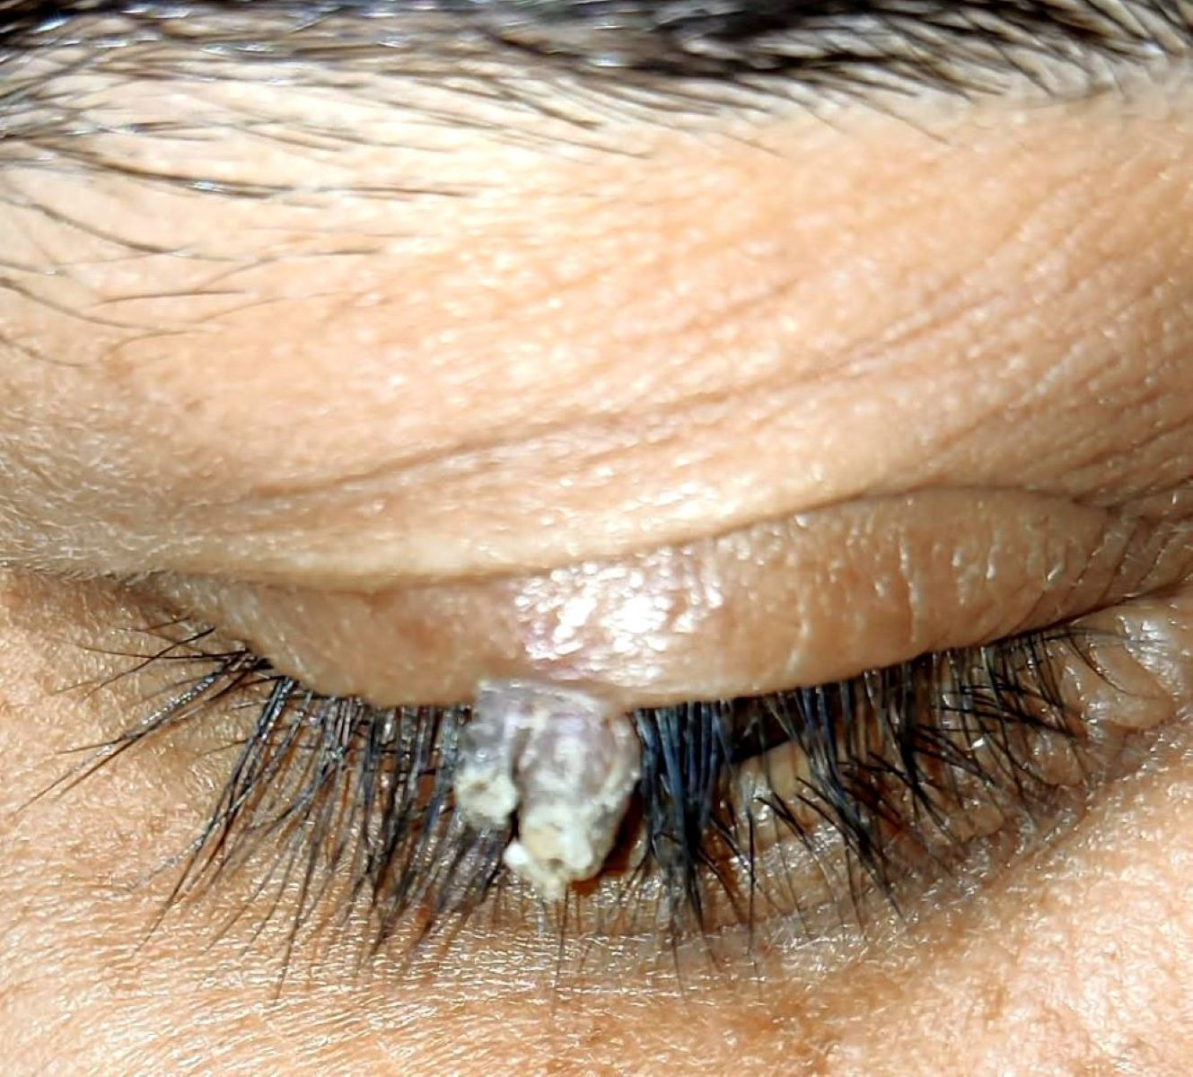

**Figure 1.** Inverted follicular keratosis: A greyish lesion with two finger like projections emerging close to lid margin in the right upper eyelid.

1. **DISCUSSION**

Inverted follicular keratosis (IFK) is a rare benign tumor of skin characterized by endophytic growth on the follicular infundibulum. A retrospective study of 2228 cases with eyelid tumors from China during 2002- 2015 (13 years) documented 36 (1.6%) cases of inverted follicular keratosis [4]. Deprez and Uffer reported the 117 cases of inverted follicular keratosis in the largest retrospective study of 5504 eyelid tumors during a period of 18 years from January 1989 to December 2007 [5]. In a retrospective study from Spain, a histologically confirmed diagnosis of periocular IFK was reported in only 11 cases during a period of 17 years between 2000 and 2017 [6]. It presents as a solitary, asymptomatic, solid, white‑pink papule or nodule predominantly on the skin of the face [2]. It is localized in head and neck region in 90% of patients [7]. The cheek and upper lip are the sites of predilection, other sites affected being the chin, forehead, eyebrow, nose, and eyelid [8]. Upper or lower lids may be involved, lesions having a predilection for the lid margins [3]. It is frequently seen in middle-aged or elderly males [7,9]. Mehregan's series (1983) reported about twice as often as women. The average age was 50 years (25-75 years) [7]. However, no gender predilection was reported in recent reviews; Deprez and Uffer, reported male female ratio 1/1 and average age 62 years (11–90) [4]. Sha-Sha Yu reported male female ratio 1/1.1 and average age 63years (37-86) [ 5].

The etiopathogenesis of the IFK is not known. Most of authors consider IFK as a squamous epithelial neoplasm of the infundibular portion of the hair follicle [7]. Some considered it to be an irritated variant of seborrheic keratosis, or verruca vulgaris [10]. Some authors reported it as a viral-induced epithelial hyperplasia with follicular patterns [11,12]. However, many other case studies have not detected human papillomavirus in most cases of the IFK [13,14]

Clinical as well as pathological resemblance between IFK and other cutaneous lesions, commonly verruca vulgaris, actinic keratosis, seborrheic keratosis, and keratoacanthoma; less commonly basal and squamous cell carcinoma; and most rarely, malignant melanoma, is reported. Therefore, IFK is frequently misdiagnosed. A correct clinical diagnosis is rarely made; Moehlenbeck reported a correct clinical diagnosis in 2% of cases, and Mehregan reported a correct clinical diagnosis in six of the 100 cases reviewed [7, 15]. Verruca vulgaris, basal epithelioma, and seborrheic keratosis were most commonly diagnosed (55%) and cutaneous horn in 5% cases in Mehregan case series [7]. Cases of IFK have also been histopathologically diagnosed incorrectly as squamous cell carcinoma [3, 9]. Histologically, there is well circumscribed growth large with lobules or finger-like extensions that resemble expanded follicles at least in parts endophytic [7,15]. The neoplastic lobules show a mixture of small basaloid cells at the periphery and larger keratinizing cells toward the center, with a number of squamous eddies which is an essential feature of IFK. The tumor is taller than broad. Mehregan described four histologic patterns: filiform or papillomatous wart -like: exophytic with overlying hyperkeratosis and parakeratosis, Keratoacanthoma-like: central exoendophytic mass, solid nodular: endophytic solid nodular lesion and Cystic type: irregular clefts within tumor and formation of small cysts [16]. Seborrheic keratosis is mostly exophytic, hyper pigmented, broader than tall, contain basaloid cells with laminated pseudo cysts. Verruca vulgaris have large, frequently angular blobs of keratohylin which lack in IFK. Tricholemmomas consist of light staining cells rich in glycogen [15, 16]. Recently, a study reported presence of Bcl2-positive epidermal dendritic cells in IFK but not in squamous cell carcinomas or SK [18].

IFK is successfully treated by a complete surgical excision of the lesion. No invasive growth or metastasis cases have been reported after the surgical excision [2, 3]. Recurrence is rare and can be avoided by a careful, complete removal of the primary lesion [19].

1. **CONCLUSION**

We report a rare case of IFK of eyelid mistaken as a cutaneous horn. Clinical diagnosis of IFK is difficult due to similarities in clinical manifestations of other skin lesions. A diagnosis of IFK is usually established by histopathology. IFK is treated by a complete surgical excision of the lesion with excellent prognosis.

**CONSENT**

Written informed consent was obtained from the patient for publication of the case.

**Disclaimer (Artificial intelligence)**

Author(s) hereby declare that NO generative AI technologies such as Large Language Models (ChatGPT, COPILOT, etc.) and text-to-image generators have been used during the writing or editing of this manuscript.

**REFERENCES**

1. Helwig, E. B. "Inverted Follicular Keratosis," in Seminar on the Skin: Neoplasms and Dermatoses, American Society of Clinical Pathologists, International Congress of Clinical Pathology, Washington, DC, September, 1954; published by American Society of Clinical Pathology, 1955.
2. Duke-Elder S, ed. System of Ophthalmology. 2nd ed. Vol. XIII. The Ocular Adnexa. StLouis: CV Mosby Co, 1974; 411-8.
3. Boniuk M, Zimmerman LE. Eyelid tumors with reference to lesions confused with squamous cell carcinoma: II. Inverted follicular keratosis. Arch Ophthalmol. 1963; 69:698-707.
4. Yu SS, Zhao Y, Zhao H, Lin JY, Tang X. A retrospective study of 2228 cases with eyelid tumors. Int J Ophthalmol. 2018;11(11):1835-1841
5. Deprez, M., & Uffer, S. Clinicopathological features of eyelid skin tumors. A retrospective study of 5504 cases and review of literature. The American Journal of dermatopathology. 2009; 31(3), 256–262. <https://doi.org/10.1097/DAD.0b013e3181961861>
6. Díez-Montero C, González González D, Pérez Martínez E, Schellini S, Galindo-Ferreiro A. Periocular inverted follicular keratosis: a retrospective series over 17 years. Jpn J Ophthalmol. 2019; Mar;63(2):210-214. doi: 10.1007/s10384-018-00650-7. Epub 2019 Jan 2. PMID: 306**0**4112.
7. Mehregan AH. Inverted follicular keratosis is a distinct follicular tumor. Am J Dermatopathol. 1983;5:467–470.
8. Mehregan AH. Inverted follicular keratosis. Arch Dermatol 1964; 89:229-35.
9. Azzopardi, J. G., & Laurini, R. Inverted follicular keratosis. Journal of clinical pathology. 1975; 28(6), 465–471. <https://doi.org/10.1136/jcp.28.6.465>
10. Schweitzer, J. G., & Yanoff, M. Inverted Follicular Keratosis. Ophthalmology.1987; 94(11), 1465–1468.
11. Hori K. Inverted follicular keratosis and papillomavirus infection. The American Journal of dermatopathology. 1991; 13(2), 145–151. https://doi.org/10.1097/00000372-199104000-00007
12. Reed, R. J & Pulitzer, D. R. Inverted follicular keratosis and human papillomaviruses. The American Journal of dermatopathology.1983, 5(5), 453–465. <https://doi.org/10.1097/00000372-198310000-00006>
13. Ruhoy SM, Thomas D, Nuovo GJ. Multiple inverted follicular keratoses as a presenting sign of Cowden’s syndrome: Case report with human papillomavirus studies. J Am Acad Dermatol 2004;51:411-5.
14. Battistella M, Peltre B, Cribier B. Composite tumors associating trichoblastoma and benign epidermal/follicular neoplasm: Another proof of the follicular nature of inverted follicular keratosis. J Cutan Pathol. 2010;37:1057‑63.
15. Moehlenbeck, F. W. Inverted follicular keratosis A morbus sui generis? The American Journal of Dermatopathology.1983; 5(5), 471–472.
16. James W.Patterson. Tumors of cutaneous appendages. En: Weedon's Skin Pathology, 5°ed; 2021: 954-956
17. Mehregan, A. H. Infundibular tumors of the skin. Journal of Cutaneous Pathology. 1984; 11(5), 387–395. doi:10.1111/j.1600-0560.1984.tb00396.x
18. Ko CJ, KimJ, Phan J, Binder SW. Bcl-2-positive epidermal dendritic cells in inverted follicular keratoses but not squamous cell carcinomas or seborrheic keratoses. J Cutan Pathol 2006; 33: 498.
19. Schweitzer, J. G., & Yanoff, M. Inverted Follicular Keratosis. Ophthalmology.1987; 94(11), 1465–1468.