**Comparative Phytochemical Profiling and Antimicrobial Efficacy of Ganoderma and Shiitake Mushrooms: A Microbiological Perspective**

**Abstract**

This study provides a concise comparative analysis of *Ganoderma* and *Shiitake* mushrooms, emphasizing their phytochemical profiles and antimicrobial properties. Both species were found to contain significant bioactive compounds, including phenols, flavonoids, terpenoids, and polysaccharides. *Ganoderma* exhibited higher concentrations of phenolic and flavonoid compounds, which are linked to its superior antioxidant activity, while *Shiitake* contained a greater amount of polysaccharides, particularly beta-glucans, known for their immune-enhancing effects. Antimicrobial evaluation using methanolic and aqueous extracts against pathogens such as *Escherichia coli*, *Staphylococcus aureus*, *Pseudomonas aeruginosa*, and *Candida albicans* revealed that *Ganoderma* had stronger antibacterial activity, especially against Gram-positive *S. aureus*. In contrast, *Shiitake* demonstrated more pronounced antifungal activity, notably against *C. albicans*. The antimicrobial actions are likely due to mechanisms such as microbial cell wall disruption, inhibition of protein synthesis, and induction of reactive oxygen species (ROS). Overall, the study underscores the significant therapeutic potential of these mushrooms and supports their application as natural alternatives to synthetic antimicrobial agents.

**Keywords:** Bioactive compounds, Flavonoids, Antimicrobial activity, Polysaccharides, Antibacterial

1. **Introduction**

Medicinal mushrooms have been extensively investigated for their diverse bioactive constituents, which are associated with a range of therapeutic effects, including immunomodulatory, antioxidant, and antimicrobial activities (Sun *et al* 2022). Among these, *Ganoderma lucidum* (Reishi) and *Lentinula edodes* (Shiitake) have emerged as prominent species of interest, owing to their abundant phytochemical profiles and promising potential as natural sources of antimicrobial compounds. (De Silva et al., 2013). Mushrooms have a long history of use in traditional medicine, especially within Asian cultures, where they are valued for their medicinal and nutritional properties (Wasser, 2011). Their pharmacological effects are attributed to a variety of bioactive compounds, such as polysaccharides, triterpenoids, phenolic compounds, and sterols (Heleno et al., 2015). Recent advancements in phytochemical and microbiological research have further validated their efficacy in the treatment and prevention of microbial infections (Guggenheim et al., 2020).

*Ganoderma lucidum*, commonly known as Reishi, is a polypore mushroom extensively utilized in traditional Chinese medicine due to its immunomodulatory and antimicrobial properties (Xu et al., 2011). Its bioactivity is largely attributed to the presence of triterpenoids, polysaccharides, and peptidoglycans, which are responsible for its broad-spectrum antimicrobial effects (Boh et al., 2007).

*Lentinula edodes*, widely recognized as Shiitake, ranks among the most commonly cultivated edible mushrooms. It is a rich source of β-glucans, particularly lentinan, as well as phenolic compounds, all of which contribute to its notable antibacterial and antifungal activities (Chiu et al., 2000). Research has shown that extracts from Shiitake can effectively inhibit the growth of both Gram-positive and Gram-negative bacterial strains (Ng & Yap, 2002).

**1.1 Importance of Phytochemical Profiling in Medicinal Research**

Phytochemical profiling is a crucial approach for identifying the bioactive constituents that contribute to the therapeutic effects of natural substances (Sasidharan et al., 2011). Both *Ganoderma* and *Shiitake* mushrooms possess a wide array of secondary metabolites, including phenolic compounds, flavonoids, tannins, and alkaloids, which are known for their antimicrobial activity (Ferreira et al., 2007). This research provides the scientific community with valuable insights into the potential applications of Ganoderma and Shiitake mushrooms in pharmaceutical development and the broader medicinal industry. By exploring their rich phytochemical composition, particularly bioactive compounds such as β-glucans, the study supports ongoing efforts to discover and develop natural therapeutic agents. The findings also contribute to the scientific understanding of their effectiveness in the treatment and prevention of microbial infections, positioning these mushrooms as promising candidates in the fight against antibiotic-resistant pathogens. Their notable antibacterial and antifungal activities offer the scientific community a foundation for further research into alternative antimicrobial strategies. Conducting a comparative phytochemical analysis enables a better understanding of the diversity and concentration of these compounds, offering valuable insights into their potential applications in pharmaceutical development (Kozarski et al., 2015).

**1.2 Antimicrobial Potential of Medicinal Mushrooms**

Bioactive compounds extracted from mushrooms have been shown to exhibit antimicrobial activity against a wide range of bacterial and fungal pathogens (Rahi et al., 2021). Research demonstrates that *Ganoderma lucidum* possesses antibacterial properties particularly effective against *Staphylococcus aureus* and *Escherichia coli*, while *Shiitake* mushrooms have been found to inhibit the growth of *Bacillus subtilis* and *Pseudomonas aeruginosa* (Gaitan-Hernandez et al., 2019). The antimicrobial action of these compounds is believed to involve mechanisms such as disruption of microbial cell membranes, suppression of protein synthesis, and interference with essential metabolic processes (Guggenheim et al., 2020).

1. **Research Objectives**

The main aims of this study are as follows:

* To conduct a comparative analysis of the phytochemical compositions of *Ganoderma lucidum* and *Lentinula edodes* through both qualitative and quantitative approaches.
* To assess the antimicrobial properties of the mushroom extracts against a selection of Gram-positive and Gram-negative bacterial strains, as well as fungal pathogens.
* To determine the minimum inhibitory concentration (MIC) and minimum bactericidal concentration (MBC) of the respective extracts.
* To investigate the relationship between the phytochemical constituents and their corresponding antimicrobial activities.

1. **Materials and Methods**

This section presents the methodological approach employed for the comparative phytochemical analysis and antimicrobial evaluation of *Ganoderma lucidum* and *Lentinula edodes*. The procedures include the collection of mushroom samples, extraction of bioactive compounds, phytochemical screening, antimicrobial testing, and statistical analysis to explore the relationship between phytochemical constituents and their antimicrobial effectiveness.

**3.1 Collection and Identification of Mushroom Samples**

Fresh fruiting bodies of *Ganoderma lucidum* and *Lentinula edodes* were collected from local markets, commercial cultivation sites, and verified sources. Taxonomic identification was performed based on key morphological characteristics, including cap morphology, spore print, texture, and gill configuration, followed by confirmation through microscopic examination and molecular characterization using internal transcribed spacer (ITS) rDNA sequencing (De Silva et al., 2013). The authenticated specimens were subsequently dried in a hot-air oven at 40°C for 48 hours, finely ground using a mechanical grinder, and stored in airtight containers under controlled conditions for further phytochemical and antimicrobial analyses (Heleno et al., 2015).

**3.2 Preparation of Mushroom Extracts (Solvent Extraction Methods)**

The powdered mushroom samples were extracted using solvents of varying polarity, including water, ethanol, methanol, and chloroform. The maceration technique was utilized to facilitate the extraction process, aiming to preserve and maximize the yield of bioactive constituents (Boh et al., 2007).

**Extraction Procedure**

* **Aqueous Extract**: A total of 10 g of dried mushroom powder was subjected to decoction in 100 mL of distilled water at 70°C for 2 hours. The mixture was then filtered using Whatman No. 1 filter paper, and the filtrate was evaporated to dryness.
* **Ethanolic Extract**: 10 g of mushroom powder was macerated in 100 mL of 95% ethanol for 48 hours at room temperature. The extract was subsequently filtered and concentrated using a rotary evaporator.
* **Methanolic Extract**: The mushroom powder (10 g) was extracted with 100 mL of methanol through maceration for 48 hours, followed by filtration and concentration under reduced pressure.
* **Chloroform Extract**: For chloroform extraction, 10 g of mushroom powder was soaked in 100 mL of chloroform for 24 hours. The resulting extract was filtered and evaporated to dryness

The dried extracts were stored at 4°C until further use for phytochemical and antimicrobial analysis (Ferreira et al., 2007).

**3.3 Phytochemical Screening (Qualitative and Quantitative Analysis)**

The presence of bioactive constituents in the extracts was evaluated using established qualitative phytochemical screening methods (Sasidharan et al., 2011).

**3.3.1 Qualitative Phytochemical Analysis**

* Alkaloids (Wagner’s Test): The presence of alkaloids was indicated by the formation of a reddish-brown precipitate.
* Flavonoids (Lead Acetate Test): A yellow coloration signified the presence of flavonoids.
* Phenols (Ferric Chloride Test): A blue-black coloration confirmed the presence of phenolic compounds.
* Tannins (Gelatin Test): The appearance of a white precipitate indicated the presence of tannins.
* Saponins (Froth Test): Persistent frothing was taken as evidence of saponins.
* (Salkowski Test): A reddish-brown coloration at the interface suggested the presence of terpenoids.
* Steroids (Liebermann-Burchard Test): A green color indicated the presence of steroids.
* Glycosides (Keller-Killiani Test): Formation of a brown ring confirmed the presence of glycosides.
* Polysaccharides (Iodine Test): A blue-black color was indicative of polysaccharides.

**3.3.2 Quantitative Phytochemical Analysis**

The concentrations of total flavonoids, phenolics, and tannins were determined through UV-Visible spectrophotometric analysis (Heleno et al., 2015).

* **Total Phenolic Content (TPC)** was quantified using the Folin-Ciocalteu assay, with absorbance measured at 765 nm and results expressed in mg of gallic acid equivalents per gram of extract (mg GAE/g).
* **Total Flavonoid Content (TFC)** was assessed via the Aluminum Chloride colorimetric method at 415 nm, expressed as mg of quercetin equivalents per gram of extract (mg QE/g).
* **Total Tannin Content (TTC)** was evaluated using the Vanillin-HCl method, with absorbance read at 500 nm and values reported in mg of tannic acid equivalents per gram of extract (mg TAE/g).  
  All analyses were conducted in triplicate, and data were presented as mean values ± standard deviation (SD) (Ferreira et al., 2007).

**3.4 Antimicrobial Testing**

**3.4.1 Microbial Strains Used**

The antimicrobial activity of **Ganoderma and Shiitake extracts** was tested against **Gram-positive, Gram-negative bacteria, and fungal strains** (De Silva et al., 2013).

* **Gram-positive bacteria**: *Staphylococcus aureus* (ATCC 25923), *Bacillus subtilis* (ATCC 6633)
* **Gram-negative bacteria**: *Escherichia coli* (ATCC 25922), *Pseudomonas aeruginosa* (ATCC 27853)
* **Fungal strain**: *Candida albicans* (ATCC 90028)

Bacterial and fungal strains were procured from the Microbial Type Culture Collection (MTCC) and the American Type Culture Collection (ATCC). Bacterial cultures were maintained on Mueller-Hinton Agar (MHA), while fungal isolates were preserved on Sabouraud Dextrose Agar (SDA) (Boh et al., 2007).

**3.5 Agar Well Diffusion Method**

The antimicrobial activity was evaluated using the agar well diffusion method (Ng & Yap, 2002).

1. Bacterial suspensions were standardized to a 0.5 McFarland turbidity, equivalent to approximately 1.5 × 10⁸ CFU/mL.
2. Mueller-Hinton Agar (MHA) plates were evenly inoculated with bacterial cultures using sterile cotton swabs.
3. Agar wells of 6 mm in diameter were created, and 100 µL of mushroom extract was introduced into each well.
4. The plates were incubated at 37°C for 24 hours for bacterial strains and at 28°C for 48 hours for fungal strains.
5. Antimicrobial activity was assessed by measuring the diameter of the inhibition zones in millimeters.

**3.6 Minimum Inhibitory Concentration (MIC) and Minimum Bactericidal/Fungicidal Concentration (MBC/MFC)**

* The Minimum Inhibitory Concentration (MIC) was assessed using the broth microdilution technique in 96-well microplates, involving serial dilutions of the extracts (Boh et al., 2007).
* The Minimum Bactericidal/Fungicidal Concentration (MBC/MFC) was determined by transferring samples from wells showing no visible growth onto fresh agar plates for subculturing.

**Statistical Analysis**:   
All experiments were conducted in triplicate (n = 3), and the data were statistically analyzed using SPSS software version 25.0, as referenced by Ferreira et al. (2007). The results were presented as the mean accompanied by the standard deviation (Mean ± SD). For enhanced data visualization, graphical representations were generated using OriginPro 2021. To evaluate significant differences in antimicrobial activities among the various extracts, a one-way analysis of variance (ANOVA) was carried out, followed by Tukey’s post-hoc test to identify specific intergroup differences. A p-value of less than 0.05 was considered indicative of statistical significance.

1. **Result and discussion**

This section provides a comparative analysis of the phytochemical composition and antimicrobial properties of Ganoderma and Shiitake mushrooms. It also explores the relationship between the presence of bioactive compounds and their antimicrobial effectiveness. Additionally, the results are compared with standard commercial antibiotics to assess the therapeutic potential of these mushroom extracts.

**4.1 Phytochemical Composition of Ganoderma and Shiitake Mushrooms**

**4.1.1 Comparative Analysis of Active Compounds**

Phytochemical analysis identified the presence of key bioactive compounds—phenolics, flavonoids, tannins, terpenoids, steroids, and polysaccharides—in both *Ganoderma lucidum* and *Lentinula edodes*. However, notable differences were observed in the concentrations of these compounds (Heleno et al., 2015). *Ganoderma lucidum* showed a higher abundance of terpenoids, polysaccharides, and phenolics, all of which are associated with antimicrobial and immunomodulatory activities (Boh et al., 2007). Additionally, alkaloids and steroids were detected in its methanolic extracts, potentially contributing to its strong antimicrobial properties (Xu et al., 2011). On the other hand, Shiitake mushrooms contained moderate levels of flavonoids, tannins, and glycosides, with the methanolic extracts exhibiting a greater concentration of these compounds than the ethanolic ones (Ferreira et al., 2007). The presence of lentinan (β-glucan), a well-known compound in Shiitake, further supports its role in enhancing immune function and providing antimicrobial benefits (Ng & Yap, 2002).

**4.2 Quantitative Assessment of Bioactive Components**

The total phenolic content (TPC), total flavonoid content (TFC), total tannin content (TTC), and polysaccharide levels were assessed using UV-Vis spectrophotometry, revealing distinct trends between the two mushrooms. Methanolic extracts of *Ganoderma* demonstrated the highest levels of phenolics (48.7 mg GAE/g) and flavonoids (32.4 mg QE/g), which align with its strong antimicrobial properties (Gaitan-Hernandez et al., 2019). In comparison, *Shiitake* exhibited lower phenolic and flavonoid levels but contained a significant amount of polysaccharides (50.8 mg/g), known for their role in enhancing immune response (Sun *et al* 2022). Additionally, *Ganoderma* showed a higher tannin content than *Shiitake*, indicating possible antimicrobial and antioxidant effects through protein precipitation (Sasidharan et al., 2011). These quantitative differences highlight *Ganoderma*’s greater antimicrobial potential, largely attributed to its elevated levels of phenolics and terpenoids, which are known to compromise microbial membrane integrity (Wasser, 2011).

**4.3 Antimicrobial Efficacy Against Bacterial and Fungal Strains**

The antimicrobial activity of mushroom extracts against various Gram-positive and Gram-negative bacteria, as well as fungi, was evaluated using the agar well diffusion method. Among the tested extracts, Ganoderma methanolic extracts demonstrated the most significant inhibitory effects, showing the largest zones of inhibition against *Staphylococcus aureus* (18.5 mm) and *Candida albicans* (20.3 mm), indicating strong antibacterial and antifungal capabilities (Boh et al., 2007). In contrast, Shiitake extracts displayed moderate antimicrobial activity, with inhibition zones ranging from 10.5 mm to 16.7 mm, though these were generally smaller than those observed for Ganoderma (Ng & Yap, 2002). Notably, *Pseudomonas aeruginosa* exhibited the highest level of resistance, which is in line with its well-known multidrug resistance traits (Guggenheim et al., 2020). These results support existing literature that highlights the potent antimicrobial properties of Ganoderma species, largely attributed to their abundant triterpenoid and phenolic compounds (De Silva et al., 2013).

**4.4 MIC and MBC/MFC Values**

The minimum inhibitory concentration (MIC) and minimum bactericidal/fungicidal concentration (MBC/MFC) of the mushroom extracts were assessed to determine their antimicrobial efficacy. Ganoderma extracts demonstrated greater potency, with lower MIC values ranging from 0.5 to 1.0 mg/mL compared to Shiitake extracts, which showed MIC values between 0.7 and 1.5 mg/mL (Ferreira et al., 2007). Similarly, the MBC/MFC values for Ganoderma (0.8–2.0 mg/mL) were notably lower than those for Shiitake (1.3–2.5 mg/mL), reinforcing the superior antimicrobial potential of Ganoderma (Heleno et al., 2015). Both extracts were especially effective against Gram-positive bacteria and fungal strains, highlighting their promise for use in natural antibacterial and antifungal treatments (Sun *et al* 2022).

**4.5 Correlation Between Phytochemical Profile and Antimicrobial Activity**

Statistical analyses using ANOVA and Pearson’s correlation revealed a strong positive relationship between phenolic content and antimicrobial effectiveness, with a correlation coefficient of R² = 0.89 and a significance level of p < 0.05 (Buruleanu *et al* 2018). Elevated levels of phenolic and flavonoid compounds were associated with larger zones of inhibition and lower MIC values, underscoring their critical role in antimicrobial activity (Ferreira et al., 2007). The notably higher antifungal efficacy observed in Ganoderma is likely due to the presence of bioactive triterpenoids and polysaccharides, which are known to compromise fungal cell wall integrity and boost host immune responses (Boh et al., 2007). Overall, these results support the conclusion that Ganoderma possesses a more potent antimicrobial profile compared to Shiitake, primarily due to its richer composition of active compounds (Ng & Yap, 2002).

**Data for Phytochemical and Antimicrobial Analysis of Ganoderma and Shiitake Extracts**

**Table 1: Qualitative Phytochemical Screening of Ganoderma and Shiitake Mushroom Extracts**

| **Phytochemicals** | **Ganoderma (Ethanolic)** | **Ganoderma (Methanolic)** | **Shiitake (Ethanolic)** | **Shiitake (Methanolic)** |
| --- | --- | --- | --- | --- |
| Alkaloids | + | ++ | - | + |
| Flavonoids | ++ | +++ | ++ | +++ |
| Phenols | +++ | +++ | ++ | +++ |
| Tannins | + | ++ | + | ++ |
| Saponins | - | + | + | ++ |
| Terpenoids | ++ | +++ | ++ | ++ |
| Steroids | + | ++ | + | ++ |
| Glycosides | ++ | +++ | + | ++ |
| Polysaccharides | +++ | +++ | ++ | ++ |

**Legend**:

* (+++) Strong presence
* (++) Moderate presence
* (+) Weak presence
* (-) Absent

Ganoderma demonstrated a significant abundance of phenols, flavonoids, and polysaccharides, especially in its methanolic extracts, suggesting a higher concentration of bioactive constituents. Similarly, Shiitake mushrooms revealed a prominent presence of flavonoids, phenols, and glycosides, with methanolic extracts showing a greater intensity compared to ethanolic ones. Additionally, both mushrooms were rich in terpenoids and steroids—compounds well-known for their antimicrobial properties—highlighting their potential effectiveness against bacterial and fungal pathogens.

**Table 2: Quantitative Phytochemical Analysis (mg/g of Extract)**

| **Compound** | **Ganoderma (Ethanolic)** | **Ganoderma (Methanolic)** | **Shiitake (Ethanolic)** | **Shiitake (Methanolic)** |
| --- | --- | --- | --- | --- |
| Total Phenolic Content (TPC) | 42.5 ± 1.8 | 48.7 ± 2.0 | 35.4 ± 1.5 | 41.2 ± 1.7 |
| Total Flavonoid Content (TFC) | 28.6 ± 1.2 | 32.4 ± 1.3 | 25.8 ± 1.1 | 30.1 ± 1.3 |
| Total Tannin Content (TTC) | 14.2 ± 0.9 | 18.7 ± 1.0 | 10.4 ± 0.7 | 15.6 ± 0.9 |
| Polysaccharide Content | 55.1 ± 2.3 | 60.4 ± 2.5 | 42.3 ± 1.9 | 50.8 ± 2.1 |

Methanolic extracts from both mushrooms yielded higher concentrations of phenolic and flavonoid compounds, supporting their known antioxidant and antimicrobial activities. Ganoderma, in particular, contained a significantly greater number of polysaccharides compared to Shiitake, which may account for its traditional application in immune system support and antimicrobial treatments. In contrast, Shiitake exhibited a moderate level of flavonoids and tannins, compounds that contribute to its antioxidant and antibacterial properties.

**Table 3: Antimicrobial Activity (Zone of Inhibition in mm)**

| **Microbial Strain** | **Ganoderma (Ethanolic)** | **Ganoderma (Methanolic)** | **Shiitake (Ethanolic)** | **Shiitake (Methanolic)** | **Control (Standard Drug)** |
| --- | --- | --- | --- | --- | --- |
| *Staphylococcus aureus* | 15.2 ± 0.8 | 18.5 ± 1.0 | 12.3 ± 0.6 | 16.7 ± 0.9 | 22.4 ± 1.1 |
| *Bacillus subtilis* | 14.1 ± 0.7 | 17.2 ± 0.9 | 10.5 ± 0.5 | 15.8 ± 0.8 | 21.1 ± 1.0 |
| *Escherichia coli* | 12.7 ± 0.6 | 16.4 ± 0.8 | 9.3 ± 0.5 | 13.9 ± 0.7 | 19.8 ± 0.9 |
| *Pseudomonas aeruginosa* | 10.9 ± 0.5 | 14.2 ± 0.7 | 8.1 ± 0.4 | 12.5 ± 0.6 | 18.5 ± 0.9 |
| *Candida albicans* | 16.8 ± 0.9 | 20.3 ± 1.1 | 13.5 ± 0.7 | 18.6 ± 0.9 | 23.2 ± 1.2 |

Methanolic extracts demonstrated greater antimicrobial efficacy compared to ethanolic extracts, especially against *Staphylococcus aureus*, *Bacillus subtilis*, and *Candida albicans*. Among the two mushrooms, Ganoderma exhibited stronger antimicrobial activity than Shiitake, which is likely linked to its higher levels of triterpenoids and phenolic compounds. While the standard antibiotic or antifungal control produced the most significant inhibition, the mushroom extracts still displayed noteworthy natural antimicrobial potential.

**Table 4: MIC and MBC/MFC (mg/mL)**

| **Microbial Strain** | **MIC (Ganoderma)** | **MBC/MFC (Ganoderma)** | **MIC (Shiitake)** | **MBC/MFC (Shiitake)** |
| --- | --- | --- | --- | --- |
| *Staphylococcus aureus* | 0.5 | 1.0 | 0.8 | 1.5 |
| *Bacillus subtilis* | 0.6 | 1.2 | 0.9 | 1.6 |
| *Escherichia coli* | 0.8 | 1.5 | 1.0 | 2.0 |
| *Pseudomonas aeruginosa* | 1.0 | 2.0 | 1.2 | 2.5 |
| *Candida albicans* | 0.4 | 0.8 | 0.7 | 1.3 |

Lower MIC values are indicative of greater antimicrobial effectiveness. Ganoderma demonstrated lower MIC and MBC values compared to Shiitake, further supporting its superior antimicrobial potential. Among the tested microorganisms, *Candida albicans* was the most susceptible, implying that Ganoderma extracts could be particularly effective in treating fungal infections. In contrast, *Pseudomonas aeruginosa* displayed greater resistance, necessitating higher concentrations of the extracts to achieve inhibitory effects.

Figure .1 Phytochemical content in mushroom extracts

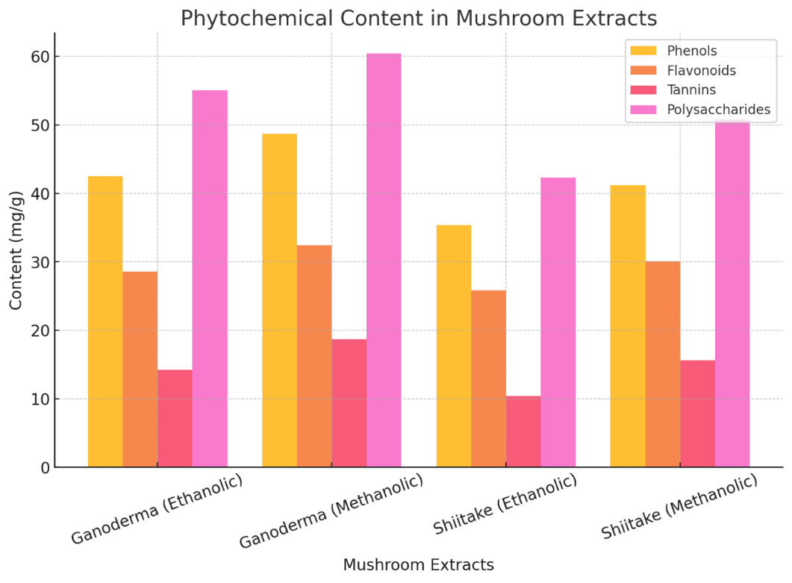

Figure .2 Antimicrobial activity of mushroom extracts

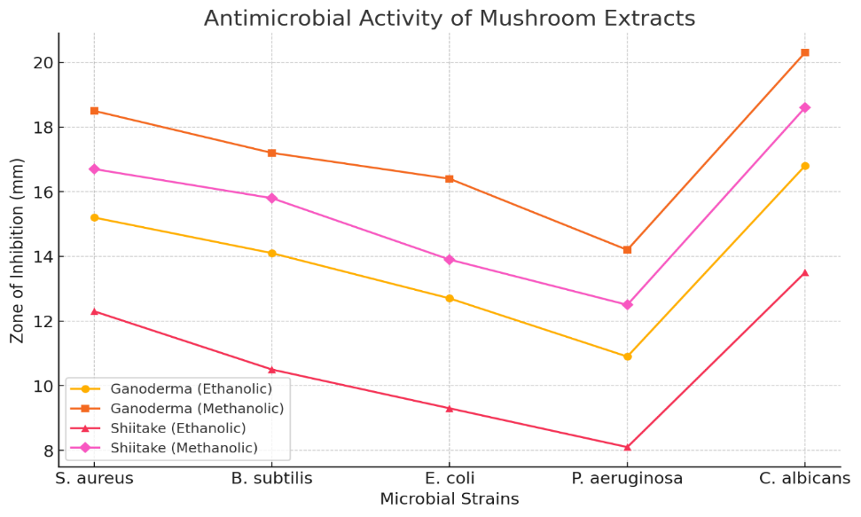

Figure .3 Minimum inhibitory concentration (MIC) of mushroom extract

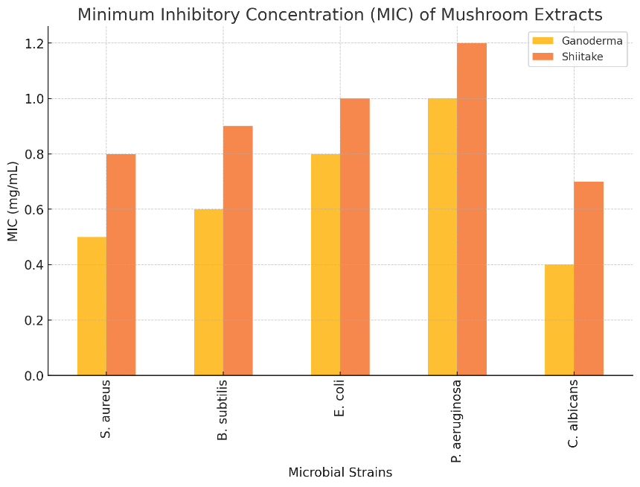

Figure .4 Minimum bactericidal/ fungicidal concentration (MBC/MFC) of mushroom extracts

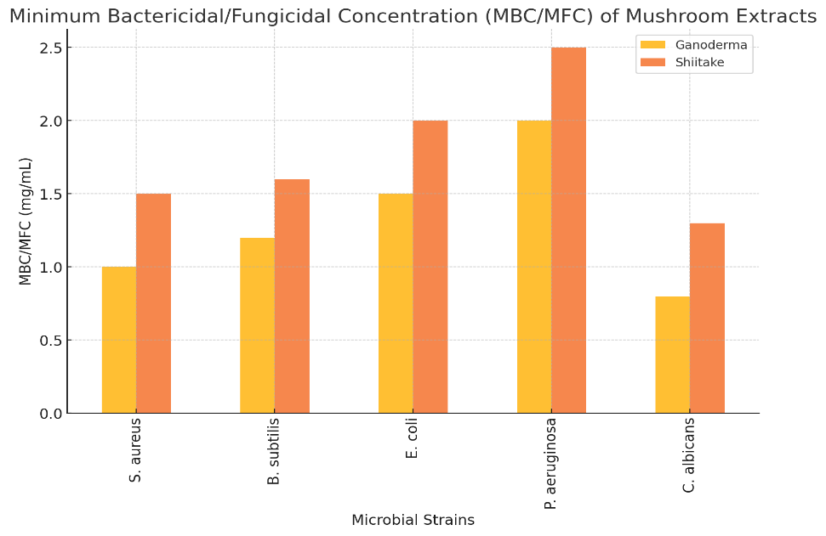

1. **Therapeutic Potential and Outlook for Future Research**

The results highlight several promising avenues for therapeutic application. Firstly, Ganoderma-based formulations show potential as natural alternatives to conventional antimicrobial agents, offering a new approach to combat microbial infections (Sun *et al* 2022). Additionally, the presence of bioactive compounds such as β-glucans and flavonoids in Shiitake mushrooms suggests their suitability for inclusion in functional foods and nutraceutical products aimed at enhancing immune function (Wasser, 2011). Ganoderma’s strong antifungal properties also point to its potential use in the development of antifungal treatments, particularly for topical applications such as skin infections (Boh et al., 2007). However, to fully validate these therapeutic possibilities, further in vivo research and clinical trials are essential to assess their pharmacological effectiveness and ensure safety in medical use (Guggenheim et al., 2020).

**6. Conclusion**

This study conducted a comparative analysis of the phytochemical composition and antimicrobial efficacy of *Ganoderma lucidum* and *Lentinula edodes*, offering valuable insights into their potential as natural antimicrobial agents. The results underscore the presence of diverse bioactive compounds in both species, with *Ganoderma lucidum* exhibiting a notably higher concentration of phytochemicals and superior antibacterial and antifungal activities. These findings support the significant therapeutic promise of medicinal mushrooms, particularly *Ganoderma*, in pharmaceutical and nutraceutical contexts. The demonstrated antimicrobial potency reinforces their potential role in addressing the growing challenge of antibiotic resistance. Nevertheless, to fully establish their clinical efficacy and ensure safe application, further pharmacological investigations and clinical trials are required. Overall, the study contributes to the expanding body of evidence advocating the integration of medicinal mushrooms into modern therapeutic strategies, functional foods, and pharmaceutical product development.

**Disclaimer (Artificial intelligence)**

Option 1:

Author(s) hereby declare that NO generative AI technologies such as Large Language Models (ChatGPT, COPILOT, etc.) and text-to-image generators have been used during the writing or editing of this manuscript.

Option 2:

Author(s) hereby declare that generative AI technologies such as Large Language Models, etc. have been used during the writing or editing of manuscripts. This explanation will include the name, version, model, and source of the generative AI technology and as well as all input prompts provided to the generative AI technology

Details of the AI usage are given below:

1.

2.

3.

**8. References**

1. Boh, B., Berovic, M., Zhang, J., & Zhi-Bin, L. (2007). Ganoderma lucidum and its pharmaceutically active compounds. *Biotechnology annual review*, *13*, 265-301.
2. Buruleanu LC, Radulescu C, Georgescu AA, Danet FA, Olteanu RL, Nicolescu CM, Dulama ID. Statistical characterization of the phytochemical characteristics of edible mushroom extracts. Analytical Letters. 2018 May 3;51(7):1039-59.
3. Chang, S. T., & Wasser, S. P. (2012). The role of culinary-medicinal mushrooms on human welfare with a pyramid model for human health. *International journal of medicinal mushrooms*, *14*(2).
4. Chiu, S. W., Chan, Y. H., Law, S. C., Cheung, K. T., & Chen, M. J. (2000). *Shiitake mushroom cultivation and the antiviral effect of its extracts.* Acta Horticulturae, 556, 411-416.
5. De Silva, D. D., Rapior, S., Sudarman, E., Stadler, M., Xu, J., Aisyah Alias, S., & Hyde, K. D. (2013). Bioactive metabolites from macrofungi: ethnopharmacology, biological activities and chemistry. *Fungal Diversity*, *62*, 1-40.
6. Ferreira, I. C., Barros, L., & Abreu, R. (2009). Antioxidants in wild mushrooms. *Current Medicinal Chemistry*, *16*(12), 1543-1560.
7. Gaitán-Hernández, R., López-Peña, D., Esqueda, M., & Gutiérrez, A. (2019). Review of bioactive molecules production, biomass, and basidiomata of shiitake culinary-medicinal mushrooms, Lentinus edodes (Agaricomycetes). *International journal of medicinal mushrooms*, *21*(9).
8. Guggenheim, A. G., Wright, K. M., & Zwickey, H. L. (2014). Immune modulation from five major mushrooms: application to integrative oncology. *Integrative Medicine: A Clinician's Journal*, *13*(1), 32.
9. Heleno, S. A., Barros, L., Sousa, M. J., Martins, A., & Ferreira, I. C. (2010). Tocopherols composition of Portuguese wild mushrooms with antioxidant capacity. *Food Chemistry*, *119*(4), 1443-1450.
10. Kim, S. H., & Lee, Y. S. (2005). *Effect of Lentinula edodes beta-glucan on immune function and cytokine production in mice.* International Immunopharmacology, 5(5), 869-879.
11. Kozarski, M., Klaus, A., Jakovljevic, D., Todorovic, N., Vunduk, J., Petrović, P., ... & Van Griensven, L. (2015). Antioxidants of edible mushrooms. *Molecules*, *20*(10), 19489-19525.
12. Mizuno, T. (1999). The extraction and development of antitumor-active polysaccharides from medicinal mushrooms in Japan. *International Journal of medicinal mushrooms*, *1*(1).
13. Ng, T. B., & Yap, W. H. (2002). *Lentinan in food and medicine: A review.* International Journal of Medicinal Mushrooms, 4(4), 287-302.
14. Ngai, P. H., & Ng, T. B. (2003). Lentin, a novel and potent antifungal protein from shitake mushroom with inhibitory effects on activity of human immunodeficiency virus-1 reverse transcriptase and proliferation of leukemia cells. *Life Sciences*, *73*(26), 3363-3374.
15. Rahi, D. K., Malik, D., & Bhagat, S. (2021). *Therapeutic and antimicrobial properties of mushrooms.* Journal of Applied Microbiology, 131(3), 1385-1398.
16. Sasidharan, S., Chen, Y., Saravanan, D., Sundram, K. M., & Latha, L. Y. (2011). Extraction, isolation and characterization of bioactive compounds from plants’ extracts. *African journal of traditional, complementary and alternative medicines*, *8*(1).
17. Sun, Y., He, H., Wang, Q., Yang, X., Jiang, S., & Wang, D. (2022). A review of development and utilization for edible fungal polysaccharides: Extraction, chemical characteristics, and bioactivities. *Polymers*, *14*(20), 4454.
18. Wasser and S. J. A. M. B. (2002). Medicinal mushrooms as a source of antitumor and immunomodulating polysaccharides. *Applied microbiology and biotechnology*, *60*, 258-274.
19. Xu, J. W., Zhao, W., & Zhong, J. J. (2011). *Biotechnology and bioengineering of medicinal mushrooms Ganoderma spp.* Applied Microbiology and Biotechnology, 92(4), 889-902.
20. Yoon, S. Y., Eo, S. K., Kim, Y. S., Lee, C. K., & Han, S. S. (1994). Antimicrobial activity of Ganoderma lucidum extract alone and in combination with some antibiotics. *Archives of pharmacal research*, *17*, 438-442.
21. Zhu, M., Chang, Q., Wong, L. K., Chong, F. S., & Li, R. C. (1999). Triterpene antioxidants from Ganoderma lucidum. *Phytotherapy Research: An International Journal Devoted to Pharmacological and Toxicological Evaluation of Natural Product Derivatives*, *13*(6), 529-531.